Supplementary Tables and Figures

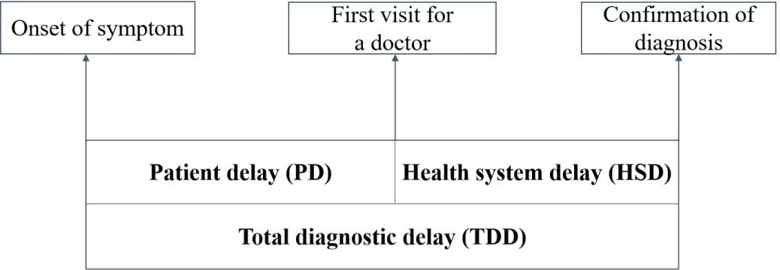
S1 Fig. Conceptual framework on definitions of delay before diagnosis among PTB patients.

S2 Fig. Trends of delay rate among PTB patients aged ≥60 years.

S1 Table The influencing factors analysis for TDD among PTB patients aged ≥60 years.
Variables | Median (days) | Total  (N=187,886) | TDD  (n ,%) | cOR  (95% CI) | aOR  (95% CI) | P value
Sex |  |  |  |  |  | <0.001
Female | 33 (15-71) | 37339 | 28416(76.1) | Reference | Reference
Male | 32 (15-68) | 150547 | 113998(75.7) | 0.98(0.95-1.01) | 0.95(0.93-0.98)
Ethnicity |  |  |  |  |  | 0.088
Han | 33 (15-69) | 186985 | 141749(75.8) | Reference | Reference
Minorities | 32 (15-73.5) | 901 | 665(73.8) | 0.89 (0.78-1.04) | 0.88(0.76-1.02)
Occupation |  |  |  |  |  | <0.001
Farmers | 34 (16-71) | 113887 | 88391(77.6) | 1.28(1.25-1.31) | 1.12(1.09-1.15)
Others | 30 (13-65) | 73999 | 54023(73.0) | Reference | Reference
Residence |  |  |  |  |  | 0.071
Local | 32 (15-68) | 183919 | 139343(75.8) | Reference | Reference
Migrant | 327 (17-79) | 3967 | 3071(77.4) | 1.10(1.01-1.18) | 1.09(0.99-1.18)
Vulnerability status* |  |  |  |  |  | 0.173
No | 32 (15-68) | 179289 | 135367(75.5) | Reference | Reference
Yes | 38 (19-81) | 8597 | 7047(82.0) | 1.48(1.40-1.56) | 0.88(0.72-1.06)
Institutional category of first medical visit |  |  |  |  |  | <0.001
Designated TB care facilities | 32 (15-69) | 182841 | 138412(75.7) | Reference | Reference
Non-designated facilities | 33 (16-58) | 5045 | 4002(79.3) | 1.23(1.15-1.32) | 1.18(1.10-1.26)
Hospital level of initial diagnosis |  |  |  |  |  | <0.001
Provincial and prefecture-level | 31 (14-65) | 47983 | 35121(73.2) | Reference | Reference
County-level | 33 (15-70) | 139903 | 107293(76.7) | 1.21(1.18-1.23) | 1.06(1.03-1.09)
Methods of case finding |  |  |  |  |  | <0.001
Active | 32 (14-67) | 71315 | 53315(74.8) | Reference | Reference
Passive | 33 (15-70) | 116571 | 89099(76.4) | 1.10(1.07-1.12) | 1.07(1.05-1.10)
Time of case finding |  |  |  |  |  | 0.242
Before COVID-19 (2010-2019) | 32 (15-68) | 149782 | 113282(75.6) | Reference | Reference
During COVID-19 (2020-2022) | 33 (15-70) | 38104 | 29132(76.5) | 1.05(1.02-1.07) | 1.03(0.99-1.06)
Region of case finding# |  |  |  |  |  | <0.001
Developed area | 29 (13-62) | 77707 | 55680(71.7) | Reference | Reference
Underdeveloped area | 35 (17-73) | 110179 | 86734(78.7) | 1.46(1.43-1.50) | 1.41(1.38-1.44)
Etiological diagnosis |  |  |  |  |  | 0.222
Positive | 34 (15-75) | 100670 | 76416(75.9) | Reference | Reference
Negative | 31 (15-64) | 87216 | 65998(75.7) | 0.98(0.97-1.01) | 0.98 (0.95-1.00)
Treatment category |  |  |  |  |  | 0.141
New | 33 (15-69) | 172031 | 130609(75.9) | Reference | Reference
Retreated | 32 (14-74) | 15855 | 11805(74.5) | 0.92(0.89-0.96) | 0.96 (0.92-1.00)
HIV/AIDS |  |  |  |  |  | 0.872
Yes | 34 (16-73) | 316 | 246(77.8) | 1.12(0.86-1.46) | 0.95(0.84-1.43)
No | 32 (15-68) | 187570 | 142168(75.8) | Reference | Reference
DM |  |  |  |  |  | 0.926
Yes | 38 (19-82) | 8006 | 6603(82.5) | 1.53(1.44-1.62) | 0.99(0.81-1.22)
No | 32 (15-68) | 179880 | 135811(75.5) | Reference | Reference
Respiratory comorbidities |  |  |  |  |  | <0.001
Yes | 40 (20-89) | 15583 | 12960(83.17) | 1.64(1.57-1.71) | 1.86(1.74-1.99)
No | 32 (15-68) | 172303 | 129454(75.13) | Reference | Reference
*vulnerability status was defined as being a close contact of active PTB patients, working in healthcare or school/daycare settings, serving as a supervisor in prisons or detention centers, working in animal husbandry, being a dust collector or having pneumoconiosis, having a psychiatric disorder, residing in nursing or welfare facilities, or living in other crowded environments. #Region of case finding included developed area (PRDR) and underdeveloped area (EG, WG and NG).

