Supporting Information
Flexoelectricity-driven giant polarization in (Bi, Na)TiO₃-based ferroelectric thin films
Yunlong Sun¹, Ranming Niu^{2,3}, Zizheng Song^{4,5}, Shiyu Tang⁶, Huizhong Wang¹, Xun Geng⁷, Ji Zhang^{1,8}, Jack Yang^{1,8}, Claudio Cazorla⁹, Changqing Guo⁶, Shery L. Y. Chang¹, Xiaojie Lou¹⁰, Houbing Huang^{6,*}, Zibin Chen^{4,5,*}, Shujun Zhang¹¹ and Danyang Wang^{1,*}

¹ School of Materials Science and Engineering, The University of New South Wales, Sydney, NSW 2052, Australia
² Australian Centre for Microscopy and Microanalysis, The University of Sydney, Sydney, NSW 2006, Australia
³ School of Aerospace, Mechanical and Mechatronic Engineering, The University of Sydney, Sydney, NSW 2006, Australia
⁴ State Key Laboratory of Ultra-Precision Machining Technology, Department of Industrial and Systems Engineering, The Hong Kong Polytechnic University, Kowloon, Hong Kong, China
⁵ Research Institute for Advanced Manufacturing, Department of Industrial and Systems Engineering, The Hong Kong Polytechnic University, Hong Kong, China
⁶ Advanced Research Institute of Multidisciplinary Science, Beijing Institute of Technology, Beijing 100081, China.
⁷ Global Innovative Center for Advanced Nanomaterials, College of Engineering, Science and Environment, The University of Newcastle, Callaghan, New South Wales, 2308, Australia
⁸ Materials and Manufacturing Futures Institute, The University of New South Wales, Sydney, NSW 2052, Australia
⁹ Departament de Física, Universitat Politècnica de Catalunya, Campus Nord B4-B5, E-08034 Barcelona, Spain
¹⁰ Frontier Institute of Science and Technology, State Key Laboratory for Mechanical Behavior of Materials and Future Industrial Innovation Institute of Emerging Information Storage and Smart Sensor, Xi'an Jiaotong University, Xi'an, 710049, China
¹¹ Institute for Superconducting and Electronic Materials, Faculty of Engineering and Information Sciences, University of Wollongong, Wollongong, NSW 2500, Australia

* Corresponding author
hbhuang@bit.edu.cn, zi-bin.chen@polyu.edu.hk, and dy.wang@unsw.edu.au

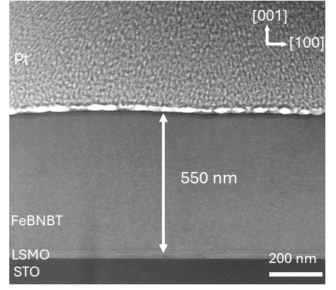
Figure 1. Low-magnification HAADF-STEM image of Fe-BNBT thin films.

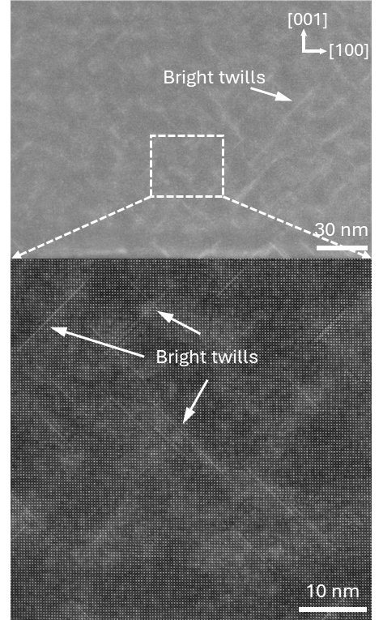
Figure 2. HAADF STEM images of Fe-BNBT thin films, indicating the high density of bright twills.

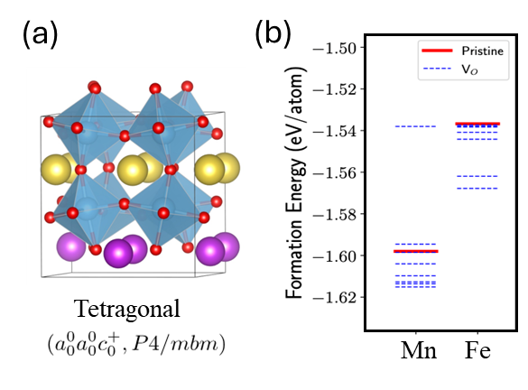
Figure 3. (a) The schematic diagram of the tetragonal unit cell of BNBT for the DFT calculation, where purple, yellow, and red spheres represent Bi, Na, and O atoms, respectively. (b) The formation energy of Mn-doped and Fe-doped BNBT unit cells with oxygen vacancy-related defects and without oxygen vacancy-related defects. The solid red lines depict the formation energy of BNBT unit cells without any oxygen vacancy-related defects while the blue dashed lines represent the formation energy of BNBT unit cells with oxygen vacancy occurring in various positions in the lattice structures. The lower the formation energy, the more stable the BNBT structures.¹

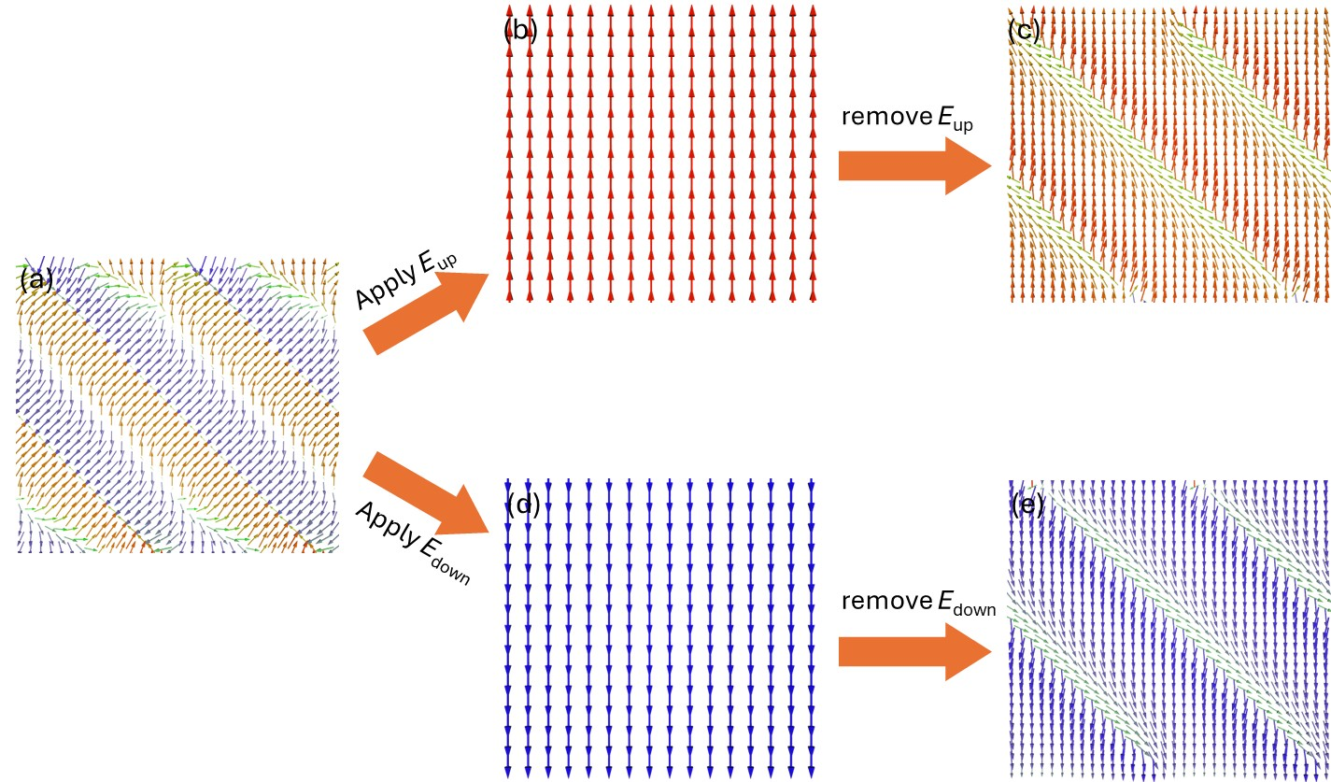
Figure 4. (a) Phase field-simulation results depicting the polarization distribution of bound charge-modified Fe-BNBT in various states: (a) initial configuration, (b) under the application of an upward-directed electric field (E_{up}), (c) following the removal of the upward electric field, (d) under the application of downward-directed electric field (E_{down}), and (e) following the removal of the downward electric field.

Figure 5. (a) and (b) The room-temperature P–E loops of BNBT thin films under selected electric fields with no dopants and with Mn dopants.

Figure 6. Temperature-dependent dielectric properties of Fe-BNBT thin films.

Reference

(1) Zeng, Z.; Calle-Vallejo, F.; Mogensen, M. B.; Rossmeisl, J.; Generalized Trends in the Formation Energies of Perovskite Oxides. Physical Chemistry Chemical Physics 2013, 15 (20), 7526-7533.

