Supplemental Table 1. Concentrations of QD502 post IV and PO administration in mice. Concentrations of QD502 at 0.083, 0.25, 0.5, 1, 2, 4, 6, 8, 24 hr plasma harvests from single dose IV and 0.5, 1, 2, 4, 7, 24 hr plasma harvests from PO administration and on day 5 of repeated dose oral administration in mice.
Single IV Dose (5mg/kg)
Time (hr) | Concentration  (ng/mL) |  |  |  |  |  | Mean  (ng/mL) | SD  (ng/mL) | CV  (%)
 | Mouse1 |  | Mouse2 |  |  | Mouse3
0.083 | 417 |  | 576 |  |  | 441 | 478 | 85.7 | 17.9
0.25 | 247 |  | 321 |  |  | 247 | 272 | 42.7 | 15.7
0.5 | 180 |  | 147 |  |  | 143 | 157 | 20.3 | 13
1 | 97.2 |  | 74.3 |  |  | 58.9 | 76.8 | 19.3 | 25.1
2 | 57.2 |  | 44.3 |  |  | 36.4 | 46.1 | 10.7 | 23.2
4 | 36.2 |  | 27.8 |  |  | 23.8 | 29.3 | 6.33 | 21.6
6 | 29.1 |  | 23.2 |  |  | 19.1 | 23.8 | 5.03 | 21.1
8 | 20.8 |  | 17.1 |  |  | 15.2 | 17.7 | 2.85 | 16.1
24 | 9.88 |  | 7.70 |  |  | 6.44 | 8.01 | 1.74 | 21.7
Day 1 (PO Dose, 30 mg/kg)
Time (hr) |  | Concentration  (ng/mL) |  |  |  |  | Mean  (ng/mL) | SD  (ng/mL) | CV  (%)
 |  | Mouse1 |  | Mouse2 | Mouse3 |  | Mean  (ng/mL) | SD  (ng/mL) | CV  (%)
0.5 |  | 429 |  | 493 | 365 |  | 429 | 64.0 | 14.9
1 |  | 228 |  | 256 | 196 |  | 227 | 30 | 13.2
2 |  | 182 |  | 162 | 123 |  | 156 | 30 | 19.3
4 |  | 95.3 |  | 78.5 | 58.1 |  | 77.3 | 18.6 | 24.1
7 |  | 63.6 |  | 50.8 | 41.3 |  | 51.9 | 11.2 | 21.6
24 |  | 25.9 |  | 19.3 | 16.1 |  | 20.9 | 5 | 24.5
Day 5 (PO Dose, 30 mg/kg)
Time (hr) |  | Concentration  (ng/mL) |  |  |  |  | Mean  (ng/mL) | SD  (ng/mL) | CV  (%)
 |  | Mouse1 |  | Mouse2 | Mouse3 |  | Mean  (ng/mL) | SD  (ng/mL) | CV  (%)
0.5 |  | 319 |  | 423 | 366 |  | 369 | 52.1 | 14.1
1 |  | 173 |  | 244 | 253 |  | 223 | 43.8 | 19.6
2 |  | 116 |  | 173 | 186 |  | 158 | 37.2 | 23.5
4 |  | 53.5 |  | 78.1 | 89.5 |  | 73.7 | 18.4 | 25
7 |  | 43.2 |  | 61.1 | 58.2 |  | 54.2 | 9.61 | 17.7
24 |  | 18.7 |  | 26.3 | 21.7 |  | 22.2 | 3.83 | 17.2

Supplemental Table 2. Concentrations of QD502 post IV and PO administration in rats. Concentrations of QD502 at 0.083, 0.25, 0.5, 1, 2, 4, 6, 8, 24 hr plasma harvests from single dose IV and , 0.5, 1, 2, 4, 7, 24 hr plasma harvests from PO administration and on day 5 of repeated dose oral administration in mice.
Single IV Dose (2mg/kg)
Time (hr) | Concentration  (ng/mL) |  |  |  |  |  | Mean  (ng/mL) | SD  (ng/mL) | CV  (%)
Time (hr) | Rat1 |  | Rat2 |  |  | Rat3 | Mean  (ng/mL) | SD  (ng/mL) | CV  (%)
0.083 | 528 |  | 419 |  |  | 430 | 459 | 60 | 13.1
0.25 | 387 |  | 313 |  |  | 315 | 338 | 42.2 | 12.5
0.5 | 245 |  | 268 |  |  | 207 | 240 | 30.8 | 12.8
1 | 126 |  | 114 |  |  | 114 | 118 | 6.93 | 5.87
2 | 57.5 |  | 45.5 |  |  | 44.1 | 49 | 7.37 | 15
4 | 25.3 |  | 19.3 |  |  | 15.5 | 20.0 | 4.94 | 24.7
6 | 18.6 |  | 15.6 |  |  | 11.6 | 15.3 | 3.51 | 23
8 | 15.1 |  | 12.8 |  |  | 9.76 | 12.6 | 2.68 | 21.3
24 | 6.48 |  | 5.25 |  |  | 4.02 | 5.25 | 1.23 | 23.4
Single PO Dose (10 mg/kg)
Time (hr) |  | Concentration  (ng/mL) |  |  |  |  | Mean  (ng/mL) | SD  (ng/mL) | CV  (%)
 |  | Rat1 |  | Rat2 | Rat3 |  | Mean  (ng/mL) | SD  (ng/mL) | CV  (%)
0.083 |  | 157 |  | 120 | 106 |  | 128 | 26.4 | 20.6
0.25 |  | 341 |  | 233 | 271 |  | 282 | 54.8 | 19.5
0.5 |  | 282 |  | 159 | 224 |  | 222 | 61.5 | 27.8
1 |  | 163 |  | 122 | 161 |  | 149 | 23.1 | 15.5
2 |  | 88.3 |  | 62.3 | 102 |  | 84.2 | 20.2 | 23.9
4 |  | 31.4 |  | 24.2 | 39.2 |  | 31.6 | 7.5 | 23.7
6 |  | 18.8 |  | 14.7 | 25.1 |  | 19.5 | 5.24 | 26.8
8 |  | 15 |  | 12.9 | 19.5 |  | 15.8 | 3.37 | 21.3
24 |  | 7.49 |  | 6.05 | 9.07 |  | 7.54 | 1.51 | 20.0

Supplemental Table 3. Plasma Pharmacokinetics of QD501 Following Single IV and PO Doses in Rats. The plasma concentration of QD501 declined in a multiphasic manner after IV administration at 2 mg/kg with an initial concentration (C₀) of 692 ng/mL and a last measurable concentration (C_{last}) of 2.80 ng/mL at 24 h post dose. QD501 displayed a high systemic clearance (CLp) of 52.2 mL/min/kg and a high steady‐state volume of distribution (Vss) of 18.9 L/kg, suggesting extensive metabolism and high tissue distribution. The total systemic exposure (AUCinf) was 644 h·ng/mL with a terminal half‐life (t_{1/2}) of 14 h. PO at 10 mg/kg, the test compound rapidly reached a peak plasma concentration (C_{max}) of 254 ng/mL within 30 min (T_{max}) (Figure 9 A-D) and S7B). After that, its plasma concentration declined in a multiphasic manner with a last measurable concentration of 7.31 ng/mL at 24 h and a terminal half‐life (t_{1/2}) of 15.6 h. The total systemic exposure (AUC_{inf}) was 815 h·ng/mL with an oral bioavailability (F) of 25.3%.
Parameter | IV | Parameter | PO
Dose (mg/kg) | 2 | Dose (mg/kg) | 10
t_{1/2} (h) | 14.0 ± 0.4 | t_{1/2} (h) | 15.6 ± 0.3
C₀ (ng/mL) | 692 ± 70.2 | T_{max} (h) | 0.5
C_{last} (ng/mL) | 2.80 ± 0.5 | C_{max} (ng/mL) | 254 ± 33.8
AUC_{last} (ng∙h/mL) | 588 ± 66.1 | C_{max}/D (mg/mL) | 25.4 ± 3.4
AUC_{inf} (ng∙h/mL) | 644 ± 75.8 | C_{last} (ng/mL) | 7.3 ± 7.3
AUC_{inf}/D (ng∙h/mL) | 322 ± 37.9 | AUC_{last} (ng∙h/mL) | 651 ± 91.3
V_{z} (L/kg) | 63.4 ± 7.6 | AUC_{inf} (ng∙h/mL) | 815 ± 124
CL_{p} (L/h/kg) | 52.2 ± 6.0 | AUC_{inf}/D (ng∙h/mL) | 81.5 ± 12.4
MRT_{inf} (h) | 6.06 ± 0.4 | MRT_{inf} (h) | 13.2 ± 0.7
V_{ss} (L/kg) | 18.9 ± 1.4 | F (%) | 25.3 ± 3.4
terminal half‐life (t_{1/2}), initial concentration (C₀), last measurable concentration (C_{last}), systemic clearance (CLp), area under the plasma concentration vs time curve (AUC), total systemic exposure (AUCinf), mean residence time (MRT) steady‐state volume of distribution (Vss)

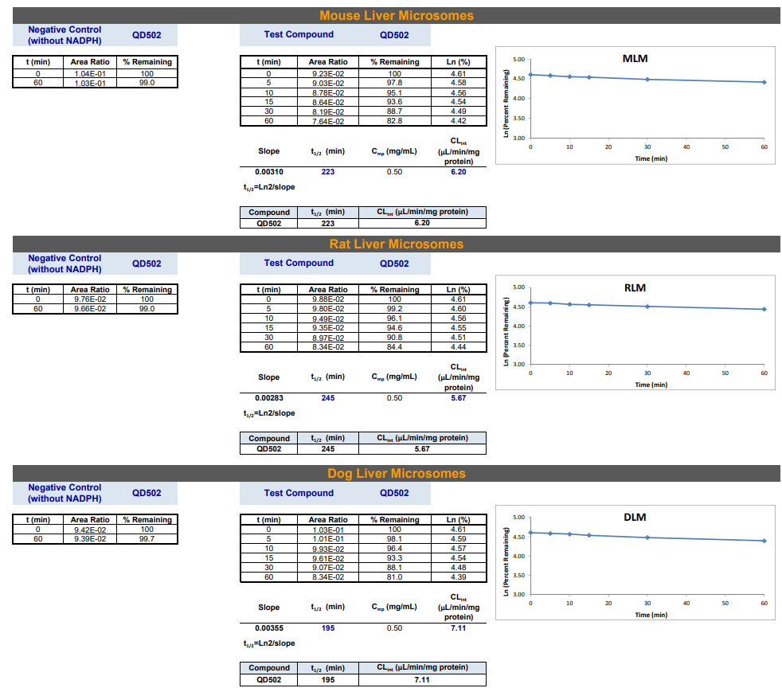
Supplemental Figure 1. Evaluation of QD502 Stability in Liver Microsomes. QD502 (2µg/mL) was dissolved and incubated with liver microsomes from a variety of species. The concentration of QD502 was measured at designated intervals for 60 minutes. t1/2 = the half-life (min), where t1/2 is equal to 0.693/slope and CLint is equal to 0.693/( t1/2 × Cmp). A negative control cohort which lacked the essential enzyme co-factor, NADPH, was also performed to validate experimental conditions.

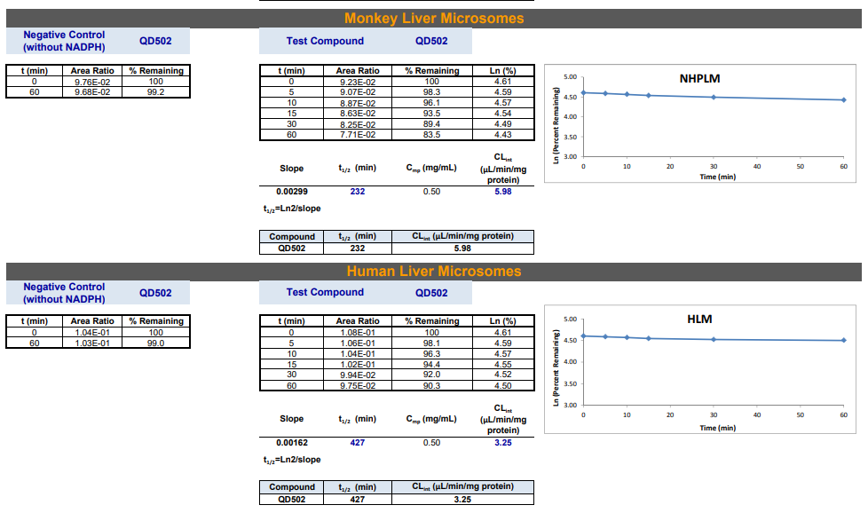

Supplemental Figure 2. Evaluation of Verapamil Stability on Liver Microsomes (Positive Control)
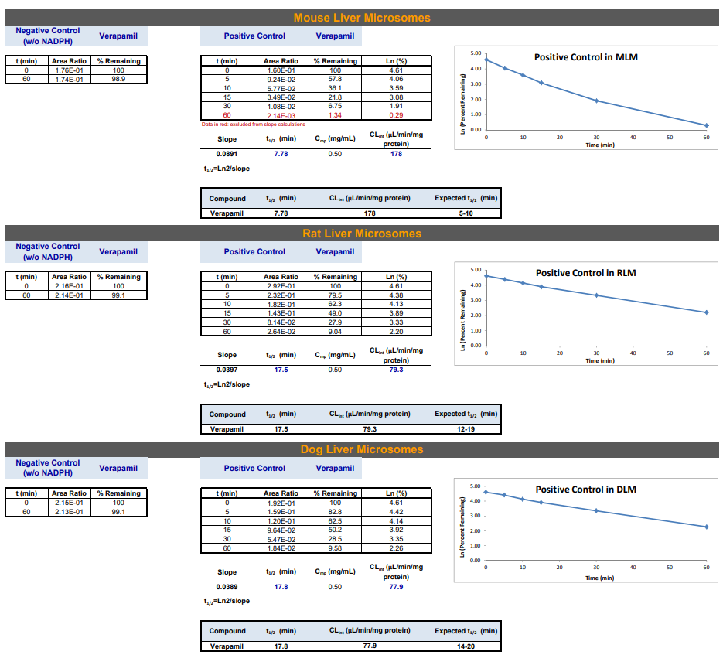
Verapamil (2µg/mL) was dissolved and incubated with liver microsomes from a variety of species. The concentration of QD502 was measured at designated intervals for 60 minutes. t1/2 = the half-life (min), where t1/2 is equal to 0.693/slope and CLint is equal to 0.693/( t1/2 × Cmp). A negative control cohort which lacked NADPH was also performed to validate experimental conditions.

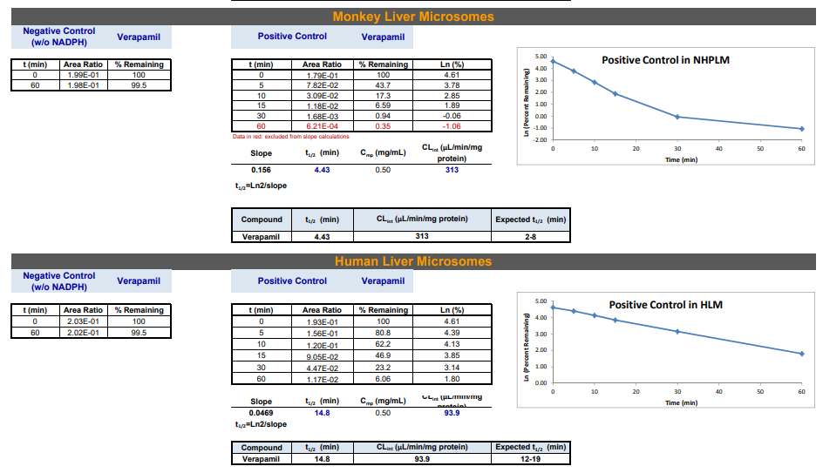

Supplemental Figure 3. Evaluation of QD502 on Key CYP 450 Enzymes. The inhibition assay is conducted in 0.2 mg/mL mix‐gender, pooled human liver microsomes (HLM), 100 mM potassium phosphate buffer , and a 2 mM NADPH cofactor. Data are represented in both tabular (A) and graphical (B) formats.
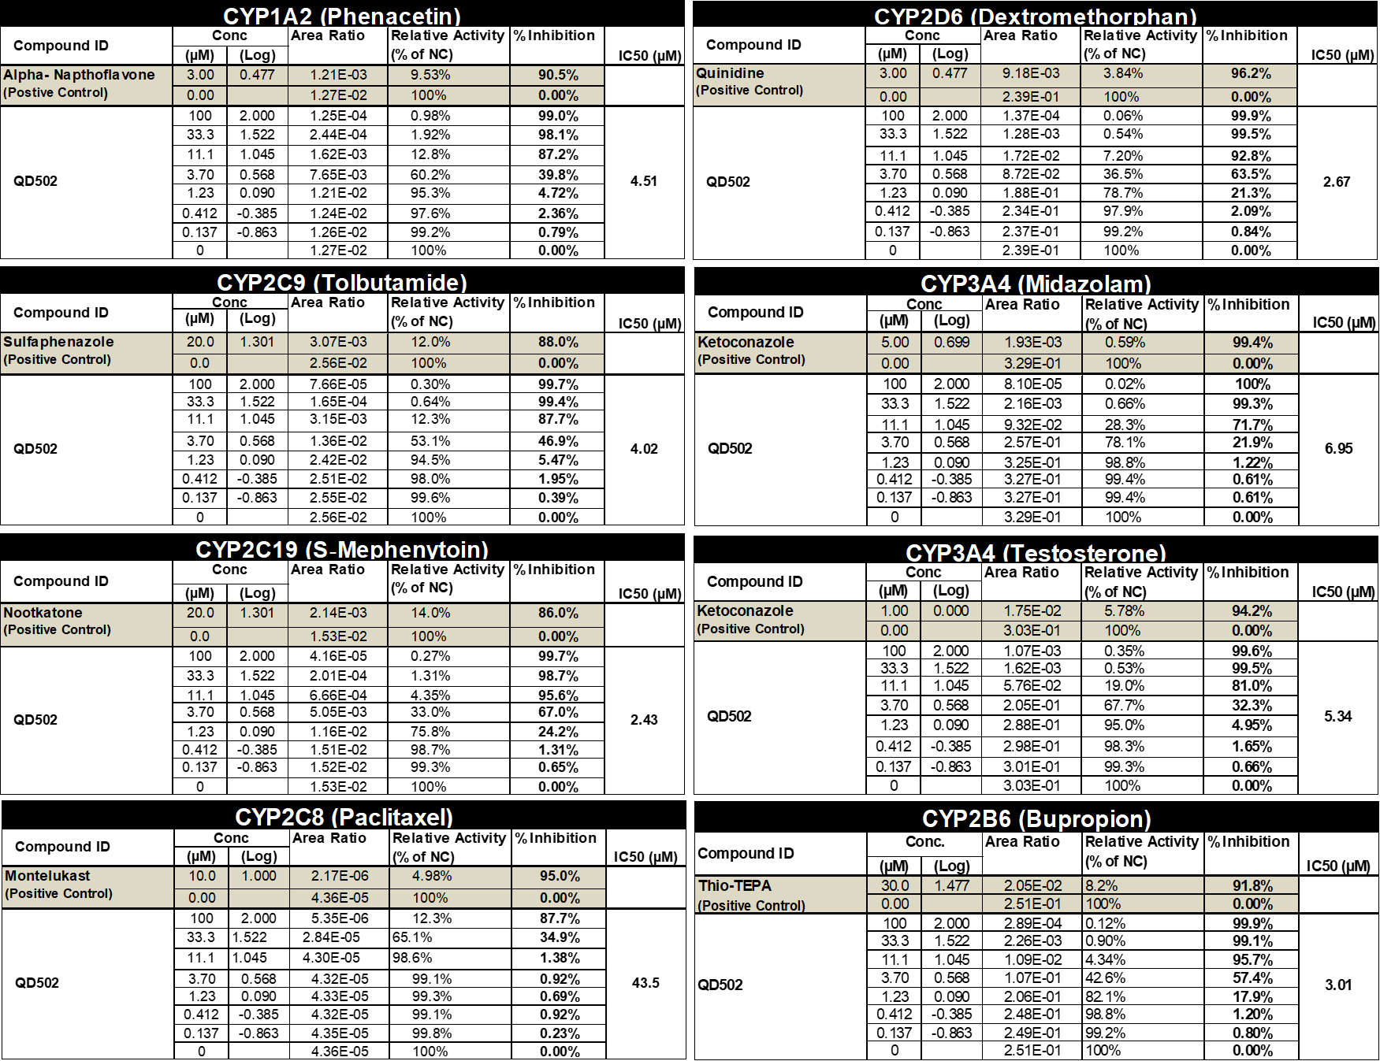
A. Inhibition Analyses of CYP 450 Enzymes (Tabular).

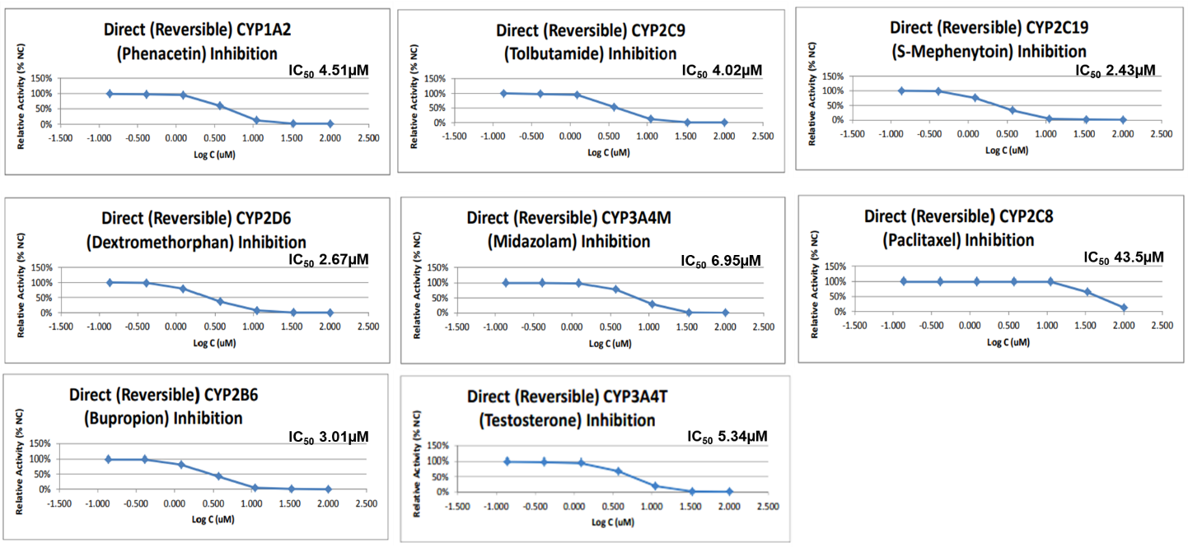
B. Inhibition Analyses of CYP 450 Enzymes (Graphed)

Supplemental Figure 4. Physical and Behavioral Observations in Mice Post QD502 Administration.
A. Body weight changes
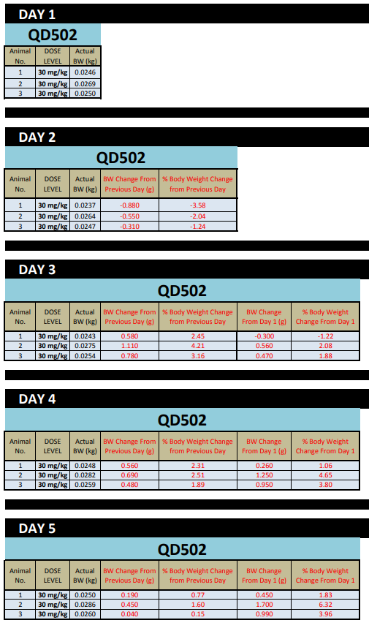

B. Behavioral Observations.
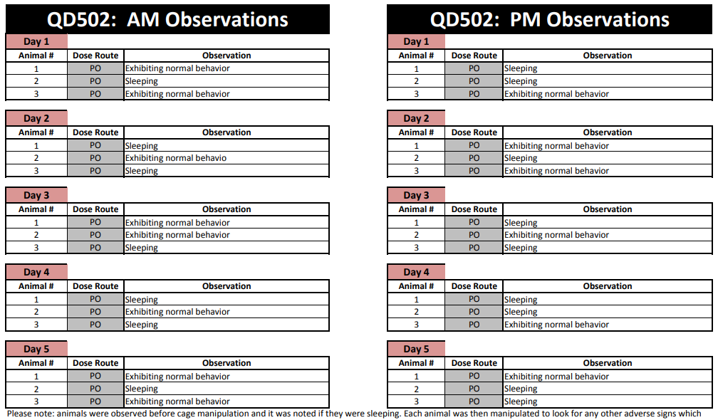

Supplemental Figure 5. PK of single intravenous administration of QD501 in rats (24 hr.). Rats (n = 3) were treated with 2 mg/kg of QD501 IV and assessed for plasma drug concentrations at 0.083, 0.25, 0.5, 1, 2, 4, 6, 8, and 24 h post initial dosing. Graphs represent linear plotting (A) or semi-log (B ) with mean values.
A
B

Supplemental Figure 6. PK of single, oral administration of QD501 in rats. Rats (n = 3) were treated with 10 mg/kg of QD501 via oral gavage and assessed for plasma drug concentrations at 0.5, 1, 2, 4, 7, and 24 h post initial dosing. Graphs represent linear (A and C) plotting and semi-log (B and D) with mean values.
A
B

Supplemental Figure 7. QD501 Shows Additive/Synergistic Cytotoxicity with Select Drugs. QD501 treatment along with irinotecan (A, D, F, G), paclitaxel (B, E) or dasatinib (C) show significant additive and synergistic effect in a 7-day colony formation assay in several cell lines (ID8, KPC-2, Pan02, LLC1 and MIA PaCa-2). Red boxes indicate wells with additive or synergistic effect in the combination treatment.
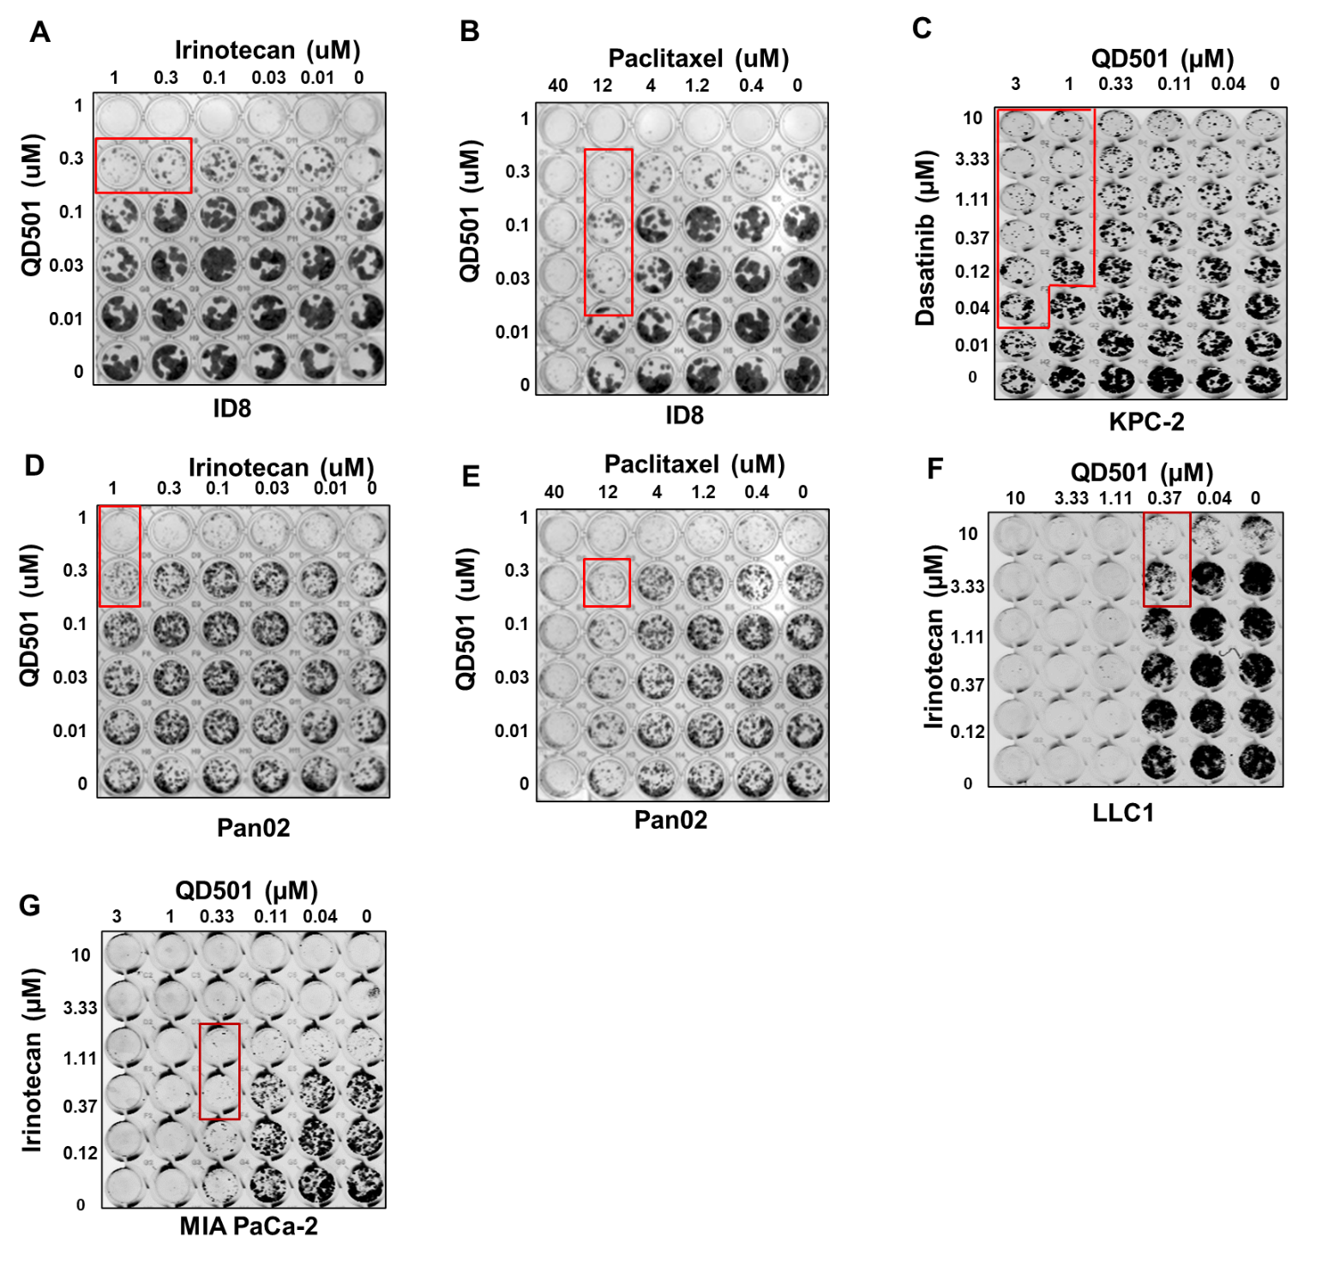

Supplemental Figure 8. Safety Panel Screening of QD501. The SafetyScreen44™ in vitro panel enables early identification of significant off-target interactions with lead drug candidates. Binding of 44 specific targets were evaluated through a variety of binding assays. Stock solutions of 10 μM of QD501 were used for analyses. Data is represented as a mean of n = 2 assay binding experiments.

