epidemiology and outcome of elderly patients after renal replacement therapy in the intensive care unit: an observational study: Supplementary material

Excluded:
- < 55 yo (135)
- Chronic dialysis (84)
- Declined data reutilization (37)
Died in ICU (148)
Died on the ward (23)
Could not be reached (23)
Unable to participate (2)
Declined participation (11)
Died during follow-up period (62)

Figure S2: Study flow chart.

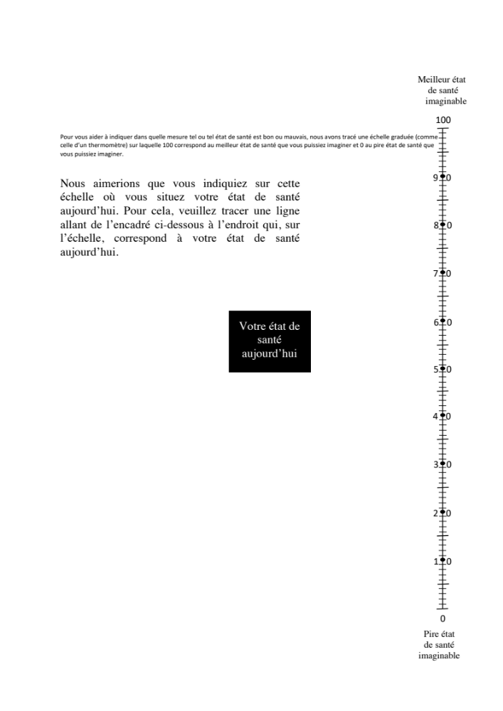

Figure S1: VAS (visual analog scale) French version, as provided by EuroQol for the use over the phone. This version has been sent to the survivors prior to the phone call.

Figure S3: Differences between observed and predicted (French speaking Swiss reference population).
Values are mean (SD). Comparisons with one sample t-test on Observed – predicted difference.
Predicted values calculated according to Ref 15 (Perneger et al).

 | TOTAL | G1 | G2 | G3 | p value
N (%) | 83 (100%) | 24 (28.9%) | 44 (53.0%) | 15 (18.1%)
Median age - years (IQR) | 68.1 (8.6) | 59.9 (5.9) | 68.9 (3.6) | 78.6 (5.0) | <0.001
Gender Male - n (%) | 60 (72.3%) | 21 (87.5%) | 28 (63.6%) | 11 (73.3%) | 0.11
Median weight – kg (IQR) | 85 (28) | 87 (26) | 85.5 (29.0) | 85 (23) | 0.72
Admission year |  |  |  |  | 0.18
2015 | 21 (25.3%) | 7 (29.2%) | 12 (27.3%) | 2 (13.3%)
2016 | 26 (31.3%) | 6 (25.0%) | 13 (29.5%) | 7 (46.7%)
2017 | 26 (31.3%) | 10 (41.7%) | 14 (31.8%) | 2 (13.3%)
2018 | 10 (12.0%) | 1 (4.2%) | 5 (11.4%) | 4 (26.7%)
Admission type
Medical | 36 (43.4%) | 9 (37.5%) | 24 (54.5%) | 3 (20.0%) | 0.08
Surgical | 43 (51.8%) | 15 (62.5%) | 17 (38.6%) | 11 (73.3%)
Other | 4 (4.8%) | 0 (0%) | 3 (6.8%) | 1 (6.7%)
Median SAPS Score (IQR) |  | 53 (22) | 56 (13) | 59 (13) | 0.27
Median ICU LOS – days (IQR) | 10.2 (17.6) | 9.8 (14.0) | 10.6 (22.3) | 6.9 (17.1) | 0.99
Median hospital LOS – days (IQR) | 38.9 (50.7) | 34.3 (51.2) | 34.0 (50.1) | 40.9 (42.2) | 0.57
Co-existing conditions – n (%) | 38 (45.8%) | 12 (50.0%) | 19 (43.2%) |  | 0.86
CKD | 21 (25.9%) | 5 (21.7%) | 15 (34.9%) | 1 (6.7%) | 0.09
CHD | 14 (16.9%) | 5 (21.7%) | 7 (15.9%) | 2 (13.3%) | 0.81
Chron.resp.D | 14 (16.9%) | 1 (4.2%) | 8 (18.2%) | 5 (33.3%) | 0.06
Chron.liver.D | 7 (8.4%) | 4 (16.7%) | 3 (6.8%) | 0 | 0.16
Immunosupp. | 8 (9.6%) | 4 (16.7%) | 4 (9.1%) | 0 | 0.23
Haematological | 3 (3.6%) | 2 (8.3%) | 1 (2.3%) | 0 | 0.31
Metastatic cancer | 0 (0%) | 0 (0%) | 0 (0%) | 0 (0%) | 1
On RRT initiation
MV on initiation | 56 (67.5%) | 18 (75.0%) | 27 (61.4%) | 11 (73.3%) | 0.45
NA on initiation | 68 (81.9%) | 20 (83.3%) | 33 (75.0%) | 15 (100%) | 0.23
Mean max creatinine - mmol/l (SD) | 366 (254) | 309 (207) | 419 (300) | 298 (106) | 0.16
Mean max lactate - mmol/l (SD) | 6.2 (2.9) | 6.2 (2.0) | 5.8 (2.7) | 6.8 (4.3) | 0.72

Table S1: Demographics of survey responders
IQR: Interquartile range, LOS: ICU length of stay, RRT: renal replacement therapy, MV: mechanical ventilation, NA: noradrenaline, max: maximum.

 |  | E-RRT |  | Swiss Reference (1) |  |  | France (2) | Germany (2)
EQ-5D health utility
 | Age groups | Women | Men | Women | Men
 | 55-64 yo | 0.83 (0.30) | 0.84 (0.21) | 0.79 (0.15) | 0.83 (0.16)
 | 65-74 yo | 0.76 (0.23) | 0.79 (0.24) | 0.79 (0.15) | 0.81 (0.11)
 | > 75 yo | 0.74 (0.06) | 0.526 (0.35) | 0.74 (0.17) | 0.79 (0.17)
Visual analogue scale
 | 55-64 yo | 83 (15) | 79 (15) | 80.1 (16.1) | 80.9 (16.1) |  | 74.2 | 72.9
 | 65-74 yo | 81 (20) | 67 (21) | 78.5 (15.3) | 79.2 (14.6) |  | 68.1 | 68.6
 | > 75 yo | 64 (10) | 52 (29) | 71.8 (18.8) | 71.7 (18.8) |  | 61.5 | 60.5

Table S2. Observed quality of life indices from our population (E-RRT) compared to Swiss, French and German reference population.

(1) Ref 15 (Perneger et al)
(2): Ref 17 (Janssen B)

