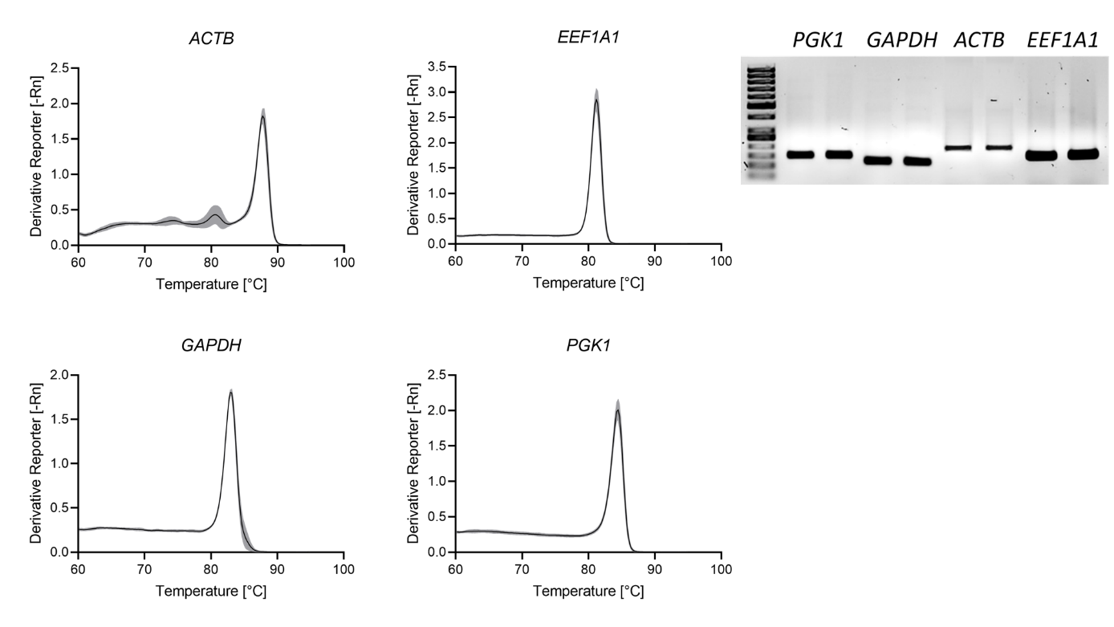
Supplementary figures

Figure S1. Melting curve and gel electrophoresis analysis of primers for candidate reference genes. Melting curve analysis was conducted during qRT-PCR and amplicons were visualized in a 1.5% agarose gel.

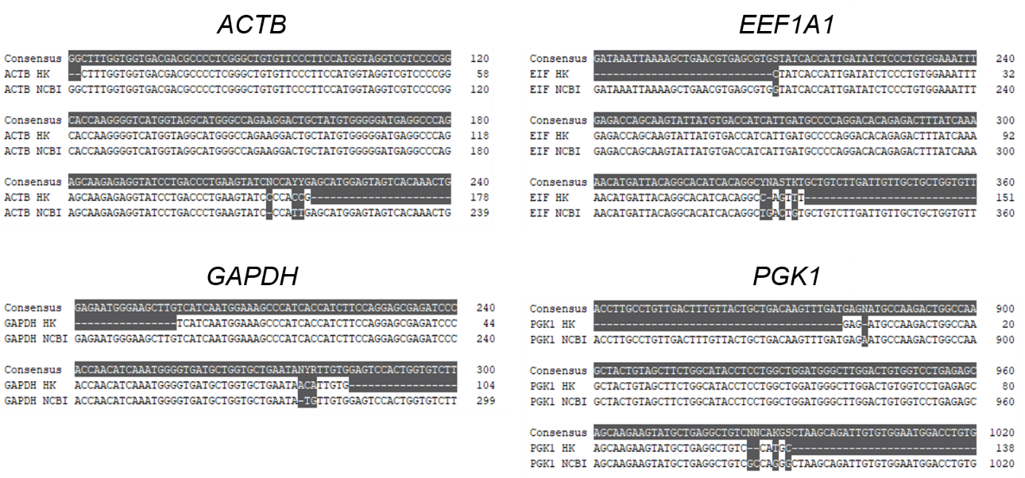

Figure S2. Sequencing analysis of PCR amplicons for candidate reference genes. PCR amplicons were purified, sequenced and aligned with the NCBI reference genes to validate the specificity of primers.

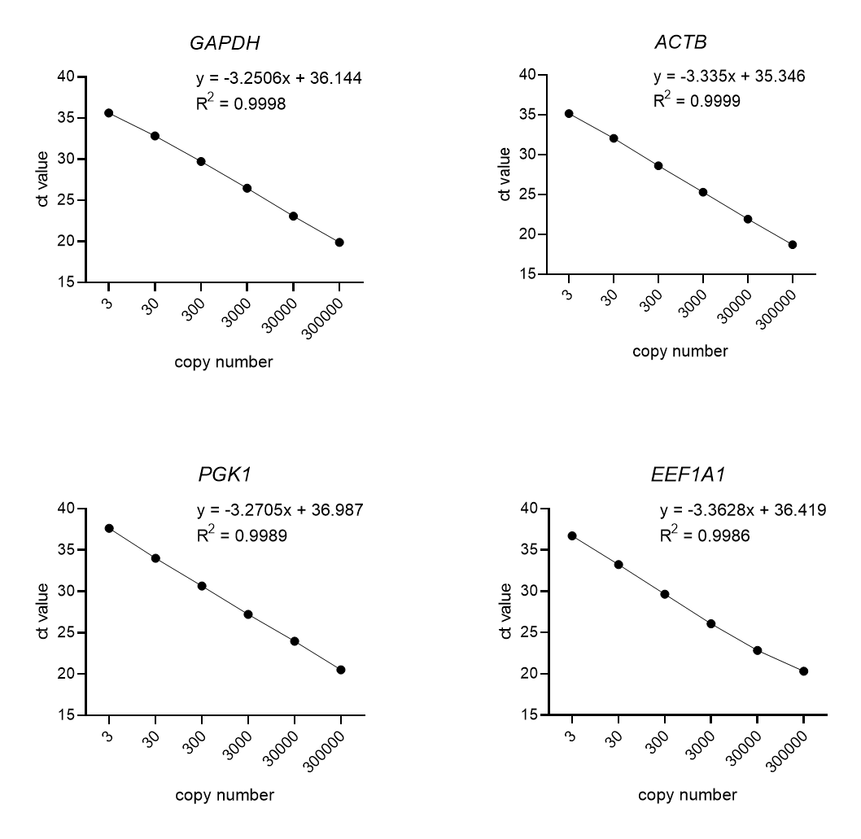

Figure S3. Standard curves for candidate reference genes. Standard curves were generated with ranges from 3 to 300,000 copies and the slopes and correlation coefficient (R²) were determined.

