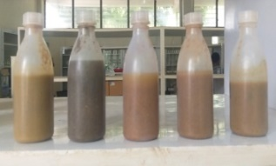
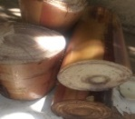
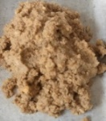
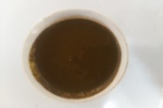
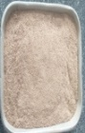
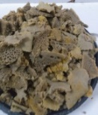

Physical pretreatment

Co-mixing and Characterization

Anaerobic digestion

Biogas
Digestate
Rumen Fluid
Powdered BS
Blended FW
Banana Stem
Food Waste
Digestate characterization

