Table :2 high content compounds in oil
Name of compounds | Molecular formul | Structure
α-tochopherol | C29H50O2 | 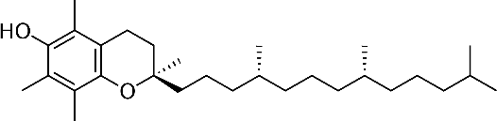
β-tochopherol | C28H48O2 | 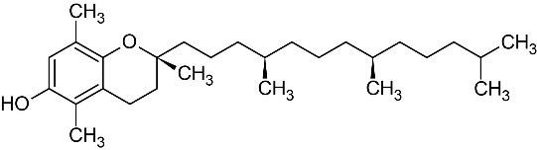
γ-tochopherol | C28H48O2 | 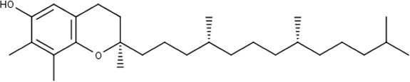
Schottenol | C29H50O | 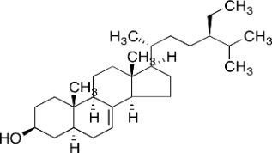
Ferulic acid | C10H10O4 | 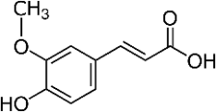
Spinasterol | C ₂₉ H ₄₈ O | 