Supplementary information
for
Trophic level decoupling drives future change in phytoplankton bloom phenology
Ryohei Yamaguchi^{1,2 *}, Keith B Rodgers^{1,2}, Karl J Stein^{1,2}, Axel Timmermann^{1,2}, Sarah Schlunegger³, Daniele Bianchi⁴, John P Dunne⁵, and Richard Slater³
¹ Center for Climate Physics, Institute for Basic Science, Busan, South Korea
² Pusan National University, Busan, South Korea
³ AOS Program, Princeton University, NJ, United States
⁴ University of California, Los Angeles, CA, United States
⁵ NOAA Geophysical Fluid Dynamics Laboratory, NJ, United States

* Corresponding author: Ryohei Yamaguchi (ryamaguchi@pusan.ac.kr)

This supplementary information includes 8 figures and 1 note.

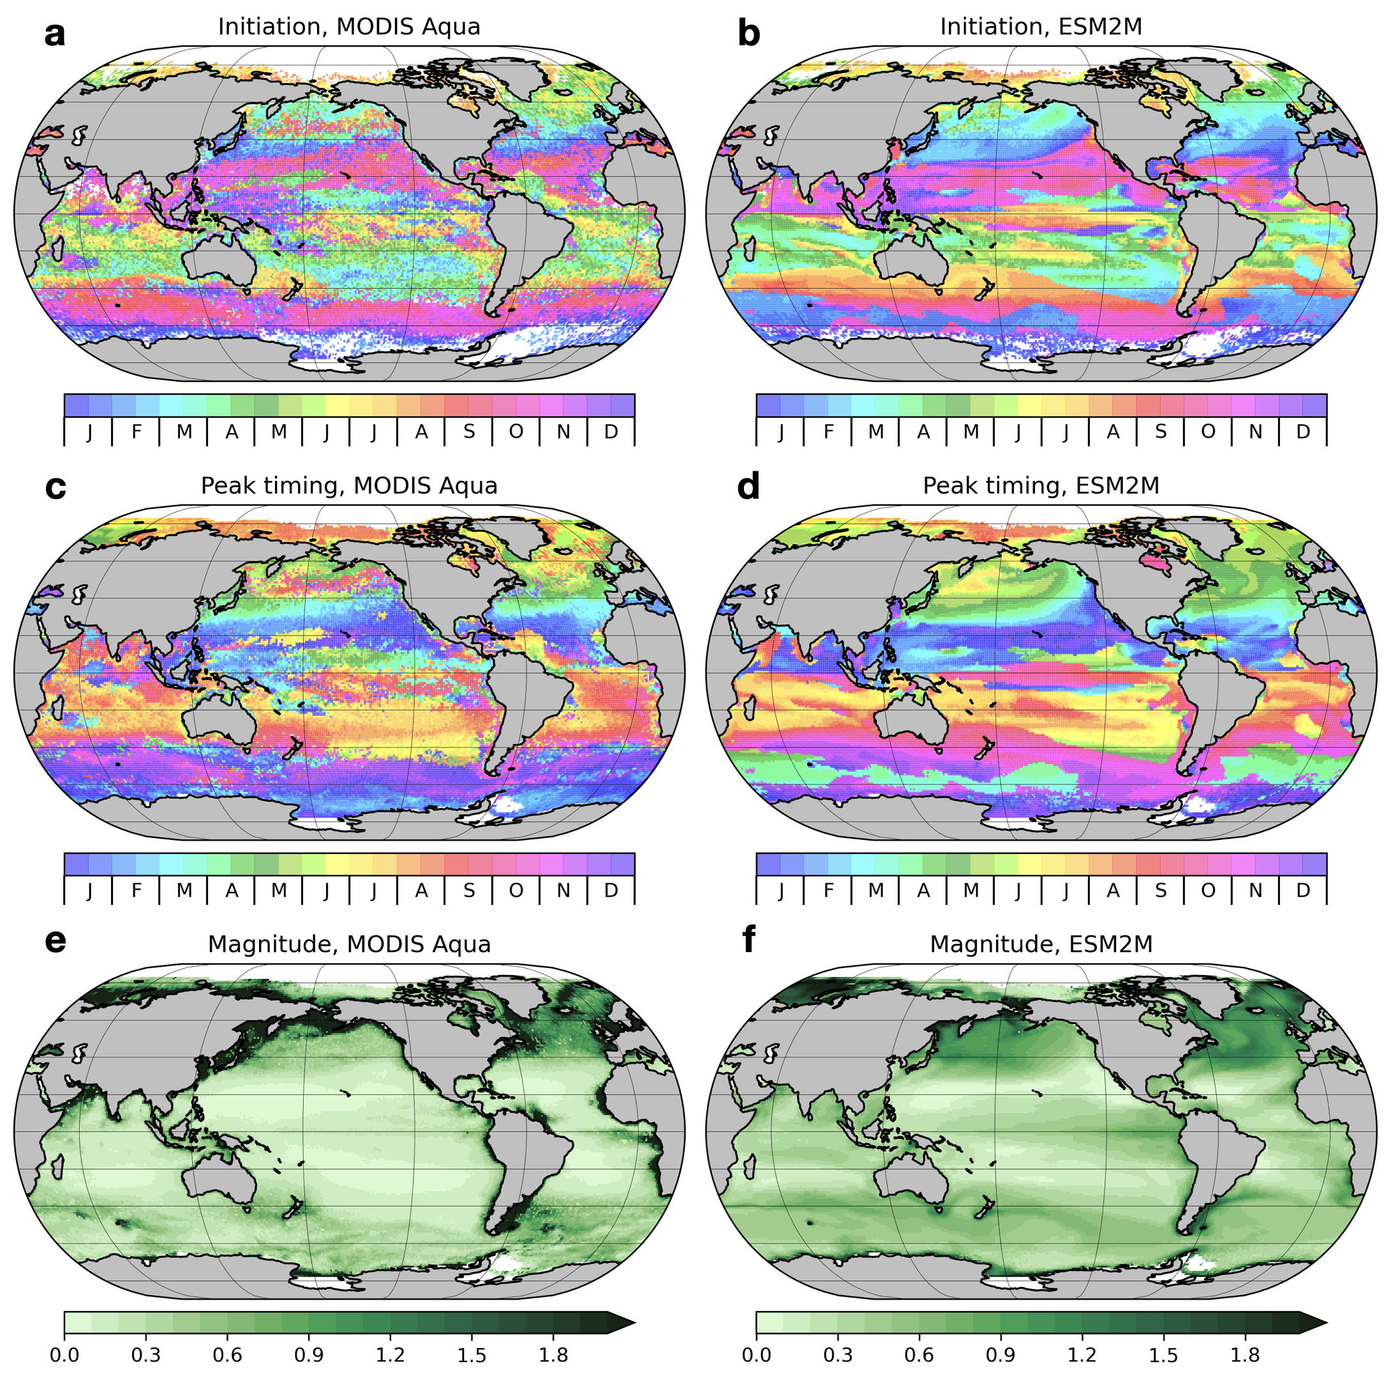
Figure S1. Climatological mean (2003-2019) phytoplankton bloom timing (initiation and peak, [calendar month]) and magnitude [mg m⁻³] from satellite observations (MODIS Aqua) and from the ESM2M large ensemble. The bloom initiation and peak timing are defined based on phytoplankton accumulation rates (see Methods), and the magnitude is the natural logarithm of surface chlorophyll concentration at the time of the bloom peak. In this comparison, individual ensemble members are resampled by removing output corresponding to missing grid information found in the satellite observations, and then the timing and magnitude are estimated for each member.

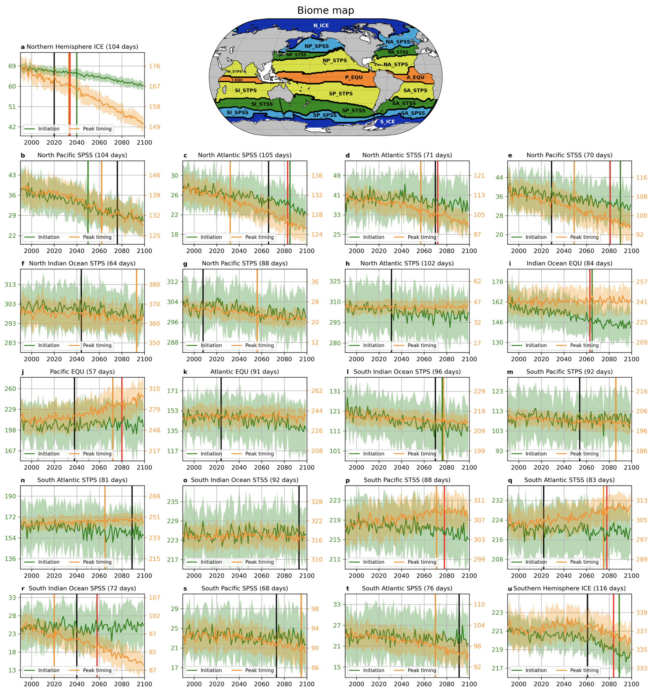
Figure S2. Biome map and biome-aggregated time series of bloom initiation (green line, left axis) and peak timing (orange line, right axis). Shading represents a one standard deviation range of the time series, and the units on the y-axes are day-of-year. Time of emergence¹ (ToE) of biome-aggregated time series of bloom magnitude, net growth period season length, bloom peak timing, and bloom initiation are shown in black, red, orange, and green vertical lines, respectively. The numbers in parentheses next to the biome names are the climatological mean of net growth period length. Time-invariant biomes used in this study are defined based on the method of Fay and McKinley (2010)² with minor modifications appropriate for the scientific focus here, identifying drivers that modulate net growth period.

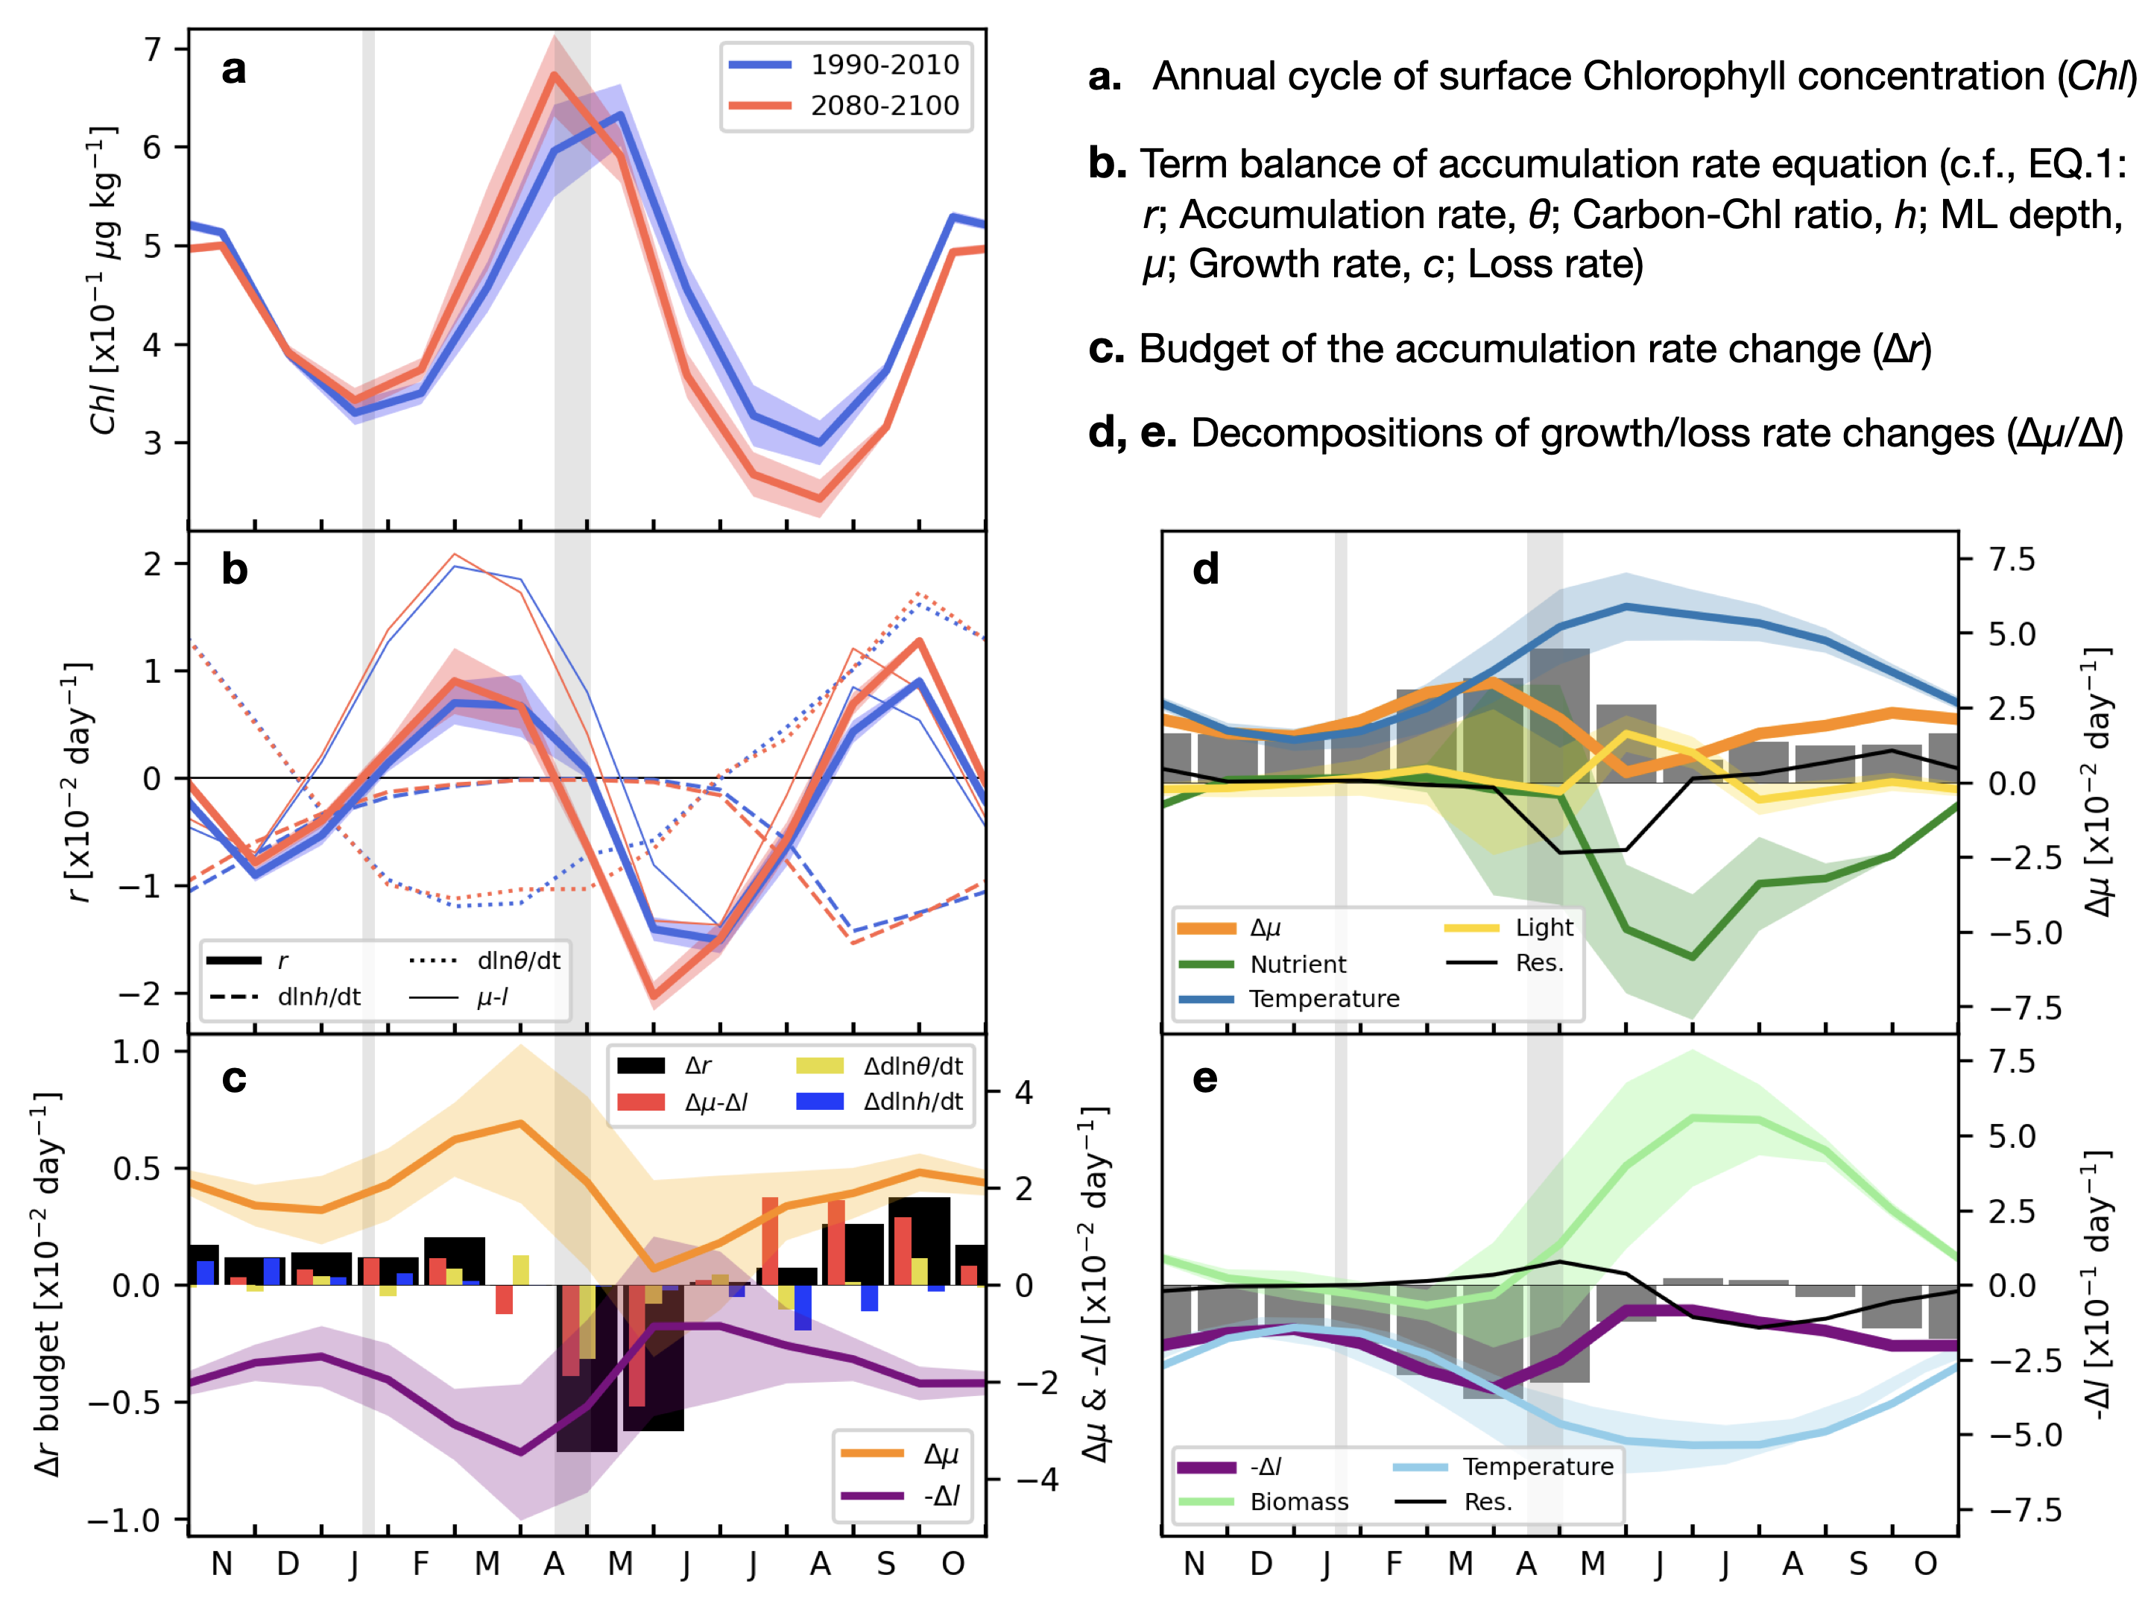
Figure S3. Same as Fig. 3, but for the case of the eastern subarctic North Pacific (150°W, 50°N)

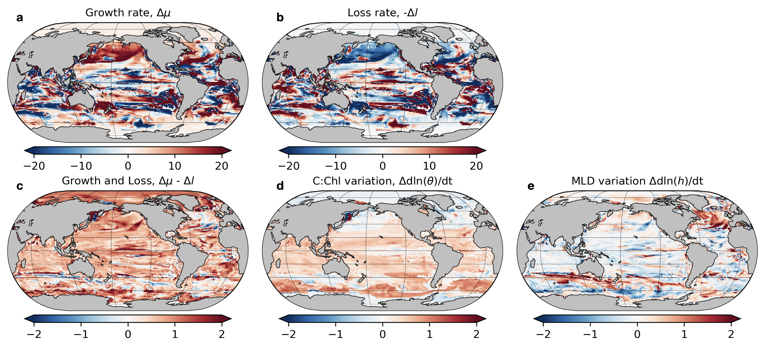
Figure S4. Relative contributions in the accumulation rate budget analysis to shift in timing of the bloom initiation. Relative contributions are the ratio of (1) the time integrated RHS terms of Equation (M4) over the period between bloom peak timings of present day and future to (2) the term on the LHS.

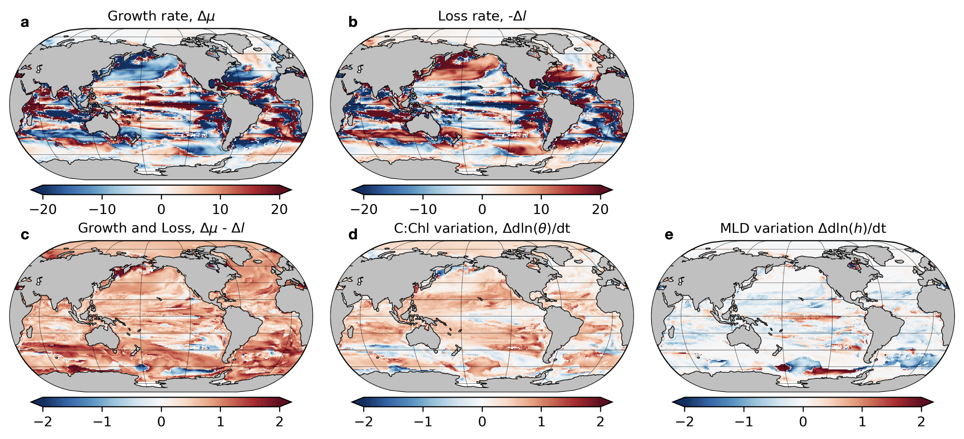
Figure S5. Same as Fig. S4, but for bloom peak timing.

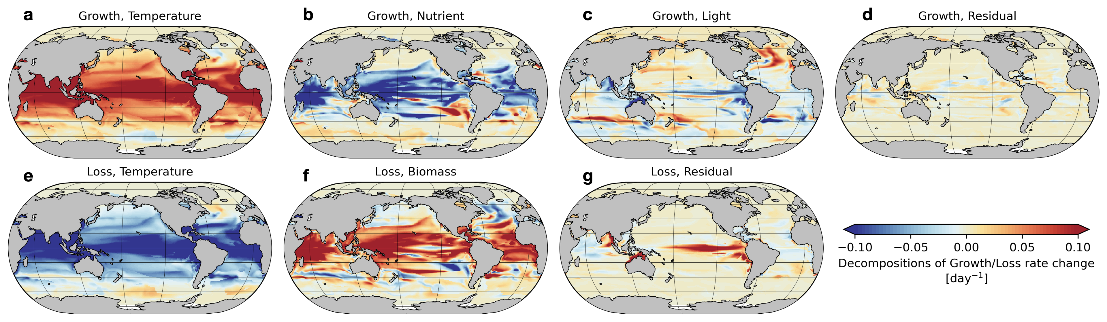
Figure S6. Decomposition of time-integrated growth and loss rate changes over the period between future and present day bloom initiation. Growth rate change ($∆μ$) and loss rate change ($-∆l$) can be decomposed into temperature, nutrient, and light limitation terms, and temperature limitation and biomass terms, respectively (Equations M5 and M6).

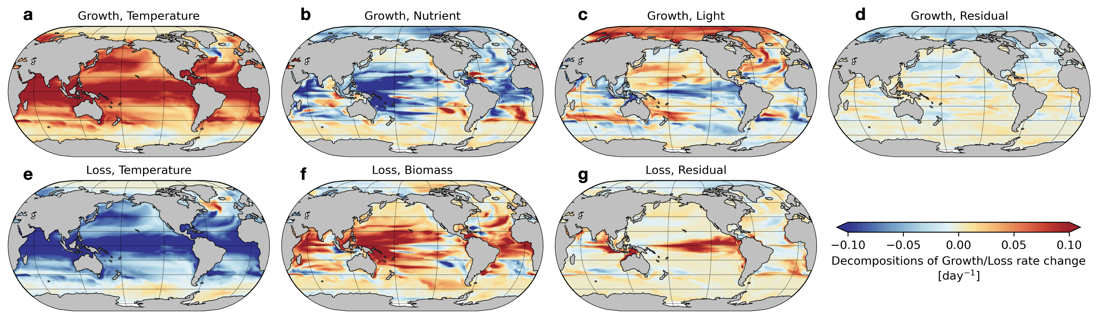

Figure S7. Same as Fig. S5, but for bloom peak timing.

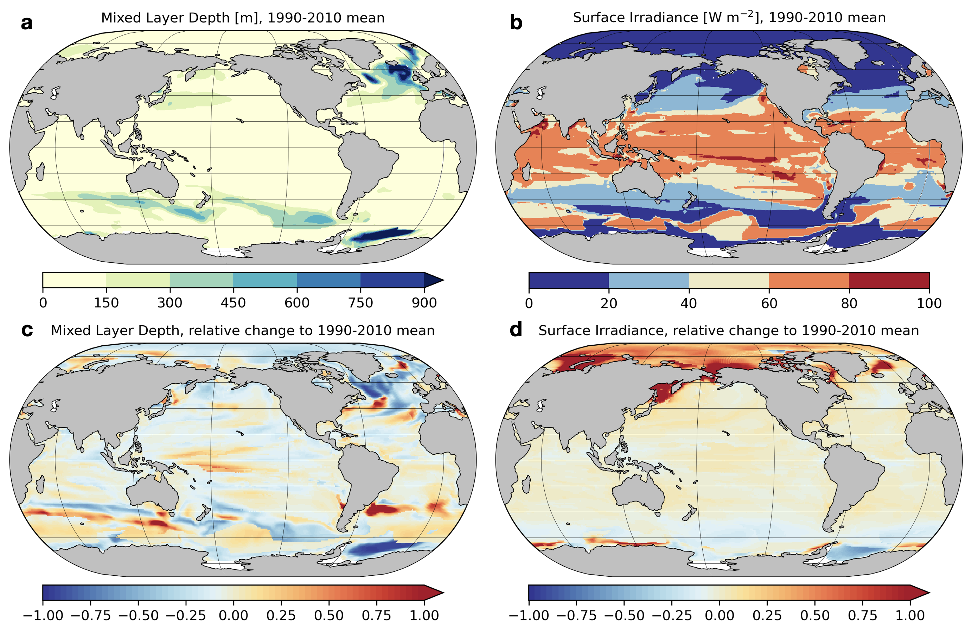
Figure S8. Present day mean (a) ML depth and (b) sea surface irradiance and relative change in (c) ML depth and (d) sea surface irradiance from present day (1990–2010) to future (2080–2100) periods in the month of bloom initiation (c.f. Fig. S1b). The changes are relative values to present day mean fields, or equivalently, divided by present day mean.

Note. Computing the accumulation rate budget from monthly output
Following the formulations of the biogeochemical component of GFDL-ESM2M (TOPAZ2; Dunne et al. 2013b³), we calculated terms in the accumulation rate budget equation separately for three phytoplankton groups from monthly model outputs. In TOPAZ2, phytoplankton biomass is prognostically computed based on nitrogen. Because the phytoplanktonic nitrogen is instantly converted to the carbon units by using a fixed organic C:N ratio (106:16), we employ the more widely used terminology of the chlorophyll to carbon ratio ($θ$), instead of the nitrogen-chlorophyll ratio.
When using temperature and nutrient concentration fields, the temperature limitation and nutrient limitation for phytoplankton growth are calculated as follows:
$T^{lim}=e^{0.063T}$, | (S1)
$N_{Sp}^{lim}=Min\left({Lim}_{Sp}^{{NO}_{3}}+{Lim}_{Sp}^{{NH}_{4}}, {Def}_{Sp}^{{PO}_{4}}, {Def}_{Sp}^{Fe}\right)$,
$N_{Lg}^{lim}=Min\left({Lim}_{Lg}^{{NO}_{3}}+{Lim}_{Lg}^{{NH}_{4}}, {Def}_{Lg}^{{PO}_{4}}, {Def}_{Lg}^{Fe}\right)$, | (S2)
$N_{Di}^{lim}=Min\left( {Def}_{Di}^{{PO}_{4}}, {Def}_{Di}^{Fe}\right)$,
where ${Lim}_{i}^{{NO}_{3}}$, ${Lim}_{i}^{{NH}_{4}}$, ${Def}_{i}^{P}$, and $, {Def}_{i}^{Fe}$ represent limitations from individual nutrients (Nitrate, ammonia, phosphate, and iron) which are parametrized based on uptake velocities. The nutrient and temperature limited growth rates for three phytoplankton groups ($i=Sp, Lg,and Di$ for small, large, and diazotrophic phytoplankton) are
$P_{i}^{cm}=P_{i}^{cmax}N_{i}^{lim}T^{lim}$, | (S3)
where $P_{i}^{cmax}$ are constants of the maximum growth rate given by Geider et al. (1997)⁴. The chlorophyll-carbon ratio is calculated using the nutrient and temperature limited growth rate and irradiance averaged over the KPP boundary layer with 24-hr memory (${IRR}_{mem}$),
$θ_{i}=θ_{i}^{min}+\frac{θ_{i}^{max}-θ_{i}^{min}}{1+\left(θ_{i}^{max}-θ_{i}^{min}\right)\frac{α_{i}{IRR}_{mem}}{2P_{i}^{cm}}}$, | (S4)
where $θ_{i}^{min}$ is a function of nutrient limitation ($N_{i}^{lim}$), and $θ_{i}^{max}$and $α_{i}$ are given constants for the three phytoplankton groups. Although chlorophyll concentrations are also available from standard model output, we can reconstruct chlorophyll concentrations from the calculated chlorophyll-carbon ratio to check whether the above calculations are valid,
${Chl}_{i}=\left(\frac{106}{16}\right)θ_{i}P_{i}$. | (S5)
The light limitation for phytoplankton is modeled after Geider et al. (1997)⁴ with some modifications by Dunne et al. (2013b)³,
$L_{i}^{lim}=1-e^{-\frac{α_{i}θ_{i}IRR}{P_{i}^{cm}}}$. | (S6)
And the phytoplankton growth rate is given as
$μ_{i}=\frac{P_{i}^{cm}L_{i}^{lim}}{1+ζ}=\frac{P_{i}^{cmax}}{1+ζ}T^{lim}N_{i}^{lim}L_{i}^{lim} (ζ=0.1)$. | (S7)
On the other hand, the phytoplankton loss rate is parameterized as follows:
$l_{Sp}=Min\left(\frac{1}{∆t},\frac{λ_{0}T^{lim}P_{Sp}^{2}}{P^{*}\left(P_{Sp}+P^{min}\right)}\right)$,
$l_{Lg}=Min\left(\frac{1}{∆t}, graze*P_{Lg}\right)$, | (S8)
$l_{Di}=Min\left(\frac{1}{∆t}, graze*P_{Di}\right)$,
$graze=\frac{λ_{0}T^{lim}{\left(\frac{P_{Lg}+P_{Di}}{P^{*}}\right)}^{\frac{1}{3}}\left(\frac{P_{Lg}+P_{Di}}{P_{Lg}+P_{Di}+P^{min}}\right)}{{\left(P_{Lg}^{2}+P_{Di}^{2}\right)}^{\frac{1}{2}}}$.
Using Equations (S4), (S7), and (S8) with ML depth ($h$), the accumulation rate budget equation (Equation 1 in Main text and Eq. M2 in Methods) can be obtained,
$\frac{d\ln\left(Chl\right)}{dt}≡r≈\sum_{i=1}^{3}{\left(\left(μ_{i}-l_{i}\right)+\frac{d\ln\left(θ_{i}\right)}{dt}\right)γ_{i}}-\frac{d\ln\left(h\right)}{dt}$  $≡μ-l+\frac{d\ln\left(θ\right)}{dt}-\frac{d\ln\left(h\right)}{dt}$, | (S9)
where$Chl$ is sum of chlorophyll concentrations of three groups ($chl=\sum_{i=1}^{3}{{Chl}_{i}}$), and $γ_{i}$ represents the concentration ratio for each group ($γ_{i}={Chl}_{i}/Chl$). In this analysis, to avoid overestimation of the light limitation term due to using monthly outputs of irradiance fields, we first calculated the growth rate as the residual of the accumulation rate budget equation (Equation S9), and then estimated the light limitation term from the estimated growth rate and nutrient and temperature limitation terms (Equation S7).

References
1. Schlunegger, S. et al. Emergence of anthropogenic signals in the ocean carbon cycle. Nat. Clim. Chang. 9, 719–725 (2019).
2. Fay, A. R. & McKinley, G. A. Global open-ocean biomes: mean and temporal variability. Earth Syst. Sci. Data 6, 273–284 (2014).
3. Dunne, J. P. et al. GFDL’s ESM2 Global Coupled Climate–Carbon Earth System Models. Part II: Carbon System Formulation and Baseline Simulation Characteristics*. Journal of Climate 26, 2247–2267 (2013).
4. Geider, R., MacIntyre, H. & Kana, T. Dynamic model of phytoplankton growth and acclimation:responses of the balanced growth rate and the chlorophyll a:carbon ratio to light, nutrient-limitation and temperature. Mar. Ecol. Prog. Ser. 148, 187–200 (1997).

