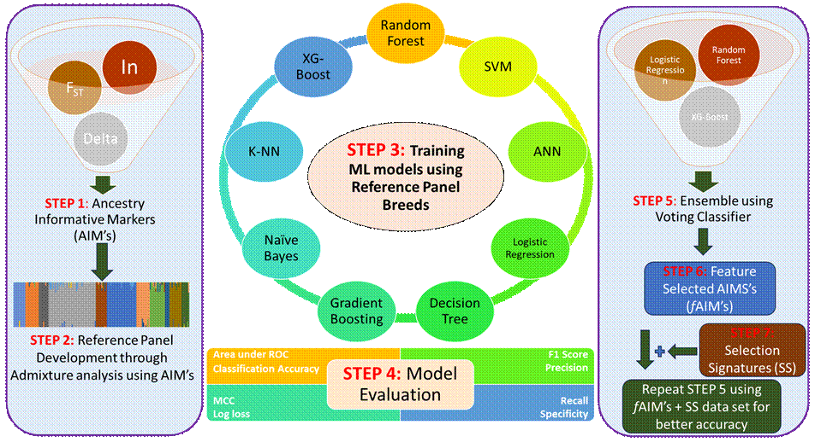
Graphical Abstract: Workflow of RASEL (R, A, S and EL stands for Reference panel, Ancestry Informative Markers, Selection Signatures and Ensemble learning respectively), an innovative machine learning pipeline developed to discriminate cattle based on breed and utility.

