Pain induces a rapid characteristic metabolic signature detectable in breath
  - Mélina Richard^{1,2}, Kapil Dev Singh^{1,2}, Dilan Sezer³, Sarah Buergler³, Luana Palermo⁵, Yannick Schulz³, Zhifeng Tang⁴, Xin Luo⁴, Urs Frey^{1,2}, Philippe C. Cattin², Xue Li⁴, Jens Gaab³, Pablo Sinues^{1,2*}
  - ¹ University Children's Hospital Basel (UKBB), Spitalstrasse 33, 4031 Basel, Switzerland
  - ²Department of Biomedical Engineering; University of Basel, Hegenheimermattweg 167b, 4123 Allschwil, Switzerland
  - ³Faculty of Psychology; University of Basel, Missionsstrasse 60/62, 4055 Basel, Switzerland
  - ⁴College of Environment and Climate, Institute of Mass Spectrometry and Atmospheric Environment, Guangdong Provincial Key Laboratory of Speed Capability Research, Jinan University, Guangzhou 510632, China.
⁵University Hospital of Child and Adolescent Psychiatry and Psychotherapy, University of Bern, Bern Switzerland
*corresponding author: pablo.sinues@unibas.ch

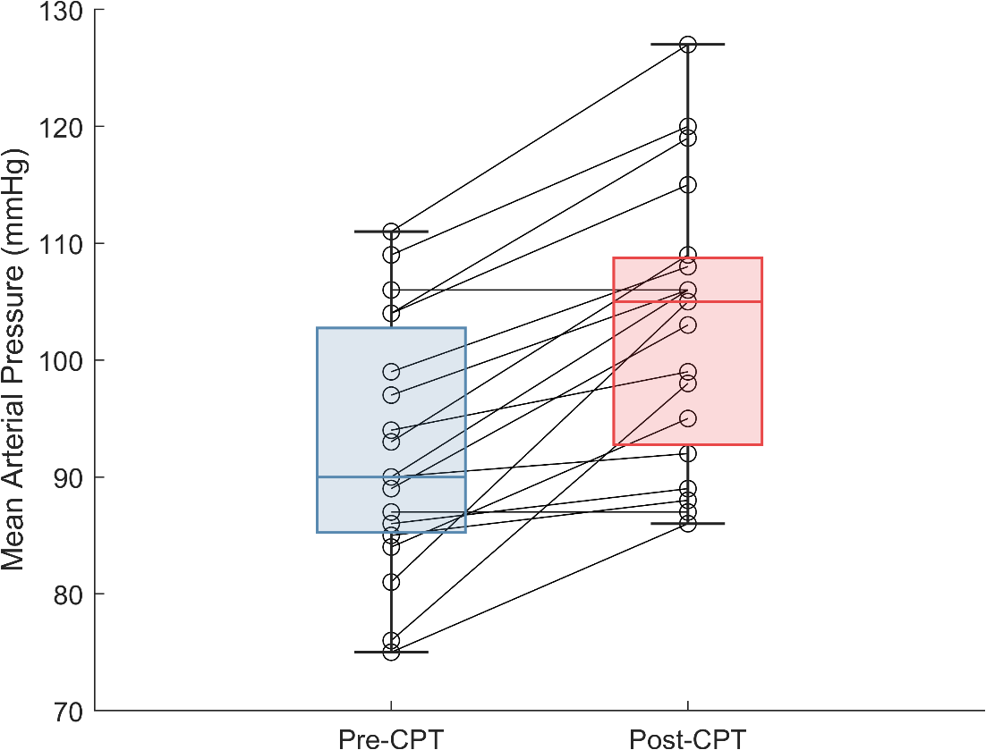
Fig. S1 Mean arterial pressure increases upon CPT intervention

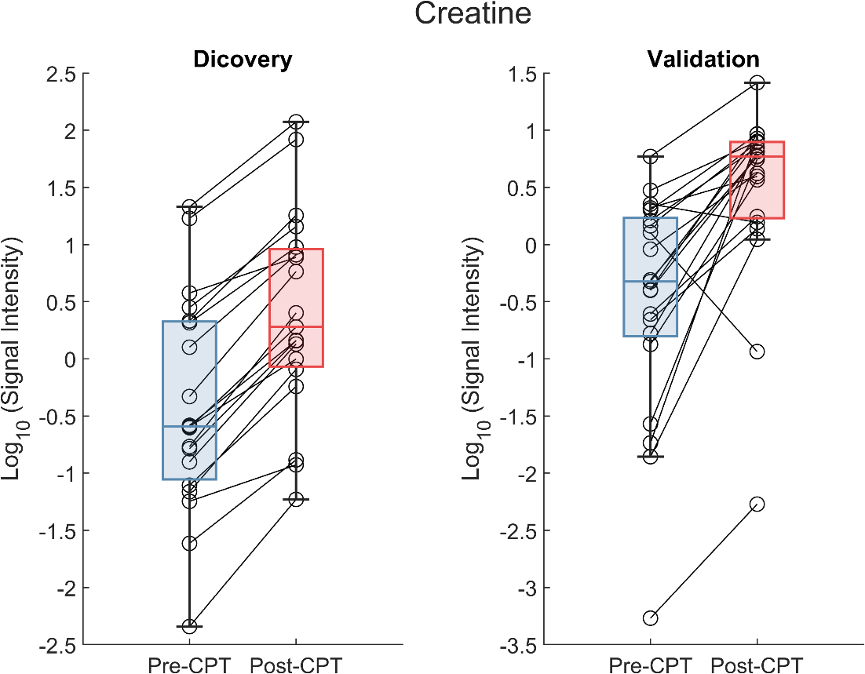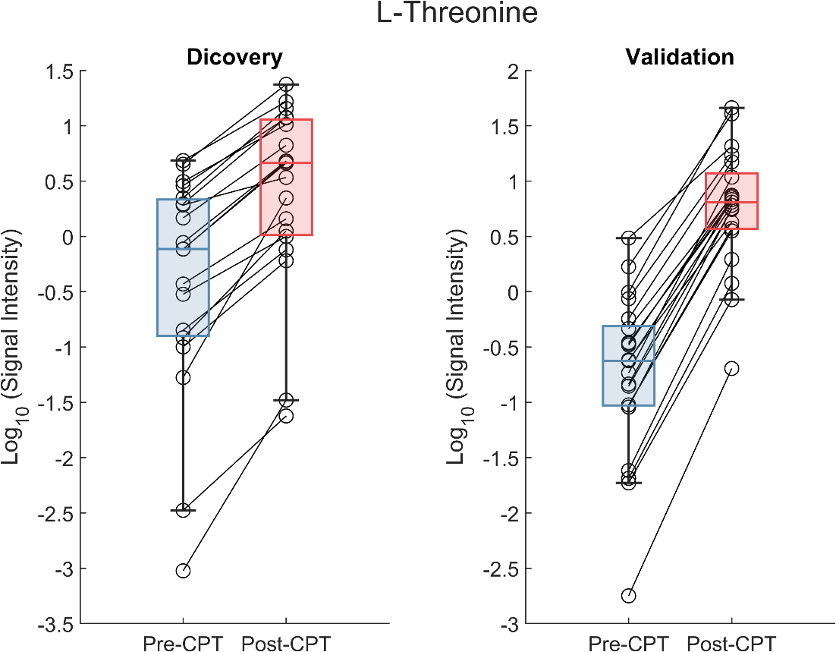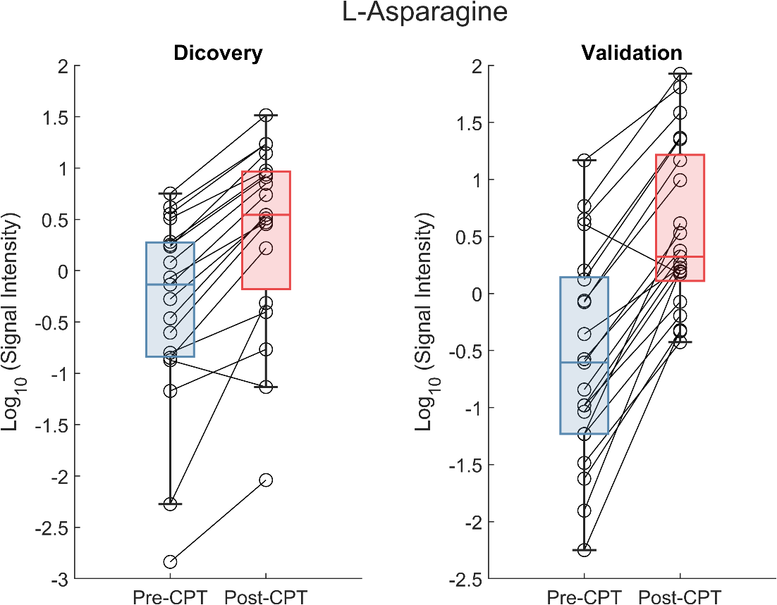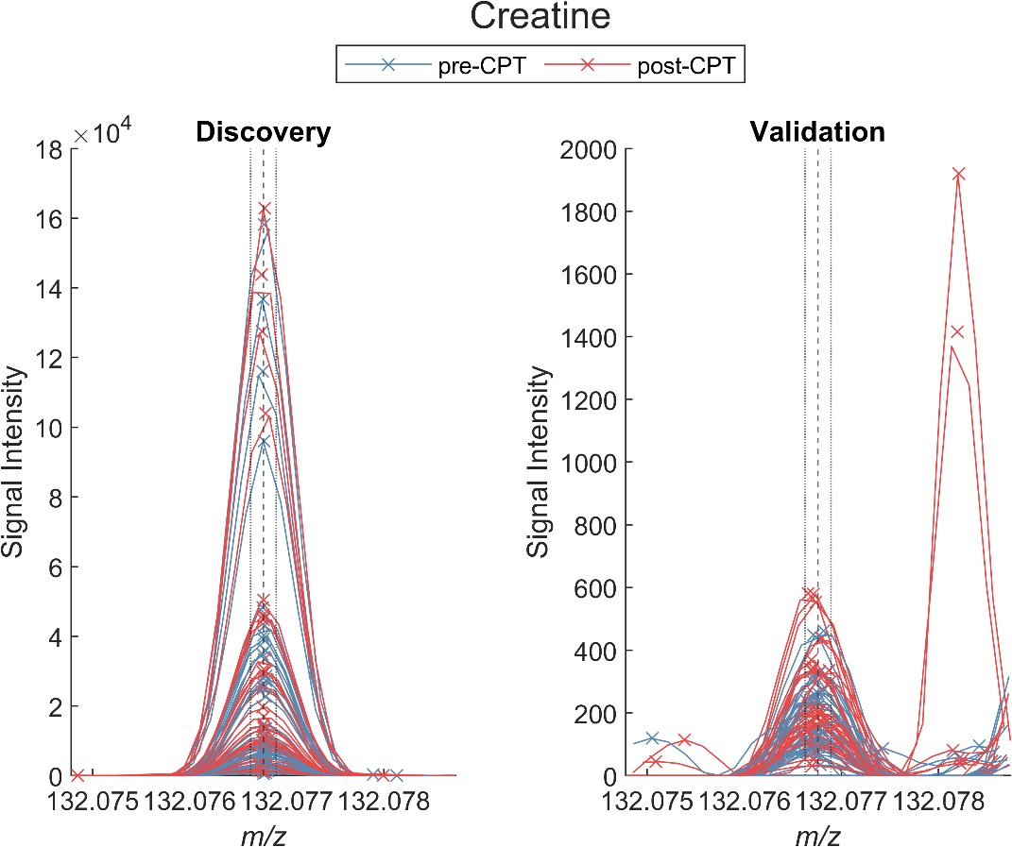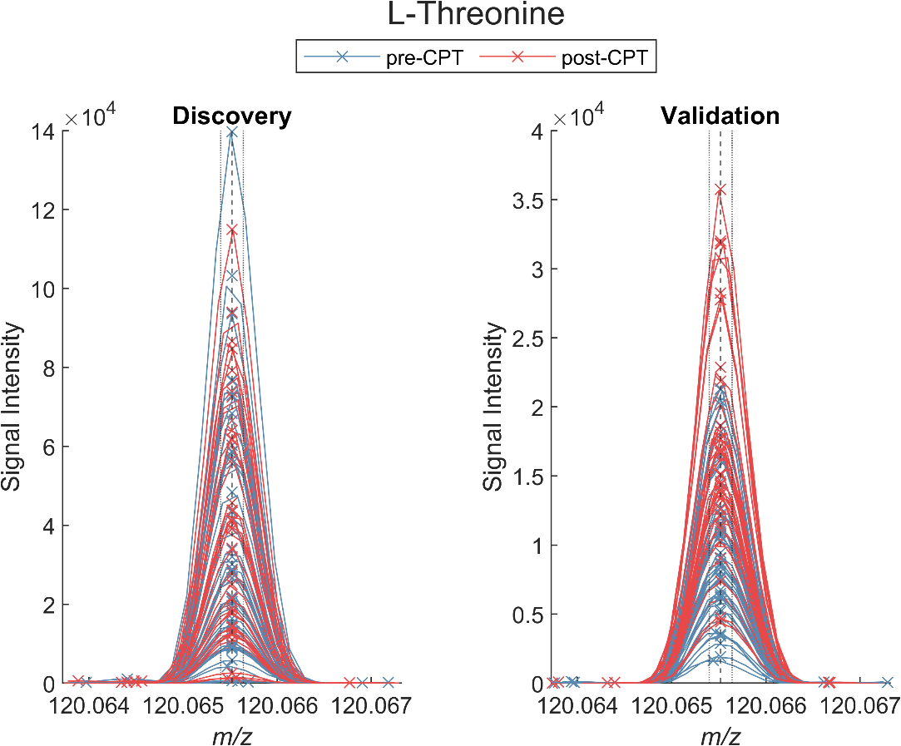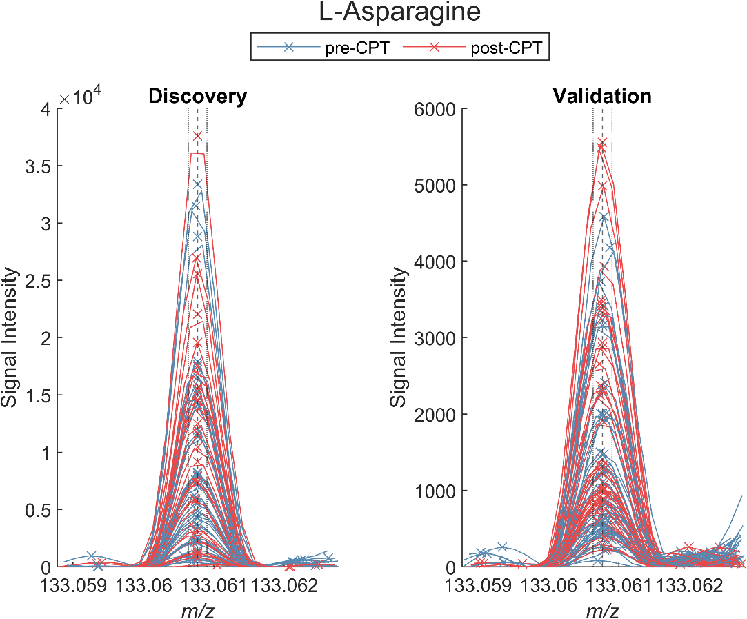
Fig. S2 Further examples of significantly increased exhaled metabolites

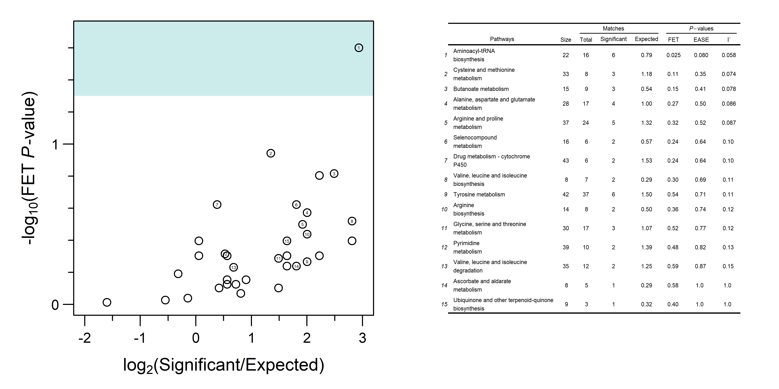
Fig. S3 Enrichment analysis output
Supplementary Table S1 and S2 are included as spreadsheets.

Name | ID | Site
BASEC ID: | 2021-01132 | CH
WHO(ICTRP) ID: | NCT04956718 | CH
Kofam ID: | SNCTP000004536 | CH
DKF CTU Basel ID: | ks21Sinues | CH
JNUKY | 2023-0059. | CN
Supplementary Table 3. Pre-Registrations and ethical committee approval

Pilot study "Metabolites in the air we breathe"
Inclusion & Exclusion Criteria Checklist
Date
Subject number*
Inclusion Criteria:
Yes No
Healthy adult person
German-speaking or very good knowledge of German
Ability to understand the study and its results
Ability to provide informed consent to participate in the study
Exclusion criteria:
Yes No
Regular use of medications that can impair the sensation of pain (analgesics, antihistamines, and calcium and potassium channel blockers)
Pregnant
Daily smokers (according to the WHO definition: A daily smoker is someone who smokes a tobacco product at least once a day)
Neuropathy (disease of the nervous system)
Chronic/long-lasting pain (> 3 months)
Neuromuscular (diseases that affect muscle function) or psychiatric disorders
Known or suspected heart, kidney, or liver disease
High blood pressure (systolic (mmHg) >130, diastolic (mmHg) >80)
History of Raynaud's phenomenon (symmetrical fading of the fingers or toes due to spasmodic narrowing of the blood vessels)
History of fainting or seizures
History of frostbite
Current medication intake (psychoactive medications, narcotics/strong painkillers, use of analgesics/analgesic or pain-relieving drugs) or psychological and psychiatric treatment

Filled by:

_____________________________________________

