Supplementary Material
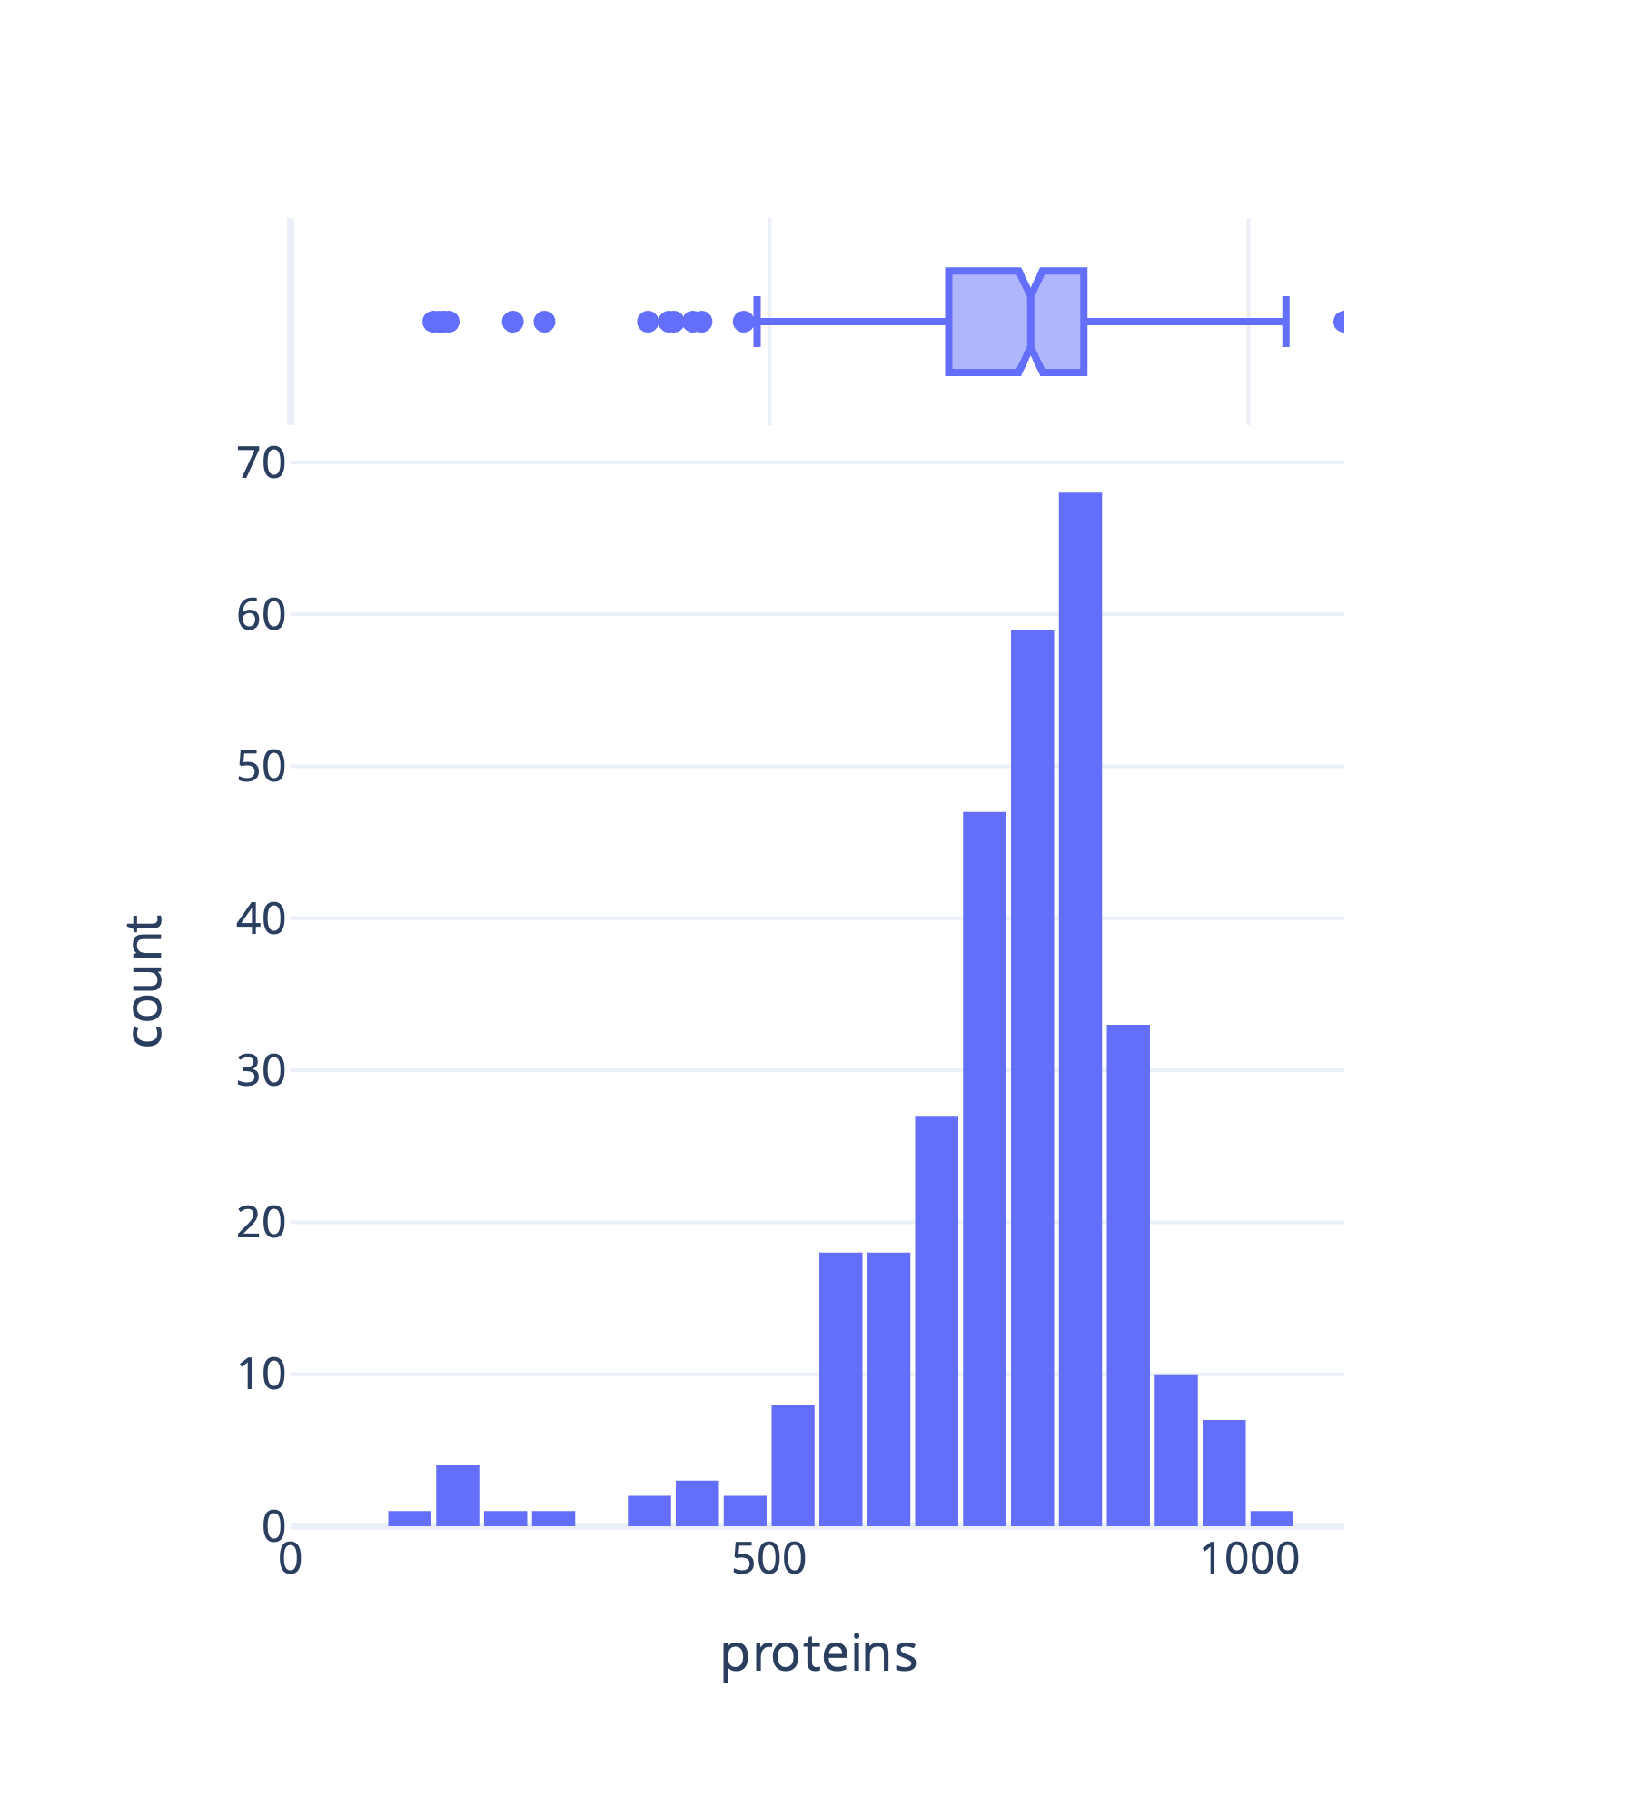
Figure 1 Histogram and marginal boxplot of the number of proteins measured in each cerebrospinal fluid sample. Samples with low protein content were removed from analysis. The cutoff for low protein count was defined by a cutoff of 1.5IQR from the 25th quantile in the boxplot (473 proteins).

Table 1 Overview of proteins with significant different protein levels in cerebrospinal fluid samples of patients with Lyme neuroborreliosis (LNB) compared to viral meningitis (VM) or controls. The column “Protein.Group” represent Uniprot identifiers. The magnitude of the change is represented by log(2) fold changes in the column “log2FC”. Only proteins with log2FC larger than 1 or smaller than -1 are included in the table. Log2FC is positive when the protein level is higher in LNB and negative when the protein level is higher in VM or controls. Gene Ontology terms and identifiers are included in the right column.
group1 | group2 | Protein.Group | Genes | Adjusted p-value | log2FC | Gene Ontology term [indetifier]
LNB | VM | A0A075B6K0 | IGLV3-16 | 2.53186E-05 | 1.1747 | immune response [GO:0006955]
LNB | VM | A0A075B6K4 | IGLV3-10 | 2.389E-07 | 1.8546 | immune response [GO:0006955]
LNB | VM | A0A0B4J1Y8 | IGLV9-49 | 2.39649E-05 | 1.6125 | immune response [GO:0006955]
LNB | VM | P01591 | JCHAIN | 5.31028E-05 | 1.5848 | immune response [GO:0006955]
LNB | VM | P01717 | IGLV3-25 | 1.79486E-09 | 1.9561 | immune response [GO:0006955]
LNB | VM | P01871 | IGHM | 1.9352E-05 | 1.7966 | adaptive immune response [GO:0002250]
LNB | VM | P06702 | S100A9 | 0.018078416 | -1.3447 | innate immune response [GO:0045087]
LNB | VM | P06733 | ENO1 | 0.000228589 | -1.0312 | other
LNB | VM | P09603 | CSF1 | 7.25579E-09 | -1.2365 | innate immune response [GO:0045087]
LNB | VM | Q9Y6R7 | FCGBP | 2.46493E-05 | 1.3237 | other
LNB | control | A0A075B6I0 | IGLV8-61 | 0.000309165 | 1.1506 | immune response [GO:0006955]
LNB | control | A0A075B6J9 | IGLV2-18 | 7.96928E-05 | 1.0590 | immune response [GO:0006955]
LNB | control | A0A075B6K0 | IGLV3-16 | 2.15317E-06 | 1.3034 | immune response [GO:0006955]
LNB | control | A0A075B6K4 | IGLV3-10 | 5.54358E-10 | 2.1034 | immune response [GO:0006955]
LNB | control | A0A075B6P5;P01615 | IGKV2-28;IGKV2D-28 | 3.38899E-06 | 1.1638 | immune response [GO:0006955]
LNB | control | A0A0B4J1V6 | IGHV3-73 | 6.13826E-06 | 1.0549 | immunoglobulin mediated immune response [GO:0016064]
LNB | control | A0A0B4J1Y8 | IGLV9-49 | 8.2725E-05 | 1.4784 | immune response [GO:0006955]
LNB | control | A0A0C4DH24 | IGKV6-21 | 4.49599E-07 | 1.1364 | immune response [GO:0006955]
LNB | control | A0A0C4DH31 | IGHV1-18 | 8.48379E-07 | 1.1144 | immunoglobulin mediated immune response [GO:0016064]
LNB | control | A0AAG2UUW0 | APOB | 2.2969E-05 | 1.4527 | other
LNB | control | B9A064 | IGLL5 | 1.27217E-06 | 1.0648 | immunoglobulin mediated immune response [GO:0016064]
LNB | control | O43866 | CD5L | 4.78052E-05 | 1.3132 | inflammatory response [GO:0006954]
LNB | control | P01591 | JCHAIN | 4.9942E-10 | 2.7718 | immune response [GO:0006955]
LNB | control | P01701 | IGLV1-51 | 1.44117E-05 | 1.1102 | immune response [GO:0006955]
LNB | control | P01709 | IGLV2-8 | 6.36568E-05 | 1.1339 | immune response [GO:0006955]
LNB | control | P01717 | IGLV3-25 | 1.15989E-08 | 1.9521 | immune response [GO:0006955]
LNB | control | P01871 | IGHM | 6.82279E-11 | 3.0667 | adaptive immune response [GO:0002250]
LNB | control | P02741 | CRP | 0.00572022 | -1.0117 | innate immune response [GO:0045087]
LNB | control | P02743 | APCS | 3.27736E-05 | 1.3845 | innate immune response [GO:0045087]
LNB | control | P02746 | C1QB | 4.73158E-08 | 1.0347 | innate immune response [GO:0045087]
LNB | control | P04003 | C4BPA | 9.4724E-06 | 1.2708 | innate immune response [GO:0045087]
LNB | control | P05408 | SCG5 | 8.14822E-08 | -1.1644 | neuropeptide signaling pathway [GO:0007218]
LNB | control | P07737 | PFN1 | 1.15996E-06 | 1.3794 | protein stabilization [GO:0050821]
LNB | control | P08670 | VIM | 6.31901E-05 | 1.2797 | positive regulation of gene expression [GO:0010628]
LNB | control | P10645 | CHGA | 1.49404E-07 | -1.5734 | innate immune response [GO:0045087]
LNB | control | P13796 | LCP1 | 1.73629E-08 | 1.4317 | cell migration [GO:0016477]
LNB | control | P23582 | NPPC | 3.57234E-09 | -1.2180 | angiogenesis [GO:0001525]
LNB | control | P26038 | MSN | 3.60631E-07 | 1.0384 | positive regulation of gene expression [GO:0010628]
LNB | control | P31146 | CORO1A | 2.56422E-07 | 1.4438 | innate immune response [GO:0045087]
LNB | control | P60709 | ACTB | 5.28812E-07 | 1.5228 | positive regulation of cell population proliferation [GO:0008284]
LNB | control | P61626 | LYZ | 8.14426E-05 | 1.0573 | inflammatory response [GO:0006954]
LNB | control | P62736;P63267 | ACTA2;ACTG2 | 6.07352E-07 | 1.4786 | positive regulation of gene expression [GO:0010628]
LNB | control | P62805 | H4C1 | 8.61539E-06 | 1.8339 | other
LNB | control | P62937 | PPIA | 1.83577E-05 | 1.0059 | apoptotic process [GO:0006915]
LNB | control | P63104 | YWHAZ | 3.20261E-07 | 1.0842 | signal transduction [GO:0007165]
LNB | control | Q562R1 | ACTBL2 | 1.09819E-07 | 1.6610 | axonogenesis [GO:0007409]
LNB | control | Q99574 | SERPINI1 | 1.18025E-06 | -1.2106 | central nervous system development [GO:0007417]
LNB | control | Q9H1Z8 | ECRG4 | 6.89432E-09 | -1.0394 | central nervous system development [GO:0007417]
LNB | control | Q9H299 | SH3BGRL3 | 7.23881E-07 | 1.0751 | other
LNB | control | Q9NZK5 | ADA2 | 1.76646E-08 | 1.2921 | other
LNB | control | Q9Y6R7 | FCGBP | 5.22605E-08 | 1.4716 | other

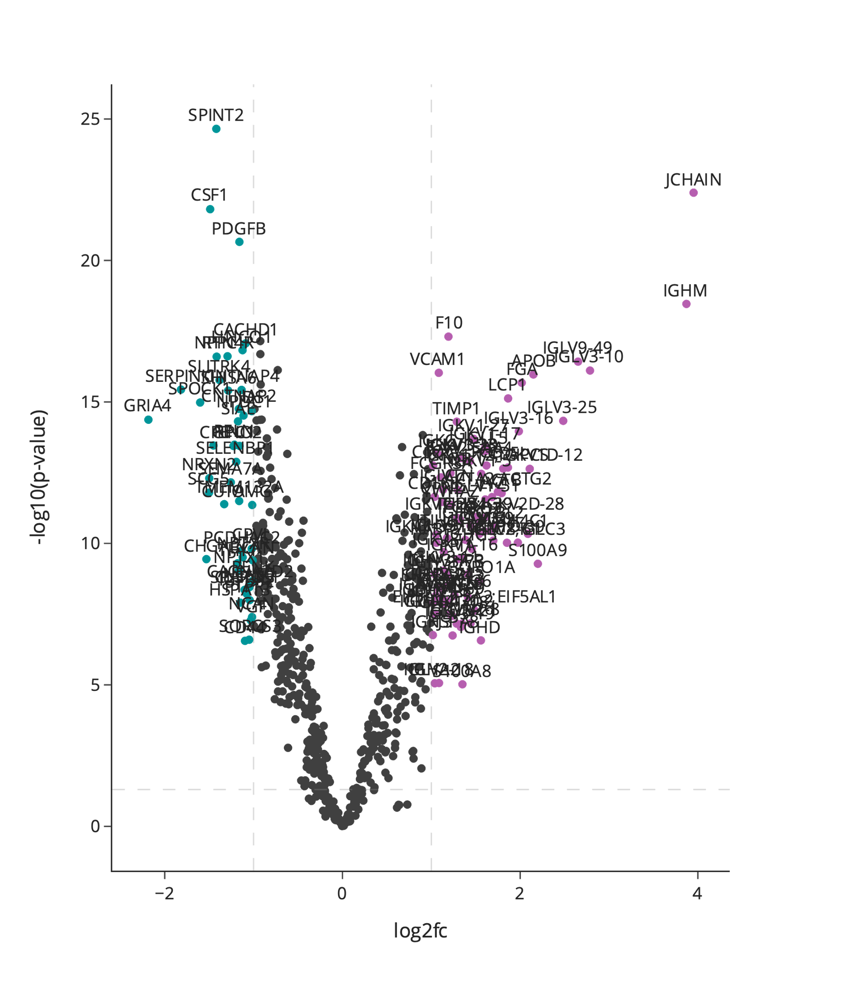
Figure 2 Volcano plot highlighting protein differences between Lyme neuroborreliosis (LNB) and controls in the cerebrospinal fluid validation cohort. Each point represents a protein, the colour purple represents upregulated proteins with a log2 fold change (FC) larger than 1, the colour blue represents downregulated proteins with a log2 fold smaller larger than -1 and the colour grey represents proteins with a log2 fold change between -1 and 1 or non-significant proteins. X-axis depicts log2 fold change and y-axis depicts the log 10 adjusted p-value. Horizontal dashed lines represent the significance threshold after multiple hypothesis correction at p=0.05. Vertical dashed lines represent large log2 fold changes: above 1 or below -1.
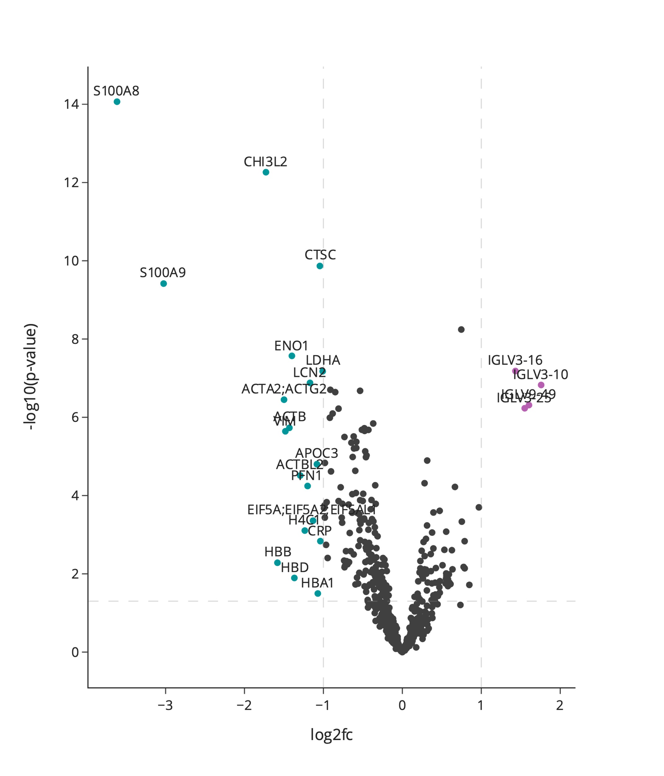
Figure 3 Volcano plot highlighting protein differences between Lyme neuroborreliosis (LNB) and viral meningitis (VM) in the cerebrospinal fluid validation cohort. Each point represents a protein, the colour purple represents upregulated proteins with a log2 fold change (FC) larger than 1, the colour blue represents downregulated proteins with a log2 fold smaller larger than -1 and the colour grey represents proteins with a log2 fold change between -1 and 1 or non-significant proteins. X-axis depicts log2 fold change and y-axis depicts the log 10 adjusted p-value. Horizontal dashed lines represent the significance threshold after multiple hypothesis correction at p=0.05. Vertical dashed lines represent large log2 fold changes: above 1 or below -1.

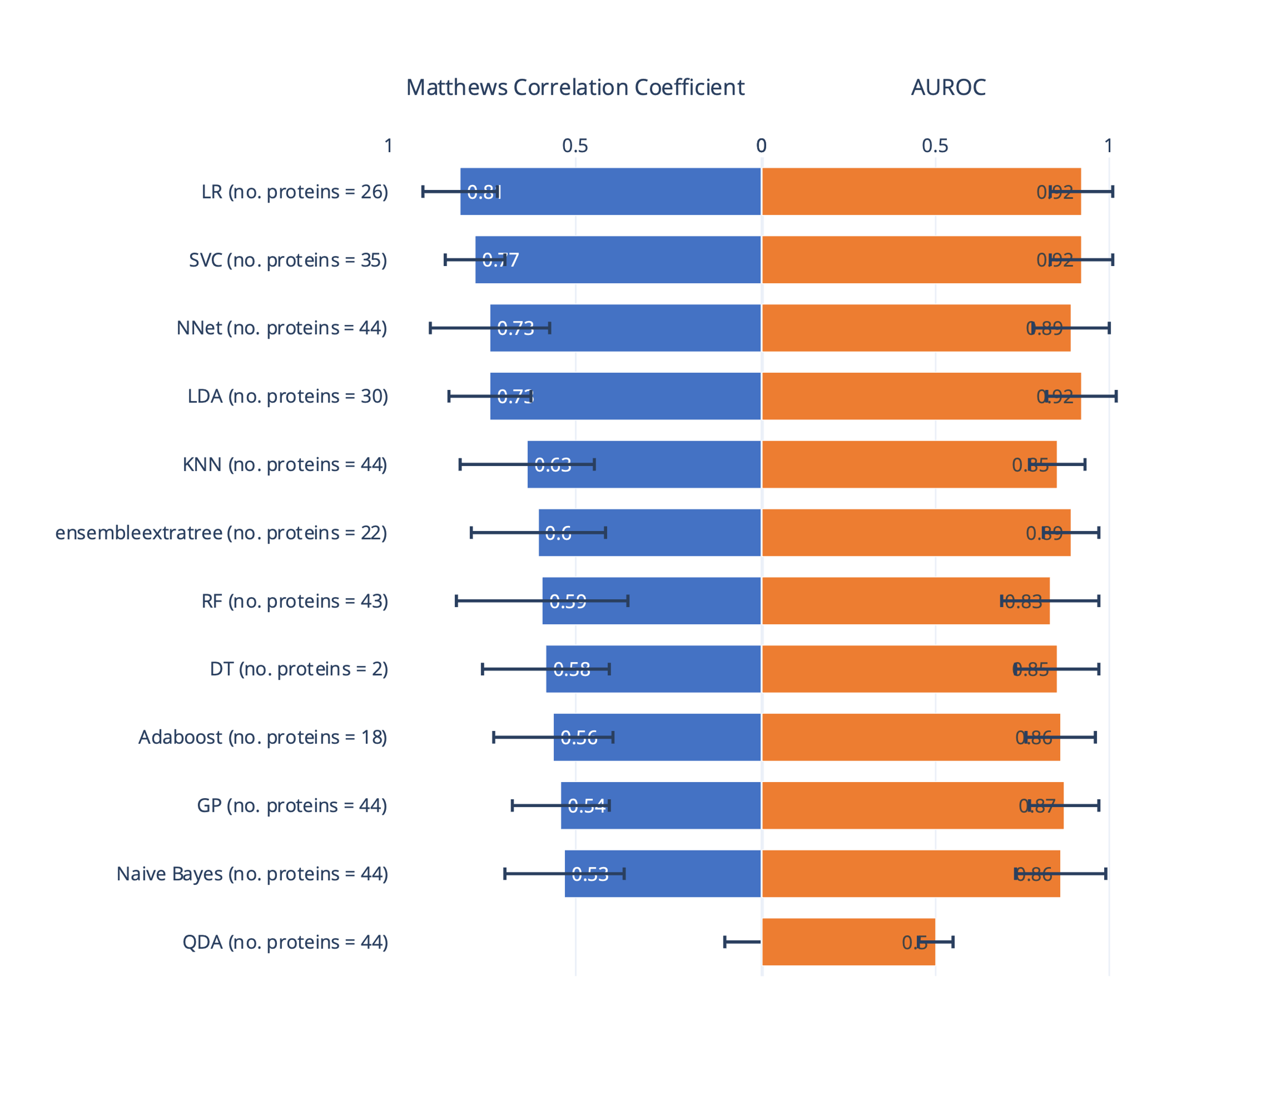
Figure 4 Output of the cross-validation grid search of algorithms, hyperparameters, and the number of proteins is displayed as the area under the receiver operating characteristic curve (AUROC) and Matthews Correlation Coefficient (MCC) from the predictions on the test sets. The model was trained to classify Lyme neuroborreliosis and viral meningitis. The number of proteins used in each model is shown to the right. The error bars represent the standard deviation across the 5-fold cross-validation runs.
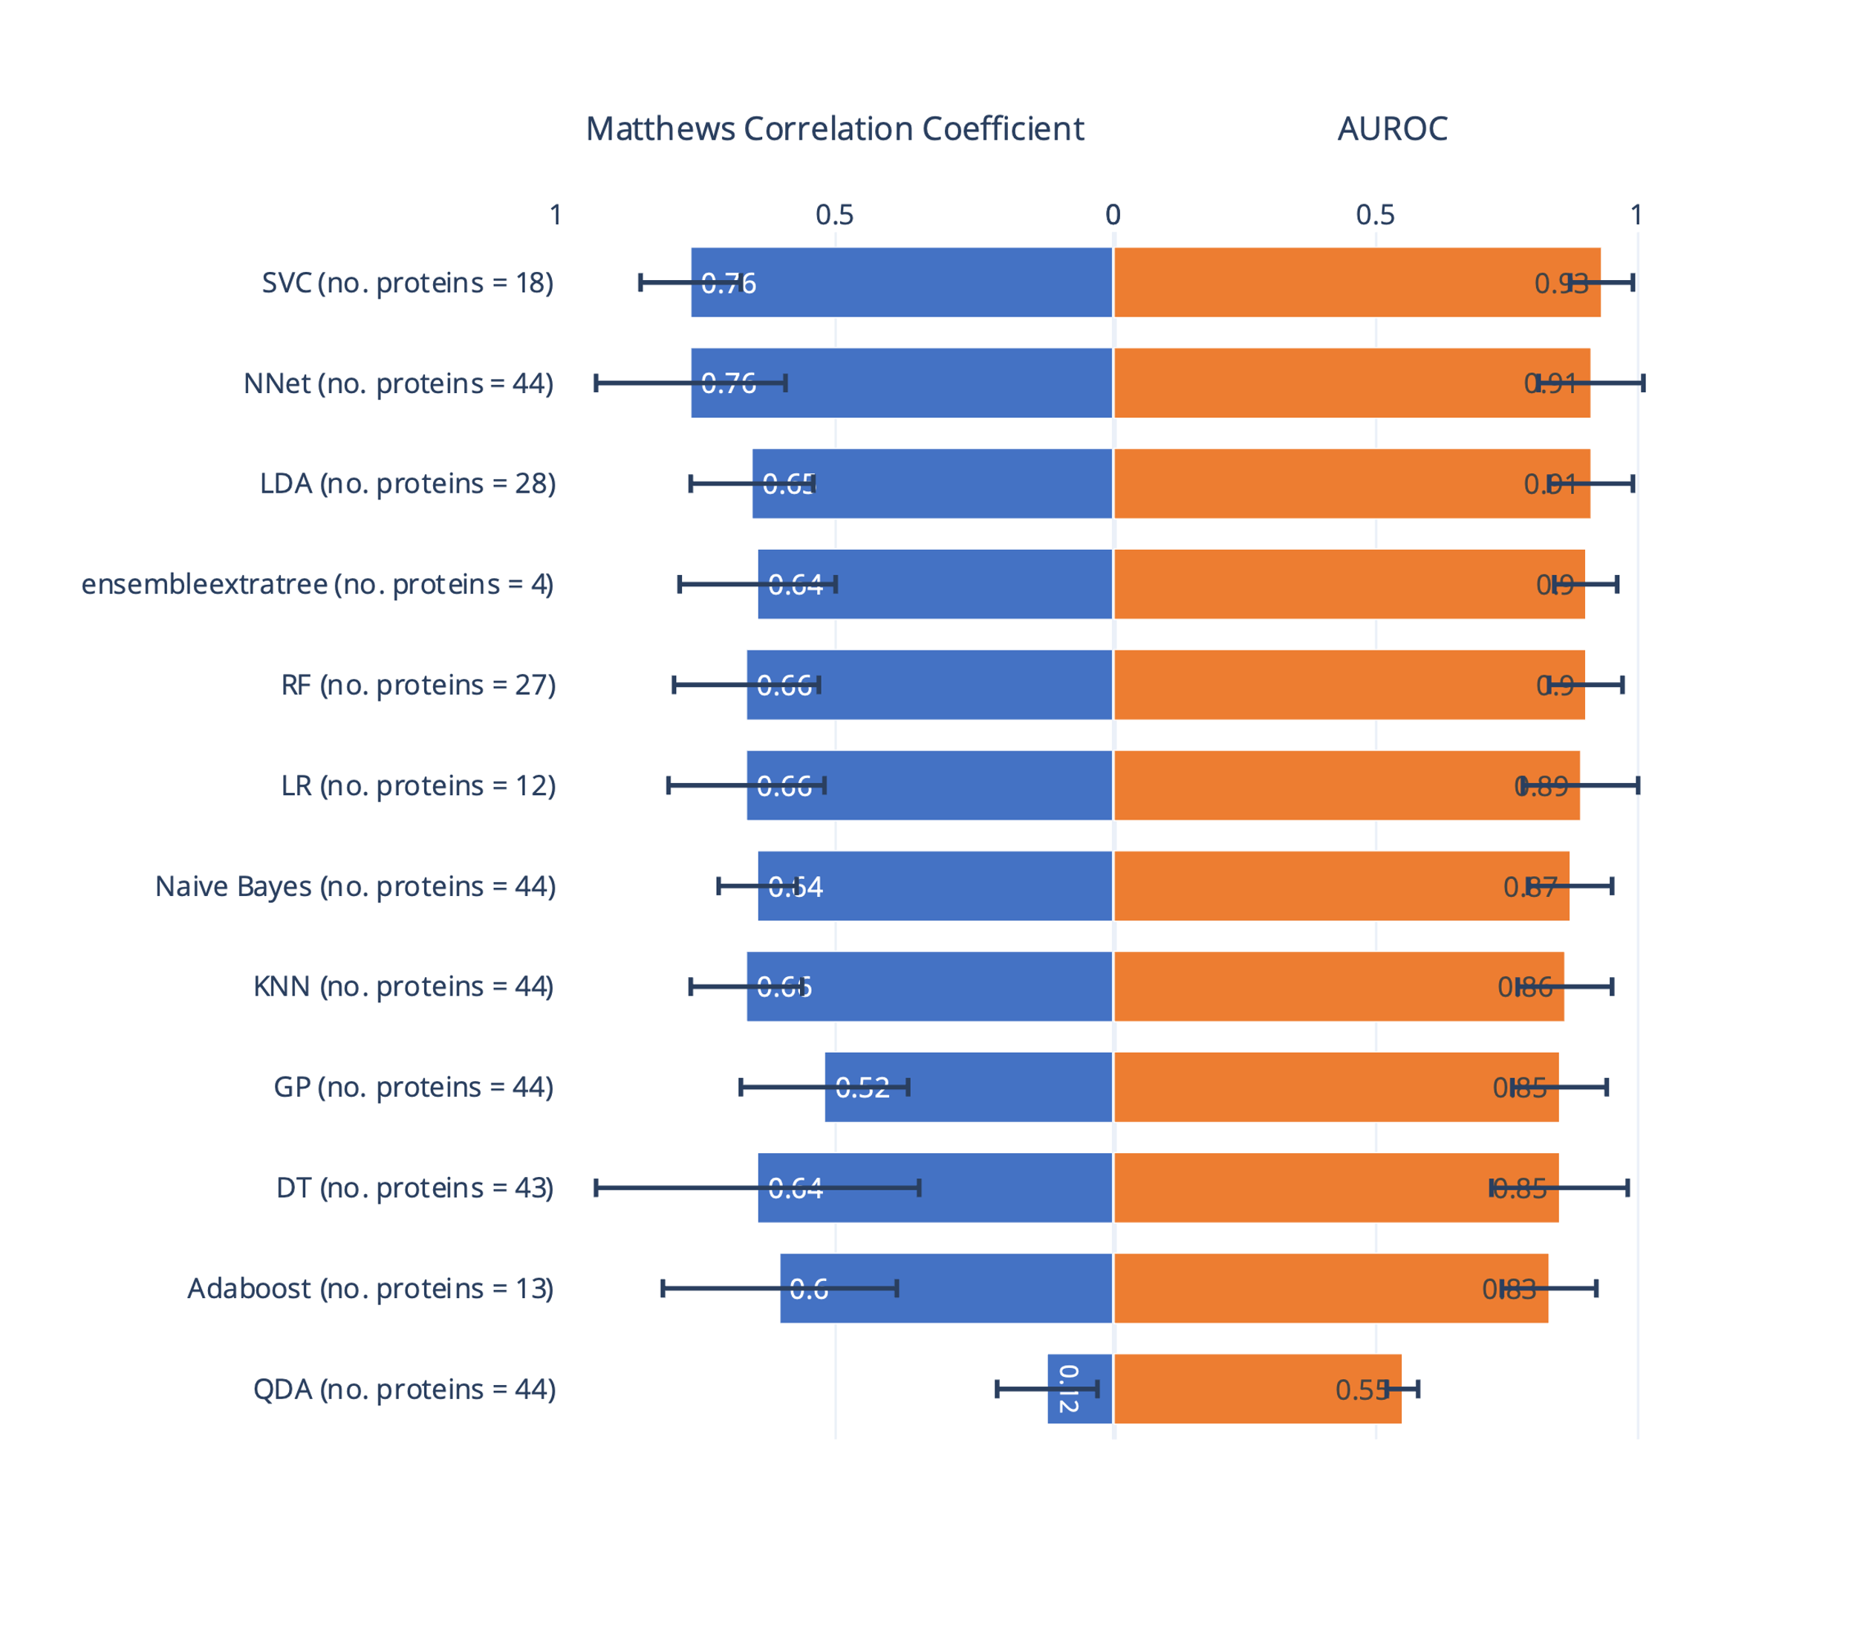
Figure 5 Output of the cross-validation grid search of algorithms, hyperparameters, and the number of proteins is displayed as the area under the receiver operating characteristic curve (AUROC) and Matthews Correlation Coefficient (MCC) from the predictions on the test sets. The model was trained to classify Lyme neuroborreliosis and controls. The number of proteins used in each model is shown to the right. The error bars represent the standard deviation across the 5-fold cross-validation runs.

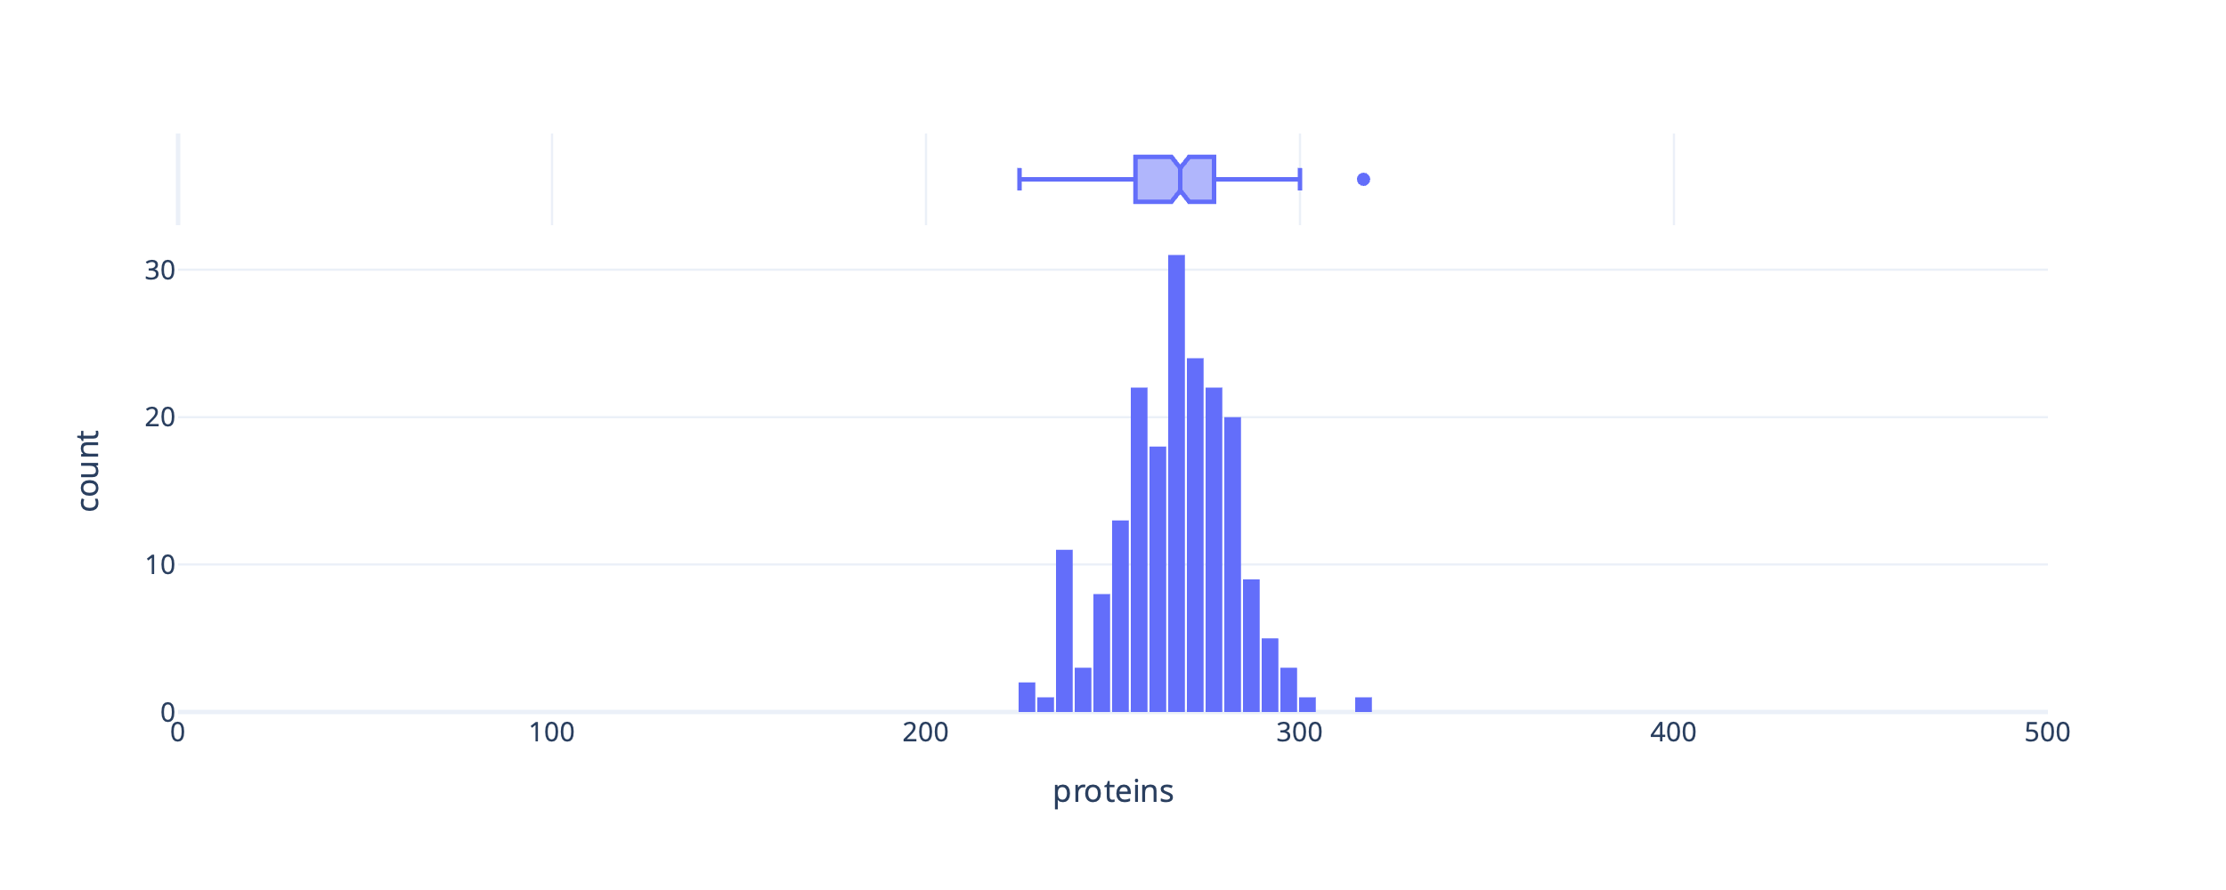
Figure 6 Histogram and marginal boxplot of the number of proteins measured in each plasma sample. Samples with low protein content were removed from analysis. The cutoff for low protein count was defined by a cutoff of 1.5IQR from the 25th quantile in the boxplot (230 proteins).

Table 2 Overview of proteins with significant different protein levels in plasma samples of patients with Lyme neuroborreliosis (LNB) compared to viral meningitis (VM) or controls. The column “Protein.Group” represent Uniprot identifiers. The magnitude of the change is represented by log(2) fold changes in the column “log2FC”. Log2FC is positive when the protein level is higher in LNB and negative when the protein level is higher in VM or controls. Gene Ontology terms and identifiers are included in the right column.
group1 | group2 | Protein.Group | Genes | Adjusted p-value | log2FC | Gene Ontology
LNB | VM | A0A075B6H7 | IGKV3-7 | 0.00856 | -0.35165 | immune response [GO:0006955]
LNB | VM | A0A075B6R9;A0A0C4DH68 | IGKV2-24;IGKV2D-24 | 0.04519 | -0.39838 | immune response [GO:0006955]
LNB | VM | A0A075B6S5 | IGKV1-27 | 0.04927 | -0.26167 | immune response [GO:0006955]
LNB | VM | A0A0B4J1X5 | IGHV3-74 | 0.03026 | -0.30631 | immunoglobulin mediated immune response [GO:0016064]
LNB | VM | A0A0C4DH24 | IGKV6-21 | 0.03736 | -0.38677 | immune response [GO:0006955]
LNB | VM | A0A0C4DH31 | IGHV1-18 | 0.01302 | -0.40935 | immunoglobulin mediated immune response [GO:0016064]
LNB | VM | A0A0C4DH36 | IGHV3-38 | 0.01744 | -0.35707 | immunoglobulin mediated immune response [GO:0016064]
LNB | VM | A0A0J9YXX1 | IGHV5-10-1 | 0.01870 | 1.13650 | immunoglobulin mediated immune response [GO:0016064]
LNB | VM | A0AAG2TVE0 | A0AAG2TVE0 | 0.04939 | 0.66621
LNB | VM | O75636 | FCN3 | 0.03694 | 0.19080 | proteolysis [GO:0006508]
LNB | VM | O75882 | ATRN | 0.02213 | 0.15305 | inflammatory response [GO:0006954]
LNB | VM | O95445 | APOM | 0.04778 | 0.18697 | high-density lipoprotein particle remodeling [GO:0034375]
LNB | VM | P00488 | F13A1 | 0.02867 | 0.24636 | blood coagulation [GO:0007596]
LNB | VM | P01602 | IGKV1-5 | 0.00037 | -0.46912 | immune response [GO:0006955]
LNB | VM | P01619 | IGKV3-20 | 0.00577 | -0.37231 | immune response [GO:0006955]
LNB | VM | P01780 | IGHV3-7 | 0.00630 | -0.30620 | immune response [GO:0006955]
LNB | VM | P01834 | IGKC | 0.04835 | -0.25036 | immune response [GO:0006955]
LNB | VM | P01857 | IGHG1 | 0.00002 | -0.35600 | adaptive immune response [GO:0002250]
LNB | VM | P02649 | APOE | 0.02676 | 0.25026 | cholesterol metabolic process [GO:0008203]
LNB | VM | P02654 | APOC1 | 0.01812 | 0.25454 | cholesterol metabolic process [GO:0008203]
LNB | VM | P02656 | APOC3 | 0.00010 | 0.49565 | high-density lipoprotein particle remodeling [GO:0034375]
LNB | VM | P02671 | FGA | 0.02274 | -0.19636 | adaptive immune response [GO:0002250]
LNB | VM | P02675 | FGB | 0.01290 | -0.28546 | adaptive immune response [GO:0002250]
LNB | VM | P02679 | FGG | 0.01150 | -0.34442 | fibrinolysis [GO:0042730]
LNB | VM | P02741 | CRP | 0.01919 | -1.17647 | innate immune response [GO:0045087]
LNB | VM | P02746 | C1QB | 0.04063 | -0.16595 | innate immune response [GO:0045087]
LNB | VM | P02747 | C1QC | 0.00153 | -0.23470 | immune response [GO:0006955]
LNB | VM | P02748 | C9 | 0.00234 | -0.37041 | complement activation, classical pathway [GO:0006958]
LNB | VM | P02750 | LRG1 | 0.00115 | -0.49298 | positive regulation of angiogenesis [GO:0045766]
LNB | VM | P02751 | FN1 | 0.00439 | -0.52337 | acute-phase response [GO:0006953]
LNB | VM | P02753 | RBP4 | 0.02769 | 0.23883 | other
LNB | VM | P02765 | AHSG | 0.03292 | -0.20536 | acute-phase response [GO:0006953]
LNB | VM | P02790 | HPX | 0.00351 | 0.18942 | intracellular iron ion homeostasis [GO:0006879]
LNB | VM | P03951 | F11 | 0.04411 | -0.17015 | blood coagulation [GO:0007596]
LNB | VM | P04004 | VTN | 0.00231 | -0.20619 | immune response [GO:0006955]
LNB | VM | P04070 | PROC | 0.02816 | 0.20194 | blood coagulation [GO:0007596]
LNB | VM | P04275 | VWF | 0.00001 | -1.39211 | blood coagulation [GO:0007596]
LNB | VM | P04433 | IGKV3-11 | 0.03232 | -0.24214 | immune response [GO:0006955]
LNB | VM | P05090 | APOD | 0.00952 | 0.34954 | angiogenesis [GO:0001525]
LNB | VM | P05109 | S100A8 | 0.03735 | -0.62225 | innate immune response [GO:0045087]
LNB | VM | P05154 | SERPINA5 | 0.00009 | 0.43218 | lipid transport [GO:0006869]
LNB | VM | P05155 | SERPING1 | 0.02323 | 0.17273 | innate immune response [GO:0045087]
LNB | VM | P05546 | SERPIND1 | 0.00690 | 0.21704 | blood coagulation [GO:0007596]
LNB | VM | P06312 | IGKV4-1 | 0.00694 | -0.32065 | immune response [GO:0006955]
LNB | VM | P06681 | C2 | 0.00905 | -0.12792 | innate immune response [GO:0045087]
LNB | VM | P06702 | S100A9 | 0.00011 | -1.02138 | innate immune response [GO:0045087]
LNB | VM | P06727 | APOA4 | 0.00069 | 0.47736 | cholesterol metabolic process [GO:0008203]
LNB | VM | P07195 | LDHB | 0.00029 | 0.45285 | other
LNB | VM | P07225 | PROS1 | 0.00001 | 0.25489 | blood coagulation [GO:0007596]
LNB | VM | P07737 | PFN1 | 0.02297 | 0.87449 | protein stabilization [GO:0050821]
LNB | VM | P08185 | SERPINA6 | 0.00647 | -0.23854 | other
LNB | VM | P08571 | CD14 | 0.00110 | -0.35763 | innate immune response [GO:0045087]
LNB | VM | P0DJI8 | SAA1 | 0.00290 | -1.55342 | acute-phase response [GO:0006953]
LNB | VM | P12259 | F5 | 0.01711 | -0.16784 | blood coagulation [GO:0007596]
LNB | VM | P13473 | LAMP2 | 0.00500 | -0.29392 | protein stabilization [GO:0050821]
LNB | VM | P13671 | C6 | 0.00437 | -0.22841 | innate immune response [GO:0045087]
LNB | VM | P14151 | SELL | 0.02676 | -0.27011 | cell adhesion [GO:0007155]
LNB | VM | P20742 | PZP | 0.03131 | -0.84446 | other
LNB | VM | P24592 | IGFBP6 | 0.02466 | 0.25876 | negative regulation of cell population proliferation [GO:0008285]
LNB | VM | P29622 | SERPINA4 | 0.00217 | 0.28261 | other
LNB | VM | P35858 | IGFALS | 0.00401 | -0.30860 | cell adhesion [GO:0007155]
LNB | VM | P51884 | LUM | 0.00808 | 0.28393 | other
LNB | VM | P60709 | ACTB | 0.00368 | 1.30850 | platelet aggregation [GO:0070527]
LNB | VM | P80108 | GPLD1 | 0.00196 | 0.26208 | negative regulation of cell population proliferation [GO:0008285]
LNB | VM | Q16610 | ECM1 | 0.01922 | -0.22499 | inflammatory response [GO:0006954]
LNB | VM | Q96IY4 | CPB2 | 0.00794 | 0.17087 | blood coagulation [GO:0007596]
LNB | VM | Q9NPH3 | IL1RAP | 0.02190 | -0.38014 | immune response [GO:0006955]
LNB | VM | Q9NZP8 | C1RL | 0.00146 | -0.19024 | innate immune response [GO:0045087]
LNB | control | A0A075B6H7 | IGKV3-7 | 0.00177 | -0.33554 | immune response [GO:0006955]
LNB | control | A0A075B6P5;P01615 | IGKV2-28;IGKV2D-28 | 0.01413 | -0.29223 | immune response [GO:0006955]
LNB | control | A0A075B6R9;A0A0C4DH68 | IGKV2-24;IGKV2D-24 | 0.00432 | -0.43494 | immune response [GO:0006955]
LNB | control | A0A087WW87;P01614 | IGKV2-40;IGKV2D-40 | 0.00049 | -0.49442 | immune response [GO:0006955]
LNB | control | A0A0B4J1V0 | IGHV3-15 | 0.01137 | -0.29754 | immunoglobulin mediated immune response [GO:0016064]
LNB | control | A0A0B4J1X5 | IGHV3-74 | 0.01247 | -0.31114 | immunoglobulin mediated immune response [GO:0016064]
LNB | control | A0A0C4DH25 | IGKV3D-20 | 0.00329 | -0.44289 | immune response [GO:0006955]
LNB | control | A0A0C4DH33 | IGHV1-24 | 0.01431 | -0.45928 | immunoglobulin mediated immune response [GO:0016064]
LNB | control | A0A0C4DH36 | IGHV3-38 | 0.00167 | -0.44729 | immunoglobulin mediated immune response [GO:0016064]
LNB | control | A0A0J9YX35 | IGHV3-64D | 0.01266 | -0.24660 | immunoglobulin mediated immune response [GO:0016064]
LNB | control | A0M8Q6 | IGLC7 | 0.02357 | -0.18057 | adaptive immune response [GO:0002250]
LNB | control | O75636 | FCN3 | 0.00312 | 0.23870 | proteolysis [GO:0006508]
LNB | control | P00488 | F13A1 | 0.00791 | 0.21285 | blood coagulation [GO:0007596]
LNB | control | P00734 | F2 | 0.02876 | -0.10192 | blood coagulation [GO:0007596]
LNB | control | P00738 | HP | 0.01893 | 0.38625 | acute-phase response [GO:0006953]
LNB | control | P00740 | F9 | 0.04619 | 0.09905 | blood coagulation [GO:0007596]
LNB | control | P00747 | PLG | 0.00278 | -0.16783 | blood coagulation [GO:0007596]
LNB | control | P01011 | SERPINA3 | 0.01873 | 0.15279 | acute-phase response [GO:0006953]
LNB | control | P01024 | C3 | 0.00184 | 0.16474 | immune response [GO:0006955]
LNB | control | P01031 | C5 | 0.00135 | 0.18593 | complement activation, classical pathway [GO:0006958]
LNB | control | P01042 | KNG1 | 0.00865 | -0.10983 | blood coagulation [GO:0007596]
LNB | control | P01619 | IGKV3-20 | 0.00009 | -0.40547 | immune response [GO:0006955]
LNB | control | P01780 | IGHV3-7 | 0.01094 | -0.30028 | immune response [GO:0006955]
LNB | control | P01834 | IGKC | 0.00367 | -0.30026 | immune response [GO:0006955]
LNB | control | P01857 | IGHG1 | 0.00007 | -0.32923 | adaptive immune response [GO:0002250]
LNB | control | P01861 | IGHG4 | 0.03574 | -0.45341 | adaptive immune response [GO:0002250]
LNB | control | P02671 | FGA | 0.03067 | -0.13049 | adaptive immune response [GO:0002250]
LNB | control | P02743 | APCS | 0.03289 | 0.20412 | innate immune response [GO:0045087]
LNB | control | P02746 | C1QB | 0.02157 | -0.11934 | innate immune response [GO:0045087]
LNB | control | P02747 | C1QC | 0.00066 | -0.21374 | immune response [GO:0006955]
LNB | control | P02751 | FN1 | 0.00001 | -0.63677 | acute-phase response [GO:0006953]
LNB | control | P02765 | AHSG | 0.00000 | -0.40582 | acute-phase response [GO:0006953]
LNB | control | P02766 | TTR | 0.02683 | -0.42209 | other
LNB | control | P02787 | TF | 0.01237 | -0.16740 | antibacterial humoral response [GO:0019731]
LNB | control | P02790 | HPX | 0.00311 | 0.15382 | intracellular iron ion homeostasis [GO:0006879]
LNB | control | P03951 | F11 | 0.04714 | -0.12687 | blood coagulation [GO:0007596]
LNB | control | P03952 | KLKB1 | 0.00873 | -0.14870 | blood coagulation [GO:0007596]
LNB | control | P04003 | C4BPA | 0.04015 | 0.11068 | innate immune response [GO:0045087]
LNB | control | P04180 | LCAT | 0.00839 | -0.14726 | cholesterol metabolic process [GO:0008203]
LNB | control | P04196 | HRG | 0.02380 | -0.16257 | fibrinolysis [GO:0042730]
LNB | control | P04275 | VWF | 0.00001 | -1.15025 | blood coagulation [GO:0007596]
LNB | control | P04430 | IGKV1-16 | 0.04914 | -0.21898 | immune response [GO:0006955]
LNB | control | P04433 | IGKV3-11 | 0.00013 | -0.35888 | immune response [GO:0006955]
LNB | control | P05109 | S100A8 | 0.00013 | -0.99785 | innate immune response [GO:0045087]
LNB | control | P05154 | SERPINA5 | 0.04019 | 0.21592 | lipid transport [GO:0006869]
LNB | control | P05155 | SERPING1 | 0.00778 | 0.24329 | innate immune response [GO:0045087]
LNB | control | P05452 | CLEC3B | 0.01633 | -0.19006 | ossification [GO:0001503]
LNB | control | P05546 | SERPIND1 | 0.00841 | 0.16932 | blood coagulation [GO:0007596]
LNB | control | P06312 | IGKV4-1 | 0.00054 | -0.30975 | immune response [GO:0006955]
LNB | control | P06396 | GSN | 0.00687 | -0.18286 | positive regulation of gene expression [GO:0010628]
LNB | control | P06702 | S100A9 | 0.00002 | -1.00485 | innate immune response [GO:0045087]
LNB | control | P07195 | LDHB | 0.00565 | 0.29196 | other
LNB | control | P07225 | PROS1 | 0.00067 | 0.14975 | blood coagulation [GO:0007596]
LNB | control | P07737 | PFN1 | 0.04692 | 0.72079 | protein stabilization [GO:0050821]
LNB | control | P07996 | THBS1 | 0.01845 | -0.45506 | immune response [GO:0006955]
LNB | control | P08185 | SERPINA6 | 0.01638 | -0.17548 | other
LNB | control | P0C0L4 | C4A | 0.01764 | 0.21733 | innate immune response [GO:0045087]
LNB | control | P0DOY2;P0DOY3 | IGLC2;IGLC3 | 0.00386 | -0.43963 | adaptive immune response [GO:0002250]
LNB | control | P13473 | LAMP2 | 0.00760 | -0.22657 | protein stabilization [GO:0050821]
LNB | control | P14151 | SELL | 0.03272 | -0.20318 | cell adhesion [GO:0007155]
LNB | control | P20742 | PZP | 0.02527 | -0.55127 | other
LNB | control | P35858 | IGFALS | 0.00310 | -0.23778 | cell adhesion [GO:0007155]
LNB | control | P60709 | ACTB | 0.02817 | 0.52901 | platelet aggregation [GO:0070527]
LNB | control | P61769 | B2M | 0.01854 | 0.24553 | positive regulation of immune response [GO:0050778]
LNB | control | Q14624 | ITIH4 | 0.00441 | 0.11570 | acute-phase response [GO:0006953]
LNB | control | Q15582 | TGFBI | 0.00302 | -0.34742 | cell adhesion [GO:0007155]
LNB | control | Q16610 | ECM1 | 0.00008 | -0.32219 | inflammatory response [GO:0006954]
LNB | control | Q96IY4 | CPB2 | 0.00369 | 0.18317 | blood coagulation [GO:0007596]
LNB | control | Q9UGM5 | FETUB | 0.02573 | -0.25847 | other

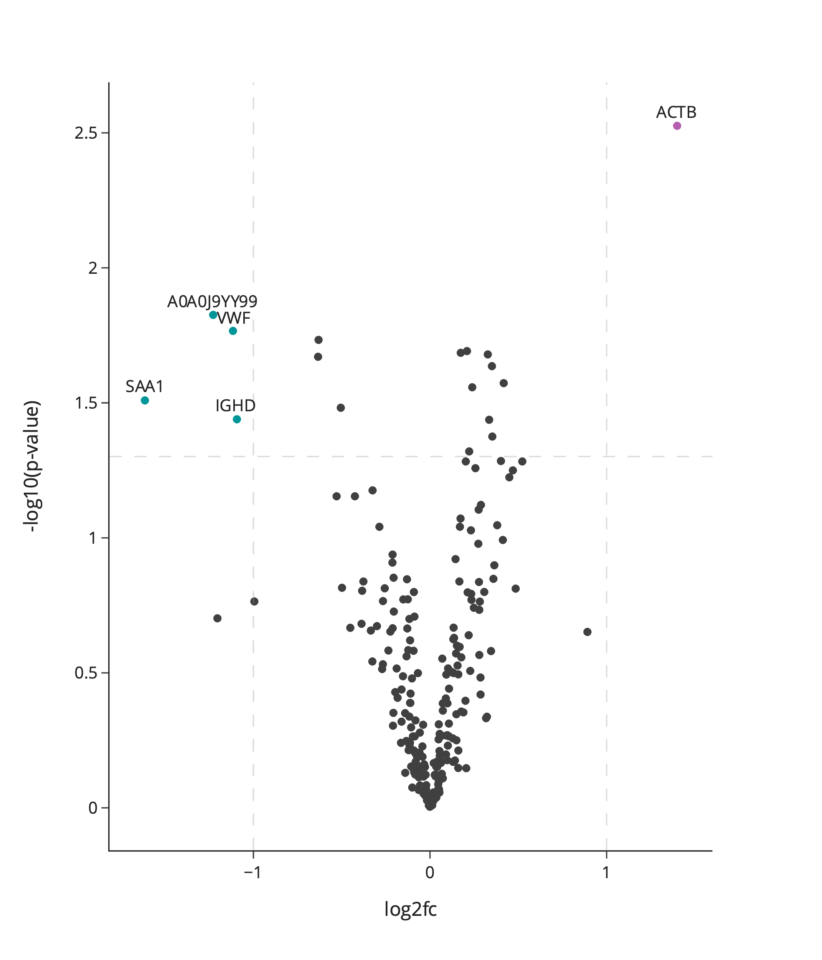
Figure 7 Volcano plot highlighting protein differences between Lyme neuroborreliosis (LNB) and controls in the plasma validation cohort. Each point represents a protein, the colour purple represents upregulated proteins with a log2 fold change (FC) larger than 1, the colour blue represents downregulated proteins with a log2 fold smaller larger than -1 and the colour grey represents proteins with a log2 fold change between -1 and 1 or non-significant proteins. X-axis depicts log2 fold change and y-axis depicts the log 10 adjusted p-value. Horizontal dashed lines represent the significance threshold after multiple hypothesis correction at p=0.05. Vertical dashed lines represent large log2 fold changes: above 1 or below -1.
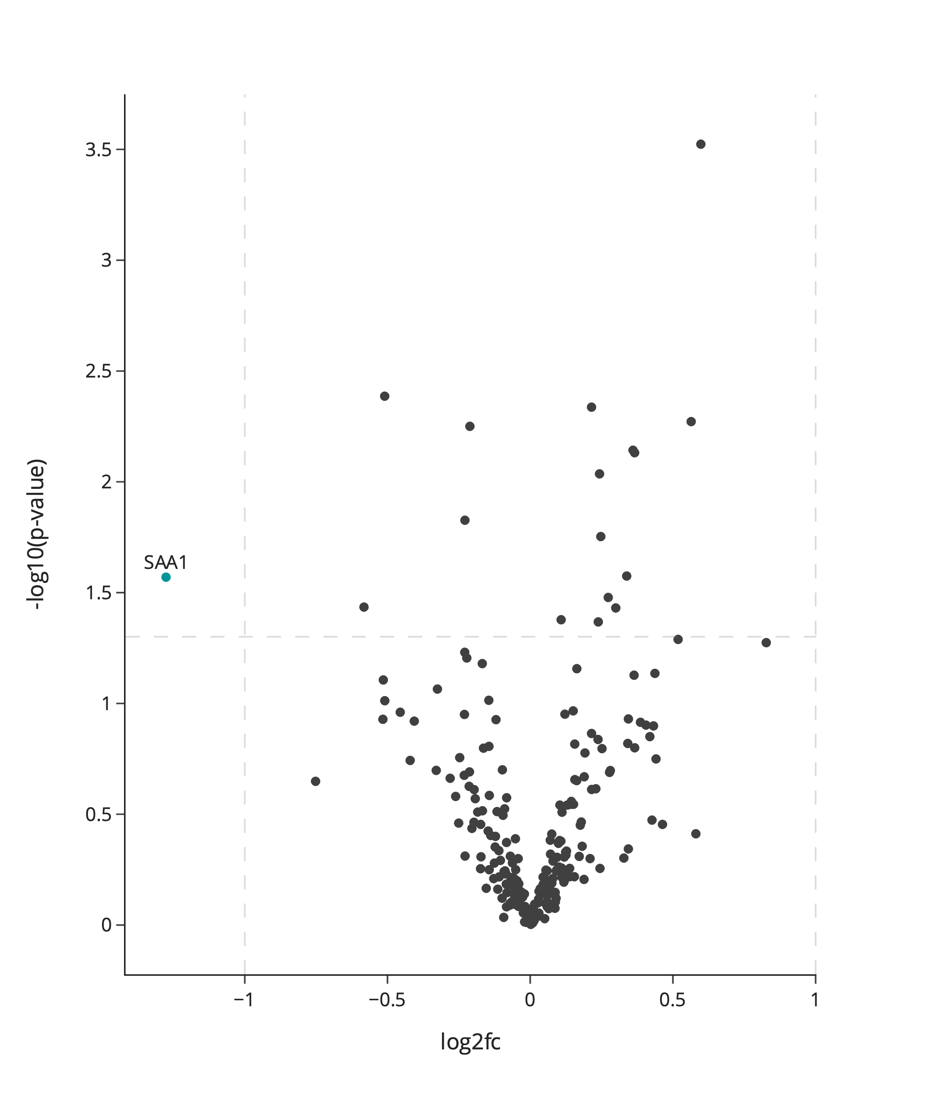
Figure 8 Volcano plot highlighting protein differences between Lyme neuroborreliosis (LNB) and viral meningitis (VM) the plasma validation cohort. Each point represents a protein, the colour purple represents upregulated proteins with a log2 fold change (FC) larger than 1, the colour blue represents downregulated proteins with a log2 fold smaller larger than -1 and the colour grey represents proteins with a log2 fold change between -1 and 1 or non-significant proteins. X-axis depicts log2 fold change and y-axis depicts the log 10 adjusted p-value. Horizontal dashed lines represent the significance threshold after multiple hypothesis correction at p=0.05. Vertical dashed lines represent large log2 fold changes: above 1 or below -1.
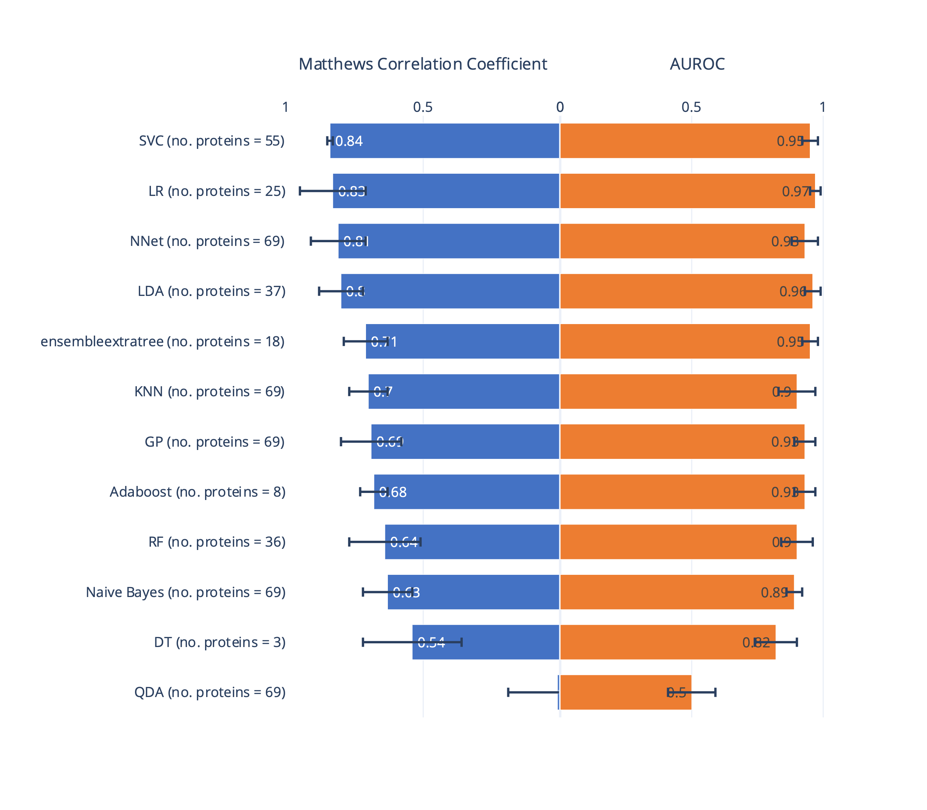
Figure 9 Output of the cross-validation grid search of algorithms, hyperparameters, and the number of proteins is displayed as the area under the receiver operating characteristic curve (AUROC) and Matthews Correlation Coefficient (MCC) from the predictions on the test sets. The model was trained to classify Lyme neuroborreliosis and controls. The number of proteins used in each model is shown to the right. The error bars represent the standard deviation across the 3-fold cross-validation runs.
Table 3 Overlap of significant proteins from the comparison of Lyme neuroborreliosis (LNB) to viral meningitis (VM) or controls in cerebrospinal fluid (CSF) and plasma. Significant differences in protein levels are represented by log(2) fold change. Non-signigicant findings are not included (missing values).
 | LNB compared to:
Gene Names | VM (CSF) | Control (CSF) | VM (plasma) | Control (plasma)
VTN | 0.03486 |  |  | -0.04154
HRG | 0.10060 |  | 0.07463
IGKV2-28 |  |  | -0.29411
CPB2 | 0.12280
CLEC3B | -0.05174 |  | 0.10654
C6 | -0.13418 |  |  | -0.07783
PROC |  | -0.19327 |  | 0.06601
F2 | -0.00860 |  | -0.01883
CD14 | 0.12670 |  |  | -0.12986
SELL | 0.04149
AHSG | -0.19228
SERPINA4 | 0.18069 |  |  | 0.00656
IGLC7 |  |  | -0.04297
TTR | 0.03729 |  | -0.06505
S100A9 |  | 0.84752
APOC3 |  | -0.00084 |  | 0.15146
GPLD1 | 0.03883 |  |  | -0.06731
IGKV1-5 |  |  |  | -0.21853
FETUB | 0.03901 |  | -0.16283
APOC1 | -0.05587 |  |  | 0.08117
ITIH4 | 0.10830 |  | 0.02824
FGG | 0.15930 |  |  | -0.12332
C9 | 0.17234 |  |  | 0.12583
SERPINA5 | -0.23208
KNG1 | -0.00931 |  | -0.03355
IGFALS | 0.09572
HPX | 0.04750
IGHV3-38 | 0.29536
C2 | 0.08790 |  |  | 0.02378
ATRN |  |  |  | -0.06195
IGKV1-27 | 0.10777 |  |  | -0.15922
KLKB1 | 0.10671 |  | 0.01229
IGHV1-18 |  |  |  | -0.13717
APCS | -0.15666 |  | -0.00795
CRP |  |  |  | 0.06933
IGHV3-15 |  |  | -0.22683
LUM |  |  |  | 0.01354
IGKV2-40 | 0.36117 |  | -0.20312
C4BPA | 0.33873 |  | 0.11014
APOD |  |  |  | 0.18827
C3 |  |  | 0.04487
S100A8 | -1.08517
IGHG4 | 0.20368 |  | -0.10122
FGB | 0.19970 |  |  | -0.06845
APOE | 0.11455 |  |  | 0.14129
RBP4 | 0.18832 |  |  | 0.12787
IGFBP6 | -0.21004 |  |  | 0.13004
IGKV1-16 | 0.44449 |  | -0.15719
APOA4 | -0.04396 |  |  | 0.05237
APOM | 0.11486 |  |  | -0.07277
ACTB | -0.16814
B2M | 0.11084 |  | 0.28193
IGKV3D-20 |  |  | -0.30725
PLG | -0.04959 |  | -0.07125
C1QC | 0.28355
C5 | 0.28369 |  | 0.05656
C1RL | -0.04385 |  |  | -0.04555
FGA | -0.04725
PFN1 | -0.41513
IGKV6-21 |  |  |  | -0.16605

