Extended Data Figures
Extended Data Figure 1. A. fumigatus A1163 Noncoding RNA candidates predicted by automated pipeline. A. Genomic position of lncRNA with respect to coding genes (lncRNA class). Novel lncRNA are predominantly intergenic (shown in blue, 60.7%), with only 39.3% being antisense (grey). B. Distribution of lncRNA length ranges between 207 bp and ~11.1 kb. Median lengths for intergenic and antisense lncRNA (indicated by dotted lines) are 0.9 kb and 1.4 kb, respectively. C. Intron number ranges between 0-9, with a median of 1 intron per lncRNA. D. Expression levels displayed as log2(mean TPM+1) of lncRNA in untreated samples ranges between 0 and ~1500 TPM. The majority (n=724, 61.4%) of lncRNA have TPM values below 5 (median TPM of 3.4 and 3.2 for intergenic and antisense, respectively).

Extended Data Figure 2. Volcano plot exhibiting condition-dependent fitness changes of lncRNA mutants. The changes in fitness, reflected by relative growth rate of the lncRNA knockouts, was investigated in four conditions, including firm media (4% agar, panel A), iron-starved conditions (panel B), oxide stress (2mM H₂O₂, Panel C) and elevated temperature (45ºC, panel D) in a high throughput screen. The growth of mutant in each condition was compared with their respective growth in standard condition AMM. The x-axis represents the normalised size change (Δ size) compared with the standard condition, and the y-axis represents the -log₁₀ p-value. LncRNAs with a significant change in expression (p< 0.05; |Δ size| >= 0.15) are shown as red dots (fitness impaired) or green dots (fitness gain).

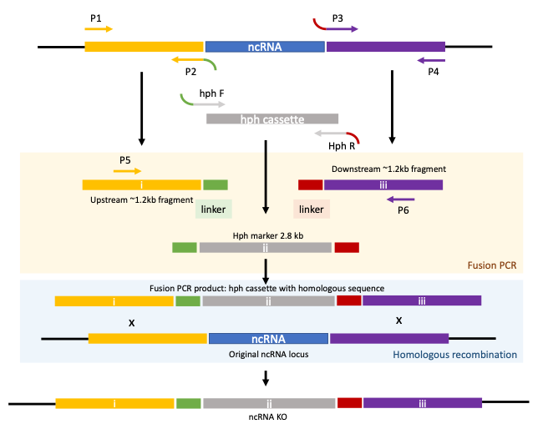
Extended Data Figure 3. Strategies used for the lncRNA deletions via fusion PCR and homologous recombination as previously described³⁹. Upstream and downstream fragments are amplified using the primers pairs P1 and P2 (upstream) and P3 and P4 (downstream). The selective marker cassette (hph) is amplified using hph F and hph R primers and pAN7-1 plasmid was used as template. Linkers sequences are incorporated into the P2 and P3 primers to promote fusion with the marker cassette. Using nested primers P5 and P6, the upstream and downstream fragments are fused to the hph selective cassette to create a linear fragment containing large homologous sequences to the upstream and downstream regions of the target lncRNAs. Following transformation and homologous recombination, the target lncRNA is replaced by the hph cassette.

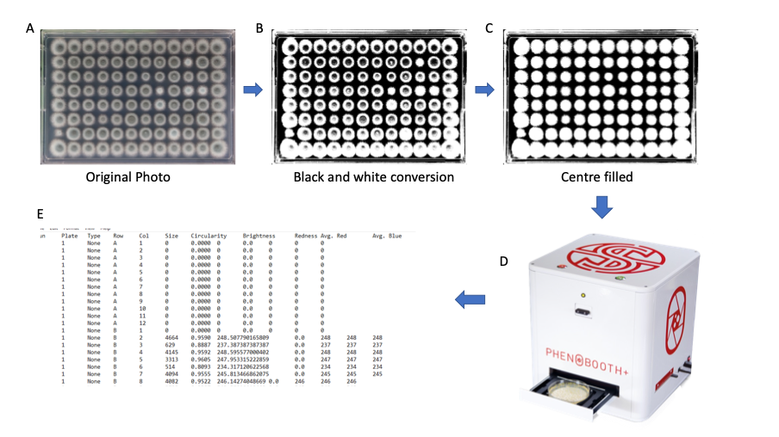Extended Data Figure 4. Schematic of experimental method used for data analysis of colony sizes. A picture of each plate was taken in the same position with consistent light source. The original photo (A) was adjusted to black and white using photo processing software (Corel PaintShop Pro 2018) to optimize the analysis (B). The unevenly colored center of each colony was then uniformly filled in white (C) to improve the accuracy of the calculation of the colony size by the Phenobooth (Singer Instruments Ltd.) (D). The resulting colony size outputs (E) were used to calculate the relative fitness of each ncRNA KO.

Extended Data Figure 5. There is significant co-expression observed between siderophore genes and co-localized lncRNA and similar correlation is not found between the lncRNA and other nearby genes. A. Three lncRNA (AFUBlnc_1915.28, AFUBlnc_1918.8 and AFUBlnc_1917.17) co-localise with sidA and displayed significant co-expression with this gene (p < 0.001). Of these co-localized lncRNA, AFUBlnc_1917.17 displays the highest correlated expression (log fold change) with sidA (R² > 0.5). B. AFUBlnc_1917.17 displays considerably lower correlation (R² < 0.5) with the next two closest genes, AFUB_023710 and AFUB_023730. In addition, the log fold change values of these genes are low (below 1). C. AFUBlnc_3085.15 displays no significant correlation with the next two closest genes outside of the sidG cluster, AFUB_044460 and AFUB_044510.

Supplementary text

LncRNAs display coordinated expression with neighbouring protein coding genes

The ability of lncRNA to play a role in azole response led us to identify further candidates that may be involved in azole susceptibility or resistance. To do this, we mapped data from an RNA-seq experiment which exposed strain A1163 to itraconazole at five MIC’s (0.25, 0.5, 1, 2 and 4) to our newly generated transcriptome. Differential expression (DE) analysis was then performed in comparison to a no drug control. A total of 2,746 PCGs and 245 lncRNAs (intergenic=130, antisense=115), were found to have a significant response to itraconazole in at least one concentration (Fig. 2G). Clustering was performed to identify lncRNA’s that have similar or opposing expression patterns with PCG’s across dosage. Using a hierarchical k-means clustering approach we were able to generate 15 distinct groups that had parallel expression patterns (Fig. 2-I).

Using our clustering results, we were able to elucidate groups of PCGs and lncRNAs that are found to be localised within 5 kb of the genome and that have either a coordinated or divergent pattern of expression. We found 1,485 lncRNA-PCG pairs of neighbouring loci, with the majority of lncRNA found to be upstream (n=1,043) of a PCG (Supplementary table 10). Of these neighbours, 46 lncRNA-PCG pairs were found to be within the same cluster, indicating coordinated expression, whereas 16 were found to be inversely clustered, indicating divergent expression. Enrichment analysis found that there were no significantly over-represented ontologies in lncRNA-PCG pairs that share either similar or opposing expression profiles. Within the 46 pairs that exhibited a similar expression profile as their neighbouring lncRNA. We performed the same analysis on differentially expressed antisense lncRNA and their “sense” PCGs (Supplementary table 11). Within this study we identified a total of 492 sense/antisense (S/AS) pairs, of these we found 48 lncRNA that are antisense to two PCGs and 3 that are antisense to three PCGs. A total of 14 S/AS pairs were clustered together and 6 were inversely clustered. Once again, neither of these pair sets were functionally enriched.

To understand whether these coordinated responses are due to the same regulatory elements controlling these loci we overlayed the binding sites of transcription factors from several studies. We found a total of 545 lncRNAs that have a transcription factor binding site within 200 bp upstream from their locus, from this we found 51 that do not have an adjacent PCG and 11 of these were found to be DE in response to itraconazole.
Cluster analysis found that three genes - hapB, sidA and sidG - had similar or opposing expression patterns to their corresponding lncRNA (see Supplementary Tables 7, 10 and 11). The CCAAT-binding complex (CBC) subunit, HapB, has an upstream bidirectional lncRNA (AFUBlnc_2633.12) found to have an opposing expression pattern in response to itraconazole. The expression pattern of this lncRNA and its co-expression with hapB is distinct to the response to itraconazole, and not observed for other antifungal drugs (Supplementary table 5).
The L-orthinine N5-oxygenase, SidA, is responsible for the first step in siderophore biosynthesis. The sidA gene is surrounded by lncRNA, with one downstream (AFUBlnc_1915.28) and two upstream lncRNA (AFUBlnc_1917.17 and AFUBlnc_1918.8) (Fig. 3A). Although only the upstream bidirectional AFUBlnc_1917.17 was classified in the same cluster as sidA (Supplementary Table 10, cluster 7), all three lncRNA near sidA displayed co-down expression dose response patterns upon itraconazole treatment (Fig. 3B). The lncRNA AFUBlnc_1917.17 was found to have a similar down expression pattern in response to all drugs excluding hygromycin, with all other drug responses identified in cluster 5 or 12 (Fig. 2J). Similar to the observation with itraconazole, AFUBlnc_1917.17 and other neighbouring lncRNA also displayed similar expression patterns to sidA in these drug datasets. There was significant correlation between sidA and AFUBlnc_1917.17 log fold change values from all drug datasets excluding hygromycin (R² = 0.7, p = 2.2e-07) (Fig. 3C and Extended Data Figure 5A). There was also significant correlation between the other nearby lncRNAs and sidA LFC values, albeit with less apparent co-expression patterns (R² = 0.46, p = 0.0001 and R² = 0.43, p = 0.0002 for AFUBlnc_1915.28 and AFUBlnc_1918.8, respectively) (Extended Data Figure 5A). No significant correlation was found between AFUBlnc_1917.17 and the next two flanking genes (AFUB_023710 and AFUB_023730) (Extended Data Figure 5B).
The fusarinine C acetyltransferase gene, sidG is located within one of the siderophore gene clusters which also includes mirB, estB and an ABC transporter (AFUB_044470)⁵⁷.The lncRNA AFUBlnc_3085.15 is also within this gene cluster and is antisense to both sidG and estB (Fig. 3D). As well as sidG, earlier cluster analysis identified that AFUBlnc_3085.15 also displayed similar itraconazole response pattern to mirB and the ABC transporter (all found in cluster 7) (Fig. 3E). Notably, AFUBlnc_3085.15 does not display correlated expression with nearby genes which are outside of the SidG cluster (AFUB_044460 and AFUB_044510) (Extended Data Figure 5C). When assessing the expression pattern of this lncRNA in other datasets, it was found to be down expressed in response to all drugs excluding hygromycin, with all other drug responses identified in either cluster 5 or 12 (Fig. 2J). As found with itraconazole, the lncRNA displayed a strikingly similar co-expression pattern to all the genes in the sidG cluster in response to simvastatin (Fig. 3E). Combining the data from all drug treatments excluding hygromycin demonstrated strong correlation between the LFC values of the lncRNA and each gene (Fig. 3F). Notably, the strongest correlation in LFC values was observed for the lncRNA with mirB and sidG (R² = 0.96, p = 3.3e-18 and R² = 0.93, p = 5.1e-15, respectively). Therefore, the novel lncRNA antisense to sidG and estB displays significant co-expression with all the genes in this siderophore-associated gene cluster.

Cyp51A is a sterol C14-demethylase and is the target of the azole antifungals. As a result, its mutation is a significant contributor to azole resistance. There are two lncRNAs found within the promoter region of Cyp51A and are hence named Cyp51A-promoter lncRNA (CPL) for the lncRNA transcribed in sense to cyp51A (AFUBlnc_4669.11) and antiCPL for the lncRNA described in the opposite direction (AFUBlnc_4670.4) (Fig. 3G). CPL covers all known regulatory binding motifs in the promoter, including the CCAAT-binding complex (CBC), HapX, SrbA¹⁹, AtrR⁵⁸ and NctA/B²⁷. AntiCPL is shorter than CPL and contained entirely within it, and notably excludes the significant regulatory section near the TR34 region. In untreated culture, CPL and antiCPL are expressed at above median lncRNA levels (3.3 TPM), 28.6 and 11.7 TPM, respectively. An example of the transcriptional profile of Cyp51A and its upstream lncRNAs is shown in Fig. 73H. Transcription from the lncRNA locus upstream of Cyp51A was validated using qRT-PCR (Fig. 3J). In response to itraconazole, CPL is significantly differentially expressed with a LFC of 1.7 at 4-fold MIC. Clustering of gene and lncRNA responses upon itraconazole treatment did not identify correlated expression between either lncRNA and Cyp51A. When assessing the behaviour of the lncRNAs and Cyp51A in the other drug datasets, it is apparent that CPL was consistently upregulated in response to drug treatment and showed distinct dose response expression patterns to Cyp51A (Fig. 3I). However, an experimental attempt to over express the lncRNAs in trans (via a plasmid) had no apparent influence on Cyp51A expression levels or azole resistance (not shown).

