Figure S1. GastroCap probeset design. The total nucleotide space allocated per virus included in the probe design is shown in the segments. From the innermost to the outermost layers the arrangement progresses from viral families to genera and species.

Figure S2. Raw read statistics and superkingdom read fractions for the metagenomic (A) and capture (B) sequence dataset.. In each section, the upper plots depict the number of reads per sample (raw and after deduplication + quality control steps). The lower plots display relative read abundances per sample at superkingdom level. Each facet represents samples sequenced within a specific batch (1-7).

Figure S3. PCA clustering of the urban wastewater compositions from 63 cities, depicting metagenomic (blue) and capture samples (red) at the taxonomic superkingdom level. The principal components were derived from read counts subjected to a CLR transformation.

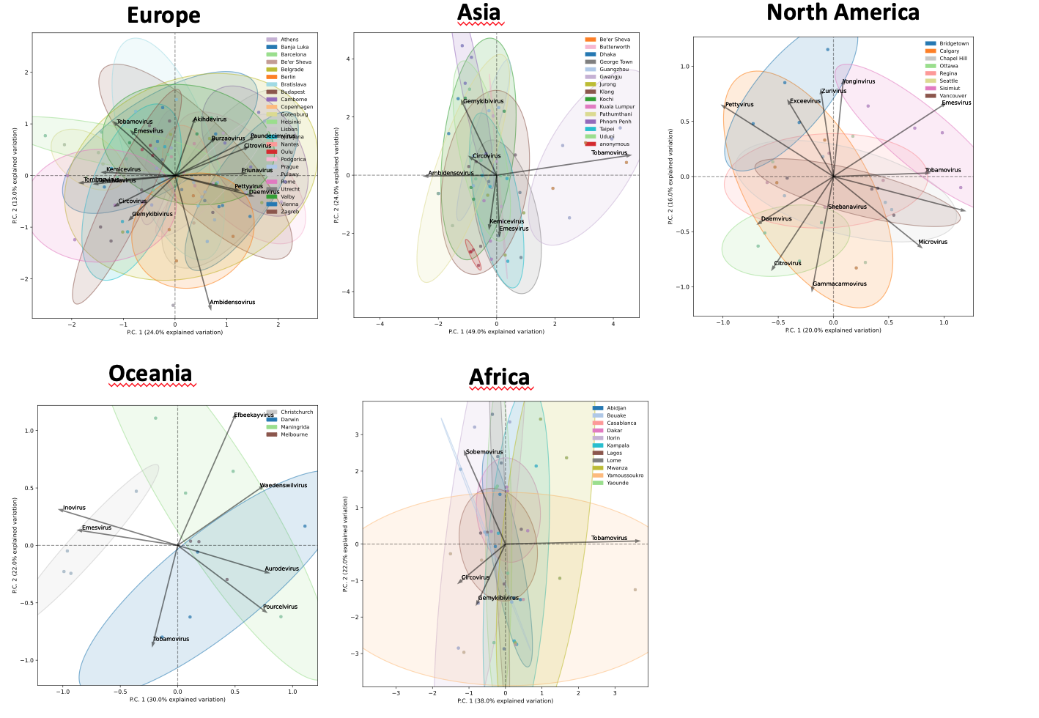
Figure S4. PCA clustering of the urban wastewater virome compositions from 63 cities of the metagenomic sequence dataset colored per city
Principal Component Analysis (PCA) clustering for the biannual wastewater samples of the metagenomic dataset faceted per continent and colored per city on genus level. Principal components were generated using principal components computed from genome size-adjusted counts that underwent a centered log-ratio (CLR) transformation.

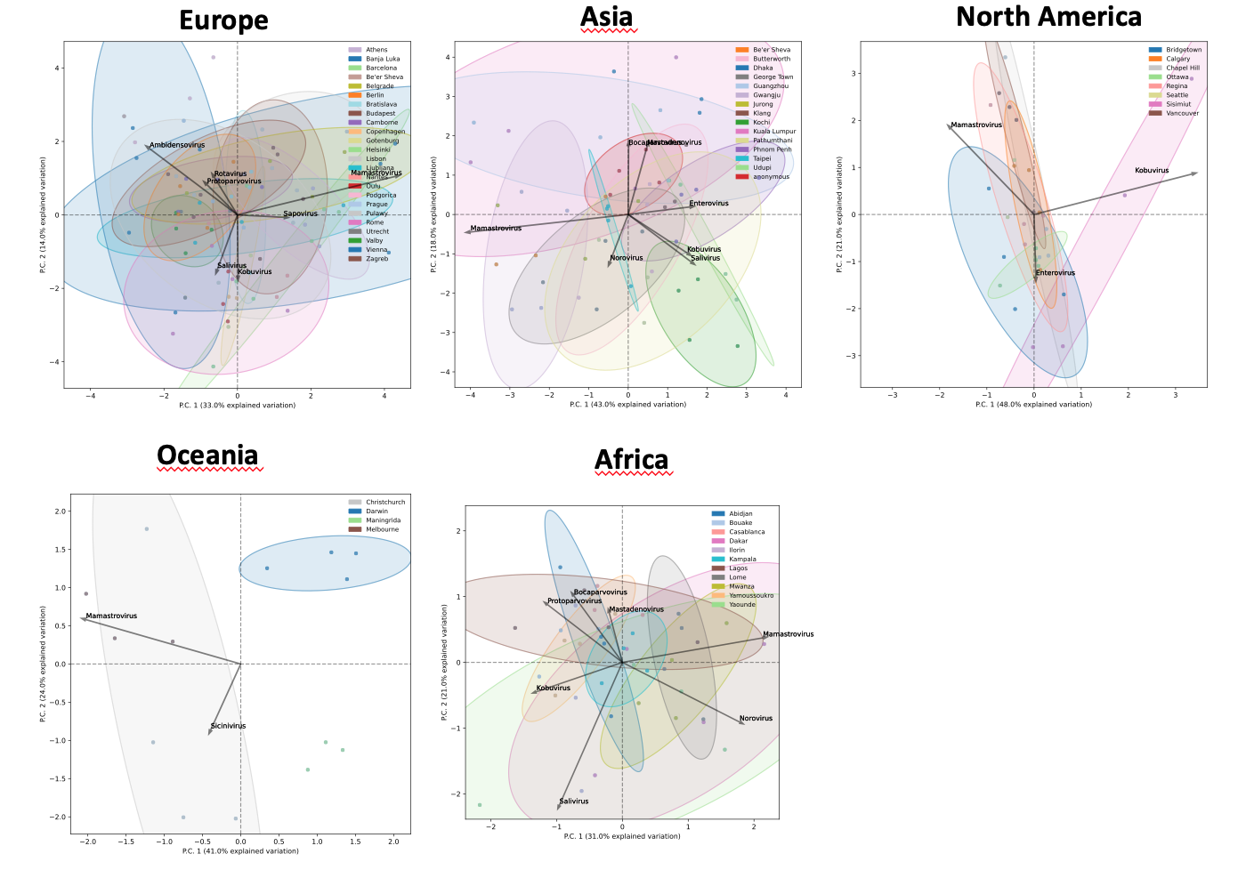
Figure S5: PCA clustering of the urban wastewater virome compositions from 63 cities of the capture sequence dataset colored per city
Principal Component Analysis (PCA) clustering for the biannual wastewater samples of the capture sequence dataset faceted per continent and colored per city on genus level. Principal components were generated using principal components computed from genome size-adjusted counts that underwent a centered log-ratio (CLR) transformation.

Figure S6 Maximum likelihood phylogenetic tree of Human astrovirus type 1-8 based on partial ORF2 gene (capsid) sequences. Sequences obtained from NCBI are indicated in colored squares, while sequences derived from wastewater with a minimum length of 500 bp are denoted in colored dots. Bootstrap values >70 are shown.

