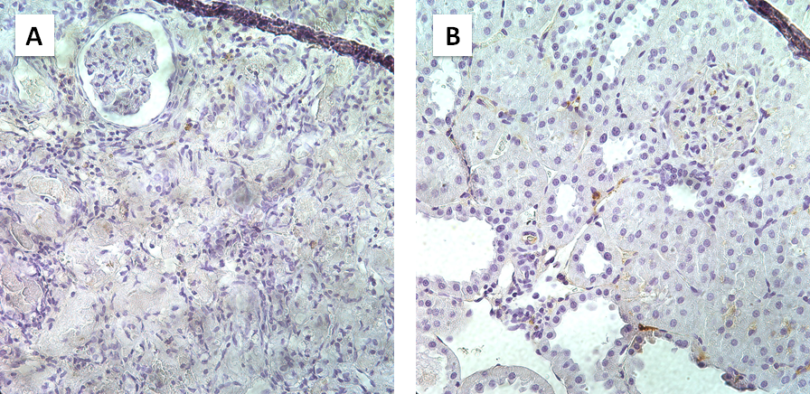

Additional figure 1. Immunohistochemistry for anti-human nucleoli antigen antibody. Immunohistochemistry for anti-human nucleoli antigen antibody, showing no positive staining for the hiPSC group (A) and the RPC group (B).

