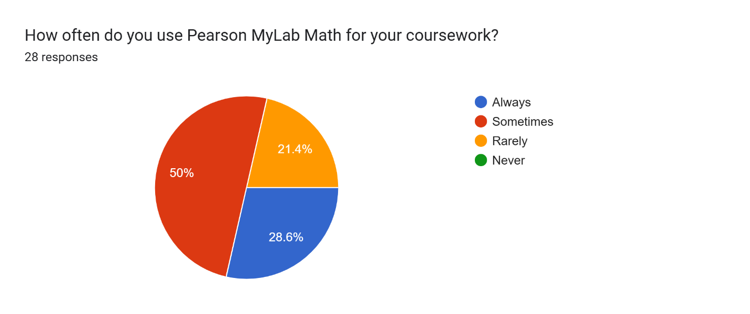
Chart 1. Students’ Use of MyLab Math

Chart 2. Students’ Rating of the Platform Testing
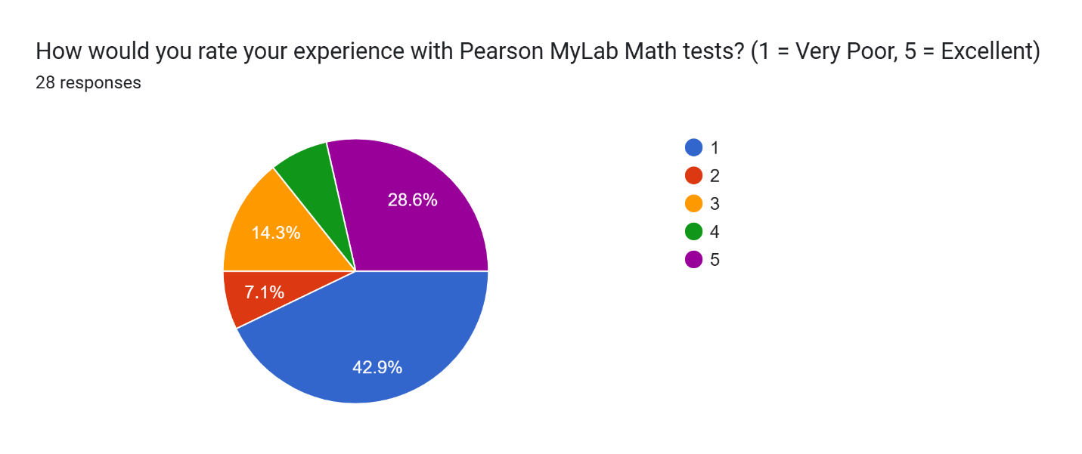
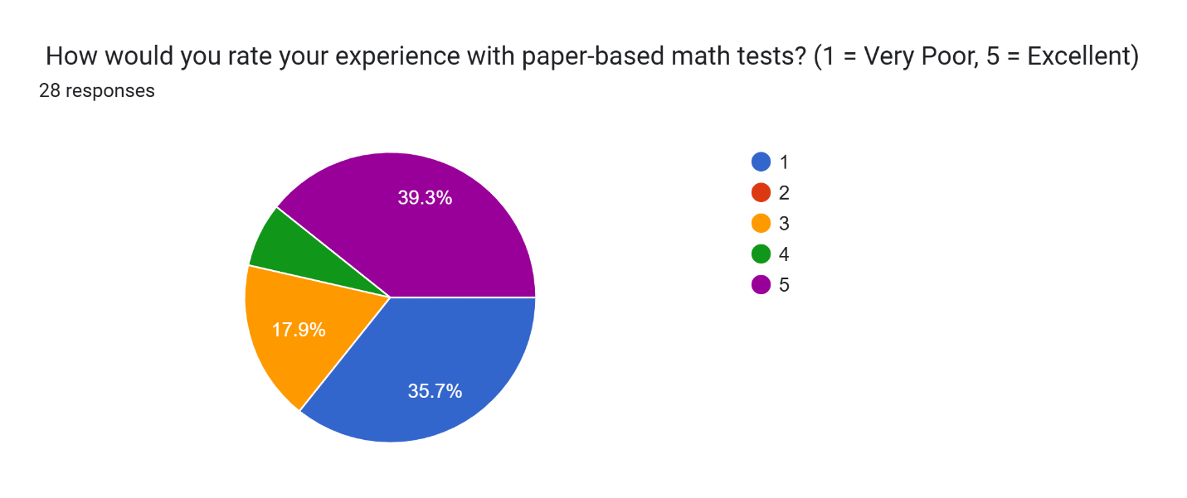
Chart 3. Students’ Rating of the Paper-based Testing

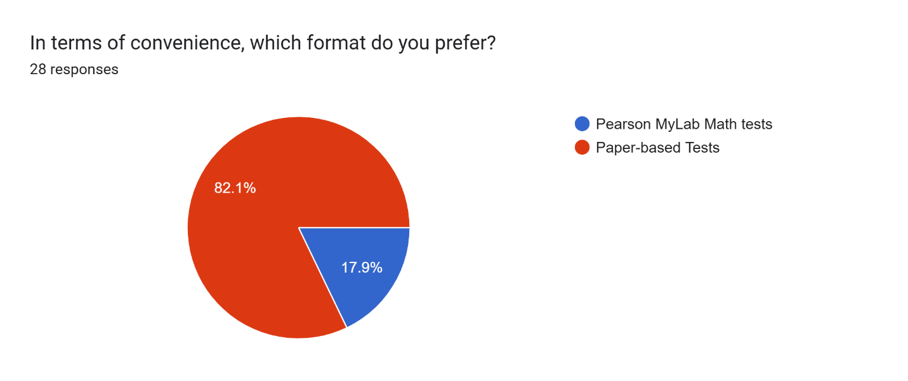
Chart 4. Students’ Rating of Convenience

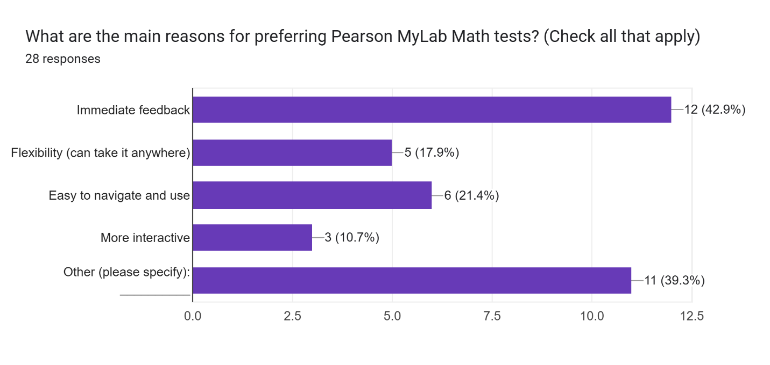
Chart 5. Platform-based Testing Preference

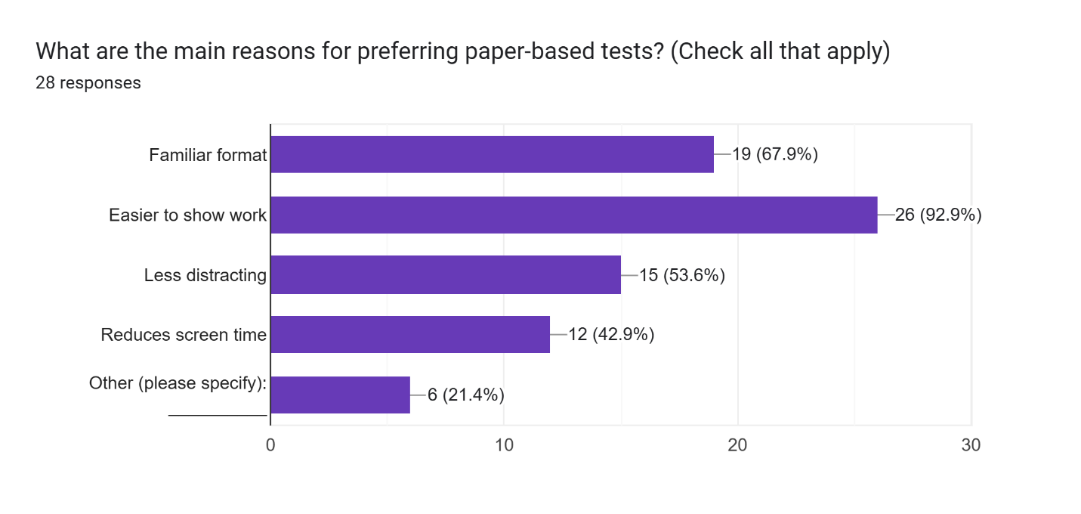
Chart 6. Paper-based Testing Preference

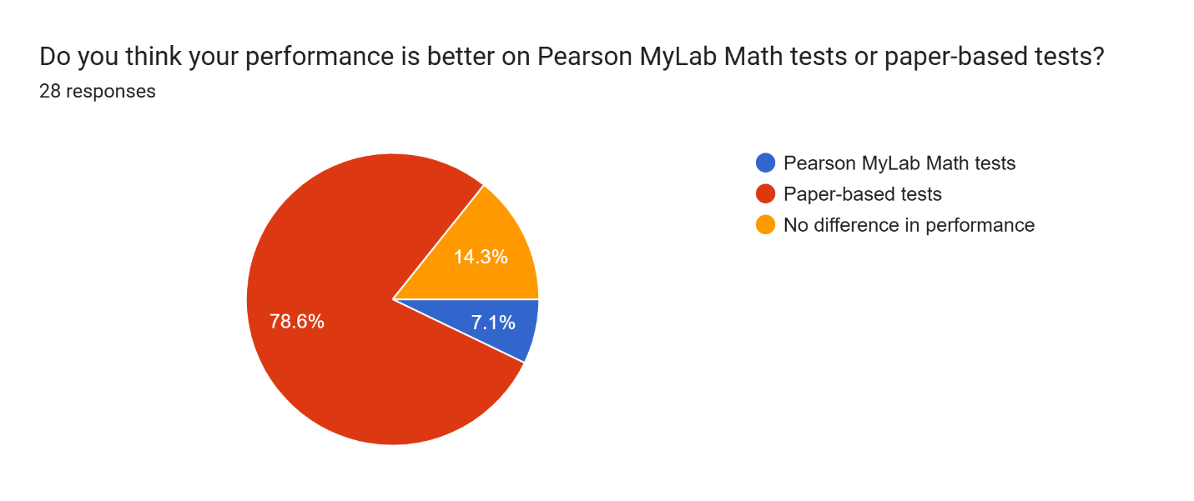
Chart 7.Test Performance

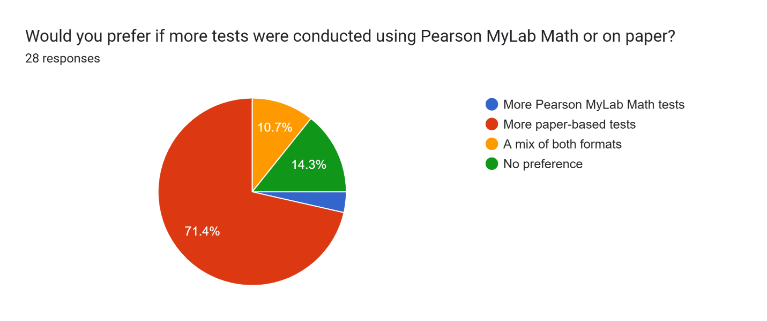
Chart 8. Students Testing Preference

Chart 9. MyLab Math Usage Frequency

Chart 10. Reported Session Duration

Chart 11. Engagements Rating Data

Chart 12. Students’ Motivation Levels

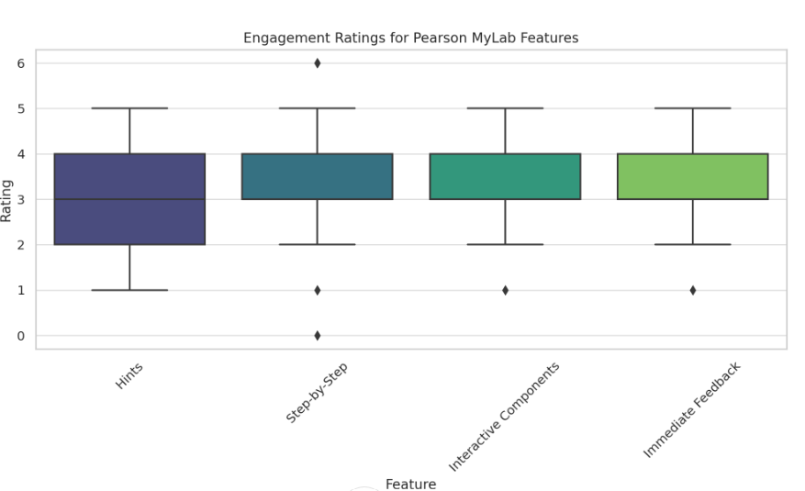
Chart 13. Effectiveness of Features

Chart 14. Engagement Aspects of Pearson MyLab Math

Chart 15. Disengagement Aspects of Pearson MyLab Math

