Table of Contents
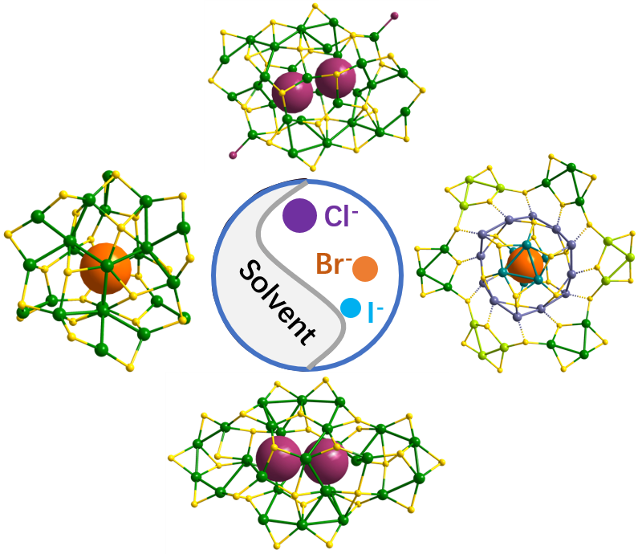
This study focuses on the synthesis of silver sulfide nanoclusters via the halide ion template method, with an in - depth exploration of the underlying synthesis mechanism. By meticulously regulating halogen ion concentration, reaction solvent, and other reaction parameters, a diverse array of nanoclusters with distinct structures has been successfully fabricated and characterized at the atomic - precision level using X-ray single crystal diffraction.

