Supporting information for
Halide Ion-Templated Atomic Precision Synthesis and Structural Modulation of Silver Sulfide Nanoclusters
Juefei Dai,‡ª Chuanhua Shi,‡ª Zhixun Zhang,‡ª Yan Nong,ª Chenchen Feng,ª Xianyong Yu,^{b} Chao Yang,ª Xueji Zhang*ª & Huayan Yang*ª

ªShenzhen Key Laboratory of Nano-Biosensing Technology，Shenzhen University Medical School，Shenzhen University，Shenzhen 518060, China,
^{b}Key Laboratory of Theoretical Organic Chemistry and Functional Molecules, Ministry of Education, Hunan University of Science and Technology, Xiangtan 411100, China,

‡These authors contributed to this work equally.
Corresponding authors: E-mail addresses: yanghuayan@szu.edu.cn (Prof. Huayan Yang); zhangxueji@szu.edu.cn (Professor Xueji Zhang)
Experimental Details
Reagents: Silver nitrate (AgNO₃, 99%), Purchase from Xilong Scientific; 4-tert-Butylbenzenethiol (HSC₆H₄^{t}Bu, 97%), Tetramethylammonium Bromide (NMe₄Br, 98%), Tetramethyl Ammonium Chloride (NMe₄Cl, 98%), Tetrabutylammonium Chloride (NEt₄Cl, 99%), Tetrabutylammonium Bromide (NEt₄Br, 98%) purchase from Adamas Pharmaceuticals, Inc; deionized water (H₂O, homemade); All reagents without further processing, use directly.
Instruments: The X-ray single crystal diffractometer used was Brooke D8 VENTURE X-ray single crystal diffractometer.

Synthesis of AgSC₆H₄^{t}Bu: Weigh 4 g AgNO₃ in a 250 mL flask and add 100 mL of water to dissolve. A 20 mL ethanol solution of 3.93 g HSC₆H₄^{t}Bu was added to the silver nitrate solution with rapid stirring under nitrogen atmosphere. to the silver nitrate solution under rapid stirring, and immediately precipitated a large amount of yellow solid. Filter and rinse three times with water, ethanol and ether. The white solid was dried under vacuum overnight, and then crushed in a fume hood. Crushed in a fume hood. 5.78 g AgSC₆H₄tBu powder was obtained with 90% yield.
Synthesis of [Br₂@[Ag₂₈(SC₆H₄^{t}Bu)₂₈(Br)₂]: In a clean 10 mL screw-necked bottle, 20 mg of AgSC₆H₄^{t}Bu and 15 mg of NMe₄Br were weighed accurately, and acetonitrile (5 mL) with the addition of deionized water (80 μL) were added. The resulting solution was magnetically stirred at ambient temperature (25°C) for 30 minutes under atmospheric conditions, followed by thermal treatment in a preheated oven maintained at 60°C for 24 hours. Solid-liquid separation of the yellow solution and the white solid in the glass vials was then carried out using a filtering device with appropriate filtration precision (e.g. filter paper with appropriate pore size and a Brinell funnel). The filtrate was collected, transferred to a clean, light-proof container and stored at room temperature in a dark place with stable environmental conditions to allow it to slowly evaporate and crystallize. After 3 weeks, yellow block crystals were precipitated.
Synthesis of [Cl@Ag₃₆(SC₆H₄^{t}Bu)₃₆]: In a clean 10 mL screw-necked bottle, 20 mg of AgSC₆H₄^{t}Bu and 5 mg of NMe₄Cl were weighed accurately, and acetonitrile (5 mL) with the addition of deionized water (80 μL) were added. The resulting solution was magnetically stirred at ambient temperature (25°C) for 30 minutes under atmospheric conditions, followed by thermal treatment in a preheated oven maintained at 60°C for 24 hours. Solid-liquid separation of the yellow solution and the white solid in the glass vials was then carried out using a filtering device with appropriate filtration precision (e.g. filter paper with appropriate pore size and a Brinell funnel). The filtrate was collected, transferred to a clean, light-proof container and stored at room temperature in a dark place with stable environmental conditions to allow it to slowly evaporate and crystallize. After 3 weeks, yellow block crystals were precipitated.
Synthesis of [Br₂@Ag₂₈(SC₆H₄^{t}Bu)₃₀]: In a clean 10 mL screw-necked bottle, 20 mg of AgSC₆H₄^{t}Bu and 15 mg of NMe₄Br were weighed accurately, and acetonitrile: acetone =2:1 (6 mL) with the addition of deionized water (100 μL) were added. The resulting solution was magnetically stirred at ambient temperature (25°C) for 30 minutes under atmospheric conditions, followed by thermal treatment in a preheated oven maintained at 60°C for 24 hours. Solid-liquid separation of the yellow solution and the white solid in the glass vials was then carried out using a filtering device with appropriate filtration precision (e.g. filter paper with appropriate pore size and a Brinell funnel). The filtrate was collected, transferred to a clean, light-proof container and stored at room temperature in a dark place with stable environmental conditions to allow it to slowly evaporate and crystallize. After 1-week, yellow rod-shaped crystals were precipitated.
Synthesis of [Cl₂@Ag₂₈(SC₆H₄^{t}Bu)₃₀]: In a clean 10 mL screw-necked bottle, 20 mg of AgSC₆H₄^{t}Bu and 15 mg of NMe₄Cl were weighed accurately, and acetonitrile: acetone =2:1 (6 mL) with the addition of deionized water (100 μL) were added. The resulting solution was magnetically stirred at ambient temperature (25°C) for 30 minutes under atmospheric conditions, followed by thermal treatment in a preheated oven maintained at 60°C for 24 hours. Solid-liquid separation of the yellow solution and the white solid in the glass vials was then carried out using a filtering device with appropriate filtration precision (e.g. filter paper with appropriate pore size and a Brinell funnel). The filtrate was collected, transferred to a clean, light-proof container and stored at room temperature in a dark place with stable environmental conditions to allow it to slowly evaporate and crystallize. After 1-week, yellow rod-shaped crystals were precipitated.
Synthesis of [Ag₂₃(SC₆H₄^{t}Bu)₂₆] ·3(NBu₄): In a clean 10 mL screw-necked bottle, 20 mg of AgSC₆H₄^{t}Bu and 5 mg of NBu₄Cl were weighed accurately, and acetone (5 mL) with the addition of deionized water (80 μL) were added. The resulting solution was magnetically stirred at ambient temperature (25°C) for 30 minutes under atmospheric conditions, followed by thermal treatment in a preheated oven maintained at 60°C for 24 hours. Solid-liquid separation of the yellow solution and the white solid in the glass vials was then carried out using a filtering device with appropriate filtration precision (e.g. filter paper with appropriate pore size and a Brinell funnel). The filtrate was collected, transferred to a clean, light-proof container and stored at room temperature in a dark place with stable environmental conditions to allow it to slowly evaporate and crystallize. After 1-week, yellow rod-shaped crystals were precipitated.
Synthesis of [Cl@Ag₂₃(SC₆H₄^{t}Bu)₂₄] ·(NBu₄): In a clean 10 mL screw-necked bottle, 20 mg of AgSC₆H₄^{t}Bu and 15 mg of NBu₄Cl were weighed accurately, and acetone (5 mL) with the addition of deionized water (80 μL) were added. The resulting solution was magnetically stirred at ambient temperature (25°C) for 30 minutes under atmospheric conditions, followed by thermal treatment in a preheated oven maintained at 60°C for 24 hours. Solid-liquid separation of the yellow solution and the white solid in the glass vials was then carried out using a filtering device with appropriate filtration precision (e.g. filter paper with appropriate pore size and a Brinell funnel). The filtrate was collected, transferred to a clean, light-proof container and stored at room temperature in a dark place with stable environmental conditions to allow it to slowly evaporate and crystallize. After 1-week, yellow block crystals were precipitated.

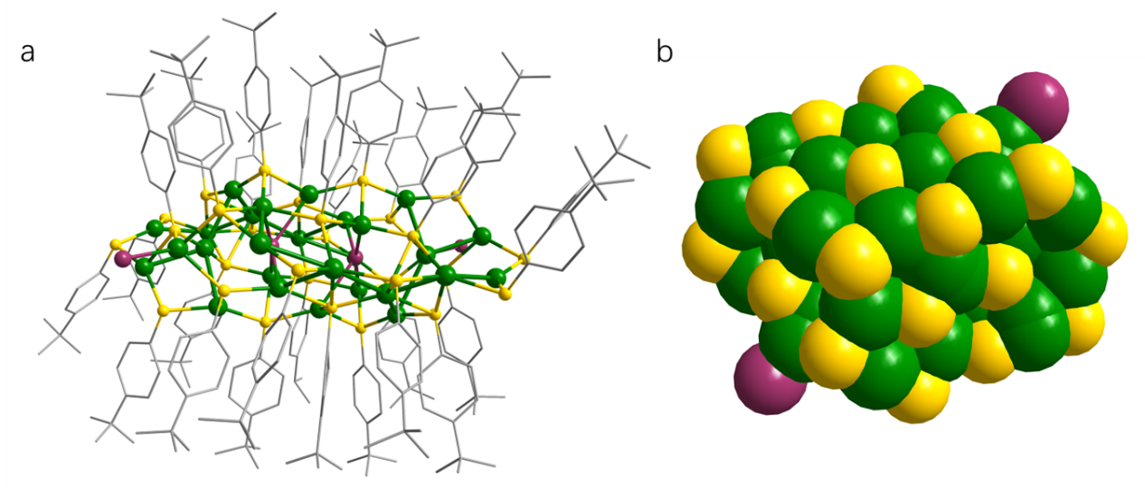
Fig.S1 The standard and Space-Filling model of the crystal structure of Br₂@Ag₂₈Br₂. Color code: green, Ag; yellow, S; gray, C; plum, Br

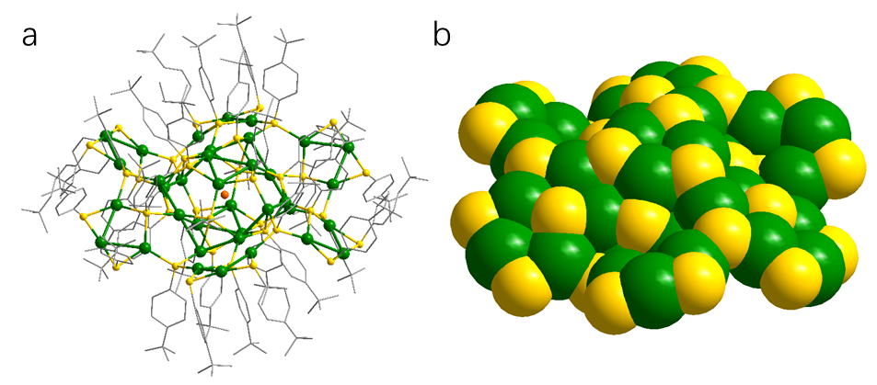
Fig.S2 The standard and Space-Filling model of the crystal structure of Cl@Ag₃₆. Color code: green, Ag; yellow, S; gray, C; orange, Cl
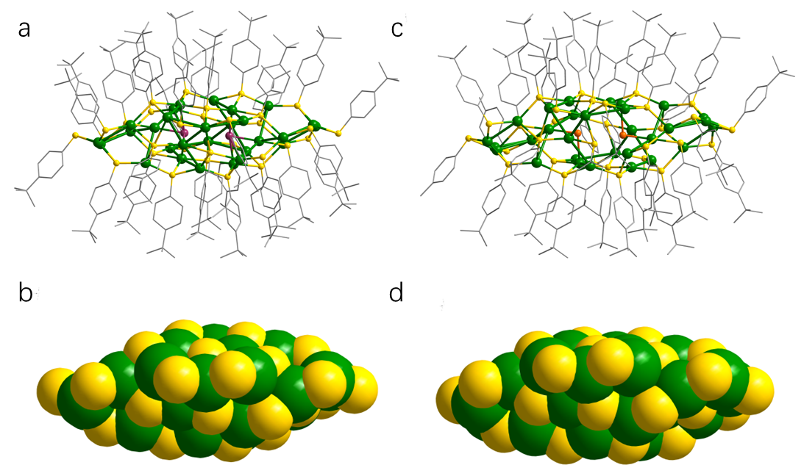Fig.S3 （a, b）The standard and Space-Filling model of the crystal structure of Br₂@Ag₂₈; (c, d) The standard and Space-Filling model of the crystal structure of Cl₂@Ag₂₈. Color code: green, Ag; yellow, S; gray, C; plum, Br; orange, Cl

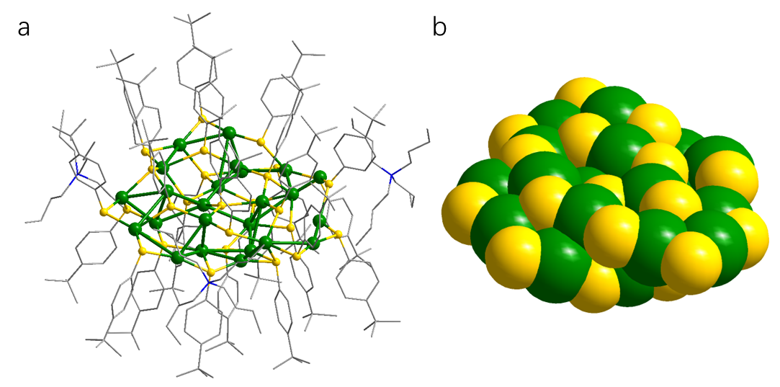
Fig.S4 The standard and Space-Filling model of the crystal structure of Ag₂₃. Color code: green, Ag; yellow, S; gray, C; blue, N

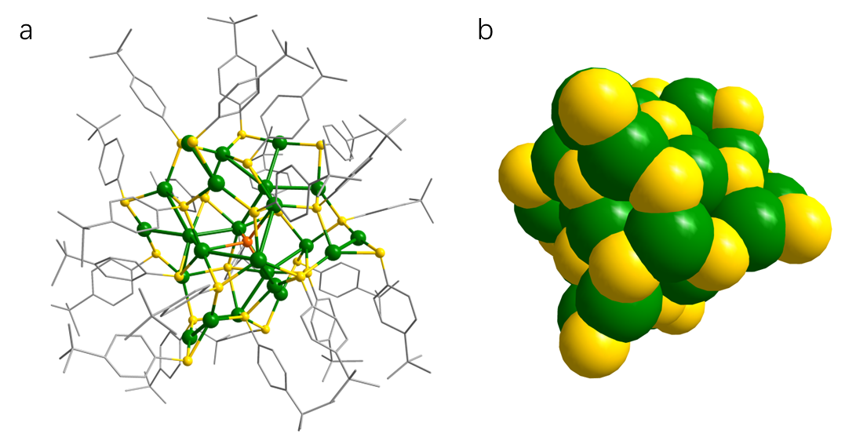
Fig.S5 The standard and Space-Filling model of the crystal structure of Cl@Ag₂₃. Color code: green, Ag; yellow, S; gray, C; orange, Cl

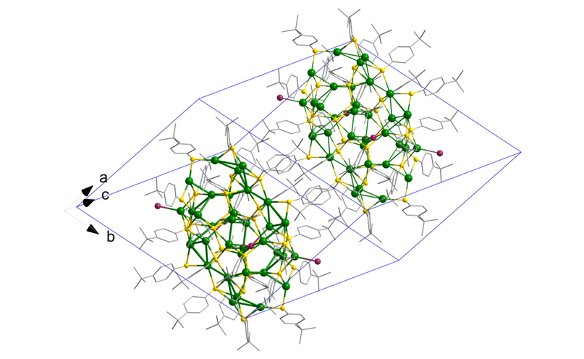
Fig.S6 The crystal packing diagrams in one unit cell of Br₂@Ag₂₈Br₂ viewed along.
Color code: green, Ag; yellow, S; gray, C; plum, Br
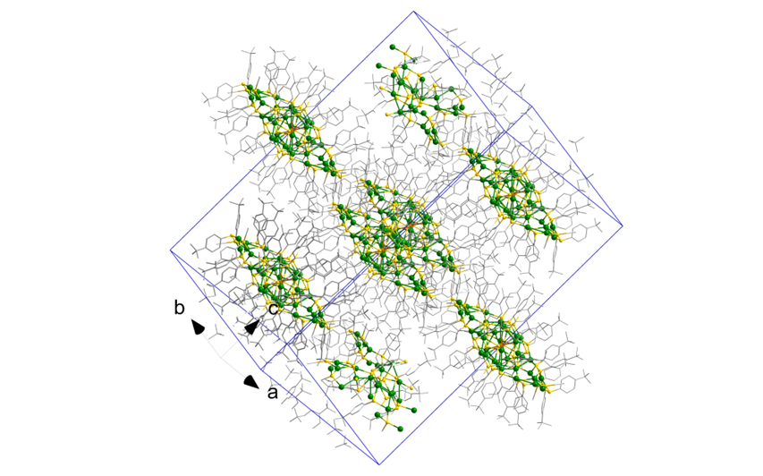
Fig.S7 The crystal packing diagrams in one unit cell of Cl@Ag₃₆ viewed along.
Color code: green, Ag; yellow, S; gray, C; orange, Cl

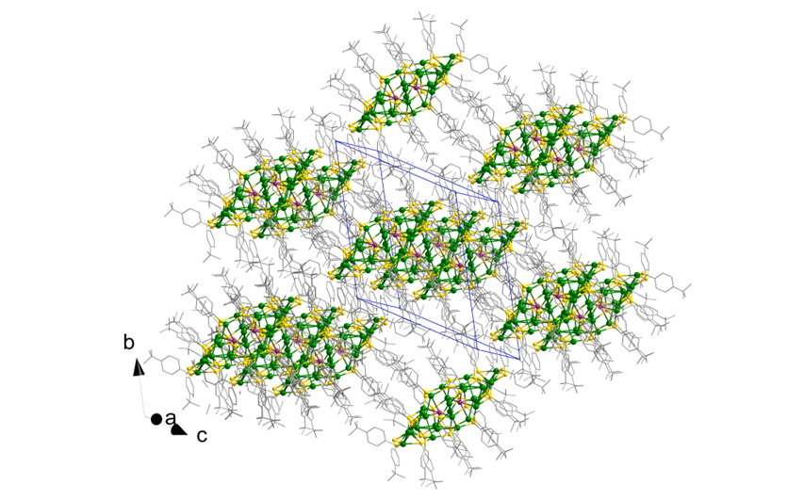
Fig.S8 The crystal packing diagrams in one unit cell of Br₂@Ag₂₈ viewed along.
Color code: green, Ag; yellow, S; gray, C; orange, Br

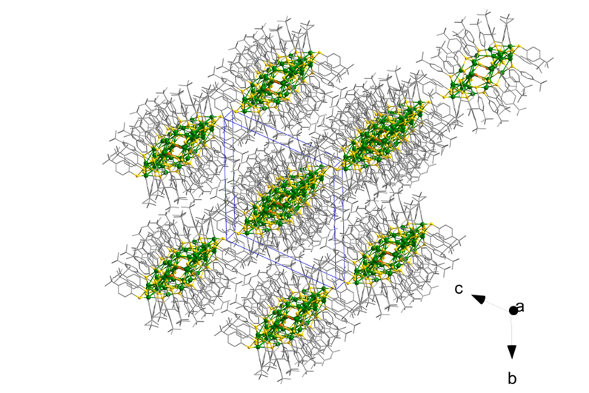
Fig.S9 The crystal packing diagrams in one unit cell of Cl₂@Ag₂₈ viewed along.
Color code: green, Ag; yellow, S; gray, C; orange, Cl

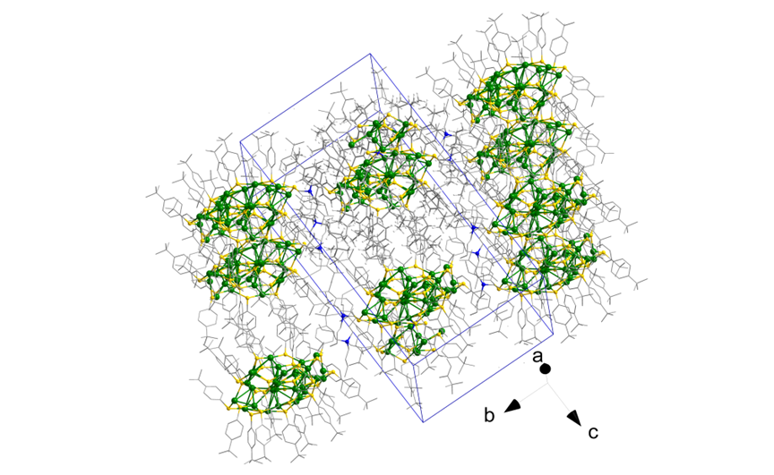
Fig.S10 The crystal packing diagrams in one unit cell of Ag₂₃ viewed along.
Color code: green, Ag; yellow, S; gray, C; blue, N

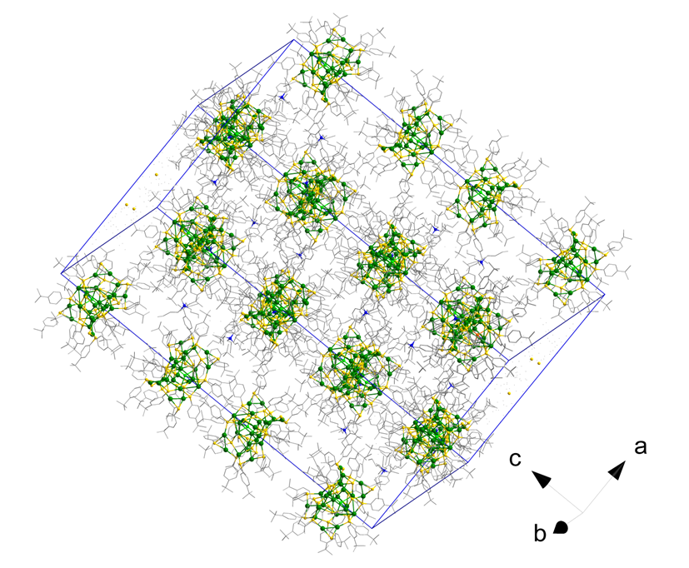
Fig.S11 The crystal packing diagrams in one unit cell of Cl@Ag₂₃ viewed along.
Color code: green, Ag; yellow, S; gray, C; orange, Cl

Table S1 Crystal data and structure refinement for Br₂@Ag₂₈Br₂
Empirical formula | C₂₈₀H₃₆₄Ag_{27.97}Br₄S₂₈
Formula weight | 7964.67
Temperature/K | 100
Crystal system | triclinic
Space group | P-1
a/Å | 19.257(4)
b/Å | 22.039(4)
c/Å | 22.857(5)
α/° | 67.46(3)
β/° | 65.12(3)
γ/° | 73.63(3)
Volume/Å³ | 8044(4)
Z | 1
ρ_{calc}g/cm³ | 1.644
μ/mm⁻¹ | 2.381
F(000) | 3947.0
Crystal size/mm³ | 0.2 × 0.5 × 0.34
Radiation | MoKα (λ = 0.71073)
2Θ range for data collection/° | 6.068 to 54.97
Index ranges | -24 ≤ h ≤ 24,  -28 ≤ k ≤ 23,  -29 ≤ l ≤ 29
Reflections collected | 79618
Independent reflections | 36611 [R_{int} = 0.0660, R_{sigma} = 0.0946]
Data/restraints/parameters | 36611/39/1614
Goodness-of-fit on F² | 1.049
Final R indexes [I>=2σ (I)] | R₁ = 0.0995,  wR₂ = 0.2488
Final R indexes [all data] | R₁ = 0.1774,  wR₂ = 0.2965
Largest diff. peak/hole / e Å⁻³ | 2.88/-2.73

Table S2 Crystal data and structure refinement for Cl@Ag₃₆
Empirical formula | C₃₆₀H4₆₂Ag₃₆ClS₃₆
Formula weight | 9862.20
Temperature/K | 100(2)
Crystal system | trigonal
Space group | R-3
a/Å | 26.447(4)
b/Å | 26.447(4)
c/Å | 53.319(11)
α/° | 90
β/° | 90
γ/° | 120
Volume/Å³ | 32296(11)
Z | 3
ρcalcg/cm³ | 1.521
μ/mm-1 | 1.817
F(000) | 14721.0
Crystal size/mm³ | 1.2 × 0.5 × 0.5
Radiation | MoKα (λ = 0.71073)
2Θ range for data collection/° | 6.062 to 29.398
Index ranges | -18 ≤ h ≤ 18  -18 ≤ k ≤ 18  -38 ≤ l ≤ 38
Reflections collected | 18983
Independent reflections | 2722 [Rint = 0.0274, Rsigma = 0.0156]
Data/restraints/parameters | 2722/26/609
Goodness-of-fit on F² | 1.096
Final R indexes [I>=2σ (I)] | R₁ = 0.0724  wR₂ = 0.2014
Final R indexes [all data] | R₁ = 0.0740  wR₂ = 0.2030
Largest diff. peak/hole / e Å⁻³ | 4.86/-0.88

Table S3 Crystal data and structure refinement for Br₂@Ag₂₈
Empirical formula | C₃₂₄H₄₃₄Ag_{28.02}Br₂N₈S₃₀
Formula weight | 8584.90
Temperature/K | 100
Crystal system | triclinic
Space group | P-1
a/Å | 21.268(4)
b/Å | 22.319(5)
c/Å | 23.252(5)
α/° | 112.20(3)
β/° | 111.52(3)
γ/° | 98.54(3)
Volume/Å3 | 8963(4)
Z | 1
ρcalcg/cm3 | 1.590
μ/mm‑1 | 1.936
F(000) | 4301.0
Crystal size/mm³ | 0.1 × 0.4 × 0.3
Radiation | MoKα (λ = 0.71073)
2Θ range for data collection/° | 6.026 to 54.968
Index ranges | -27 ≤ h ≤ 26,  -28 ≤ k ≤ 27,  -29 ≤ l ≤ 30
Reflections collected | 87740
Independent reflections | 40756 [R_{int} = 0.0930, R_{sigma} = 0.1309]
Data/restraints/parameters | 40756/6/1827
Goodness-of-fit on F² | 1.021
Final R indexes [I>=2σ (I)] | R₁ = 0.0826  wR₂ = 0.1745
Final R indexes [all data] | R₁ = 0.1988  wR₂ = 0.2940
Largest diff. peak/hole / e Å⁻³ | 12.80/-1.76

Table S4 Crystal data and structure refinement for Cl₂@Ag₂₈
Empirical formula | C₃₂₄H₄₃₄Ag_{28.02}Cl₂N₈S₃₀
Formula weight | 8495.55
Temperature/K | 100
Crystal system | triclinic
Space group | P-1
a/Å | 21.268(4)
b/Å | 22.319(5)
c/Å | 23.252(5)
α/° | 112.20(3)
β/° | 111.52(3)
γ/° | 98.54(3)
Volume/Å³ | 8963(4)
Z | 1
ρ_{calc}g/cm³ | 1.574
μ/mm⁻¹ | 1.727
F(000) | 4265.0
Crystal size/mm³ | 0.25 × 0.3 × 0.45
Radiation | MoKα (λ = 0.71073)
2Θ range for data collection/° | 6.026 to 54.968
Index ranges | -27 ≤ h ≤ 26,  -28 ≤ k ≤ 27,  -29 ≤ l ≤ 30
Reflections collected | 87740
Independent reflections | 40756 [R_{int} = 0.0930, R_{sigma} = 0.1309]
Data/restraints/parameters | 40756/6/1827
Goodness-of-fit on F² | 1.032
Final R indexes [I>=2σ (I)] | R₁ = 0.1169,  wR₂ = 0.2963
Final R indexes [all data] | R₁ = 0.1976,  wR₂ = 0.3542
Largest diff. peak/hole / e Å⁻³ | 13.38/-1.75

Table S5 Crystal data and structure refinement for Ag₂₃
Empirical formula | C₃₀₆H₄₃₆Ag_{23.19}N₃S₂₆
Formula weight | 7491.19
Temperature/K | 100
Crystal system | triclinic
Space group | P-1
a/Å | 21.614(4)
b/Å | 22.646(5)
c/Å | 39.253(8)
α/° | 97.91(3)
β/° | 95.41(3)
γ/° | 117.88(3)
Volume/Å³ | 16542(7)
Z | 2
ρ_{calc}g/cm³ | 1.504
μ/mm⁻¹ | 1.548
F(000) | 7597.0
Crystal size/mm³ | 0.3 × 0.4 × 0.4
Radiation | MoKα (λ = 0.71073)
2Θ range for data collection/° | 6.006 to 54.97
Index ranges | -28 ≤ h ≤ 28,  -27 ≤ k ≤ 29,  -50 ≤ l ≤ 50
Reflections collected | 152185
Independent reflections | 71718 [R_{int} = 0.0932, R_{sigma} = 0.1226]
Data/restraints/parameters | 71718/28/3374
Goodness-of-fit on F² | 1.033
Final R indexes [I>=2σ (I)] | R₁ = 0.0816,  wR₂ = 0.2289
Final R indexes [all data] | R₁ = 0.1207,  wR₂ = 0.2633
Largest diff. peak/hole / e Å⁻³ | 7.11/-2.02

Table S6 Crystal data and structure refinement for Cl@Ag₂₃
Empirical formula | C₂₆₄H₃₅₇Ag₂₃ClN_{1.5}S₂₄
Formula weight | 6837.39
Temperature/K | 100K
Crystal system | trigonal
Space group | R-3c
a/Å | 39.243(6)
b/Å | 39.243(6)
c/Å | 73.915(15)
α/° | 90
β/° | 90
γ/° | 120
Volume/Å³ | 98580(34)
Z | 12
ρcalcg/cm³ | 1.382
μ/mm-1 | 1.536
F(000) | 41202.0
Crystal size/mm³ | 0.4 × 0.5 × 0.2
Radiation | MoKα (λ = 0.71073)
2Θ range for data collection/° | 6.01 to 41.636
Index ranges | -39 ≤ h ≤ 29,  -39 ≤ k ≤ 32,  -73 ≤ l ≤ 73
Reflections collected | 52234
Independent reflections | 11135 [Rint = 0.1040, Rsigma = 0.0910]
Data/restraints/parameters | 11135/6/932
Goodness-of-fit on F² | 1.082
Final R indexes [I>=2σ (I)] | R₁ = 0.0702  wR₂ = 0.2043
Final R indexes [all data] | R₁ = 0.0903  wR₂ = 0.2227
Largest diff. peak/hole / e Å⁻³ | 0.82/-0.74

