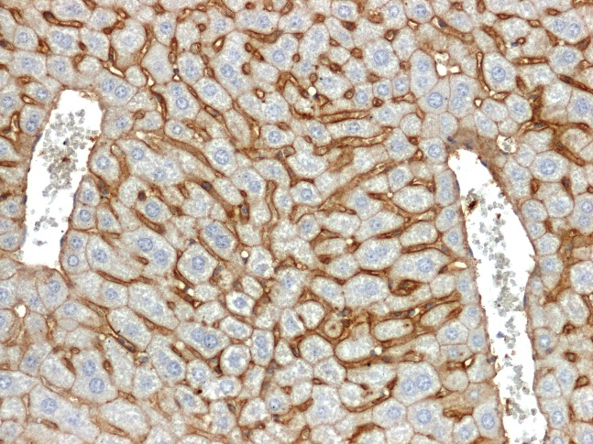
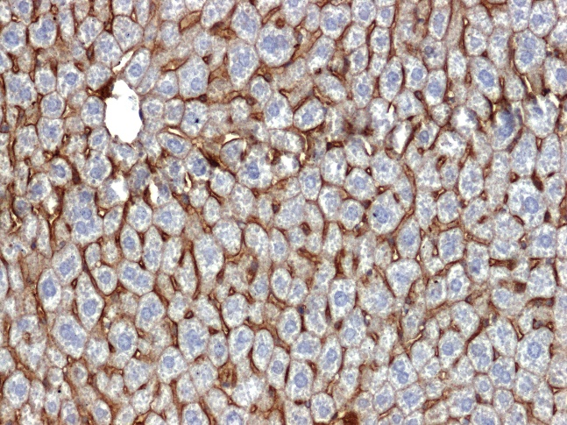
B
A

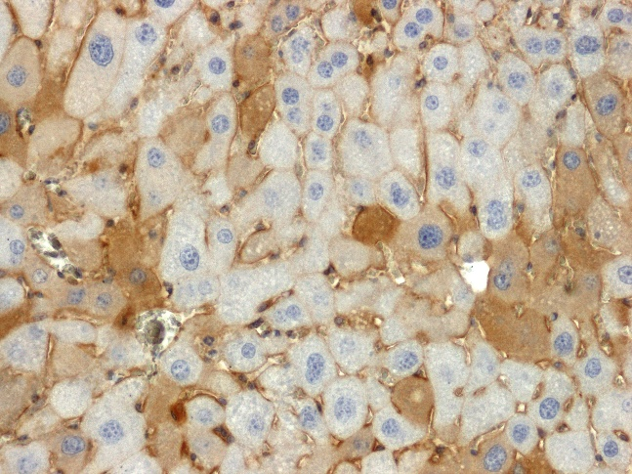
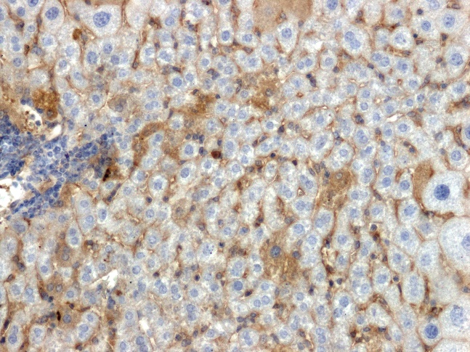
D
C

S1 Fig. Immunohistology of liver’s hepatocyte during HCC development. Representative photomicrographs for immunodetection of β-catenin in the liver of mice at 15th week of hepatocellular carcinoma development: A) L-BMR control group, B) H-BMR control group, C) L-BMR DEN-treated group, D) H-BMR DEN-treated group. Magnification x200.

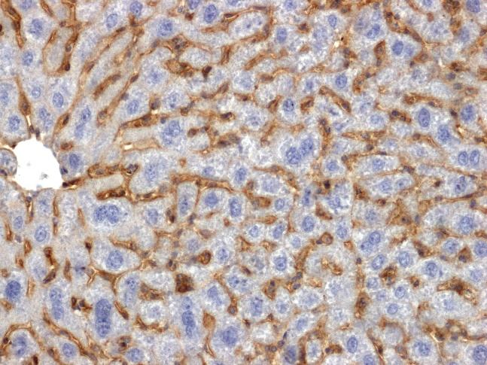
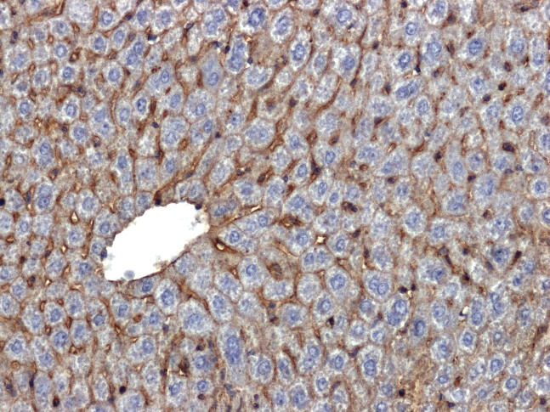
B
A

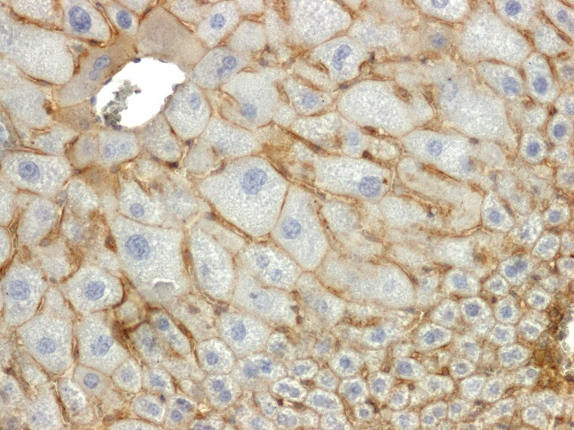
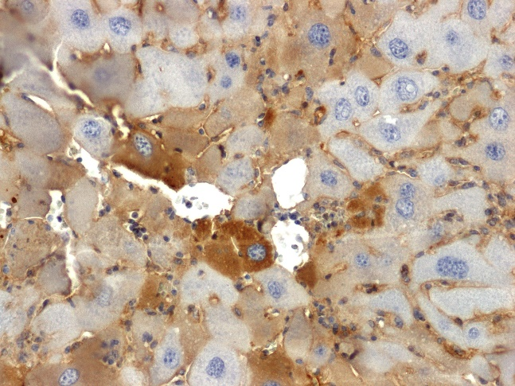
C
D

S2 Fig. Immunohistology of liver’s hepatocyte during HCC development cont. Representative photomicrographs of β-catenin immunoreactivity in the liver of mice at 35th week of hepatocellular carcinoma development: A) L-BMR control group, B) H-BMR control group, C) L-BMR DEN-treated group, D) H-BMR DEN-treated group. Magnification x200.

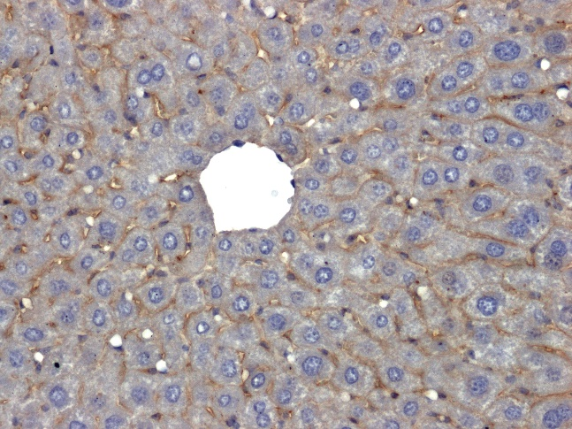
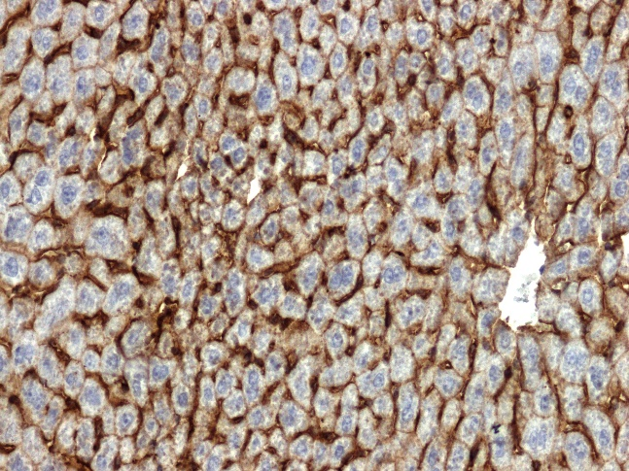
B
A

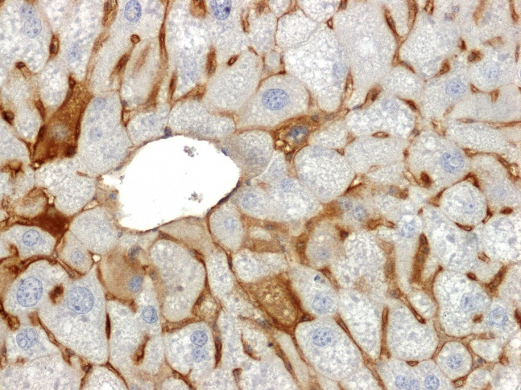
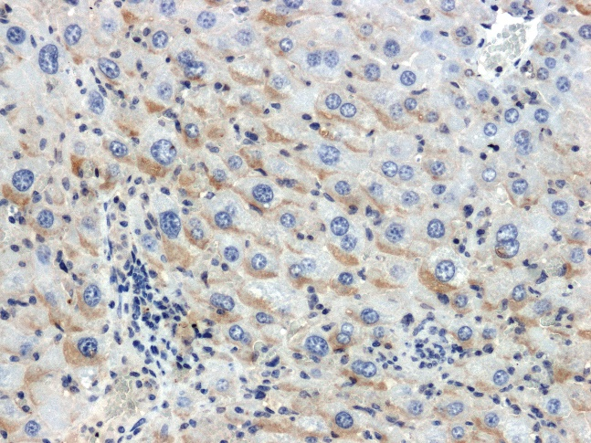
D
C

S3 Fig. Immunohistology of liver’s hepatocyte during HCC development cont. Representative photomicrographs of β-catenin immunolocalization in the liver of mice at 45th week of hepatocellular carcinoma development: A) L-BMR control group, B) H-BMR control group, C) L-BMR DEN-treated group, D) H-BMR DEN-treated group. Magnification x200.

