Using low - molecular - weight ligands for targeting in integrated chemodynamic/starvation therapy and chemotherapy for prostate cancer
Xiaoli Zhang ^{a, b,1}, Jie He ^{a, d, 1}, Yu An ^{c, d,1}, Kehua Jiang ^{e}, Qing Wang ^{e}, Wenrui Deng ^{e}, Qiqi Yang ^{d}, Fa Sun ^{a, c*}, Kun Chen^{b*}
a Medical College, Guizhou University, Guizhou 550000, China
b Department of Medical Genetics of Guizhou Provincial People's Hospital, Guizhou 550002, China.
c Guizhou Medical University, Guizhou 550003, China
d NHC Key Laboratory of PulmonaryImmune-related Diseases, Guizhou Provincial People’ Hospital, Guizhou 550002, China
e Urology Department of Guizhou Provincial People's Hospital, Guizhou 550002, China
1 Contributed equally to this work.
*Corresponding
Fa Sun, Department of Guizhou Provincial People's Hospital, No.83 Zhongshan East Road, Guiyang, Guizhou Province 550002, China
E-mail address: sfgmc@sina.com
Kun Chen, Department of Medical Genetics of Guizhou Provincial People's Hospital, No.83 Zhongshan East Road, Guiyang, Guizhou Province 550002, China
E-mail address: 44844956@qq.com (K. Chen)

Supplementary Material
- Detailed materials
Tetraethyl orthosilicate (TEOS), cetyltrimethylammonium bromide (CTAB), Glucose oxidase (Gox, from Aspergillus niger), D-(+)-glucose, methylene blue (MB), doxorubicin hydrochloride (DOX), glutathione (GSH, 98%), 5,5′ -dithiobis (2-nitrobenzoic acid) (DTNB), 2,7′ -dichlorodihydrofluorescein diacetate (DCFH-DA), Rhodamine 6G (R6G), and 4,4′-diamino- 3,3′,5,5′-tetramethylbiphenyl (TMB) were purchased from Aladdin Chemical Co., Ltd. Bis[3-(triethoxysilyl) propyl] disulfide (BTESPD) were purchased from Sigma-Aldrich Trading Co., Ltd. H₂O₂ (35%) and potassium permanganate (KMnO₄) standard solution were purchased from Chuandong Chemical Co., Ltd. The Cell Counting Kit-8 (CCK-8), ATP level assay kit, H₂O₂ level assay kit, BCA protein assay kit, Calcein-AM/PI cell activity and cytotoxicity detection kit, mitochondrial membrane potential assay kit with JC-1, GSH/GSSH assay kit were purchased from Biyuntian Biotechnology Co., Ltd. Rabbit anti-mouse antibodies of caspase-3 and Ki-67 were purchased from Biosynthesis Biotech. (Beijing, China).
- Synthetic of the DCL-PEG2k-COOH
0.5 g of HOOC-PEG2k-NHS was dissolved in 6 mL of dichloromethane. DCL (1.1 eq) and TEA (1.5 eq) were added to the solution mixed. The reaction mixture was allowed to react at 30°C for 2 h in a water bath. The mixture was concentrated under reduced pressure, and the product was precipitated by adding the concentrated mixture to a large volume of ice-cold diethyl ether. The precipitate was collected by centrifugation and dried under vacuum to obtain DCL-PEG2k-COOH.
- Characterization and analysis of the NPs
Transmission electron microscopy (TEM, JEOL JEM-2100F, Japan) was used to analyze the morphology and elemental composition of the NPs. MSN@Mn NPs were dispersed in ethanol (0.5 mg/mL), sonicated for 10 min (40 kHz, 100 W), and drop-casted onto carbon-coated copper grids (300 mesh). Acquisition Parameter: Voltage 200.0kV, Real Tim 122.01 sec, Energy Range 0 - 40 keV, Probe Current 7.47500nA, Counting Rate 344 Counts/sec, PHA Mode T4. Dynamic light scattering (DLS) analysis (Malvern Zetasizer Nano ZS90, UK) was used to examine the zeta potentials and hydrodynamic diameters of the NPs. X-ray photoelectron spectroscopy (XPS) data were collected using a Scientific ES-CALAB 250Xi instrument (Thermo Scientific). Acquisition Parameters: Total acquisition time 2 mins 16.1 secs, Number of Scans 1, Source Gun Type Al K Alpha, Spot Size 400 µm, Analyser Mode CAE: Pass Energy 150.0 eV, Energy Step Size 1.000 eV, Number of Energy Steps 1361. Fourier transform infrared (FT-IR) spectroscopy (Thermo Scientific Nicolet 6700, USA) was employed to verify the chemical composition of the NPs.
- Hemolysis assay
The hemolytic activity of SMPG NPs against red blood cells was assessed. Mouse blood was collected and centrifuged at 1500 rpm for 10 minutes to separate the red blood cells (RBCs). The cell pellet was washed five times with 0.9% saline to remove plasma and other components. The purified RBCs were then resuspended in 0.9% saline to obtain a 4% RBC suspension. For the hemolysis assay, 200 µL of the 4% RBC suspension was incubated with various concentrations of SMPG NPs (0.6 mL) at 37°C for 2 hours. Phosphate-buffered saline (PBS) and deionized water were used as negative and positive controls, respectively. After incubation, the mixtures were centrifuged at 1500 rpm for 5 minutes, and the absorbance of the supernatant was measured at 540 nm. The hemolysis percentage was calculated using the following formula:
Hemolysis (%) = $\frac{A sample - A negative}{Apositive - Anegative}×100\%$
- Cell culture
22RV1, PC3, and SV-HUC-1 cells purchased from ATCC. 22RV1 cells were cultured in 1640 medium (37 ◦C, 5% CO2, 21% O2) containing 1% penicillin/streptomycin antibiotic and 10% FBS. PC3 cells and SV-HUC-1 cells were cultured in F12K medium (37 ◦C, 5% CO2, 21% O2) containing 1% penicillin/streptomycin antibiotic and 10% FBS. The culture medium was refreshed every 1–2 days and the cells were passaged when reaching approximately 80% confluence.
- Cellular uptake assay
22RV1 cells were preincubated for 30 min with endocytosis inhibitors, namely, nystatin (15 μg/mL),M-β-CD (6.6 mg mL⁻¹), chlorpromazine (10 μg/mL), amiloride (13.3 μ g/mL) ^{[23]}. Following 2 h of incubation with NPs containing equimolar concentrations of DOX, the medium was aspirated and the cells were thoroughly rinsed with PBS. Cells were then treated with the lysed using Triton X-100 (0.5%) at 4°C for 2h. The DOX content in the cell lysates was subsequently determined using a microplate reader (Bio-Rad Model680, USA).
- Intracellular ATP and GSH levels
Intracellular ATP and GSH levels were measured using commercial ATP and GSH assay kits, respectively. First, 22RV1 cells were seeded into 24-well plates. After the cells had fully adhered to the wells, they were incubated with 50 μg/mL of MSN@Mn@PDA, SMPG, VHH-SMPG, and DCL-SMPG NPs. Intracellular ATP levels were then determined using the ATP assay kit. The same procedure was followed to evaluate intracellular GSH levels using the GSH assay kit.

Figure S1 N₂ adsorption-desorption isotherm of MSN@Mn NPs (A) and corresponding pore size distribution (B).

Table S1 Porosity Parameters of MSN@Mn NPs
BET surface area | Micropore area |  | micropore volume | Average pore size
60.4631 m²/g |  | 1.7846 m²/g | 0.000200 cm³/g |  | 6.2843 nm

Figure S2. The average hydrodynamic diameters of the DCL-SMPG NPs in PBS and FBS after storage.

Figure S3. The 24h cumulative release of DOX from VHH-SMPG/DOX and DCL-SMPG/DOX NPs under different conditions.

Figure S4. UV/vis absorption spectra of GSH after incubation with different concentration SMPG NPs.

Figure S5. UV/vis absorption spectra of MB after treatment with different concentrations of GSH.

Figure S6. UV/vis absorption spectra of MB after incubation with SMPG NPs and glucose.

Figure S7. Confocal laser scanning microscopy (CLSM) images of the 22RV1 cells after incubation with VHH-SMPG/DOX and DCL-SMPG/DOX at various time (1, 2,and 4h).

Figure S8. Viability of 22RV1 cells after treatment with different concentrations of VHH-SMPG and DCL-SMPG NPs.

Figure S9. Viability of 22RV1 cells and PC-3 cells after treatment with different NPs of DOX, SMPG, SMPG/DOX, VHH-SMPG and DCL-SMPG NPs.

Figure S10. Viability of SV-HUC-1, 22RV1, and PC3 cells after treatment with different concentrations of MSN@PDA NPs.

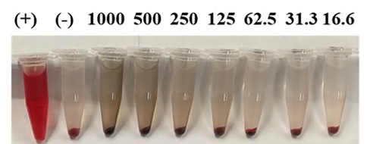
Figure S11. Hemolysis rates induced by SMPG NPs and corresponding images.

Figure S12. Flow cytometric analysis of ROS generation in 22RV1 cells after incubation with various treatments.
Figure S13. Ratio of GSH to GSSG in 22RV1 cells after incubation with various treatments.
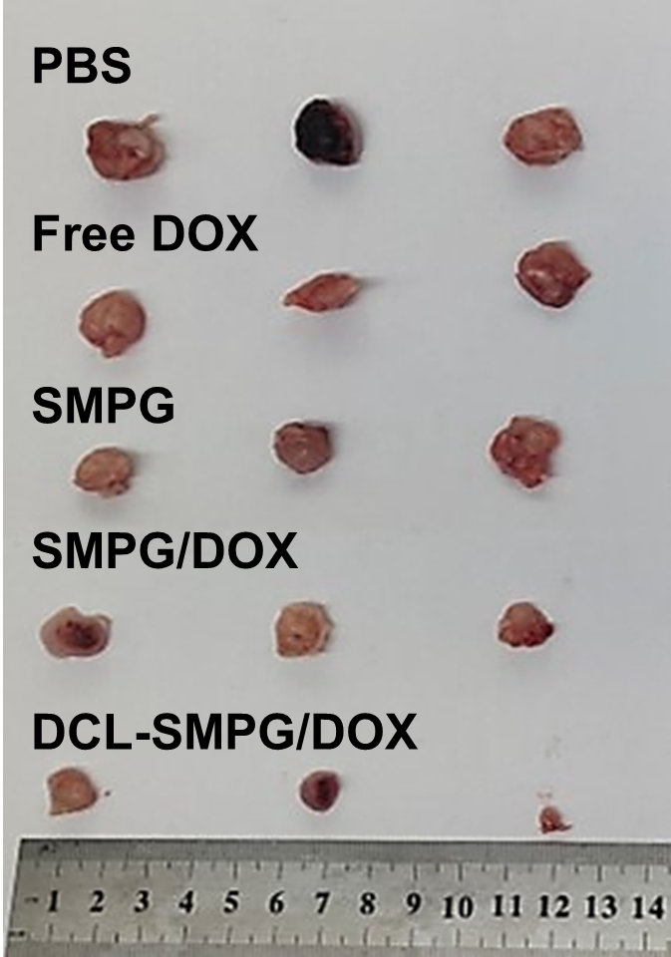
Figure S14. The morphology of tumors after 21 days of treatment.

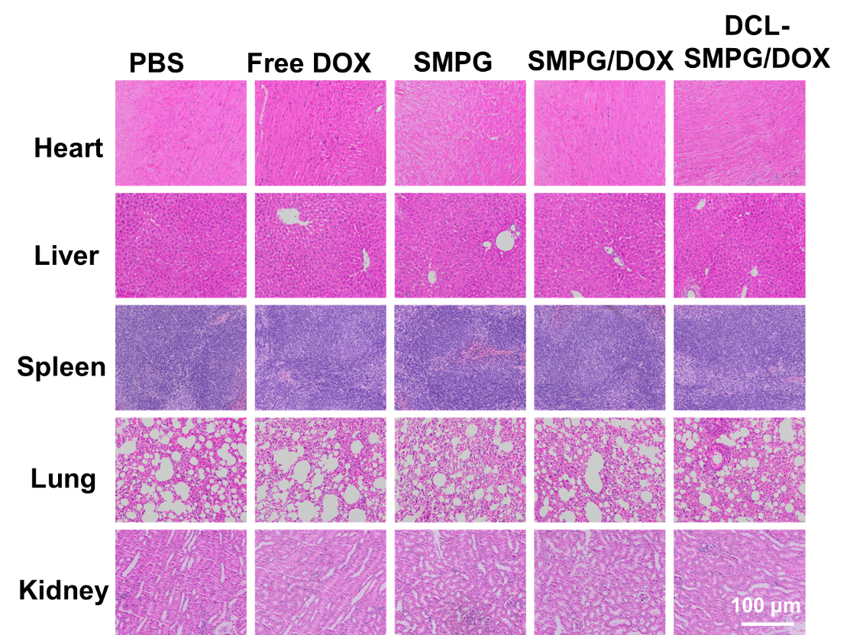
Figure S15. H&E staining of non-tumor tissues.

