Supplementary Information For “Probing Polarization-Tunable Sub-Terahertz Spin Pumping in Bimodal α-Fe2O3 /Pt”

Extended Data
As mentioned in the main text, power-dependent curves have been measured for the ISHE voltages in both bulk and thin-film devices. We observe linear relationships in all regards, consistent with pure spin-pumping signals, as shown in Figure S1a and S1c for the bulk and thin film samples respectively. We also report the sensitivity of our transducers with respect to frequency. We track the dependence for the decomposed signals and plot the dependence for the symmetric, antisymmetric and total signals in Figure S1b and S1d for the bulk and thin film acoustic modes respectively. We find that the frequency dependent transmission of our free-space microwaves results in a non-monotonous development, so that the nature of the dependence is not clear upon decomposition. In Table 1, we directly compare our sensitivities in the bulk and thin-film transducers with those reported in the acoustic mode in the literature. We find that in the acoustic mode a maximum sensitivity of 22 nV/W is found in the bulk and 13 nV/W in the film. Larger signals in the optical mode give a maximum sensitivity of 80 nV/W.
Table S1: Reports of acoustic mode sensitivities in α-Fe2O3/Pt microwave transducer devices.
α-Fe2O3/Pt microwave transducer | Frequency | Mode | Max Sensitivity (μV/W)
This work | Sub-THz | Acoustic  Optical | 0.02 (bulk)/0.013 (film  0.08 (bulk)
Hattori, et al. (2024)¹ | Sub-THz | Acoustic | 1 (estimate)
Gabrielyan, et al (2024)² | Few GHz | Acoustic | 10.1
Wang, et al. (2021)³ | Few GHz | Acoustic | 15
Boventer, et al. (2021)⁴ | Few GHz | Acoustic | 0.4
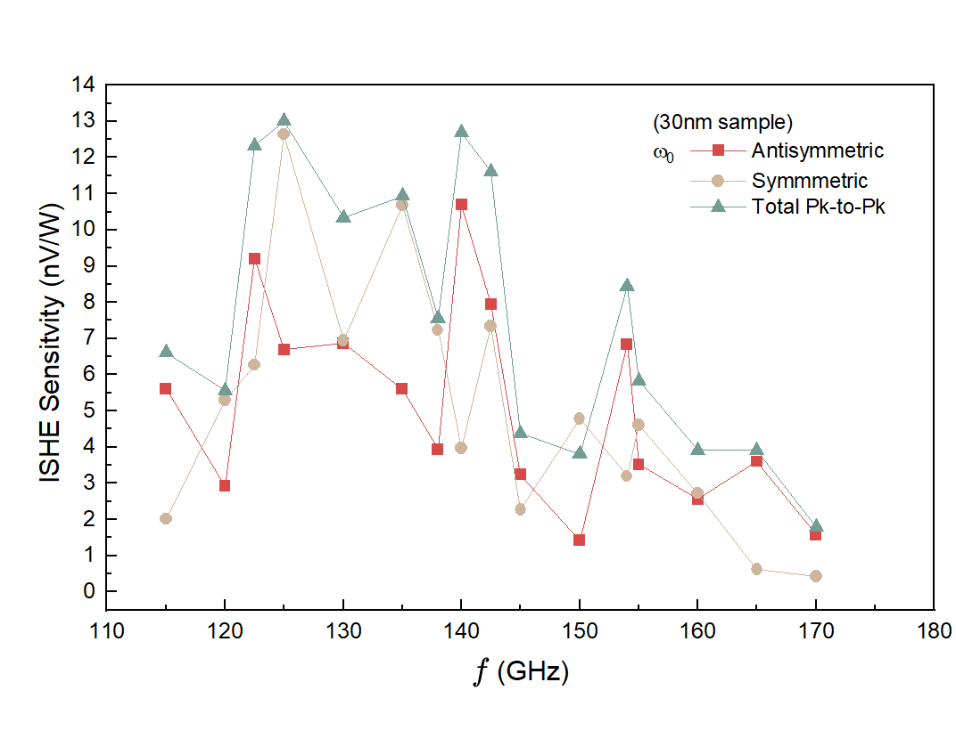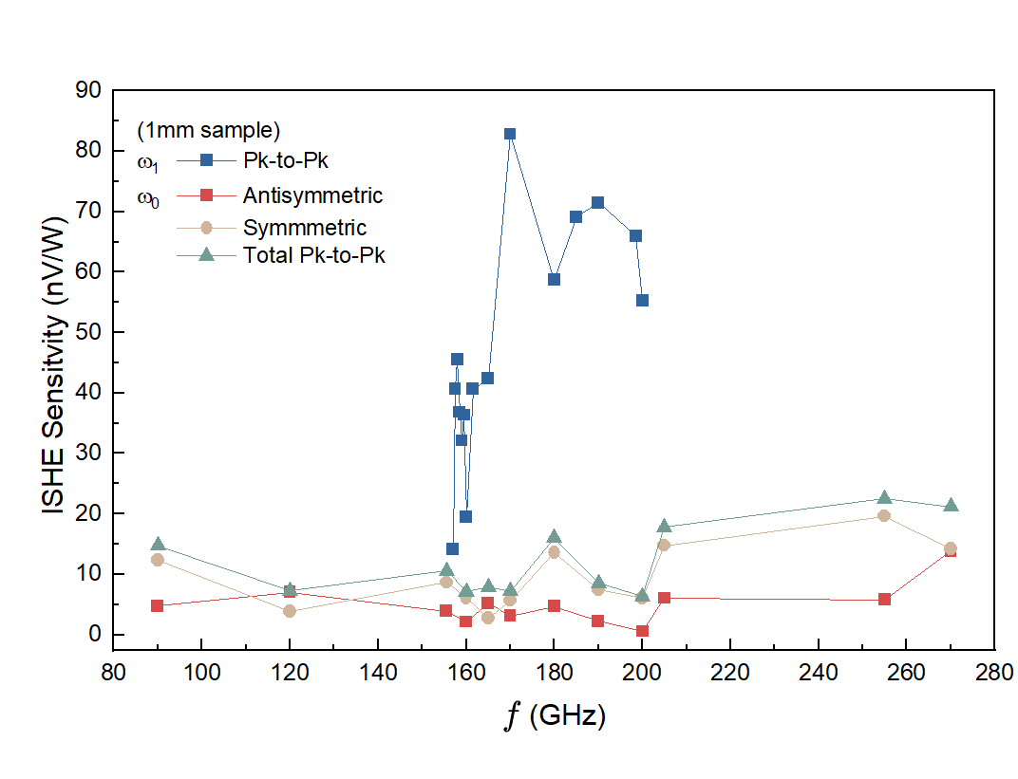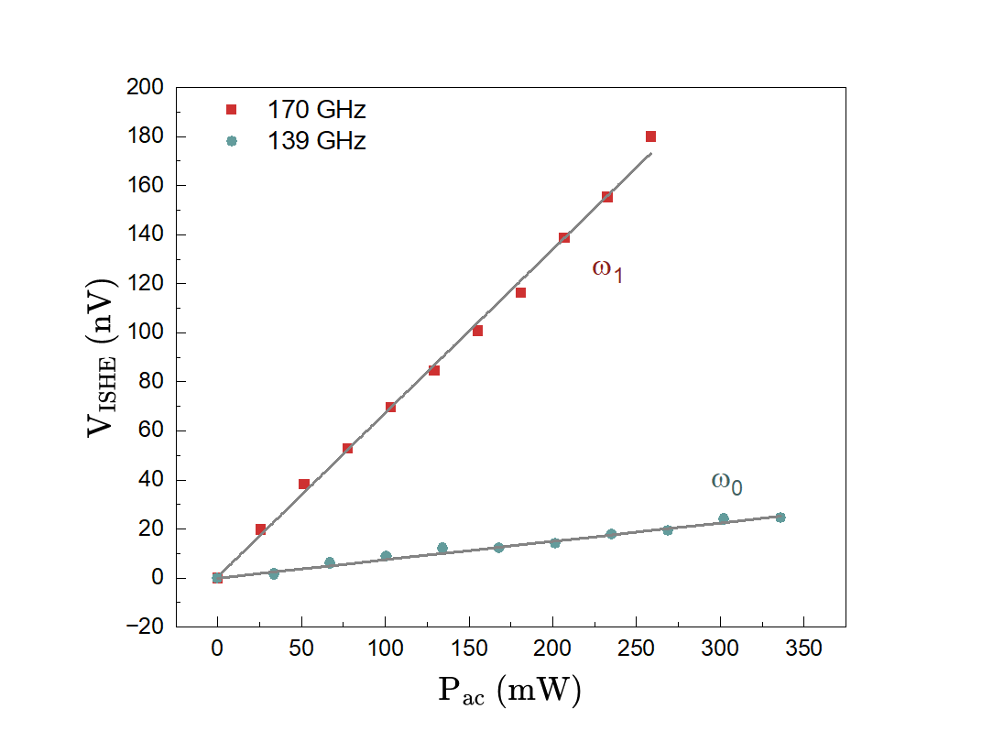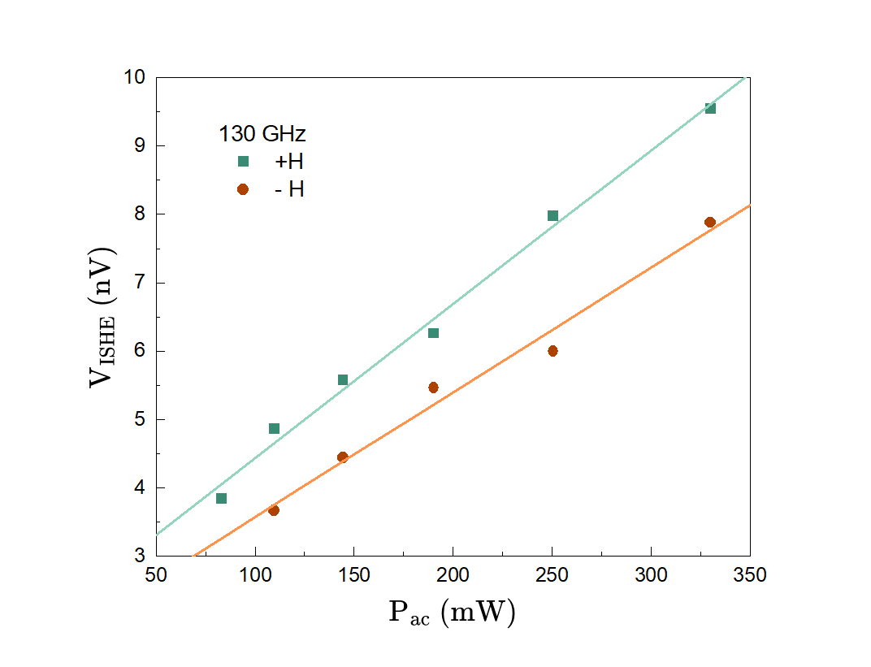
b)
a)
c)
d)
Figure S1: Relations of ISHE voltages to microwave power for bulk (a-b) and thin film (c-d) samples. (a) Power dependent curves for both modes of bulk hematite excited in Voigt geometry with $h_{ac}$ $‖ y(x)$ for $ω_{0}$ ($ω_{1}$). (c) Power dependent curves for the acoustic mode in thin-film hematite for positive and negative field sweeps and $h_{ac} ‖ y$. Linear dependence on microwave power is associated with coherent spin pumping. (b) Bulk transducer sensitivity calculated from peak-to-peak voltages ($ω_{1}$) and decomposed $ω_{0}$ sensitivity with respect to excitation frequency. Thin-film transducer decomposed $ω_{0}$ sensitivity with respect to excitation frequency. Signals are decomposed into symmetric and antisymmetric Lorentzian line shapes and scaled by microwave input power.

Polarization dependent scans for the acoustic mode in both Faraday and Voigt configurations are repeated at 155.5 GHz (Figure S2). For the Faraday contour, a full 360° scan is taken in 7.5° steps with 16 field sweeps averaged per step near 180° tapering to 4 averages at 0,360°. For the Voigt contour, polarizations surrounding the maximum voltage and up to the circular states is measured in 15° steps, with 2 averages per step. We again fit the maximum voltages to tilted sine curves and obtain maximum signal shifts towards CCW elliptical polarization.
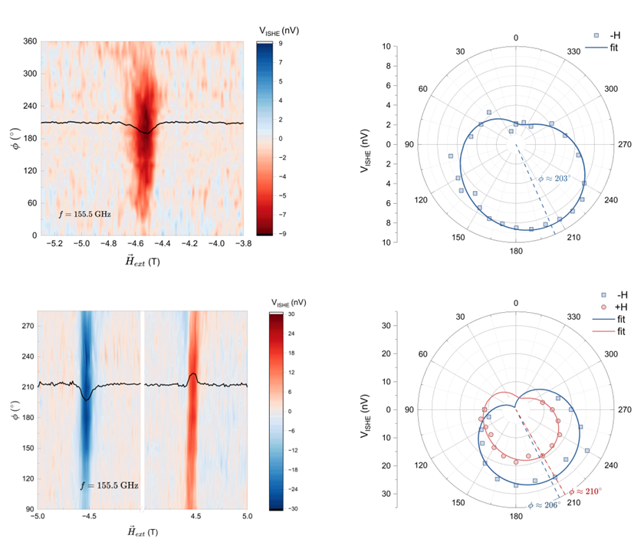
c)
d)
b)
a)
Figure S2: Polarization scans and polar plots of V_{ISHE} at 155.5 GHz. (a-b) Faraday (a) polarization mapping and (d) polar plot of signal maximum. (c-d) Voigt (c) polarization mapping and (d) polar plot (d) of signal maximum. Blue and red solid lines in (b) and (d) are fits to a two-term tilted sine function. Dashed lines indicate the fitting maximum.s

Faraday Projection Resonance Diagrams
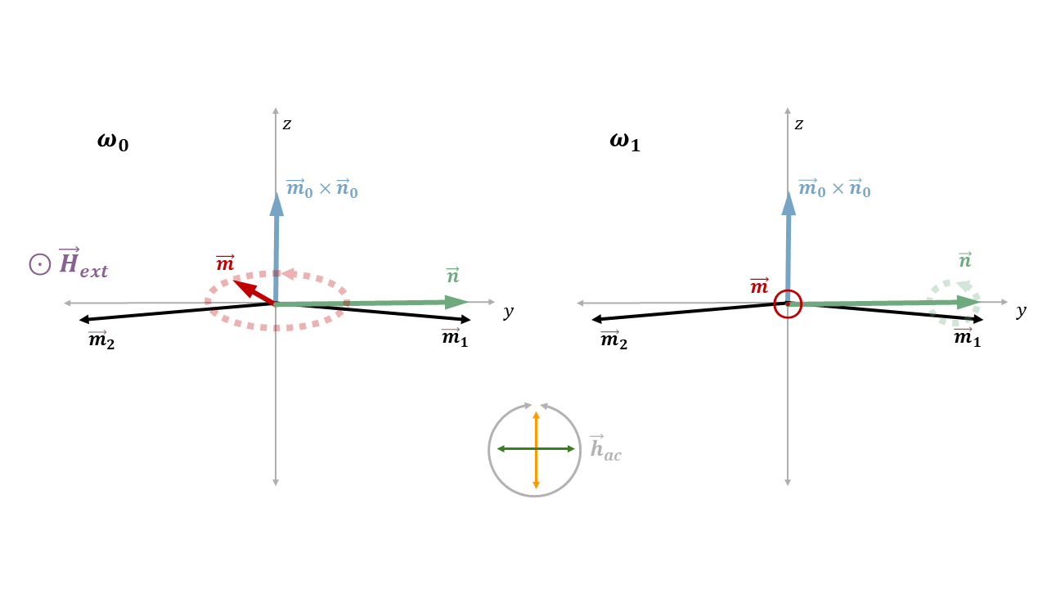
b)
a)
Figure S3: Planar projections of the sublattice magnetizations in the Faraday geometry. (a) Projection for the acoustic magnon mode (b) Projection for the optical magnon mode.
In the Faraday geometry, a null value is expected for the optical mode resonance, since no coupling can occur between the microwave magnetic field and the oscillation of m for any microwave polarization. Figure S3 shows the projection of the magnetizations in Faraday geometry for the (a) acoustic magnon mode (b) optical magnon mode. For completeness we show the diagram of the optical mode resonance not included in the main text. Experimentally, we obtain null results for all polarization types applied along the optical resonance in the Faraday condition consistent with this picture.

MPI Simulated Polarization
Graphical illustration of the microwave polarization states with respect to the phase difference in the MPI for Faraday propagation is provided in Figure S4. 0,360° phase differences generate fully $z$-polarized microwave while 180° corresponds to fully y-polarized microwave. 90°(270°) phase differences generate CW (CCW).
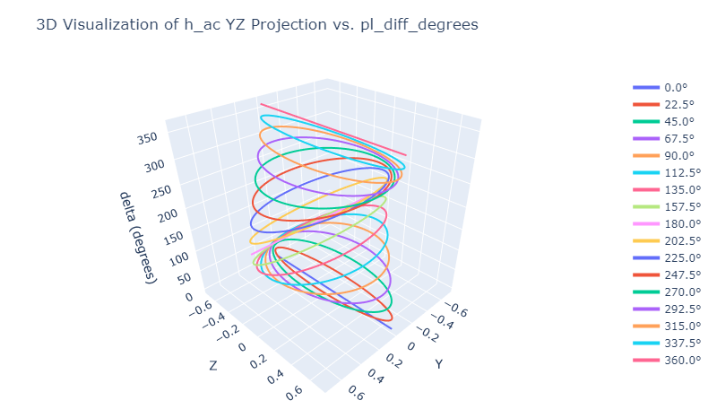
Figure S4: Illustration of microwave polarization traces for differing values of the MPI phase delay, $ϕ$.

ISHE response to Film Sample Rotation
In addition to polarization-dependent mappings, sample rotations are performed in the thin-film hematite, using a custom rotation stage for ISHE measurements. Rotations are taken in steps of 15°, where 0° corresponds to $\vec{H} || \vec{x}$, i.e. the external field aligned with the basal plane. Microwaves propagate in the Voigt geometry and are polarized as ${\vec{h}}_{ac} || y{⊥\vec{m}}_{0}$, the preferred direction for excitation of the acoustic mode. The signal shows a field minimum for 0°, indicating good alignment. For increasing angles, larger fields are required to excite resonance, as the projection of $\vec{H}$ within the plane decreases. Beyond ±45° resonances are no longer observed as the resonances rapidly move towards higher fields, and beyond +60° the sample becomes largely obstructed by the micro-coaxial housing.
Figure S5: Rotation dependence of $V_{ISHE}$ in Voigt geometry for 30nm thin film sample. $θ$ is the angle between the sample surface and the magnetic field, such that the sample rotates about the $\vec{y}$-axis.

Sample Characterization
The following sample characterization is representative of our samples and previously reported exactly in the supplementary information of our previous report⁵.
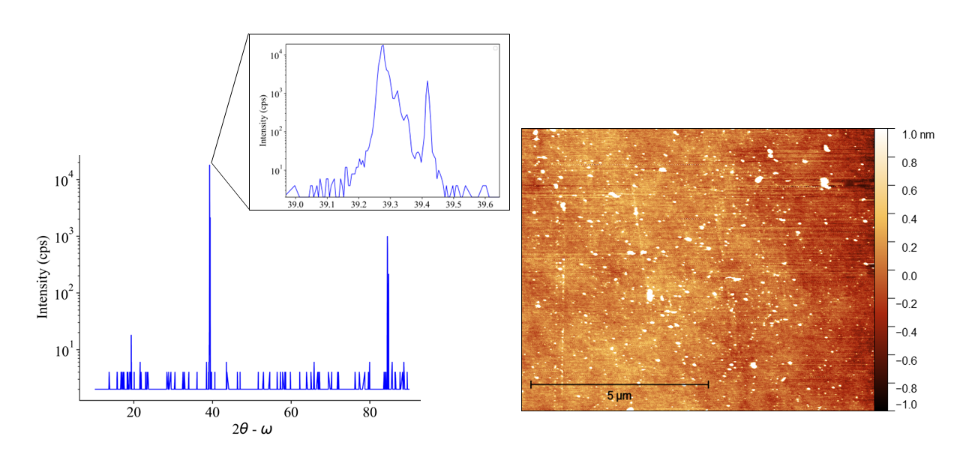
b)
a)
Figure S6: Bulk α-Fe₂O₃ sample characterization. (a) X-ray diffraction of c-plane α-Fe₂O₃ crystal obtained from MTI. Inset shows a double peak feature at the bulk lattice constant. (b) Atomic force microscopy showing RMS roughness <1 nm.
Figure S6 shows XRD and AFM of a bulk c-plane α-Fe₂O₃ crystal purchased from MTI. While the primary signal show the crystal at the bulk lattice constant, a double peak is obtained from the main diffraction line (inset). This indicates part of the sample is strained differently while remaining in the Alpha phase. The AFM shows an RMS roughness <1nm with small mounds <5nm. The small mounds scattered on the single crystal surface are due to the preparation of the α-Fe₂O₃ crystal by the vendor, which does not affect the ISHE measurements in any major way. Thus, the roughness for consideration of the ISHE measurements is the RMS value of <1 nm, for which a 5 nm Pt overlayer was chosen to give a mostly uniform Pt layer with consistent and clear ISHE signals for this work. The non-uniformity at the regions of <5 nm mounds only leads to a very small contribution to the ISHE signals. Figure S7 shows XRD and AFM for a sample thin film c-plane α-Fe₂O₃.
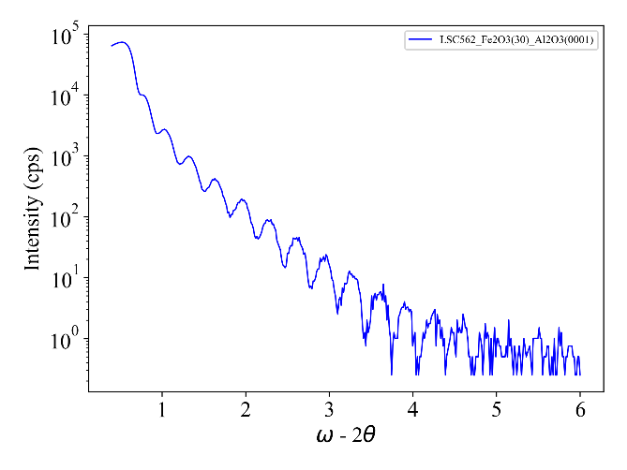
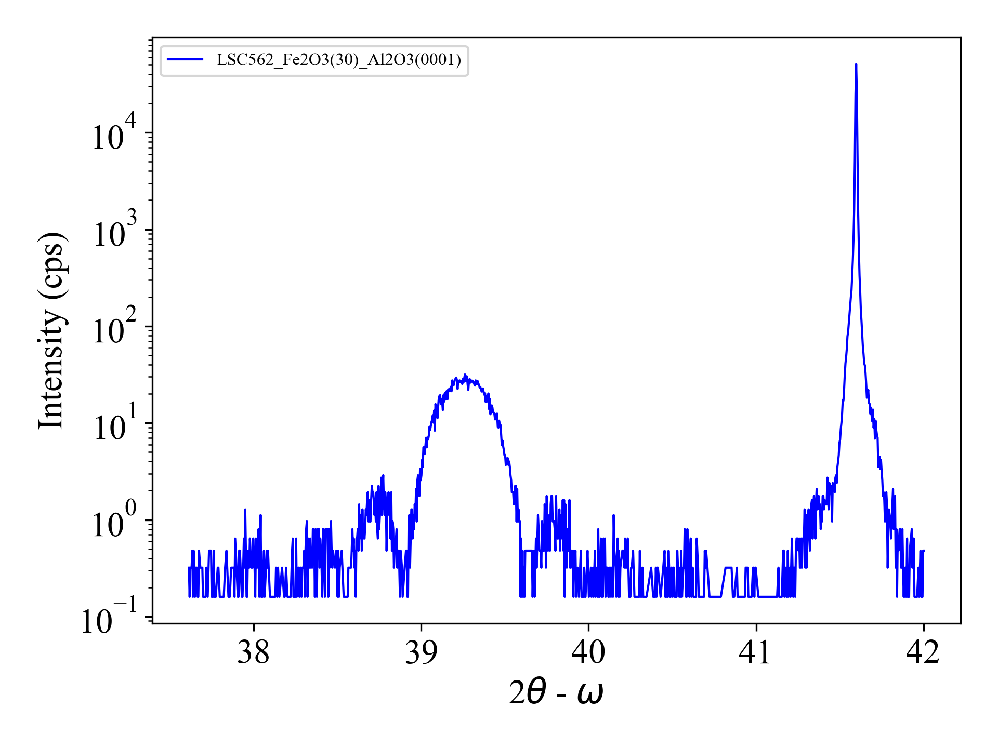
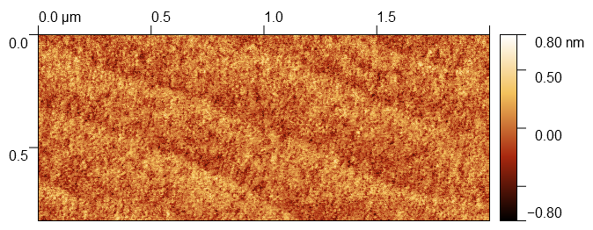
Figure S7: Thin-film α-Fe2O3 characterization. (a) XRD and (b) XRR of an α-Fe₂O₃(30 nm) epitaxial film grown on Al₂O₃(0001) substrate. (c) AFM image of an α-Fe₂O₃(30 nm) epitaxial film showing clear atomic plane terraces.
c)
b)
a)

References
1. Hattori, T. et al. Inter- and Intrasublattice Spin Mixing Conductance of the Antiferromagnetic Spin Pumping Effect in α-Fe2O3/Pt. Phys. Rev. Lett. 133, 256701 (2024).
2. Gabrielyan, D. et al. Room-temperature spin pumping from canted antiferromagnet α-Fe2O3. Journal of Applied Physics 136, 083902 (2024).
3. Wang, H. et al. Spin Pumping of an Easy-Plane Antiferromagnet Enhanced by Dzyaloshinskii--Moriya Interaction. Phys. Rev. Lett. 127, 117202 (2021).
4. Boventer, I. et al. Room-Temperature Antiferromagnetic Resonance and Inverse Spin-Hall Voltage in Canted Antiferromagnets. Phys. Rev. Lett. 126, 187201 (2021).
5. Fritjofson, G. et al. Coherent Spin Pumping Originated from Sub-Terahertz Néel Vector Dynamics in Easy Plane α-Fe2O3/Pt. Preprint at https://doi.org/10.48550/arXiv.2502.11281 (2025).
Figure Legends
Figure S1: Relations of ISHE voltages to microwave power for bulk (a-b) and thin film (c-d) samples. (a) Power dependent curves for both modes of bulk hematite excited in Voigt geometry with $hac$ $‖ y(x)$ for $ω0$ ($ω1$). (c) Power dependent curves for the acoustic mode in thin-film hematite for positive and negative field sweeps and $hac ‖ y$. Linear dependence on microwave power is associated with coherent spin pumping. (b) Bulk transducer sensitivity calculated from peak-to-peak voltages ($ω1$) and decomposed $ω0$ sensitivity with respect to excitation frequency. Thin-film transducer decomposed $ω0$ sensitivity with respect to excitation frequency. Signals are decomposed into symmetric and antisymmetric Lorentzian line shapes and scaled by microwave input power. 2
Figure S2: Polarization scans and polar plots of V_{ISHE} at 155.5 GHz. (a-b) Faraday (a) polarization mapping and (d) polar plot of signal maximum. (c-d) Voigt (c) polarization mapping and (d) polar plot (d) of signal maximum. Blue and red solid lines in (b) and (d) are fits to a two-term tilted sine function. Dashed lines indicate the fitting maximum.s 3
Figure S3: Planar projections of the sublattice magnetizations in the Faraday geometry. (a) Projection for the acoustic magnon mode (b) Projection for the optical magnon mode. 4
Figure S4: Illustration of microwave polarization traces for differing values of the MPI phase delay, $ϕ$. 5
Figure S5: Rotation dependence of $VISHE$ in Voigt geometry for 30nm thin film sample. $θ$ is the angle between the sample surface and the magnetic field, such that the sample rotates about the $y$-axis. 6
Figure S6: Bulk α-Fe₂O₃ sample characterization. (a) X-ray diffraction of c-plane α-Fe₂O₃ crystal obtained from MTI. Inset shows a double peak feature at the bulk lattice constant. (b) Atomic force microscopy showing RMS roughness <1 nm. 7
Figure S7: Thin-film α-Fe2O3 characterization. (a) XRD and (b) XRR of an α-Fe₂O₃(30 nm) epitaxial film grown on Al₂O₃(0001) substrate. (c) AFM image of an α-Fe₂O₃(30 nm) epitaxial film showing clear atomic plane terraces. 8

