Supplementary Information for：
Climate-smart urbanization could reduce carbon and nitrogen emission in China

Table of Contents
Supplementary Methods 3
Supplementary Figures 7
Fig. S1 | SEM of GDP impacts on residential electricity consumption intensity. 7
Fig. S2 | City-level spatial characteristics of GHG and NO_{x} emissions per capita from residential electricity consumption in 2020 and 2050. 8
Fig. S3 | Inter-provincial net population migration flow of China from 2015 to 2020. The number represents the number of people, k means 1,000 capita. 9
Fig. S4 | Forecast of the proportion of residential electricity consumption in total social electricity consumption in 2050 using ARIMA model. 10
Supplementary Tables 11
Table S1 Future scenario description 11
Table S2 Historical changes in key indicators related to residential electricity consumption in China 12
Table S3 Description of key conclusions under future scenarios and their differences from 2020 15
Table S4 Summary statistics for main variables used in regression analysis 18
Table S5 Path Coefficients and P-values of the Structural Equation Model (SEM) 19
Table S6 Comparison of carbon emission of domestic electricity from multiple sources 20
Table S7 Reginal electricity grid GHG and NO_{x} emission factors in 2020 21
Table S8 Provincial electricity GHG and NO_{x} emission factors in 2020 22
Table S9 Mitigation benefits 23
Table S10 Comparison of the projected residential electricity energy mix in this study with GEIDCO and BCG projections. 24
Table S11 Full names and abbreviations of China's provinces 25
References 26

Supplementary Methods

Urban expansion modeling
We calculated the priority level of urban expansion for each grid across China. We assumed that urban expansion is continuous and will start from the boundary of current built-up areas. We set 10 × 10 grids to calculate the priority level at the center of these grids. Here, priority describes the expansion of urban land outward along the boundaries of existing cities. A higher proportion of urban land within the 10 × 10 grids indicates a more likely chosen grid for expansion. We set the value of urban land to 1 and all the other uses of land to 0 on the 2020 land use map and analyzed the potential distribution of new urban lands using the Focal Statistics tool in ArcGIS Pro 2.5. We counted the number of these two land types within the 100 grids and calculated the priority level for the central grid using equation
$\text{U}{\text{K}}_{\text{i}}\text{=}\frac{{\text{U}}_{\text{i}}}{\text{10×10}}$ (1)
Where U_{i} refers to the number of urban grids in the surrounding 100 by 100 grids centred on the ith grid. We ranked the UK_{i} for all grids in descending order, and eliminate grids that are objectively unlikely to develop into cities (including current urban areas and water). If multiple girds have equal UK_{i}, they are ranked according to GDP from largest to smallest, and by default regions with higher GDP are more likely to develop into cities. Based on the following linear plan, urban expansion grids are filtered out.
$$\text{maxmize r}$$
$\text{s.t.=}\sum_{\text{i=1}}^{\text{r}}{\text{U}{\text{P}}_{\text{j}}}\text{≤U}{\text{P}}_{\text{2050}}$ (2)
Where j is the serial number ranked by $\text{U}{\text{K}}_{\text{i}}$ and GDP, and $\text{U}{\text{P}}_{\text{j}}$ is the urban population in the jth grid, $\text{U}{\text{P}}_{\text{2050}}$ is the national urban population in 2050 as projected by SSP1 from Scientific Data Bank.

Rural land reclamation modeling
In the simulation of rural built-up area reclamation, we mainly considered whether there was a large amount of cropland around the homestead; otherwise, it would not be reclaimed or it would instead be returned to natural, unmanaged land, which is common in the southern mountainous areas. For instance, restoration of forest vegetation to abandoned rural homesteads in some islands in East China has occurred. Similar to urban expansion, we estimated the degree of rural land reclaimed by calculating the priority level for all of the grids across China. As continuous croplands are best suited for large-scale farming, we gave high priority to rural lands surrounded by croplands. We set 3 × 3 grids to calculate the priority level of reclaiming rural land at the center of these grids. We set the values of cropland and rural land to 1 and 10, respectively, on the 2015 land use map and analyzed the potential distribution of new croplands using the Focal Statistics tool in ArcGIS version 10.6. We counted the number of the two land use types in the nine grids and calculated the priority level for the central grid using equation：
$\text{R}{\text{K}}_{\text{i}}\text{=}\frac{{\text{C}}_{\text{i}}\text{+}{\text{R}}_{\text{i}}}{{\text{R}}_{\text{i}}}$ (3)
Where C_{i} and R_{i} denote the number of grids of cropland and rural land in 3 × 3 grids, respectively. We ranked all the rural grids in descending order of RK_{i} and eliminated the grids which were unsuitable for reclamation (slope > 25 degrees or elevation > 3000 m). Finally, based on the following linear programming, reclamation grids in 2050 were filtered out.
$$\text{maxmize r}$$
$\text{s.t.=}\sum_{\text{i=1}}^{\text{r}}{\text{R}{\text{P}}_{\text{j}}}\text{≤R}{\text{P}}_{\text{2050}}$ (4)
Where j is the raster number ranked by RP_{i}, and RP_{j} is the rural population in the jth grid, RP₂₀₅₀ is the national rural population in 2050 as projected by SSP1 from Scientific Data Bank.

Focal Statistics
The focal statistics tool performs neighborhood operations to calculate the output raster data, where the value of each output pixel is a function of all input pixel values within its specified neighborhood range. By applying this function, statistical data such as the maximum, average, or sum of all values within the neighborhood can be derived. Conceptually, this algorithm works by accessing each pixel in the raster and calculating the specified statistical data based on the identified neighborhood range. The pixel for which the statistical data is being calculated is referred to as the "focal pixel". The value of the focal pixel and all the pixel values in the identified neighborhood are included in the calculation of the neighborhood statistics. In this study, we use the sum statistic in the focal statistics tool, and its expression is as follows:
${\text{S}}_{\text{i}}\text{=}\sum_{\text{i=1}}^{\text{N}}{{\text{X}}_{\text{i}}}$ (5)
Where ${\text{S}}_{\text{i}}$ is the sum of the focal pixel, N is the number of pixels in the neighborhood, and ${\text{X}}_{\text{i}}$ is the input pixel value.

Urbanization process simulation under different scenarios
LECI Scenario: In the selection of urban expansion points, the choice of expansion points is influenced by both the grid code value and the residential electricity consumption intensity. The lower the residential electricity consumption intensity and the higher the grid code value, the higher the priority for urban expansion at that point. Then select all urban expansion points based on this principle. For the selection of rural reclamation points, the influence of rural residential electricity consumption intensity is considered. When the reclamation value of a point is higher and the rural residential electricity consumption intensity is higher, that point is more likely to be reclaimed as arable land, thus being prioritized for reclamation.

LEF Scenario: In the selection of urban expansion points, the choice of expansion points is influenced by both the grid code value and the electricity GHG and NO_{x} emission factors. The lower the emission factors and the higher the grid code value, the higher the priority for urban expansion at that point. Then select all urban expansion points based on this principle. For the selection of rural reclamation points, the influence of emission factors on reclamation is considered. When the reclamation value of a point is higher and the emission factor in the rural area is higher, that point is more likely to be reclaimed as arable land, thus being prioritized for reclamation.

ALL Scenario: In the selection of urban expansion points, the choice of expansion points is influenced by the grid code value, GDP value, and per capita GHG and NO_{x} emissions. The lower the per capita electricity GHG and NO_{x} emissions, and the higher the grid code and GDP values, the higher the priority for urban expansion at that point. Then select all urban expansion points based on this principle. For the selection of rural reclamation points, the influence of per capita GHG and NO_{x} emissions on reclamation is considered. When the reclamation value of a point is higher and the per capita GHG and NO_{x} emissions in the rural area are higher, that point is more likely to be reclaimed as arable land, thus being prioritized for reclamation.

The calculation of the GHG and NO_{x} emission factors for electricity
The direct GHG emissions generated by electricity production in the geographic area covered by regional power grid i (C_{grid,i}) can be calculated by the product of fossil fuel consumption (FC_{m}), the average net calorific value (NCV_{m}) of the fuel, and the fuel emission factor (EF_{m}), as shown in equation (6)
${\text{C}}_{\text{grid,i}}\text{=}\sum_{\text{m}}{\text{(}{\text{FC}}_{\text{m}}\text{×}{\text{NCV}}_{\text{m}}\text{×}{\text{EF}}_{\text{m}}\text{÷100)}}$ (6)
Where FC_{m} represents the consumption of fossil fuel m used for electricity generation in the geographic area covered by power grid i, in units of 10⁴ t (for solid or liquid fuels) or 10⁸ m³ (for gas fuels); NCV_{m} is the average net calorific value of fossil fuel m, in units of MJ/t (for solid or liquid fuels) or MJ/10⁴ m³ (for gas fuels), from China Energy Statistical Yearbook 2021¹, Statistical system for energy resource consumption in public institutions² and Yueyang Statistics Bureau³; EF_{m} is the GHG emission factor for fossil fuel m (the CO₂ emission factor is calculated from equation (7)), in units of g CO₂eq/MJ; m represents the type of fossil fuel consumed for electricity generation. Electricity CO2 emission factors in Russia and Myanmar come from International Renewable Energy Agency (IRENA)⁴.

When calculating the emissions of different types of greenhouse gases, the fuel emission factor (EF_{m}) in equation (6) varies depending on the gas: for CO₂ emissions, the local data from China should be used and calculated based on equation (7); for CH₄ and N₂O, due to a lack of more precise data, emission factors based on fuel calorific value can be directly applied⁵.
${\text{EF}}_{\text{m}}\text{=}{\text{CC}}_{\text{m}}\text{×}{\text{OF}}_{\text{m}}\text{×}\frac{\text{44}}{\text{12}}$ (7)
Where ${\text{CC}}_{\text{m}}$ represents the carbon content per unit heat value of fossil fuel m, in units of g/MJ, from Guidelines for the preparation of provincial greenhouse gas inventory (Trial)⁶ and Research on China’s greenhouse gas inventory: 2005⁷; ${\text{OF}}_{\text{m}}$ is the carbon oxidation rate of fossil fuel m, in percentage (%), from Guidelines for the preparation of provincial greenhouse gas inventory⁶ and Research on China’s greenhouse gas inventory: 2005⁷; $\frac{\text{44}}{\text{12}}$ is the conversion factor from carbon to carbon dioxide. The CO₂ emissions of heat is 0.11 t CO₂/GJ from Accounting methods and reporting guidelines for greenhouse gas emissions of Chinese power generation enterprises (Trial)⁸. Calculation of CO₂eq using the 100-year global warming potential (GWP) values presented in Climate Change 2019: The Sixth Assessment Report of the United Nations Intergovernmental Panel on Climate Change⁹.
When calculating the net electricity fed into the grid by power plants in this region, the electricity consumption of the power generation company itself should be deducted, as shown in equation (8)
${\text{E}}_{\text{grid,i,q}}\text{=}{\text{E}}_{\text{x,i,q}}\text{×(1-}{\text{PCR}}_{\text{i,q}}\text{)}$ (8)
Where ${\text{E}}_{\text{grid,i,q}}$ is the net electricity fed into the grid by power plants in ith region. ${\text{E}}_{\text{x,i,q}}$ represents the annual electricity generation from power plants using qth technology type within the geographic area covered by ith regional grid 10⁴ kWh. ${\text{PCR}}_{\text{i,q}}$ is the average auxiliary power consumption rate (%) for power plants using q th technology type within the geographic area covered by ith regional grid, from Compilation of Elecricity Industry statistics 2020¹⁰. The calculation of E_{p,q}, which refers to the annual net electricity fed into the grid from power plants in pth province using qth technology type, uses the same method as shown in equation (8).

The net electricity exported from ith regional grid to pth province is calculated using equation (9).
${\text{E}}_{\text{imp,i,q}}\text{=max(}\left({\text{E}}_{\text{s,p}}\text{-}{\text{E}}_{\text{p}}\text{-}\sum_{\text{n}}{{\text{E}}_{\text{imp,n,p}}}\text{-}\sum_{\text{k}}{{\text{E}}_{\text{imp,k,p}}}\right)\text{,0)}$ (9)
Where ${\text{E}}_{\text{s,p}}$ represents the total annual electricity consumption of the entire society in pth province (10⁴ kWh). ${\text{E}}_{\text{p}}$ is the total electricity electricity in pth province. ${\text{E}}_{\text{imp,n,p}}$ is the net electricity transmitted from nth province to pth province, 10⁴ kWh. ${\text{E}}_{\text{imp,k,p}}$ is the net electricity exported from kth country to pth province, 10⁴ kWh.

When calculating the EF_{NOx}, NO_{x} emissions factor for fossil fuel could be found in Hao et al¹¹., other equations are consistent with GHG emission.

Supplementary Figures

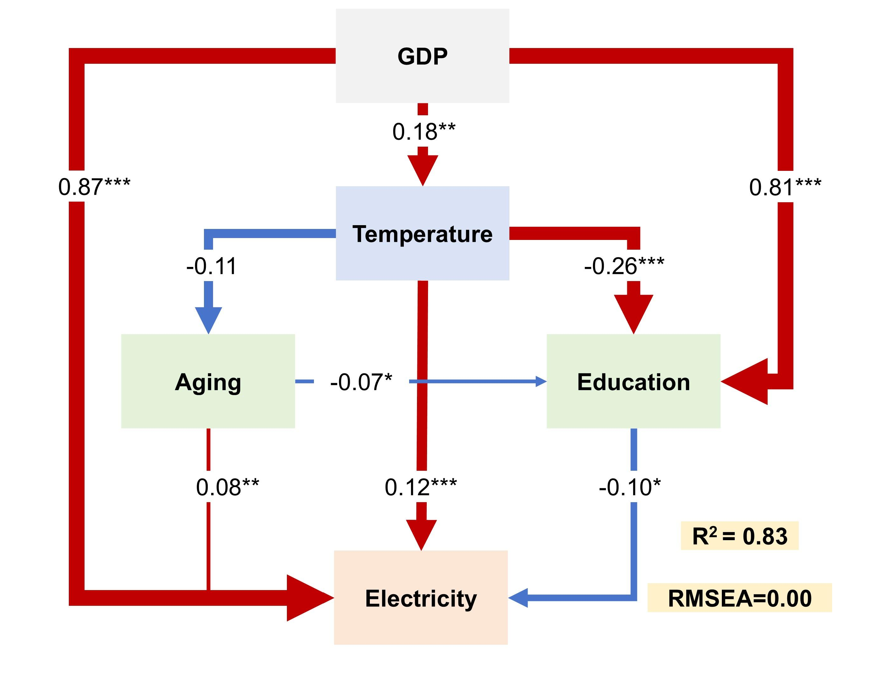

Fig. S1 | SEM of GDP impacts on residential electricity consumption intensity. The asterisks indicate the statistical significance level based on P values: *P < 0.1, **P < 0.05, ***P < 0.01. The numbers adjacent to the lines are the standardized path coefficients, indicating the degree of standard deviation changes in dependent variables if each of the independent variables change by one standard deviation. The blue and red lines represent positive and negative effects, respectively. The line width is proportional to the strength of the standardized path coefficient. Exact P values are listed in Table S5.

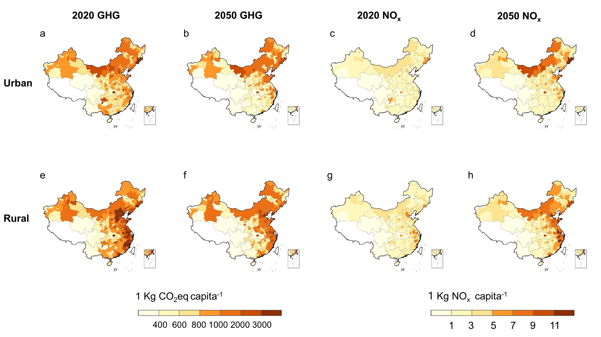

Fig. S2 | City-level spatial characteristics of GHG and NO_{x} emissions per capita from residential electricity consumption in 2020 and 2050. The two rows represent urban and rural, respectively. The first two columns represent GHG emissions per capita, and the last two columns represent NO_{x} emissions per capita. a-d, Urban spatial characteristics of GHG emissions per capita from residential electricity consumption in 2020 (a), 2050 (b), and NO_{x} emissions per capita from residential electricity consumption in 2020 (c), 2050 (d). e-h, Rural spatial characteristics of GHG emissions per capita from residential electricity consumption in 2020 (e), 2050 (f), and NO_{x} emissions per capita from residential electricity consumption in 2020 (g), 2050 (h).

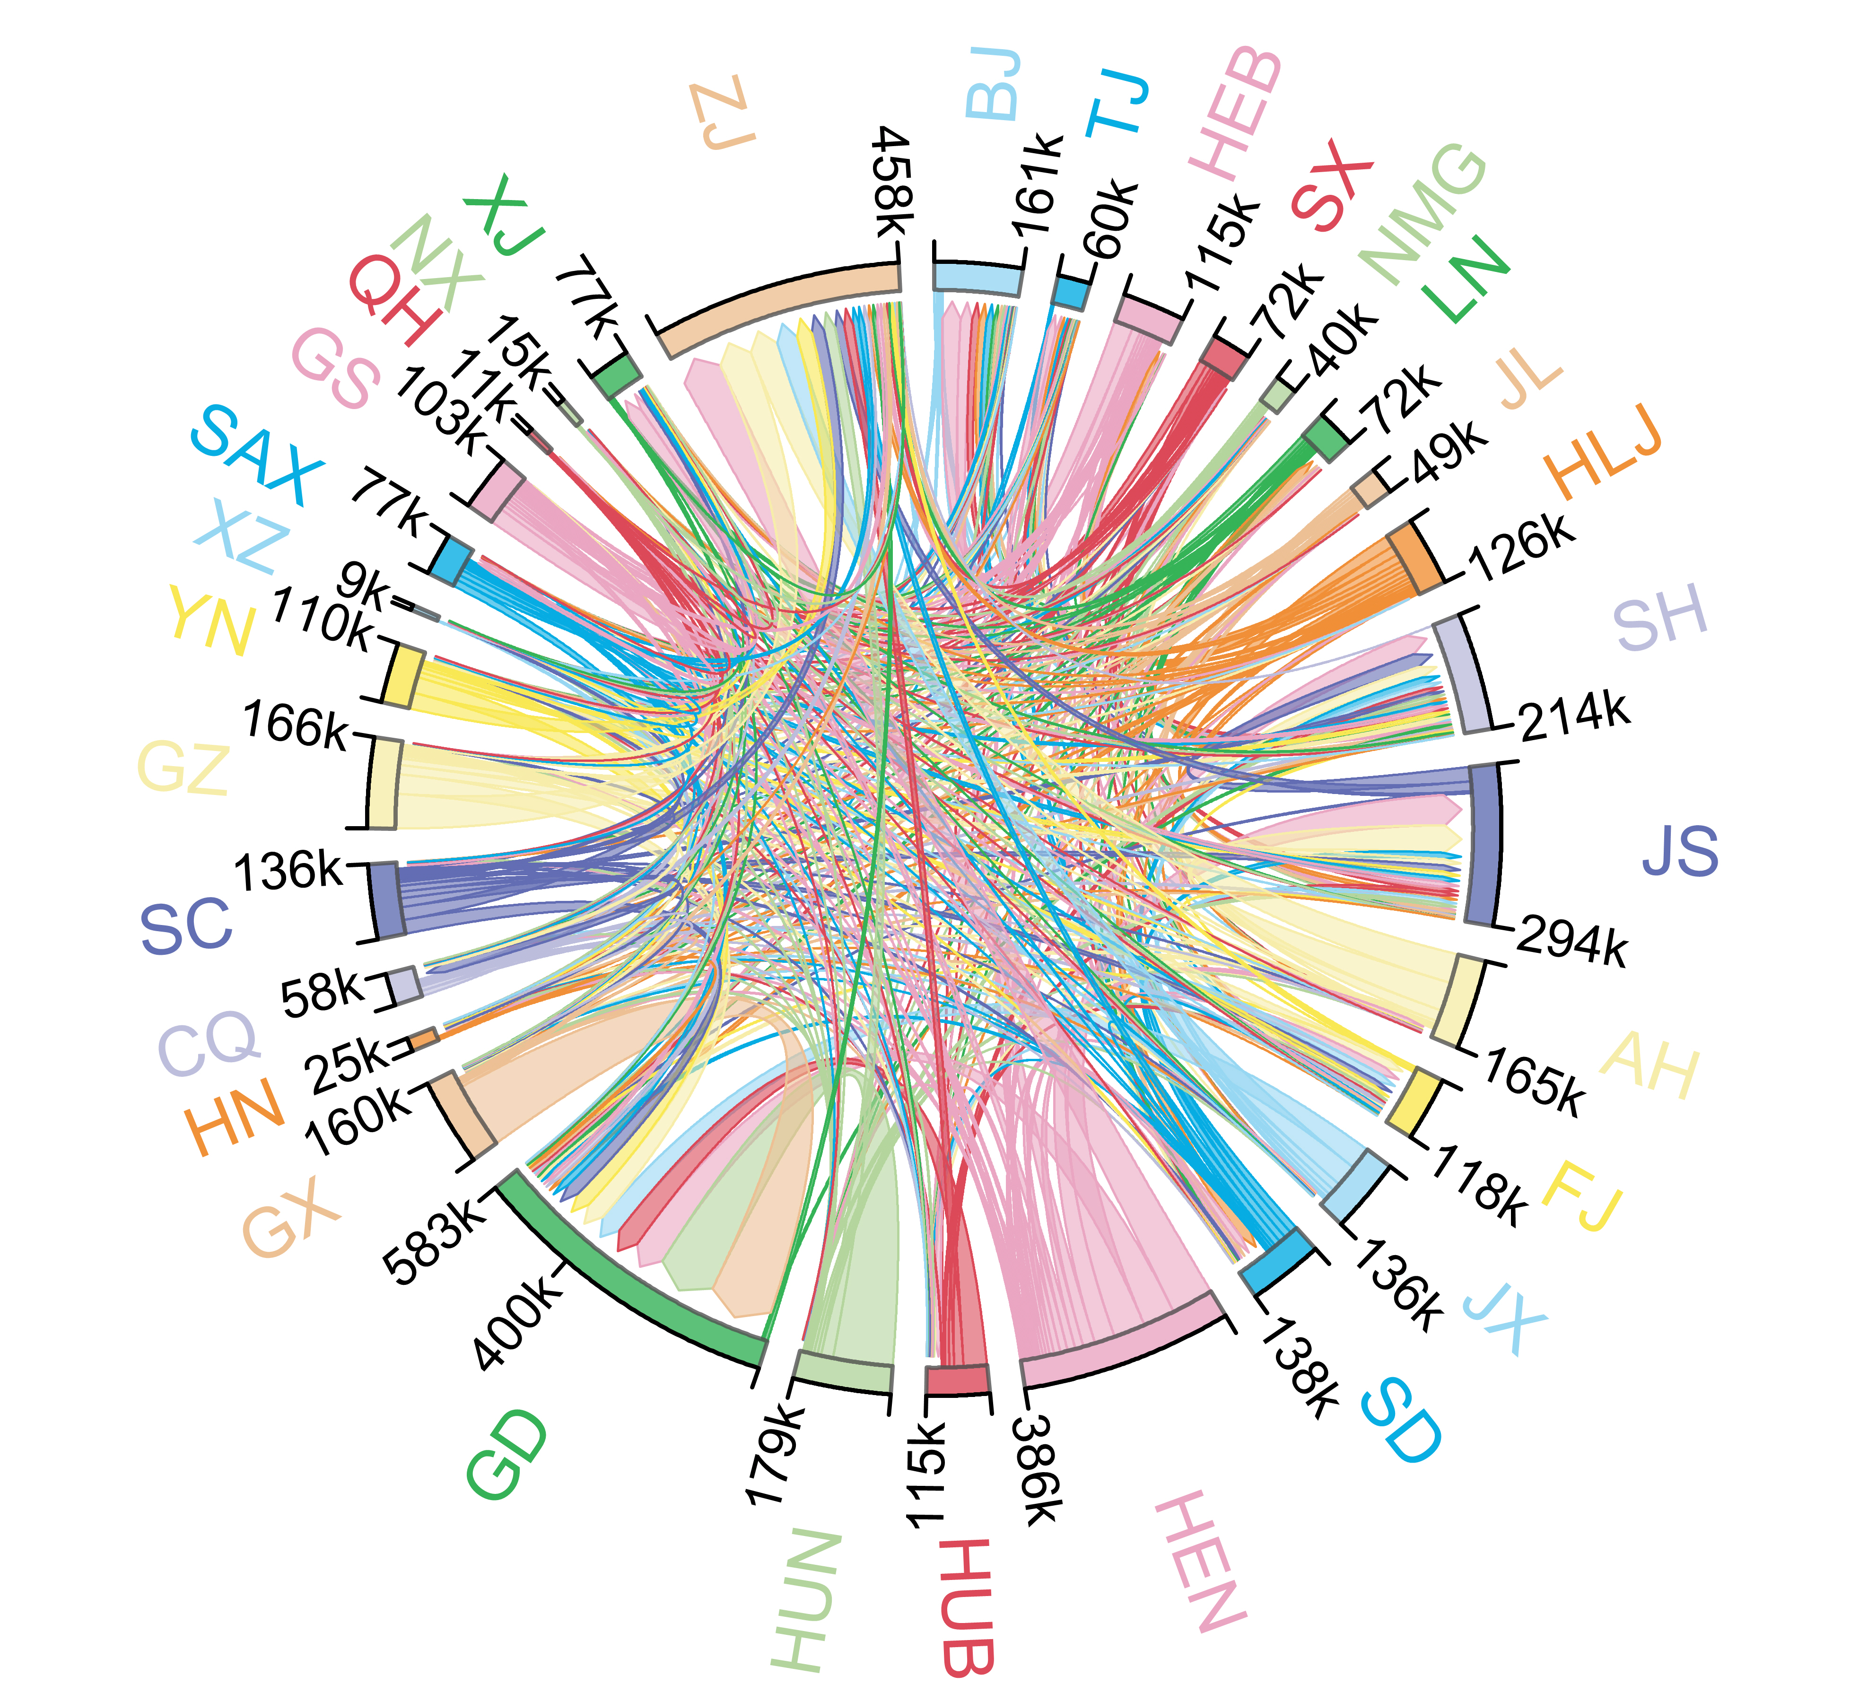

Fig. S3 | Inter-provincial net population migration flow of China from 2015 to 2020. The number represents the number of people, k means 1,000 capita. The capital letters with different colors represent the abbreviations of the 31 provinces of China; for the full names, see Table S11.

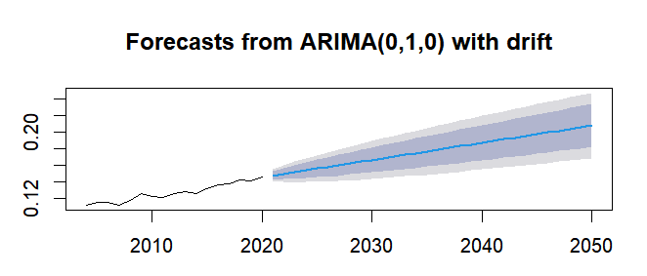

Fig. S4 | Forecast of the proportion of residential electricity consumption in total social electricity consumption in 2050 using ARIMA model. Vertical coordinate numbers indicate the share of residential electricity consumption in the total electricity consumption of the whole society (%), horizontal coordinates indicate the year, and the data start in 2004.

Supplementary Tables

Table S1 Future scenario description
Scenario | Scenario assumption
BAU  (Business As Usual) | Only consider GDP, following the conclusions of past studies. This scenario assumes that, in the future, population migration will prioritize regions with higher GDP, specifically the coastal urban clusters in eastern China, in accordance with historical urban-rural migration patterns
LECI  (Low Electricity Consumption Intensity) | Rural-to-urban migration will prioritize regions with lower residential electricity consumption intensity. Essentially, migration will tend to flow towards areas with slower economic development, lower temperatures, lower levels of aging, but relatively higher education levels
LEF  (Low Emission Factor per unit of Electricity Consumption） | Rural-to-urban migration will prioritize regions with lower electricity GHG and NO_{x} emission factors. Essentially, migration will tend to flow towards areas with a higher proportion of renewable energy and lower coal consumption per unit of electricity generation in coal-fired power plants.
ALL  (combined optimization of both) | Combining the LECI and LEF scenarios, rural to urban migration will prioritize regions with lower per capita electricity-related greenhouse gas and nitrogen emissions, as well as higher GDP.

Table S2 Historical changes in key indicators related to residential electricity consumption in China
 | Residential electricity consumption  (Billion kWh) |  |  |  | Residential electricity consumption intensity  (kWh per capita) |  |  |  | GHG emissions (Mt)
Year | Total | Urban | Rural | Change rate relative to 1990 (%) | Total | Urban | Rural | Change rate relative to 1990 (%) | Total | Urban | Rural | Change rate relative to 1990 (%)
1990 | 48.08 | 27.22 | 20.86 | 0.00 | 42.57 | 115.51 | 23.33 | 0.00 | 46.25 | 25.87 | 20.38 | 0.00
1995 | 100.37 | 57.58 | 42.79 | 1.09 | 84.72 | 203.89 | 47.42 | 0.99 | 95.27 | 54.03 | 41.24 | 1.06
2000 | 166.53 | 99.45 | 67.08 | 2.46 | 131.93 | 213.56 | 84.21 | 2.10 | 156.87 | 93.59 | 63.28 | 2.39
2005 | 283.18 | 173.19 | 109.99 | 4.89 | 220.19 | 309.10 | 151.55 | 4.17 | 266.56 | 161.91 | 104.65 | 4.76
2010 | 508.95 | 295.49 | 213.46 | 9.59 | 381.56 | 440.12 | 322.24 | 7.96 | 353.54 | 203.42 | 150.12 | 6.64
2015 | 732.26 | 414.19 | 318.07 | 14.23 | 530.25 | 523.76 | 538.95 | 11.46 | 685.02 | 388.20 | 296.82 | 13.81
2020 | 1094.61 | 615.72 | 478.89 | 21.77 | 776.44 | 684.14 | 939.39 | 17.24 | 713.70 | 397.39 | 316.95 | 14.43

 | GHG emissions per capita (Mt per capita) |  |  |  | NO_{x} emissions (10³ t) |  |  |  | NO_{x} emissions per capita (10³ t per capita)
Year | Total | Urban | Rural | Change rate relative to 1990 (%) | Total | Urban | Rural | Change rate relative to 1990 (%) | Total | Urban | Rural | Change rate relative to 1990 (%)
1990 | 40.95 | 109.77 | 22.80 | 0.00 | 196.50 | 109.91 | 86.59 | 0.00 | 0.17 | 0.47 | 0.10 | 0.00
1995 | 80.42 | 191.31 | 45.71 | 0.96 | 404.78 | 229.56 | 175.22 | 1.06 | 0.34 | 0.81 | 0.19 | 0.96
2000 | 124.28 | 200.98 | 79.44 | 2.04 | 666.49 | 397.63 | 268.86 | 2.39 | 0.53 | 0.85 | 0.34 | 2.04
2005 | 207.27 | 288.97 | 144.19 | 4.06 | 1132.48 | 687.88 | 444.60 | 4.76 | 0.88 | 1.23 | 0.61 | 4.06
2010 | 265.05 | 302.99 | 226.62 | 5.47 | 1521.18 | 878.00 | 643.18 | 6.74 | 1.14 | 1.31 | 0.97 | 5.56
2015 | 496.04 | 490.89 | 502.95 | 11.11 | 2974.55 | 1686.76 | 1287.79 | 14.14 | 2.15 | 2.13 | 2.18 | 11.38
2020 | 506.25 | 441.55 | 621.73 | 11.36 | 3073.29 | 1720.72 | 1355.61 | 14.64 | 2.18 | 1.91 | 2.66 | 11.53

 | Electricity GHG emission Factors  (kg CO₂eq/kWh) |  | Electricity NO_{x} emission Factors  (kg /kWh) |  | Coefficient of Variation between urban and rural residential electricity consumption intensity (%) | Coefficient of Variation between provincial residential electricity consumption intensity (%)
Year | Total | Change rate relative to 1990  (%) | Total | Change rate relative to 1990  (%)
1990 | 9.62 | 0.00 | 0.04 | 0.00 | 94 | 56
1995 | 9.49 | -0.01 | 0.04 | -0.01 | 88 | 55
2000 | 9.42 | -0.02 | 0.04 | -0.02 | 61 | 55
2005 | 9.41 | -0.02 | 0.04 | -0.02 | 48 | 52
2010 | 6.95 | -0.28 | 0.03 | -0.27 | 22 | 37
2015 | 9.35 | -0.03 | 0.04 | -0.01 | 2 | 27
2020 | 6.52 | -0.32 | 0.03 | -0.31 | 22 | 27

Table S3 Description of key conclusions under future scenarios and their differences from 2020
 | 2020 | Scenario
 | 2020 | BAU | LECI | LEF | ALL
Population (Billion capita) | 1.41 | 1.35 | 1.35 | 1.35 | 1.35
Urban population (Billion capita) | 0.90 | 1.05 | 1.05 | 1.05 | 1.05
Rural population (Billion capita) | 0.51 | 0.30 | 0.30 | 0.30 | 0.30
Urban area (10,000 ha) | 723.5 | 871.1 | 867.6 | 820.9 | 816.7
Rural area (10,000 ha) | 1451.7 | 813.6 | 672.3 | 465.0 | 554.5
Urban electricity consumption (Billion kWh) | 652.2 | 1291.6 | 1170.5 | 1279.2 | 1188.5
Rural electricity consumption (Billion kWh) | 442.4 | 499.0 | 321.9 | 407.3 | 268.2
Electricity consumption (Billion kWh) | 1094.6 | 1790.7 | 1492.4 | 1686.5 | 1456.7
GHG emission for urban electricity consumption (Mt) | 418.2 | 856.8 | 787.0 | 808.0 | 769.2
GHG emission for rural electricity consumption (Mt) | 296.2 | 317.9 | 195.3 | 215.7 | 144.0
GHG emission for electricity consumption (Mt) | 714.3 | 1174.8 | 982.3 | 1023.6 | 913.2
NO_{x} emission for urban electricity consumption (10³t) | 1812.8 | 3709.6 | 3384.3 | 3498.6 | 3329.0
NO_{x} emission for rural electricity consumption (10³t) | 1263.6 | 1385.3 | 855.2 | 931.2 | 632.5
NO_{x} emission for electricity consumption (10³t) | 3076.4 | 5094.9 | 4239.5 | 4429.8 | 3961.5
Urban sprawl area (10,000 ha) |  | 147.6 | 144.1 | 97.4 | 93.2
Rural reclamation area (10,000 ha) |  | 638.1 | 779.4 | 986.7 | 897.3
Demographic change (10,000 capita) |  | -5373.7 | -5743.4 | -5809.5 | -5702.4
Immigration regions (+) |  | Eastern Coastal Region (Yangtze River Delta Economic Zone, Northern Maritime Economic Zone, Pearl River Delta Economic Zone), Middle Reaches of the Yangtze River | Right of the Hu's line | Southern region below the Yangtze River | Central China
Emigration regions (-) |  | Middle and Lower Reaches of the Yellow Riverr, South of the Yangtze River Regions | North China | North east, North China | Eastern Coastal Region, North east
Urban sprawl leads to changes in GHG emissions (Mt) |  | 149.2 | 79.4 | 100.4 | 61.5
Rural reclamation leads to changes in GHG emissions (Mt) |  | 180.1 | 303.2 | 281.9 | 355.1
Urban sprawl leads to changes in NO_{x} emissions (10³t) |  | 648.7 | 323.3 | 437.6 | 268.1
Rural reclamation leads to changes in NO_{x} emissions (10³t) |  | 743.2 | 1274.8 | 1195.1 | 1500.9
Changes in GHG emissions by 2050 (Mt) |  | 460.4 | 267.9 | 309.3 | 198.8
Changes in NO_{x} emissions by 2050 (10³t) |  | 2018.5 | 1163.1 | 1353.4 | 885.2
The rate of change in GHG emissions |  | 64% | 38% | 43% | 28%
The rate of change in NO_{x} emissions |  | 66% | 38% | 44% | 29%

Table S4 Summary statistics for main variables used in regression analysis
 | Residential electricity consumption intensity in China
 | Obs | Mean | SD | Min | Max
Urbanization | 217 | 61.27 | 11.79 | 28.87 | 89.30
Ln GDP | 217 | 10.97 | 0.41 | 10.16 | 12.14
Education | 217 | 0.18 | 0.81 | 0.08 | 0.55
Aging | 217 | 0.12 | 0.03 | 0.05 | 0.19
Temperature | 217 | 14.94 | 5.70 | 3.01 | 25.84
Note: Urbanization is the proportion of urban population to the total population. Ln GDP is the logarithm of Gross Domestic Product per capita. Education is the proportion of the population with higher education relative to the total educated population. Aging is the proportion of population over 65 years of age divided by the total population. Temperature is average temperature by province.

Table S5 Path Coefficients and P-values of the Structural Equation Model (SEM)
Dependent variable | Independent variable | Path coefficient | P-values
Education | Temperature | -0.26*** | (0.000)
Education | Ln GDP | 0.81*** | (0.000)
Education | Aging | -0.07 | (0.100)
Temperature | Ln GDP | 0.18*** | (0.000)
Temperature | Aging | -0.11*** | (0.000)
Electricity | Education | -0.10** | (0.005)
Electricity | Temperature | 0.12* | (0.017)
Electricity | Ln GDP | 0.87*** | (0.000)
Electricity | Aging | 0.08* | (0.024)

Table S6 Comparison of carbon emission of domestic electricity from multiple sources
Data set | GHG emissions in 2020 (Mt) | Research Methods | Time frames are covered
This study 2020 scenario | 714 |  | 2020-2050
Chen et al., Energies. 2016¹² | 475.65 | SD Model | 2015-2020
Xing et al., Environmental Research Letters, 2021¹³ | 697.43 | AIM/Enduse model | 2010-2050
Zhang et al., Applied Energy, 2023¹⁴ | 836.84 | Decomposing  structural decomposition (DSD) | 2000-2020

Table S7 Reginal electricity grid GHG and NO_{x} emission factors in 2020
EF (kg kWh⁻¹) |  | 2020
Reginal power grids | Including provinces | GHG | NO_{x}
North China power grid | BJ, TJ, HEB, SX, SD, NMG | 0.9531 | 0.0040
Northeast China Power Grid | LN, JL, HLJ | 0.9194 | 0.0039
East China Power Grid | SH, JS, ZJ, AH, FJ | 0.6857 | 0.0030
Central China Power Grid | HEN, HUB, HUN, JX, SC, CQ | 0.4712 | 0.0020
Southern Power Grid | GD, GX, YN, GZ, HN | 0.4569 | 0.0020
Northwest Power Grid | SAX, GS, QH, NX, XJ | 0.6837 | 0.0033

Table S8 Provincial electricity GHG and NO_{x} emission factors in 2020
 | EF (kg kWh⁻¹)
Province | GHG | NO_{x}
Beijing | 0.7328 | 0.0029
Tianjin | 0.9165 | 0.0036
Hebei | 1.1721 | 0.0037
Shanxi | 0.9661 | 0.0046
Inner Mongolia | 1.0622 | 0.0051
Liaoning | 0.9281 | 0.0038
Jilin | 0.9321 | 0.0044
Heilongjiang | 0.9443 | 0.0043
Shanghai | 0.5957 | 0.0025
Jiangsu | 0.7527 | 0.0032
Zhejiang | 0.5755 | 0.0027
Anhui | 0.8576 | 0.0038
Fujian | 0.5397 | 0.0024
Jiangxi | 0.6970 | 0.0029
Shandong | 0.8331 | 0.0037
Henan | 0.7996 | 0.0037
Hubei | 0.3512 | 0.0015
Hunan | 0.5192 | 0.0021
Guangdong | 0.4962 | 0.0022
Guangxi | 0.5762 | 0.0022
Hainan | 0.5300 | 0.0024
Chongqing | 0.4922 | 0.0020
Sichuan | 0.1460 | 0.0005
Guizhou | 0.5041 | 0.0030
Yunnan | 0.1665 | 0.0006
Tibet | - | -
Shannxi | 0.7339 | 0.0033
Gansu | 0.4666 | 0.0022
Qinghai | 0.1018 | 0.0005
Ningxia | 0.8549 | 0.0042

Table S9 Mitigation benefits
 | Unit benefit (US$ kg N⁻¹) |  |  |  |  | Benefit (US$ billion)
 | Human health | Ecosystem | Climate damage |  |  | Human health |  |  | Ecosystem |  |  | Climate damage
NO_{x} | 18.7 | 8.1 | -3.6 |  |  | LECI-BAU | LEF-BAU | ALL-BAU | LECI-BAU | LEF-BAU | ALL-BAU | LECI-BAU | LEF-BAU | ALL-BAU
GHG | - | - | 9000 |  | NO_{x} | 16.00 | 12.44 | 21.19 | 6.93 | 5.39 | 9.18 | -3.09 | -2.40 | -4.09
 |  |  |  |  | GHG | - | - | - | - | - | - | 1.73 | 1.36 | 2.35
Note: original unit cost data are derived from Zhu et al. (2022)¹⁵.

Table S10 Comparison of the projected residential electricity energy mix in this study with GEIDCO and BCG projections.
 | This study  Projected urban-rural residential electricity consumption in 2050 |  |  |  | GEIDCO  Projected urban-rural residential electricity consumption in 2050 (converted) | BCG  Projected urban-rural residential electricity consumption in 2050 (converted)
Unit: TWh | BAU | LECI | LEF | ALL | - | -
Total | 1790 | 1492 | 1686 | 1457 | 3217 | 2565
Thermal power | 1210 | 987 | 1063 | 932 | 690 | 577
Biomass energy | 32 | 26 | 28 | 24 | 161 | 41
Hydro power | 329 | 300 | 386 | 332 | 564 | 400
Nuclear power | 107 | 77 | 106 | 74 | 305 | 287
Wind power | 90 | 82 | 82 | 76 | 758 | 667
Solar power | 53 | 46 | 48 | 43 | 739 | 593
Note: GEIDCO is projection from the Global Energy Interconnection Development and Cooperation Organization, BCG is projection from the Boston Consulting Group.

Table S11 Full names and abbreviations of China's provinces
Province | Abbreviation |  | Province | Abbreviation
Beijing | BJ |  | Hubei | HUB
Tianjin | TJ |  | Hunan | HUN
Hebei | HEB |  | Guangdong | GD
Shanxi | SX |  | Guangxi | GX
Inner Mongolia | NMG |  | Hainan | HN
Liaoning | LN |  | Chongqing | CQ
Jilin | JL |  | Sichuan | SC
Heilongjiang | HLJ |  | Guizhou | GZ
Shanghai | SH |  | Yunnan | YN
Jiangsu | JS |  | Tibet | XZ
Zhejiang | ZJ |  | Shanxi | SAX
Anhui | AH |  | Gansu | GS
Fujian | FJ |  | Qinghai | QH
Jiangxi | JX |  | Ningxia | NX
Shandong | SD |  | Xinjiang | XJ
Henan | HEN

References
1. China Statistics Press. China Energy Statistical Yearbook 2021. (2021).
2. State Administration for State Organ Affairs. Statistical system for energy resource consumption in public institutions. https://ecpi.ggj.gov.cn/zlxz/201707/t20170728_40347.htm. (2017).
3. Yueyang Statistics Bureau. Reference coefficients for converting various energy sources to standard coal. https://tjj.yueyang.gov.cn/22771/22774/content_1983338.html. (2022).
4. International Renewable Energy Agency. Statistical Profiles. https: // www. irena. org. (2022).
5. IPCC, 2006 IPCC Guidelines for National Greenhouse Gas Inventories, Prepared by the National Greenhouse Gas Inventories Programme, Eggleston H.S., Buendia L., Miwa K., Ngara T. and Tanabe K. (eds). (IGES, 2006). https://www.ipcc-nggip.iges.or.jp/public/2006gl/index.html.
6. National Development and Reform Commission. Guidelines for the preparation of provincial greenhouse gas inventory (Trial). http://www.ncsc.org.cn/SY/tjkhybg/202003/t20200319_769763.shtml. (2011).
7. National Development and Reform Commission. Research on China’s greenhouse gas inventory: 2005. (China Environmental Science Press, 2014).
8. National Development and Reform Commission. Accounting methods and reporting guidelines for greenhouse gas emissions of Chinese power generation enterprises (Trial). https://www.gov.cn/gzdt/att/att/site1/20131104/001e3741a2cc13e13f1101.pdf. (2013).
9. IPCC. Summary for Policymakers. In: Climate Change 2021: The Physical Science Basis. Contribution of Working Group I to the Sixth Assessment Report of the Intergovernmental Panel on Climate Change. (Cambridge University Press, 2021)..
10. China Electricity Council. Compilation of Electricity Industry statistics 2020. http://60.16.24.131/CSYDMirror/trade/Yearbook/Single/N2022060182?z=Z025. (2021).
11. Hao, J., Tian, H. & Lu, Y. Emission Inventories of NOx from Commercial Energy Consumption in China, 1995−1998. Environ. Sci. Technol. 36, 552-560 (2002).
12. Chen, X., Wang, G., Guo, X. & Fu, J. An Analysis Based on SD Model for Energy-Related CO 2 Mitigation in the Chinese Household Sector. Energies 9 (2016).
13. Xing, R., Hanaoka, T. & Masui, T. Deep decarbonization pathways in the building sector: China’s NDC and the Paris agreement. Environ. Res. Lett. 16, 44054 (2021).
14. Zhang, S. et al. Pathway for decarbonizing residential building operations in the US and China beyond the mid-century. Appl. Energy 342, 121164 (2023).
15. Zhu, Z. et al. Integrated livestock sector nitrogen pollution abatement measures could generate net benefits for human and ecosystem health in China. Nat. Food 3, 161-168 (2022).

