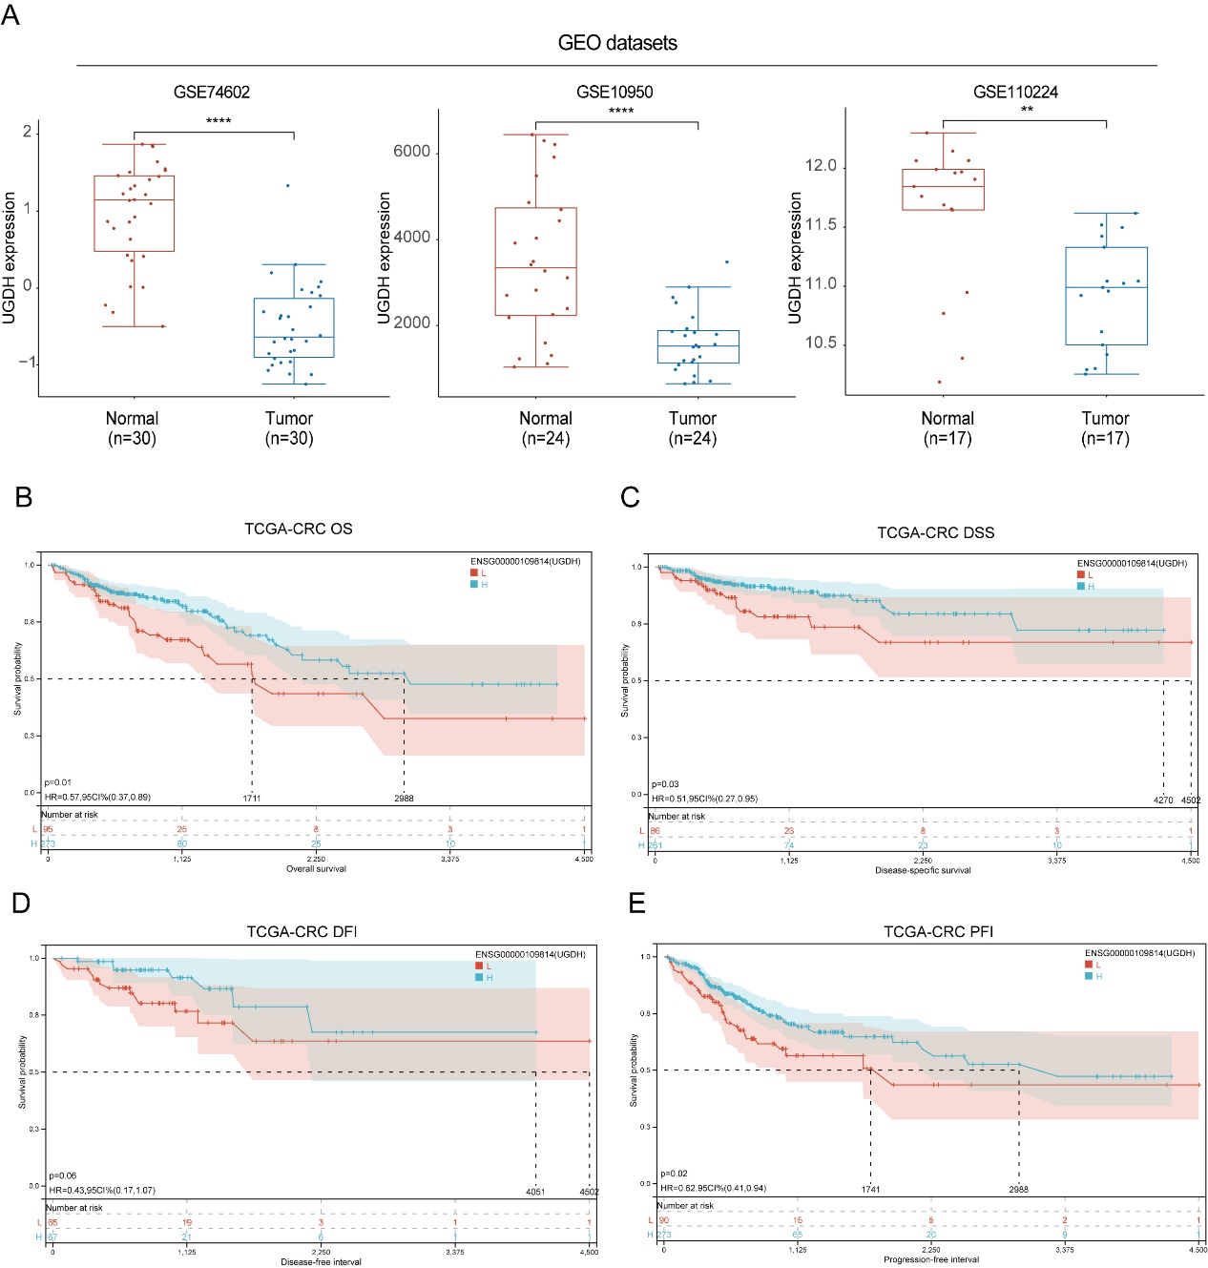
Figure S1. UGDH mRNA expression in GEO datasets and prognostic analysis in TGCA database. (A) UGDH expression analysis between the normal and CRC tissues in GSE74602, GSE10950, and GSE110224 datasets. (B) The OS analysis between UGDH mRNA expression and CRC in the TCGA database. (C) The DSS analysis between UGDH mRNA expression and CRC in the TCGA database. (D) The DFI analysis between UGDH mRNA expression and CRC in the TCGA database. (E) The PFI analysis between UGDH mRNA expression and CRC in the TCGA database.
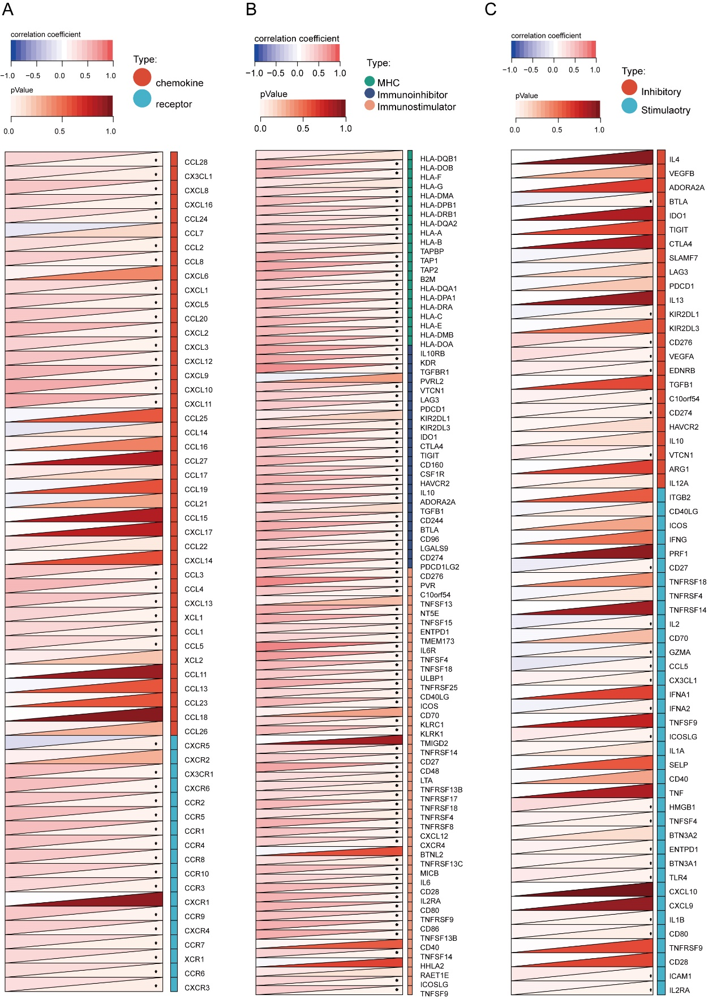
Figure S2. Correlation analysis between UGDH and immune-related gene expression. (A) Correlation analysis between UGDH to chemokines and receptors. (B) Correlation analysis between UGDH to immunomodulators. (C) Correlation analysis between UGDH to inhibitory and stimulatory genes.

