CNOT1 contributes to small nuclear non-coding RNA maturation

Chisato Umehara1,3, Reika Sakurai1,3, Hiroaki Sako2,3*, Tadashi Yamamoto2*

¹ Keio University School of Medicine, 35 Shinanomachi, Shinjuku, Tokyo 160-8582, Japan
² Cell Signal Unit, Okinawa Institute of Science and Technology Graduate University (OIST), Onna, Okinawa 904-0495, Japan.

* co-corresponding
³ These authors contributed equally

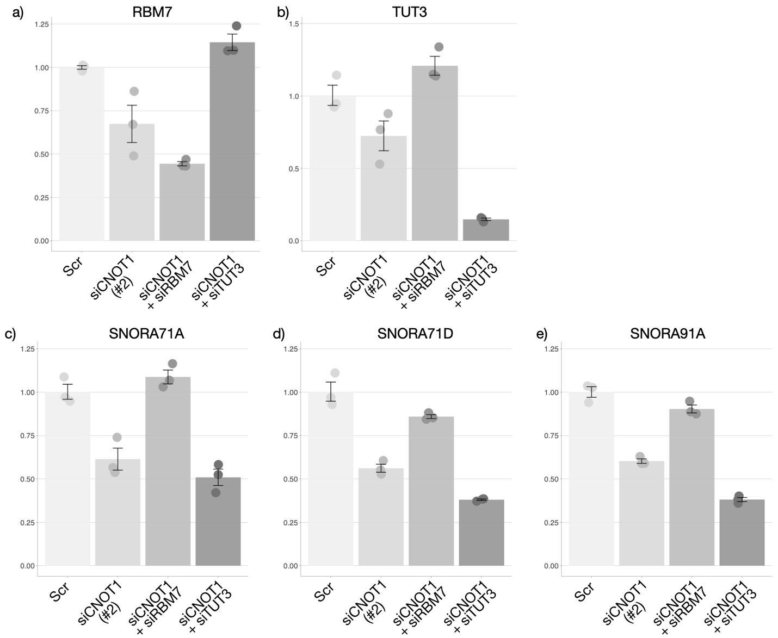
Supplementary Figure 1. Knockdown of RBM7, but not TUT3 rescued the effect of CNOT1 depletion on sno/scaRNAs.
HEK293T cells were treated with Scr control, siCNOT1, or siCNOT1 together with siRBM7 or TUT3 for 96 hr, followed by RT-qPCR analysis (a-e). N=3. Mean ± SE.

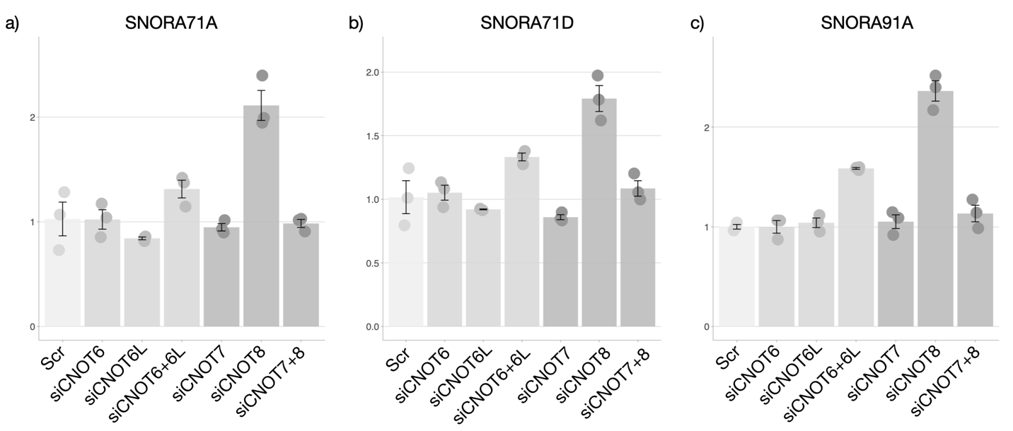

Supplementary Figure 2. Knockdown of deadenylase subunits of CCR4-NOT did not reduce the expression of snoRNAs.
HEK293T cells were treated with Scr control, combination of siCNOT6, siCNOT6L, siCNOT7, and siCNOT8 followed by RT-qPCR analysis (a-c). N=3. Mean ± SE.

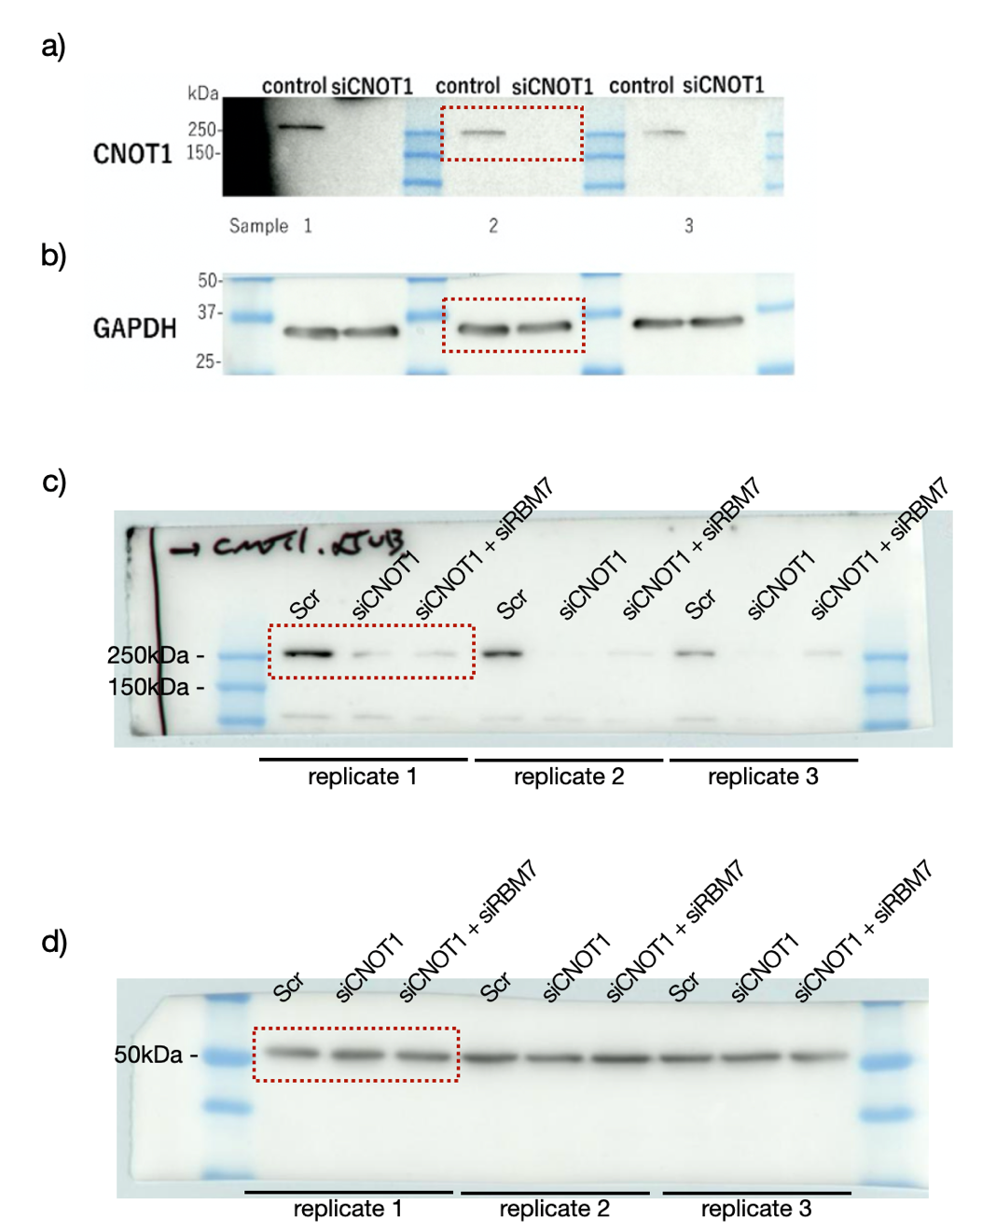

Supplementary Figure 3. Uncropped western blot images with replicates.
Red dashed lines were cropped to yield the representative images shown in Figure 3a (a, b) as well as Figure 6a (c, d).

Supplementary Table 1. Primer suqences
EBLN3P_Fw | gtgCATACAGACACACAtatttctg
EBLN3P_Rv | ccaatctagaaaatctgaacaccgg
LINC01003_Fw | GTCAACAAATACTTCTTGGACGT
LINC01003_Rv | CATAGTAATATTTTATTTTCTTCCCAATGTGG
SCARNA5_Fw | GGCTCACAGCTGACGAGTATC
SCARNA5_Rv | TGCACCATCACACCCATGAC
SCARNA6_Fw | CACTCCGTGATGTCCCTCAT
SCARNA6_Rv | ACAGATACCAGCACTCCCAAC
SCARNA7_Fw | GTGTGTGCTTGTGGTGGCTA
SCARNA7_Rv | CAGGCTAGTTAGGTGAGCTGT
SCARNA13_Fw | GAGCACACCAGACTTGCAGA
SCARNA13_Rv | CGTGGCAACAGTGACCAGAA
SCARNA27_Fw | CATGGTTTGGGGCTGCTATCT
SCARNA27_Rv | GTAGGAGGCTTTTTCAGAGGAGAA
SNORA12_Fw | ATGGCAAAGGCTTGTGACGG
SNORA12_Rv | GGAGCCATTCTCTGATGCAGG
SNORA71A_Fw | CTGAAAGAGGTTGTCCCCGT
SNORA71A_Rv | GTTGTGTGAAAGCTTCAGGGT
SNORA71D_Fw | TCGAAAGTGATCGTGGGCT
SNORA71D_Rv | GAAGCACTTTCCGCGATTTCT
SNORA73B_Fw | CCAACGTGGATACCCTGGGA
SNORA73B_Rv | CACAGGACTCTGGGAAGCTGTA
SNORD69_Fw | GTGAAGCAAATGATGATAAACTGGA
SNORD69_Rv | AACATGAAGCTCAGGGTTGGA
SNORD91A_Fw | GGTTTTATTCATATCGTCTGAACCT
SNORD91A_Rv | AGTCTCAGAACCACACAGAGA
SNORD104_Fw | CCTGCTGTGATGACATTCCAATTA
SNORD104_Rv | CTCAGACTCCAGTTCGCATCA
TSR1_Fw | AAGCTCATAAAGGCGGACGG
TSR1_Rv | CTTCTCTGCCAGAACCGCC
SNHG17_Fw | CTGGGATCTGGGTTTGCTGA
SNHG17_Rv | ATTGAACAGTGGATCCGGGG
RBM7_Fw | ACCAGGCTGGGCCAGTAATA
RBM7_Rv | TGGGGCATGACTACTTCCTGA

Supplementary Table 2. siRNA suqences
Scr | UUCUCCGAACGUGUCACGUTT
siCNOT1 #1 | CUUCACGUCGUGAAUACCUCA
siCNOT1 #2 | UGCUCCUGACCUCUGAUAAAG
siCNOT6 | GGUUGAAACGGAACAGUAUUA
siCNOT6L | GACCCAGAGUAUUCUGAUGTT
siCNOT7 | GGUGUAAUGUAGACUUGUUAA
siCNOT8 | GACCCUUCUCGAGGACAUUUG
siTUT3 | GGACGACACUUCAAUUAUUGU
siRBM7 | #4427037 (ID# s19835, Silence Select Pre-Designed siRNA, Invitrogen)

