Extensive mapping of somatosensory perception thresholds in the upper limb: interaction between gender and stimulation position
Carolina Travassos^{1,2}, Alexandre Sayal^{1,2}, Bruno Direito^{1,3,4}, Paulo Fonte^{1,5,6}, Teresa Sousa^{1,4,7}, and Miguel Castelo-Branco^{1,4,7,*}
¹Coimbra Institute for Biomedical Imaging and Translational Research (CIBIT), Institute for Nuclear Sciences Applied to Health (ICNAS), University of Coimbra (UC), Pólo das Ciências da Saúde Azinhaga de R. Santa Comba, 3000-548, Coimbra, Portugal
²Siemens Healthineers, Rua Irmãos Siemens, 1 - 1A, 2720-093, Lisbon, Portugal
³Centre for Informatics and Systems of the University of Coimbra (CISUC), Rua Miguel Bombarda, 3030-790 Coimbra, Portugal
⁴Intelligent Systems Associate Laboratory (LASI), Escola de Engenharia - Universidade do Minho, Campus Azurém, 4800-058 Guimarães, Portugal
⁵Laboratory of Instrumentation and Experimental Particle Physics (LIP), Departamento de Física da Universidade de Coimbra, Rua Larga, 3004-516 Coimbra, Portugal
⁶Polytechnic Institute of Coimbra, Coimbra Institute of Engineering, Rua Pedro Nunes - Quinta da Nora, 3030-199 Coimbra, Portugal
⁷Medicine faculty, University of Coimbra (UC), Coimbra, Portugal
*mcbranco@fmed.uc.pt

Somatosensory Electrocutaneous Perception Thresholds
Supplementary Table 1 - Results of the mixed-effects analyses performed to study the effect of gender and stimulation segments on the perception thresholds: estimates of interactions and posthoc tests, as well as, effect size (Cohen’s d) are shown. Significant differences (p < 0.05) are highlighted with bold lettering. Post-hoc tests, when fixing the stimulation segment, were corrected using Bonferroni for multiple comparisons.
Perception thresholds (mA)
Difference between gender per stimulation segment | Estimate | p-corr. | Effect size
Male - Female (Middle finger)  Male - Female (Hand)  Male - Female (Forearm)  Male - Female (Arm) | 0.279 ± 0.098  0.187 ± 0.093  0.433 ± 0.087  0.334 ± 0.086 | 0.006  0.050  1.900 x ${10}^{-5}$  4.690 x ${10}^{-4}$ | 0.581  0.412  1.011  0.794

Supplementary Table 2 - Results of the mixed-effects analyses performed to study the effect of gender and stimulation segments on the perception thresholds: estimates of interactions and posthoc tests, as well as, effect size (Cohen’s d) are shown. Significant differences (p < 0.05) are highlighted with bold lettering. Post-hoc tests, when fixing gender, were corrected using Bonferroni for multiple comparisons.
Perception thresholds (mA)
Difference between stimulation segments per gender | Estimate | p-corr. | Effect size
Female:  Middle finger-Hand  Middle finger-Forearm  Middle finger-Arm  Hand-Forearm  Hand-Arm  Forearm-Arm  Male:  Middle finger-Hand  Middle finger-Forearm  Middle finger-Arm  Hand-Forearm  Hand-Arm  Forearm-Arm | 0.015 ± 0.058  0.731 ± 0.053  0.754 ± 0.052  0.715 ± 0.048  0.738 ± 0.047  0.023 ± 0.041  0.109 ± 0.057  0.577 ± 0.053  0.699 ± 0.052  0.470 ± 0.048  0.591 ± 0.047  0.122 ± 0.041 | 1.000  2.543 x ${10}^{-38}$  3.237 x ${10}^{-42}$  5.189 x ${10}^{-44}$  6.106 x${10}^{-49}$  1.000  0.365  2.889 x ${10}^{-25}$  3.025 x ${10}^{-37}$  7.286 x ${10}^{-21}$  1.9783 x ${10}^{-33}$  0.020 | 0.054  2.800  2.957  3.024  3.213  0.113  0.383  2.221  2.755  2.001  2.591  0.603

Supplementary Table 3 - Results of the mixed-effects analyses performed to study the effect of gender and stimulation position on the perception thresholds: estimates of interactions and posthoc tests, as well as, effect size (Cohen’s d) are shown. Significant differences (p < 0.05) are highlighted with bold lettering. Post-hoc tests, when fixing the stimulation position, were corrected using Bonferroni for multiple comparisons.
Perception thresholds (mA)
Difference between gender per stimulation position | Estimate | p-corr. | Effect size
Male - Female (E1)  Male - Female (E2)  Male - Female (E3)  Male - Female (E4)  Male - Female (E5)  Male - Female (E6)  Male - Female (E7)  Male - Female (E8)  Male - Female (E9)  Male - Female (E10)  Male - Female (E11)  Male - Female (E12)  Male - Female (E13)  Male - Female (E14)  Male - Female (E15)  Male - Female (E16)  Male - Female (E17)  Male - Female (E18)  Male - Female (E19)  Male - Female (E20) | 0.306 ± 0.124  0.084 ± 0.122  0.449 ± 0.121  0.031 ± 0.123  0.142 ± 0.121  0.159 ± 0.121  0.415 ± 0.121  0.395 ± 0.121  0.330 ± 0.121  0.555 ± 0.121  0.424 ± 0.121  0.524 ± 0.121  0.370 ± 0.121  0.340 ± 0.121  0.305 ± 0.121  0.361 ± 0.121  0.467 ± 0.121  0.278 ± 0.121  0.280 ± 0.121  0.309 ± 0.121 | 0.015  0.489  3.080 x ${10}^{-4}$  0.802  0.240  0.190  7.990 x ${10}^{-4}$  0.001  0.007  1.100 x ${10}^{-5}$  6.330 x ${10}^{-4}$  2.800 x ${10}^{-5}$  0.003  0.006  0.013  0.003  1.760 x ${10}^{-4}$  0.023  0.022  0.012 | 0.504  0.142  0.759  0.051  0.241  0.269  0.702  0.668  0.558  0.938  0.717  0.889  0.625  0.575  0.516  0.610  0.789  0.470  0.473  0.522

Supplementary Table 4 - Results of the mixed-effects analyses performed to study the effect of gender and stimulation position on the perception thresholds: estimates of interactions and posthoc tests, as well as, effect size (Cohen’s d) are shown. Significant differences (p < 0.05) are highlighted with bold lettering. Post-hoc tests, when fixing gender, were corrected using Bonferroni for multiple comparisons.
Perception thresholds (mA)
Difference | Estimate |  | p-corr. |  | Effect size
Difference | Female | Male | Female | Male | Female | Male
E1-E2  E1-E3  E1-E4  E1-E5  E1-E6  E1-E7  E1-E8  E1-E9  E1-E10  E1-E11  E1-E12  E1-E13  E1-E14  E1-E15  E1-E16  E1-E17  E1-E18  E1-E19  E1-E20  E2-E3  E2-E4  E2-E5  E2-E6  E2-E7  E2-E8  E2-E9  E2-E10  E2-E11  E2-E12  E2-E13  E2-E14  E2-E15  E2-E16  E2-E17  E2-E18  E2-E19  E2-E20  E3-E4  E3-E5  E3-E6  E3-E7  E3-E8  E3-E9  E3-E10  E3-E11  E3-E12  E3-E13  E3-E14  E3-E15  E3-E16  E3-E17  E3-E18  E3-E19  E3-E20  E4-E5  E4-E6  E4-E7  E4-E8  E4-E9  E4-E10  E4-E11  E4-E12  E4-E13  E4-E14  E4-E15  E4-E16  E4-E17  E4-E18  E4-E19  E4-E20  E5-E6  E5-E7  E5-E8  E5-E9  E5-E10  E5-E11  E5-E12  E5-E13  E5-E14  E5-E15  E5-E16  E5-E17  E5-E18  E5-E19  E5-E20  E6-E7  E6-E8  E6-E9  E6-E10  E6-E11  E6-E12  E6-E13  E6-E14  E6-E15  E6-E16  E6-E17  E6-E18  E6-E19  E6-E20  E7-E8  E7-E9  E7-E10  E7-E11  E7-E12  E7-E13  E7-E14  E7-E15  E7-E16  E7-E17  E7-E18  E7-E19  E7-E20  E8-E9  E8-E10  E8-E11  E8-E12  E8-E13  E8-E14  E8-E15  E8-E16  E8-E17  E8-E18  E8-E19  E8-E20  E9-E10  E9-E11  E9-E12  E9-E13  E9-E14  E9-E15  E9-E16  E9-E17  E9-E18  E9-E19  E9-E20  E10-E11  E10-E12  E10-E13  E10-E14  E10-E15  E10-E16  E10-E17  E10-E18  E10-E19  E10-E20  E11-E12  E11-E13  E11-E14  E11-E15  E11-E16  E11-E17  E11-E18  E11-E19  E11-E20  E12-E13  E12-E14  E12-E15  E12-E16  E12-E17  E12-E18  E12-E19  E12-E20  E13-E14  E13-E15  E13-E16  E13-E17  E13-E18  E13-E19  E13-E20  E14-E15  E14-E16  E14-E17  E14-E18  E14-E19  E14-E20  E15-E16  E15-E17  E15-E18  E15-E19  E15-E20  E16-E17  E16-E18  E16-E19  E16-E20  E17-E18  E17-E19  E17-E20  E18-E19  E18-E20  E19-E20 | -0.377 ± 0.096  -0.565 ± 0.095  -0.326 ± 0.097  -0.206 ± 0.095  -0.419 ± 0.095  -0.279 ± 0.095  0.102 ± 0.095  0.269 ± 0.095  0.400 ± 0.095  0.477 ± 0.095  0.562 ± 0.095  0.639 ± 0.095  0.562 ± 0.095  0.558 ± 0.095  0.529 ± 0.095  0.460 ± 0.095  0.329 ± 0.095  0.233 ± 0.095  0.346 ± 0.095  -0.188 ± 0.094  0.051 ± 0.096  0.171 ± 0.094  -0.042 ± 0.094  0.098 ± 0.094  0.479 ± 0.094  0.646 ± 0.094  0.777 ± 0.094  0.854 ± 0.094  0.939 ± 0.094  1.016 ± 0.094  0.939 ± 0.094  0.935 ± 0.094  0.906 ± 0.094  0.837 ± 0.094  0.706 ± 0.094  0.610 ± 0.094  0.723 ± 0.094  0.238 ± 0.095  0.358 ± 0.093  0.146 ± 0.093  0.285 ± 0.093  0.667 ± 0.093  0.833 ± 0.093  0.965 ± 0.093  1.042 ± 0.093  1.127 ± 0.093  1.204 ± 0.093  1.127 ± 0.093  1.123 ± 0.093  1.094 ± 0.093  1.025 ± 0.093  0.894 ± 0.093  0.798 ± 0.093  0.910 ± 0.093  0.120 ± 0.095  -0.093 ± 0.095  0.047 ± 0.095  0.428 ± 0.095  0.595 ± 0.095  0.726 ± 0.095  0.803 ± 0.095  0.889 ± 0.095  0.966 ± 0.095  0.889 ± 0.095  0.884 ± 0.095  0.855 ± 0.095  0.787 ± 0.095  0.655 ± 0.095  0.559 ± 0.095  0.672 ± 0.095  -0.213 ± 0.093  -0.073 ± 0.093  0.308 ± 0.093  0.475 ± 0.093  0.606 ± 0.093  0.683 ± 0.093  0.769 ± 0.093  0.846 ± 0.093  0.769 ± 0.093  0.765 ± 0.093  0.735 ± 0.093  0.667 ± 0.093  0.535 ± 0.093  0.440 ± 0.093  0.552 ± 0.093  0.140 ± 0.093  0.521 ± 0.093  0.688 ± 0.093  0.819 ± 0.093  0.896 ± 0.093  0.981 ± 0.093  1.058 ± 0.093  0.981 ± 0.093  0.977 ± 0.093  0.948 ± 0.093  0.879 ± 0.093  0.748 ± 0.093  0.652 ± 0.093  0.765 ± 0.093  0.381 ± 0.093  0.548 ± 0.093  0.679 ± 0.093  0.756 ± 0.093  0.842 ± 0.093  0.919 ± 0.093  0.842 ± 0.093  0.838 ± 0.093  0.808 ± 0.093  0.740 ± 0.093  0.608 ± 0.093  0.513 ± 0.093  0.625 ± 0.093  0.167 ± 0.093  0.298 ± 0.093  0.375 ± 0.093  0.460 ± 0.093  0.538 ± 0.093  0.460 ± 0.093  0.456 ± 0.093  0.427 ± 0.093  0.358 ± 0.093  0.227 ± 0.093  0.131 ± 0.093  0.244 ± 0.093  0.131 ± 0.093  0.131 ± 0.093  0.131 ± 0.093  0.131 ± 0.093  0.131 ± 0.093  0.131 ± 0.093  0.131 ± 0.093  0.131 ± 0.093  0.131 ± 0.093  0.131 ± 0.093  0.131 ± 0.093  0.077 ± 0.093  0.163 ± 0.093  0.240 ± 0.093  0.163 ± 0.093  0.158 ± 0.093  0.129 ± 0.093  0.060 ± 0.093  -0.071 ± 0.093  -0.167 ± 0.093  -0.054 ± 0.093  0.085 ± 0.093  0.163 ± 0.093  0.085 ± 0.093  0.081 ± 0.093  0.052 ± 0.093  -0.017 ± 0.093  -0.148 ± 0.093  -0.244 ± 0.093  -0.131 ± 0.093  0.077 ± 0.093  1x${10}^{-16}$ ± 0.093  -0.004 ± 0.093  -0.033 ± 0.093  -0.102 ± 0.093  -0.233 ± 0.093  -0.329 ± 0.093  -0.217 ± 0.093  -0.077 ± 0.093  -0.081 ± 0.093  -0.110 ± 0.093  -0.179 ± 0.093  -0.310 ± 0.093  -0.406 ± 0.093  -0.294 ± 0.093  -0.004 ± 0.093  -0.033 ± 0.093  -0.102 ± 0.093  -0.233 ± 0.093  -0.329 ± 0.093  -0.217 ± 0.093  -0.029 ± 0.093  -0.098 ± 0.093  -0.229 ± 0.093  -0.325 ± 0.093  -0.212 ± 0.093  -0.069 ± 0.093  -0.200 ± 0.093  -0.296 ± 0.093  -0.183 ± 0.093  -0.131 ± 0.093  -0.227 ± 0.093  -0.115 ± 0.093  -0.096 ± 0.093  0.017 ± 0.093  0.113 ± 0.093 | -0.155 ± 0.095  -0.707 ± 0.095  -0.051 ± 0.095  -0.043 ± 0.095  -0.272 ± 0.095  -0.389 ± 0.095  0.014 ± 0.095  0.245 ± 0.095  0.151 ± 0.095  .359 ± 0.095  0.343 ± 0.095  0.576 ± 0.095  0.528 ± 0.095  0.559 ± 0.095  0.474 ± 0.095  0.299 ± 0.095  0.357 ± 0.095  0.259 ± 0.095  0.343 ± 0.095  -0.552 ± 0.093  0.104 ± 0.093  0.113 ± 0.093  -0.117 ± 0.093  -0.233 ± 0.093  0.169 ± 0.093  0.400 ± 0.093  0.306 ± 0.093  0.515 ± 0.093  0.498 ± 0.093  0.731 ± 0.093  0.683 ± 0.093  0.715 ± 0.093  0.629 ± 0.093  0.454 ± 0.093  0.512 ± 0.093  0.415 ± 0.093  0.498 ± 0.093  0.656 ± 0.093  0.665 ± 0.093  0.435 ± 0.093  0.319 ± 0.093  0.721 ± 0.093  0.952 ± 0.093  0.858 ± 0.093  1.067 ± 0.093  1.050 ± 0.093  1.283 ± 0.093  1.235 ± 0.093  1.267 ± 0.093  1.181 ± 0.093  1.006 ± 0.093  1.065 ± 0.093  0.967 ± 0.093  1.050 ± 0.093  0.008 ± 0.093  -0.221 ± 0.093  -0.338 ± 0.093  0.065 ± 0.093  0.296 ± 0.093  0.202 ± 0.093  0.410 ± 0.093  0.394 ± 0.093  0.627 ± 0.093  0.579 ± 0.093  0.610 ± 0.093  0.525 ± 0.093  0.350 ± 0.093  0.408 ± 0.093  0.310 ± 0.093  0.394 ± 0.093  -0.229 ± 0.093  -0.346 ± 0.093  0.056 ± 0.093  0.288 ± 0.093  0.194 ± 0.093  0.402 ± 0.093  0.385 ± 0.093  0.619 ± 0.093  0.571 ± 0.093  0.602 ± 0.093  0.517 ± 0.093  0.342 ± 0.093  0.400 ± 0.093  0.302 ± 0.093  0.385 ± 0.093  -0.117 ± 0.093  0.285 ± 0.093  0.517 ± 0.093  0.423 ± 0.093  0.631 ± 0.093  0.615 ± 0.093  0.848 ± 0.093  0.800 ± 0.093  0.831 ± 0.093  0.746 ± 0.093  0.571 ± 0.093  0.629 ± 0.093  0.531 ± 0.093  0.615 ± 0.093  0.402 ± 0.093  0.633 ± 0.093  0.540 ± 0.093  0.748 ± 0.093  0.731 ± 0.093  0.965 ± 0.093  0.917 ± 0.093  0.948 ± 0.093  0.863 ± 0.093  0.688 ± 0.093  0.746 ± 0.093  0.648 ± 0.093  0.731 ± 0.093  0.231 ± 0.093  0.138 ± 0.093  0.346 ± 0.093  0.329 ± 0.093  0.563 ± 0.093  0.515 ± 0.093  0.546 ± 0.093  0.460 ± 0.093  0.285 ± 0.093  0.344 ± 0.093  0.246 ± 0.093  0.329 ± 0.093  -0.094 ± 0.093  0.115 ± 0.093  0.098 ± 0.093  0.331 ± 0.093  0.283 ± 0.093  0.315 ± 0.093  0.229 ± 0.093  0.054 ± 0.093  0.113 ± 0.093  0.015 ± 0.093  0.098 ± 0.093  0.208 ± 0.093  0.192 ± 0.093  0.425 ± 0.093  0.377 ± 0.093  0.408 ± 0.093  0.323 ± 0.093  0.148 ± 0.093  0.206 ± 0.093  0.108 ± 0.093  0.192 ± 0.093  -0.017 ± 0.093  0.217 ± 0.093  0.169 ± 0.093  0.200 ± 0.093  0.115 ± 0.093  -0.060 ± 0.093  -0.002 ± 0.093  -0.100 ± 0.093  -0.017 ± 0.093  0.233 ± 0.093  0.185 ± 0.093  0.217 ± 0.093  0.131 ± 0.093  -0.044 ± 0.093  0.015 ± 0.093  -0.083 ± 0.093  3x${10}^{-14}$± 0.093  -0.048 ± 0.093  -0.017 ± 0.093  -0.102 ± 0.093  -0.277 ± 0.093  -0.219 ± 0.093  -0.317 ± 0.093  -0.233 ± 0.093  0.031 ± 0.093  -0.054 ± 0.093  -0.229 ± 0.093  -0.171 ± 0.093  -0.269 ± 0.093  -0.185 ± 0.093  -0.085 ± 0.093  -0.260 ± 0.093  -0.202 ± 0.093  -0.300 ± 0.093  -0.217 ± 0.093  -0.175 ± 0.093  -0.117 ± 0.093  -0.215 ± 0.093  -0.131 ± 0.093  0.058 ± 0.093  -0.040 ± 0.093  0.044 ± 0.093  -0.098 ± 0.093  -0.015 ± 0.093  0.083 ± 0.093 | 0.018  8.26 x ${10}^{-7}$  0.160  1.000  0.002  0.656  1.000  0.932  0.006  1.259 x${10}^{-4}$  9.505 x ${10}^{-7}$  6.354 x ${10}^{-9}$  9.505 x ${10}^{-7}$  1.226 x ${10}^{-6}$  6.959 x ${10}^{-6}$  3.008 x${10}^{-4}$  0.110  1.000  0.057  1.000  1.000  1.000  1.000  8.297 x ${10}^{-5}$  2.405 x ${10}^{-9}$  1.003 x ${10}^{-13}$  1.308 x ${10}^{-16}$  4.614 x ${10}^{-20}$  2.132 x ${10}^{-23}$  4.614 x ${10}^{-20}$  6.895 x ${10}^{-20}$  1.103 x ${10}^{-18}$  5.746 x ${10}^{-16}$  2.822 x${10}^{-11}$  2.776 x ${10}^{-8}$  7.800 x ${10}^{-12}$  1.000  0.024  1.000  0.423  3.081 x ${10}^{-10}$  3.583 x${10}^{-16}$  1.358 x ${10}^{-21}$  4.628 x ${10}^{-25}$  3.928 x ${10}^{-29}$  5.325 x ${10}^{-33}$  3.928 x ${10}^{-29}$  6.282 x ${10}^{-29}$  1.624 x ${10}^{-27}$  2.705 x ${10}^{-24}$  1.371x ${10}^{-18}$  8.073 x ${10}^{-15}$  2.795 x ${10}^{-19}$  1.000  1.000  1.000  0.001  1.231 x ${10}^{-7}$  1.180 x ${10}^{-11}$  2.498 x ${10}^{-14}$  1.499 x ${10}^{-17}$  1.110 x ${10}^{-20}$  1.499 x ${10}^{-17}$  2.183 x ${10}^{-17}$  2.915 x ${10}^{-16}$  9.884 x ${10}^{-14}$  2.119 x ${10}^{-9}$  1.136 x ${10}^{-6}$  6.510 x ${10}^{-10}$  1.000  1.000  0.182  7.693 x ${10}^{-5}$  2.292 x ${10}^{-8}$  8.822 x ${10}^{-11}$  9.653 x ${10}^{-14}$  1.162 x ${10}^{-16}$  9.653 x${10}^{-14}$  1.367 x ${10}^{-13}$  1.496 x ${10}^{-12}$  3.081 x ${10}^{-10}$  2.272 x ${10}^{-6}$  5.101 x ${10}^{-4}$  8.057 x ${10}^{-7}$  1.000  5.499 x ${10}^{-6}$  6.427 x ${10}^{-11}$  1.309 x ${10}^{-15}$  1.125 x ${10}^{-18}$  2.515 x ${10}^{-22}$  7.752 x ${10}^{-26}$  2.515 x ${10}^{-22}$  3.842 x ${10}^{-22}$  7.177 x${ 10}^{-21}$  5.406 x ${10}^{-18}$  5.418 x ${10}^{-13}$  9.004 x ${10}^{-10}$  1.367 x ${10}^{-13}$  0.009  1.047 x ${10}^{-6}$  1.209 x ${10}^{-10}$  2.730 x ${10}^{-13}$  1.694 x ${10}^{-16}$  1.251 x ${10}^{-19}$  1.694 x ${10}^{-16}$  2.465 x ${10}^{-16}$  3.267 x ${10}^{-15}$  1.068 x ${10}^{-12}$  1.987 x ${10}^{-8}$  9.026 x ${10}^{-6}$  6.249 x ${10}^{-9}$  1.000  0.269  0.012  1.703 x ${10}^{-4}$  1.999 x ${10}^{-6}$  1.703 x ${10}^{-4}$  2.128 x ${10}^{-4}$  0.001  0.024  1.000  1.000  1.000  1.000  1.000  0.313  0.014  0.313  0.365  0.997  1.000  1.000  1.000  1.000  1.000  1.000  1.000  1.000  1.000  1.000  1.000  1.000  1.000  1.000  1.000  1.000  1.000  1.000  1.000  1.000  1.000  1.000  1.000  1.000  1.000  1.000  1.000  1.000  1.000  0.081  1.000  1.000  1.000  1.000  1.000  0.168  0.003  0.313  1.000  1.000  1.000  1.000  0.081  1.000  1.000  1.000  1.000  0.095  1.000  1.000  1.000  0.290  1.000  1.000  1.000  1.000  1.000  1.000  1.000 | 1.000  4.927 x ${10}^{-11}$  1.000  1.000  0.839  0.009  1.000  1.000  1.000  0.033  0.064  4.075 x ${10}^{-7}$  7.338 x ${10}^{-6}$  1.142 x${ 10}^{-4}$  1.475 x${ 10}^{-4}$  0.333  0.036  1.000  0.064  8.057 x${ 10}^{-7}$  1.000  1.000  1.000  1.000  1.000  0.004  0.197  7.979 x${ 10}^{-6}$  2.112 x${ 10}^{-5}$  2.093 x${ 10}^{-12}$  8.822 x${ 10}^{-11}$  7.879 x${ 10}^{-12}$  4.660 x${ 10}^{-9}$  2.378 x${ 10}^{-4}$  9.026 x${ 10}^{-16}$  0.002  2.112 x${ 10}^{-5}$  6.641 x${ 10}^{-10}$  3.595 x${ 10}^{-10}$  0.001  0.122  4.807 x${ 10}^{-12}$  4.744 x${ 10}^{-21}$  3.720 x${ 10}^{-17}$  3.148 x${ 10}^{-26}$  1.899 x${ 10}^{-25}$  3.762 x${ 10}^{-37}$  1.285 x${ 10}^{-34}$  2.909 x${ 10}^{-36}$  7.847 x${ 10}^{-32}$  1.922 x${ 10}^{-23}$  3.945 x${ 10}^{-26}$  1.102 x${ 10}^{-21}$  1.899 x${ 10}^{-25}$  1.000  1.000  0.058  1.000  0.290  1.000  0.002  0.005  5.397 x${ 10}^{-9}$  1.409 x${ 10}^{-7}$  1.722 x${ 10}^{-8}$  4.281 x${ 10}^{-6}$  0.034  0.002  0.168  0.005  1.000  0.041  1.000  0.393  1.000  0.003  0.007  9.674 x${ 10}^{-9}$  2.428 x${ 10}^{-7}$  3.045 x${ 10}^{-8}$  7.051 x${ 10}^{-6}$  0.049  0.004  0.231  0.007  1.000  0.423  7.051 x${ 10}^{-6}$  0.001  4.022 x${ 10}^{-9}$  1.292 x${ 10}^{-8}$  9.622 x${ 10}^{-17}$  6.742 x${ 10}^{-15}$  4.316 x${ 10}^{-16}$  6.424 x${ 10}^{-13}$  2.428 x${ 10}^{-7}$  4.660 x${ 10}^{-9}$  2.931 x${ 10}^{-6}$  1.292 x${ 10}^{-8}$  0.003  3.469 x${ 10}^{-9}$  1.758 x${ 10}^{-6}$  5.418 x${ 10}^{-13}$  2.093 x${ 10}^{-12}$  1.358 x${ 10}^{-21}$  1.530 x${ 10}^{-19}$  7.177 x${ 10}^{-21}$  2.537 x${ 10}^{-17}$  6.427 x${ 10}^{-11}$  6.424 x${ 10}^{-13}$  1.219 x${ 10}^{-9}$  2.093 x${ 10}^{-12}$  1.000  1.000  0.041  0.081  4.156 x${ 10}^{-7}$  7.979 x${ 10}^{-6}$  1.192 x${ 10}^{-6}$  1.703 x${ 10}^{-4}$  0.423  0.045  1.000  0.081  1.000  1.000  1.000  0.074  0.456  0.143  1.000  1.000  1.000  1.000  1.000  1.000  1.000  0.001  0.010  0.002  0.104  1.000  1.000  1.000  1.000  1.000  1.000  1.000  1.000  1.000  1.000  1.000  1.000  1.000  1.000  1.000  1.000  1.000  1.000  1.000  1.000  1.000  1.000  1.000  1.000  0.567  1.000  0.132  1.000  1.000  1.000  1.000  1.000  0.755  1.000  1.000  0.997  1.000  0.249  1.000  1.000  1.000  1.000  1.000  1.000  1.000  1.000  1.000  1.000  1.000 | -0.799  -1.211  -0.684  -0.442  -0.898  -0.598  0.219  0.576  0.857  1.022  1.204  1.369  1.204  1.196  1.134  0.986  0.705  0.500  0.741  -0.407  0.107  0.370  -0.091  0.212  1.039  1.401  1.686  1.853  2.037  2.204  2.037  2.028  1.965  1.816  1.532  1.323  1.568  0.511  0.785  0.320  0.626  1.463  1.827  2.117  2.285  2.472  2.641  2.472  2.463  2.400  2.248  1.961  1.750  1.996  0.257  -0.198  0.101  0.917  1.275  1.556  1.721  1.905  2.070  1.905  1.894  1.832  1.686  1.404  1.198  1.440  -0.466  -0.160  0.676  1.042  1.329  1.498  1.687  1.856  1.687  1.678  1.612  1.463  1.173  0.965  1.211  0.306  1.143  1.509  1.796  1.965  2.152  2.321  2.152  2.143  2.079  1.928  1.641  1.430  1.678  0.836  1.202  1.489  1.658  1.847  2.016  1.847  1.838  1.772  1.623  1.334  1.125  1.371  0.366  0.653  0.823  1.009  1.180  1.009  1.000  0.937  0.785  0.498  0.288  0.535  0.288  0.288  0.288  0.288  0.288  0.288  0.288  0.288  0.288  0.288  0.288  0.169  0.356  0.525  0.356  0.347  0.283  0.133  -0.155  -0.366  -0.119  0.187  0.356  0.187  0.178  0.114  -0.037  -0.324  -0.535  -0.288  0.169  0.000  -0.009  -0.073  -0.224  -0.512  -0.722  -0.475  -0.169  -0.178  -0.242  -0.393  -0.681  -0.890  -0.644  -0.009  -0.073  -0.224  -0.512  -0.722  -0.475  -0.064  -0.215  -0.503  -0.713  -0.466  -0.151  -0.439  -0.649  -0.402  -0.288  -0.498  -0.251  -0.210  0.037  0.247 | -0.333  -1.515  -0.109  -0.091  -0.583  -0.834  0.029  0.525  0.324  0.769  0.734  1.234  1.131  1.198  1.016  0.641  0.765  0.556  0.734  -1.211  0.228  0.247  -0.256  -0.512  0.370  0.877  0.672  1.130  1.092  1.603  1.498  1.568  1.380  0.996  1.123  0.910  1.092  1.439  1.459  0.954  0.699  1.581  2.088  1.882  2.340  2.303  2.814  2.709  2.779  2.590  2.206  2.336  2.121  2.303  0.018  -0.484  -0.740  0.142  0.649  0.443  0.899  0.864  1.375  1.270  1.338  1.152  0.768  0.895  0.681  0.864  -0.503  -0.759  0.123  0.631  0.425  0.882  0.844  1.358  1.252  1.320  1.134  0.750  0.877  0.663  0.844  -0.256  0.626  1.134  0.928  1.384  1.349  1.860  1.755  1.823  1.636  1.252  1.380  1.165  1.349  0.882  1.388  1.184  1.641  1.603  2.117  2.011  2.079  1.893  1.509  1.636  1.421  1.603  0.507  0.302  0.759  0.722  1.235  1.130  1.198  1.009  0.626  0.755  0.539  0.722  -0.206  0.251  0.215  0.727  0.621  0.690  0.503  0.119  0.247  0.032  0.215  0.457  0.420  0.932  0.827  0.895  0.708  0.324  0.452  0.238  0.420  -0.037  0.475  0.370  0.439  0.251  -0.133  -0.005  -0.219  -0.037  0.512  0.407  0.475  0.288  -0.096  0.032  -0.183  0.000  -0.105  -0.037  -0.224  -0.608  -0.480  -0.695  -0.512  0.069  -0.119  -0.503  -0.375  -0.589  -0.407  -0.187  -0.571  -0.443  -0.658  -0.475  -0.384  -0.256  -0.471  -0.288  0.128  -0.087  0.096  -0.215  -0.032  0.183

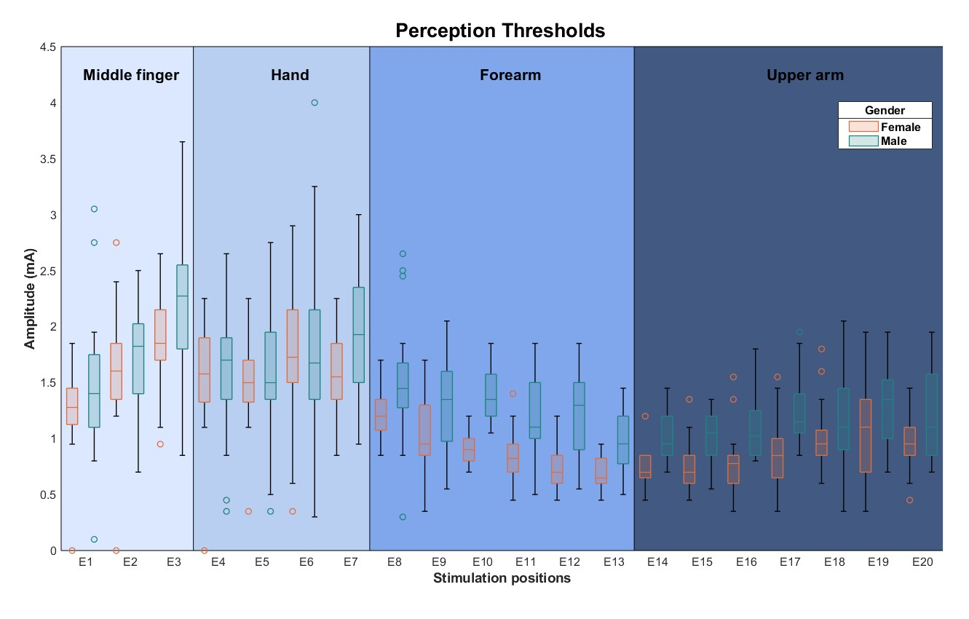

Supplementary Fig. 1 - Distribution of perception thresholds for each stimulation position (represented as electrodes 1 to 20 - E1 to E20) for females (orange) and males (blue), regardless of frequency.

Subjective perception - quantitative, qualitative, spatial, and temporal stimulation qualities
Supplementary Table 5 - Median sensation intensities for each stimulation position (represented as electrodes 1 to 20 - E1 to E20), on a scale of 0-10, for each frequency and gender at the perception threshold intensity.
Stimulation position | Sensation Intensity
Stimulation position | 30 Hz, Female | 30 Hz, Male | 100 Hz, female | 100 Hz, Male
E1 | 1.00 | 1.00 | 1.00 | 1.00
E2 | 1.00 | 1.00 | 1.00 | 1.00
E3 | 1.00 | 1.00 | 1.00 | 1.00
E4 | 1.00 | 1.00 | 1.00 | 1.00
E5 | 1.00 | 1.50 | 1.00 | 1.00
E6 | 1.00 | 1.00 | 1.00 | 1.00
E7 | 1.00 | 1.00 | 1.00 | 1.00
E8 | 1.00 | 1.00 | 1.00 | 1.00
E9 | 1.00 | 1.00 | 1.00 | 1.00
E10 | 1.00 | 1.00 | 1.00 | 1.00
E11 | 1.00 | 1.00 | 1.00 | 1.00
E12 | 1.00 | 2.00 | 1.00 | 1.00
E13 | 1.00 | 1.00 | 1.00 | 1.00
E14 | 1.00 | 1.00 | 1.00 | 1.00
E15 | 1.00 | 1.00 | 1.00 | 1.00
E16 | 1.00 | 1.00 | 1.00 | 1.00
E17 | 1.00 | 1.00 | 1.00 | 1.00
E18 | 1.00 | 1.00 | 1.00 | 1.00
E19 | 1.50 | 1.00 | 1.00 | 1.00
E20 | 1.00 | 1.00 | 1.00 | 1.00

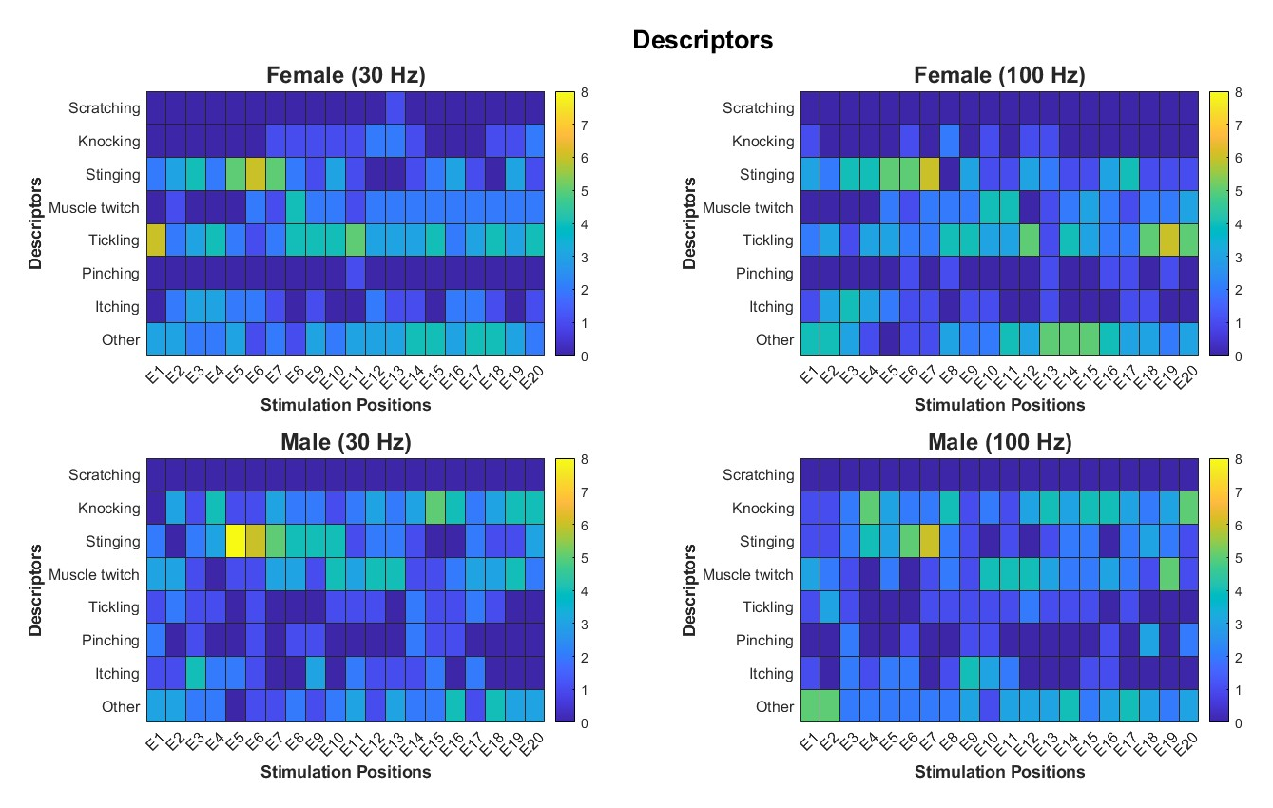
Supplementary Fig. 2 - Heat maps illustrating the descriptors used to characterize the sensation caused by the electric stimulation of each stimulation position (represented as electrodes 1 to 20 - E1 to E20) for each stimulation frequency (30 Hz at left and 100 Hz at right) and gender (Female on the top and Male on the bottom). The y-axis is the number of participants.

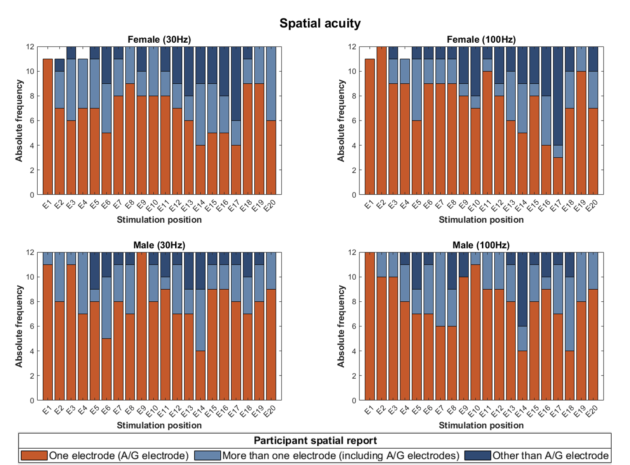
Supplementary Fig. 3 - Spatial acuity for each stimulation position (represented as electrodes 1 to 20 - E1 to E20) for females (top) and males (bottom) participants at 30 Hz (left) and 100 Hz (right). Light blue bars indicate that participants identify the sensation at the active or ground (A/G) electrodes; blue bars mean that participants identified the sensation at an electrode away more than one from the correct one (including A/G electrodes); dark blue bars mean that participants identified other than A/G electrodes. The y-axis is the number of participants.

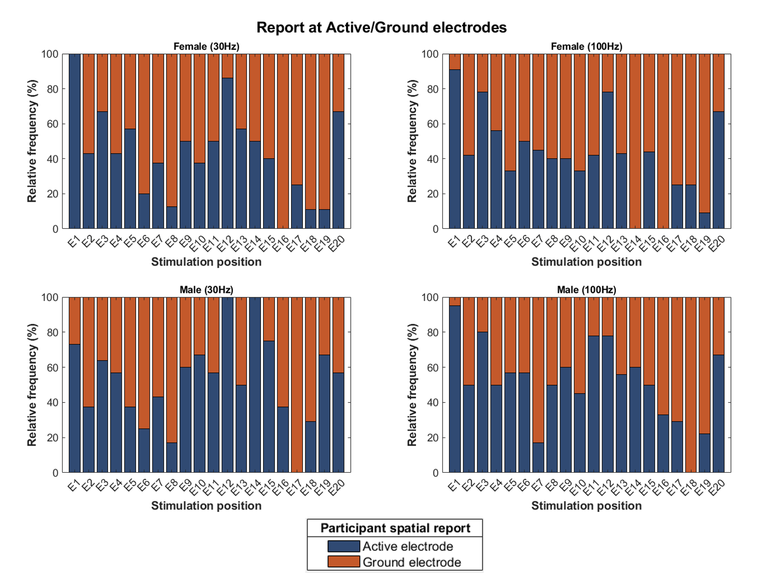
Supplementary Fig. 4 - Percentage of stimulation positions where the stimulation at the PT was felt at the active (yellow) and ground (blue) electrodes for female (top) and male (bottom) participants at 30 Hz (left) and 100 Hz (right).

