Escape Room Experience for Medical Students - First Escape Room:
Prerequisite knowledge:
- Basics of:
  - Anesthesia drugs
  - Monitoring in the operating room (OR)
  - Preoperative evaluation
  - Anesthesia planning
- Basic life support (BLS)
- Familiarity with:
  - ISBAR principles
  - Patient safety principles
  - Team communication principles and skills
The escape room is suitable for groups of 3-5 students
Schedule:
- Briefing: up to 10 minutes - a presentation of the escape room concept and safety instructions
- The escape room time allotment: 60 minutes
- Debriefing and feedback: up to 30 minutes
Equipment requirements:
- Computer with internet connection
- Projector and additional computer for operating the projector
- Simulator (SIM-MAN, Laerdal™)
- Anesthesia workstation
- Monitors
- BLS simulator connected to the QCPR Training application (Laerdal™)
- Walkie-talkie x2
- Boxes x2 including code lock x2
- Inflatable balloons (normal balloon) + needle
- Medicine cart
- Drug ampules + stickers
- Syringes + needles for preparing the drugs
- Needle disposing bin
- Face masks + surgical caps + gloves
- Medical file
- Optional operating room lights
- Decoration items

At the entrance to the escape room, participants first view the following information:
“Welcome to the “Crash Induction” Escape Room. This assignment consists of 5 stations that contain various riddles and tasks. To proceed from one station to the next, you are required to successfully accomplish the task at that station. When the task is accomplished, you will receive a written or vocal notification to proceed to the next station. To complete the Escape Room, you must finish all 5 stations within 60 minutes. You are required to work as a team and to demonstrate the clinical knowledge and manual skills that you acquired during the first week of the anesthesia rotation. You are allowed to use only the materials that are displayed in that station. No cellphones or other media are allowed unless you have been specifically told otherwise. There is no need to use raw strength. In case you are stuck, you can ask the operator for a clue, this will “cost” you 5 minutes. For example, if you asked 2 questions during the Escape Room, you will need to accomplish the mission in 50 minutes instead of 60.
Please do not inject drugs or fluids into the simulator.”

Participants enter the room. The lights are dimmed except for 3 operating room lights in different corners of the room. A background story is projected on the wall, accompanied by dramatic music. The background story lasts about 2 minutes, at the end of which appears the following sentence: “your 60 minutes start now” and the digital clock starts counting down 59:59…

1st station – Preoperative assessment:
The participants find a medical record on the table among other decorative items and cards with various old anesthetic drug descriptions (as an article regarding chloroform, first use of laughing gas, Arabic and Chinese herbal medicine, that were thought to have analgesic properties).
Figure 1 – the first station.
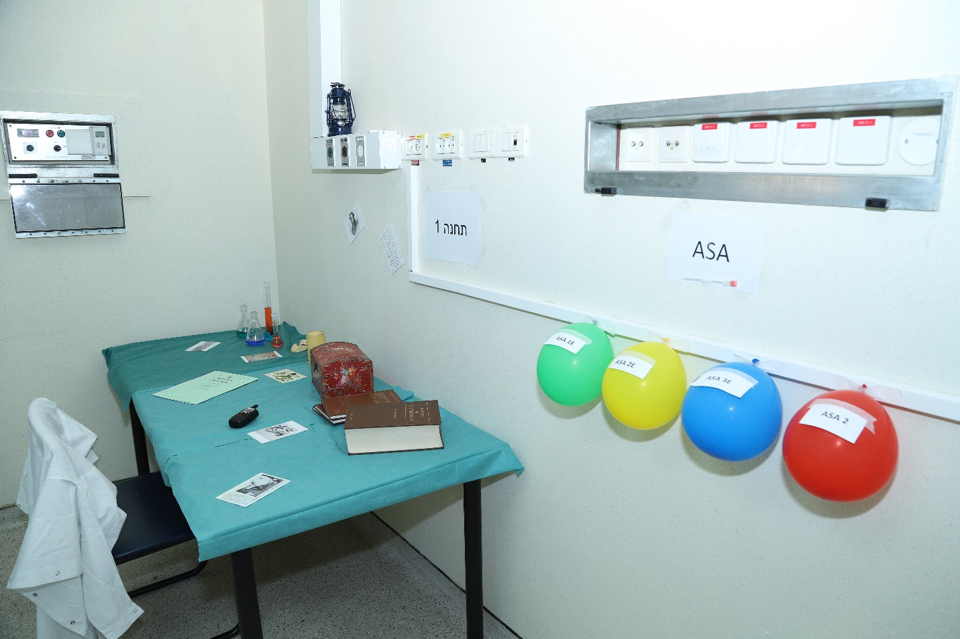

The contents of the medical record:
- Summary of the event and some medical history, as was assessed in the emergency department
- CT scan description
- Labs
- Relevant X-ray description
- Anesthesia assessment containing questions the participants need to answer. The correct answers to these questions lead to the lock combination on the box, which is found on the table.
- ASA assessment with a place for 2 cards:

ASA

Medical history:
A 25-year-old man with no chronic diseases was involved in an accident while on a motorcycle, he was wearing a helmet.
First evaluation at the field – GCS 15
Evaluation in the emergency department – conscious, PR – 120, BP 100/60, pale, RR 24 bpm, saturation 95% in the room air, no flail chest, open fracture of distal radius, Rt arm bleeding.
In the emergency department, the patient was treated with 1L of normal saline, with improvement of his vitals, and 5mg morphine and tetanus toxoid.
The patient now requires exploratory surgery of the arm, ligation of the blood vessels and a fixation of the fracture.
Additional checkups:
Total body CT scan:
No evidence of intracranial hemorrhage, no skull fractures. Fracture of the ribs 10 + 11 on the right side, no pleural effusion or pneumothorax, no pericardial effusion. Swelling of the abdominal wall on the right side without internal bleeding or contusion of the internal organs.
X-ray of the arm:
Fracture of the distal radius Rt arm
Labs:
WBC 10K, HGB 11, PLT 230K
INR 1
Cr 0.8, Urea 45, K 4.4, Na 141, Cl 102, Ca 10, Uric A. 7.8
Bilirubin 0.7, AST 45, ALT 50, ALKPH 130, LDH 280
pH 7.35, PO₂ 45, CO₂ 50, HCO₃ 26, lactate 25

Preoperative evaluation:
- What are the fasting recommendations for the patient, considering that he had a meal at 19:00, the accident occurred at 20:00 and the current time is 01:00?
- The same guidelines as for elective surgery: 6 hours following a meal and at least 2 hours for clear liquids.
- The guidelines in this situation are 8 hours following a meal and one hour for clear liquids.
- For infants, the guidelines are 4 hours fasting for breast milk, as well as for baby formula.
- Despite the urgency of the surgery, the patient must fast as for every surgery, because patient’s safety is prior to all other considerations.
- Since trauma can cause delayed emptying of the stomach, the patient should be considered as having a “full stomach” and the induction should be a “rapid sequence induction”.

- During the medical examination, the patient reveals that he has smoked a half pack of cigarettes a day for 10 years. In the case of elective surgery, what would be the guidelines regarding smoking cessation?
- To ease the smoking cessation process for the patient, the guideline is to quit smoking only 24 hours prior to the surgery
- The maximal effect of smoking cessation on reducing the complications of anesthesia occurs at least 8 weeks after the cessation
- The earliest effect of smoking cessation is the improvement of muco-ciliary function, which occurs within 12-24 hours after the cessation.
- There is no evidence that smoking cessation is beneficial in patients without any evidence of lung disease.

- Which of the following is correct regarding the preoperative evaluation?
- ECG must be routinely performed for every patient who undergoes surgery, due to the high chance of uncovering active ischemic heart disease.
- ECG is recommended for every patient aged above 65 years who undergoes general anesthesia.
- For low risk surgeries, patients without any risk factors or chronic diseases do not require any lab or imaging studies prior to the surgery
- Patients with diabetes require chest X-ray imaging prior to surgery due to a high risk of accompanying pulmonary disease

- Which of the below is correct regarding the attached chest X-ray?
- The chest X-ray in combination with a clinical examination and the anamnesis is suspicious for chronic obstructive pulmonary disease.
- The heart silhouette cannot be discussed because the X-ray was taken while standing.
- The X-ray is considered asymmetrical because the diaphragm height is not equal on both sides.
- There is evidence of pleural effusion on the right side that should be drained prior to the anesthesia and positive pressure ventilation

Figure 2 – Chest X-ray from the medical file.
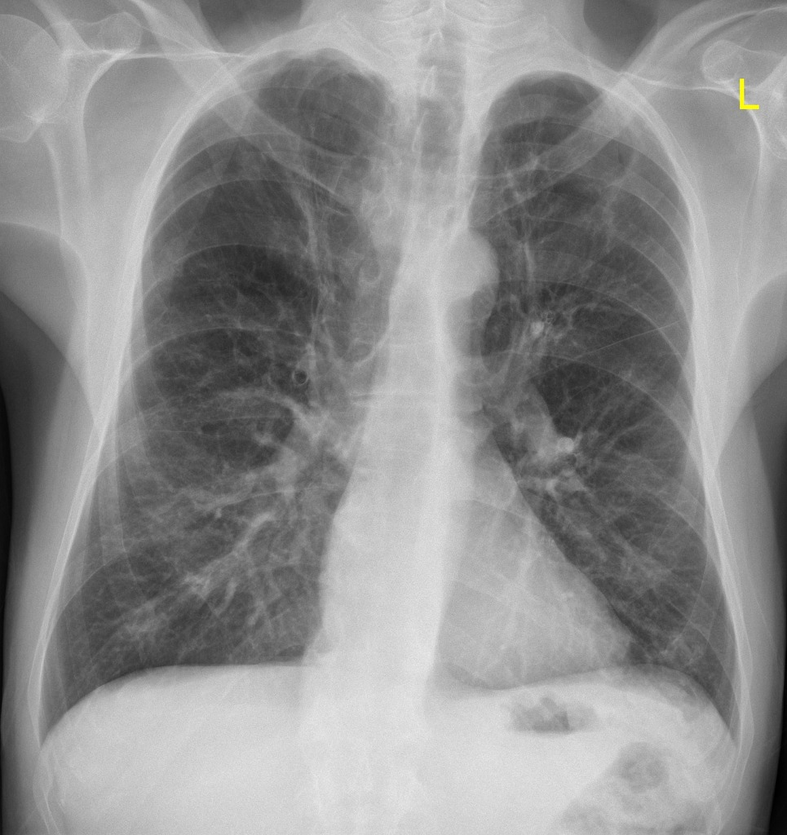
The correct combination is: 5231

Inside the box are cards that describe additional aspects of the patient’s medical history. These may help to correctly evaluate his ASA score. Each card contains some medical information about the patient, a number or a letter appears on the back of the card. Only relevant medical conditions have a letter/number that comprise the final ASA score.

Figure 3 - Cards for the ASA evaluation (the two adjoined cards are the two sides of the same card):

Family history of colon cancer
B
Saturation with nasal cannula 99%
G

Height 1.7 meters
F
Was born at 32 weeks
4

Does not consume alcohol
1
Wears glasses
D

Smokes a pack of cigarettes daily since age 15 years
3
s/p Appendectomy at age 12 years
A

BMI 33 kg/m2
2
Surgical urgency
E

Near the table are 4 balloons and a needle, with 4 ASA scores, only one of them is correct. Within the balloons are notes. The correct ASA score (2E) balloon contains a note that states: “You are correct, please proceed to the next station and prepare the drugs for the induction”. The other balloons contain a note that says: “The ASA that you’ve chosen is incorrect. Try again using the table attached:”

Figure 4 – ASA classification.
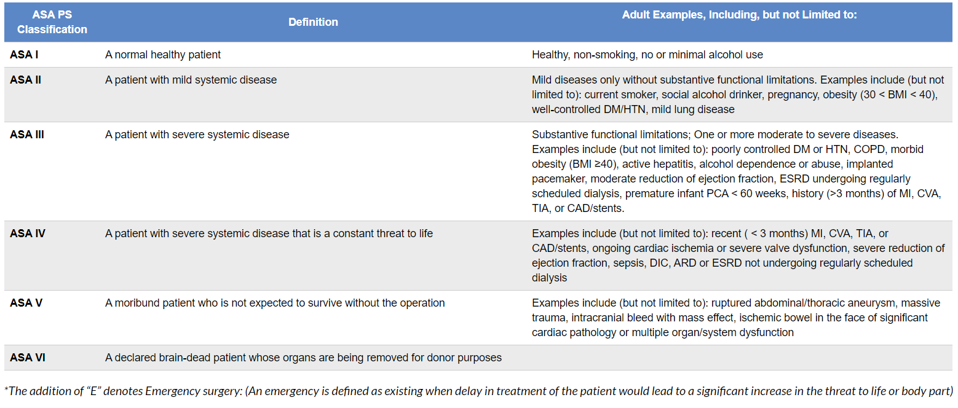
*The table is adapted from ASA Physical Status Classification System available at: https://www.asahq.org/standards-and-guidelines/asa-physical-status-classification-system

Station 2 – anesthetic drugs:
At this station, the participants are expected to prepare the drugs for the induction of anesthesia, as described in the note at the end of the previous station. Underneath the tray for the prepared drugs they will find a crossword.
Figure 5 –Station 2 – medicine cart.
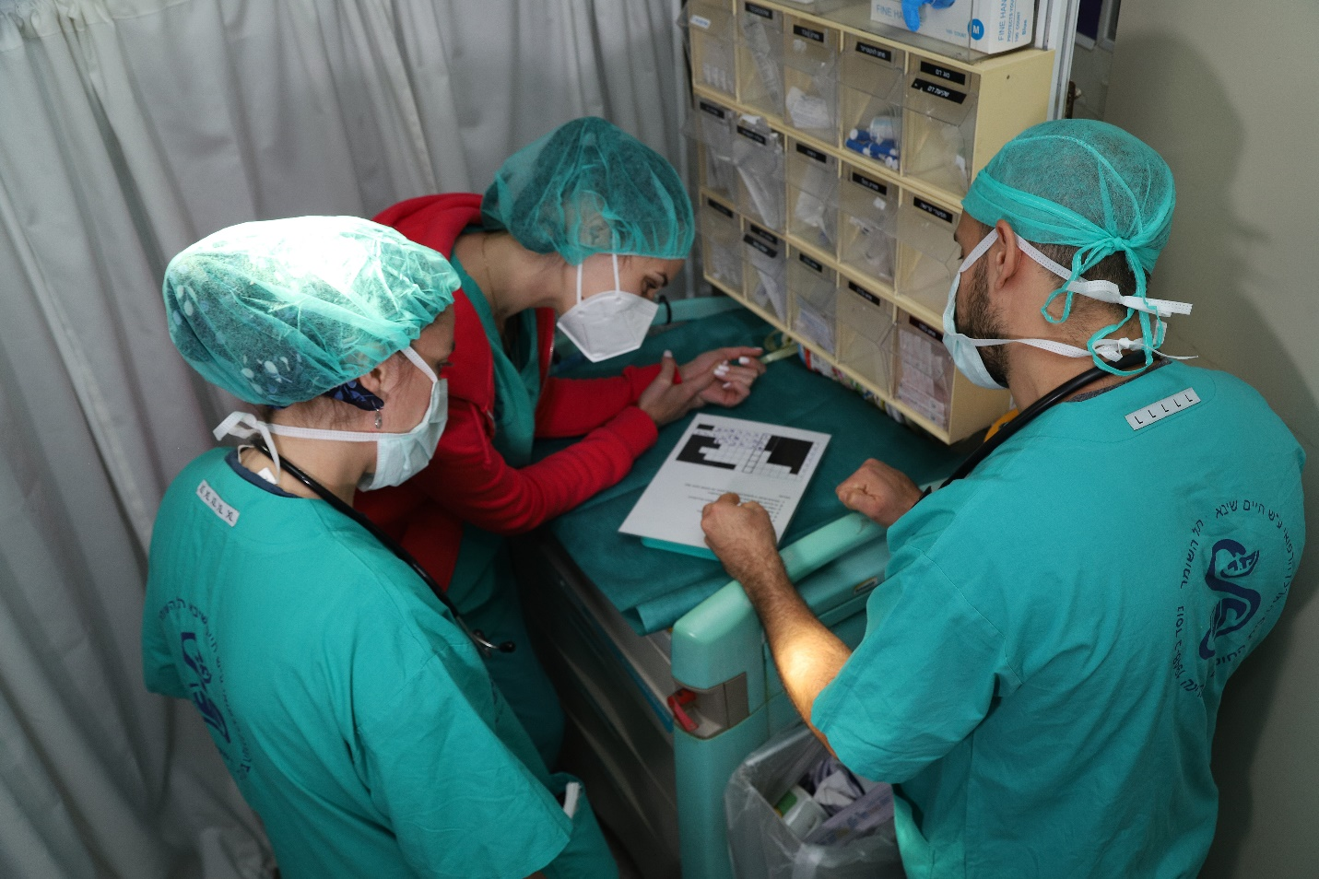
The marked word is the key to the computer file for the third station.

Figure 6 – the crossword.

1 |  |  |  |  |  |  | f | e | n | t | a | n | y | l
2 |  |  |  |  |  |  |  | a | t | r | o | p | i | n | e
3 |  |  |  |  |  |  |  |  |  | i | s | o | f | l | u | r | a | n | e
4 |  |  |  | S | E | V | o | f | l | u | r | a | n | e
5 |  |  |  |  |  |  |  |  |  | m | i | d | a | z | o | l | a | m
6 |  |  |  |  |  |  | p | r | o | p | o | f | o | l
7 | s | u | c | C | I | N | y | l | c | h | o | l | i | n | e
Hints:
- This drug is 100 times as potent as Morphine (Fentanyl)
- This drug is added to Neostigmine to reduce its side effects (Atropine)
- An inhaled anesthetic agent that is still widely used with the lowest MAC (Isoflurane)
- An inhalation anesthetic agent with a non-purulent odor that can be used for induction of anesthesia (Sevoflurane)
- This drug can cause anterograde as well as retrograde amnesia (Midazolam)
- This drug causes hemodynamic and respiratory depression (Propofol)
- This drug can cause significant side effects of hyperkalemia and bradycardia (Succinylcholine)

Station 3 – ISBAR and communication technique:
At this station is a computer with an open pdf file that requires a password in order to view its contents. The password to the file is the aforementioned marked word from the crossword.
The file contains a short description and a summary of a previous surgery that the patient underwent, together with questions, and the task that the participants must complete at this station.
Figure 7 – third station.
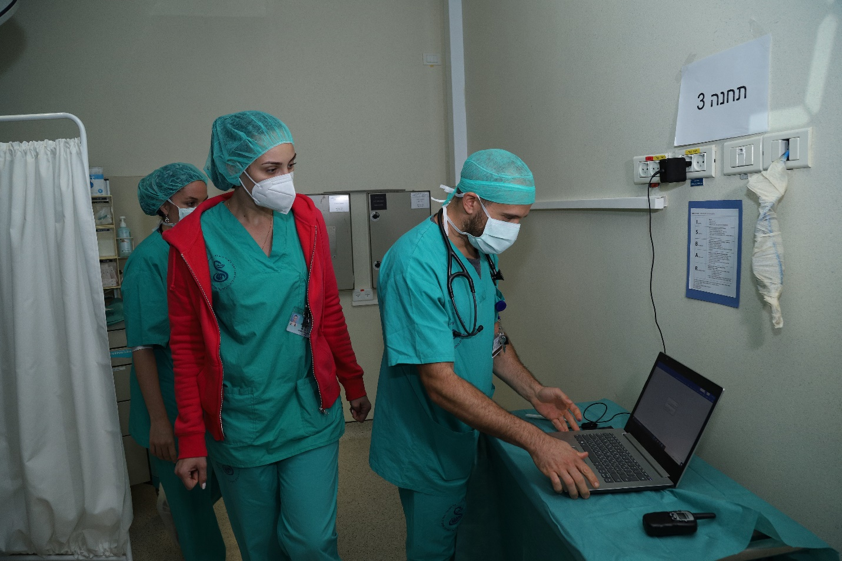

At the computer, the participants find a description of the ISBAR technique.

*The ISBAR description is taken from: Sykepleien Forskning 2019;14(74699):(e-74699)

The participants must first correctly present the case to the senior anesthesiologist (the ER operator) via walkie-talkies; this is followed by a short discussion regarding the anesthesia induction. Subsequently, the participants are requested to take the prepared drugs to the next station – the operating room – and begin the induction of anesthesia.

The contents of the pdf file:
The patient is very concerned about his upcoming surgery. At age 12 years, he underwent an urgent appendectomy under general anesthesia. He was then told that during the surgery he had had a rash and that he might be allergic to one of the anesthetic agents.

Here is the anesthesia sheet from his surgery:

Surgery: Appendectomy
Date: 08/01/2008

Patient in OR: 18:45
Anesthesia start: 18:47
Intubation: 18:55
Surgery start: 19:15

Antibiotics: Cefazolin 1 gr time: 19:01

Monitors: Saturation NIBP Temperature: Nasopharyngeal ECG ETCO2 NGT
Lines: IV L HAND size 18G
Fluids: Hartman 1000cc start: 18:47

Anesthesia:
NPO: No
Schedule: Urgent
Anesthesia type: General
Induction Method: Modified Rapid Sequence
Airway: intubation route: oral; type: single lumen; size: 6 height: 19; inflation: 4cc
Intubation difficulty: easy; laryngoscopic view: 1; Intubation performance: direct laryngoscopy Macintosh blade

Ventilation: VCV FiO2: 50% TV: 350 RR: 14/min I:E: 1:2
Induction:
Fentanyl
Dosage: 100 mcg time: 18:50
Propofol
Dosage: 150 mg time: 18:51
Rocuronium
Dosage: 70 mg time: 18:51
Maintenance:
Sevoflurane 2-3% start: 18:55 end: 19:50

Analgetic drugs:
Fentanyl
Dosage: 100 mcg time: 19:07
Morphine
Dosage: 5 mg time: 19:10
Paracetamol
Dosage: 850 mg time: 19:12
Other Drugs:
Dexamethasone
Dosage: 10 mg time: 18:56
Granisetron
Dosage: 1 mg time: 19:20

Special events:
Rash on face and thorax following induction at 18:52, without hemodynamic or respiratory change, no mucosal swelling, resolved after 15 minutes. Suspected drug-induced sensitivity.

Surgery end: 19:52
Extubation: 19:55
Anesthesia end: 19:55
Patient out of OR: 19:57

The questions at the end of the file:
- Which of the drugs that the patient received most likely caused the sensitivity reaction?
- What is the most common expression of a hypersensitivity reaction to anesthetic drugs?
- What is the adrenaline dosage for anaphylactic shock during anesthesia?

*At this station you are allowed to use media.
Please present the patient to the senior anesthesiologist using the ISBAR technique, in order to proceed to the Operating Theater.

Figure 8 – ISBAR structured communication
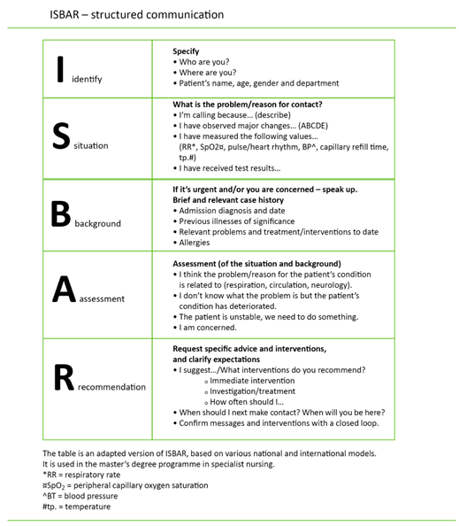

Station 4 – Monitoring and Simulator (SIM MAN):
At this station, the participants are expected to connect the patient (the manikin) to the monitors.

Figure 9 –Station – anesthesia workstation and monitoring.
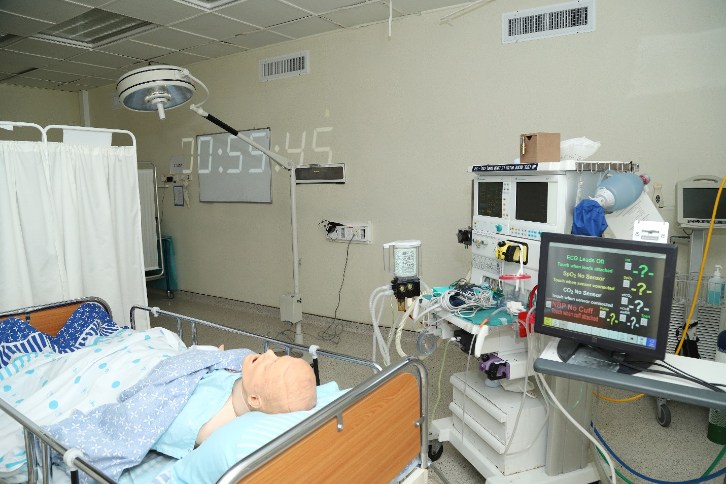

Under the blanket, the participants find the next riddle: the cards containing a number of ETCO₂ graphs that need to be matched to appropriate descriptions in the attached figure (Figure 10). On the back of each card is a code for a lock box that is located on the anesthesia workstation.

Within the box is a note: “One of the anesthesiologists accidently injected a drug that the patient is allergic to. As a consequence, the patient is now under cardiac arrest. To rescue him you must perform 3 full cycles of cardiac compressions at the next station. Do not forget to switch participants every 2 minutes”.

Figure 10 - Cards for the capnography quiz.
2. Normal capnography curve | - Probable bronchospasm
- The tube has been misplaced in the esophagus | - The inspiration starts at this point

**The first four cards are the correct match for the table above, they contain the numbers for the combination of the lock box. The other cards are for distraction, and should contain random numbers, that are not part of the code.

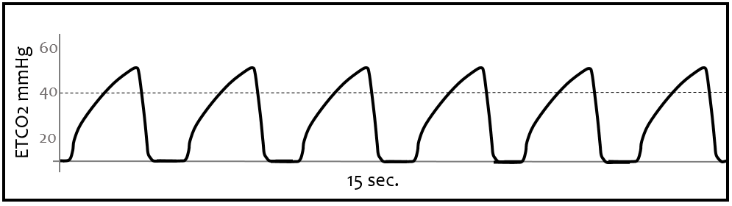

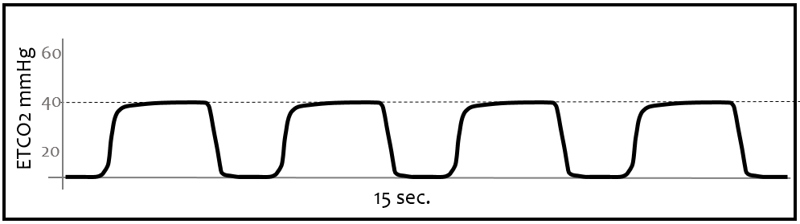
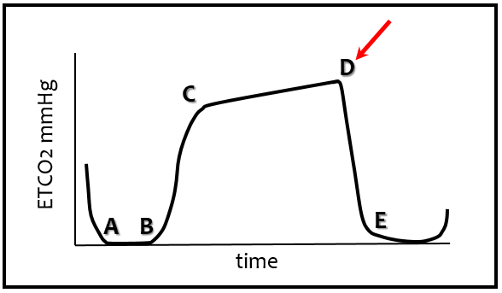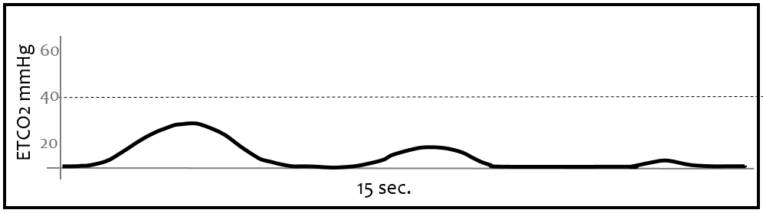
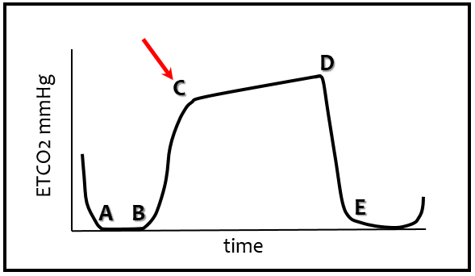
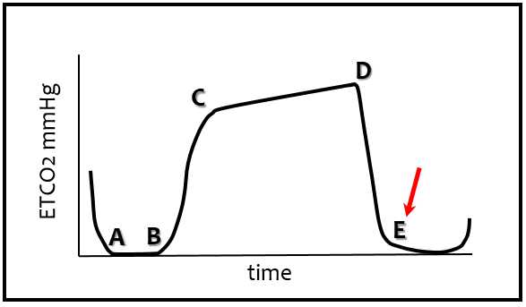
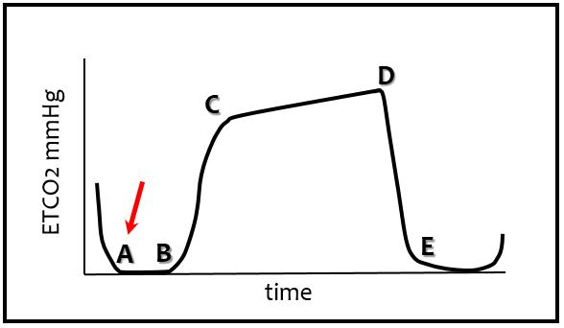
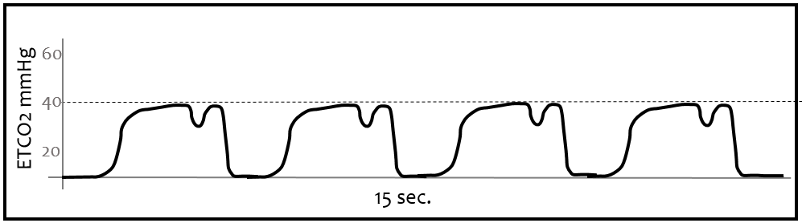

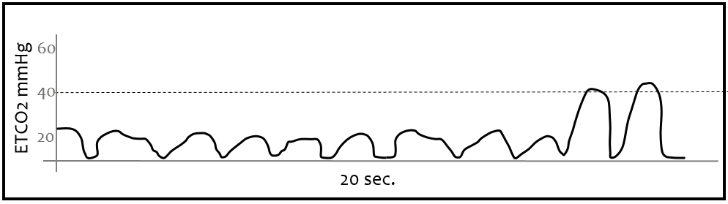

Station 5 – Basic Life Support
Figure 11 – 5th station - Manikin for practicing Basic Life Support.
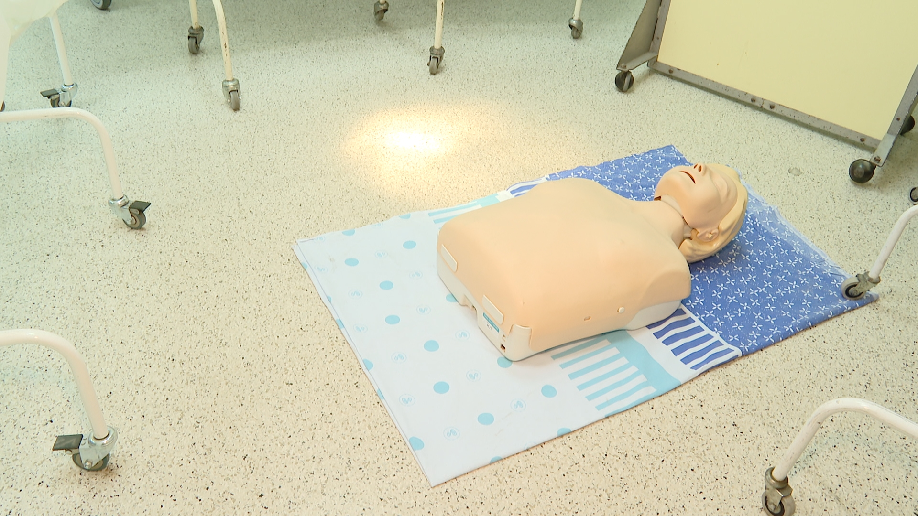
At this station, the participants are expected to perform 3 full cycles of Basic Life Support, comprising only cardiac compressions. The manikin is connected to the QCPR Training application (Laerdal™), which enables the operator to assess the quality of the compressions. If the compressions are inadequate (<95% score), the participants are guided to repeat the cycle.
After accomplishing 3 full cycles, the end of the Escape Room is announced, accompanied by cheerful music, and the participants are offered to take a photo-finish.

Abbreviations:
ISBAR – Identify, Situation, Background, Assessment, Recommendations
ASA - American Society of Anesthesiologists physical status classification system
GCS – Glasgow Coma Scale
PR – pulse rate
BP – blood pressure
RR – respiratory rate
Rt – right
WBC – white blood cells
HGB – hemoglobin
PLT - platelets
INR - International Normalized Ratio
Cr – creatinine
K – potassium
Na – sodium
Cl – chloride
Ca – calcium
Uric A. – uric acid
AST - aspartate aminotransferase
ALT - alanine transaminase
ALKPH – alkaline phosphatase
LDH - lactate dehydrogenase
PO₂ - partial pressure of oxygen
CO₂ – carbon dioxide
HCO₃ - bicarbonate
ETCO₂ – end tidal CO₂

