Supporting Information—Figure
Bacterial communities of sediments in a seawater-freshwater transition zone during the wet and dry seasons in Pearl River Estuary
Yongbin Li#, Duanyi Huang#, Weimin Sun#, Xiaoxu Sun, Geng Yan, Wenlong Gao, Hanzhi Lin*
¹ National-Regional Joint Engineering Research Center for Soil Pollution Control and Remediation in South China, Guangdong Key Laboratory of Integrated Agro-environmental Pollution Control and Management, Institute of Eco-environmental and Soil Sciences, Guangdong Academy of Sciences, Guangzhou 510650, China
# These authors contributed equally to this work
* Corresponding authors:
Dr. Hanzhi Lin
E-mail: hanzhi_lin@126.com
Address: 808 Tianyuan Road, Tianhe District, Guangzhou City, Guangdong Province, China.
Tel: + 86-020-87024633, Fax: + 86-020-87024123
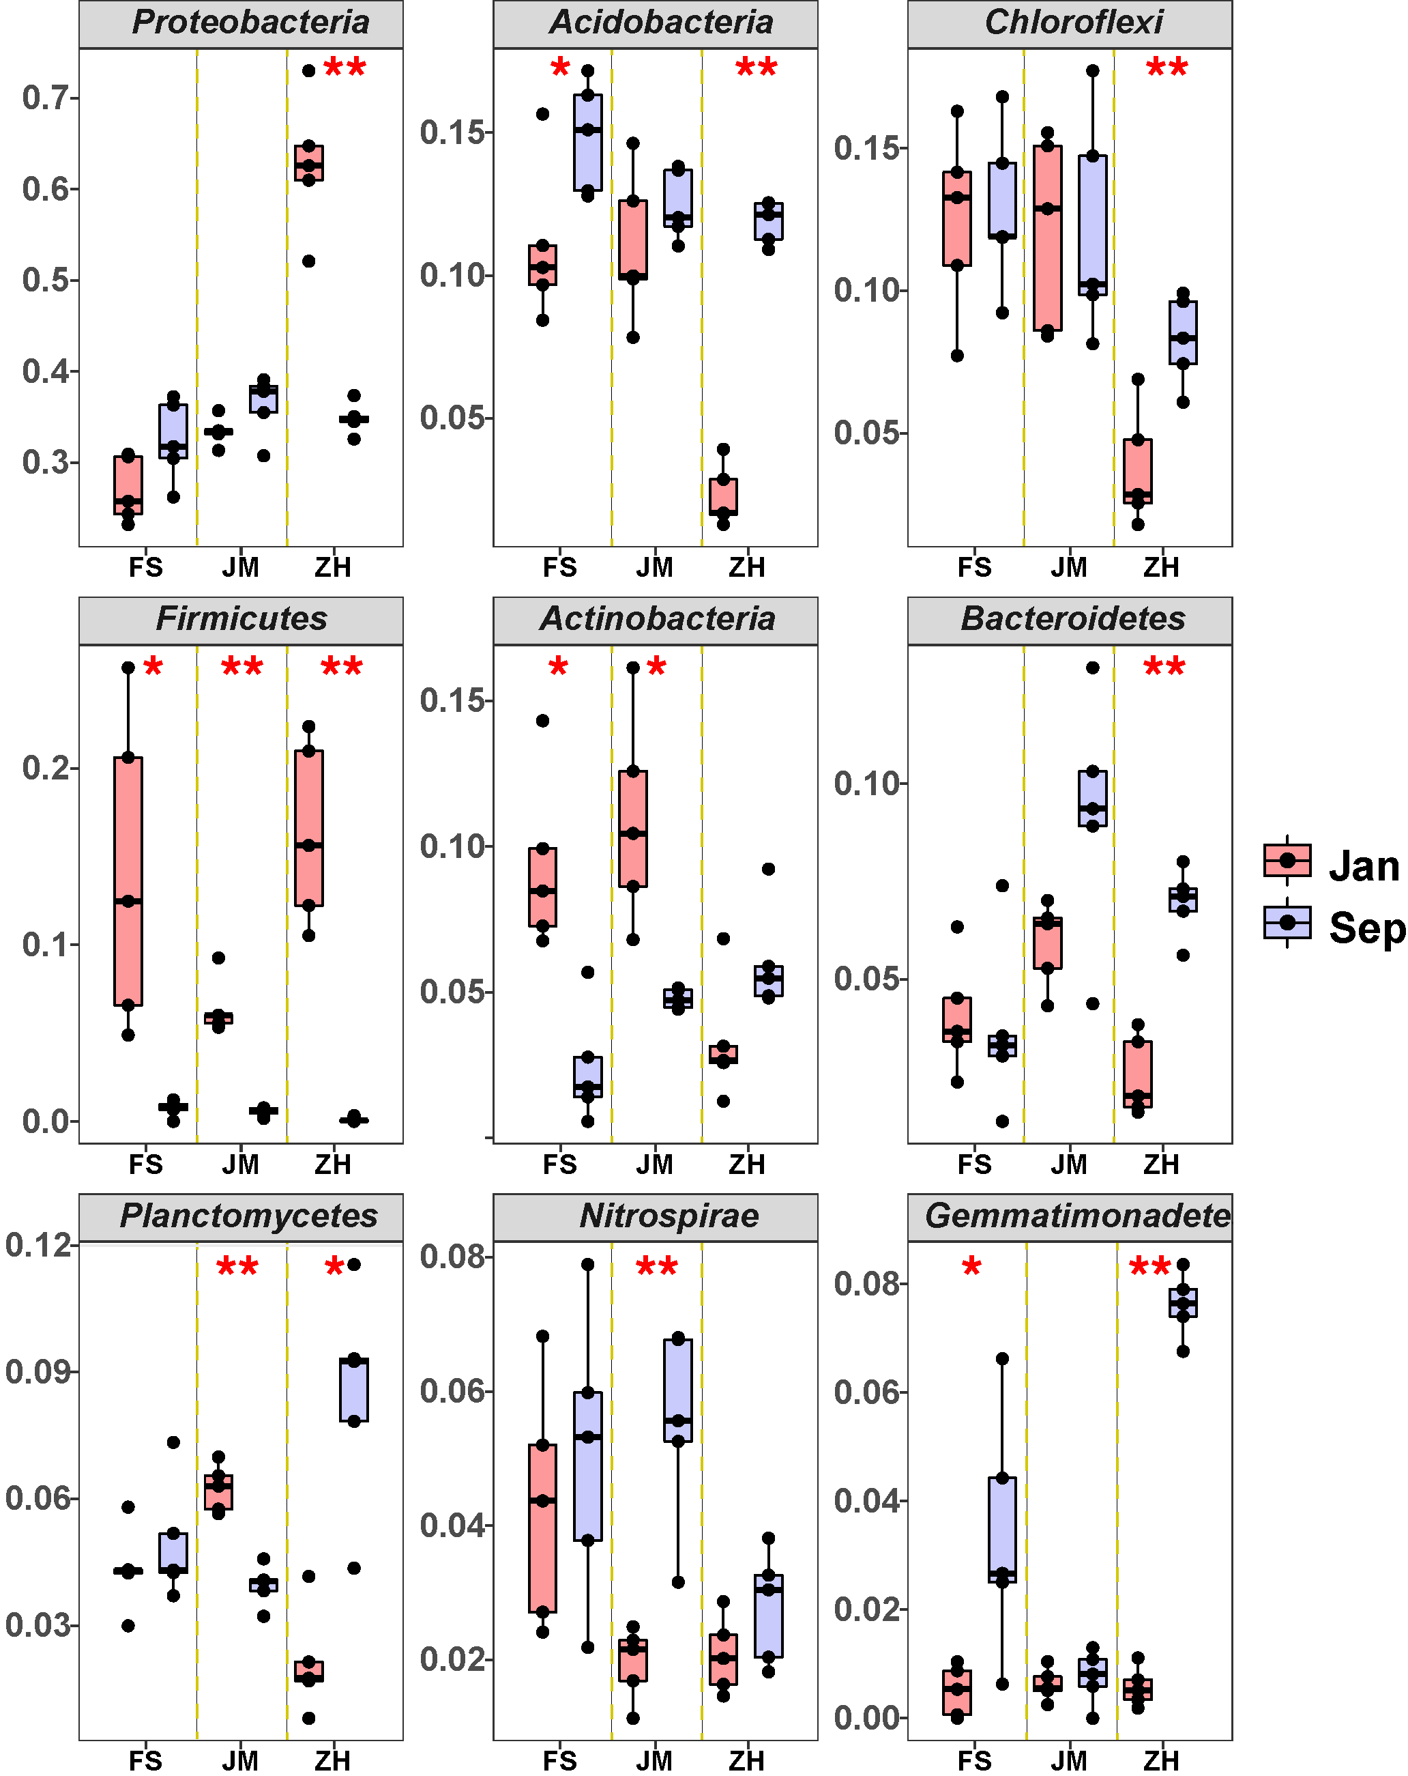
Figure S1: The relative abundances at the phylum level. * and ** indicate significant differences at p < 0.05 and p < 0.01, respectively.

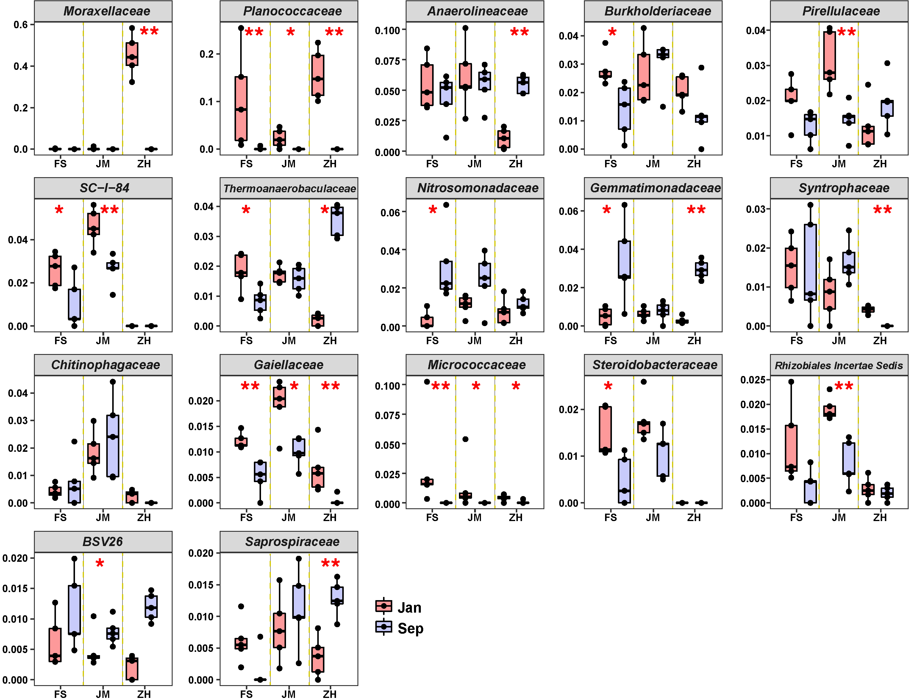
Figure S2: The relative abundances at the family level. * and ** indicate significant differences at p < 0.05 and p < 0.01, respectively.

