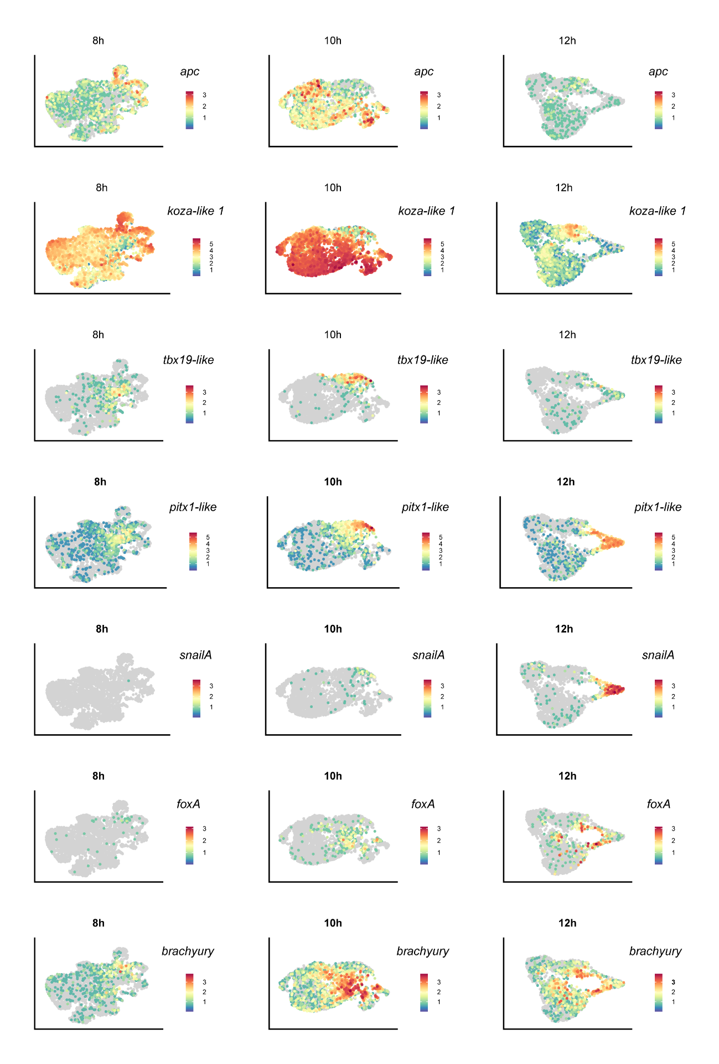

Supplementary Fig. 1. UMAP projections of single RNAseq datasets at 8, 10 and 12hpf.
Visualization of the cells expressing ectodermal genes (apc, koza-like 1), mesodermal genes (tbx19-like, pitx1-like, snailA) and endodermal genes (foxA, brachyury) at different time points during early development in Nematostella.

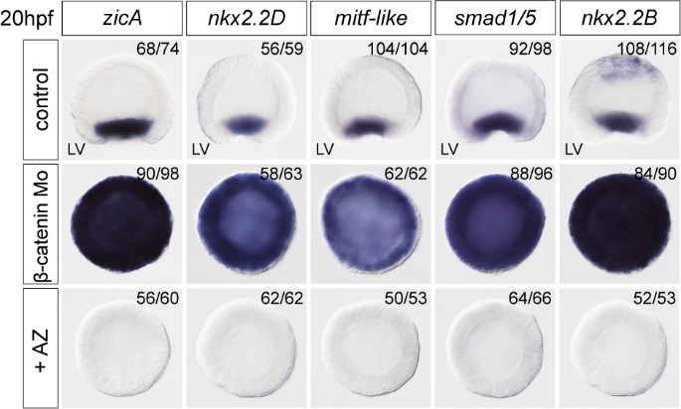

Supplementary Fig. 2 β-catenin signaling prevents mesodermal marker expression at 20 hpf. Expression of mesodermal genes zicA, nkx2.2D, mitf-like, smad1/5, nkx2.2B in AZ treated embryos or β-catenin morpholino injected embryos at 20hpf. LV; lateral view.

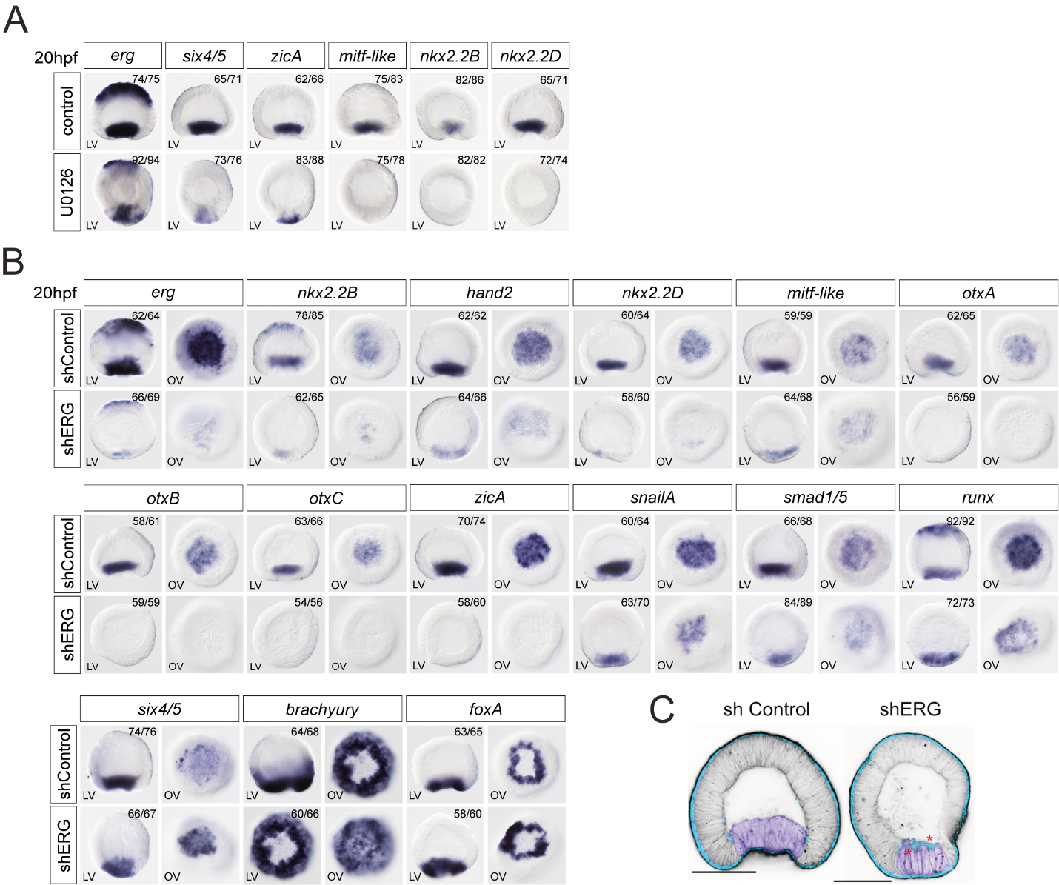

Supplementary Fig. 4 ERG is essential for mesoderm specification and morphogenesis. (A) Mesodermal gene expression analysis by in situ hybridization on 20hpf U0126 treated and control embryos. LV; lateral view. (B) Mesodermal (erg, nkx2.2B, hand2, nkx2.2D, mitf-like, otxA, otxB, otxC, zicA, snailA, smad1/5, runx, six4/5) and endodermal (brachyury, foxA) gene expression analysis by in situ hybridization on 20hpf shERG injected embryos. LV; lateral view, OV; oral view. (C) The effect of the erg knockdown on cdh3 expression (blue) and on gastrulation movements phenocopies the effect of the MAPK signaling inhibition by U0126. F-actin (black) staining is used to show the cell outlines.
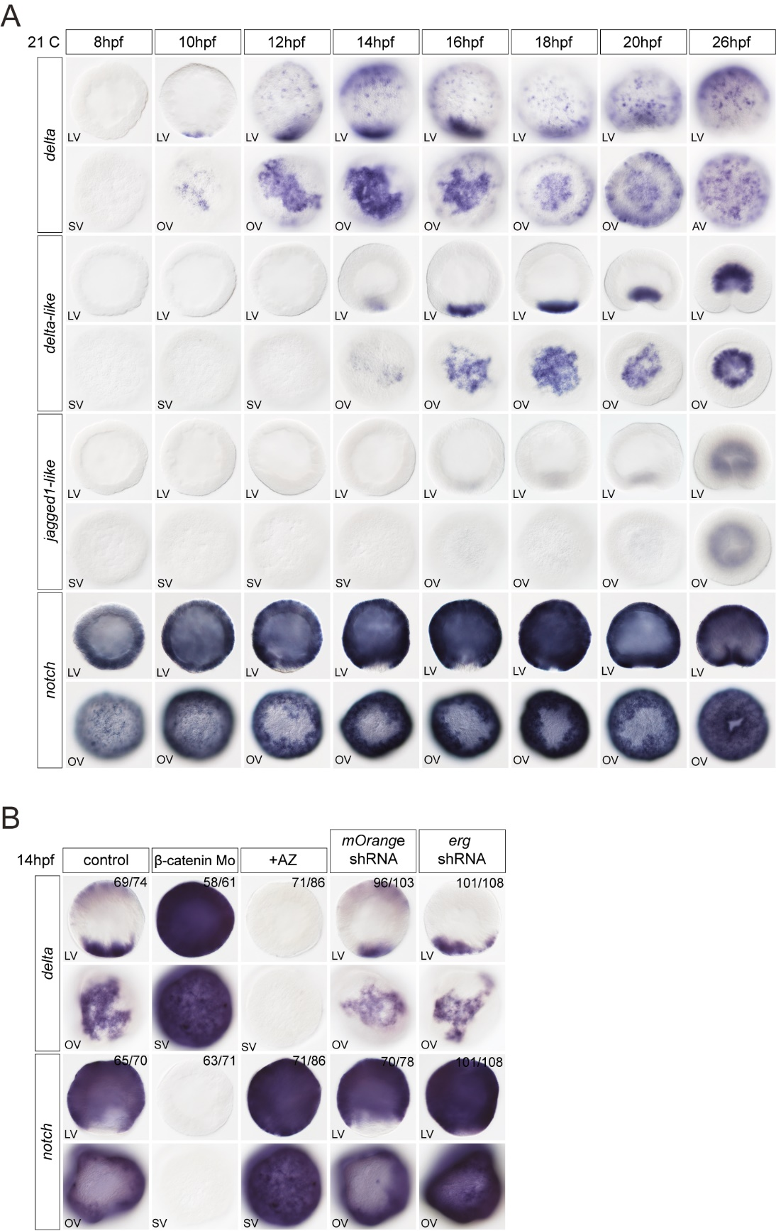

Supplementary Fig. 5 Regulation of ligands and receptor of the Notch pathway. (A) Expression analysis of genes coding for ligands (delta, delta-like, jagged1-like)and receptor (notch) of the Notch pathway from 8hpf to 26hpf by in situ hybridization. LV; lateral view, OV; oral view. (B) In situ hybridization at 14hpf in AZ treated embryos, β-catenin morpholino or shRNA against erg injected embryos to visualize mesodermal (delta) and ectodermal (notch) genes expression. LV; lateral view, OV; oral view, SV; surface view.

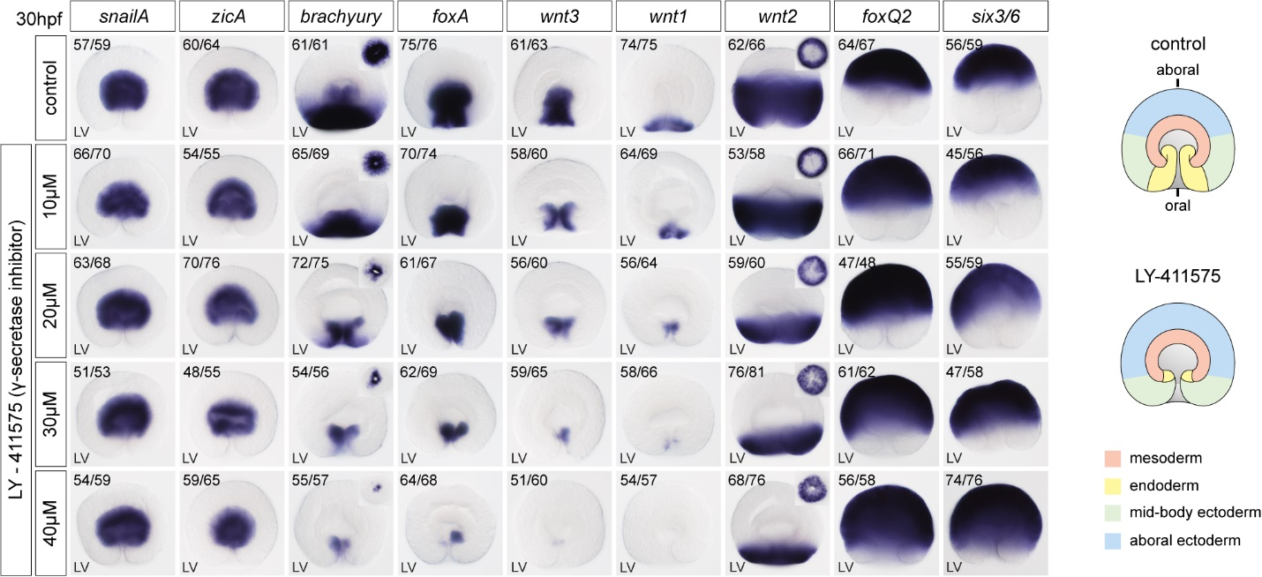

Supplementary Fig. 6. Notch signaling is essential for endodermal gene expression. Mesodermal (snailA, zicA), endodermal (brachyury, foxA, wnt1, wnt3, wnt1) and ectodermal (wnt2, foxQ2, six3/6) gene expression analysis at 30hpf on embryos treated with LY-411575 using in situ hybridization; Expression of endodermal genes is downregulated after inhibition of the Notch signaling. LV; lateral view, OV; oral view.

