- GMB analysis in pretreatment DLBCL patients (PRG) and healthy controls (CG)
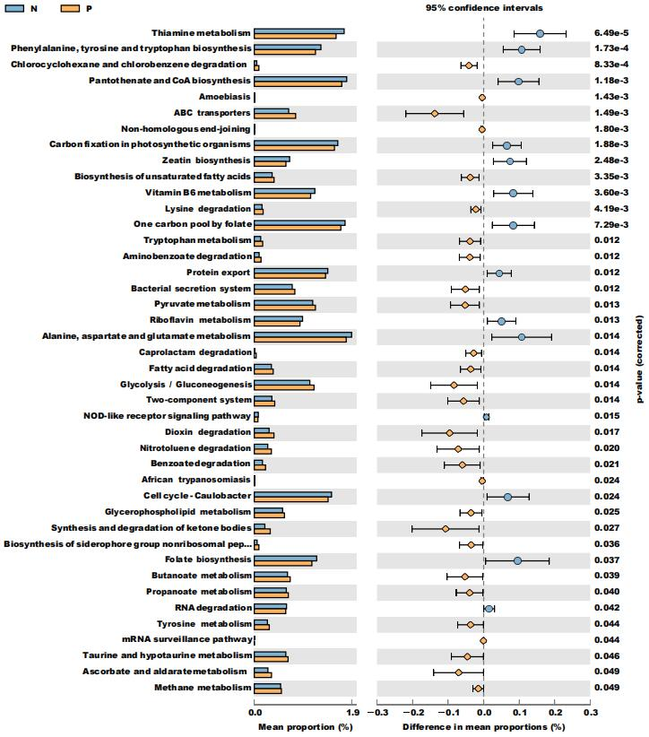

- GMB analysis in pretreatment (PRG) and posttreatment (POG) DLBCL patients
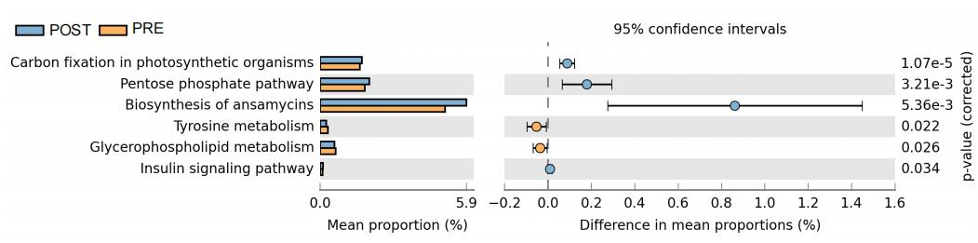

- GMB analysis in posttreatment(POG) DLBCL patients and healthy controls (CG)
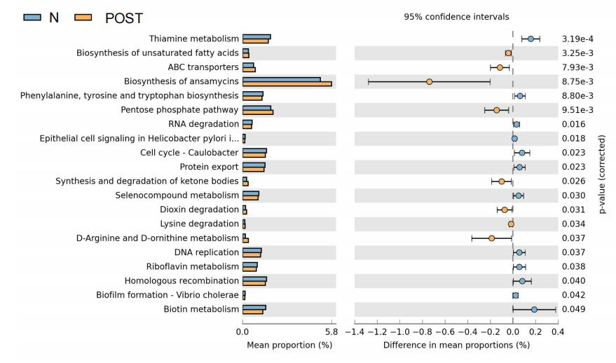

4. GMB analysis in complete remission(CRG) and non-complete remisison (NCRG) DLBCL patients following chemotherapy
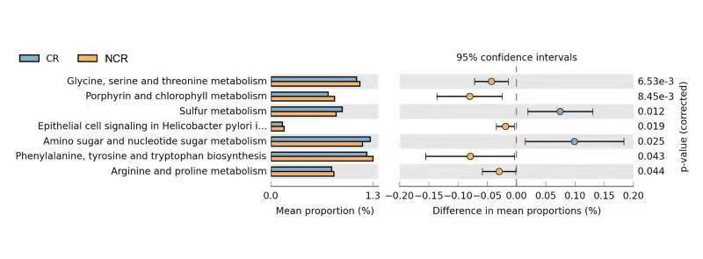

5.GMB analysis in the pretreatment fecal samples from complete remission (CR_PRE) and non-complete remission(NCR_PRE)
