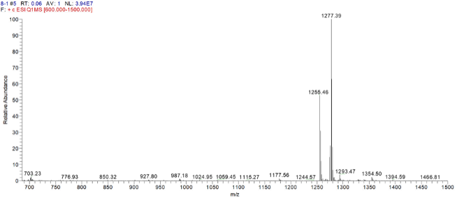
a
b
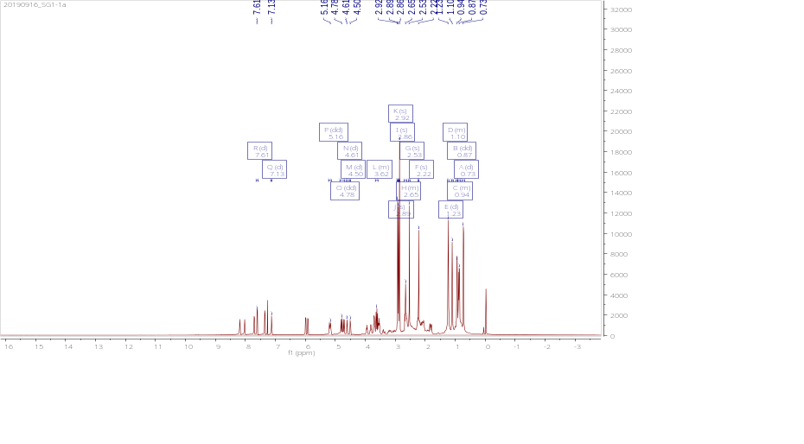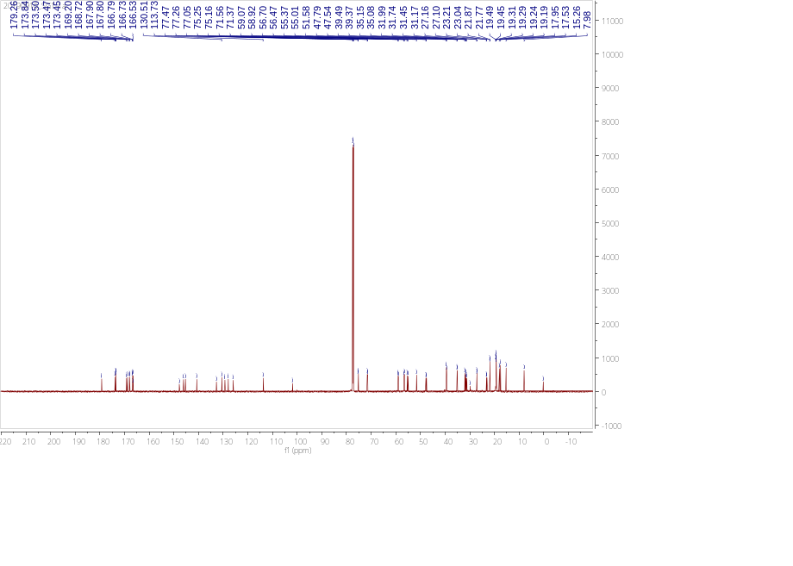
c

Fig. 1 Identification of compound 1: Actinomycin D
(a) Mass spectrometry. (b) Proton (1H) nuclear magnetic resonance. (c) Carbon (13C) nuclear magnetic resonance spectrum of the compound 1 in Chloroform-d.

a
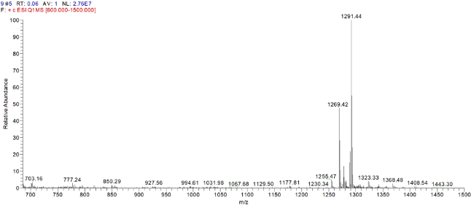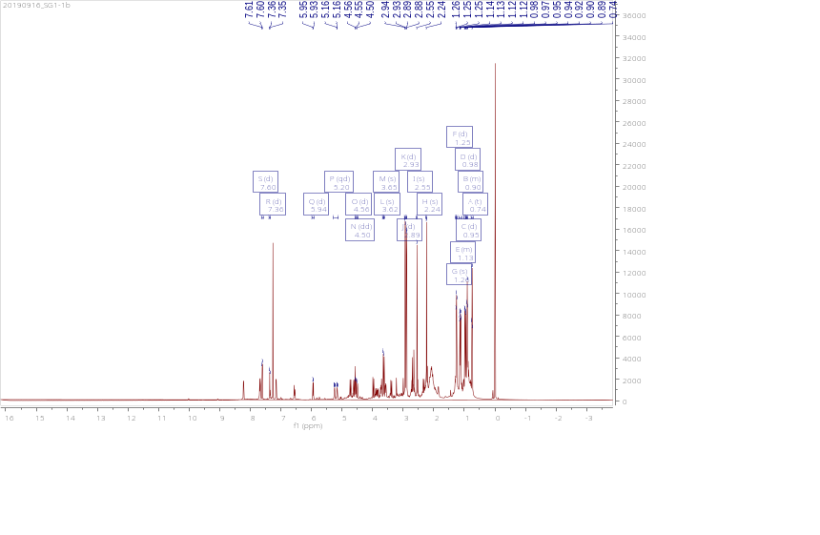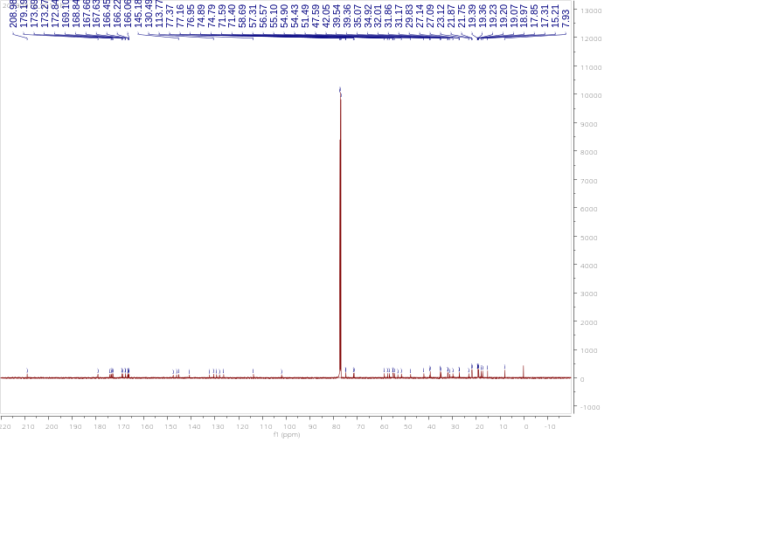
c
b
Fig. 2 Identification of compound 2: Actinomycin X₂
(a) Mass spectrometry. (b) Proton (1H) nuclear magnetic resonance. (c) Carbon (13C) nuclear magnetic resonance spectrum of the compound 2 in Chloroform-d.
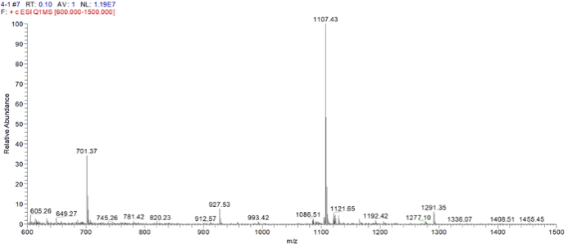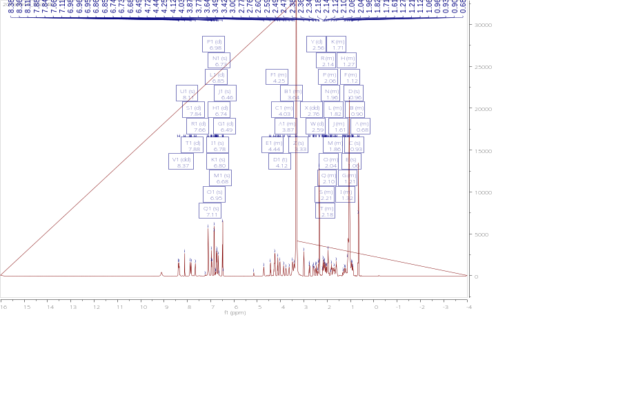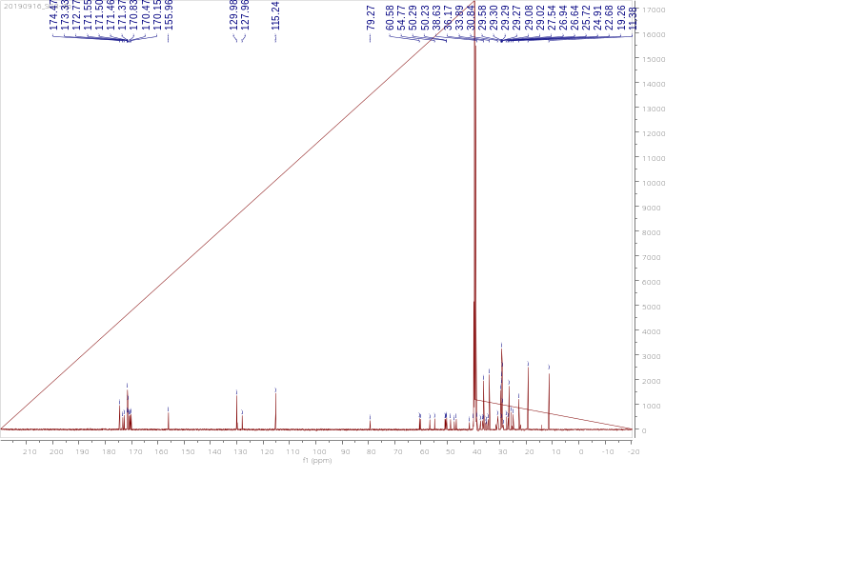
c
b
a
Fig. 3 Identification of compound 3: Mojavensin A
(a) Mass spectrometry. (b) Proton (1H) nuclear magnetic resonance. (c) Carbon (13C) nuclear magnetic resonance spectrum of the compound 3 in DMOS-6d.

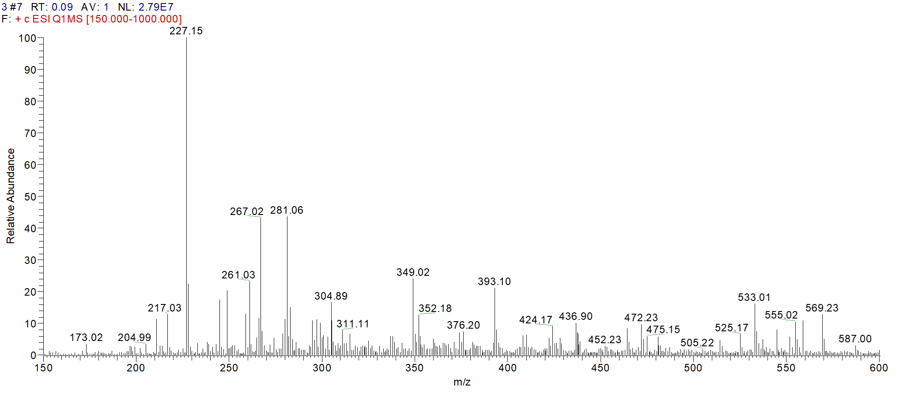
a

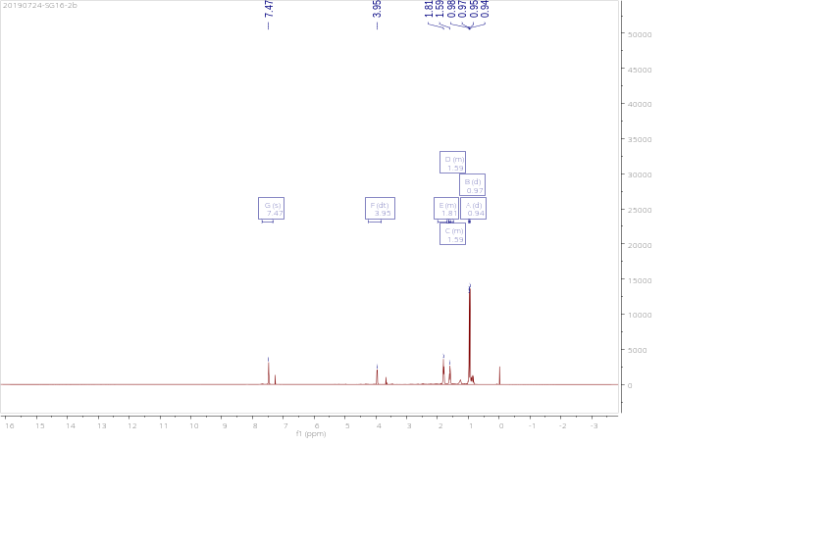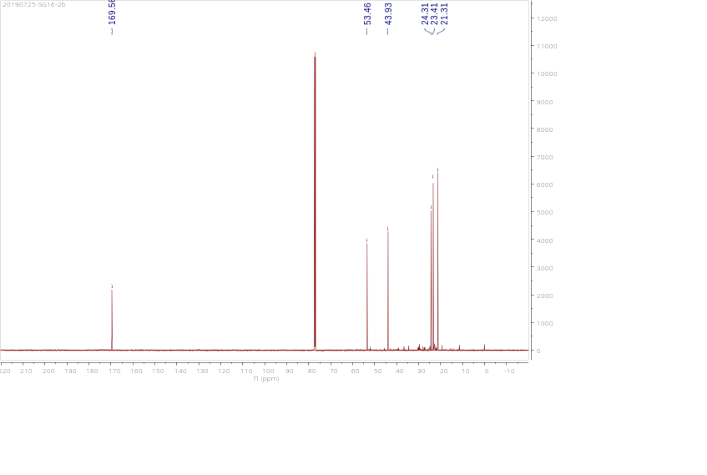
b
c
Fig. 4 Identification of compound 4: cyclic (leucine-leucine) dipeptide
(a) Mass spectrometry. (b) Proton (1H) nuclear magnetic resonance. (c) Carbon (13C) nuclear magnetic resonance spectrum of the compound 4 in Chloroform-d.

