Supplementary Note 1
From a static analysis perspective, S1 (b) and (c) in present the Mean Patch Area (MPA) and Landscape Shape Index (LSI) for two fully forested grids, 423753 and 421214, in 2000. The results indicate that the values of these indices are identical when the grids are completely covered by forest. However, even relatively intact forests can be influenced by adjacent fragmented areas. To quantify this effect, we introduced the Mean Gradient Distance (MGD) and combined MPA and LSI to construct the Forest Fragmentation Gradient Index (FFGI), which specifically evaluates the influence of fragmented forest areas on relatively intact forests. When landscape pattern indices such as MPA and LSI are identical, a larger gradient distance corresponds to a higher FFGI value (as shown in e).
From a dynamic analysis perspective, as fragmentation increased, the average distance gradient (MGD) decreased significantly, from 11,255.94 in 2000 to 2,758.14 in 2023 for one grid, and from 7,097.70 to 1,223.19 for the other. Correspondingly, MPA and LSI values also shifted, resulting in a decline in FFGI values from 0.996 to 0.945 and from 0.993 to 0.205, respectively. These findings demonstrate that relatively intact forests located near forest edges are more susceptible to intensified fragmentation over time.
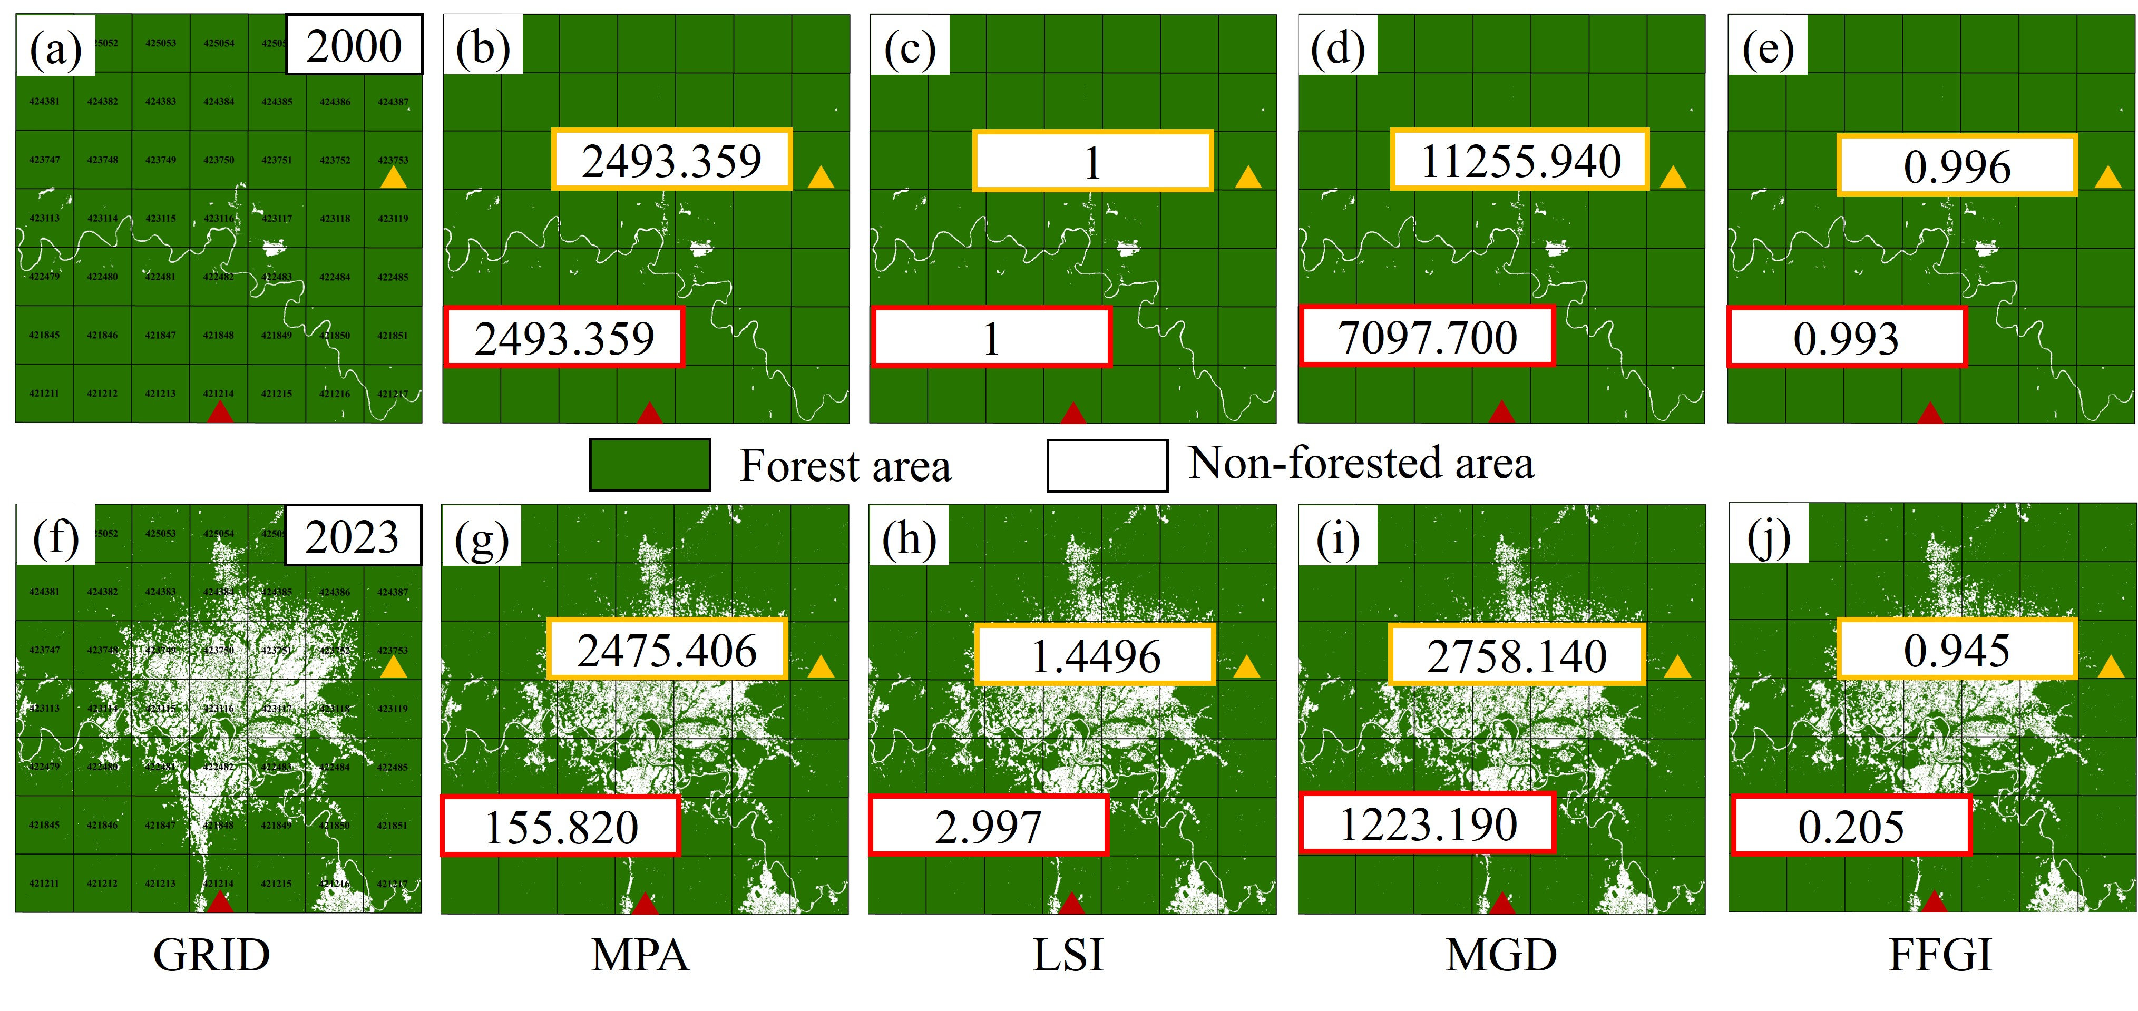
Supplementary Fig. 1 When MPA and LSI are equal when the forest is intact in the fixed grid, it is necessary to introduce the mean distance gradient index to construct FFGI.(a) and (f) are forest fragmentation diagrams under partial grid units of African tropical forests in 2000 and 2023, respectively; Maps of landscape pattern indices in 2000 and 2023, showing (b, g) Mean Patch Area (MPA), (c, h) Landscape Shape Index (LSI), (d, i) Mean Gradient Distance (MGD), and (e, j) Forest Fragmentation Gradient Index (FFGI) for grid 423753 (yellow triangle) and grid 421214 (red triangle).

Supplementary Note 2
Identifying forest patches across large, fragmented regions like Africa, where intensified fragmentation generates numerous isolated patches of varying sizes, requires significant computational resources. Due to memory limitations, it is challenging to process binary forest maps in a single operation. To address this, we developed a distributed fragment connectivity identification (DFCI) algorithm. The process begins by dividing the binary forest map S2(a) into two parts and independently identifying isolated patches within each segment using a four-neighborhood connectivity algorithm, assigning unique attributes to each patch (That is, the attribute values of all pixels in the same patch are the same) S2(b). The connectivity analysis results from the two segmented parts were merged S2(c). Subsequently, a connectivity analysis was conducted on all forest pixels within a one-pixel range on both sides of the segmentation line S2(d) and (e) Finally, the initial patch connectivity attributes are replaced using the new patch connectivity values and location attribute mappings S2(f). This algorithm offers an efficient and innovative solution for large-region, and lots of forest patch identification, overcoming computational constraints and enabling accurate assessments of fragmented landscapes.
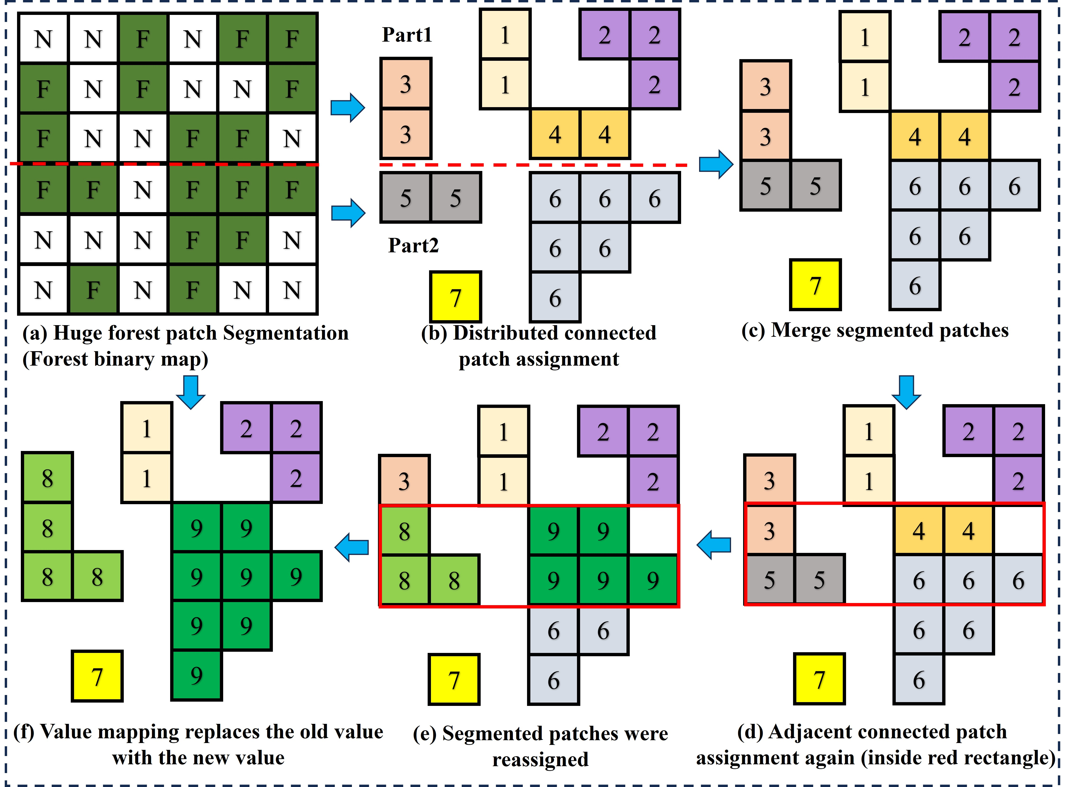
Supplementary Fig. 2 Distributed fragment connectivity identification (DFCI) algorithm for large forest patches connectively analysis.

Supplementary Note 3
Between 2000 and 2023, African tropical forests experienced significant fragmentation, particularly in humid forest regions. From a static perspective, the most severe fragmentation areas [0,0.2], showed substantial increases in proportion for key metrics. Specifically, in 2000, these areas accounted for 66.61% and 75.48% of the (a) mean gradient distance (MGD) and (d) mean patch area (MPA), respectively. By 2023, these proportions rose to (b) 77.42% and (e)86.48%. In contrast, for the landscape shape index (LSI), although forest fragmentation did not strongly influence its values, relatively intact regions within the range [0.8, 1] declined from 63% in 2000 (g) to 51.38% in 2023 (h).
From a dynamic perspective, regions exhibiting declines in ΔMGD, ΔMPA, and ΔLSI accounted for 74.72%, 74.32%, and 70.94% of the landscape, respectively. Notably, the areas with the most pronounced decreases were predominantly concentrated in the Congo, Cameroon, Liberia, Sierra Leone, and Central African regions.
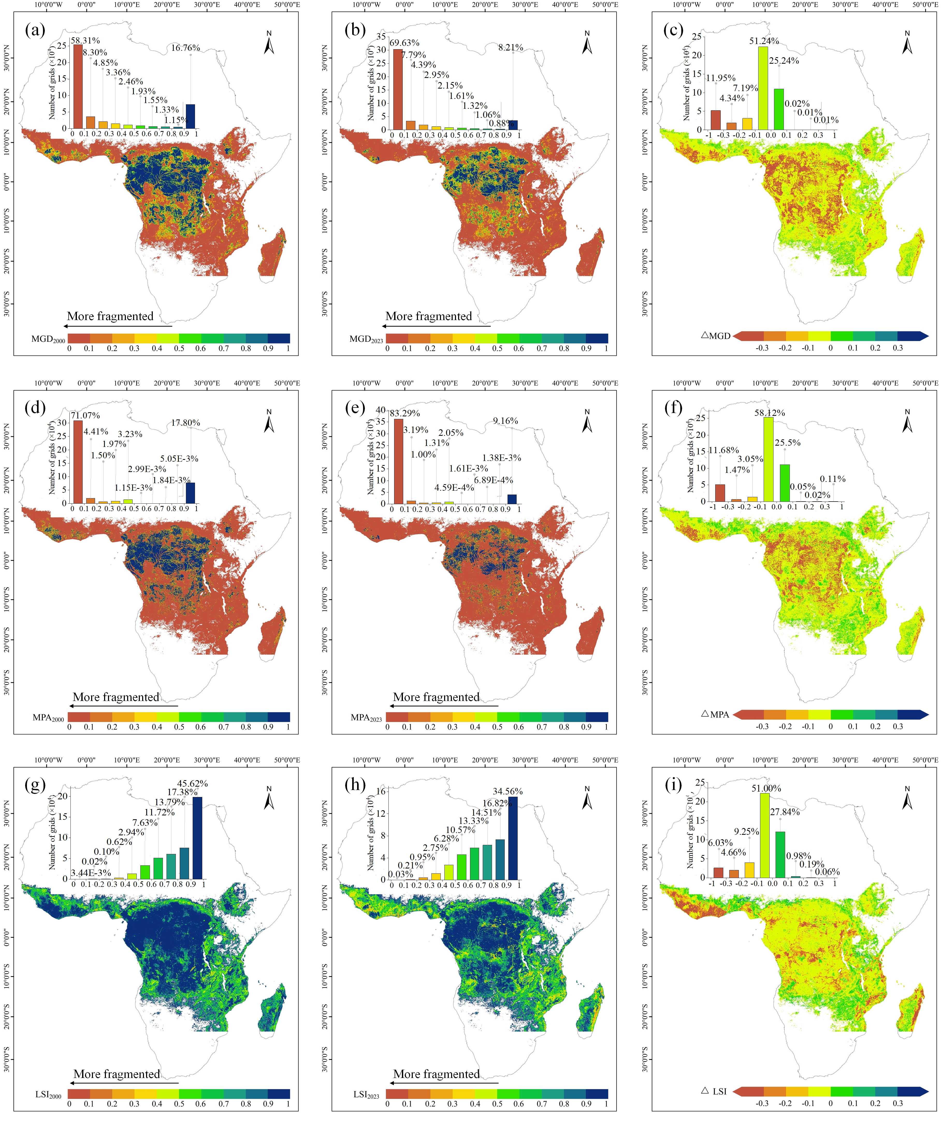
Supplementary Fig. 3. The spatial distributions of key landscape metrics for African tropical forests in 2000 and 2023 are analyzed, including the (a-b) mean gradient distance (MGD), (d-e) mean patch area (MPA), and (g-h) landscape shape index (LSI). Additionally, the corresponding changes in these metrics from 2000 to 2023 are represented as (c) ΔMGD, (f) ΔMPA, and (i) ΔLSI, respectively.
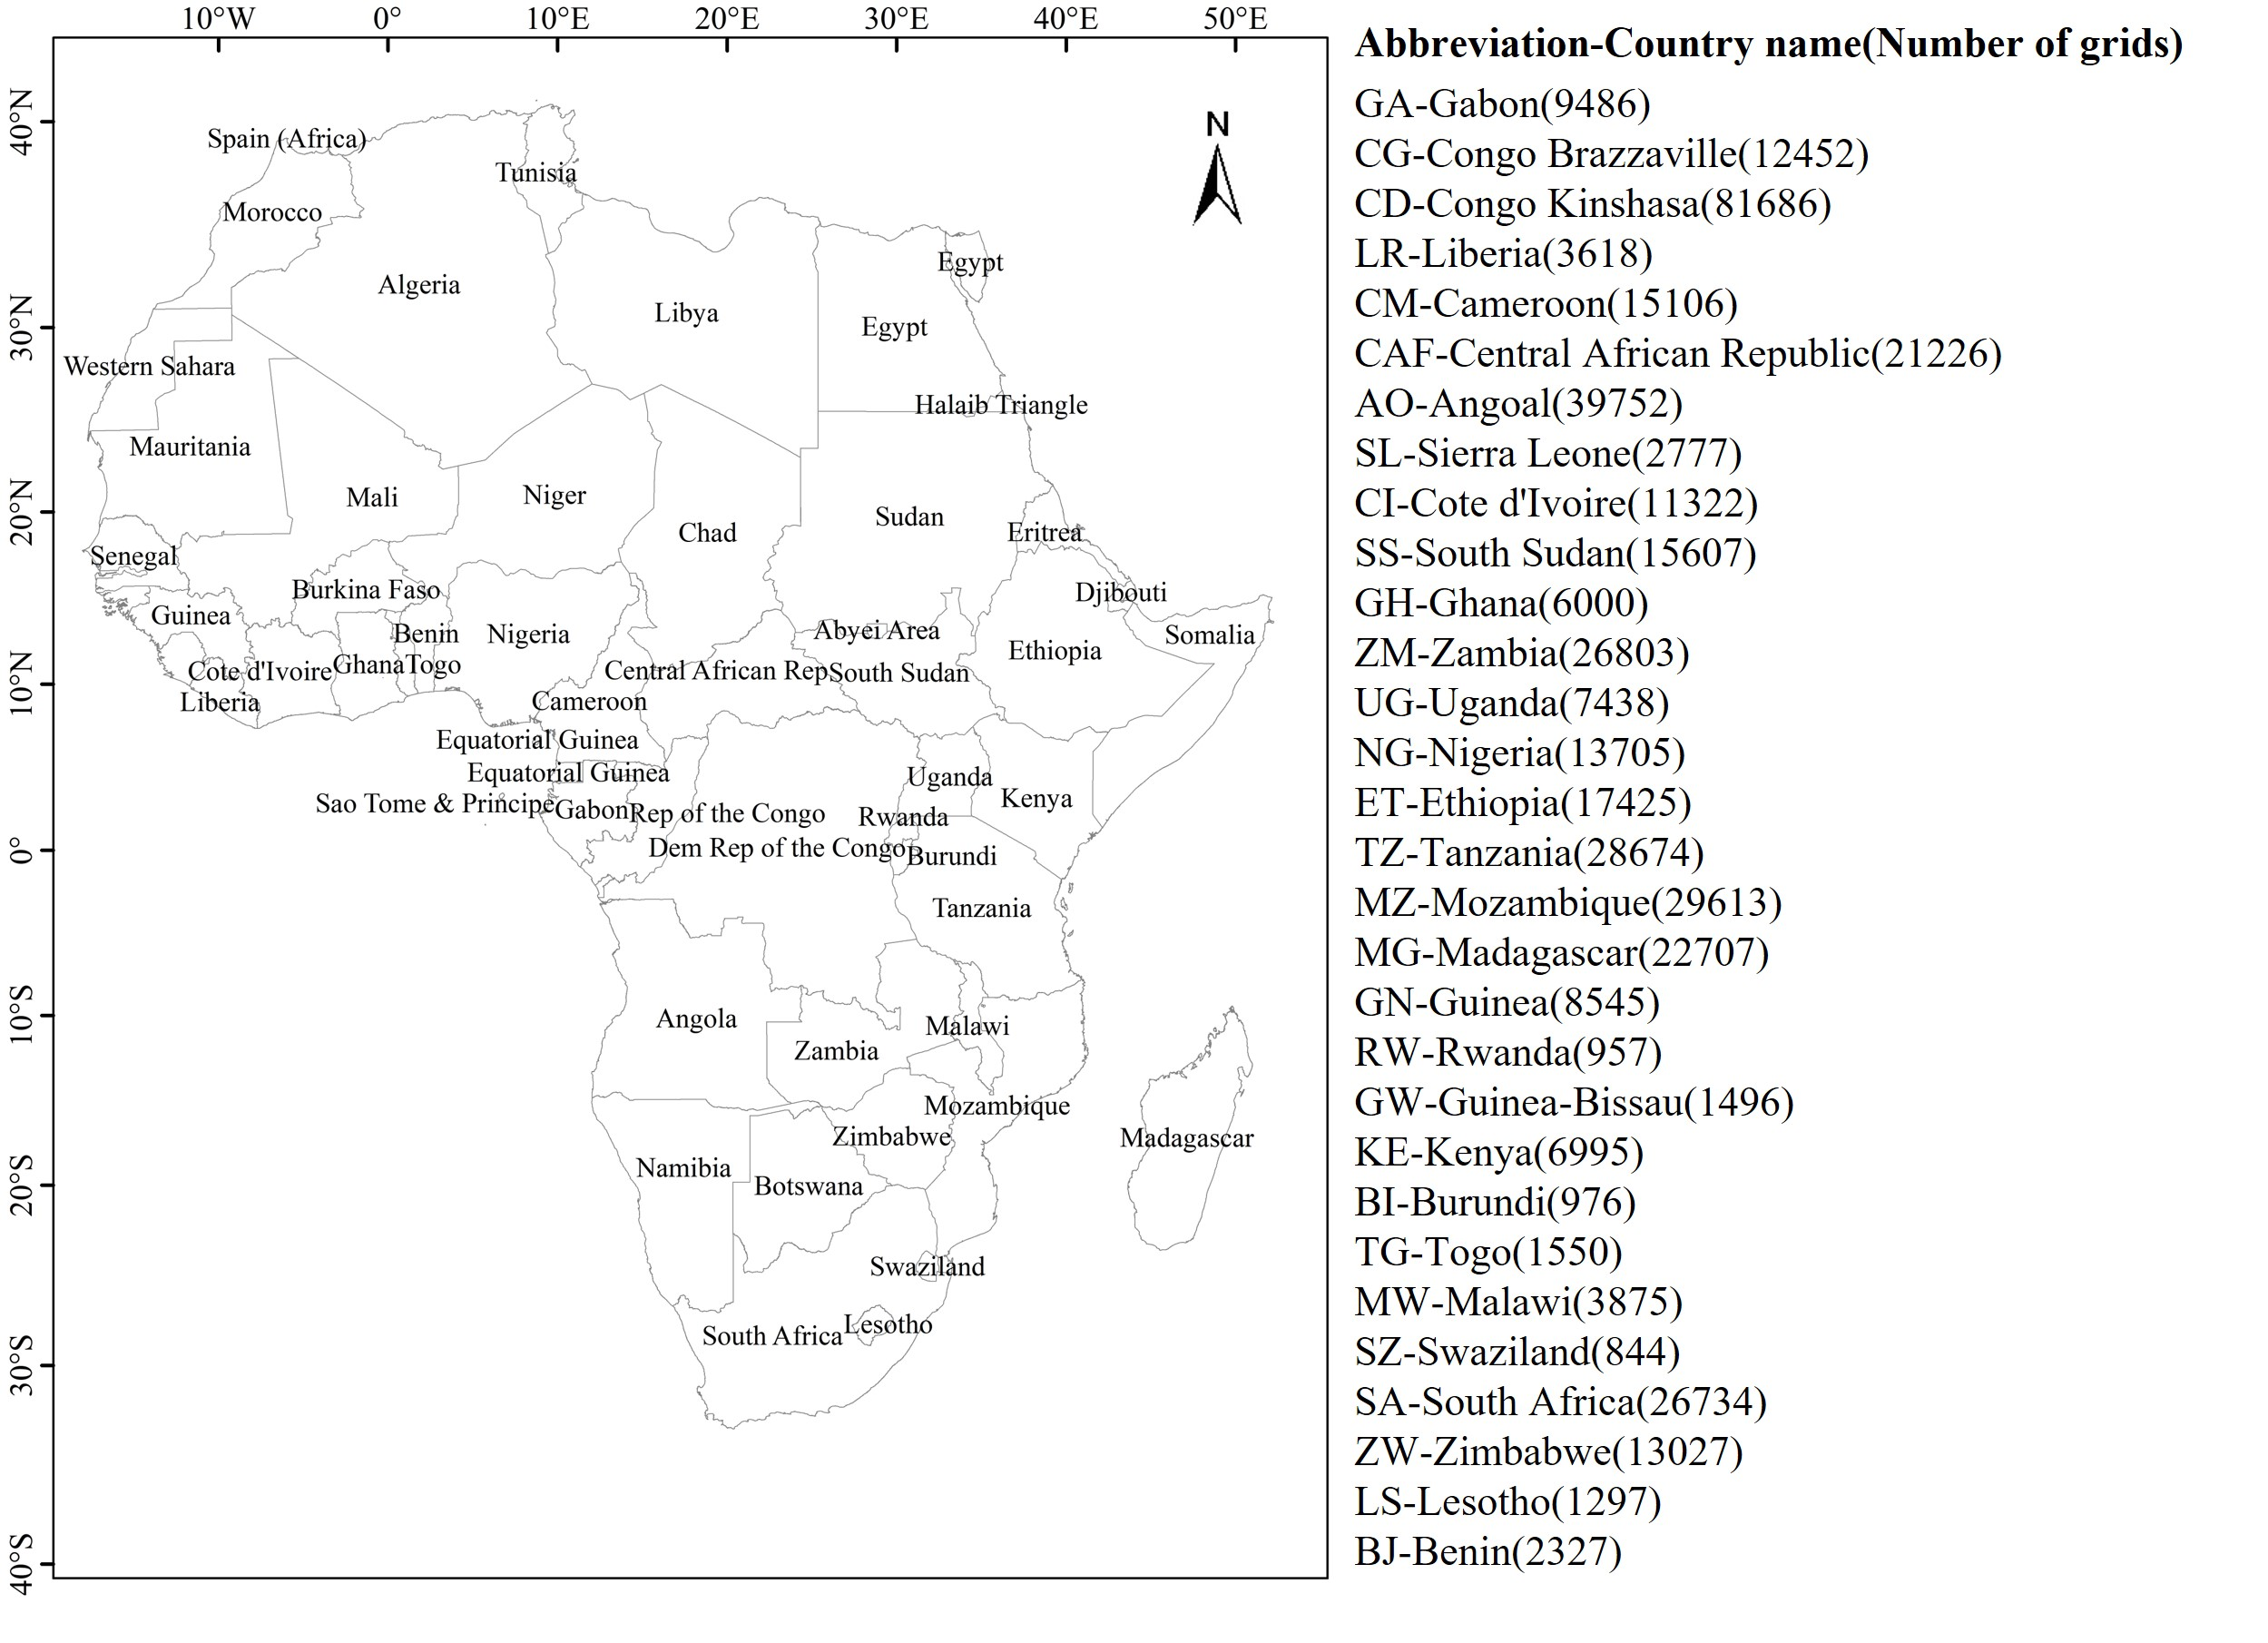
Supplementary Fig. 4. The spatial location of 30 African countries with a certain forest area and the country names corresponding to their abbreviations.

Supplementary Note 4
The entropy weight method (EWM) operates on the principle that when the values of an indicator among evaluated objects show significant variation, the entropy value of that indicator decreases, indicating its greater importance in the evaluation system. Consequently, it is assigned a higher weight. Conversely, when the values are more uniform, the entropy value increases, leading to a lower weight for that indicator. This method uncovers latent information in the data, enhances differentiation among indicators, and alleviates analytical challenges arising from subtle distinctions between them. The implementation process of EWM typically involves four main steps:
Additionally, to ensure that the same indicator is comparable in different years, the maximum and minimum values of the same indicator were unified in the normalization process in different years.
- Normalization of each indicator
$Positive: x_{ij}^{'}={\left[x_{ij}-min⁡(x_{ij})\right]}/{\left[\max\left(x_{ij}\right)-min⁡(x_{ij})\right]}$ (1)
$Negative: x_{ij}^{'}=\left[\max\left(x_{ij}\right)-x_{ij}\right]/\left[\max\left(x_{ij}\right)-min⁡(x_{ij})\right]$ (2)
where $x_{ij}^{'}$ represents the normalized value of the $i_{th}$ sample in the $j_{th}$ indicator, $x_{ij}$ represents the $i_{th}$ sample value in the $j_{th}$ indicator, $max⁡(x_{ij})$ and $min⁡(x_{ij})$ represent the maximum and minimum sample value of $j$ indicator; and for the evaluation object, positive indicates that a higher value of indicator j is better, while negative means that a lower value is preferred.
- The proportion calculation of each indicator
$p_{ij}={x_{ij}^{'}}/{\sum_{i=1}^{m}{x_{ij}^{'}}}$ (3)
- Calculation the information entropy of indicator$j$
$e_{j}=-\frac{1}{ln⁡(n)}\sum_{i=1}^{m}{(p_{ij}·ln⁡(p_{ij}))}$ (4)
- The weight of indicator $j$ is calculated
$W_{j}={(1-e_{j})}/{\sum_{j=1}^{n}{(1-e_{j})}}$ (5)

Supplementary Note 5

$kNDVI= \frac{k\left(n,n\right)-k(n,r)}{k\left(n,n\right)+k(n,r)}$ (6)
where n and r represent the reflectance of the near-infrared and infrared respectively, and k is used to measure the similarity between the two bands.
$k\left(a,b\right)=e^{\frac{{-(n-r)}^{2}}{{2σ}^{2}}}$ (7)
where σ refers to the distance between the near-infrared and infrared bands, which can be simplified by bringing in equation (8):
$kNDVI=tanh⁡({(\frac{n-r}{2σ})}^{2})$ (8)
the average $σ=0.5(n+r)$ is often taken, so it can be further simplified to:
$kNDVI=tanh⁡({NDVI}^{2})$ (9)

Supplementary Note 6

$q=1-\frac{1}{nσ_{H}^{2}}\sum_{i=1}^{m}{n_{i}σ_{i}^{2}}$ (10)
where the$q$ value represents the explanatory power of meteorological factors on the spatial distribution of kNDVI. A higher $q$ value indicates a stronger influence of the meteorological factor on kNDVI. In the formula, $n$ denotes the total number of samples in the study area,$σ_{H}^{2}$ is the total variance of the dependent variable kNDVI across the study area, $n_{i}$ is the number of samples in each subregion, and $σ_{i}^{2}$ is the local variance within the subregion.

