Extended data figures and tables

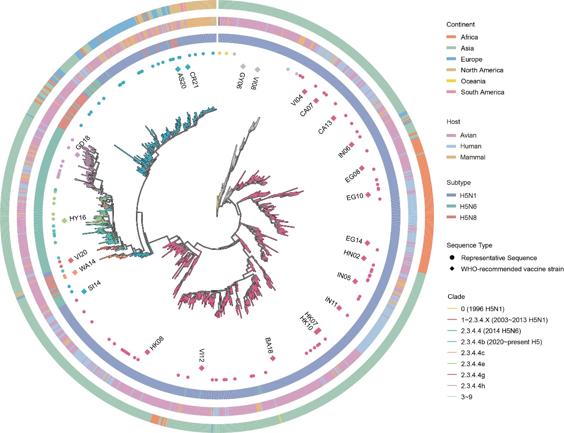
Extended data Fig. 1: Phylogenetic tree of H5 viruses based on the HA amino acid sequences. Vaccine strains are represented by squares and representative strains are represented by circles. The continental distribution, host, subtype, and clade information of the strains are shown.

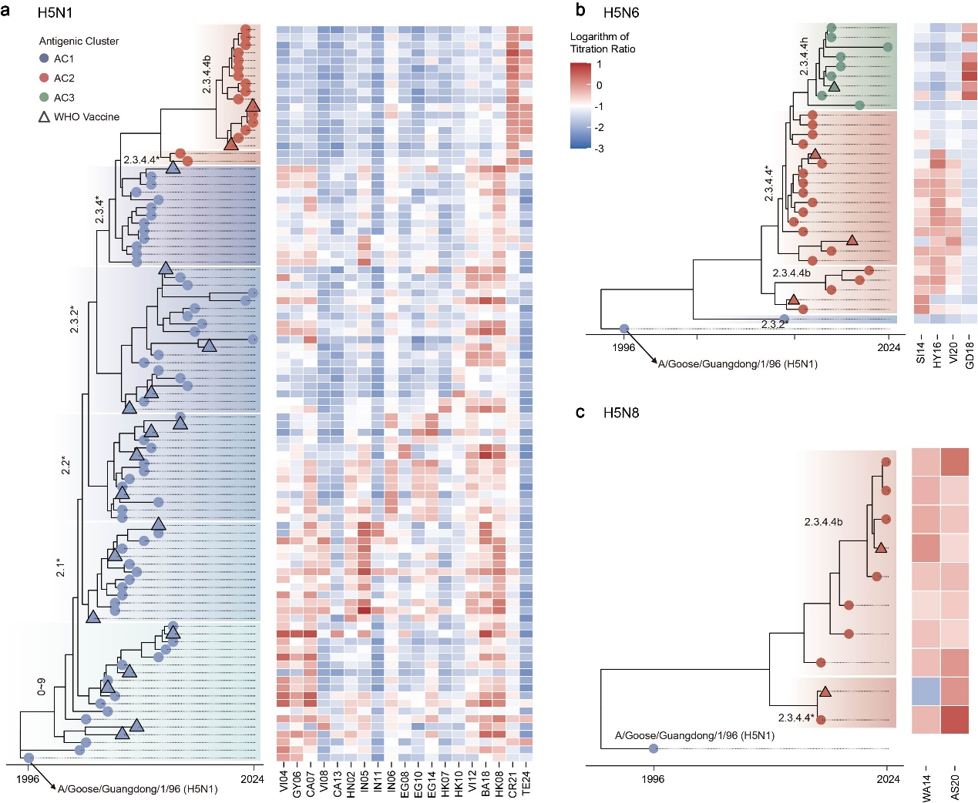
Extended data Fig. 2: Antigenic evolutionary relationships of H5N1, H5N6, and H5N8 subtypes. Molecular clock trees and pseudotyped virus neutralization heatmaps for H5N1 (a), H5N6 (b), and H5N8 (c) subtypes, respectively. In the phylogenetic trees, blue areas indicate antigenic cluster AC1, red areas indicate antigenic cluster AC2, and green areas indicate antigenic cluster AC3. Representative strains are represented by circles, and the vaccine strains are represented by triangles with black edges. Values in the heatmaps indicate the logarithm (log10) of neutralization titer ratio between representative and vaccine strain.

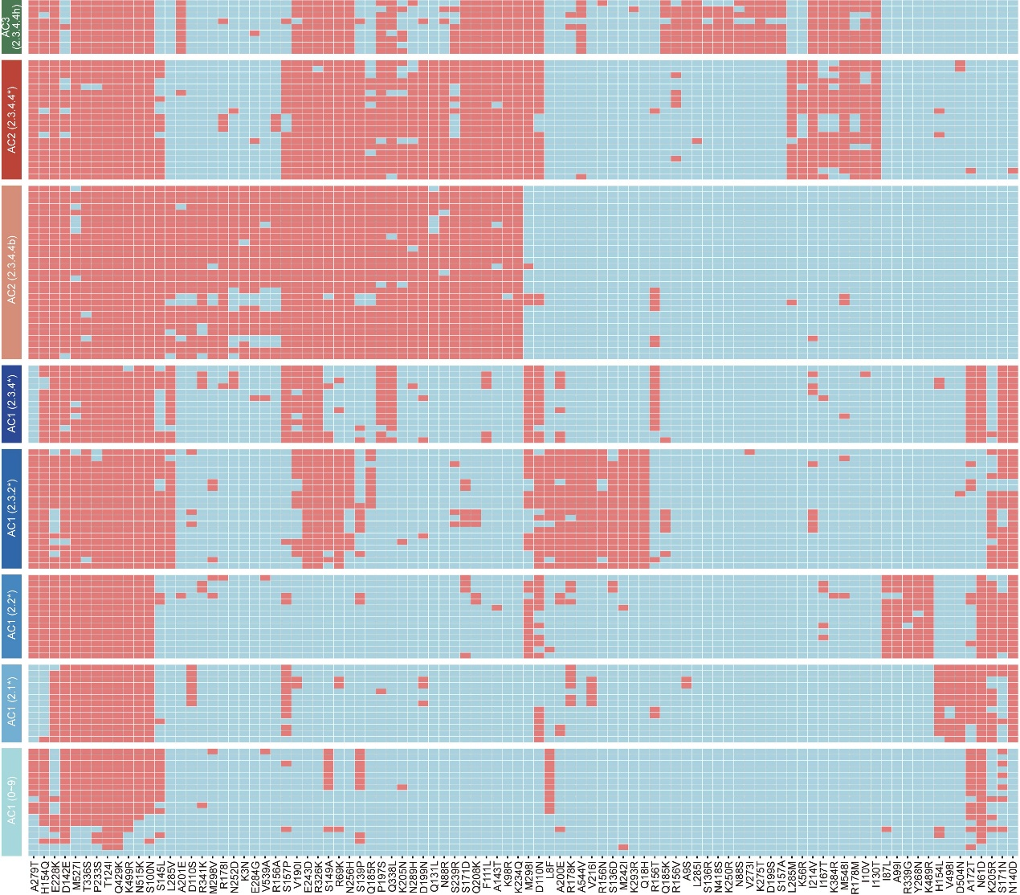
Extended data Fig. 3: Characteristic mutations in different antigenic clusters and clades. Mutations occurring at frequencies higher than 70% in each clade are shown.

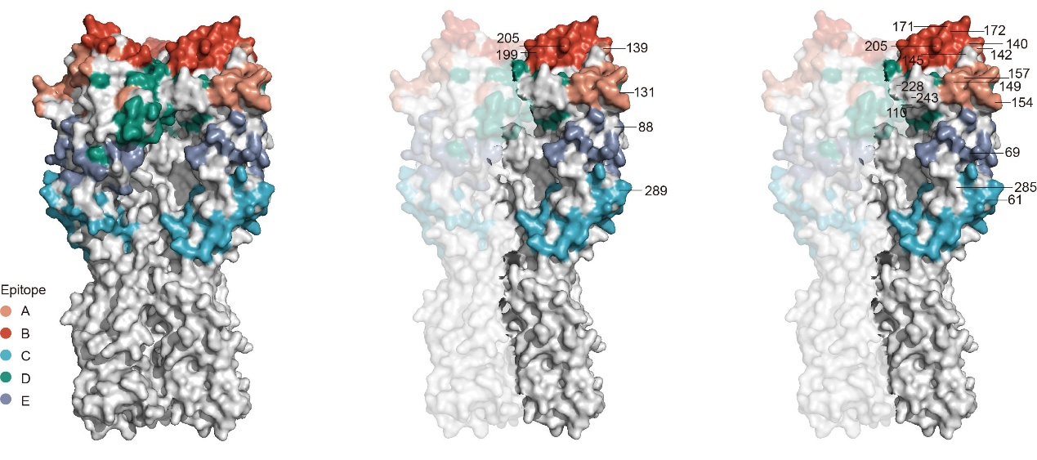
Extended data Fig. 4: Distribution of key positions driving H5 antigenic changes on the HA trimer structure. The left panel indicates the distribution of A-E epitopes in the trimeric structure. The middle panel shows the distribution of six positions 88, 131, 139, 199, 205, and 289 that determine the evolution of AC1>AC2>AC3 on the HA trimer. The right panel shows the distribution of positions 61, 69, 110, 140, 142, 145, 149, 154, 157, 171, 172, 205, 228, 243 and 285, which determine the antigenic differences within AC1.

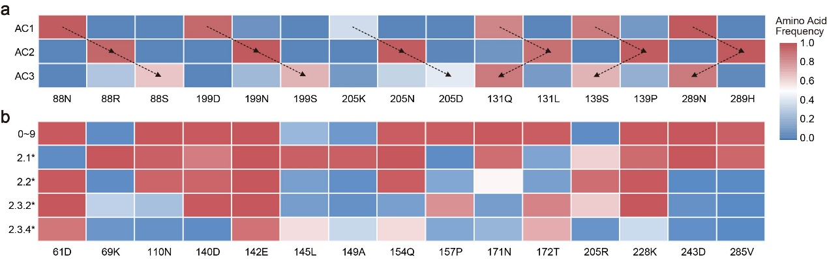
Extended data Fig. 5: Frequencies of key mutations in antigenic clusters and genetic clades. a, Mutation frequencies at positions 88, 131, 139, 199, 205, and 289 in AC1, AC2, and AC3. b, Mutation frequencies at positions 61, 69, 110, 140, 142, 145, 149, 154, 157, 171, 172, 205, 228, 243, and 285 in different clades of AC1.

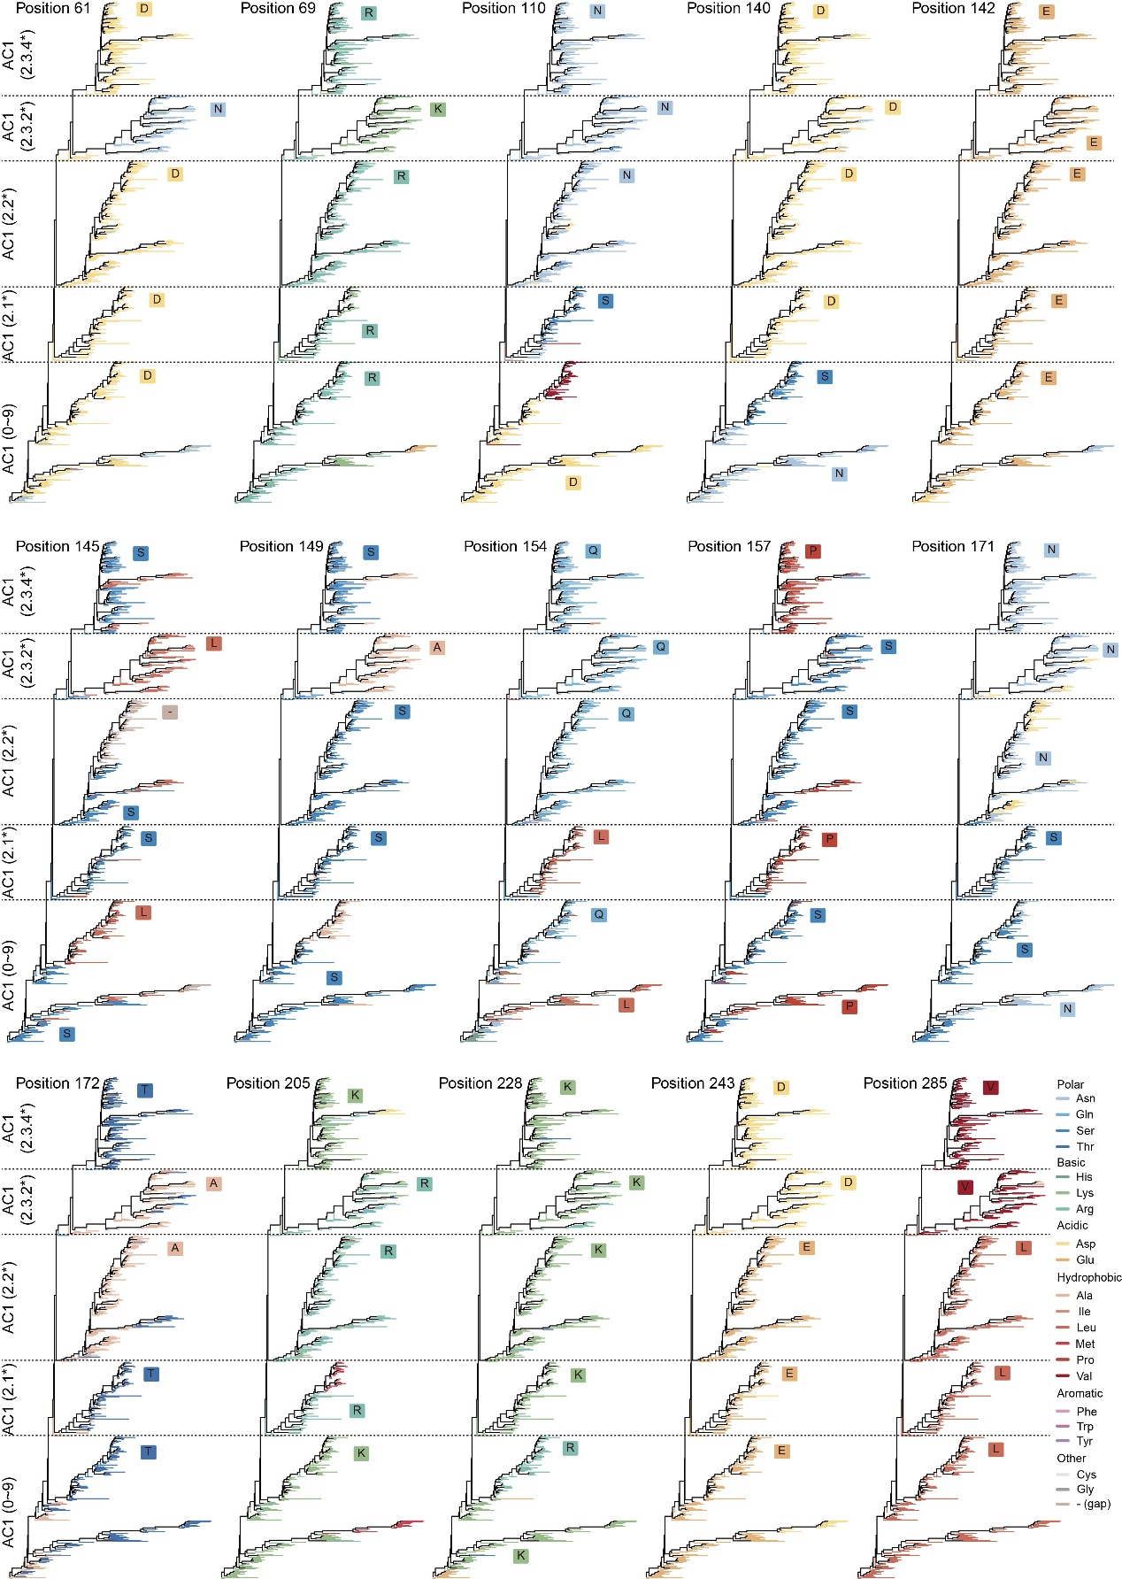
Extended data Fig. 6: Evolutionary trajectories of positions 61, 69, 110, 140, 142, 145, 149, 154, 157, 171, 172, 205, 228, 243, and 285 within the AC1 antigenic cluster. Dashed lines separate clades 0~9, 2.1*, 2.2*, 2.3.2* and 2.3.4*, and different colors represent different amino acids.
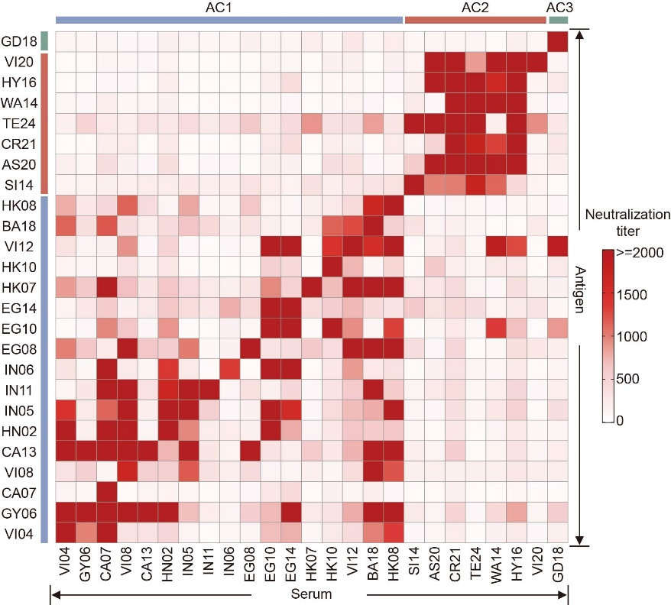
Extended data Fig. 7: Cross-neutralization among vaccine strains. The blue, red, and green areas indicate antigen clusters AC1, AC2, and AC3, respectively. The horizontal axis represents the immunized serum of vaccine strains and the vertical axis represents the vaccine strains. Values in the heatmap represent neutralization titers.

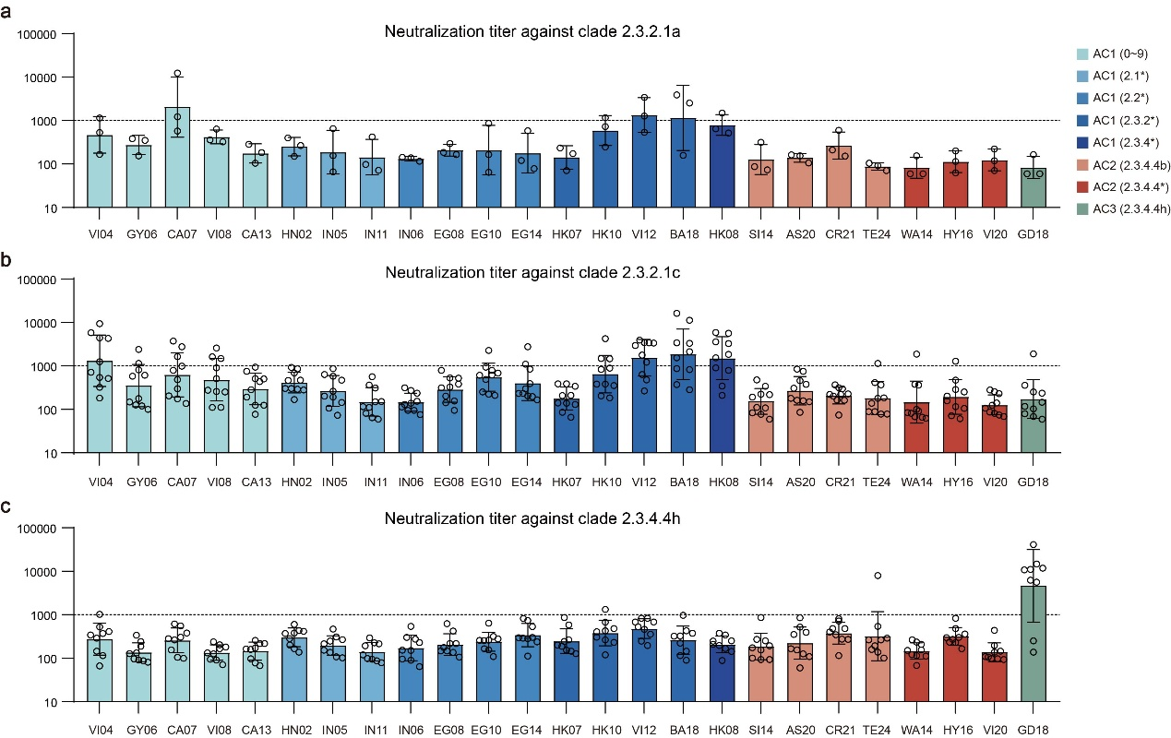
Extended data Fig. 8: Neutralization titers of serum elicited by different vaccine strains against clades 2.3.2.1a, 2.3.2.1c and 2.3.4.4h. Vertical axes indicate the neutralizing titers. The horizontal axes represent vaccine strains, with vaccines from different clades shown in different colors. Circles in the columns indicate individual strains in each clade.

Extended data Table 1: Information of vaccine strains used in this study. Detailed information includes strain name, abbreviation, clade, and subtype information.
Extended data Table 2: Information of representative strains used in this study. Detailed information includes strain name, isolate id, clade, host, subtype and continent.
Extended data Table 3: Genetic distance among representative strains.
Extended data Table 4: Antigenic distance among representative strains.
Extended data Table 5: Characteristic mutations of different antigenic clusters and clades with their structural domains. H5 numbering was based on the A/Goose/Guangdong/1/96 (H5N1) strain. Common mutations are defined as mutations that occur with a frequency of >70% in two or more clades. Specific mutations are defined as mutations that occur with a frequency of >70% in one clade while having frequencies of <30% in all other clades.

