Untargeted Lipidomics Profiling Provides Novel Insights into Pediatric Patients with Sepsis: An Exploratory Study
Reyihangu Awuti^{1#}, Jiayi Bai^{1#}, Ye Cheng^{1#}, Weili Yang¹, Zimei Cheng¹, Hetian Zhou¹, Guoyun Su⁵, Kexin Wang⁴, Yaodong Wang¹, Tingyan Liu¹, Ying Liu², Weiming Chen¹, Hehe Chen^{6*}, Guoping Lu^{1,2,3*}, and Caiyan Zhang^{1*}
- Department of Critical Care Medicine, and Department of Emergency, Children's Hospital of Fudan University, National Children’s Medical Center, Fudan University, Shanghai 201102, China.
- School of Public Health & Shanghai Institute of Infectious Disease and Biosecurity, Fudan University, Shanghai 200032, China.
- Department of Pediatric Critical Care Unit, Anhui Povincial Children's Hospital, Hefei 230051, China
- The Shanghai Key Laboratory of Medical Epigenetics, International Co-laboratory of Medical Epigenetics and Metabolism, Ministry of Science and Technology, Institutes of Biomedical Sciences, Fudan University, Shanghai 200032, China.
- Pediatric Intensive Care Unit, Shenzhen Children's Hospital, Shenzhen 518026, China.
- Department of Critical Care Medicine, Women and Children's Hospital of Ningbo University, Ningbo, Zhejiang 315000, China.
#These authors contributed equally to this work.
*Correspondence to: Caiyan Zhang, PhD, e-mail: zhangcy17@fudan.edu.cn; Guoping Lu, MD, PhD, e-mail: lgp@fudan.edu.cn; or Hehe Chen, MD, PhD, e-mail: hehebb0425@163.com. 399 Wanyuan Rd, Minhang, Shanghai 201102, China.

Supplement
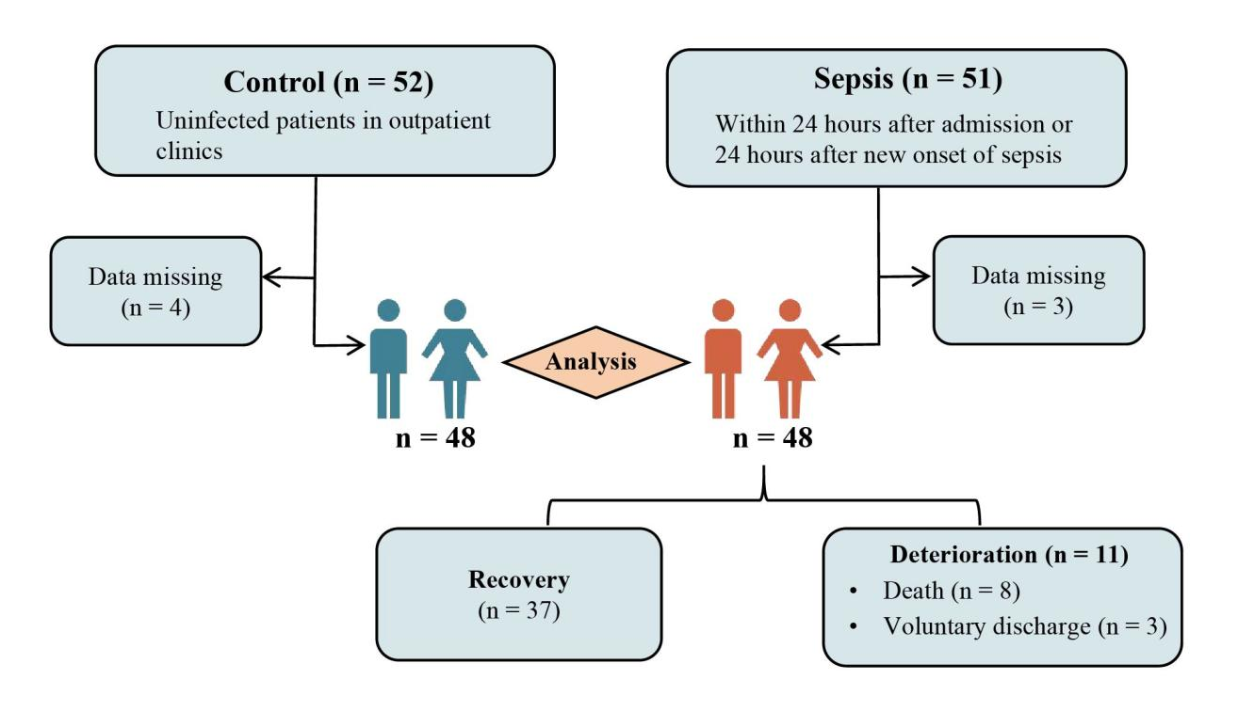
Fig. S1 Flowchart depicting group composition, exclusions and comparisons between groups.

Table S1 Overview of lipid class nomenclature
Abbr. | Common name | Category | Lipid No.
PA | Phosphatidic acid | [GP] | 23
PC | Phosphatidylcholine | [GP] | 639
PE | Phosphatidylethanolamine | [GP] | 358
PG | Phosphatidylglycerol | [GP] | 63
PI | Phosphatidylinositol | [GP] | 7
PS | Phosphatidylserine | [GP] | 87
LPA | Lysophosphatidic acid | [GP] | 1
LPC | Lysophosphatidylcholine | [GP] | 70
LPE | Lysophosphatidylethanolamine | [GP] | 28
LPG | Lysophosphatidylglycerol | [GP] | 5
LPI | Lysophosphatidylinositol | [GP] | 3
PIP | Phosphatidylinositol(4)phosphate | [GP] | 7
PIP2 | Phosphatidylinositol(4,5)bisphosphate | [GP] | 1
PIP3 | Phosphatidylinositol(3,4,5)triphosphate | [GP] | 1
CL | Cardiolipin | [GP] | 192
Cer | Ceramides | [SP] | 344
SM | Sphingomyelin | [SP] | 216
CerG2GNAc1 | N-acetylhexosyl ceramide | [SP] | 33
CerG3GNAc1 | Dihexosyl N-acetylhexosyl ceramide | [SP] | 23
CerG3GNAc2 | Trihexosyl di-N-acetylhexosyl ceramide | [SP] | 1
CerP | Ceramides phosphate | [SP] | 27
Hex1Cer | Hexosyl ceramide | [SP] | 214
Hex2Cer | Hexosyl ceramide | [SP] | 160
Hex3Cer | Hexosyl ceramide | [SP] | 81
ST | Sulfatide (galactosyl ceramide sulfate) | [SP] | 48
phSM | Phytosphingosine | [SP] | 44
GD1a | Ganglioside, disialo tetrahexosyl ceramide | [SP] | 3
GD2 | Ganglioside, disialo dihexosyl ceramide | [SP] | 2
GM1 | Ganglioside, monosialo tetrahexosyl ceramide | [SP] | 1
GM2 | Ganglioside, monosialo dihexosyl ceramide | [SP] | 2
GM3 | Ganglioside, monosialo trihexosyl ceramide | [SP] | 71
GT3 | Ganglioside, trisialo trihexosyl | [SP] | 1
SPH | Sphingosine bases | [SP] | 35
MG | Monoglyceride | [GL] | 24
TG | Triglyceride | [GL] | 886
DG | Diglyceride | [GL] | 222
OAHFA | (O-acyl)-1-hydroxy fatty acid | [FA] | 23
WE | Wax esters | [FA] | 33
AcCa | Acyl Carnitine | [FA] | 33
FA | Fatty acid | [FA] | 3
Co | Coenzyme Q | [PL] | 3
ZyE | Zymosterol ester | [ST] | 11
ChE | Cholesteryl ester | [ST] | 21
SiE | Sitosterol ester | [ST] | 2
Fig. S2 PLS-DA analysis of the metabolic profiles in controls and sepsis patients. a, b PLS-DA model: R² = 0.975, Q² = 0.913.

Fig. S3 Changes in the plasma lipidome in sepsis patients (Display only the lipids showing significant differences). The box plot shows whole-class plasma lipid differences between patients with sepsis and controls (n = 48 per group) (The abundance value of each lipid is the sum of all lipids per class per subject). Statistically significant differences are indicated, with *P < 0.05, **P < 0.01, ***P < 0.001, ****P < 0.0001.

Table S2 pSOFA-Related Lipids

Lipidion Rho Adjusted P
LPC(15:0)* | -0.46 | 0.007
LPC(16:1e)* | -0.49 | 0.003
LPC(18:1)* | -0.38 | 0.033
LPC(18:3)* | -0.38 | 0.033
LPC(20:1)* | -0.43 | 0.013
OAHFA(47:6) | 0.41 | 0.021
OAHFA(47:7)* | 0.49 | 0.003
PC(18:3e)* | -0.39 | 0.025
CL(85:5) | -0.39 | 0.029
Cer(d18:1_16:0) | 0.38 | 0.035
Cer(d18:1_16:1)* | 0.40 | 0.023
Cer(d18:1_24:2) | 0.36 | 0.048
Cer(d18:2_24:2)* | 0.42 | 0.016
Cer(m34:1+O) | 0.38 | 0.035
Cer(t17:1_25:1) | 0.41 | 0.019
CerG2GNAc1(d32:1)* | -0.45 | 0.009
GM3(m38:2)* | -0.43 | 0.014
LPC(18:2)* | -0.36 | 0.042
LPC(19:1)* | -0.48 | 0.004
Cer(d44:6) | 0.39 | 0.026
PG(34:1) | -0.37 | 0.042
Cer(m19:1_23:3) | 0.36 | 0.043
AcCa(8:0)* | 0.49 | 0.003
TG(46:13)* | 0.40 | 0.025
Adjusted for mutiple testing with the Benjamini-Hochberg method. * Defined as the overlapping lipid molecules between differential lipids and pSOFA-associated lipids in the sepsis recovery and deterioration groups.

