Supplementary Information
Ultra-fast ammonia decomposition using a tungsten wire lightbulb reactor
Keshia Saradima Indriadi^{1,2, †}, Sie Shing Wong^{1, †}, Sikai Wang¹, Di Xu^{1,2}, Ning Yan^{*,1,2,3}

¹ Department of Chemical and Biomolecular Engineering, National University of Singapore, Singapore 117585
² Joint School of National University of Singapore and Tianjin University, Fuzhou 350207, China
³ Centre for Hydrogen Innovations, National University of Singapore, Singapore 117580
†Both authors contributed equally
*Corresponding author: ning.yan@nus.edu.sg (N. Yan)
Table of Contents
Computational Methods 2
Supplementary Text 6
Text S1: Calculations of ammonia decomposition rate constants 6
Text S2: Theoretical tungsten wire temperature estimation 7
Text S3: Calculations of energy efficiency 8
Text S4: Energy balance calculations 8
Text S5: Calculations of volume, cost, and global warming potential 9
Text S6: Calculations for TWL reactor performance in different application scenarios 9
Supplementary Figures 10
Figure S1. Theoretical estimation of tungsten wire temperature at 220 h⁻¹ NH₃ space velocity compared to experimental measurement. 10
Figure S2. IR photographs of tungsten wire at various power inputs. 10
Figure S3. SEM images of tungsten wire. 11
Figure S4. Kinetics measurements using an analogous thermal-catalytic tungsten mesh system. 12
Figure S5. Mesh sensitivity analysis. 12
Figure S6. Comparison of experimental and modelled temperature and power input values. 13
Figure S7. Temperature contour plots. 13
Figure S8. Comparison of maximum and average temperatures at 1,100 h⁻¹. 14
Figure S9. Estimated reaction rate constants of non-catalytic ADR compared to measured rate constants of a commercial Ru catalyst. 14
Figure S10. Mass transfer limitation experiment. 15
Figure S11. Typical velocity profile, at a reaction condition of 25 W input and 1,100 h⁻¹ space velocity. 15
Figure S12. Variation in velocity, density, and dynamic viscosity across the reactor at the condition of 25 W input and 1,100 h⁻¹ space velocity. 16
Figure S13. Flux in mol m⁻² s⁻¹ of NH₃ and H₂ at two different power inputs and 1,100 h⁻¹ space velocity. 16
Figure S14. Change in energy balance. 17
Figure S15. Net radiative heat flux at the tungsten wire boundary at different power inputs and 1,100 h⁻¹ NH₃ space velocity. 17
Figure S16. Emission and absorption of radiation in the gas phase at different power inputs and 1,100 h⁻¹ NH₃ space velocity. 18
Figure S17. Images of reactor with reflector walls at various energy inputs. 18
Figure S18. Conversion and energy efficiency of modified reactors at 25 W input and 1,090 h⁻¹ space velocity. 19
Figure S19. Optimisation of reactor tube radius. 19
Figure S20. Geometry for 3D multi-tubular reactor calculations. 20
Figure S21. Comparison of single-tube and multi-tube simulation performance. 20
Figure S22. Operating cost composition in ADR and TWL reactors. 21
Supplementary Tables 22
Table S1. Conversion of lab-scale TWL reactor measured with IC. 22
Table S2. Comparison of activity and efficiency of other reported ammonia decomposition systems, as depicted in Fig 3d. 22
Table S3. Comparison of tube arrangements in multi-tubular model. 24
Supplementary References 25

Computational Methods
The model geometry closely follows the experimental setup, consisting of a tungsten wire (0.1 mm thickness, 10 cm length) connected to two copper rods (0.8 mm diameter, 10 cm length) in a 0.5 cm radius reactor chamber enclosed by a 0.27 cm thick quartz wall, with the length of the reactor and quartz wall being 12 cm. Fittings and electrical connections were omitted for simplicity.

Electric Currents
Ohm’s Law is used to describe the electric current applied:
$$J=σE+J_{e}$$
Where $σ$ is the electrical conductivity, E the electric field, and J the current density. A temperature-dependent linearized resistivity conduction model is used.
The following variables are used for the relevant materials:
Material | Reference resistivity ($ρ_{0}, Ω m)$ | Resistivity temperature coefficient ($α$, 1/K) | Reference temperature ($T_{ref}$, K)
Tungsten | 5.6E-8 | 0.0045 | 293
Copper | 1.72E-8 | 0.0039 | 298

One end of the copper rod was defined as a constant applied electric potential while the other end is defined as ground ($V=0$).

Mass and Momentum Conservation
As the flow rates are low and Reynolds number always remains small, an incompressible laminar flow was used to model the reactant gases. Thus, the continuity equation is:
$$ρ∇∙u=0$$
And the stationary Navier-Stokes equation can be implemented as such: $$ρ\left(u∙∇\right)u=∇∙\left[pI+Κ\right]+F$$
Here, u is the velocity vector, p is pressure, and F the volume force vector. The stress constitutive equation is:
$$Κ=μ(∇u+{\left(∇u\right)}^{T})$$
No slip boundary condition is applied on the inner walls of the reactor tube. A standard flow rate is set at the inlet boundary and a constant pressure at the outlet boundary.

Energy Balance
Heat transfer in the solid surfaces is defined as:
$$ρC_{p}u∙∇T+∇∙q=Q+Q_{ted}$$
Q is the heat source, which is generated from electromagnetic Joule heating at the boundaries of the tungsten wire and copper rods.
$$Q_{E}=J∙E$$
The equation also accounts for thermoelastic damping effects ($Q_{ted})$. In the fluid surface, there is additionally work done by pressure changes ($Q_{p}$) and viscous dissipation ($Q_{vd}$) in the fluid:
$$ρC_{p}u∙∇T+∇∙q=Q+Q_{p}+Q_{vd}$$
The conductive heat flux is calculated based on the thermal conductivity (k) of each material: $$q=-k∇T$$
Density of the fluid is calculated assuming ideal gas conditions:
$$ρ=\frac{p_{A}}{RT}$$
Convective heat transfer within the gas flow regime is calculated by coupling the laminar flow and conductive heat transfer equations. On the external reactor walls, there is heat dissipation due to natural convection.
The model defines the ammonia fluid as a participating medium that partially absorbs and scatters heat radiation while the other surfaces are opaque to radiation. Thus, radiative heat is approximated as:
$$Q_{r}=κ\left(G-4πI_{b}\right) \\ ∇∙\left(-D_{P1}∇G\right)=-κ\left(G-4πI_{b}\right) \\ D_{P1}=\frac{1}{3\left(κ+σ_{s}\right)}$$
Where $κ$ is the absorption coefficient, G the incident radiation, and $I_{b}$ the blackbody radiative intensity. Radiative scattering is negligible in gases due to the small size of gas molecules, so the scattering coefficient $σ_{s}$ is assumed to be zero. The Planck-mean absorption coefficient is used for $κ$, which is defined as:
$$κ_{P}=\frac{1}{I_{b}}\int_{0}^{∞}{κ_{η}I_{bη}dη}$$
As mononuclear molecules such as H₂ and N₂ do not absorb infrared radiation, only the absorption coefficient of NH₃ need to be considered. This can be calculated by the formula¹:
$$κ_{P,NH_{3}}=C_{0}+\frac{C_{1}}{T}+\frac{C_{2}}{T^{2}}+\frac{C_{3}}{T^{3}}+\frac{C_{4}}{T^{4}}+\frac{C_{5}}{T^{5}}$$
The constants C₀ through C₅ are defined as:
 | $$300≤T≤1100$$ | $$1100<T≤2500$$
C₀ | 1.15691E+01 | −5.10770E−02
C₁ | −3.56117E+04 | −8.61034E+02
C₂ | 3.33438E+07 | 9.23915E+06
C₃ | −7.08740E+09 | −2.94040E+10
C₄ | 2.26363E+11 | 3.65220E+13
C₅ | 6.26830E+13 | −1.29468E+16

The absorption coefficient implemented in the model is thus weighted by the mass composition of NH₃ at a given point:
$$κ=w_{NH_{3}}×κ_{P,NH_{3}}$$

Chemical Reaction
Ammonia decomposition is an endothermic equilibrium reaction:
$$2NH_{3}⇌{3H}_{2}+N_{2}$$
As the reverse ammonia synthesis reaction is thermodynamically highly unfavourable in low pressure and high temperature conditions, the reaction is assumed to be irreversible in the model:
$$2NH_{3}→{3H}_{2}+N_{2}$$
The reaction rate is thus:
$$r=k{\left[NH_{3}\right]}^{n}$$
Here n is the reaction order with respect to NH₃ and has been determined experimentally (Fig S5b). The rate constant is defined using Arrhenius equations:
$$k=A e^{-\frac{E_{a}}{RT}}$$
Activation energy ($E_{a}$) has also been determined experimentally and the pre-exponential factor A was determined through fitting of the model to the experimental data.
Chemical reactions were applied to the entire fluid domain, but since high temperatures with considerable reaction rates are only found immediately next to the tungsten wire, this should be an adequate approximation for catalytic reactions on the tungsten wire surface.
Mesh
Free triangular elements were used to generate the mesh, usually with an element size not more than 0.1 mm, and an even finer mesh set at the tungsten wire domain. The mesh is also refined along the boundary layers of the fluid domain.

Multi-tubular model
A 3D model was developed to simulate the multi-tubular configuration of the reactor. To further simplify the geometry, the copper rods were omitted such that the reactor has the same length as the tungsten wire. All other boundary conditions are the same as in the 2D axisymmetric model. Though smaller tube diameters bring less radial heat loss, an upper limit of 1,173 K was put on the reactor wall temperature as few materials can withstand such high temperatures long term.

Supplementary Text

Text S1: Calculations of ammonia decomposition rate constants
The transition state theory derived Eyring-Polanyi equation was used to calculate rate constants k of non-catalytic ammonia decomposition at different temperatures:
$$k=\frac{κk_{B}T}{h}e^{-\frac{ΔG^{‡}}{RT}}$$
Where $k_{B}$ is Boltzmann constant and h Planck’s constant. To obtain Gibbs activation energy $ΔG^{‡}$, Gibbs free energies of NH₃ and the product of the initial dehydrogenation step (NH₂+H) were calculated using the Gaussian software. The difference between these two free energies was then taken to be $ΔG^{‡}$, as the initial dehydrogenation step is often considered the rate determining step of the reaction. The transmission coefficient $κ$ was assumed to be unity, meaning that the entire flux proceeds to the product and does not recross into the transition state. Regardless, even if $κ$ is assumed to be other values such as 0.5 or 0.25, the rate constants are not significantly changed (Fig S9).
Rate constants for the commercial Ru/Al₂O₃ catalyst in Fig S9 is based on the microkinetic model of Prasad et al.², where E_{app} is 117 kJ mol⁻¹ and k₀ is 6E8 s⁻¹:
$$k=k_{0}e^{-\frac{E_{app}}{RT}}$$
Rate constants of other ADR systems in literature were calculated from the mass balance of an ideal isothermal plug flow reactor, assuming steady-state and first-order kinetics:
$$\frac{dC_{NH_{3}}}{dτ}=rate=-kC_{NH_{3}}$$
This is integrated into:
$$\int_{C_{NH_{3},0}}^{C_{NH_{3}}}{\frac{dC_{NH_{3}}}{-C_{NH_{3}}}}=\int_{0}^{τ}{k dτ} \\ kτ=\ln\left(\frac{C_{NH_{3},0}}{C_{NH_{3}}}\right)$$
Where residence time $τ$ is
$$τ=\frac{V}{F_{NH_{3}}}$$
The volumetric flow rate $F_{NH_{3}}$ is known while if reactor volume V is not reported, it is calculated based on the catalyst weight and density. If the density of the catalyst is not known, it is assumed to be the same as the density of the support material. Then by defining the final concentration $C_{NH_{3}}$ in terms of the initial concentration $C_{NH_{3},0}$ and conversion X
$$C_{NH_{3}}=C_{NH_{3,0}}(1-X)$$
The following equation is obtained, and rate constant can be calculated from the reported experimental conditions:
$$k=\frac{F_{NH_{3}}}{V}\ln\left(\frac{1}{1-X} \right)$$
For our TWL system, rate constants were calculated using the Arrhenius equation and experimentally estimated kinetic parameters and tungsten wire temperature.

Text S2: Theoretical tungsten wire temperature estimation
The tungsten wire temperature can be estimated based on the relation between resistivity and temperature³. Resistivity $ρ$ of tungsten at a given temperature can be calculated by:
$${ρ=ρ}_{0}\left(1+α\left(T-T_{ref}\right)\right)$$
The reference resistivity of tungsten $ρ_{0}$ at the reference temperature of 293 K is $5.6×{10}^{-8} Ω m$, and the temperature coefficient $α$ is 0.0045 K⁻¹. A relation between resistivity and temperature can then be obtained:
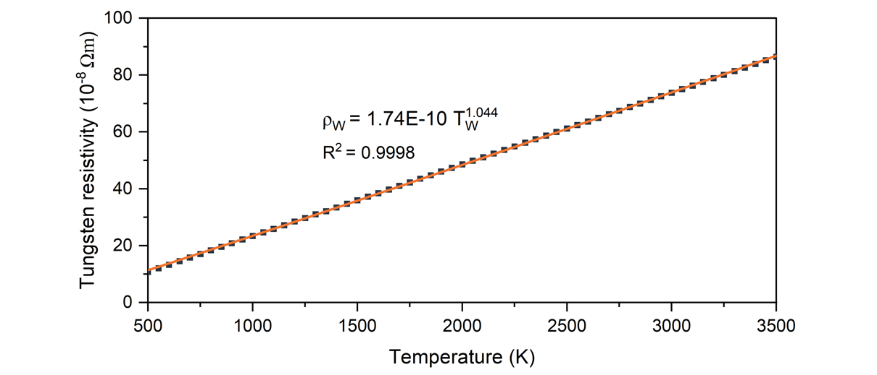
Resistance can be obtained through Ohm’s Law:
$$R=\frac{V}{I}$$
And, through a relation with resistivity and wire length L and cross-sectional area A:
$$R=\frac{ρL}{A}$$
Combining these two equations with the relation between tungsten resistivity and temperature then gives the following expression for temperature:
$$T_{W}={\left(\frac{V×A}{1.74×{10}^{-10}×I×L}\right)}^{\frac{1}{1.044}}$$

Text S3: Calculations of energy efficiency
Hydrogen production rate can be calculated from the conversion and flow rate:
$$H_{2} production rate (mol_{H_{2}}g_{cat}^{-1}h^{-1})=\frac{X \left(\%\right)×F_{NH_{3}}(mL h^{-1})×1.5}{g_{cat}×22,400 mL mol^{-1}}$$
Energy efficiency is calculated based on the power input and the lower heating values of the hydrogen and ammonia flows:
$$EE \left(\%\right)=\frac{H_{2} Out \left(g s^{-1}\right)×LHV_{H_{2}}\left(J g^{-1}\right)}{Power In \left(W\right)+NH_{3} Consumed \left(g s^{-1}\right)×LHV_{NH_{3}}\left(J g^{-1}\right)}$$
Where $LHV_{H_{2}}$ is 119,960 J g⁻¹ and $LHV_{NH_{3}}$ is 18,650 J g⁻¹.

Text S4: Energy balance calculations
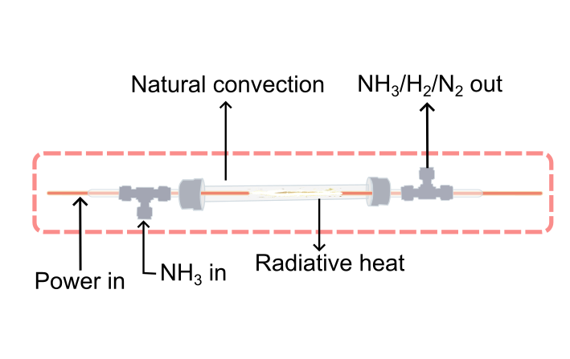
The overall energy balance in the system is estimated assuming boundary conditions as depicted above with the red dashed lines. Energy of NH₃ in, H₂ out ($P_{H_{2}})$, and unreacted NH₃ ($P_{NH_{3}}$) is based on the lower heating values of each species. Convective heat loss at the outside of the reactor was calculated using the Churchill and Chu correlation for natural convection adjacent to a vertical plane to calculate the convective heat transfer coefficient:
$$h=\frac{k}{L}{\left(0.825+\frac{0.387{Ra}^{\frac{1}{6}}}{{\left[1+{\left(0.492/Pr\right)}^{\frac{9}{16}}\right]}^{\frac{4}{9}}}\right)}^{2}$$
The Rayleigh number Ra is a product of the Grashof number Gr and Prandtl number Pr:
$$Gr=\frac{gβ\left({T_{s}-T}_{∞}\right)L^{3}}{v^{2}}$$
$$Pr=\frac{kC_{p}}{v}$$
Where $β$ is the coefficient of volume expansion (equivalent to 1/T for ideal gases), $T_{s}$ the reactor wall temperature, $T_{∞}$ the ambient temperature, L the characteristic length or reactor length, v the kinematic viscosity of air, k the conductivity of air, and $C_{p}$ the heat capacity of air. Wall temperature is calculated by the CFD model. Energy absorbed by the gas ($P_{gas})$ is calculated based on the specific heat capacity of ammonia at the reactor’s temperature. Thermal radiation is calculated based on the Stefan-Boltzmann law:
$$P_{rad}=Aε_{W}σT^{4}$$
Where A is the surface area, $ε_{W}$ the emissivity of tungsten at 0.4, and $σ$ the Stefan-Boltzmann constant. T is the temperature of the radiative heat source which was measured experimentally.

Text S5: Calculations of volume, cost, and global warming potential
The volume of a single TWL reactor module was calculated with a target of minimally producing 100kg_{H2}/day. At our conditions for 97% conversion and 76% energy efficiency, this would require 1,700 parallel tubes to achieve. We then determine the diameter of a cylinder needed to fit this number of tubes with an outer diameter of 0.34 cm (inner diameter 0.3 cm) to be 16 cm. The height of the reactor is 9 cm with heads of 4 cm height on the inlet and outlet sides.
Costs for conventional ADR and the TWL reactor are calculated based on variable operating costs, including green ammonia, electricity, and other utilities. The price of green ammonia⁴ is set at $700/ton_{NH3} and the price of green electricity $0.2/kWh (solar energy). Feedstock and energy requirements for ADR were taken from the model by Makhloufi and Kezibri for a 200 ton_{H2}/day ammonia cracking plant⁵. Global warming potential (GWP) of ADR is based on the electricity requirement of the process assuming emissions of 25 g_{CO2}/kWh for a renewable electricity source and additional NO_{x} emissions from using NH₃ as a heating fuel. GWP of the TWL reactor is also based on the electricity requirement and the assumption of 25 g_{CO2}/kWh for a renewable electricity source.

Text S6: Calculations for TWL reactor performance in different application scenarios
The hydrogen purity requirements for stationary fuel cell and fuel cell vehicle applications are based on the international standard ISO 14687:2019⁶. Stationary fuel cell units are usually small at about 1 MW in capacity and 51% in efficiency⁷, so the required hydrogen amount for this application is calculated based on this and the energy content of hydrogen. Hydrogen refueling stations are usually of the scale 0.3-1 tpd_{H2}, with the maximum able to refuel about 200 cars with a 5 kg tank and 100 kW engine⁸. Energy output of the partial cracking scenario is calculated assuming 40% of the fuel energy content is converted to electricity by the turbine.
Removal of trace ammonia was assumed to use dynamic adsorption methods that only requires water and negligible energy input but is able to reduce ammonia content from 1000 ppm to <0.1 ppm⁹. PSA is assumed to require 0.5 kWh/kg_{H2} for removal of N₂ to below 300 ppm¹⁰. Hydrogen compression energy consumption from 1 bar to the required 880 bar for vehicle refueling is 3.2 kWh/kg_{H2}¹¹. Stationery PEMFC for power generation is typically operated at 3-4 bar, so the energy consumption for this compression is assumed to be negligible.
Solar panel requirement of the vehicle refueling scenario was calculated based on the average solar irradiance in Singapore¹² of 1,580 kWh/m²/year and a panel efficiency of 23%.

Supplementary Figures
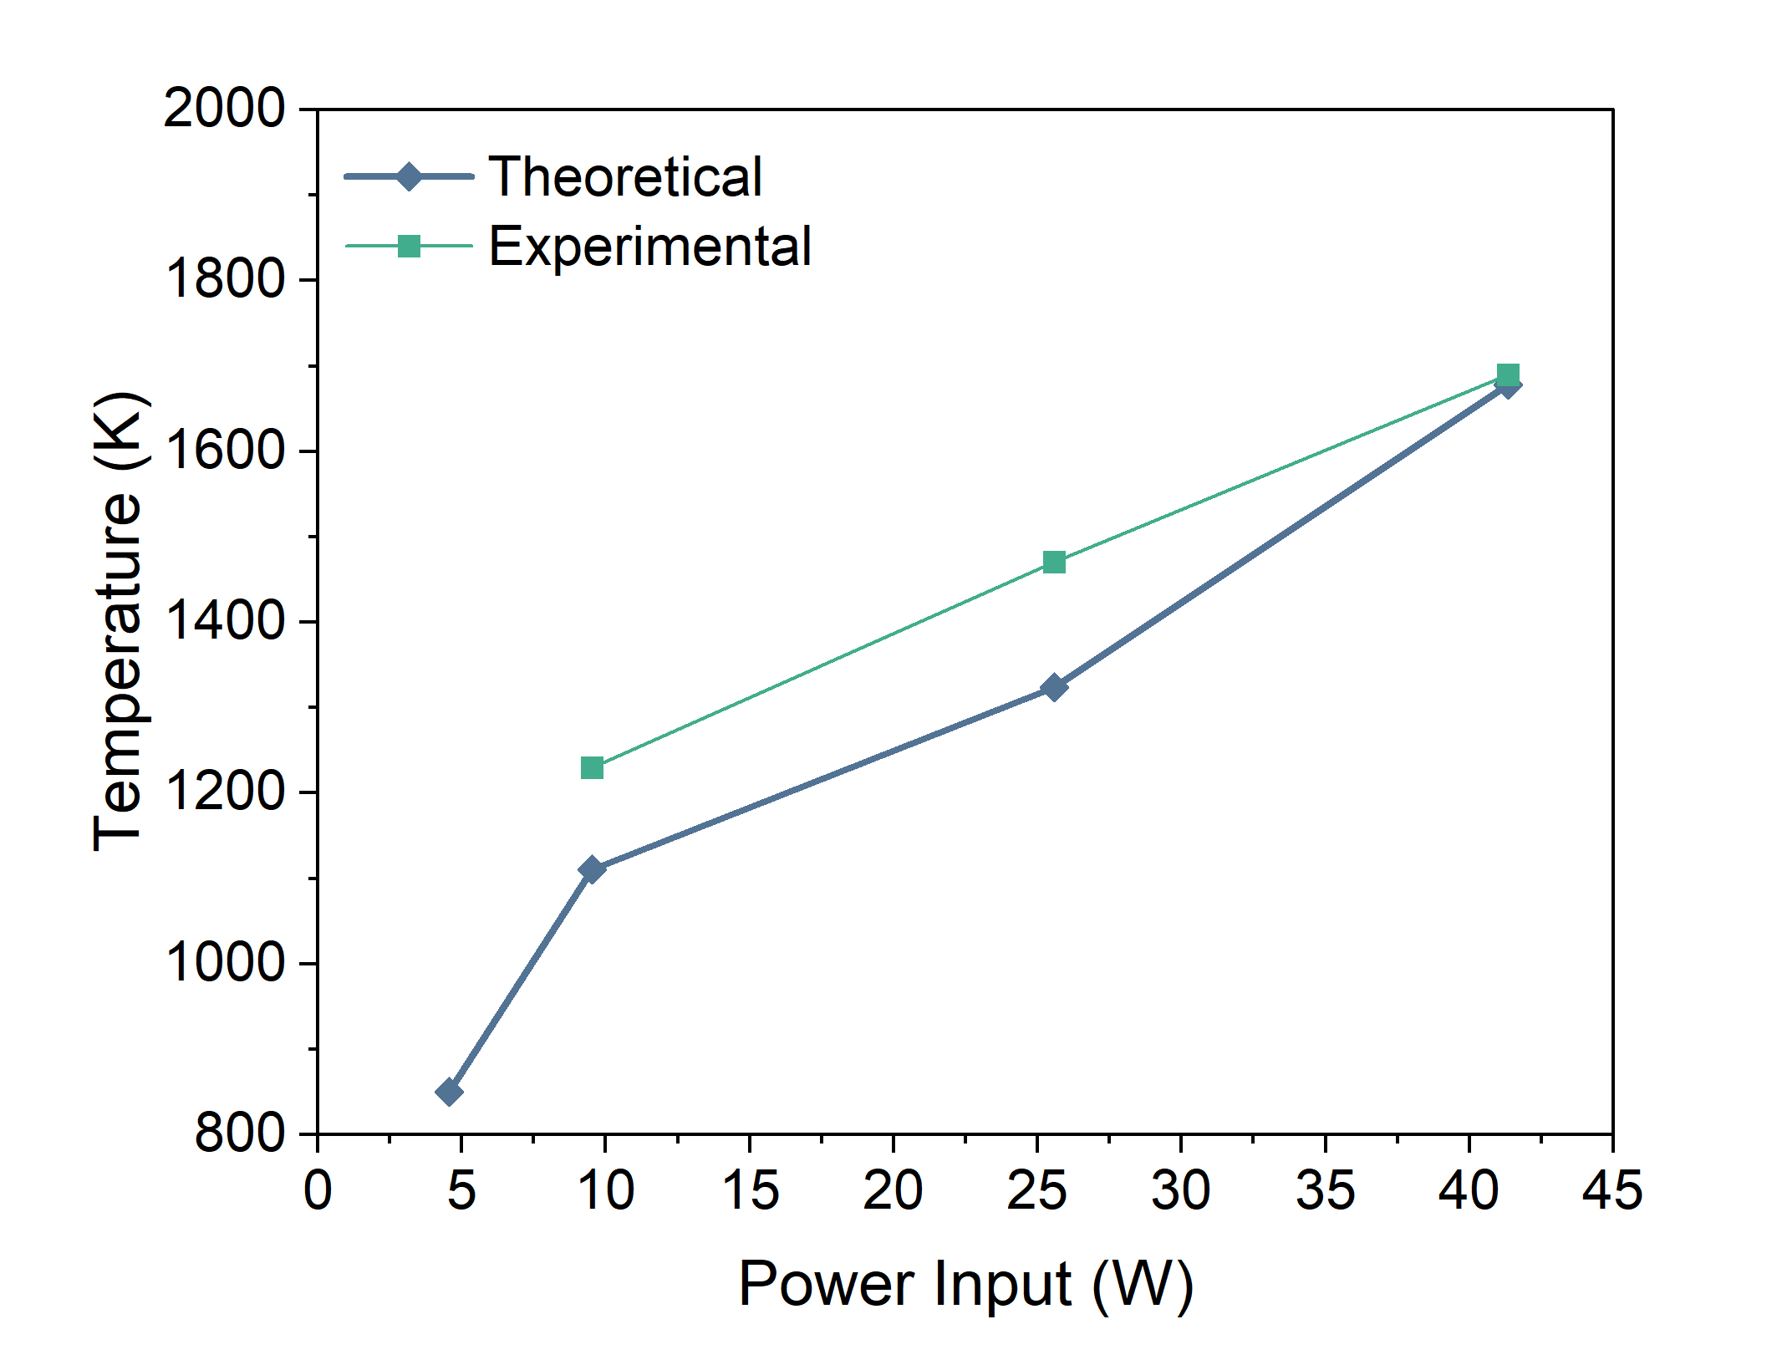

Figure S1. Theoretical estimation of tungsten wire temperature at 220 h⁻¹ NH₃ space velocity compared to experimental measurement.

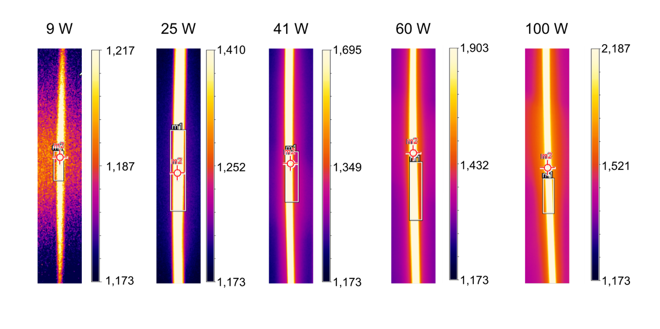

Figure S2. IR photographs of tungsten wire at various power inputs.
The color bar scale is temperature in Kelvins. The total image size is 3.4x0.5 mm.

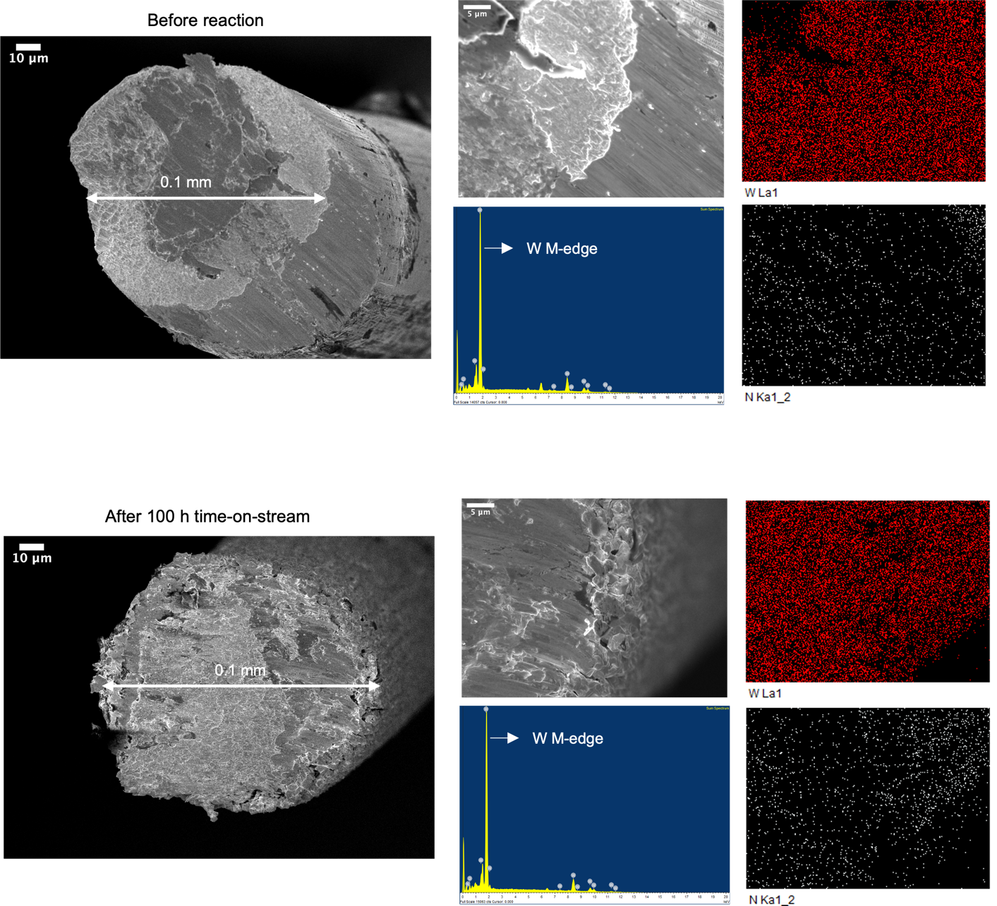

Figure S3. SEM images of tungsten wire.
Above are images of fresh tungsten wire before reaction and below of spent tungsten wire after 100 hours time-on-stream with 25 W power input and 655 h⁻¹ space velocity. The wire diameter does not change after reaction. The EDX mapping and point scan results on the right hand side further show that there is no nitride formation on the tungsten wire.

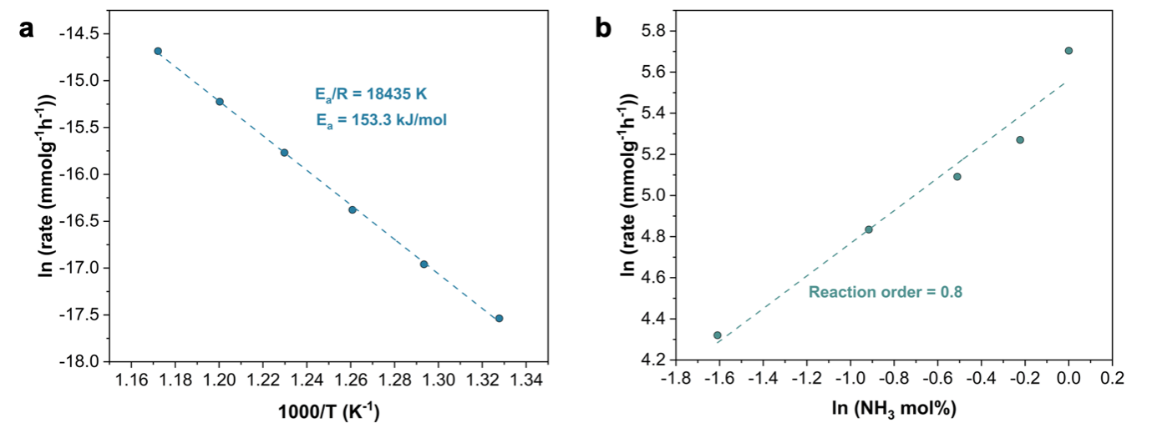

Figure S4. Kinetics measurements using an analogous thermal-catalytic tungsten mesh system.
a Activation energy of tungsten catalyst. b Reaction order of tungsten catalyst with respect to ammonia concentration.

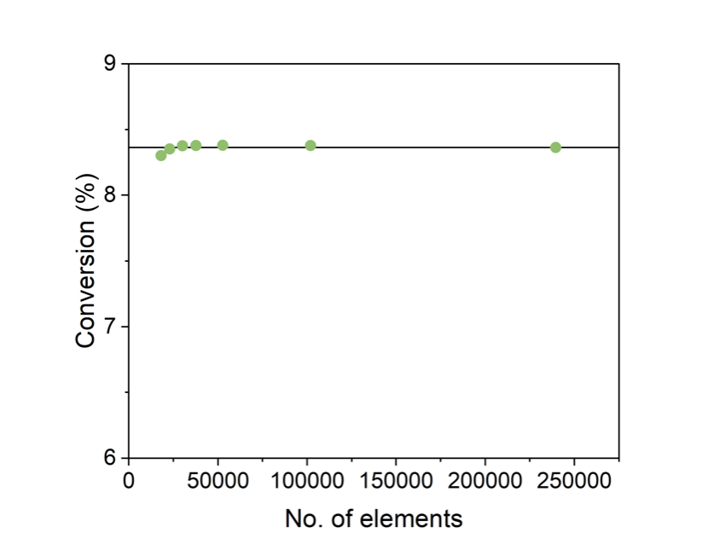

Figure S5. Mesh sensitivity analysis.
The relative error of conversion to the results at the finest mesh is not more than 0.7% at all other points tested, so simulations were performed with about 30,000 mesh elements.

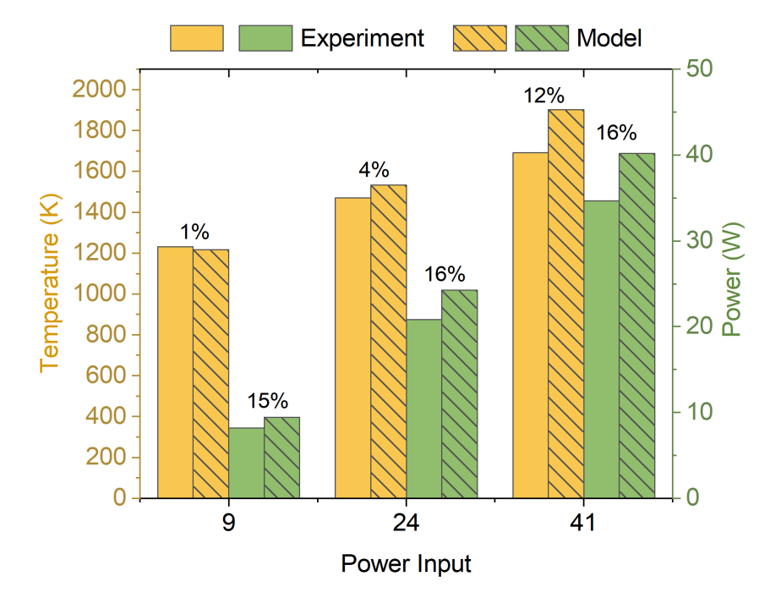

Figure S6. Comparison of experimental and modelled temperature and power input values.
Numbers above the bars show the percentage error between the experimental and modelled values.

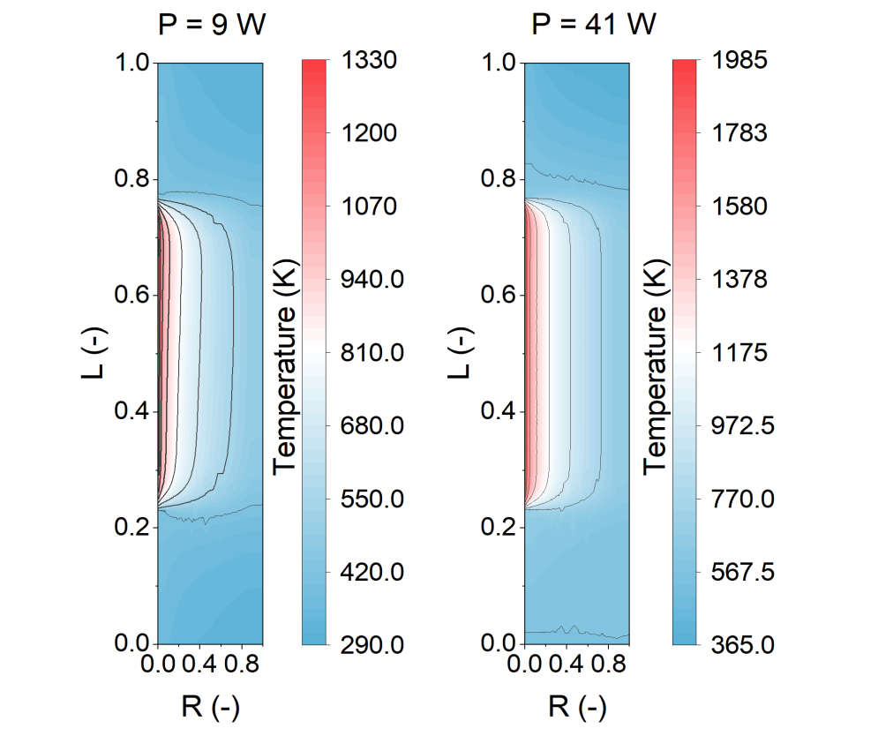

Figure S7. Temperature contour plots.
For different power inputs and 220 h⁻¹ space velocity; similar patterns are achieved at other space velocities.

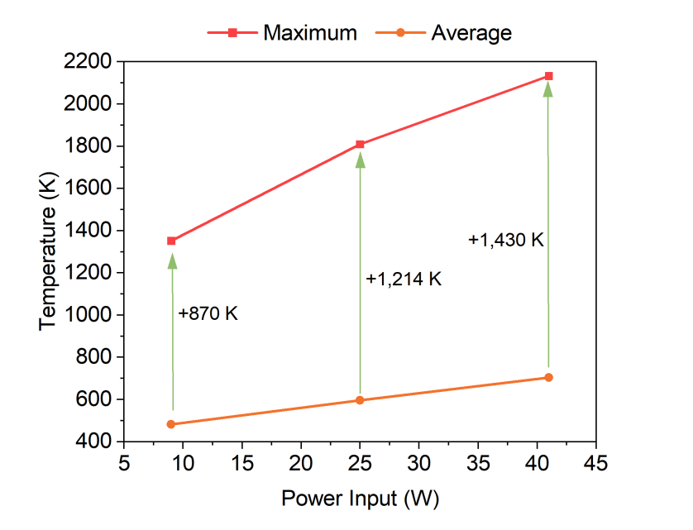

Figure S8. Comparison of maximum and average temperatures at 1,100 h⁻¹.
The maximum temperature is the experimentally measured tungsten wire temperature while the average is taken over the reactor gas flow domain in the CFD model.

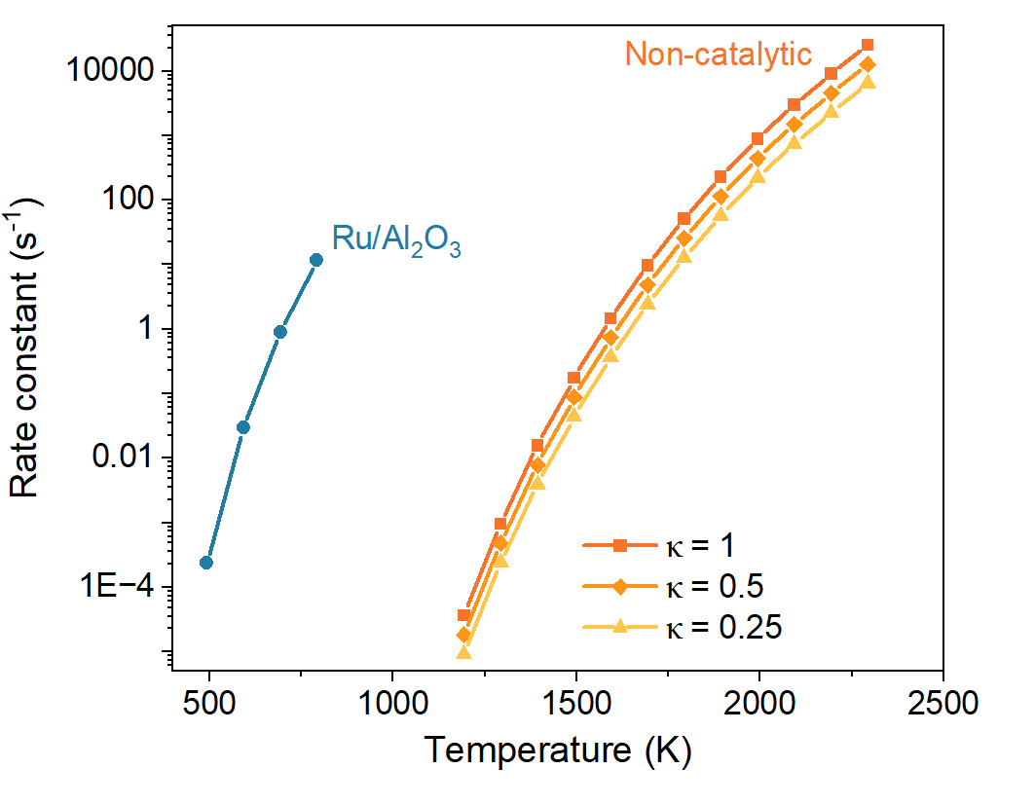

Figure S9. Estimated reaction rate constants of non-catalytic ADR compared to measured rate constants of a commercial Ru catalyst.
Non-catalytic rate constant at 1,573 K (0.9 s⁻¹) is comparable to the rate constant of the Ru catalyst at its typical operating temperature of 773 K (0.2 s⁻¹), so considerable gas-phase reactions should be expected only at temperatures above 1,573 K.
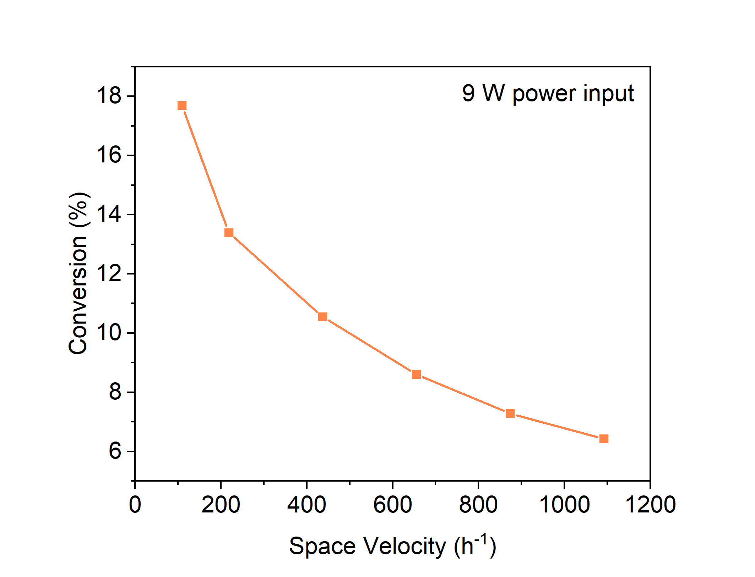

Figure S10. Mass transfer limitation experiment.
The reactor has some mass transfer limitations as conversion does not decrease proportionally with the increase in space velocity when conversions are low.

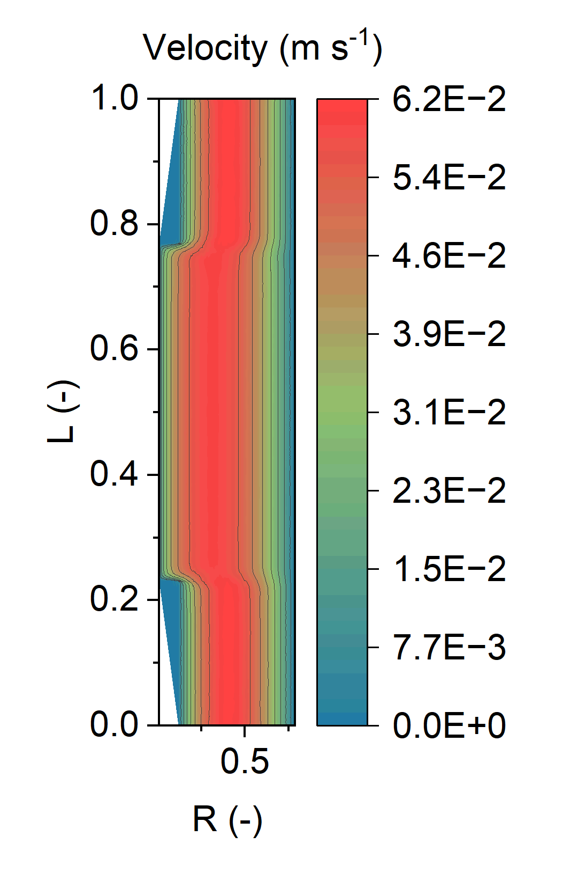

Figure S11. Typical velocity profile, at a reaction condition of 25 W input and 1,100 h⁻¹ space velocity.

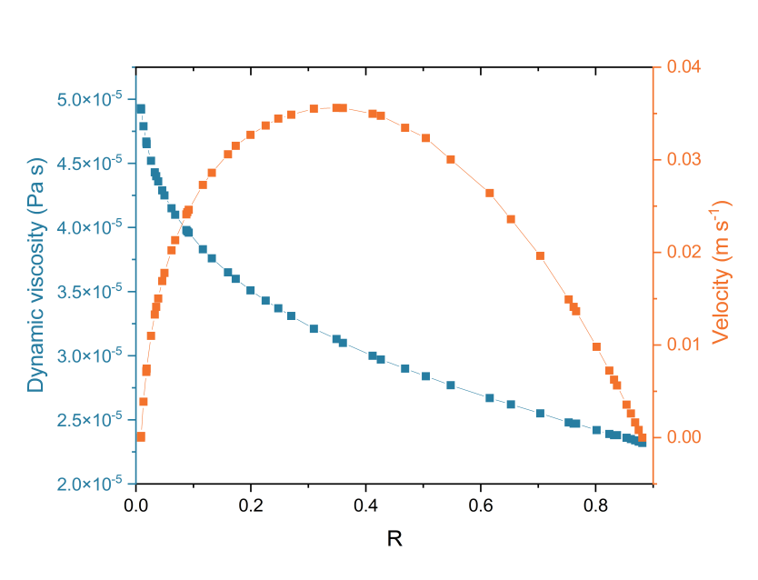

Figure S12. Variation in velocity, density, and dynamic viscosity across the reactor at the condition of 25 W input and 1,100 h⁻¹ space velocity.

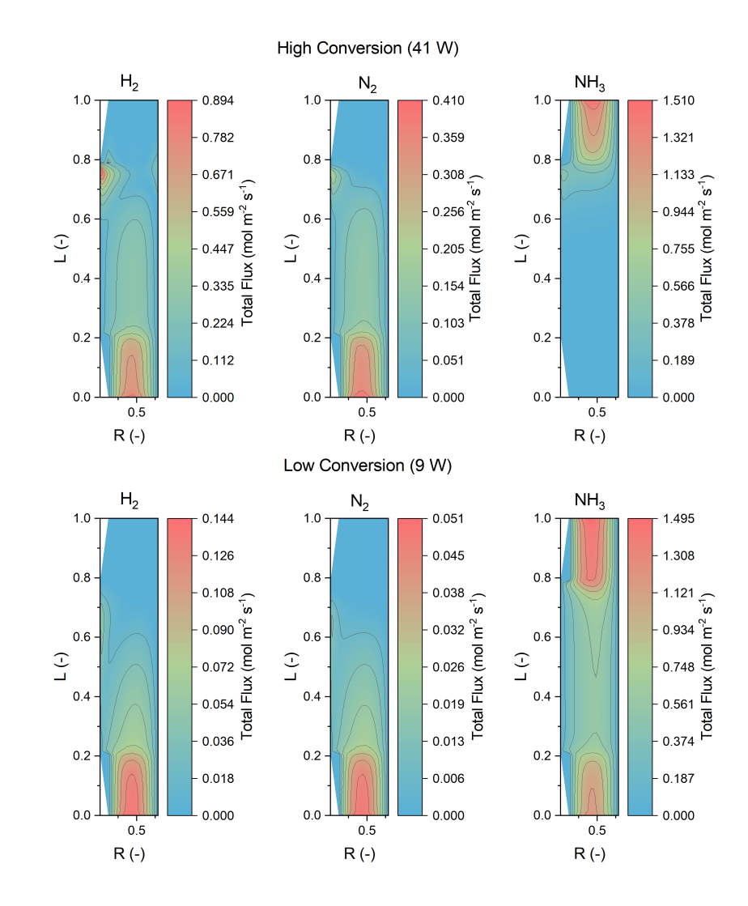

Figure S13. Flux in mol m⁻² s⁻¹ of NH₃ and H₂ at two different power inputs and 1,100 h⁻¹ space velocity.

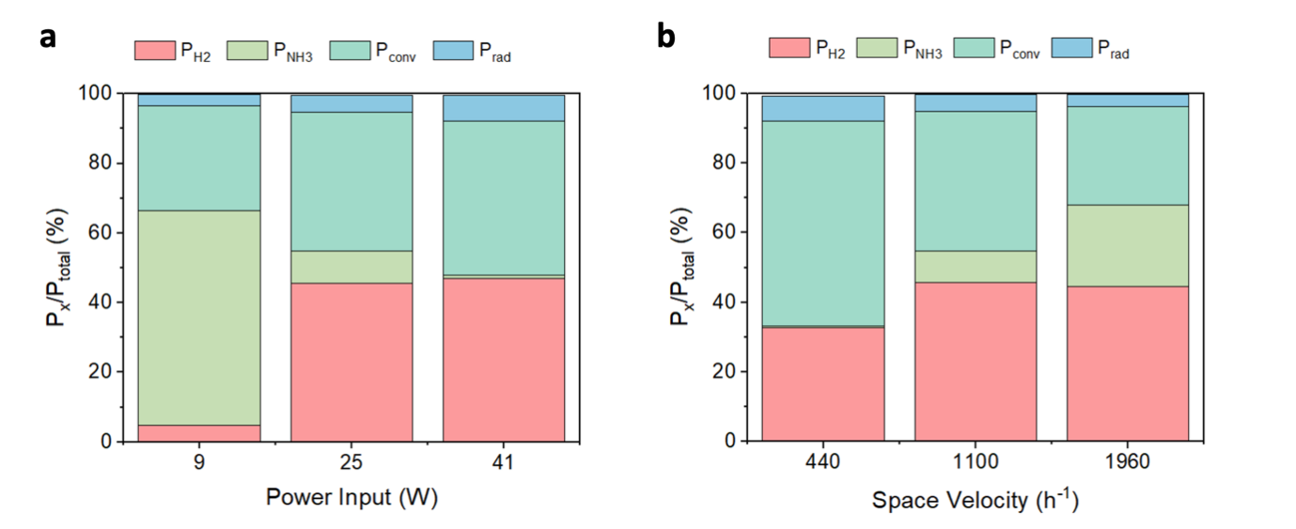

Figure S14. Change in energy balance.
a. Effect of different power inputs, 1,100 h⁻¹ NH₃ space velocity b. Effect of different space velocities, 25 W power input.

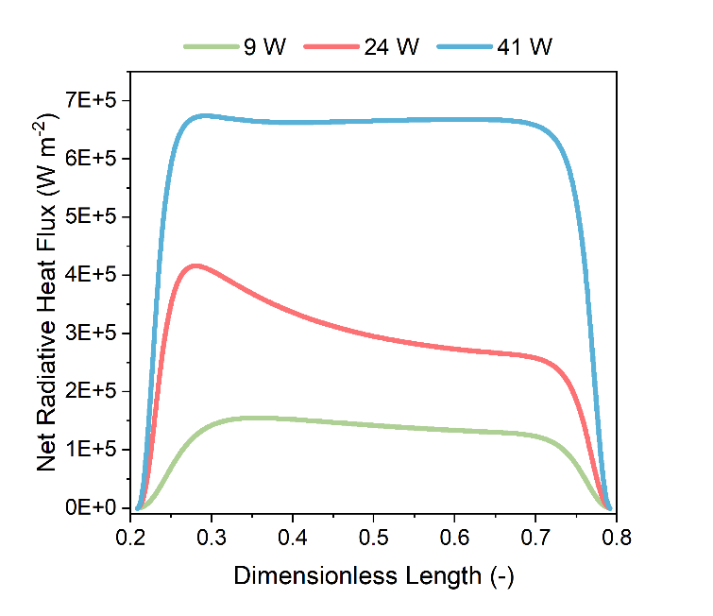

Figure S15. Net radiative heat flux at the tungsten wire boundary at different power inputs and 1,100 h⁻¹ NH₃ space velocity.

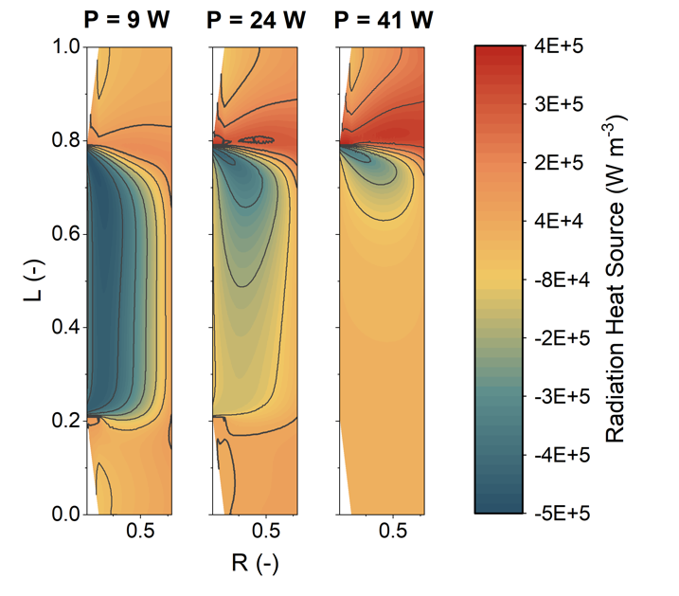

Figure S16. Emission and absorption of radiation in the gas phase at different power inputs and 1,100 h⁻¹ NH₃ space velocity.

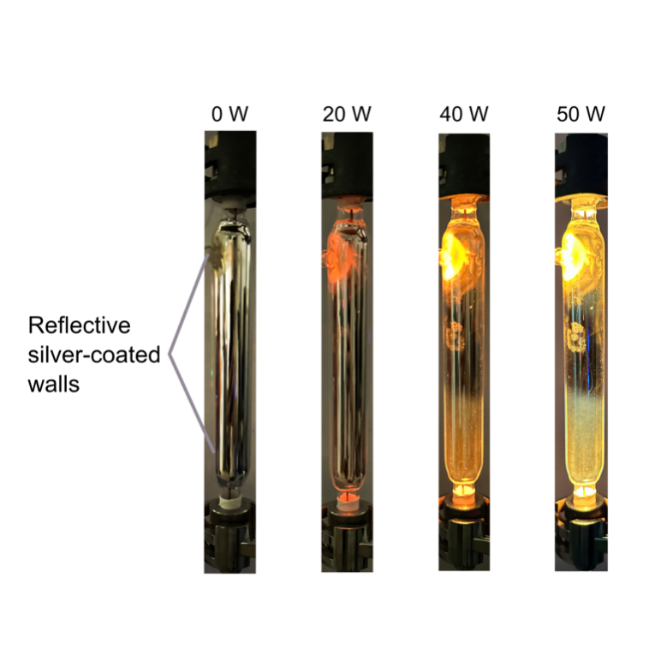

Figure S17. Images of reactor with reflector walls at various energy inputs.

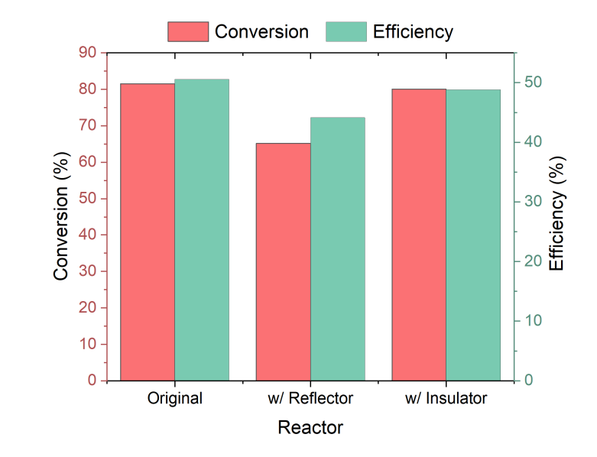

Figure S18. Conversion and energy efficiency of modified reactors at 25 W input and 1,090 h⁻¹ space velocity.

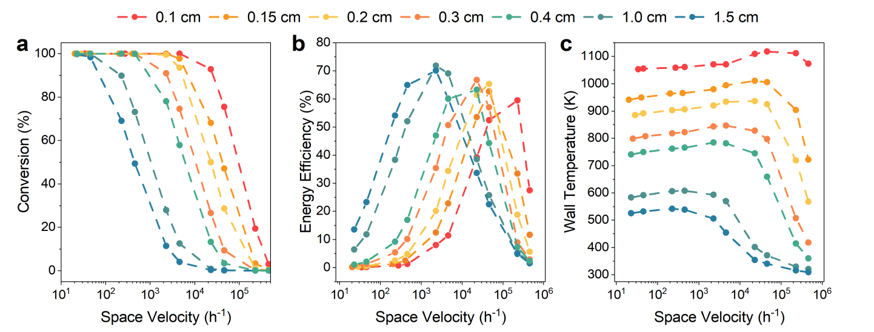

Figure S19. Optimisation of reactor tube radius.
Effect of tube radius on a conversion, b energy efficiency, and c reactor wall temperature at various space velocities and around 25 W power input.

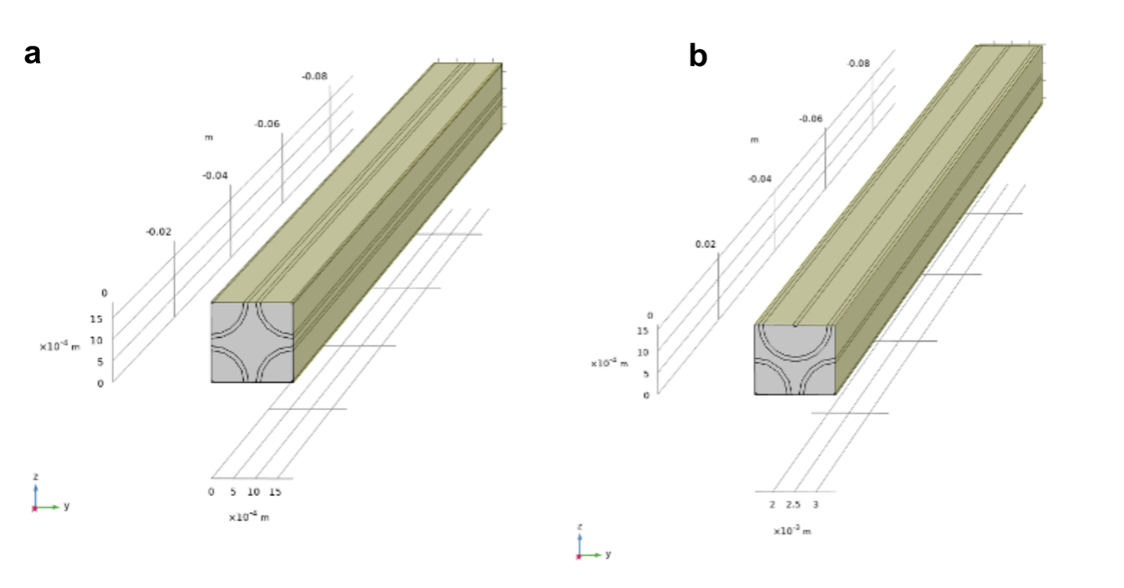

Figure S20. Geometry for 3D multi-tubular reactor calculations.
Geometry for multi-tubular calculations where the tubes are arranged either in a a square or b triangular array. Symmetry boundary conditions are applied to the surfaces highlighted in yellow.

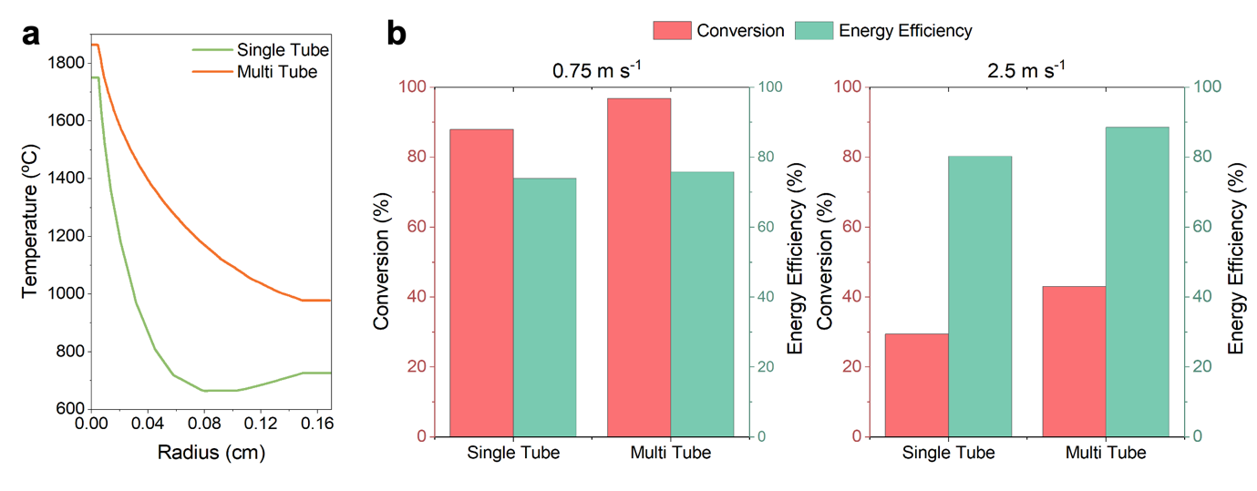

Figure S21. Comparison of single-tube and multi-tube simulation performance.
Results are for a reactor with 0.3 cm diameter and 35 W power input. a Temperature across the radius of the reactor at 0.75 m s⁻¹. Packing multiple tubes close together reduces heat loss and thus increases the reactor temperatures. b Conversion and energy efficiency at low and high velocity conditions.

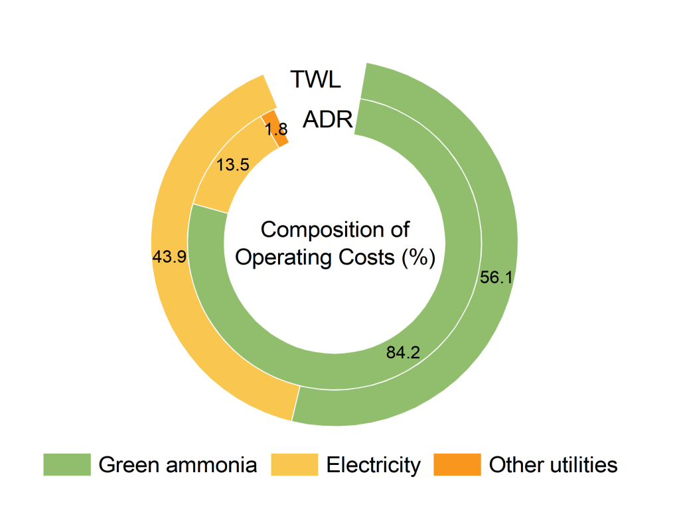

Figure S22. Operating cost composition in ADR and TWL reactors.
The major component of the operating cost of green ammonia fuelled hydrogen production technologies is the cost of green ammonia itself, thus a reduction in the cost of green ammonia would greatly lower the operating costs of conventional ADR and the TWL process. In ADR, green ammonia is both the feedstock and fuel for combustion.

Supplementary Tables

Table S1. Conversion of lab-scale TWL reactor measured with IC.
Power (W) | NH₃ space velocity (h⁻¹) | Conversion (%) | NH₃ concentration (ppm)
60 | 110 | 99.9956 | 44
60 | 218 | 99.9787 | 213
50 | 110 | 99.9450 | 550
50 | 218 | 99.9102 | 898
50 | 545 | 98.5523 | 14,477
40 | 218 | 99.8751 | 1,249
40 | 1091 | 96.6748 | 33,252

Table S2. Comparison of activity and efficiency of other reported ammonia decomposition systems, as depicted in Fig 3d.
Heating Method | Catalyst | Flow Rate | Conversion (%) | Volume (cm³) | Energy Input (W) | Energy Efficiency | Reference
Resistive heating | Tungsten wire | 180 | 63% |  | 25 | 61% | This work
Resistive heating | Tungsten wire | 120 | 95% |  | 41 | 47% | This work
Resistive heating | iRu/NF |  | 99% | 7.7 | 72 | 69% | ¹³
Plasma | Co/Al₂O₃ | 40 | 95.20% | 0.22ª | 137 | 29% | ¹⁴
Plasma | Mo₂N | 40 | 92% | 1.51 | 40 | 21% | ¹⁵
Photo | Cu-Fe | 100 | 54% | 11 | 300 | 10% | ¹⁶
Thermal | Ru/MgO | 25 | 99% | 0.01ª | 100^{b} | 6% | ¹⁷
Thermal | K-CoNi/MgCeSrO_{x} | 10 | 99% | 0.02 | 100^{b} | 3% | ¹⁸
Thermal | LiNH₂ | 30 | 98% | 0.85ª | 100^{b} | 7% | ¹⁹
Thermal | CoMoNiFeCu/CNF | 15 | 99% | 0.02ª | 100^{b} | 4% | ²⁰
(Auto)thermal | Ru/Al₂O₃ | 6000 | 99% | 12.17 | 905^{c} | 75% | ²¹
(Auto)thermal | Ru/La-Al₂O₃ | 1000 | 98% | 3.78ª | 146^{d} | 71% | ²²
Thermal | Ru/h-BN | 40 | 27% | 0.02ª | 100^{b} | 3% | ²³
Thermal | Ni/BaTiO_{3-x}N_{y} | 25 | 99% | 0.02ª | 100^{b} | 7% | ²⁴
Thermal | Fe/MgO | 2.4 | 50% | 0.01ª | 100^{b} | 0.3% | ²⁵
Thermal | CoRe_{1.6} | 2.5 | 90% | 0.003ª | 100^{b} | 1% | ²⁶
Thermal | La_{0.5}Sr_{0.5}NiO_{3-δ} | 15 | 90% | 0.19 | 100^{b} | 4% | ²⁷
Thermal | Ni-Ru/CeO₂ | 25 | 72% | 0.41 | 100^{b} | 5% | ²⁸
Microwave | Co₂Mo₃N | 6 | 90% | 6.28 | 40 | 4% | ²⁹
Thermal | MoMgAl-N | 25 | 99% | 0.03 | 100^{b} | 7% | ³⁰

ª Volume was calculated based on the catalyst mass and density of the support material.
^{b} For thermal-catalytic systems, activity data at 450-500 ºC were taken and the energy input was assumed to be 100 W for the furnace to reach and maintain that temperature. This energy input is based on the performance of our ThermConcept ROK 70/250/11-S tube furnace, which has a power rating of 1 kW but uses only about 10% of that when operating at 500 ºC.
^{c} Power input was calculated from the flow rate of NH₃ used as fuel and the lower heating value of NH₃. Despite the high efficiency, a substantial amount of NO_{x} pollutant is released from the ammonia combustion used to generate heat.
^{d} Power input was calculated from the flow rate of H₂ used as fuel and the lower heating value of H₂. Despite the high efficiency, more than half of the product H₂ is required for combustion to generate the process heat.

Table S3. Comparison of tube arrangements in multi-tubular model.

 | Square array | Triangular array
Temperature distribution (K) | 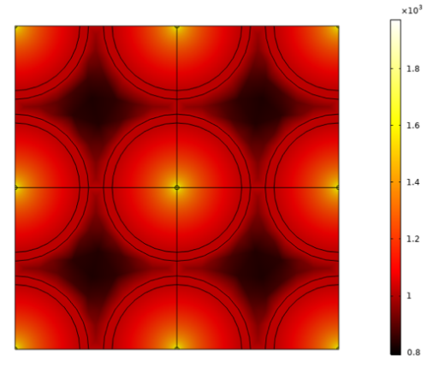 | 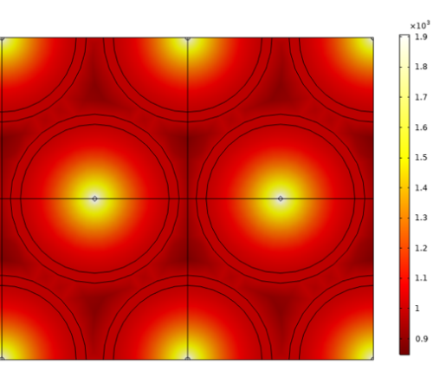
Conversion (%) | 92.16 | 96.76
Wall temperature (K) | 1032 | 1035
Energy efficiency (%) | 73.62 | 75.83
Volume (m³) | 3.9 | 3.7

Results are for a tube of 0.3 cm diameter and 9 cm length, with a power input of around 35 W and inlet velocity of 0.75 m s⁻¹. The color scale represents temperature in Kelvins. Volume was calculated by numbering up the tubes to produce 200 ton_{H2}/day. The configuration with the triangular array was chosen as it results in higher conversion and efficiency and a slightly smaller reactor volume.

Supplementary References
1 Nakamura, H. & Shindo, M. Effects of radiation heat loss on laminar premixed ammonia/air flames. Proc. Combust. Inst. 37, 1741-1748 (2019). https://doi.org:10.1016/j.proci.2018.06.138
2 Prasad, V., Karim, A. M., Arya, A. & Vlachos, D. G. Assessment of Overall Rate Expressions and Multiscale, Microkinetic Model Uniqueness via Experimental Data Injection: Ammonia Decomposition on Ru/γ-Al2O3 for Hydrogen Production. Industrial & Engineering Chemistry Research 48, 5255-5265 (2009). https://doi.org:10.1021/ie900144x
3 Logerais, P. O., Chapron, D., Garnier, J. & Bouteville, A. Validation of a Rapid Thermal Processing model in steady-state. Microelectron. Eng. 85, 2282-2289 (2008). https://doi.org:10.1016/j.mee.2008.07.012
4 Burgess, J. Blue, green ammonia prices diverge as electrolysis power prices rise, natural gas falls, <https://www.spglobal.com/commodityinsights/en/market-insights/latest-news/energy-transition/031924-blue-green-ammonia-prices-diverge-as-electrolysis-power-prices-rise-natural-gas-falls> (2024).
5 Makhloufi, C. & Kezibri, N. Large-scale decomposition of green ammonia for pure hydrogen production. Int. J. Hydrog. Energy 46, 34777-34787 (2021). https://doi.org:10.1016/j.ijhydene.2021.07.188
6 Institution, B. S. (International Organization for Standardization, Switzerland, 2019).
7 Weidner, E., Ortiz Cebolla, R. & Davies, J. Global deployment of large capacity stationary fuel cells – Drivers of, and barriers to, stationary fuel cell deployment. (Joint Research Centre, Luxembourg, 2019).
8 Lim, D. et al. A 4E feasibility analysis of an on-site, ammonia sourced, hydrogen refueling station. J. Clean. Prod. 363 (2022). https://doi.org:10.1016/j.jclepro.2022.132356
9 Miyaoka, H., Miyaoka, H., Ichikawa, T., Ichikawa, T. & Kojima, Y. Highly purified hydrogen production from ammonia for PEM fuel cell. Int. J. Hydrog. Energy 43, 14486-14492 (2018). https://doi.org:https://doi.org/10.1016/j.ijhydene.2018.06.065
10 Ligen, Y., Vrubel, H. & Girault, H. Energy efficient hydrogen drying and purification for fuel cell vehicles. Int. J. Hydrog. Energy 45, 10639-10647 (2020). https://doi.org:https://doi.org/10.1016/j.ijhydene.2020.02.035
11 Gardiner, M. Energy requirements for hydrogen gas compression and
liquefaction as related to vehicle storage needs. (Department of Energy, United States of America, 2009).
12 Singapore, E. M. A. o. What is the potential of solar energy in Singapore?, <https://www.ema.gov.sg/resources/faqs/energy-supply/solar/what-is-the-potential-of-solar-energy-in-singapore> (2023).
13 Badakhsh, A. et al. A compact catalytic foam reactor for decomposition of ammonia by the Joule-heating mechanism. Chem. Eng. J. 426 (2021). https://doi.org:10.1016/j.cej.2021.130802
14 Wang, L. et al. NH3 Decomposition for H2 Generation: Effects of Cheap Metals and Supports on Plasma–Catalyst Synergy. ACS Catal. 5, 4167-4174 (2015). https://doi.org:10.1021/acscatal.5b00728
15 Yu, X. et al. Plasma-Catalytic Ammonia Decomposition for Carbon-Free Hydrogen Production Using Low Pressure-Synthesized Mo2N Catalyst. Plasma Chem. Plasma Process. 43, 183-197 (2023). https://doi.org:10.1007/s11090-022-10282-y
16 Yuan, Y. et al. Earth-abundant photocatalyst for H2 generation from NH3 with light-emitting diode illumination. Science 378, 889-893 (2022).
17 Fang, H. et al. Dispersed surface Ru ensembles on MgO(111) for catalytic ammonia decomposition. Nat. Commun. 14, 647 (2023). https://doi.org:10.1038/s41467-023-36339-w
18 Tabassum, H. et al. Hydrogen generation via ammonia decomposition on highly efficient and stable Ru-free catalysts: approaching complete conversion at 450 °C. Energy Environ. Sci. 15, 4190-4200 (2022). https://doi.org:10.1039/d1ee03730g
19 Wood, T. J. & Makepeace, J. W. Assessing Potential Supports for Lithium Amide-imide Ammonia Decomposition Catalysts. ACS Applied Energy Materials 1, 2657-2663 (2018). https://doi.org:10.1021/acsaem.8b00351
20 Xie, P. et al. Highly efficient decomposition of ammonia using high-entropy alloy catalysts. Nat. Commun. 10, 4011 (2019). https://doi.org:10.1038/s41467-019-11848-9
21 Engelbrecht, N., Chiuta, S. & Bessarabov, D. G. A highly efficient autothermal microchannel reactor for ammonia decomposition: Analysis of hydrogen production in transient and steady-state regimes. J. Power Sources 386, 47-55 (2018). https://doi.org:10.1016/j.jpowsour.2018.03.043
22 Badakhsh, A. et al. Autothermal recirculating reactor (ARR) with Cu-BN composite as a stable reactor material for sustainable hydrogen release from ammonia. J. Power Sources 506 (2021). https://doi.org:10.1016/j.jpowsour.2021.230081
23 Kang, S. et al. Heteroepitaxial Growth of B(5) -Site-Rich Ru Nanoparticles Guided by Hexagonal Boron Nitride for Low-Temperature Ammonia Dehydrogenation. Adv. Mater. 35, e2203364 (2023). https://doi.org:10.1002/adma.202203364
24 Ogasawara, K. et al. Ammonia Decomposition over Water‐Durable Hexagonal BaTiO3−xNy‐Supported Ni Catalysts. Adv. Energy Mater. 13 (2023). https://doi.org:10.1002/aenm.202301286
25 Chen, S. et al. Highly loaded bimetallic iron-cobalt catalysts for hydrogen release from ammonia. Nat. Commun. 15, 871 (2024). https://doi.org:10.1038/s41467-023-44661-6
26 Kirste, K. G. et al. COx-free hydrogen production from ammonia – mimicking the activity of Ru catalysts with unsupported Co-Re alloys. Appl. Catal. B 280 (2021). https://doi.org:10.1016/j.apcatb.2020.119405
27 Guo, X.-Y. et al. Alkaline earth metal promoted hydrogen production from ammonia decomposition over Ni/La2O3-based catalysts. Applied Catalysis B: Environment and Energy 348, 123844 (2024). https://doi.org:https://doi.org/10.1016/j.apcatb.2024.123844
28 Lucentini, I. et al. Ni-Ru supported on CeO2 obtained by mechanochemical milling for catalytic hydrogen production from ammonia. iScience 27, 110028 (2024). https://doi.org:https://doi.org/10.1016/j.isci.2024.110028
29 Dutta, B., Wildfire, C. & Shekhawat, D. Microwave-assisted ammonia decomposition over metal nitride catalysts at low temperatures. Int. J. Hydrog. Energy 72, 652-660 (2024). https://doi.org:https://doi.org/10.1016/j.ijhydene.2024.05.379
30 Wei, X. et al. Supported highly dispersed molybdenum nitride derived from molybdate-intercalated Mg‒Al hydrotalcite-like compounds as a catalyst for ammonia decomposition. Molecular Catalysis 562, 114201 (2024). https://doi.org:https://doi.org/10.1016/j.mcat.2024.114201

