Supplementary Material for
“Multiple-microwave-photon transition of nitrogen-vacancy centers in diamond”
Haonan Chang^{1,2}, Feilong Song¹, Fan Xia³, Simin Pang¹, Zhennan Wang^{1,2}, Yanpei Lv^{1,2}, Gang-Qing Liu³, Jun Zhang^{1,2,*}
¹State Key Laboratory of Semiconductor Physics and Chip Technologies, Institute of Semiconductors, Chinese Academy of Sciences, Beijing 100083, China
²Center of Materials Science and Optoelectronics Engineering, University of Chinese Academy of Sciences, Beijing 100049, China
³Beijing National Laboratory for Condensed Matter Physics, Institute of Physics, Chinese Academy of Sciences, Beijing 100190, China
*Corresponding email: zhangjwill@semi.ac.cn
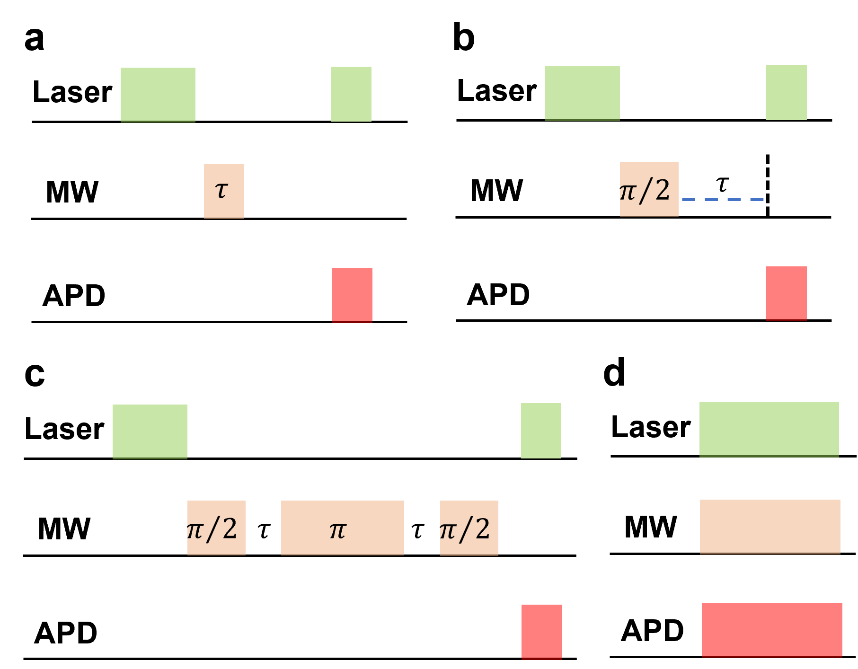
Supplementary Fig. S1 Experimental sequence. (a) Rabi sequence, where the first laser pulse is used to initialize the spin state and the second pulse is employed to read out the state after the microwave (MW) pulse. (b) Ramsey interference pulse sequence, where the first laser pulse for spin polarization, a microwave π/2 − π/2-pulses for spin manipulation, and the second laser pulse for state readout. (c) Hanh echo pulse sequence, where the first laser pulse for spin polarization, a microwave π/2 − π − π/2-pulses for spin manipulation, and the second laser pulse for state readout. (d) Continue wave (CW) sequence for measuring CW ODMR spectra.

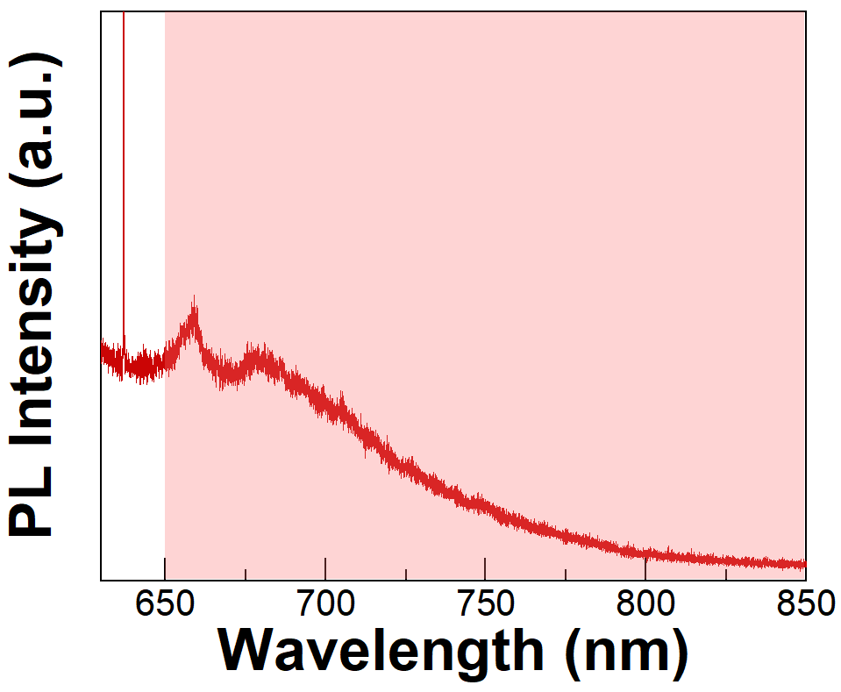
Supplementary Fig. S2 Photoluminescence (PL) spectrum of NV centers with 520 nm laser excitation at 4 K. The PL spectrum has been filtered by a 600-nm long-pass filter. For the ODMR experiment in the main text, the PL spectrum has been filtered by a 650-nm long-pass filter and an 850-nm short-pass filter.

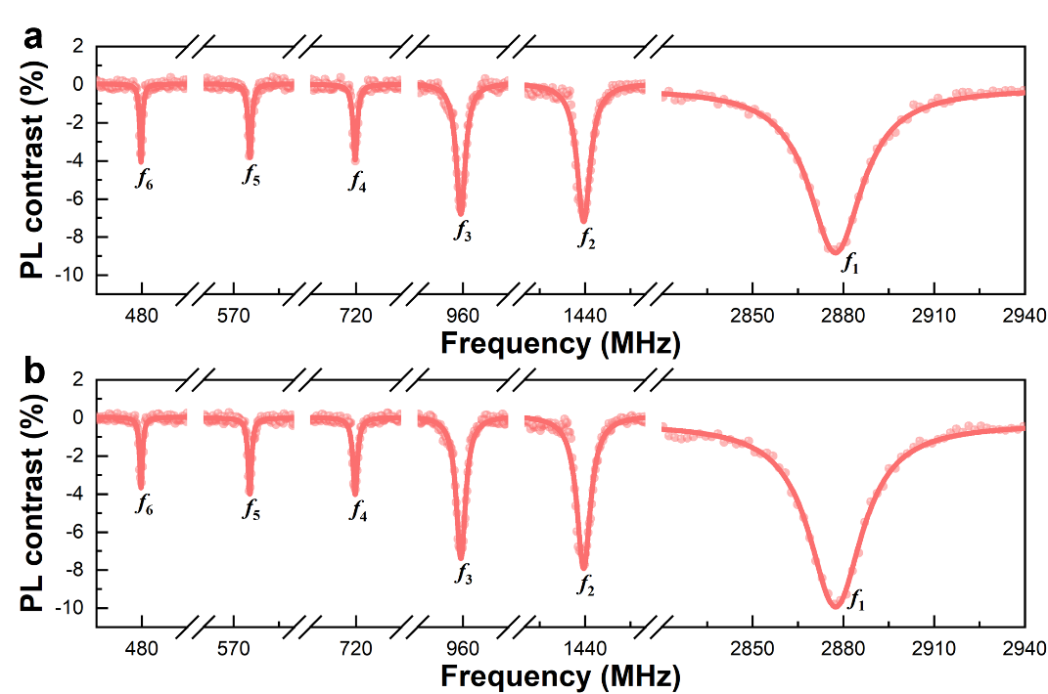
Supplementary Fig. S3 CW spectra at different positions of the sample at 4 K. To exclude the influence of other defects, we change the sample position and collect the ODMR spectra.

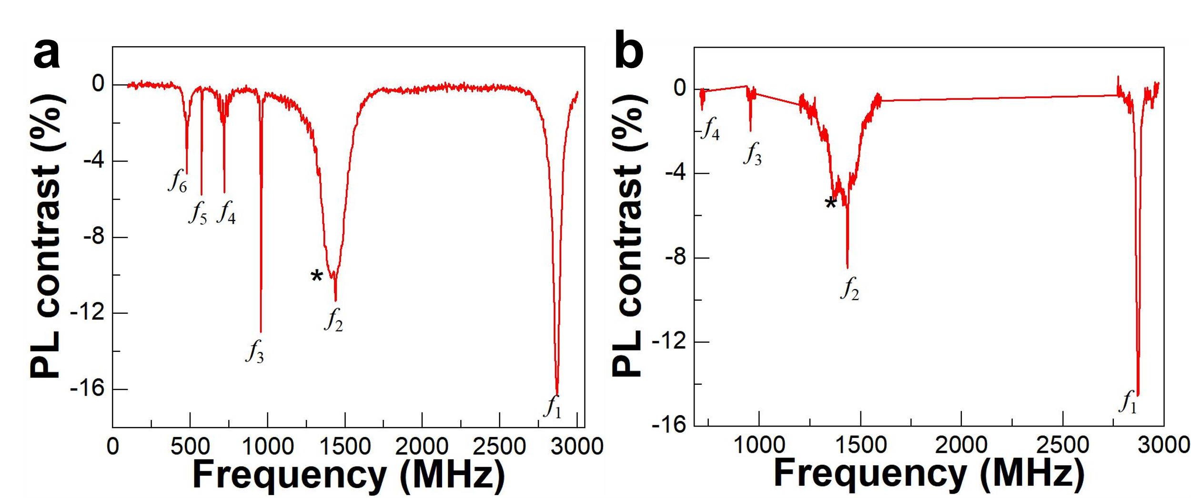
Supplementary Fig. S4 CW spectra of the sample at room temperature. (a) At room temperature, we also observed the multi-photon transition of the ground state of NV centers. Besides, we also observed the excited states (*) of NV centers, which could not be observed at 4 K. (b) CW spectra of the sample at room temperature measured at Gang-Qing Liu’s Lab. At another experimental setup, we also observed the multiple-photon transition of NV centers in diamonds.

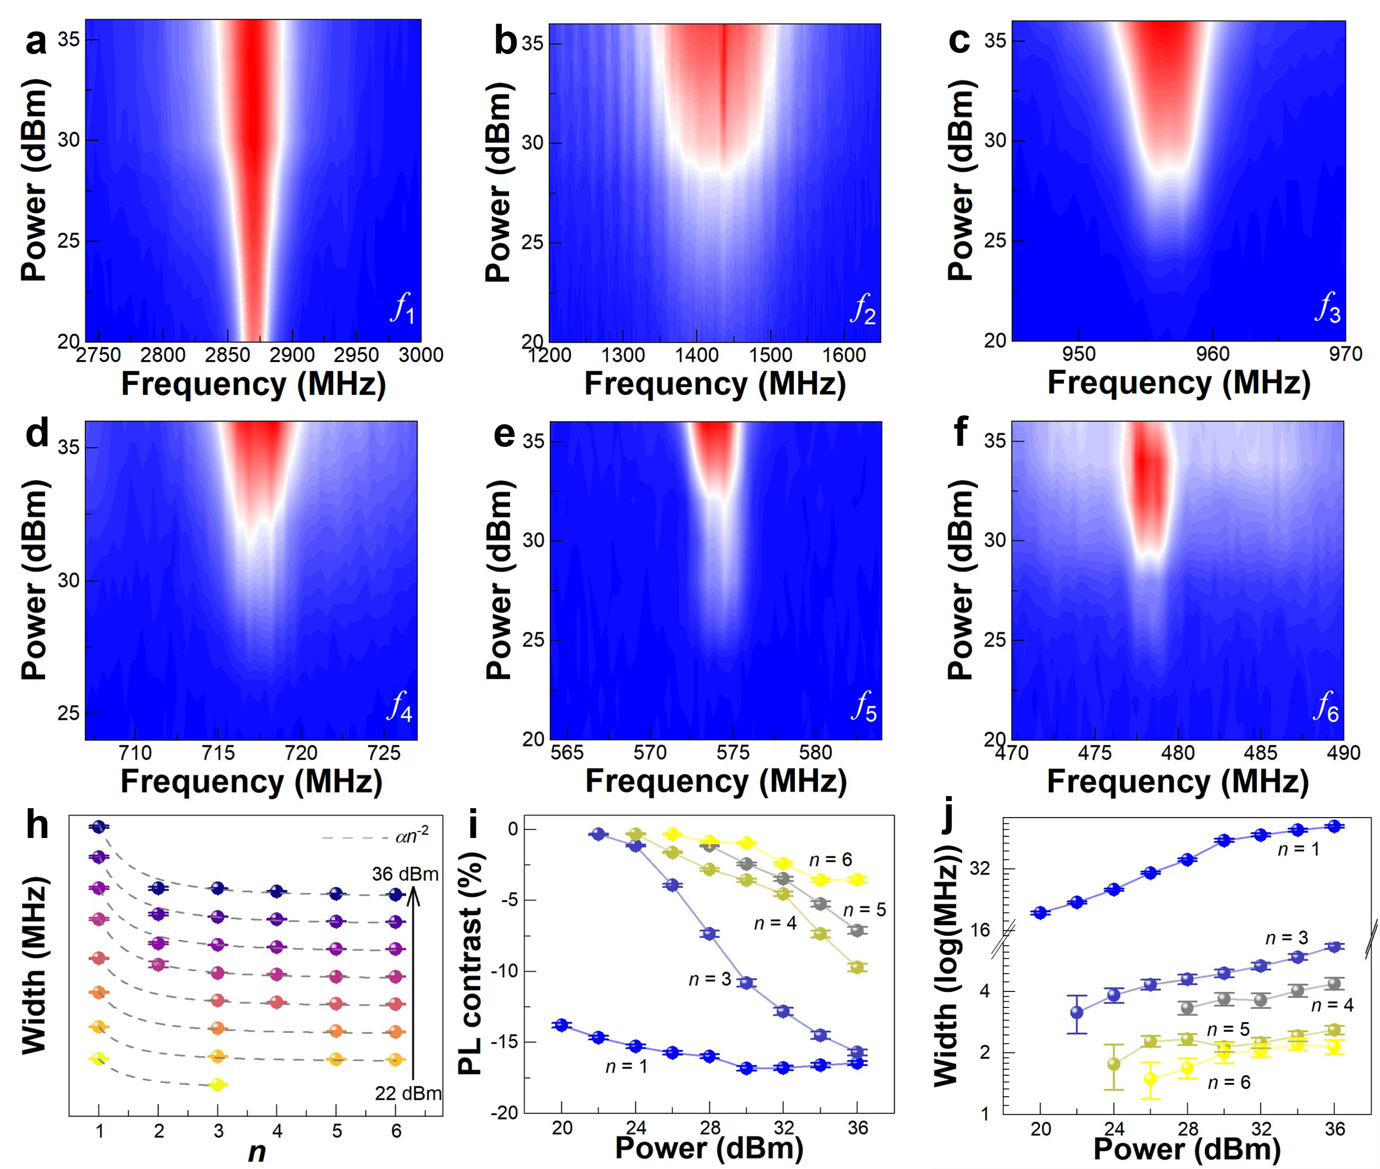
Supplementary Fig. S5 Microwave-power dependence of CW spectra at room temperature. (a-f) Contour plot spectra of the CW spectra of NV centers under excitation frequency from f₁ to f₆. (h) The relationship between the linewidth of the CW spectrum and the order n under microwave excitation of different power. The dots are the experimental data, and the dash lines (αn⁻²) are the corresponding fitted results of data. (i) Microwave-power dependence of the PL contrast of CW spectra. (j) Microwave-power dependence of the width of CW spectra.

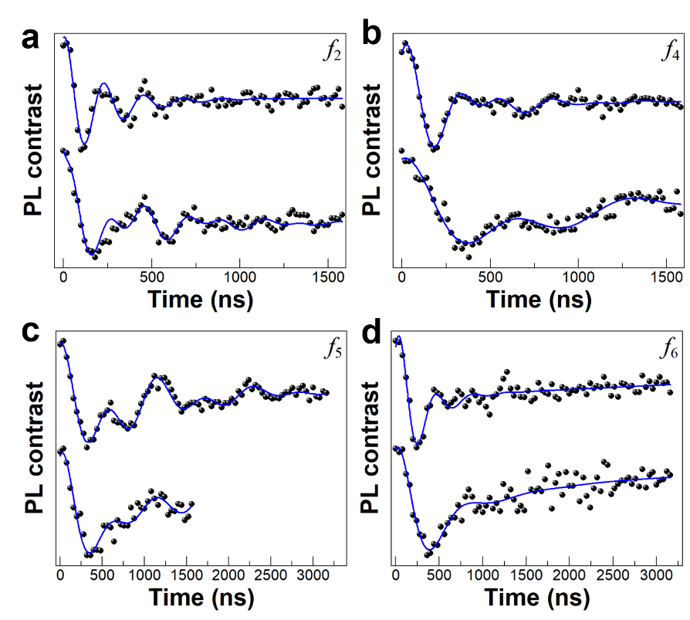
Supplementary Fig. S6 Rabi oscillation at 4 K. Rabi oscillation of the m_{s} = 0 to m_{s} = + 1 (top curve) and m_{s}=0 to m_{s} = - 1(bottom curve) ground state transition under 2 mT magnetic field normal to the diamond (100) plane with f₂, f₄, f₅ and f₆ microwave excitation, respectively. The data are fitted (blue curve) using $aⅇ^{-t/τ_{1}}\cos\left(2πω_{1}t+φ_{1}\right)\cos\left(2π{fω}_{2}t+φ_{2}\right)+bⅇ^{-t/τ_{2}}+c$, where $a$, $τ_{1}$, $ω_{i}$, $φ_{i}$, $b$, $τ_{2}$, $c$, is oscillation amplitude, oscillation decay time, frequency, phase, background decay amplitude, background decay time, and constant background, respectively.

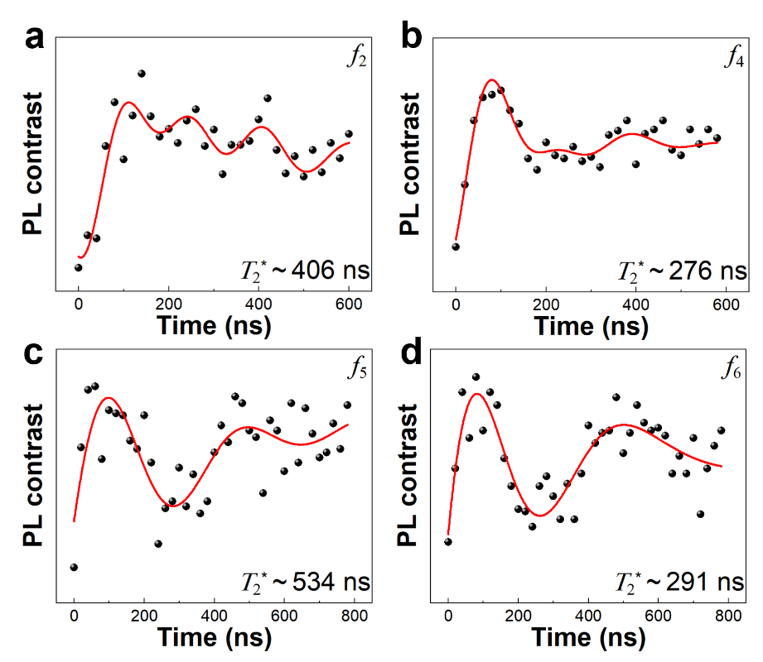
Supplementary Fig. S7 Ramsey interference at 4 K. Ramsey interference results of the m_{s} = 0 to m_{s} = + 1 ground state transition under 2 mT magnetic field normal to the diamond (100) plane with f₂, f₄, f₅ and f₆ microwave excitation, respectively. The data are fitted (red curve) using $aⅇ^{{-(t/T_{2}^{*})}^{2}}[\sin\left(2πω_{1}t+φ_{1}\right)+sin\left(2πω_{2}t+φ_{2}\right)+sin\left(2πω_{3}t+φ_{3}\right)]+c$, where $a$, $T_{2}^{*}$, $ω_{i}$, $φ_{i}$, c is oscillation amplitude, oscillation decay time, frequency, phase, and constant background, respectively.

