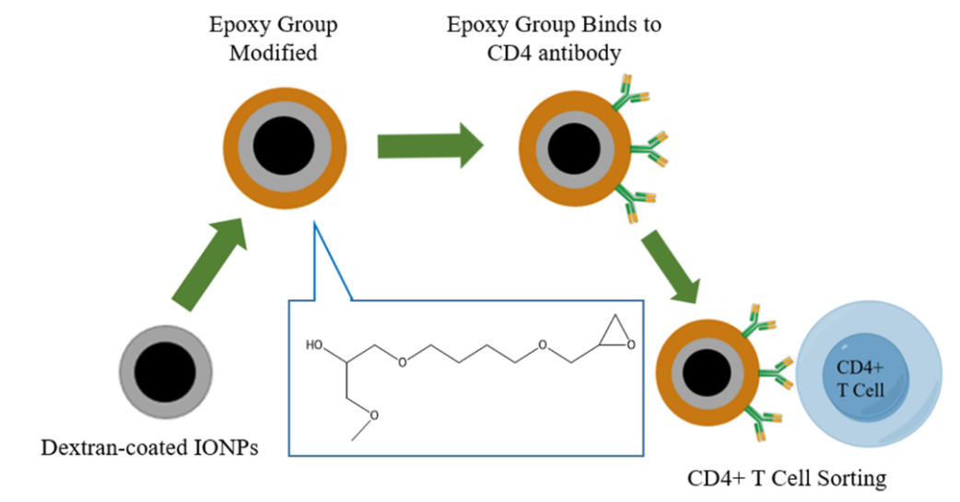
Scheme 1. Schematic diagram of IONP epoxy group surface functionalization coupled with CD4 antibody for sorting CD4+T cells

