Supplementary information for
Presence of primordial Mg explains the seismic low-velocity layer in the Earth’s outermost outer core

Tao Liu¹ and Zhicheng Jing^{1,*}

¹Department of Earth and Space Sciences, Southern University of Science and Technology, Shenzhen, Guangdong, 518055, China

*Corresponding to: Z. Jing, jingzc@sustech.edu.cn

Contents of this file

Supplementary Figures S1 to S7
Supplementary Tables S1 to S3
Supplementary References

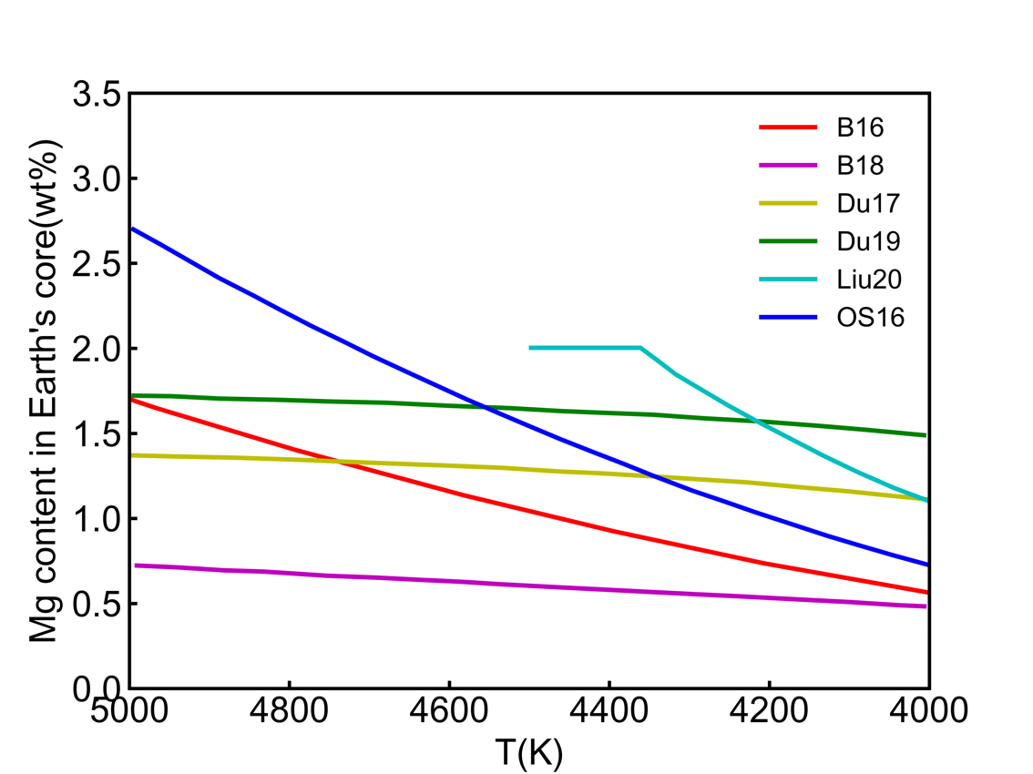
Supplementary Fig. S1 The estimated Mg content in the core as a function of temperature from metal-silicate partitioning data. The abbreviations B16, OS16, B18, Du17, Du19, and Liu20 correspond to references of Badro et al. (2016), O’Rourke and Stevenson (2016), Badro et al. (2018), Du et al. (2017), Du et al. (2019), and Liu et al. (2020), respectively.

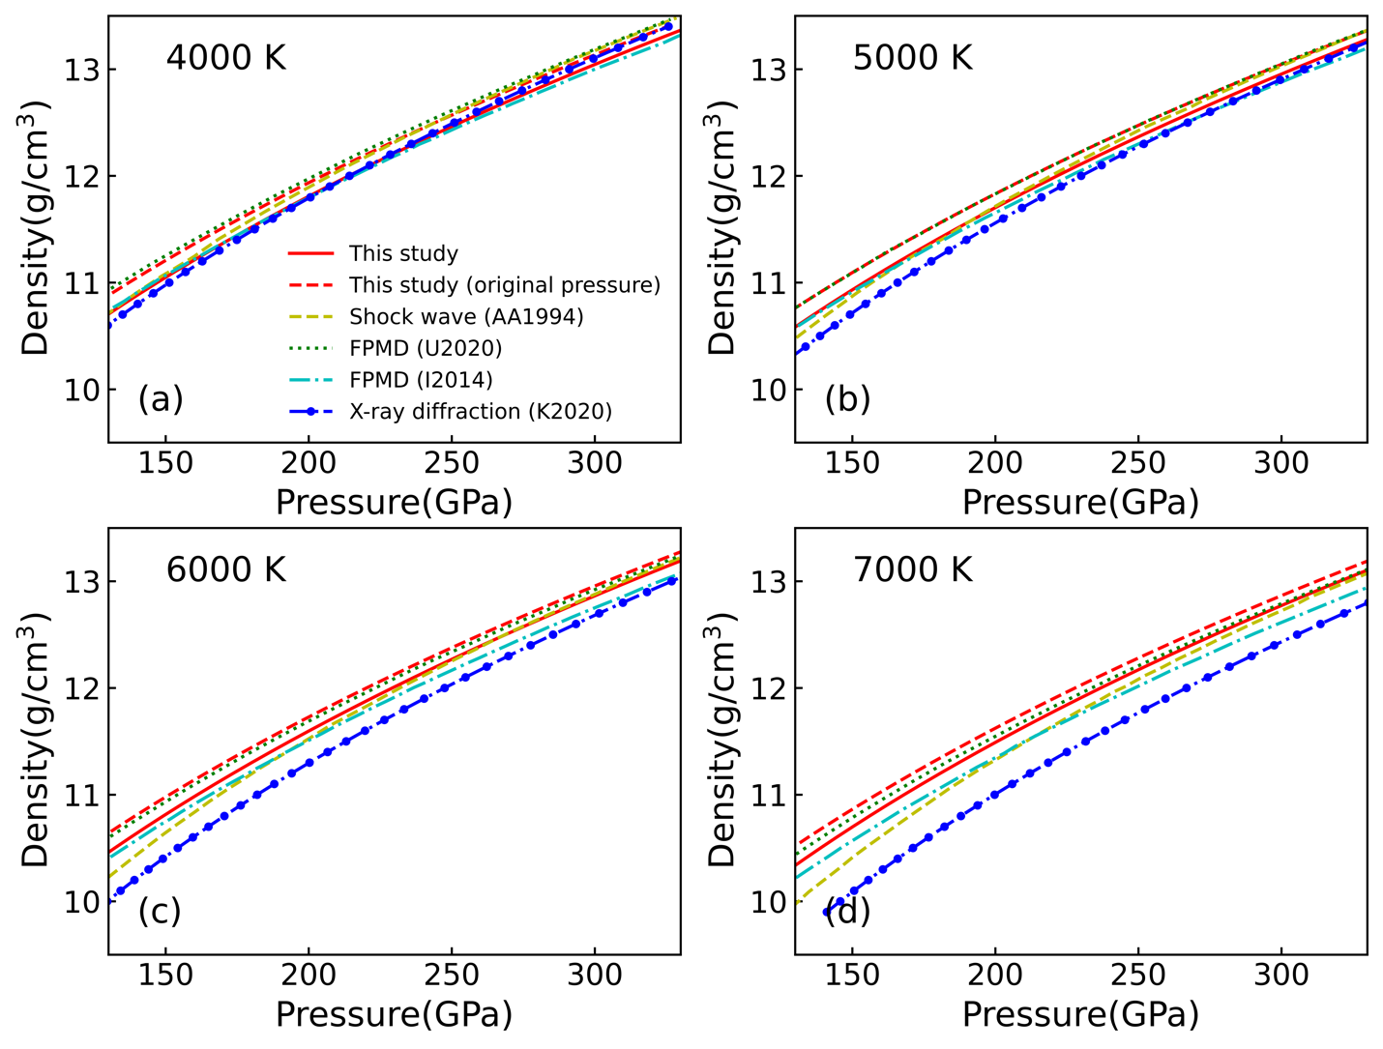
Supplementary Fig. S2 Equation of state of pure liquid Fe under Earth’s outer core conditions. The equations of state are plotted along different isotherms at 4000 K (a), 5000 K (b), 6000 K (c), and 7000 K (d), respectively. The red solid and dashed lines (this study), green dotted lines(Umemoto and Hirose, 2020), and cyan dash-dot lines(Ichikawa et al., 2014) are from the results of FPMD computations. The yellow dashed lines and blue dash-dot-dot lines are experimental results from shock wave(Anderson and Ahrens, 1994) and inelastic x-ray scattering measurements(Kuwayama et al., 2020).

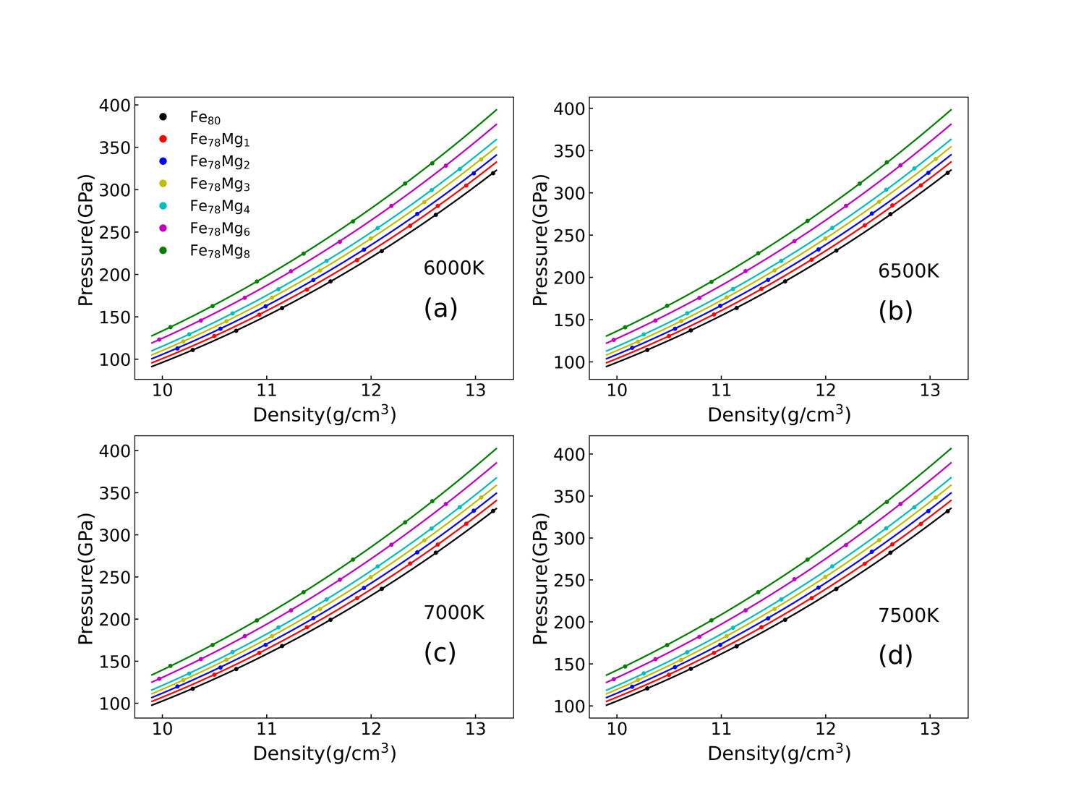
Supplementary Fig. S3 Equation of state (at originally computed pressures) of pure liquid Fe and Fe-Mg alloys under Earth’s outer conditions. These equations of state are plotted along different isotherms at 6000 K (a), 6500 K (b), 7000 K (c), and 7500 K (d), respectively. The fitting parameters are listed in Table S1.

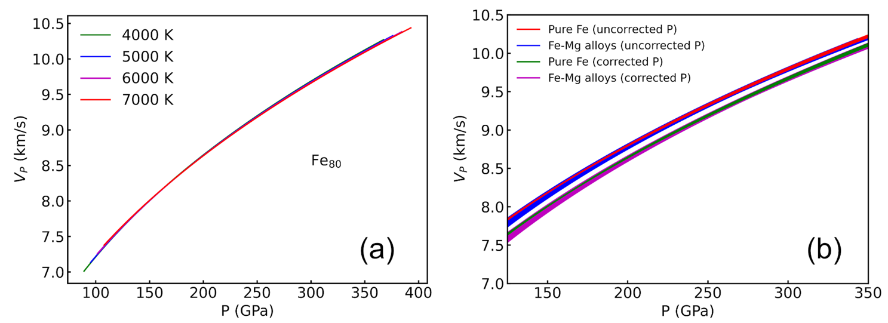
Supplementary Fig. S4 Compressional wave velocity (V_{P}) of pure Fe liquid and Fe-Mg alloying liquids under Earth’s core conditions. (a) The V_{P} of pure Fe liquid at temperatures of 4000 K (green), 5000 K (blue), 6000 K (purple), and 7000 K (red). Fe₈₀ means that a supercell of 80 Fe atoms was used in FPMD simulations. (b) The V_{P} of pure Fe liquid (red and green lines) and Fe-Mg alloying liquids (blue and purple lines) at 4000 K, 5000 K, 6000 K, and 7000 K. Results of six Fe-Mg alloys with super cells of Fe₇₈Mg₁, Fe₇₈Mg₂, Fe₇₈Mg₃, Fe₇₈Mg₄, Fe₇₈Mg₆, and Fe₇₈Mg₈ are plotted. Both originally computed pressures from FPMD simulations (red and blue lines for pure Fe and Fe-Mg alloys, respectively) and corrected pressures for the effect of GGA approximation (green and purple lines for pure Fe and Fe-Mg alloys, respectively) are used for plotting V_{P}. As both temperature and Mg content show limited effects on V_{P}, results at different temperatures and Mg contents are plotted using same colors in (b).

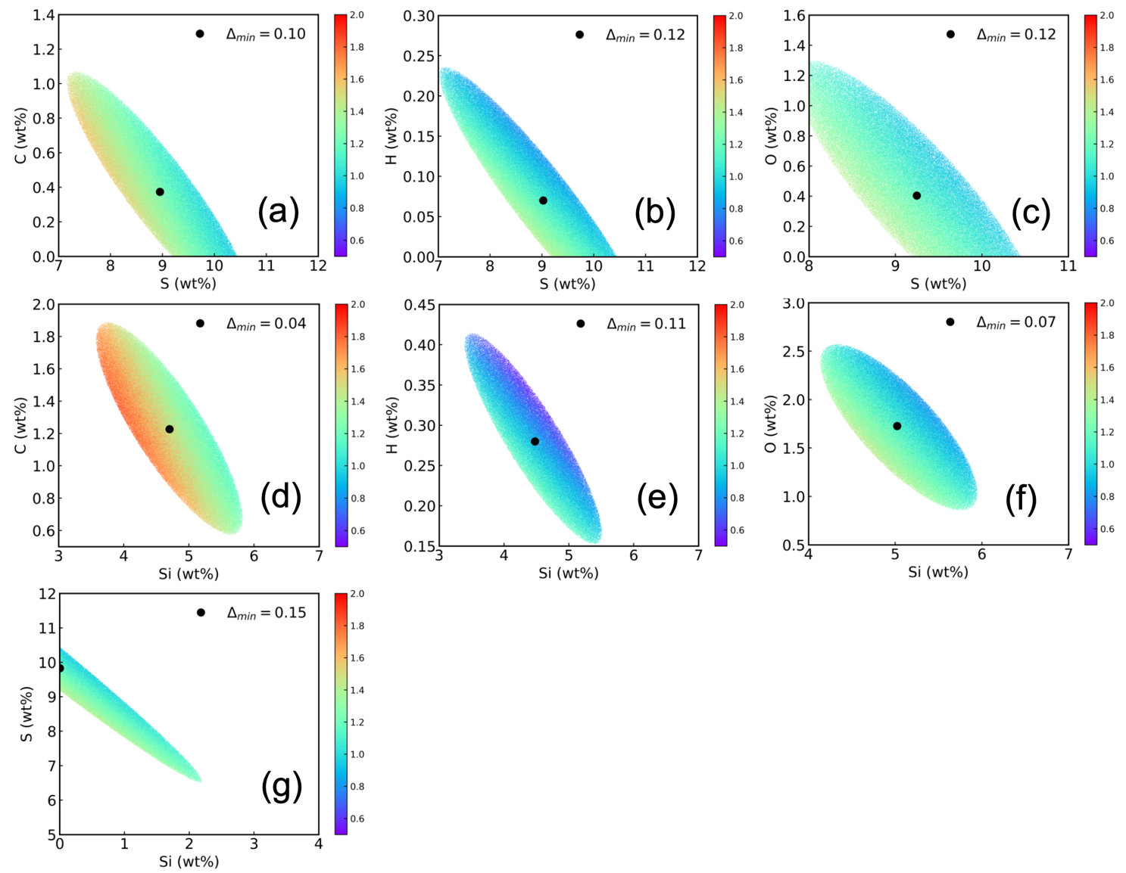
Supplementary Fig.S5 Optimized outer core compositions for the one-layer model with reduced misfit ∆< 0.25 using the PREM model as constraints. The color bars indicate the Mg content in the outer core in wt%. The solid black circles denote the best-fit compositions.

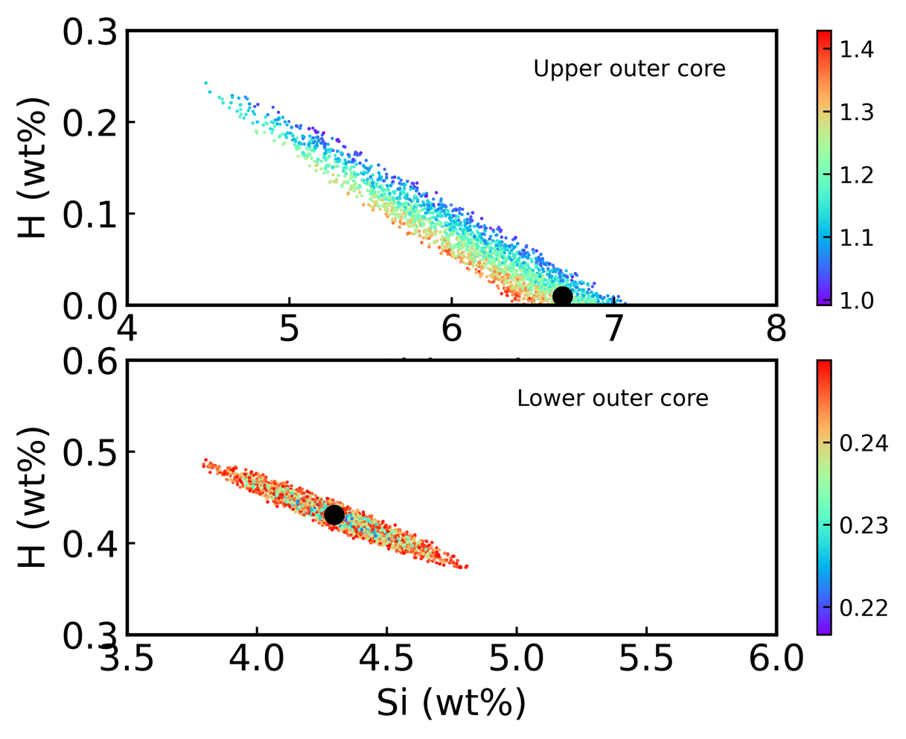
Supplementary Fig.S6 Optimized upper outer core and lower outer core compositions for the two-layer model with reduced misfit ∆< 0.25 using the PREM model as constraints. The color bars indicate the Mg content in upper outer core in wt% and the ∆ values for lower outer core, respectively. The solid black circles represent the best-fit compositions.

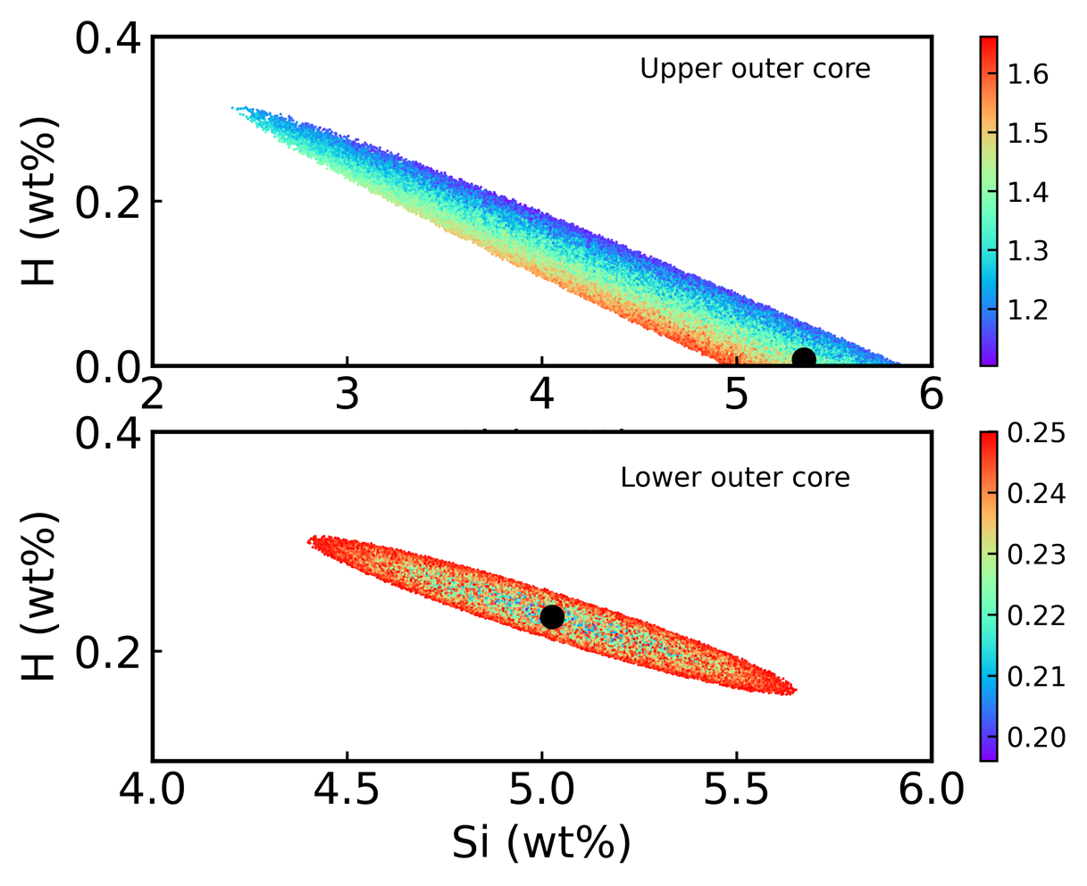
Supplementary Fig.S7 Optimized upper outer core and lower outer core compositions for the two-layer model with reduced misfit ∆< 0.25 using the EPOC model as constraints. The black circles represent the best-fit of composition. The color bars indicate the Mg content in upper outer core in wt% and the ∆ values for lower outer core, respectively. The solid black circles represent the best-fit compositions.

Supplementary Table S1 Best-fit EOS parameters of pure Fe and Fe-Mg alloying liquids
 | $ρ_{0}$ (g/cm³) | $K_{T0}$ (GPa) | $$K_{T0}^{'}$$ | a (GPa/K)×10⁻² | b (GPa/K) ×10⁻² | Mg§ (wt%)
Fe₈₀† | 6.96(0.04) | 117.47(3.76) | 4.47(0.03) | 1.43(0.09) | -1.14(0.15) | 0
Fe₇₈Mg₁† | 6.89(0.07) | 116.85(7.23) | 4.44(0.06) | 1.33(0.14) | -0.99(0.24) | 0.55
Fe₇₈Mg₂† | 6.78(0.06) | 113.98(5.55) | 4.41(0.05) | 1.53(0.13) | -1.33(0.23) | 1.10
Fe₇₈Mg₃† | 6.72(0.04) | 115.02(3.38) | 4.37(0.03) | 1.46(0.08) | -1.24(0.14) | 1.65
Fe₇₈Mg₄† | 6.58(0.05) | 109.68(4.34) | 4.36(0.04) | 1.60(0.09) | -1.54(0.16) | 2.18
Fe₇₈Mg₆† | 6.36(0.07) | 101.69(6.08) | 4.36(0.05) | 1.56(0.14) | -1.51(0.26) | 3.24
Fe₇₈Mg₈† | 6.31(0.06) | 107.52(5.82) | 4.26(0.04) | 1.49(0.12) | -1.39(0.23) | 4.27
Fe₈₀‡ | 6.29(0.06) | 77.61(3.89) | 4.60(0.04) | 1.42(0.09) | -1.25(0.17) | 0
Fe₇₈Mg₁‡ | 6.22(0.11) | 77.62(7.40) | 4.57(0.08) | 1.31(0.13) | -1.08(0.26) | 0.55
Fe₇₈Mg₂‡ | 6.10(0.09) | 75.28(5.71) | 4.53(0.06) | 1.51(0.13) | -1.46(0.26) | 1.10
Fe₇₈Mg₃‡ | 6.06(0.05) | 77.16(3.43) | 4.48(0.03) | 1.44(0.08) | -1.35(0.16) | 1.65
Fe₇₈Mg₄‡ | 5.92(0.07) | 72.43(4.38) | 4.48(0.04) | 1.59(0.09) | -1.69(0.18) | 2.18
Fe₇₈Mg₆‡ | 5.67(0.11) | 65.18(6.10) | 4.48(0.06) | 1.54(0.14) | -1.68(0.30) | 3.24
Fe₇₈Mg₈‡ | 5.67(0.09) | 72.08(5.80) | 4.36(0.05) | 1.47(0.12) | -1.53(0.25) | 4.27
Notes:
†Fitted EOS parameters using the originally computed pressures from FPMD simulations.
‡Fitted EOS parameters using the corrected pressures for the GGA approximation.
§Mg contents in the Fe-Mg alloying liquids are computed directly from the atomic ratios of the supercells.
Numbers in parentheses represent 1σ errors for the parameters.

Supplementary Table S2 Best-fit parameters for the Grüneisen parameter $γ$
 | $$γ_{0}$$ | $$c$$
Fe₈₀† | 1.99(0.04) | 0.74(0.04)
Fe₇₈Mg₁† | 2.06(0.06) | 0.83(0.06)
Fe₇₈Mg₂† | 1.92(0.08) | 0.69(0.08)
Fe₇₈Mg₃† | 1.97(0.04) | 0.77(0.04)
Fe₇₈Mg₄† | 1.77(0.02) | 0.59(0.02)
Fe₇₈Mg₆† | 1.79(0.09) | 0.61(0.09)
Fe₇₈Mg₈† | 1.92(0.03) | 0.78(0.03)
Fe80‡ | 2.12(0.05) | 0.74(0.04)
Fe₇₈Mg₁‡ | 2.22(0.08) | 0.83(0.06)
Fe₇₈Mg₂‡ | 2.04(0.10) | 0.69(0.08)
Fe₇₈Mg₃‡ | 2.10(0.05) | 0.77(0.04)
Fe₇₈Mg₄‡ | 1.86(0.03) | 0.59(0.02)
Fe₇₈Mg₆‡ | 1.90(0.11) | 0.61(0.09)
Fe₇₈Mg₈‡ | 2.06(0.04) | 0.78(0.03)
Notes:
†Fitted parameters using the originally computed pressures from FPMD simulations.
‡Fitted parameters using the corrected pressures for the GGA approximation.
Numbers in parentheses represent 1σ errors for the parameters.

Supplementary Table S3 Computed pressure-volume data for hcp-Fe₆₀Mg₄ under inner core conditions (330 GPa and 6000 K)
P (GPa) | V(Å³)
344.5 | 434.1
325.5 | 440.7
324.2 | 441.1
322.5 | 441.7
The calculated atomic volumes of Mg and Fe in hcp structured Fe-Mg alloys at 330 GPa and 6000 K are 7.777 Å³ (this study) and 6.80 Å³ (our previous study(Liu and Jing, 2024)).

Supplementary references

Anderson, W.W., Ahrens, T.J., 1994. An equation of state for liquid iron and implications for the Earth’s core. J Geophys Res Solid Earth 99, 4273–4284. https://doi.org/10.1029/93jb03158
Badro, J., Aubert, J., Hirose, K., Nomura, R., Blanchard, I., Borensztajn, S., Siebert, J., 2018. Magnesium Partitioning Between Earth’s Mantle and Core and its Potential to Drive an Early Exsolution Geodynamo. Geophys Res Lett 45, 13,240-13,248. https://doi.org/10.1029/2018gl080405
Badro, J., Siebert, J., Nimmo, F., 2016. An early geodynamo driven by exsolution of mantle components from Earth’s core. Nature 536, 326–328. https://doi.org/10.1038/nature18594
Du, Z., Boujibar, A., Driscoll, P., Fei, Y., 2019. Experimental Constraints on an MgO Exsolution‐Driven Geodynamo. Geophys Res Lett 46, 7379–7385. https://doi.org/10.1029/2019gl083017
Du, Z., Jackson, C., Bennett, N., Driscoll, P., Deng, J., Lee, K.K.M., Greenberg, E., Prakapenka, V.B., Fei, Y., 2017. Insufficient Energy From MgO Exsolution to Power Early Geodynamo. Geophys Res Lett 44, 11,376-11,381. https://doi.org/10.1002/2017gl075283
Ichikawa, H., Tsuchiya, T., Tange, Y., 2014. The P-V-T equation of state and thermodynamic properties of liquid iron. J Geophys Res Solid Earth 119, 240–252. https://doi.org/10.1002/2013jb010732
Kuwayama, Y., Morard, G., Nakajima, Y., Hirose, K., Baron, A.Q.R., Kawaguchi, S.I., Tsuchiya, T., Ishikawa, D., Hirao, N., Ohishi, Y., 2020. Equation of State of Liquid Iron under Extreme Conditions. Phys Rev Lett 124, 165701. https://doi.org/10.1103/physrevlett.124.165701
Liu, T., Jing, Z., 2024. Hydrogen and silicon are the preferred light elements in Earth’s core. Commun. Earth Environ. 5, 282. https://doi.org/10.1038/s43247-024-01450-3
Liu, W., Zhang, Y., Yin, Q.-Z., Zhao, Y., Zhang, Z., 2020. Magnesium partitioning between silicate melt and liquid iron using first-principles molecular dynamics: Implications for the early thermal history of the Earth’s core. Earth Planet Sc Lett 531, 115934. https://doi.org/10.1016/j.epsl.2019.115934
O’Rourke, J.G., Stevenson, D.J., 2016. Powering Earth’s dynamo with magnesium precipitation from the core. Nature 529, 387. https://doi.org/10.1038/nature16495
Umemoto, K., Hirose, K., 2020. Chemical compositions of the outer core examined by first principles calculations. Earth Planet Sc Lett 531, 116009. https://doi.org/10.1016/j.epsl.2019.116009

