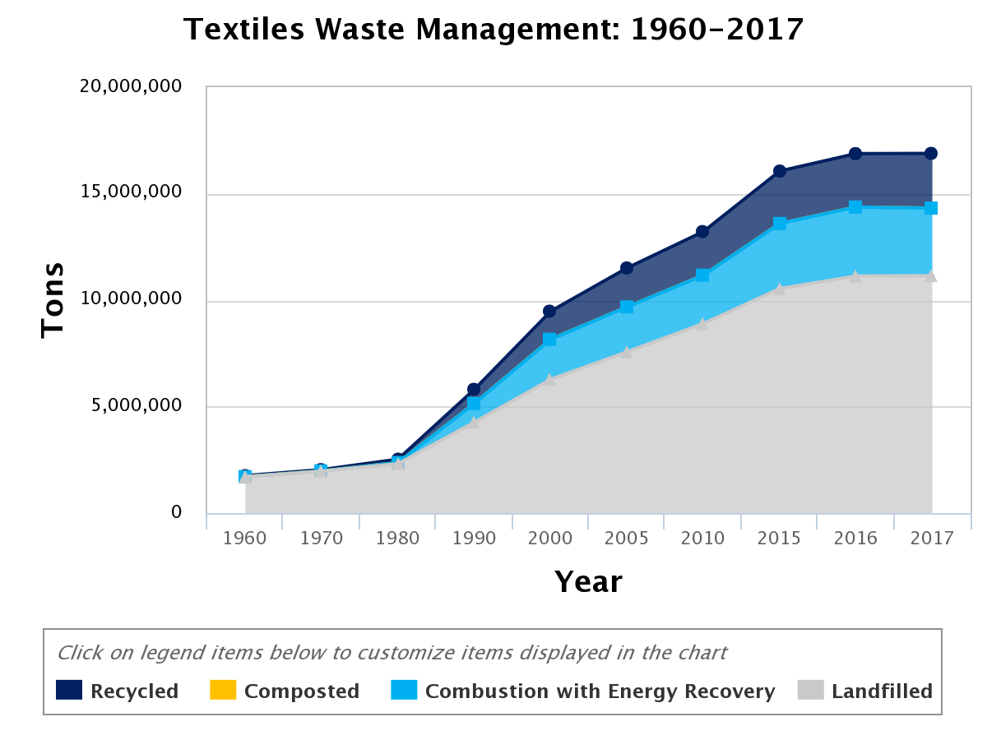
Supplementary Figure 1. The total number of tons of textiles generated, recycled, composted, combusted with recovery and landfilled from 1960 to 2017.¹ Copyright from United States Environmental Protection Agency.

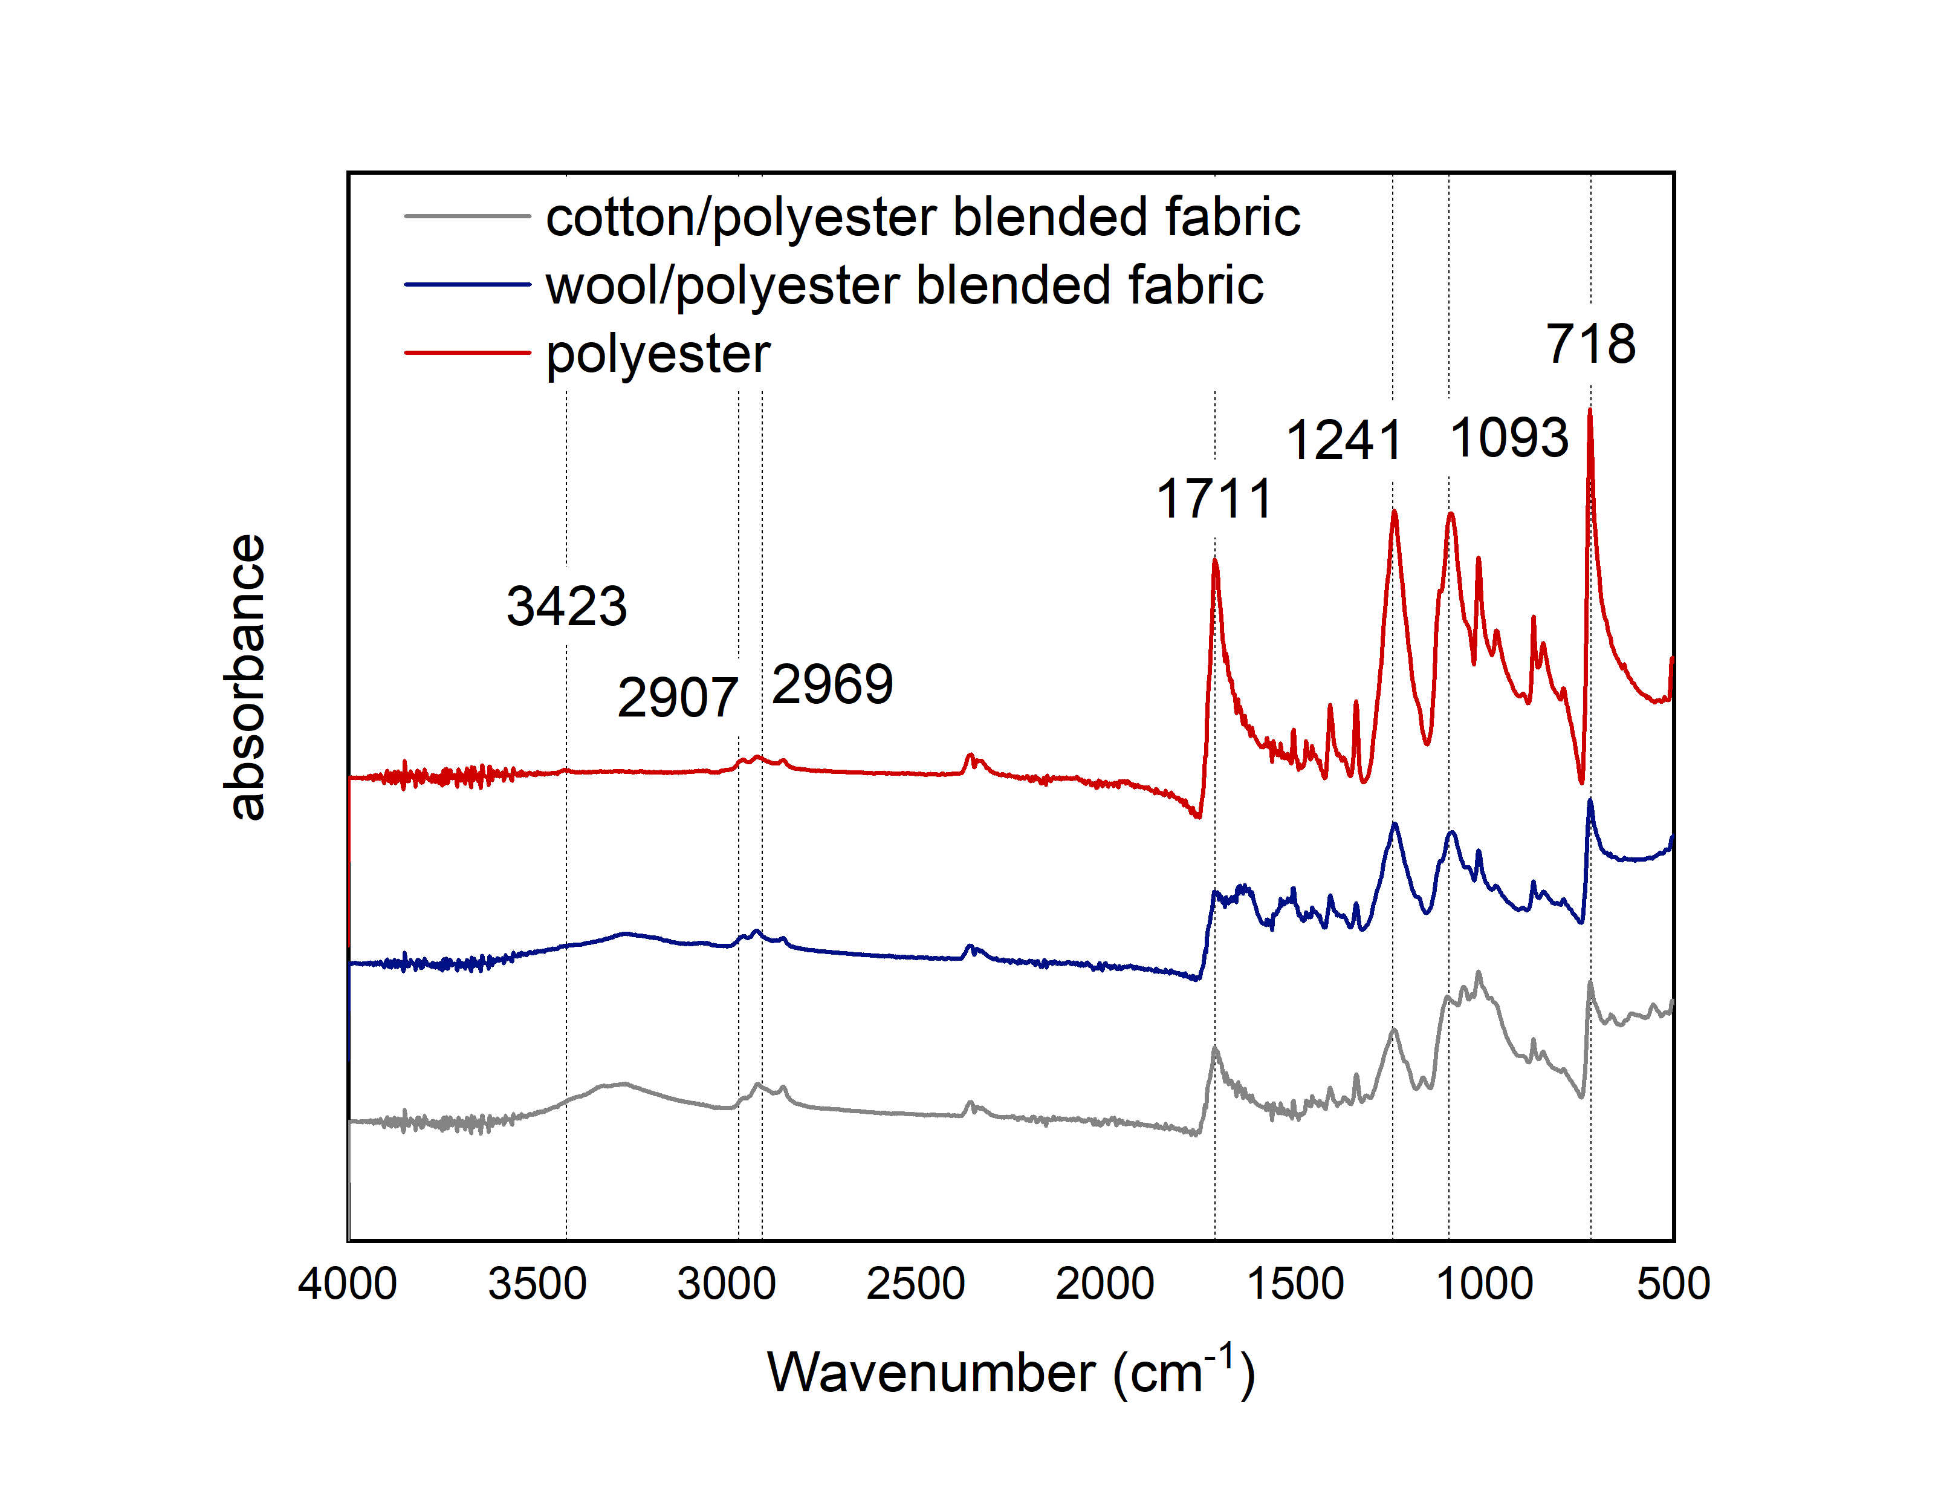
Supplementary Figure 2. FTIR spectra of cotton/polyester blended and wool/polyester blended fabrics before and after dissolution.

Supplementary Figure 3. Dissolution rate of cotton in [BMIM][Cl] with different temperature (a), dissolution time (b) and pre-treatment time (c). The pre-treatment process was operated by soaking fabric into water with different duration and dried before dissolution.

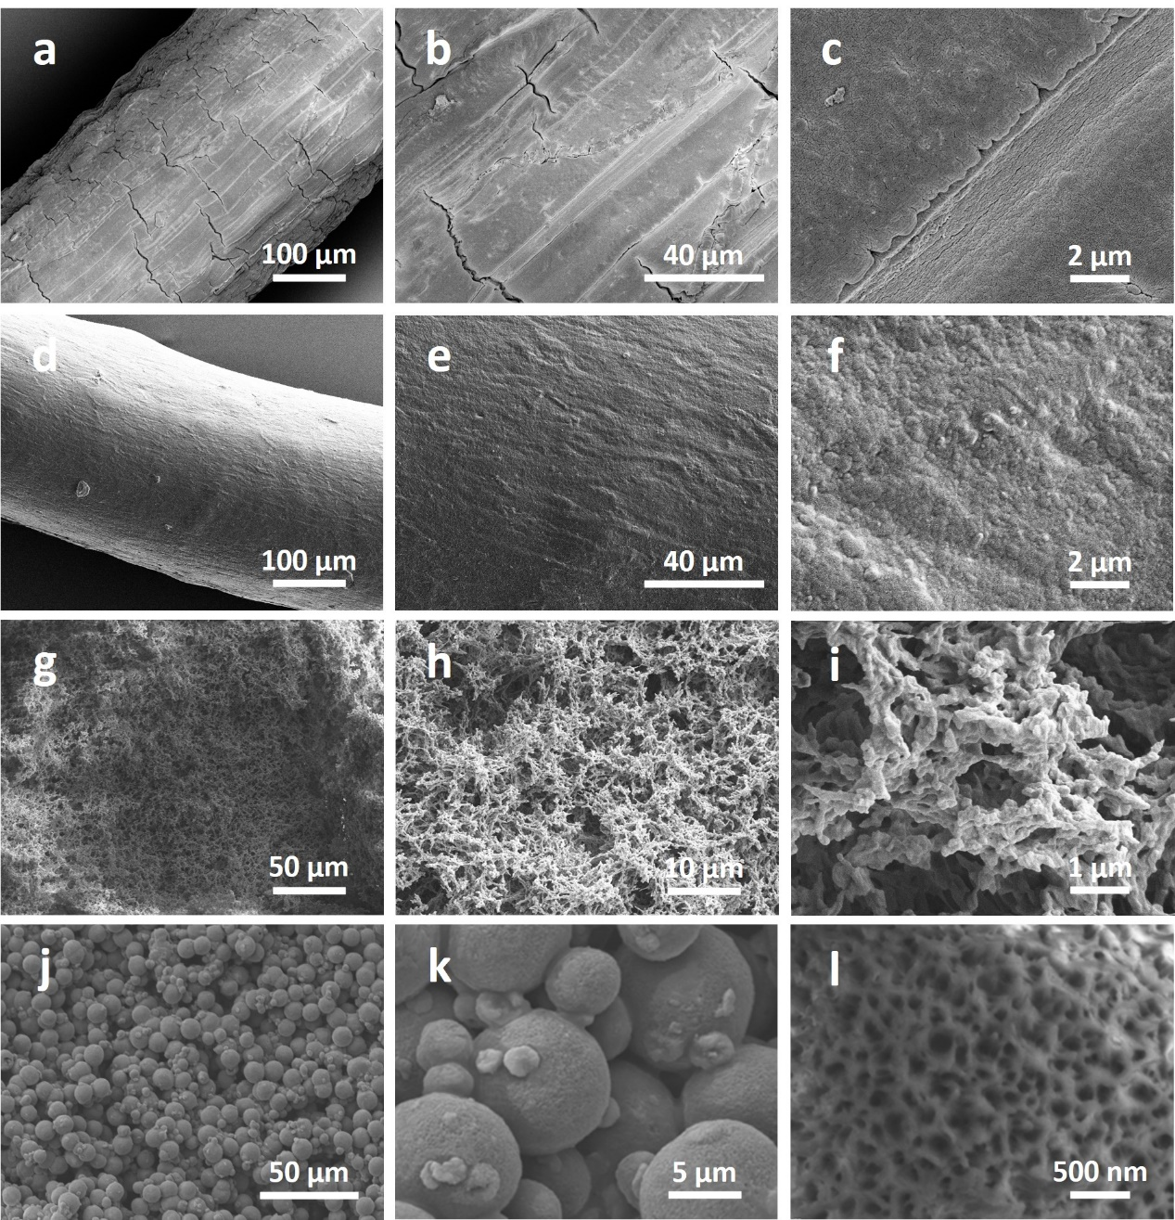
Supplementary Figure 4. a, b, c, SEM images of regenerated acrylic fibre from [BMIM][Cl]. d, e, f, SEM images of regenerated cellulose/wool keratin (w/w=1/3) composite fibre from [BMIM][Cl]. g, h, i, SEM images of freeze-dried regenerated wool keratin hydrogel. j, k, l, SEM images of regenerated cellulose microspheres.

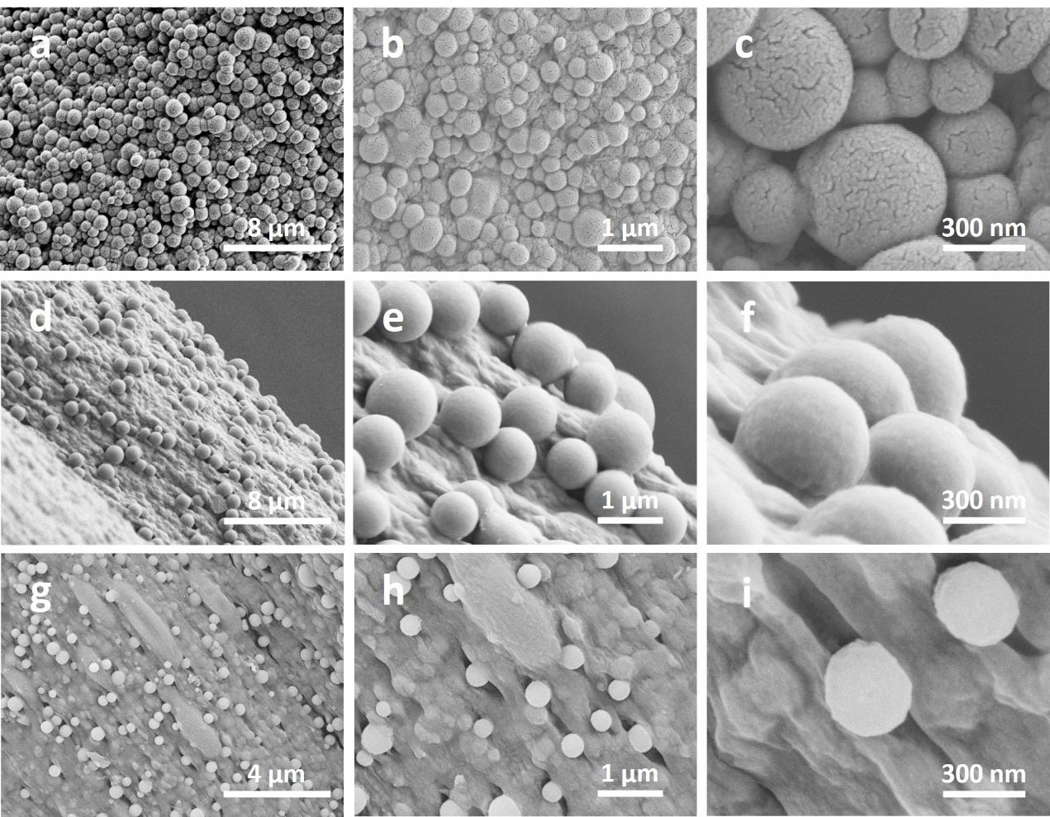
Supplementary Figure 5. a-c, SEM images of regenerated cellulose/wool keratin (w/w=1/1) composite fibre from [MMIM][DMP] with relatively lower spinning speed. d-f, SEM images of anterior part of regenerated cellulose/wool keratin (w/w=1/1) composite fibre from [MMIM][DMP] with relatively higher spinning speed. g-i, SEM images of posterior part of regenerated cellulose/wool keratin (w/w=1/1) composite fibre from [MMIM][DMP] with relatively higher spinning speed.
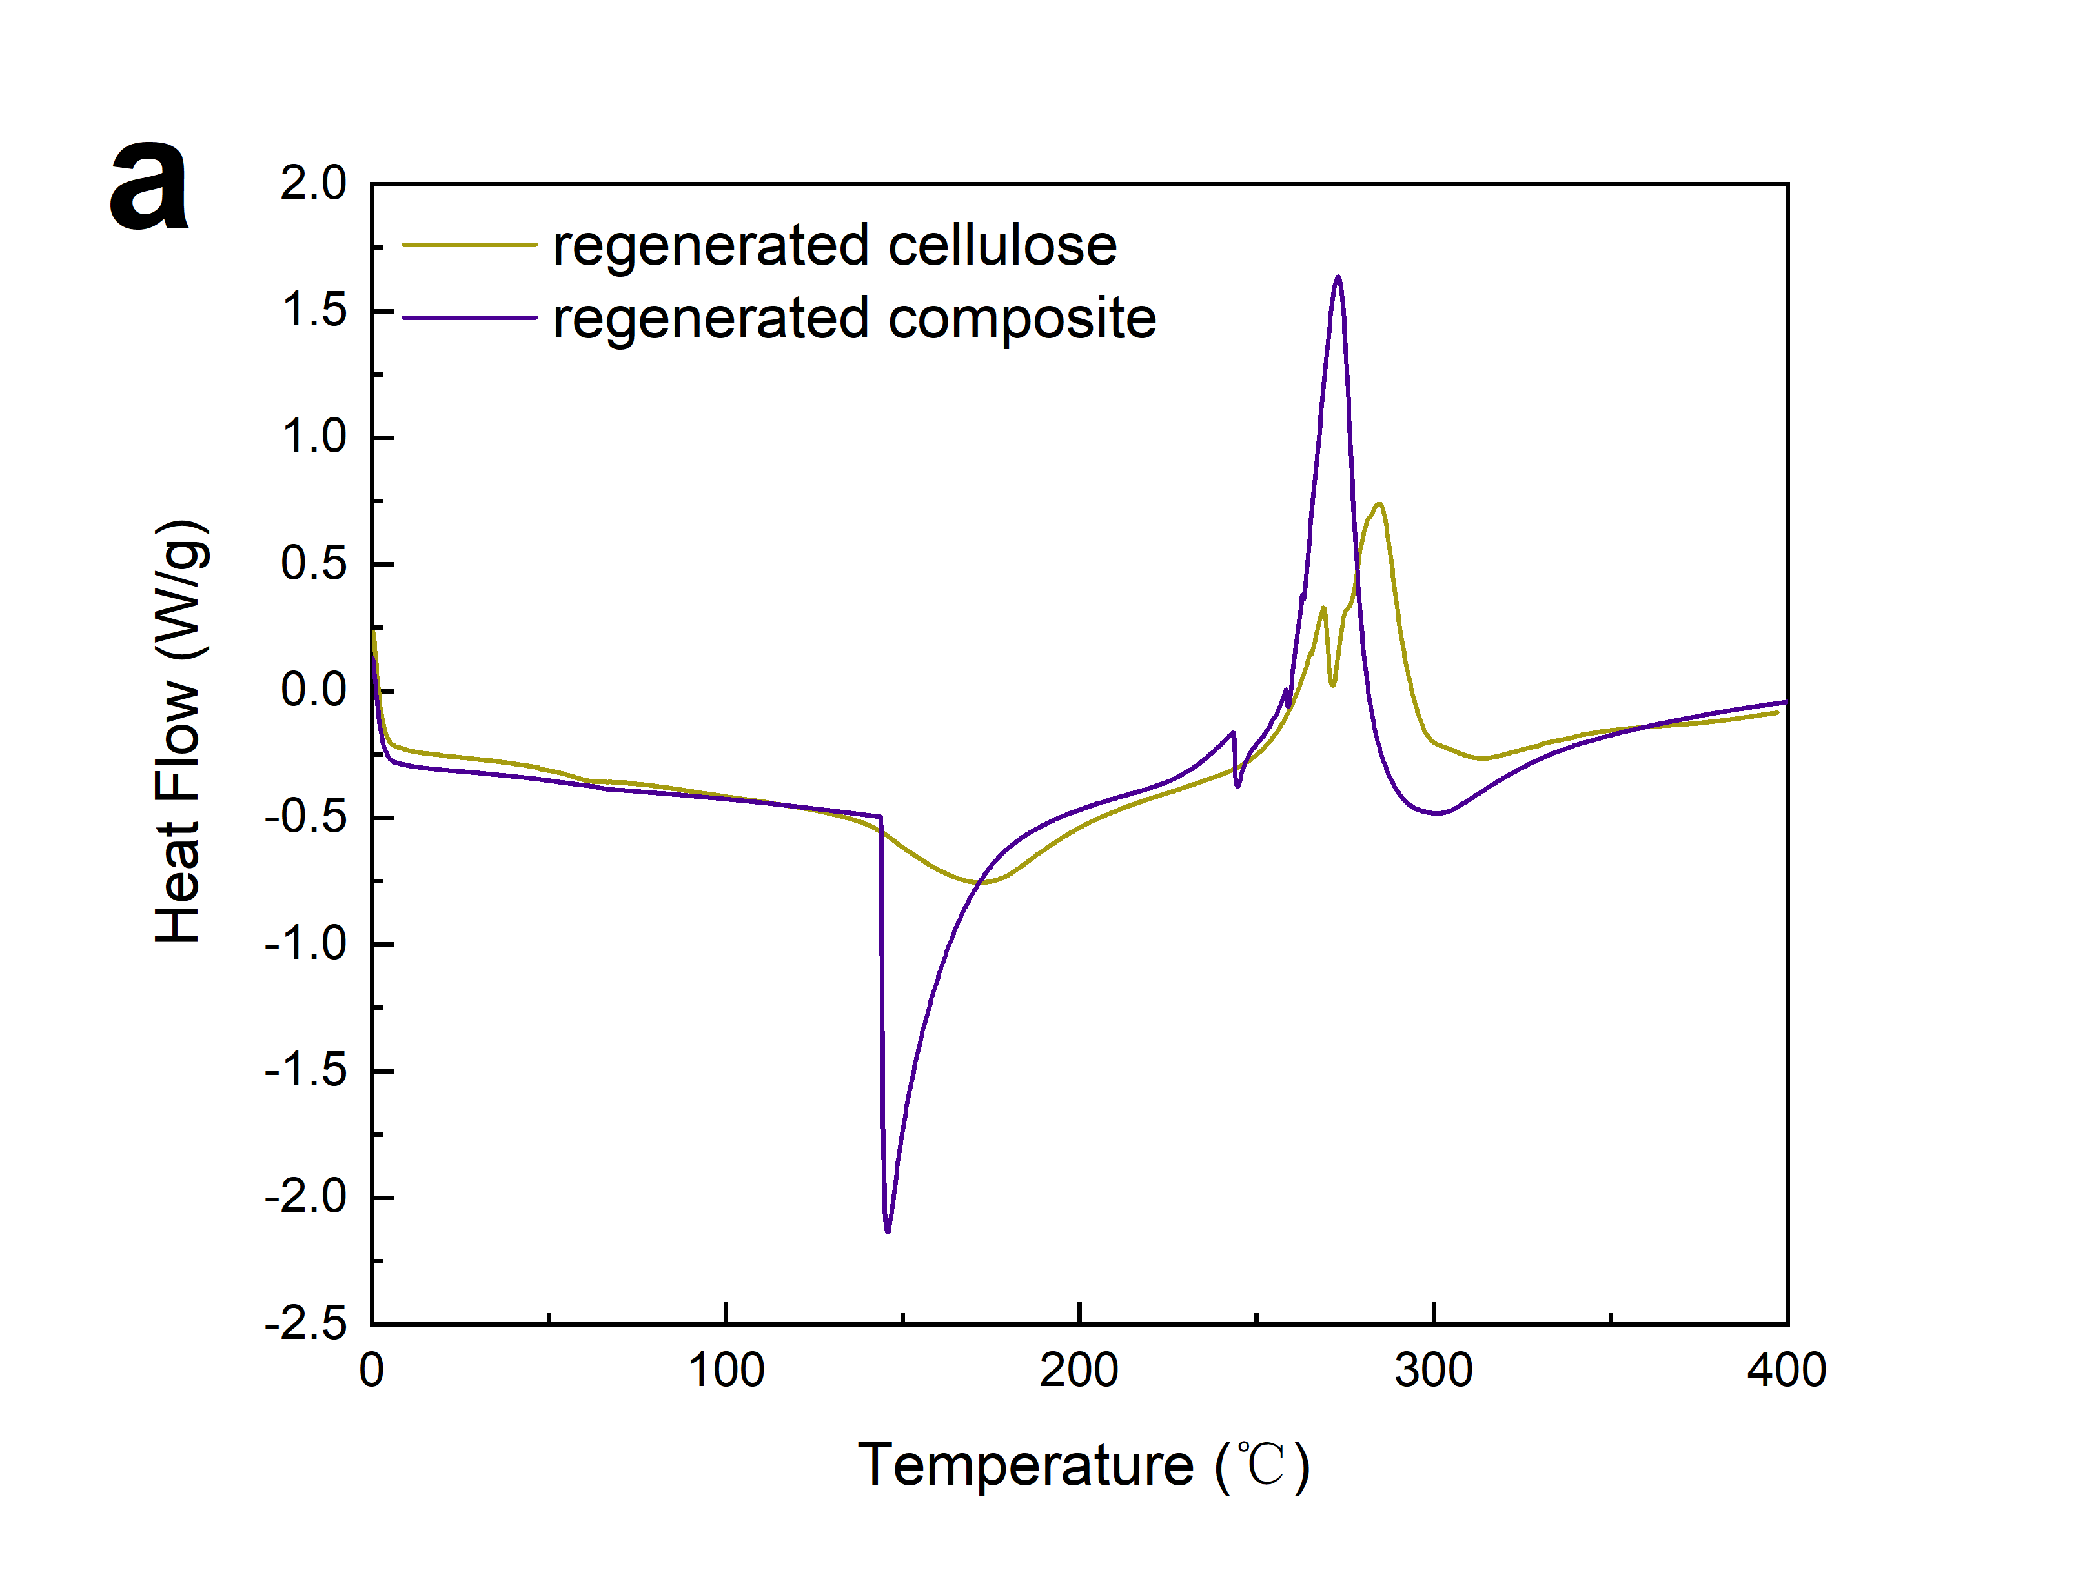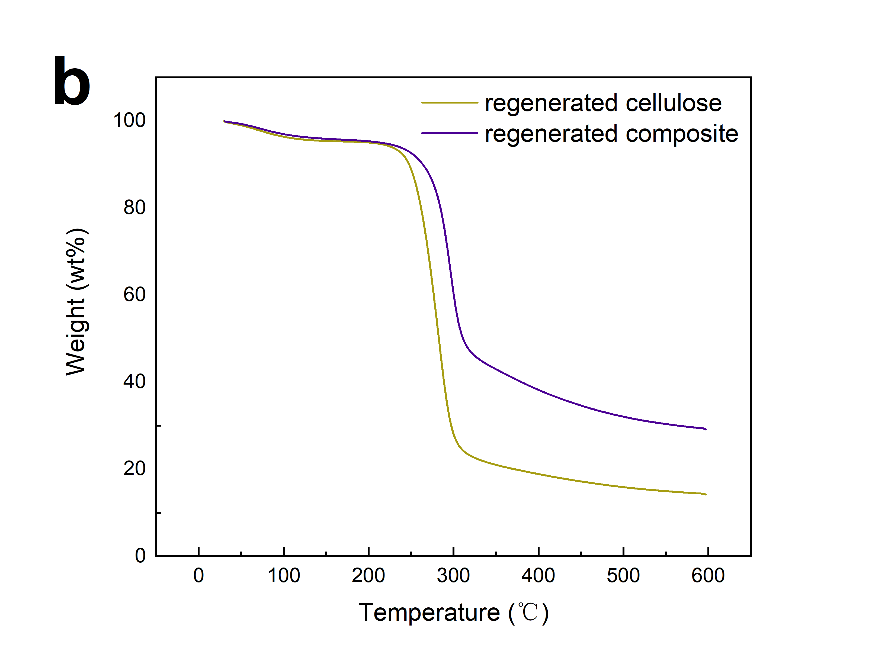

Supplementary Figure 6. DSC (a) and TGA (b) plots relative to regenerated cellulose fibre and regenerated cellulose/wool keratin (w/w=1/1) composite fibre as measured under nitrogen atmosphere.

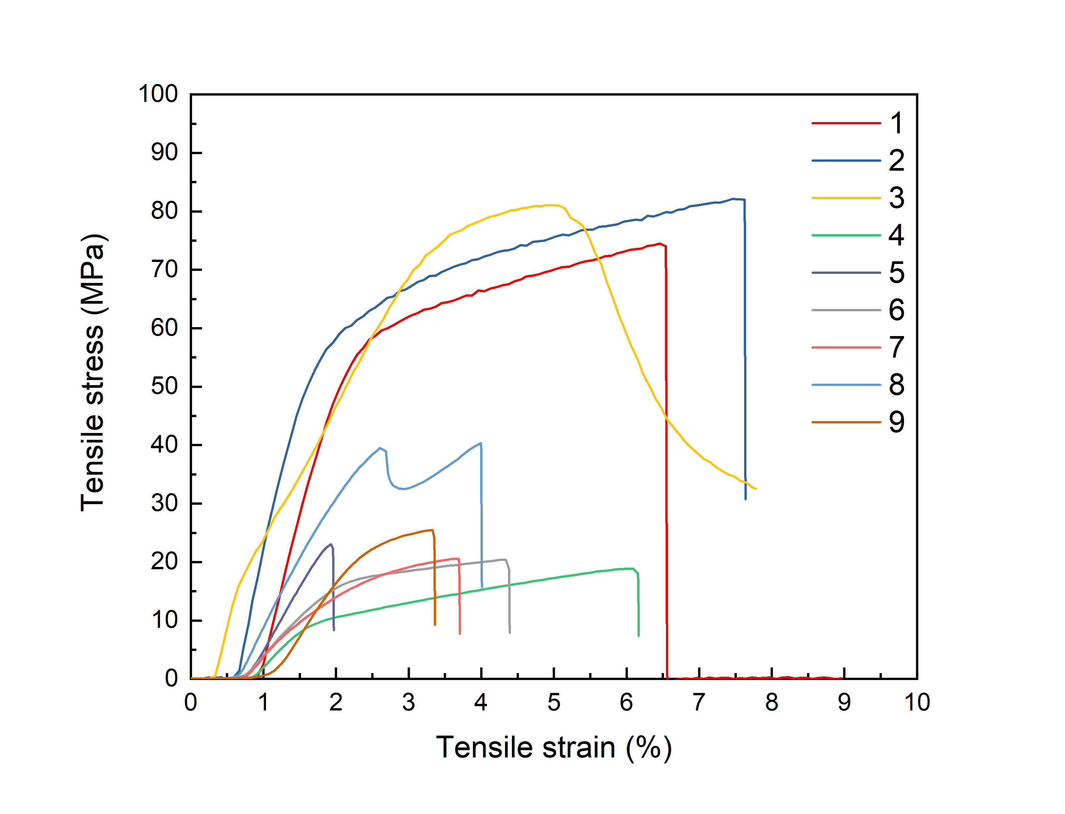
Supplementary Figure 7. Respective stress-strain curves of the regenerated cellulose fibre (sample 1-3) and cellulose/wool keratin composite fibre (sample 4-9).

Supplementary References:
1. Textiles: Material-Specific Data. United States Environmental Protection Agency (2017).
2. Sandin, G. & Peters, G. M. Environmental impact of textile reuse and recycling e A review. J. Clean. Prod. 184, 353–365 (2018).

