Supplementary Materials for
Cryogenic In-Situ Fabrication of Reconfigurable Direct-Write Logic Circuits and Devices
Yuhao Hong^{1,2#}, Lei Wang^{1#}, Ziyue Shen¹, Tongrui Li¹, Long Wei¹, Shilin Hu¹, Junhua Liu¹, Wen Xiao¹, Lin Li¹, Mark Huijben², Kai Chen¹, Yulin Gan¹, Guus Rijnders², Gertjan Koster^{2*}, Zhaoliang Liao^{1*}
¹National Synchrotron Radiation Laboratory, University of Science and Technology of China; Hefei, 230029, China
²MESA+ Institute for Nanotechnology, University of Twente; Enschede, 7500 AE, the Netherlands.
*To whom correspondence should be addressed: g.koster@utwente.nl, zliao@ustc.edu.cn

1. Characteristics of contact barrier
Fig. S1 | I_{D}-V_{DS} characteristics of metal contact at 2 K.
Both the 2-wire method (orange line) and the Van der Pauw method (purple line) demonstrate similar linear I_{D}-V_{DS} characteristics. This indicates the absence of a Schottky barrier between the C-2DEG and the metal electrode surface, confirming a metal-metal ohmic contact.

2. Transport characteristics at different temperature
Fig. S2 | V_{DS}-dependent I_{D}-V_{BG} characteristics at different temperature. Transport characteristics (I_{D}-V_{BG}) of sample with a STO substrate thickness of 0.5 mm are shown under different V_{DS} (from 0.5 mV to 5 mV) at 10 K (a), 30 K (b) and 50 K (c).
The saturation I_{D} increases with V_{DS} at all temperatures, aligning with the trend observed at 2 K (see Fig. 3b in main text). Meanwhile, large I_{on}/I_{off} ratio (over 10⁴) at V_{DS} = 0.5 mV is maintained even at 30 K. However, at 50 K, due to the substantial vaporization in the gas ice layer, the maximum charge capacity decreases, and only a small number of charge carriers are depleted at the C-2DEG interface. Consequently, the on/off ratio is significantly reduced. It is worth noting that the kink origin of all curves at V_{BG} = 20 V is attributed to the voltage source switching of the Keithley 2400 source meter.

3. Output characteristics at different temperatures
Fig. S3 | V_{BG}-dependent I_{D}-V_{DS} characteristics at different temperature. Output characteristics (I_{D}-V_{DS}) of sample with STO substrate thickness of 0.5 mm under different V_{BG} (from 200 V to 25 V) at 2 K (a), 10 K (b), 30 K (c) and 50 K (d).
At 2 K, linear I_{D}-V_{DS} characteristics emerge when V_{BG} ≥ 75 V, indicating that the channel is fully turned on. With rising temperature, the minimum required V_{BG} for the linear I_{D}-V_{DS} decreases, and eventually disappears at 50 K.
4. Impact of STO substrate thickness
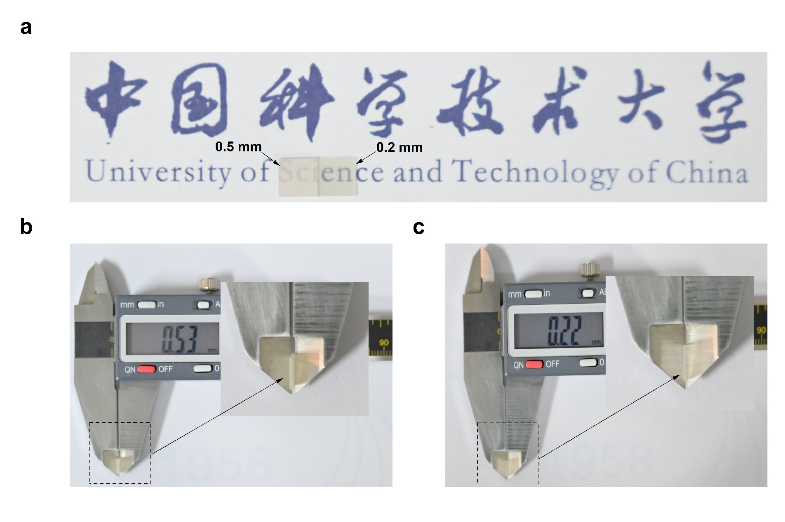
Fig. S4 | Comparison of samples with substrates of different thickness. a, Optical image comparison of substrates with different thicknesses. Thickness measured using a vernier caliper before (b) and after (c) thinning the STO substrate.

5. Growth of LaFeO₃ and LaAlO₃ films
Fig. S5 | RHEED characterization. RHEED intensity oscillations during the growth of LFO (5 u.c., red line) and LAO (10 u.c., blue line). The upper left inset shows the RHEED pattern of the STO substrate before growth, and the lower right inset shows the RHEED pattern of the sample.

Pulsed back-gate voltage (V） | 0 | 100 | 150 | 175 | 210
Charge density in gas ice layer (×10¹³ cm⁻²) | 0 | 1.067 | 1.600 | 1.867 | 1.932
C-2DEG carrier concentration (×10¹³ cm⁻²) | 1.932 | 0.865 | 0.332 | 0.065 | 0
Mobility (cm²V⁻¹s⁻¹) | 2396 | 2396 | 2396 | 2396 | 2396
Calculate resistance (Ohm) | - | 301.410 | 785.602 | 3992.142 | ∞
Real resistance  (Ohm) | 135.815 | 301.464 | 761.964 | 3558.438 | 2.156×10¹⁰
Accuracy (R_{C}/R_{R}) | - | 99.98 % | 103.10 % | 112.19 % | -
Table S1 | Assuming constant mobility, the charge quantity of the gas ice layer, the interface carrier concentration, and the interface resistance are calculated after applying different pulsed V_{BG} (ranging from 0 to 210 V). This is done through the analogy of parallel plate capacitors. The calculated resistance is then compared with the actual resistance (extracted from Fig. 1c in main text).
The calculated resistance demonstrates excellent accuracy at V_{BG} = 100 V. As V_{BG} increases and the electric field intensity rises, the relative dielectric constant of the single crystal STO decreases. Consequently, the actual charge amount in the gas ice layer becomes less than the calculated value, resulting in the calculated resistance being greater than the real resistance.

V_{BG} (V） | 0 | 30 | 50 | 75 | 150 | 210
Injected carrier concentration (×10¹³ cm⁻²) | 0 | 0.320 | 0.533 | 0.800 | 1.600 | 2.240
Real resistance  (Ohm) | 2.156×10¹⁰ | 2950.310 | 2107.001 | 1589.054 | 621.538 | 344.618
Mobility (cm²V⁻¹s⁻¹) | - | 662 | 557 | 492 | 628 | 810
Table S2 | Carrier concentration and its mobility induced by different V_{BG} (from 0 to 210 V) are calculated by the parallel plate capacitor model. Actual resistance is extracted from Fig. 2c in main text. The carrier mobility induced by V_{BG} is significantly lower than the initial mobility, but is still above 500 cm²V⁻¹s⁻¹.

