Supplementary table 1. Distribution of pT and miT.
 | pT2 | pT ≥ 3a | Total
miT2 | 74 | 51 | 125
miT ≥ 3a | 18 | 43 | 61
Total | 92 | 94 | 186

Supplementary table 2. Distribution of pN and miN.
 | pN0 | pN1 | Total
miN0 | 149 | 19 | 168
miN1/2 | 5 | 13 | 18
Total | 154 | 32 | 186

Supplementary table 3. Univariate analysis for the association of ⁶⁸Ga-PSMA-11 PET findings with surgical margin status.
 | No. of  patients | Odds ratio | 95% CI | p value*
miTNM classification, no., n = 186
miT status
2 | 125 | Reference
≥ 3a | 61 | 3.380 | 1.477-7.732 | 0.004
miN status
No LN metastasis | 168 | Reference
With LN metastasis | 18 | 7.526 | 2.659-21.305 | <0.001
SUV_{mean} of prostatic lesions | 183 | 1.035 | 0.996-1.076 | 0.076
SUV_{max} of prostatic lesions | 183 | 1.026 | 1.001-1.052 | 0.039
TV of prostatic lesions | 183 | 0.992 | 0.941-1.046 | 0.775
TL of prostatic lesions | 183 | 1.007 | 1.001-1.014 | 0.021
*Significant associations are given in bold.
CI = confidence interval; LN = lymph node; PET = positron emission tomography; PSMA = prostate-specific membrane antigen; SUV = standardized uptake value; TL = total lesion; TV = tumor volume.

Supplementary Fig.1 Flowchart of inclusion and exclusion steps.

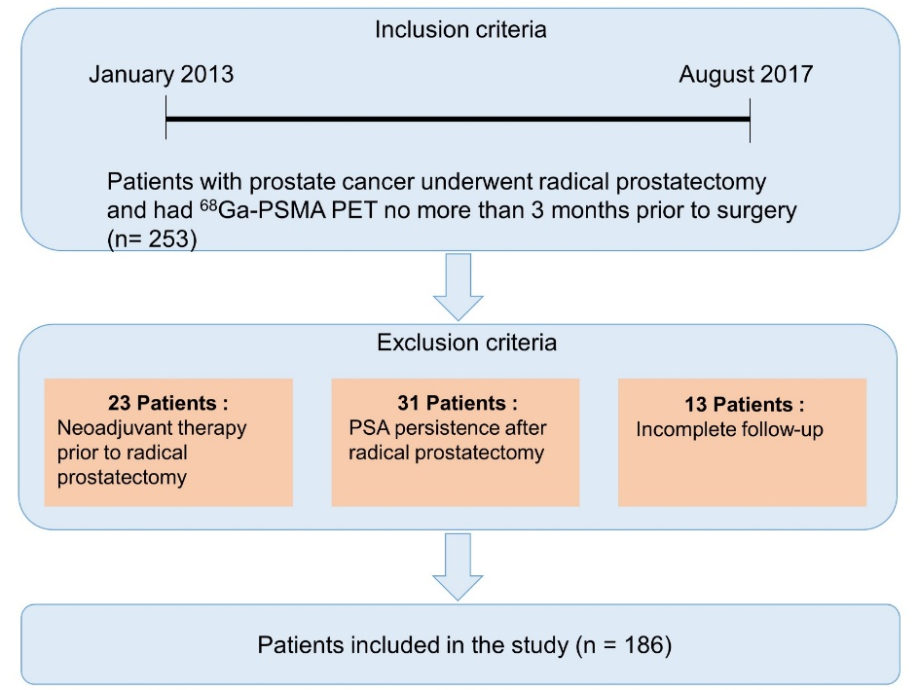

Supplementary Fig.2 Longer biochemical recurrence-free survival was associated with (A) pT=2, (B) pN=0, (C) Gleason Score < 8 and (D) negative surgical margin.

