SUPPLEMENTARY RESULTS
Converging Results using Ensemble Learning
We used gradient boosting algorithms because of their capabilities in terms of accuracy and interpretability. However, many data science competitions favor an ensemble machine learning framework, which enhances accuracy and robustness by training multiple algorithms and averaging their predictions. We implemented an ensemble learning approach and observed that the most accurate feature sets became slightly better at predicting current symptoms and longitudinal outcomes (Figure S8). Specifically, our ability to explain differences in current symptoms of general psychopathology was 31.9% with gradient boosting and 33.4% with ensemble learning, which was a statistically significant improvement (p = 0.04). However, model accuracy did not improve universally, as some feature sets performed worse with an ensemble machine learning framework. In particular, the cognitive and brain-based models of psychopathology yielded predictions that were negatively correlated with actual symptoms, indicating they were less accurate than simply using the mean symptom levels to predict individual differences (Figure S8). Consistent with our main results, the relative differences between feature sets did not change, as the rank ordering of the most important feature sets matched the results produced by gradient boosting.

Baseline-Adjusted Longitudinal Analyses
We conducted a series of sensitivity analyses to better understand the performance of our longitudinal models. First, we aimed to ensure that our results predicting future symptom severity were not driven by individual differences in symptoms at baseline. Accordingly, we modeled the relationship between baseline and future symptoms using linear regressions and extracted the residuals to capture variability in future symptoms that could not be explained by baseline symptom levels. Additional algorithms were optimized to predict these residuals, which we refer to as the baseline-adjusted future symptoms. Predictive accuracy was slightly lower across all models (R² > 0.13), except for the demographics model whose predictions were 2.3% more accurate, which was the highest of all the unimodal models (Figure S9). Biological sex had an even greater contribution to the predictive power of these models, as its Gini impurities were more than double the next best predictors, which was a summary score of social victimization (Figure S11).

Pairwise Correlations & Stepwise Selection
Next, we used pairwise correlations to understand how the performance of our predictive algorithms compared to simply using baseline symptoms to estimate longitudinal mental health outcomes. Baseline symptoms were negatively correlated with the rate of change across adolescence, and this relationship was stronger than any set of predictions that we derived for rate of change (Figure 7A). However, our multimodal model yielded predictions of future symptoms that were more strongly correlated than baseline symptoms (Figure 7B), indicating that these predictors tapped into a unique and useful source of variability beyond baseline symptoms. Lastly, we used bidirectional stepwise selection models to determine how much variability in longitudinal outcomes could be explained by using baseline symptoms and all sets of predictions from the unimodal models collectively. This multiple regression technique is designed to maximize the explained variance in the outcome variable while also excluding parameters that are redundant or do not contribute meaningfully. By leveraging this technique, we were able to demonstrate how combining predictions from different models enhances our understanding of longitudinal mental health outcomes, beyond simply using baseline symptoms (Figure S10). Stepwise regressions were able to explain 31% of the individual differences in the longitudinal rate of change, and the following parameters were not determined by to be useful based on bidirectional selection: cognition, functional MRI, and diffusion MRI. The stepwise regression for future symptom severity accounted for 23% of the individual differences and used all parameters, except for neurobiological features from all MRI sequences.

FIGURES
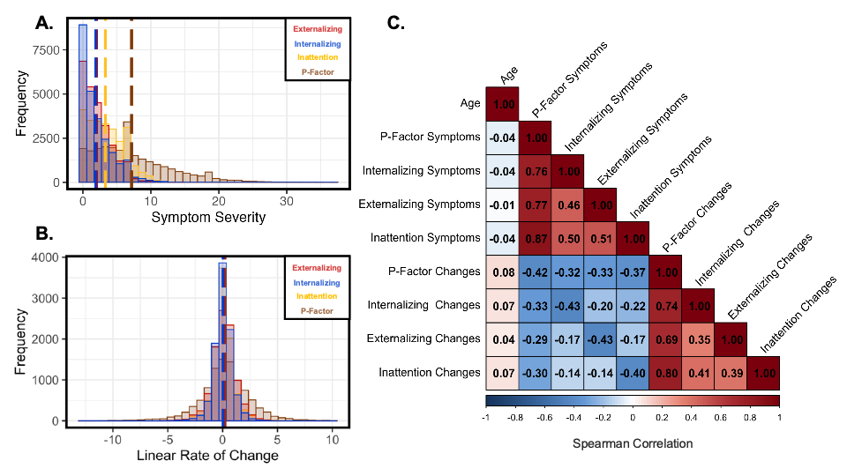Figure S1. Clinical characteristics of the ABCD sample. A) All dimensions of psychopathology were positively skewed with the majority of people in our sample exhibited low to subclinical symptoms. B) Changes in symptom severity was normally distributed with general psychopathology exhibiting the most variability across time. C) Symptom severity across all dimensions were moderate to strongly correlated (r > 0.46) as well as the rate of changes across all dimensions (r > 0.35). Baseline symptoms were inversely correlated with the longitudinal rates of change for all dimensions of psychopathology (r < -0.14). These results indicate the individuals who experience high symptom levels at baseline tend to exhibit less severe symptoms overtime.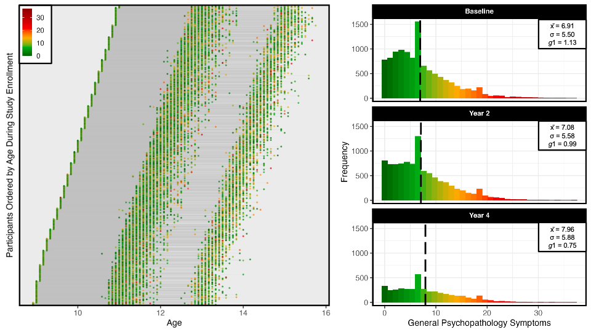Figure S2. Enrollment of ABCD data color coded by symptom severity of general psychopathology. Participants completed up to three waves of data from the ages of 9 – 16. In total, we have mental health data from 11,552 individuals who collectively completed 24,838 assessments, including 1,778 individuals who completed one timepoint, 6,262 completed two timepoints, and 3,512 completed all three timepoints. Each successive wave of data collection contained more symptoms of general psychopathology, which was reflected by higher symptoms on average and a distribution that was less positively skewed.

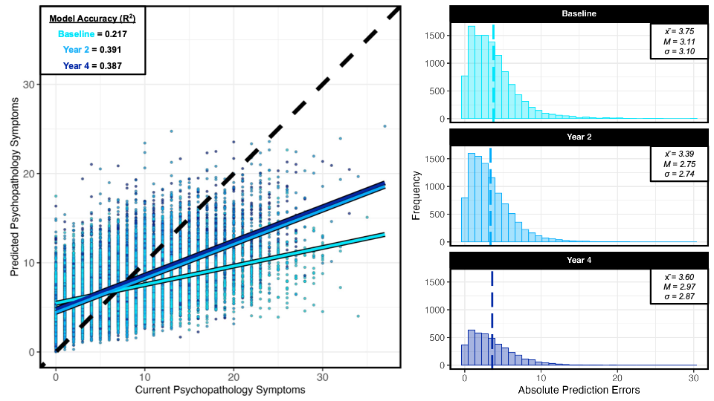
Figure S3. Accuracy of our models was lowest when predicting baseline symptoms of general psychopathology. Models were trained across all available timepoints but to better understand performance we evaluated the prediction errors across each wave of data. Accuracy was worst at baseline, but substantially better and consistent across the following two waves of data. This finding could be due to symptom severity being lower at baseline and more symptoms emerged in the following timepoints. Baseline also had more missing data, especially for the most important features (Peer Experiences Questionnaire), which may partly explain why predictive accuracy was the lowest at baseline.

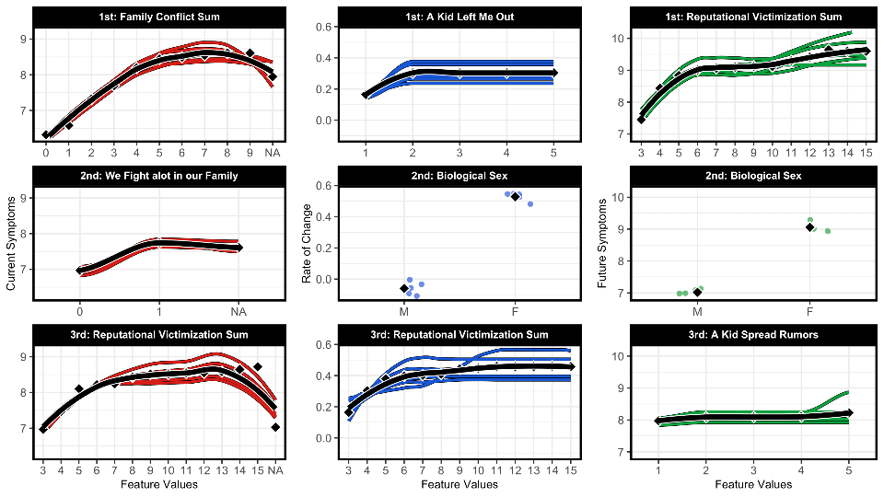Figure S4. Partial dependence plots for the three most important predictors of current symptoms, changes across time, and future symptoms. To better understand the magnitude and direction that each of the top predictors had on our models we used partial dependence analyses. Partial dependence analyses work by evaluating the effect of a single feature on the predictions of mental health, while keeping all other features constant, providing a clearer view of how changes in that specific feature influence the outcome. All of the top factors increased the risk of psychopathology, and sex-differences indicated females were predicted to have worse longitudinal outcomes relative to males. Results are color-coded depending on the target variable of interest with predictors of current symptoms represented in red, predictors of the rate of change in blue, and predictors of future symptoms in green. Colored lines represent the out-of-sample predictions for one of our five models, because we used nested 5-fold cross validation approach. The black lines display the mean across all five models.
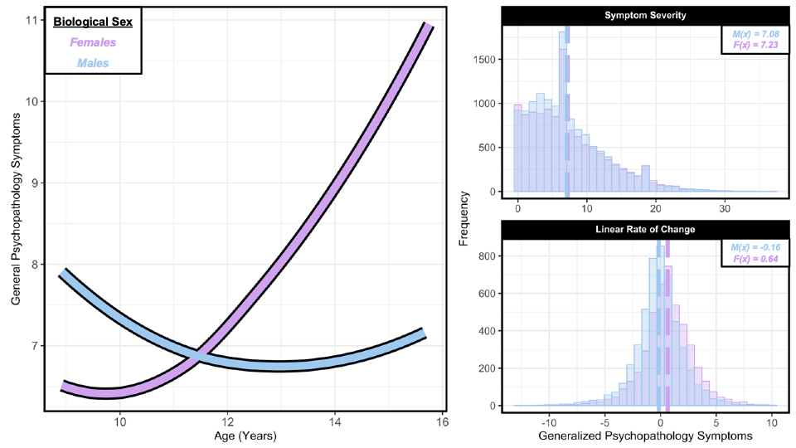
Figure S5. Pronounced sex-differences were found in the age-related changes of general psychopathology. Biological sex consistently emerged as a top predictor among our models predicting longitudinal outcomes. To further understand this potential difference, we evaluated the actual differences between males and females across current symptoms and changes overtime. Non-linear trajectories of psychopathology were illustrated using the locally estimated scatterplot smoothing method. The sex-differences were even more pronounced than the patterns that were learned by our model, as females exhibited greater symptoms on average and more severe symptoms overtime.
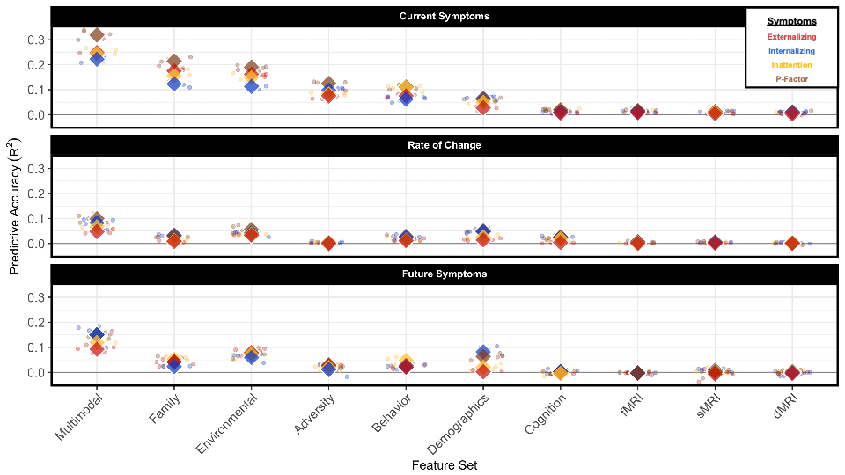 Figure S6. Predictive accuracy of general psychopathology and all domain-specific models varied greatly between feature sets and mental health targets. Results are color-coded depending on the dimension of psychopathology we aimed to predict. The colored dots represent the accuracy for a given out-of-sample split from one of our five models, because we used nested 5-fold cross validation approach. The average across all models is denoted by the colored diamonds. One key pattern in these results is that models predicting general psychopathology were almost always more accurate than the domain-specific models, especially when using all multimodal features. A key exception to this pattern was among the demographic models, as they appeared better at detecting individual differences in internalizing symptoms, especially when predicting future symptom severity.
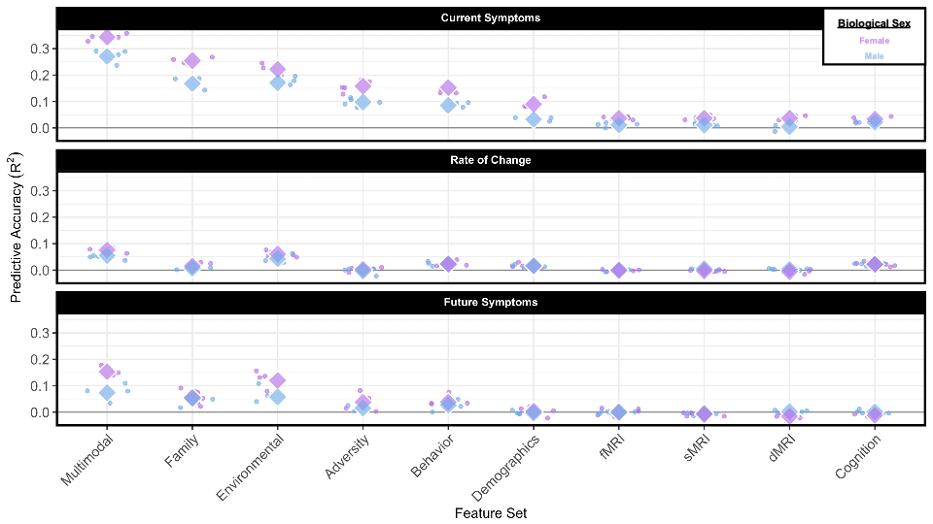Figure S7. Predictive accuracy differed greatly between males and females, as nearly all feature sets were able to derive more accurate predictions when trained and tested on females. Results are color-coded depending on whether models were developed and tested across males or females. The colored dots represent the accuracy for a given out-of-sample split from one of our five models, because we used nested 5-fold cross validation. The average across all models is denoted by the colored diamonds. Sex-differences were much better at detecting differences in females for almost all cases. These differences were most pronounced when predicting current and future symptom severity.
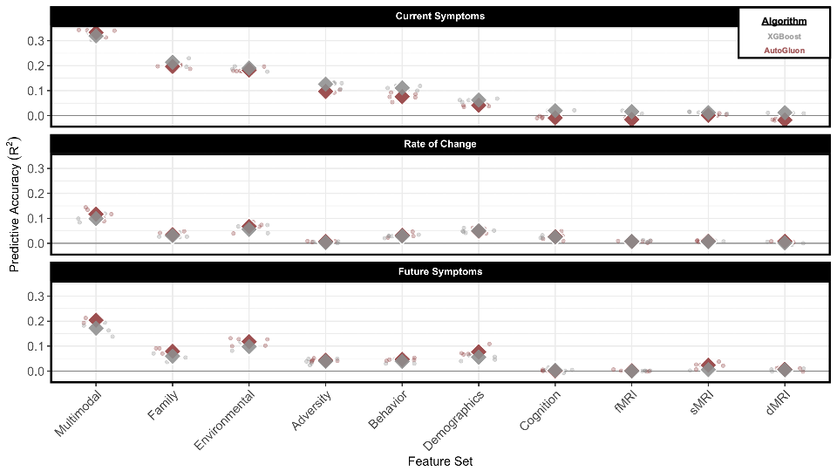Figure S8. Feature sets that were most accurate of psychopathology tended to become even better when using an ensemble machine learning framework, whereas the least accurate became worse. Results are color-coded depending on the machine learning framework we implemented to predict general psychopathology. The colored dots represent the accuracy for a given out-of-sample split from one of our five models, because we used nested 5-fold cross validation approach. The average across all models is denoted by the colored diamonds. AutoGluon is an AutoML package that optimizes a combination of tree-based and deep-learning algorithms and subsequently averages predictions from all models. This complex predictive model approach improved accuracy among our most important feature spaces. However, accuracy was worse among most of the cognitive and neurobiological features.

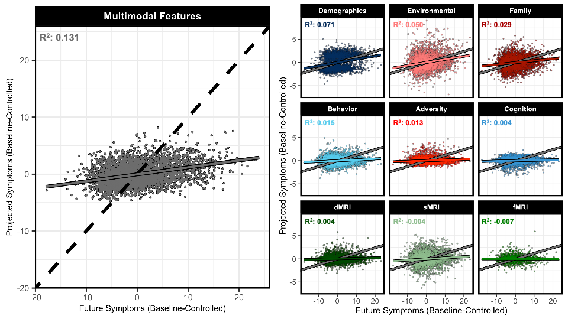Figure S9. Predictive accuracy was slightly worse when predicting baseline-adjusted future symptoms, except for models trained on demographic information. Each scatterplot displays the accuracy between the out-of-sample predictions and actual symptoms of general psychopathology at the last timepoint. Multimodal features derived the most accurate prediction as displayed by the solid gray line on the left. For perspective, the dashed black line represents a perfect correlation between predictions and symptoms. Each of the unimodal predictions are color coded and ordered from most to least accurate on the right. To compare the relative differences between the multimodal and unimodal models, the slope of the multimodal model is also displayed on the right, as shown by the solid gray lines.

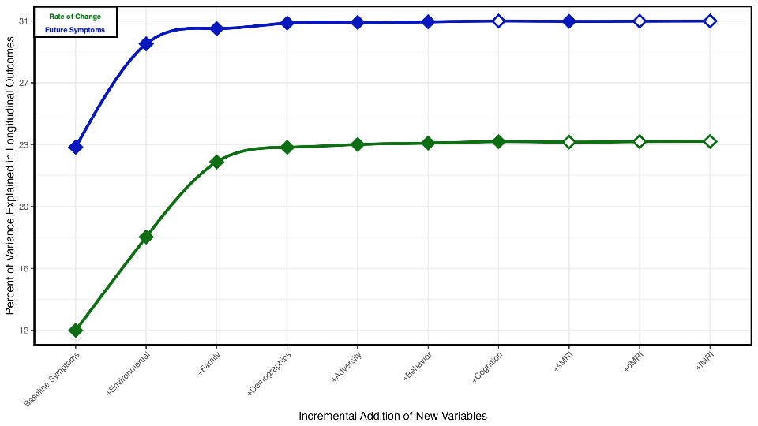Figure S10. Stepwise selection models were used to demonstrate how combining predictions from different models enhances our understanding of longitudinal outcomes, beyond simply using baseline symptoms. The largest gained in explainability of longitudinal outcomes was when using baseline symptoms and predictions from the environmental and family models. The final stepwise models accounted for 31% of the individual differences in the longitudinal rate of change and 23% of the variability in future symptoms. The variables or sets of predictions that did not meaningful contribute were a combination of cognitive and brain-based models, which were displayed by having an unfilled colored point.
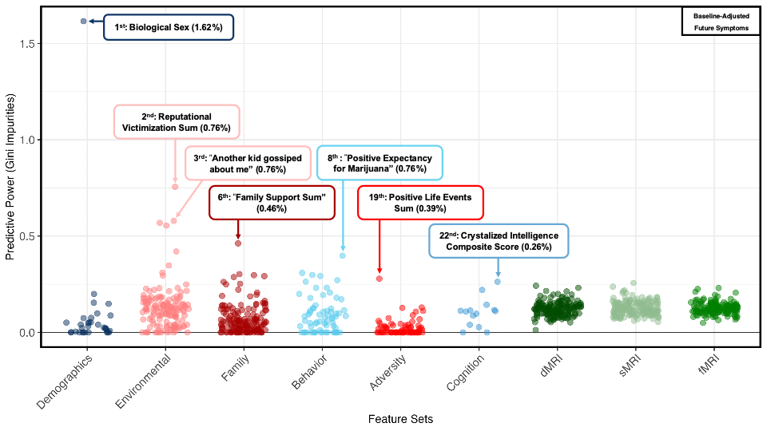 Figure S11. Biological sex was even more important in the prediction of baseline-adjusted future symptoms, followed by social victimization among peers. Models trained on demographic information were the most accurate of the unimodal models, and Gini impurities further suggest that biological sex was the key demographic feature that was used to derive accurate multimodal predictions. Further, biological sex was twice as important than the next set of key factors, which were related to social conflicts between peers in the environment.

TABLES
Table S1. Top ten predictors from the domain-specific models predicting current symptoms.
Feature Rank | Generalized Psychopathology | Inattention Symptoms | Externalizing Symptoms | Internalizing Symptoms
1st | FES - Family Conflict Sum | FES - Family Conflict Sum | FES - Family Conflict Sum | “We fight a lot in our family”
2nd | “We fight a lot in our family” | “We fight a lot in our family” | “We fight a lot in our family” | PEQ - Reputational Victimization Sum
3rd | PEQ - Reputational Victimization Sum | PMQ - Parent Monitoring Sum | PEQ - Overt Aggression Sum | PEQ - Relational Victimization Sum
4th | “Family members often criticize each other” | “Usually, school bores me” | “I threatened to hurt or beat up another kid” | “Parents argued more than previously”
5th | PMQ - Parent Monitoring Sum | CRBI – Parent Acceptance Sum | PEQ - Reputational Aggression Sum | FES - Family Conflict Sum
6th | “Usually, school bores me” | PEQ – Overt Victimization Sum | “Usually, school bores me” | “Family member had mental/emotional problem”
7th | PEQ - Relational Victimization Sum | PEQ - Reputational Victimization Sum | CRBI – Parent Acceptance Sum | “Family members often criticize each other”
8th | “Caregiver is easy to talk to” | “Caregiver is easy to talk to” | PMQ - Parent Monitoring Sum | “Lost a close friend”
9th | PEQ – Overt Victimization Sum | PEQ - Relational Victimization Sum | PEQ - Reputational Victimization Sum | “Caregiver is easy to talk to”
10th | “Parents argued more than previously” | “Lost a close friend” | PEQ - Relational Aggression Sum | Homosexual Identity
Notes. The rank ordering shown above are based on which ten features that had the largest mean Gini impurities across our multimodal models predicting current symptoms from a unique dimension of psychopathology.
Table S2. Top ten predictors from the domain-specific models predicting the rate of change in symptom severity.
Feature Rank | Generalized Psychopathology | Inattention Symptoms | Externalizing Symptoms | Internalizing Symptoms
1st | “A kid left me out of what they were doing” | “A kid left me out of what they were doing” | PEQ - Reputational Aggression Sum | Biological Sex
2nd | Biological Sex | PEQ - Reputational Victimization Sum | PEQ - Reputational Victimization Sum | “A kid left me out of what they were doing”
3rd | PEQ - Reputational Victimization Sum | PEQ - Relational Aggression Sum | Biological Sex | PEQ - Relational Aggression Sum
4th | “I left another kid out of what I was doing” | Biological Sex | PEQ - Reputational Aggression Sum | Age-Adjusted Crystalized Intelligence
5th | PEQ - Relational Victimization Sum | PEQ - Relational Victimization Sum | PEQ - Overt Aggression Sum | “A kid tried to damage my social reputation”
6th | PEQ - Relational Aggression Sum | “Sometime kids left me out of an activity or conversation” | “A kid tried to damage my social reputation by spreading rumors” | PEQ - Relational Victimization Sum
7th | “A kid tried to damage my social reputation by spreading rumors” | WISCV Total Raw Score | “I threatened to hurt or beat up another kid” | FES - Family Conflict Sum
8th | “Another kid gossiped about me so others would not like me” | Age-Adjusted Crystalized Intelligence | “Have you had a bad experience with the police” | “Some kids left me out of an activity or conversation”
9th | Age-Adjusted Crystalized Intelligence | “I left another kid out of what I was doing” | PEQ - Relational Victimization Sum | MACV- Family Referent Sum
10th | Mormon Religion | “Another kid gossiped about me so others would not like me” | “Family members sometime hit each other” | “How often do your parents know where you are”
Notes. The rank ordering shown above are based on which ten features that had the largest mean Gini impurities across our multimodal models predicting the rate of change for a unique dimension of psychopathology.

Table S3. Top ten predictors from the domain-specific models predicting future symptoms.
Feature Rank | Generalized Psychopathology | Inattention Symptoms | Externalizing Symptoms | Internalizing Symptoms
1st | PEQ - Reputational Victimization Sum | PEQ - Reputational Victimization Sum | PEQ - Reputational Victimization Sum | Biological Sex
2nd | Biological Sex | PEQ - Relational Victimization Sum | “I threatened to hurt or beat up another kid” | PEQ - Reputational Victimization Sum
3rd | “A kid tried to damage my social reputation by spreading rumors” | School Grades Last Year | PEQ - Overt Aggression Sum | ADI - Neighborhood Disadvantage Score
4th | SRFP - School Involvement Sum | SRFP - School Involvement Sum | SRFP - School Involvement Sum | PEQ - Relational Victimization Sum
5th | PEQ - Relational Victimization Sum | “Usually, school bores me” | “Have you had a bad experience with the police” | MEEQ – Positive Expectancies for Marijuana Sum
6th | “Have you had a bad experience with the police” | FES – Family Organization Sum | FES - Family Conflict Sum | “Marijuana helps a person relax”
7th | PMQ - Parent Monitoring Sum | Biological Sex | “We fight a lot in our family” | “Have you had a bad experience with the police”
8th | “In an average week, how many times do you and your parents eat dinner together” | PBP –Prosocial Peers Involvement Sum | PEQ - Relational Aggression Sum | “Family member had mental/emotional problem”
9th | “Usually, school bores me” | PMQ - Parent Monitoring Sum | Brain Volume of Right Insula | “Parent has a problem with alcohol”
10th | PBP –Prosocial Peers Involvement Sum | “I get along with my teachers” | “I like school because I do well in class” | “Caregiver went to doctor/therapist due to emotional/mental problems”
Notes. The rank ordering shown above are based on which ten features that had the largest mean Gini impurities across our multimodal models predicting future symptom severity for a unique dimension of psychopathology.

Target | Feature Rank | Entire Sample |  | Males |  | Females
Current Symptoms | 1st | FES - Family Conflict Sum | FES - Family Conflict Sum |  | FES - Family Conflict Sum
 | 2nd | “We fight a lot in our family” | “We fight a lot in our family” |  | “We fight a lot in our family”
 | 3rd | PEQ - Reputational Victimization Sum | PMQ - Parent Monitoring Sum |  | PEQ - Overt Victimization Sum
 | 4th | “Family members often criticize each other” | PEQ - Reputational Victimization Sum |  | PEQ - Reputational Victimization Sum
 | 5th | PMQ - Parent Monitoring Sum | PEQ - Relational Victimization Sum |  | PEQ - Relational Victimization Sum
Rate of Change | 1st | “A kid left me out of what they were doing” | “I left another kid out of what I was doing” |  | “A kid left me out of what they were doing”
 | 2nd | Biological Sex | PEQ - Relational Aggression Sum |  | PEQ - Reputational Victimization Sum
 | 3rd | PEQ - Reputational Victimization Sum | Age-Adjusted Crystalized Intelligence |  | “A kid tried to damage my social reputation by spreading rumors”
 | 4th | “I left another kid out of what I was doing” | PEQ - Relational Victimization Sum |  | “Another kid gossiped about me so others would not like me”
 | 5th | PEQ - Relational Victimization Sum | Black Racial Identity |  | Age-Adjusted Crystalized Intelligence
Future Symptoms | 1st | PEQ - Reputational Victimization Sum | PEQ - Reputational Victimization Sum |  | PEQ - Reputational Victimization Sum
 | 2nd | Biological Sex | “I threatened to hurt or beat up another kid” |  | PEQ - Relational Victimization Sum
 | 3rd | “A kid tried to damage my social reputation by spreading rumors” | PMQ - Parent Monitoring Sum |  | “Another kid gossiped about me so others would not like me”
 | 4th | SRFP - School Involvement Sum | SRFP - School Involvement Sum |  | “A kid tried to damage my social reputation by spreading rumors”
 | 5th | PEQ - Relational Victimization Sum | “Usually, school bores me” |  | “Marijuana helps a person relax”
Table S4. Top five predictors of the sex-specific models predicting general psychopathology.
Notes. The rank ordering shown above are based on which five features that had the largest mean Gini impurities across our multimodal sex-specific models that predict general psychopathology at a certain timepoint or across all timepoints.

Variable of Interest | Entire Sample  (n = 24,838) | Males (n = 12,970) | Females (n = 11,868) | Significance Testing
Age (Years) | 11.44 (1.66) | 11.46 (1.67) | 11.44 (1.66) | 0.001 (p = 0.459)
Family Income (Stratified) | 7.51 (2.30) | 7.51 (2.32) | 7.52 (2.29) | 0.002 (p = 0.874)
Summary Score of Family Conflict | 1.99 (1.92) | 2.04 (1.90) | 1.93 (1.94) | 0.056 (p < 0.001)
“We fight a lot in our family” | 0.16 (0.37) | 0.16 (0.37) | 0.15 (0.36) | 0.001 (p = 0.467)
Reputational Victimization | 3.89 (1.72) | 3.75 (1.59) | 4.04 (1.82) | 0.166 (p < 0.001)
Relational Victimization | 4.62 (1.87) | 4.49 (1.76) | 4.75 (1.96) | 0.138 (p < 0.001)
Reputational Aggression | 3.15 (0.63) | 3.16 (0.62) | 3.15 (0.64) | 0.001(p = 0.398)
Relational Aggression | 3.84 (1.25) | 3.89 (1.28) | 3.79 (1.22) | 0.085 (p < 0.001)
Inattention Symptoms | 3.29 (2.63) | 3.38 (2.62) | 3.18 (2.65) | 0.076 (p < 0.001)
Internalizing Symptoms | 1.87 (2.22) | 1.64 (2.05) | 2.12 (2.36) | 0.216 (p < 0.001)
Externalizing Symptoms | 1.99 (1.98) | 2.05 (2.02) | 1.92 (1.94) | 0.063 (p < 0.001)
General Psychopathology | 7.15 (5.61) | 7.08 (5.49) | 7.23 (5.73) | 0.027 (p = 0.035)
Table S5. Sample demographics, clinical characteristics, and key predictors.
Notes. The mean and standard deviation are reported for each numerical variable above. Cohen’s d was used to quantify the magnitude of the differences between males and females and Welch two sample t-test was used to measure whether such differences were statistically significant.

