Supplementary Materials for

Types of Subducted Material Controlling Tethyan Porphyry Copper Mineralization

Hua-Wei Li^{1, 2}, Zhi-Ming Yang^{1,} *, Yong-Jun Lu^{3, 4}, Zeng-Qian Hou¹
¹ State Key Laboratory of Deep Earth and Mineral Exploration, Institute of Geology, Chinese Academy of Geological Sciences, Beijing, China.
² School of Earth and Space Sciences, Peking University, Beijing, China.
³ RSC Global Pty Ltd, West Perth, Australia.
⁴ Centre for Exploration Targeting, School of Earth and Oceans, University of Western Australia, Crawley, Australia.
* Corresponding author. Email: zm.yang@hotmail.com (Zhi-Ming Yang)
This PDF file includes:
Supplementary Text
Supplementary Figs. 1 to 3
References (1–39)

Supplementary Text
The evolution of Neo-Tethys Ocean
The splitting up of Cimmerian terranes (mainly including Indochina, Sibumasu, South Qiangtang, Lhasa terranes, Afghan, and Central Iran) from Gondwana during Late Carboniferous to Early Permian marked the opening of the Neo-Tethys Ocean (Supplementary Fig. 1a) ^{1–6}. The opening of the Neo-Tethys Ocean co-occurs from west to east, but each terrane has a different drift and subduction history, eventually, the Indian, Arabian, and African continents collided with the Eurasian continent (Supplementary Fig. 1b–c) ^{7,8}.
The Eastern Tethys (Himalayas–Indochina). The Lhasa and South Qiangtang had different drifting processes, thus, there are two branches of the Neo-Tethys Ocean in this region: The Bangong-Nujiang Ocean and the Yarlung-Tsangpo Ocean in the north and south of the Lhasa terrane, respectively ^{9,10}. The Bangong-Nujiang Ocean began to subduct southward in the Middle Permian (or earlier) and subduct northward in the Middle-Late Triassic, eventually, the Lhasa terrane diachronously collided with the South Qiangtang terrane during the latest Jurassic- Early Cretaceous (ca. 150–130 Ma, earlier in the east and later in the west), leading to the closure of Bangong-Nujiang Ocean ¹¹. The northward subduction of the Yarlung-Tsangpo Ocean can be traced back to the Late Triassic ¹². The Indian continent drifted northward and eventually collided with the Lhasa terrane and West Burma terrane in the Paleocene–Early Eocene (ca. 65~50 Ma), which led to the gradual closure of the Neo-Tethys Ocean ^{7,8,13–17}.
The Central Tethys (Turkey, the Lesser Caucasus, Iran, western Pakistan). The initial subduction of the Neo-Tethys ocean in Turkey started in the Early Jurassic, generating Jurassic-Late Cretaceous Pontides granitoids ^{18,19}. In the late Paleocene- Early Eocene, Anatolide-Tauride collided with Pontides along the Izmir–Ankara–Erzincan suture. Eventually, the Arabian continent collided with Anatolide-Tauride along the Bitlis-Zagros suture in the Late Eocene–Early Miocene ^{20,18,19}. The subduction of a northern branch of the Neo-Tethys Ocean in the Lesser Caucasus region (Armenia and Azerbaijan) occurred during the Jurassic–Cretaceous, subsequently, the South Armenia block collided with Eurasia in the Late Cretaceous (73~71 Ma) or Paleocene and was followed by final Arabia-Eurasia collision during the late Eocene to early Oligocene ^{20,18,19}. The subduction of the Neo-Tethys Ocean in Iran started in the Late Triassic- Early Jurassic and formed a large-scale magmatic arc unital the collision between Arabian and Eurasian continents during the Late Eocene–Oligocene ^{8,21,22}. The Late Cretaceous–Late Paleocene magmas in the Chagai area of Pakistan are characterized by an oceanic island arc and then transformed to a continental arc after colliding with the Afghan plate in the Eocene-Oligocene ^{23,24}.
The Western Tethys (Carpathians and Balkans/Southeast Europe). The subduction of the Vardar Ocean, a branch of the Neo-Tethys Ocean, started in the Early Jurassic, forming the Jurassic-Cretaceous arc magmas. The Vardar Ocean closed in the Late Cretaceous–Paleogene and then turned into a collisional setting ^{25–27}.
Porphyry copper deposits in the Neo-Tethys domain
A compiled porphyry deposit database including deposit name, location, age, tonnages, resources, and grades are listed in Supplementary Table 1.
There are over one hundred porphyry Cu deposits related to the Neo-Tethys evolution (Fig. 1). They are located in several ore belts/districts, including Southeast Europe, Turkey, Lesser Caucasus, Iran, Pakistan, Tibet, and Indochina (Fig. 1). According to their metallogenic ages and Tethyan evolution, porphyry Cu deposits in the Tethys domain can be classified as subduction-related and collision-related.
In Southeast Europe, major porphyry Cu deposits were formed during two periods of Cretaceous and Cenozoic magmatism. The Cretaceous porphyry deposits, dominated by Cu-Au mineralization, are related to the Neo-Tethys subduction, mainly formed at 93–83 Ma, representative by giant Bor, Majdanpek, and Veliki Krivelj in Serbia ²⁸. The Cenozoic collision-related porphyry Cu- Au- Mo deposits mainly occurred at 36–8 Ma, such as Recsk in Hungary and Rosia Poieni in Romania ²⁸.
Turkey developed two metallogenic belts, Pontides in the north and Anatolides in the south. The porphyry deposits in the Pontides belt are mainly Cu and Cu–Mo mineralization related to northward oceanic subduction during the Cretaceous and Paleocene, such as Derekoy, Konak and Hüyüklü ^{19,29,30}. The porphyry deposits in the Anatolides belt are characterized by Cu–Mo–Au mineralization, such as Tepeköy Cu–Au, Kisladag Au, and Ardala Cu–Mo–Au. These deposits were formed after the collision between the Pontides and Tauride–Anatolide platform during the Paleocene–Early Eocene ^{18,28,30}.
Three metallogenic events have been recognized in the Lesser Caucasus. The Late Jurassic–Early Cretaceous porphyry Cu deposits in the Somkheto–Karabagh belt are related to the subduction of a northern branch of the Neo-Tethys Ocean, the Eocene porphyry Cu–Mo deposits are attributed to the final subduction of the southern branch of Neo-Tethys Ocean, and the Oligocene–Miocene porphyry Cu deposits are linked to post-collision magmatism ^{31–33}.
The majority of porphyry Cu–Mo deposits in Iran are collision-related and located in the Urumieh– Dokhtar magmatic arc, also known as the Arasbaran–Kerman belt, such as giant Sungun, Meiduk and Sar Cheshmeh ^{21,34}. The metallogenesis has consistently occurred at 28– 7 Ma ²¹. Only one Eocene porphyry Cu-Mo (Kal-e-kaf) has developed in Central Iran ³⁵.
Porphyry Cu deposits in Pakistan are located in Chagai, such as Reko Diq, Saindak, and Dasht-e-Kain. They are subduction-related and formed at 24–10 Ma ^{23,24}.
Porphyry deposits in Tibet are related to three major magmatic suites: Jurassic Xiongcun porphyry Cu–Au deposit is linked to the northward subduction of the Yarlung–Tsangpo Ocean ³⁶. Given that the Bangong–Nujiang Ocean closed in the latest Jurassic–Early Cretaceous (ca. 150–130 Ma), porphyry Cu-Au deposits (~120 Ma) in the Bangong belt are inferred to have been generated during the collision between the Lhasa and South Qiangtang terranes rather than the oceanic subduction ¹¹. The Cenozoic post-collision porphyry Cu deposits in Tibet are mainly developed in the Gangdese belt and Yulong belt. The metallogenic ages of Gangdese deposits are 50–13 Ma, concentrated in the Miocene, such as giant Qulong, Jiama, Zhunuo, and a series of moderate–small porphyry Cu deposits ³⁷. Deposits in the Yulong belt are mainly formed at 43–35 Ma ³⁷. There are also several small-sized Eocene porphyry Cu–Mo–Au deposits in the Ailaoshan-Red River belt ³⁷.
Shangalon porphyry Cu–Au deposit in West Burma is formed in the Eocene (~39 Ma) in a collisional setting ¹⁷.
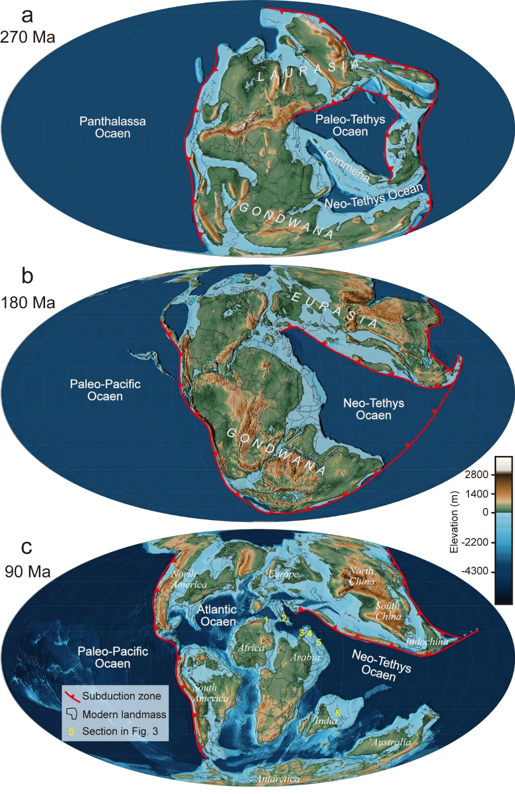

Supplementary Fig. 1.
Paleogeographic reconstruction ³⁸ of the Neo-Tethyan ocean basin during the Permian, Jurassic, and Cretaceous.
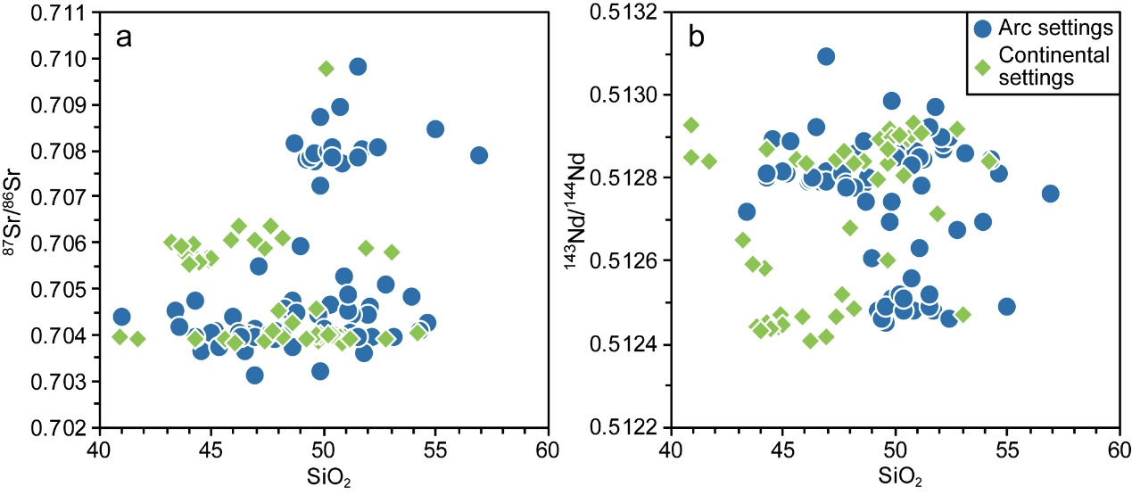

Supplementary Fig. 2.
Diagrams of whole-rock ⁸⁷Sr/⁸⁶Sr and ¹⁴³Nd/¹⁴⁴Nd ratios versus SiO₂ contents for mafic rocks from the Tethyan belt. a, Whole-rock ⁸⁷Sr/⁸⁶Sr versus SiO₂; b, Whole-rock ¹⁴³Nd/¹⁴⁴Nd versus SiO₂.

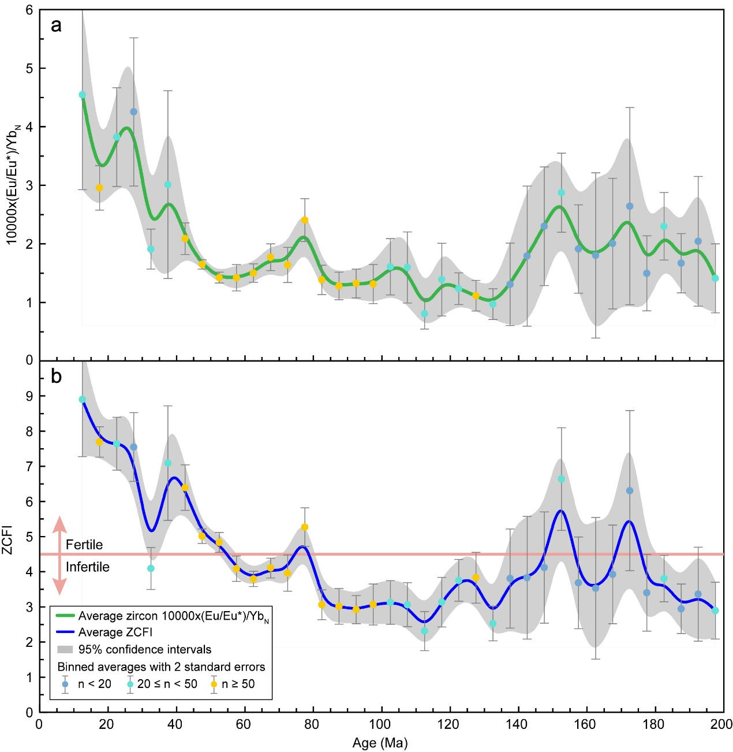

Supplementary Fig. 3.
Variation of zircon trace element indicators of hydration and oxidation state. (A) Zircon 10000×(Eu/Eu*) /Yb_{N} variation over time, presented as binned averages with a bin size of 5 Myr; (B) The variation of ZCFI (zircon copper fertility index) over time, presented as binned averages with a bin size of 5 Myr, ZCFI = 10000 × (Eu/Eu*) /Yb_{N} + 5 Ce/√ (U_{i} × Ti) ³⁹.

References
1. Wan, B. et al. Cyclical one-way continental rupture-drift in the Tethyan evolution: Subduction-driven plate tectonics. Sci. China Earth Sci. 62, 2005–2016 (2019).
2. Şengör, A. M. C. Plate tectonics and orogenic research after 25 years: a Tethyan perspective. Earth-Sci. Rev. 27, 1–201 (1990).
3. Stampfli, G. M. & Borel, G. D. A plate tectonic model for the Paleozoic and Mesozoic constrained by dynamic plate boundaries and restored synthetic oceanic isochrons. Earth Planet. Sci. Lett. 196, 17–33 (2002).
4. Li, Z.-H., Cui, F., Yang, S. & Zhong, X. Key geodynamic processes and driving forces of Tethyan evolution. Sci. China Earth Sci. 66, 2666–2685 (2023).
5. Zhao, G. et al. Geological reconstructions of the East Asian blocks: From the breakup of Rodinia to the assembly of Pangea. Earth-Sci. Rev. 186, 262–286 (2018).
6. Stampfli, G. M. Tethyan oceans. Geol. Soc. Lond. Spec. Publ. 173, 1–23 (2000).
7. Wu, F., Wan, B., Zhao, L., Xiao, W. & Zhu, R. Tethyan geodynamics. Acta Petrol. Sin. 36, 1627–1674 (2020).
8. Zhu, R., Zhao, P. & Zhao, L. Tectonic evolution and geodynamics of the Neo-Tethys Ocean. Sci. China Earth Sci. 65, 1–24 (2022).
9. Zhu, D.-C. et al. The Lhasa Terrane: Record of a microcontinent and its histories of drift and growth. Earth Planet. Sci. Lett. 301, 241–255 (2011).
10. Zhu, D.-C. et al. The origin and pre-Cenozoic evolution of the Tibetan Plateau. Gondwana Res. 23, 1429–1454 (2013).
11. Hu, X. et al. Exploring a lost ocean in the Tibetan Plateau: Birth, growth, and demise of the Bangong-Nujiang Ocean. Earth-Sci. Rev. 229, 104031 (2022).
12. Ji, W.-Q., Wu, F.-Y., Chung, S.-L., Li, J.-X. & Liu, C.-Z. Zircon U–Pb geochronology and Hf isotopic constraints on petrogenesis of the Gangdese batholith, southern Tibet. Chem. Geol. 262, 229–245 (2009).
13. Wu, F.-Y. et al. Zircon U–Pb and Hf isotopic constraints on the onset time of India-Asia collision. Am. J. Sci. 314, 548–579 (2014).
14. Hu, X., Garzanti, E., Moore, T. & Raffi, I. Direct stratigraphic dating of India-Asia collision onset at the Selandian (middle Paleocene, 59 ± 1 Ma). Geology 43, 859–862 (2015).
15. Zhu, D.-C. et al. Magmatic record of India-Asia collision. Sci. Rep. 5, 14289 (2015).
16. Westerweel, J. et al. Burma Terrane part of the Trans-Tethyan arc during collision with India according to palaeomagnetic data. Nat. Geosci. 12, 863–868 (2019).
17. Li, J.-X. et al. Mesozoic-Cenozoic tectonic evolution and metallogeny in Myanmar: Evidence from zircon/cassiterite U–Pb and molybdenite Re–Os geochronology. Ore Geol. Rev. 102, 829–845 (2018).
18. Yigit, O. Gold in Turkey—a missing link in Tethyan metallogeny. Ore Geol. Rev. 28, 147–179 (2006).
19. Yigit, O. Mineral deposits of Turkey in relation to Tethyan metallogeny: implications for future mineral exploration. Econ. Geol. 104, 19–51 (2009).
20. Richards, J. P. Tectonic, magmatic, and metallogenic evolution of the Tethyan orogen: from subduction to collision. Ore Geol. Rev. 70, 323–345 (2015).
21. Aghazadeh, M., Hou, Z., Badrzadeh, Z. & Zhou, L. Temporal–spatial distribution and tectonic setting of porphyry copper deposits in Iran: Constraints from zircon U–Pb and molybdenite Re–Os geochronology. Ore Geol. Rev. 70, 385–406 (2015).
22. Zhang, H. & Hou, Z. Metallogenesis within continental collision zones: Comparisons of modern collisional orogens. Sci. China Earth Sci. 61, 1737–1760 (2018).
23. Richards, J. P., Spell, T., Rameh, E., Razique, A. & Fletcher, T. High Sr/Y magmas reflect arc maturity, high magmatic water content, and porphyry Cu ± Mo ± Au potential: examples from the Tethyan arcs of central and eastern Iran and western Pakistan. Econ. Geol. 107, 295–332 (2012).
24. Perelló, J., Razique, A., Schloderer, J., & Asad-ur-Rehman. The Chagai porphyry copper belt, Baluchistan Province, Pakistan. Econ. Geol. 103, 1583–1612 (2008).
25. Krstekanić, N. et al. Analogue modelling of strain partitioning along a curved strike-slip fault system during backarc-convex orocline formation: Implications for the Cerna-Timok fault system of the Carpatho-Balkanides. J. Struct. Geol. 149, 104386 (2021).
26. Mațenco, L. Tectonics and exhumation of Romanian Carpathians: inferences from kinematic and thermochronological studies. in Landform Dynamics and Evolution in Romania (eds. Radoane, M. & Vespremeanu-Stroe, A.) 15–56 (Springer International Publishing, Cham, 2017). doi:10.1007/978-3-319-32589-7_2.
27. Robertson, A. H. F., Trivić, B., Đerić, N. & Bucur, I. I. Tectonic development of the Vardar ocean and its margins: Evidence from the Republic of Macedonia and Greek Macedonia. Tectonophysics 595–596, 25–54 (2013).
28. Baker, T. Gold ± copper endowment and deposit diversity in the western Tethyan magmatic belt, southeast Europe: implications for exploration. Econ. Geol. 114, 1237–1250 (2019).
29. Delibas, O., Moritz, R., Selby, D., Göç, D. & Revan, M. K. Multiple porphyry Cu-Mo events in the eastern Pontides metallogenic belt, Turkey: from early Cretaceous subduction to Eocene postcollision evolution. Econ. Geol. 114, 1285–1300 (2019).
30. Kuşcu, İ. Episodic porphyry Cu (-Mo-Au) formation and associated magmatic evolution in Turkish Tethyan collage. Ore Geol. Rev. 107, 119–154 (2019).
31. Hovakimyan, S., Moritz, R., Tayan, R., Melkonyan, R. & Harutyunyan, M. Cenozoic strike-slip tectonics and structural controls of porphyry Cu-Mo and epithermal deposits during geodynamic evolution of the southernmost Lesser Caucasus, Tethyan metallogenic belt. Econ. Geol. 114, 1301–1337 (2019).
32. Moritz, R. et al. Metallogeny of the Lesser Caucasus: from arc construction to postcollision evolution. Soc. Econ. Geol. Spec. Publ. 19, 157–192 (2016).
33. Rezeau, H., Moritz, R., Wotzlaw, J.-F., Hovakimyan, S. & Tayan, R. Zircon petrochronology of the Meghri-Ordubad pluton, Lesser Caucasus: fingerprinting igneous processes and implications for the exploration of porphyry Cu-Mo deposits. Econ. Geol. 114, 1365–1388 (2019).
34. Hou, Z. & Zhang, H. Geodynamics and metallogeny of the eastern Tethyan metallogenic domain. Ore Geol. Rev. 70, 346–384 (2015).
35. Richards, J. P. & Sholeh, A. The Tethyan tectonic history and Cu-Au metallogeny of Iran. Soc. Econ. Geol. Spec. Publ. 19, 193–212 (2016).
36. Tang, J. et al. Geological characteristics and genesis of the Jurassic No. I porphyry Cu–Au deposit in the Xiongcun district, Gangdese porphyry copper belt, Tibet. Ore Geol. Rev. 70, 438–456 (2015).
37. Yang, Z. & Cao, K. Post-collisional porphyry copper deposits in Tibet: an overview. Earth-Sci. Rev. 258, 104954 (2024).
38. Scotese, C. R. An atlas of Phanerozoic paleogeographic maps: the seas come in and the seas go ou. Annu. Rev. Earth Planet. Sci. 49, 679–728 (2021).
39. Loucks, R. R., Henríquez, G. J. & Fiorentini, M. L. Zircon and whole-rock trace element indicators of magmatic hydration state and oxidation state discriminate copper ore-forming from barren arc magmas. Econ. Geol. 119, 511–523 (2024).

