Supplementary Material

Predicting future regional tau accumulation in asymptomatic and early Alzheimer’s disease

Authors: Joseph Giorgio, William J, Jagust, Suzanne Baker, Susan M. Landau, Peter Tino, Zoe Kourtzi, for the Alzheimer’s Disease Neuroimaging Initiative

Supplementary Methods
Generalised Matrix Learning Vector Quantisation
Learning Vector Quantisation (LVQ)
Learning Vector Quantisation (LVQ) comprises classifiers that operate in a supervised manner to iteratively modify class-specific prototypes to find boundaries of discrete classes. In particular, LVQ classifiers are defined by a set of vectors (prototypes) that represent classes within the input space. These prototypes are updated iteratively throughout the training phase, resulting in changes in class boundaries. For each training example, the closest prototype for each class is determined. These prototypes are then updated so that the closest prototype representing the same class as the input example is moved towards the input example and those representing different classes are moved further away.
Training data sample of size n is denoted by $\left(x_{i},y_{i}\right) ∈ R^{m} ×\left\{1,…, K\right\}, i=1,2,…,n$, where m denotes data dimensionality and K the number of different classes. In this instance the LVQ network comprises L prototypes $w_{q}∈ R^{m}, q=1,2,…,L$defined by their location in the input space and their class label $c\left(w_{q}\right) ∈\left\{1,…,K\right\}.$
Prototypes are adapted automatically throughout training so that distances between points of class $c∈\left\{1,…,K\right\}$ and their corresponding prototypes sharing the same label c is minimised, while keeping the prototypes of other classes as far as possible. Classification is then performed on test data based on a winner-takes-all process, whereby a previously unseen input vector $x_{i} ∈ R^{m}$ is assigned the class label $c\left(w_{q}\right)$ of the closest prototype $\left(w_{q}\right)$.
The Generalised Matrix LVQ (GMLVQ)
The Generalised Matrix LVQ (GMLVQ) (Schneider, Biehl, & Hammer, 2009) extends the LVQ utilising a full metric-tensor for a more robust (with respect to the classification task) distance measure in the input space. To do this, the metric tensor induces feature scaling in its diagonal elements, while accounting for task conditional interactions between pairs of features (co-ordinates of the input space).
Given a positive definite matrix $Λ$, $Λ ≻0$, the generalised form of the squared distance is calculated as
$d_{Λ}\left(x,w\right)={(x-w)}^{T}Λ(x-w)$.
Positive definiteness of $Λ$ can be ensured by defining $Λ=Ω^{T}Ω$ where $Ω ∈ R^{m ×m}$ is a full rank matrix. Note that only relative distances of input points to the prototypes are important. Hence, the metric tensor can be multiplied by any positive real number without effecting the classifier performance in any way. To account for this inherently ill-posed nature of the model fitting and hence to ensure the stability of the algorithm, $Λ$ must be normalised following each learning step e.g. by making sure that $\sum_{i}{Λ_{i,i}=1}$, fixing the trace throughout learning.
Using the steepest descent method, the cost function to be minimised through online learning is
$$f_{GMLVQ}=\sum_{i=1}^{n}{φ\left(μ_{Λ}(x_{i})\right)}$$
where
$$μ_{Λ}\left(x_{i}\right)=\frac{d_{Λ}\left(x_{i},w^{+}\right)-d_{Λ}\left(x_{i},w^{-}\right)}{d_{Λ}\left(x_{i},w^{+}\right)+d_{Λ}\left(x_{i},w^{-}\right)}$$
In this instance $φ$ is a monotonic identity function$φ\left(l\right)=l$, $d_{Λ}\left(x_{i},w^{+}\right)$ is the distance between the sample vector $x_{i}$ from the closest prototype with the same class label ${c(w)}^{+}={c(x}_{i})$ and $d_{Λ}\left(x_{i},w^{-}\right)$is the distance from $x_{i}$ to the closest prototype of a different class. We assessed model performance by classification accuracy, true positive rate, true negative rate and averaged error (i.e. average error of false positive and false negative).
Interrogating the Metric Tensor Matrix:
The metric tensor provides a way to determine how predictive different data is in the classification task. Below are toy examples highlighting how the elements of the metric tensor transform the feature space by weighting univariate and pairwise features. The examples show a hypothetical binary classification task. The data and metric tensor are shown in the original space and in the learnt space (i.e. after feature scaling by the metric tensor). The metric tensor is learnt to ensure that all points have a neighbour of the same class, that is, the shortest pairwise distance for all points is with a point from the same class.
Here, we provide 3 examples of how the elements of the metric tensor scales the data in the input space and the interpretation of the metric tensor.
Panel a: All examples show the initialised metric tensor on the left panel, where the diagonal values are both equal to 0.5 and the off diagonals are equal to 0. The panel on the right gives an example of the data distribution in the original space, where red circles are training data of class 1 and blue dots are of class 2. The solid black line represents the X and Y axis in the original space.
Panel b: All examples show the learnt metric tensor following the GMLVQ process on the left panel, note the diagonal terms sum to 1 and the off diagonals can be either negative of positive. The right panel shows the transformed space when scaled by the learnt metric tensor: the red circles and the blue dots are the same individuals from Panel a in the transformed space following the GMLVQ process and the solid black lines show the transformation of the X and Y axis into the learnt space.

Example 2.1: Univariate weights
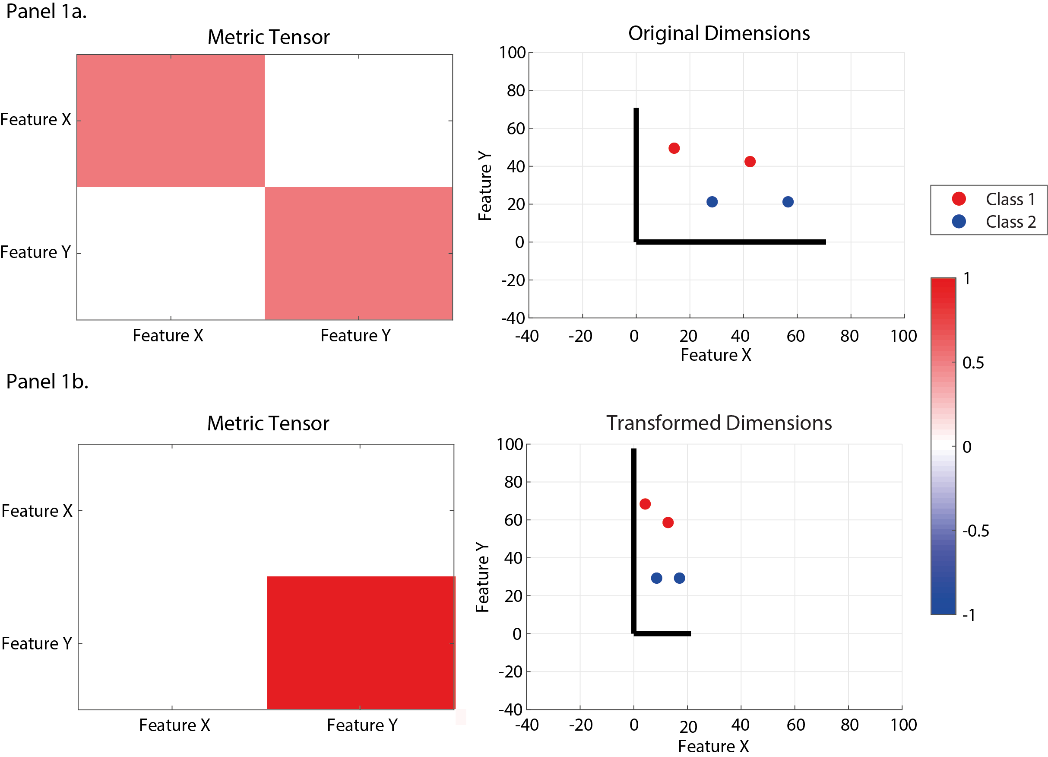
Example 2.1 shows that for all data have a neighbour of the same class the diagonals need to be scaled so that the term for Feature Y has to be increased relative to Feature X The conclusion that is drawn from the metric tensor is that Feature Y is the most relevant feature.

Example 2.2 Multivariate weights (positive)
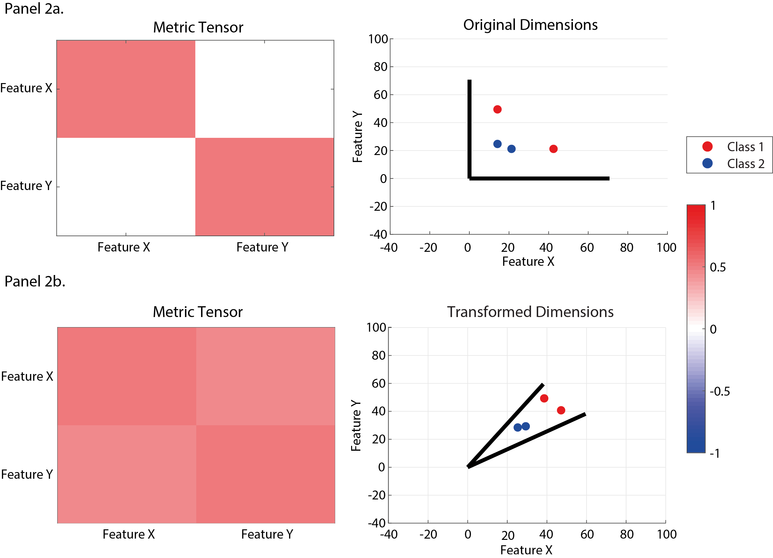
Example 2.2, the interaction between Feature X and Feature Y is highly relevant to group training samples of the same class (Note that the off-diagonal terms are positive). This interaction term collapses the angle between the two dimensions causing data of the same class to group together.

Example 2.3 Multivariate weights (negative)
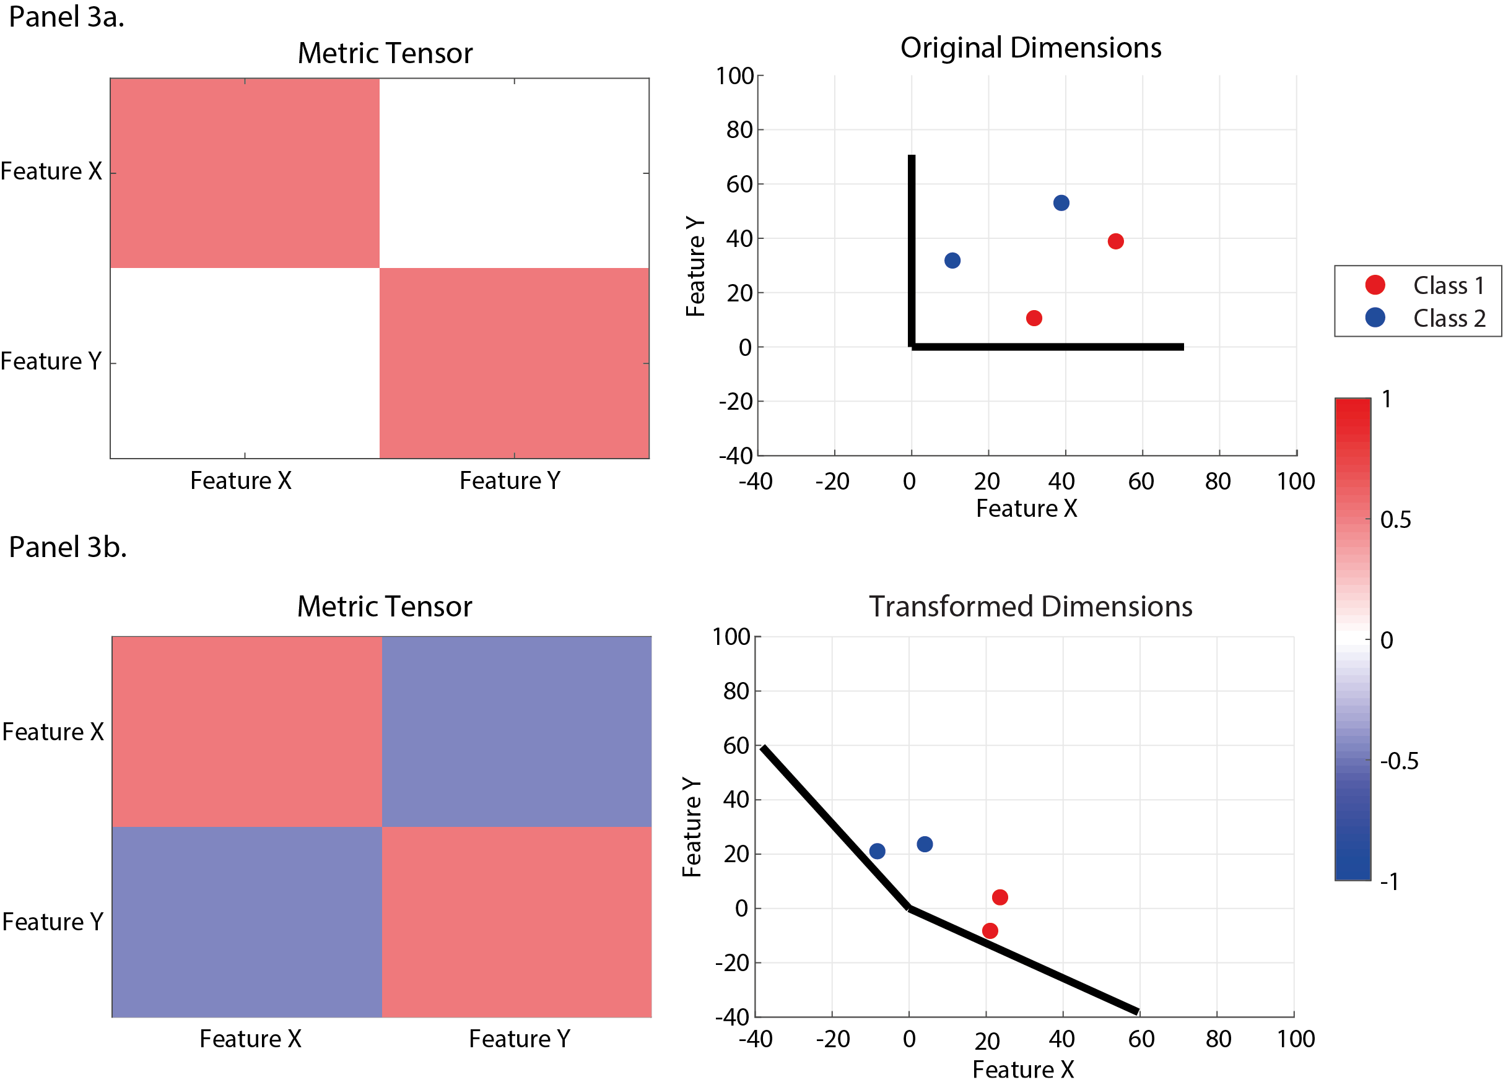
Example 2.3 shows that for all data to have a neighbour of the same class the interaction between Feature X and Feature Y is relevant; however, as this term is negative it increases the angle between the two dimensions. Thus, we conclude that these two features separate points from different classes.

To interpret these examples mathematically, note that the squared distance can be written as
$d_{Λ}\left(x,w\right)={\left(x-w\right)}^{T}Λ\left(x-w\right)= {\left(X-W\right)}^{T}\left(X-W\right)= d_{2}\left(X,W\right)$,
where $d_{2}\left(.,.\right)$ denotes the squared Euclidean distance and ${X=Λ}^{1/2}x$, ${W=Λ}^{1/2}w$. Hence, the original vectors (including the unit directional vectors of the standard axis) are transformed by the linear operator equal to the square root of the symmetric positive-definite metric tensor $Λ$ into a space where the new distance (defined by $Λ$) can be re-interpreted as the usual Euclidean distance.

GMLVQ – Scalar Projection
The GMLVQ- Scalar Projection method extends the GMLVQ framework to extract specific distance information from the sample vector $x_{i}$ and the learnt prototypes$w_{(SC,EAD)}$.
Specifically, we determine the distance in the learnt space (i.e. after applying the learnt metric tensor) between an individual with sample vector $x_{i}$and the learnt prototype $w_{stable}$ along the vector separating $w_{SC}$ and $w_{EAD}$

Following the learning process in GMLVQ we transformed the sample vector $x_{i}$ and prototypes $w_{(SC,EAD)}$into the learnt space via the metric tensor$Λ$.
$$X_{i}=Λ^{1/2} x_{i}$$
$$W_{(SC,EAD)}=Λ^{1/2}w_{(SC,EAD)}$$
As the metric tensor $Λ$ is learnt in the non-Euclidean space:$d_{Λ}\left(x,w\right)={(x-w)}^{T}Λ(x-w)$, we applied the square root of this tensor to re-represent the data so that the squared norm of a vector in the non-Euclidian space is equal to the squared Euclidean norm of the transformed space.
We centred the coordinate system on $W_{(SC)}$ and calculated the orthogonal projection of each vector $X_{i}$ onto the vector $W_{\left(EAD\right)}$, in this co-ordinate system.
$$Projection=\frac{\overset{⃑}{X_{i}W_{SC}}.\overset{⃑}{W_{EAD}W_{SC}}}{\left|\overset{⃑}{W_{EAD}W_{SC}}\right|}$$
To normalise the projections with respect to the position of the prototype $W_{(SC)}$, we divided the projection by the norm of $\overset{⃑}{W_{SC}W_{EAD}}$:
$$Scalar Projection=\frac{\overset{⃑}{X_{i}W_{SC}}.\overset{⃑}{W_{EAD}W_{SC}}}{{\left|\overset{⃑}{W_{EAD}W_{SC}}\right|}^{2}}$$
The resultant value indicates the separation of a test point from prototype $W_{SC}$ along the direction of $\overset{⃑}{W_{EAD}W_{SC}}$. To determine the relative separation from the stable prototype, we normalised the projection by the distance between each prototype $W_{EAD},W_{SC}$, as indicated by squaring the norm of vector $\overset{⃑}{W_{EAD}W_{SC}}$. A large positive projection indicates a large separation from $W_{SC}$ in direction $\overset{⃑}{W_{EAD}W_{SC}}$ and a large negative projection indicates a large separation from $W_{stable}$in the opposite direction i.e. $\overset{⃑}{W_{SC}W_{EAD}}$. In particular, a value of 1 indicates that a sample is incident to prototype $W_{EAD},$whereas a value of 0 indicates that a sample is incident to prototype $W_{SC}$. A value of 0.5 is the decision boundary separating the two classes within the binary classification framework. That is, the scalar projection has a large positive value for progressive individuals and zero or negative value for stable individuals.

Graphical Interpretation

Deriving the GMLVQ – Scalar Projection: Prototype Vector

The figure below uses the data from Example 2 above to graphically derive the Prototype Vector ($\overset{⃑}{W_{q}W_{j}})$ that is generated following the GMLVQ learning process. Note: Here we return to general notation, where class 1 is progressive and class 2 is stable in the description above.

Figure 2.3 Prototype vector

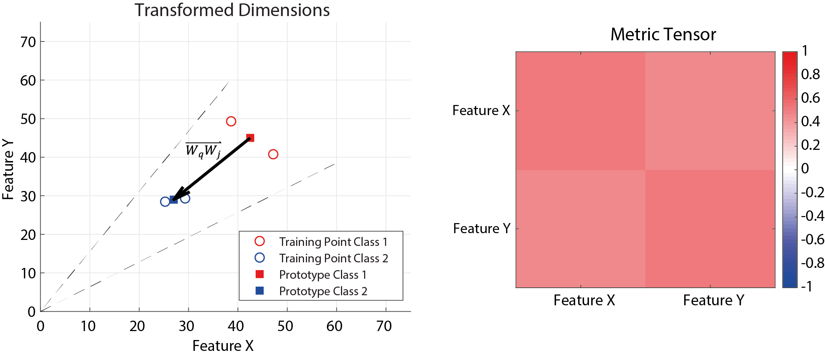

Figure 2.3 The left panel shows the vector $\overset{⃑}{W_{q}W_{j}}$ represented by the black arrow connecting prototypes for class 1 and class 2. The dashed lines show the transformed axis from the original space. The right panel is the learnt metric tensor used to transform the data from the original space into the learnt space.

Deriving the GMLVQ – Scalar Projection: Test Projections
Here, we use the data and learnt metric tensor from Example 2.2 in Interrogating the Metric Tensor Matrix to show three scenarios where values for the scalar projection are calculated and interpreted in a general sense.
The left panel shows a possible test point in the original data space of Example 2.2. The red dots are the training sample for class 1, the blue dots are the training sample for class 2 and the black X is the test point in the original space.
The right panel shows the graphical derivation of the scalar projection in the learnt space for the test data point X. Here, the red dots are the training sample for class 1 and the blue dots are the training sample for class 2, the black X is the test point in the learnt space (i.e. after the GMLVQ learning process) and the dashed black lines show the transformation of the X and Y axis into the learnt space.
The red square is the prototype for class 1 in the learnt space, the blue square is the prototype for class 2 in the learnt space. The vector $\overset{⃑}{W_{q}W_{j}}$ connects the prototypes for class 1 and class 2, and vector $\overset{⃑}{X_{i}W_{j}}$ connects the test point in the learnt space with the prototype for class 2. The dashed blue line is the orthogonal projection from the test point in the learnt space to vector $\overset{⃑}{W_{q}W_{j}}$. The solid blue line represents the scalar projection from the test point in the learnt space to the class 2 prototype along the vector $\overset{⃑}{W_{q}W_{j}}$.

Example 2.4 Between two classes

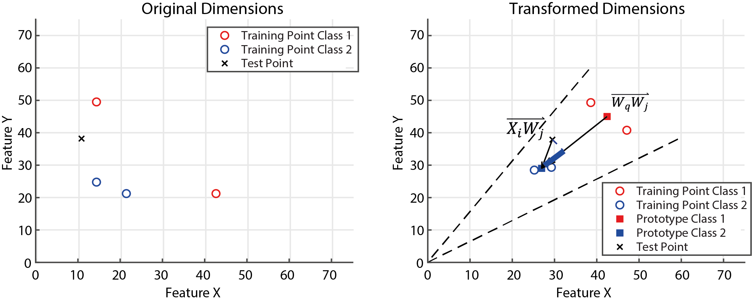

Example 2.4 shows an example of a scalar projection that has a length between 0 and 1. Within the binary classification framework a decision boundary exists at 0.5, where a value below this will cause the point to be labelled as class 2 and a value beyond this will cause the point to be labelled class 1. This is interpreted as an individual that is between the two classes.

Example 2.5 Positive value greater than one

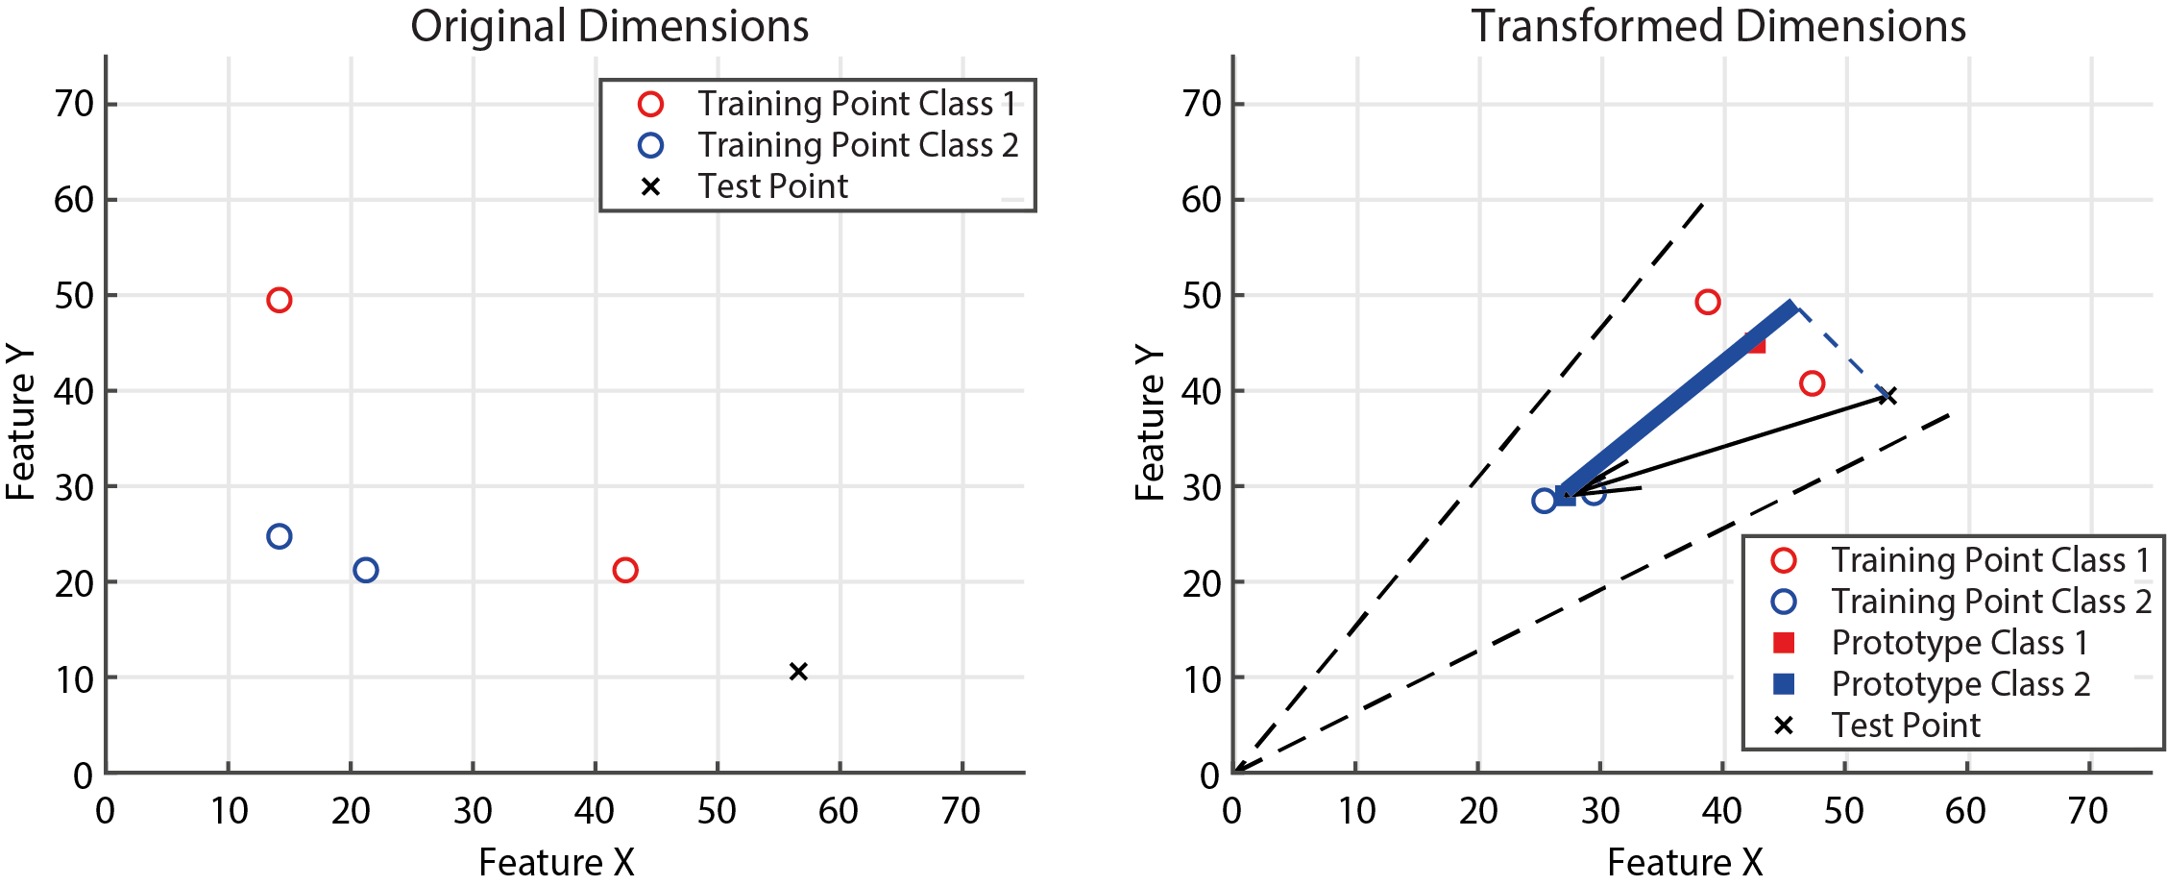

Example 2.5 is given where the length of the scalar projection is larger than 1, in this example the individual is further away from class 2 prototype along the prototype vector than the class 1 prototype. This is interpreted as being further away from the class 2 prototype than the majority of class 1 individuals.

Example 2.6 Negative value

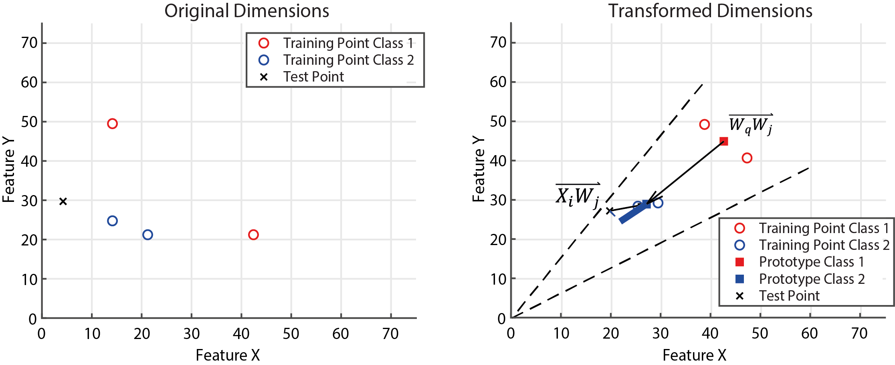
Example 2.6 shows an example where the length of the scalar projection is negative. In this example the individual is further away from the class 1 prototype than the class 2 prototype along the prototype vector. This is interpreted as being further away from the class 1 prototype than the majority of class 2 individuals.

GMLVQ – Scalar Projection: Summary/Conclusion
The GMLVQ-scalar projection approach is a method for deriving a continuous predictive variable from the GMLVQ classification framework. Our methodology defines a novel way of learning a continuous prognostic metric while training using ‘noisy’ diagnostic labels. The development of this approach was motivated to capitalise on broad class labels to train a model and derive an individual continuous score. By building a model to separate two continuous target values into two general categories (i.e. stable or progressive), we have forced the model to concentrate on the main structures in the data that lie between distinguishing the higher and lower target values. As our model has relatively - compared to deep learning approaches- few degrees of freedom (DOF), the model is unlikely to overfit the training data.
Where DOF for the model is DOF for prototypes + DOF for metric tensor.
DOF for the prototypes = D*C*P, and, metric tensor = D²- (D²-D)/2
D = number of original input features (input dimensions)
C = number of classes
P = number of prototypes per class

The GMLVQ-scalar projection approach addresses three inherent issues with prognostic models in AD research. 1.) The GMLVQ-scalar projection approach is able to account for target uncertainty. This is achieved by having a model that learns a low-parameter task-dependent scaling matrix (metric tensor), and only two locations in hyperdimensional space (prototypes). These univariate (diagonal) and multivariate (off diagonal) relationships are learnt to separate the two classes (stable condition vs early AD) as best possible from a global perspective (vs local metric tensors) without over constraining the predictor data. Similarly, by defining only one position in this learnt space that best determines if a person is stable or progressive, the model must ignore subtle differences for any given target, learning a broad location that best describes stable / progressive populations. By not over constraining the data, this type of model will not be sensitive enough to overfit based on subtle difference in diagnostic criteria or by patients on the class boarder. 2.) The GMLVQ-scalar projection approach is able to derive a continuous metric of how far an individual is from the stable condition prototype along the dimension that best separates stable and early AD training samples. This allows the model to learn implicitly a continuous prognostic trajectory for an individual that may be predictive of underlying pathophysiological change that leads to a deteriorating condition (i.e. early AD pathophysiology). 3.) The GMLVQ-scalar projection approach is perfectly suited to harmonise data that was collected using diagnostic criteria based on syndromic definitions with inherently poor sensitivity and specificity to extract a highly sensitive continuous prognostic index.

