Supplementary Information

Contents of this file
Supplementary Tables 1 to 4
Supplementary Figures 1 to 4

Introduction
This Supporting Information includes the tables and figures referred to in the main text.

Supplementary Table 1. A synthesis of %Ndff values (the % of crop N derived from fertilizer applied in the current season) in Chinese cereal cropping systems.
 | Crop type | N rate  (kg N ha⁻¹) | N uptake  (kg N ha⁻¹) | %Ndff | NUE_{15N} | Reference
1 | maize | 150 | 230 | 0.161 | 0.247 | Chen et al. 1996
2 | maize | 225 | 314 | 0.210 | 0.293 | Chen et al. 1996
3 | maize | 150 | 310 | 0.234 | 0.484 | Dai et al. 2012
4 | maize | 210 | 261 | 0.332 | 0.413 | Dai et al. 2012
5 | maize | 270 | 239 | 0.438 | 0.388 | Dai et al. 2012
6 | maize | 260 | 297 | 0.287 | 0.328 | Guo et al. 2019
7 | maize | 260 | 256 | 0.194 | 0.191 | Guo et al. 2019
8 | maize | 120 | 168 | 0.376 | 0.526 | Ju et al. 2002
9 | maize | 120 | 168 | 0.366 | 0.512 | Ju et al. 2007
10 | maize | 150 | 239 | 0.344 | 0.548 | Li Let al. 2011
11 | maize | 225 | 265 | 0.184 | 0.217 | Li et al. 2019
12 | maize | 225 | 301 | 0.227 | 0.304 | Li et al. 2019
13 | maize | 225 | 410 | 0.207 | 0.377 | Li et al. 2019
14 | maize | 225 | 245 | 0.185 | 0.201 | Li et al. 2019
15 | maize | 225 | 348 | 0.192 | 0.297 | Li et al. 2019
16 | maize | 225 | 466 | 0.176 | 0.365 | Li et al. 2019
17 | maize | 276 | 227 | 0.280 | 0.230 | Liu et al. 2014
18 | maize | 281 | 131 | 0.500 | 0.233 | Liu et al. 2015
19 | maize | 281 | 200 | 0.264 | 0.188 | Liu et al. 2015
20 | maize | 300 | 191 | 0.405 | 0.258 | Pan et al. 2009
21 | maize | 150 | 158 | 0.297 | 0.313 | Pan et al. 2001b
22 | maize | 225 | 172 | 0.351 | 0.268 | Pan et al. 2001b
23 | maize | 150 | 161 | 0.352 | 0.378 | Pan et al. 2001b
24 | maize | 225 | 167 | 0.405 | 0.301 | Pan et al. 2001b
25 | maize | 200 | 279 | 0.370 | 0.516 | Quan et al. 2020
26 | maize | 200 | 262 | 0.380 | 0.498 | Quan et al. 2020
27 | maize | 200 | 332 | 0.320 | 0.531 | Quan et al. 2020
28 | maize | 200 | 192 | 0.460 | 0.442 | Quan et al. 2020
29 | maize | 200 | 221 | 0.260 | 0.287 | Quan et al. 2020
30 | maize | 200 | 226 | 0.390 | 0.441 | Quan et al. 2020
31 | maize | 210 | 315 | 0.341 | 0.512 | Sui et al. 2018
32 | maize | 210 | 347 | 0.359 | 0.593 | Sui et al. 2018
33 | maize | 225 | 233 | 0.263 | 0.272 | Wang et al. 2016a
34 | maize | 225 | 256 | 0.321 | 0.365 | Wang et al. 2016a
35 | maize | 225 | 275 | 0.299 | 0.365 | Wang et al. 2016a
36 | maize | 225 | 237 | 0.272 | 0.287 | Wang et al. 2016a
37 | maize | 225 | 266 | 0.327 | 0.387 | Wang et al. 2016a
38 | maize | 225 | 285 | 0.328 | 0.415 | Wang et al. 2016a
39 | maize | 240 | 256 | 0.270 | 0.288 | Wang et al. 2009
40 | maize | 168 | 253 | 0.280 | 0.422 | Wang et al. 2009
41 | maize | 168 | 263 | 0.293 | 0.459 | Wang et al. 2009
42 | maize | 180 | 216 | 0.399 | 0.479 | Wang et al. 2009
43 | maize | 270 | 213 | 0.524 | 0.413 | Wang et al. 2009
44 | maize | 240 | 213 | 0.364 | 0.323 | Wang et al. 2016b
45 | maize | 250 | 192 | 0.271 | 0.208 | Xu et al. 2015
46 | maize | 180 | 215 | 0.346 | 0.413 | Yang et al. 2011
47 | maize | 270 | 240 | 0.436 | 0.388 | Yang et al. 2011
48 | maize | 120 | 216 | 0.180 | 0.324 | Zhong et al. 2004
49 | maize | 160 | 220 | 0.223 | 0.307 | Zhong et al. 2004
50 | maize | 240 | 241 | 0.266 | 0.267 | Zhong et al. 2004
51 | rice | 300 | 186 | 0.510 | 0.316 | Cao and Yin 2015
52 | rice | 225 | 204 | 0.527 | 0.478 | Cao and Yin 2015
53 | rice | 110 | 200 | 0.184 | 0.335 | Chen et al. 2019
54 | rice | 135 | 232 | 0.212 | 0.364 | Chen et al. 2019
55 | rice | 110 | 221 | 0.197 | 0.396 | Chen et al. 2019
56 | rice | 135 | 248 | 0.224 | 0.411 | Chen et al. 2019
57 | rice | 150 | 332 | 0.166 | 0.367 | Chen et al. 2010
58 | rice | 150 | 316 | 0.178 | 0.375 | Chen et al. 2010
59 | rice | 220 | 178 | 0.318 | 0.257 | Fan et al. 2010
60 | rice | 220 | 166 | 0.311 | 0.235 | Fan et al. 2010
61 | rice | 220 | 137 | 0.335 | 0.209 | Fan et al. 2010
62 | rice | 150 | 171 | 0.195 | 0.222 | Han et al. 2003
63 | rice | 150 | 188 | 0.367 | 0.460 | Han et al. 2003
64 | rice | 150 | 182 | 0.376 | 0.456 | Han et al. 2003
65 | rice | 143 | 104 | 0.306 | 0.223 | Jiang et al. 2000
66 | rice | 143 | 133 | 0.316 | 0.294 | Jiang et al. 2000
67 | rice | 143 | 120 | 0.341 | 0.286 | Jiang et al. 2000
68 | rice | 100 | 166 | 0.162 | 0.269 | Xu et al. 2011
69 | rice | 200 | 200 | 0.282 | 0.282 | Xu et al. 2011
70 | rice | 300 | 220 | 0.334 | 0.245 | Xu et al. 2011
71 | rice | 100 | 270 | 0.115 | 0.311 | Xu et al. 2011
72 | rice | 200 | 361 | 0.167 | 0.301 | Xu et al. 2011
73 | rice | 300 | 401 | 0.197 | 0.263 | Xu et al. 2011
74 | rice | 240 | 227 | 0.320 | 0.303 | Zhang Het al. 2011
75 | rice | 240 | 232 | 0.398 | 0.385 | Zhang Het al. 2011
76 | rice | 300 | 198 | 0.396 | 0.261 | Zhang Het al. 2011
77 | rice | 300 | 219 | 0.417 | 0.304 | Zhang Het al. 2011
78 | rice | 240 | 227 | 0.320 | 0.303 | Zhang et al. 2012
79 | rice | 300 | 198 | 0.396 | 0.261 | Zhang et al. 2012
80 | rice | 240 | 232 | 0.398 | 0.385 | Zhang et al. 2012
81 | rice | 300 | 219 | 0.417 | 0.304 | Zhang et al. 2012
82 | rice | 225 | 231 | 0.378 | 0.388 | Zhong et al. 2017
83 | rice | 210 | 142 | 0.311 | 0.210 | Wang et al. 2018
84 | rice | 225 | 166 | 0.385 | 0.284 | Wang et al. 2018
85 | rice | 225 | 162 | 0.462 | 0.333 | Wang et al. 2018
86 | rice | 225 | 163 | 0.402 | 0.291 | Wang et al. 2018
87 | rice | 225 | 136 | 0.535 | 0.323 | Yao et al. 2018
88 | rice | 225 | 185 | 0.634 | 0.521 | Yao et al. 2018
89 | wheat | 150 | 105 | 0.519 | 0.363 | Chen et al. 2016a
90 | wheat | 240 | 136 | 0.599 | 0.339 | Chen et al. 2016a
91 | wheat | 150 | 107 | 0.501 | 0.357 | Chen et al. 2016a
92 | wheat | 240 | 133 | 0.563 | 0.312 | Chen et al. 2016a
93 | wheat | 150 | 150 | 0.311 | 0.311 | Chen et al. 2016b
94 | wheat | 240 | 189 | 0.403 | 0.317 | Chen et al. 2016b
95 | wheat | 150 | 150 | 0.224 | 0.224 | Chen et al. 2016b
96 | wheat | 240 | 159 | 0.272 | 0.180 | Chen et al. 2016b
97 | wheat | 150 | 97 | 0.346 | 0.224 | Chen et al. 2017
98 | wheat | 195 | 118 | 0.376 | 0.228 | Chen et al. 2017
99 | wheat | 240 | 134 | 0.418 | 0.233 | Chen et al. 2017
100 | wheat | 150 | 184 | 0.343 | 0.421 | Dai et al. 2012
101 | wheat | 210 | 213 | 0.468 | 0.475 | Dai et al. 2012
102 | wheat | 270 | 207 | 0.552 | 0.423 | Dai et al. 2012
103 | wheat | 150 | 194 | 0.381 | 0.493 | Dai et al. 2012
104 | wheat | 210 | 211 | 0.491 | 0.493 | Dai et al. 2012
105 | wheat | 270 | 238 | 0.530 | 0.467 | Dai et al. 2012
106 | wheat | 100 | 115 | 0.333 | 0.383 | Dang et al. 2002
107 | wheat | 100 | 112 | 0.329 | 0.368 | Dang et al. 2002
108 | wheat | 150 | 136 | 0.404 | 0.366 | Dang et al. 2002
109 | wheat | 100 | 115 | 0.333 | 0.383 | Dang et al. 2003
110 | wheat | 150 | 168 | 0.329 | 0.368 | Dang et al. 2003
111 | wheat | 150 | 136 | 0.404 | 0.366 | Dang et al. 2003
112 | wheat | 180 | 273 | 0.215 | 0.326 | Han et al. 2007
113 | wheat | 270 | 216 | 0.319 | 0.255 | Han et al. 2007
114 | wheat | 180 | 271 | 0.256 | 0.385 | Han et al. 2007
115 | wheat | 270 | 216 | 0.388 | 0.310 | Han et al. 2007
116 | wheat | 240 | 384 | 0.281 | 0.450 | He et al. 2005
117 | wheat | 240 | 380 | 0.241 | 0.382 | He et al. 2005
118 | wheat | 168 | 358 | 0.260 | 0.554 | He et al. 2005
119 | wheat | 168 | 348 | 0.233 | 0.483 | He et al. 2005
120 | wheat | 258 | 214 | 0.301 | 0.250 | Huang et al. 2015
121 | wheat | 150 | 167 | 0.457 | 0.509 | Ji et al. 2010
122 | wheat | 225 | 175 | 0.599 | 0.466 | Ji et al. 2010
123 | wheat | 300 | 175 | 0.638 | 0.372 | Ji et al. 2010
124 | wheat | 150 | 184 | 0.342 | 0.420 | Jia et al. 2011
125 | wheat | 210 | 211 | 0.468 | 0.470 | Jia et al. 2011
126 | wheat | 270 | 205 | 0.552 | 0.419 | Jia et al. 2011
127 | wheat | 150 | 193 | 0.381 | 0.490 | Jia et al. 2011
128 | wheat | 210 | 210 | 0.491 | 0.491 | Jia et al. 2011
129 | wheat | 270 | 239 | 0.531 | 0.470 | Jia et al. 2011
130 | wheat | 120 | 158 | 0.344 | 0.453 | Ju et al. 2000
131 | wheat | 240 | 158 | 0.456 | 0.300 | Ju et al. 2000
132 | wheat | 240 | 151 | 0.478 | 0.301 | Ju et al. 2002
133 | wheat | 120 | 149 | 0.365 | 0.453 | Ju et al. 2003
134 | wheat | 120 | 148 | 0.360 | 0.444 | Ju et al. 2007
135 | wheat | 144 | 183 | 0.273 | 0.347 | Li et al. 2002
136 | wheat | 144 | 177 | 0.239 | 0.294 | Li et al. 2002
137 | wheat | 213 | 186 | 0.355 | 0.310 | Li et al. 2002
138 | wheat | 213 | 188 | 0.354 | 0.312 | Li et al. 2002
139 | wheat | 144 | 184 | 0.227 | 0.290 | Li et al. 2002
140 | wheat | 144 | 179 | 0.225 | 0.280 | Li et al. 2002
141 | wheat | 213 | 197 | 0.296 | 0.274 | Li et al. 2002
142 | wheat | 150 | 154 | 0.470 | 0.483 | Li et al. 2007
143 | wheat | 225 | 165 | 0.602 | 0.441 | Li et al. 2007
144 | wheat | 300 | 175 | 0.646 | 0.377 | Li et al. 2007
145 | wheat | 150 | 168 | 0.455 | 0.510 | Li et al. 2007
146 | wheat | 225 | 175 | 0.599 | 0.466 | Li et al. 2007
147 | wheat | 300 | 175 | 0.638 | 0.372 | Li et al. 2007
148 | wheat | 150 | 105 | 0.329 | 0.230 | Liu et al. 1997
149 | wheat | 225 | 138 | 0.439 | 0.269 | Liu et al. 1997
150 | wheat | 300 | 155 | 0.542 | 0.280 | Liu et al. 1997
151 | wheat | 150 | 197 | 0.242 | 0.318 | Liu et al. 1997
152 | wheat | 225 | 267 | 0.308 | 0.365 | Liu et al. 1997
153 | wheat | 300 | 295 | 0.407 | 0.400 | Liu et al. 1997
154 | wheat | 150 | 163 | 0.458 | 0.498 | Liu et al. 2010
155 | wheat | 225 | 173 | 0.591 | 0.454 | Liu et al. 2010
156 | wheat | 300 | 182 | 0.616 | 0.374 | Liu et al. 2010
157 | wheat | 240 | 251 | 0.378 | 0.395 | Ma et al. 2006
158 | wheat | 160 | 255 | 0.288 | 0.459 | Ma et al. 2006
159 | wheat | 160 | 256 | 0.273 | 0.437 | Ma et al. 2006
160 | wheat | 210 | 256 | 0.346 | 0.422 | Meng et al. 2011
161 | wheat | 210 | 257 | 0.318 | 0.389 | Meng et al. 2011
162 | wheat | 210 | 313 | 0.225 | 0.335 | Meng et al. 2011
163 | wheat | 300 | 166 | 0.473 | 0.262 | Pan et al. 2003
164 | wheat | 300 | 190 | 0.556 | 0.352 | Pan et al. 2003
165 | wheat | 300 | 155 | 0.583 | 0.301 | Pan et al. 2003
166 | wheat | 300 | 136 | 0.598 | 0.271 | Pan et al. 2003
167 | wheat | 300 | 157 | 0.608 | 0.318 | Pan et al. 2003
168 | wheat | 300 | 149 | 0.604 | 0.300 | Pan et al. 2003
169 | wheat | 300 | 144 | 0.549 | 0.264 | Pan et al. 2003
170 | wheat | 300 | 161 | 0.592 | 0.318 | Pan et al. 2003
171 | wheat | 300 | 149 | 0.564 | 0.280 | Pan et al. 2003
172 | wheat | 300 | 150 | 0.639 | 0.320 | Pan et al. 2003
173 | wheat | 300 | 152 | 0.696 | 0.353 | Pan et al. 2003
174 | wheat | 240 | 143 | 0.378 | 0.225 | Pan et al. 2003
175 | wheat | 150 | 233 | 0.218 | 0.339 | Pan et al. 2001b
176 | wheat | 225 | 200 | 0.280 | 0.249 | Pan et al. 2001b
177 | wheat | 100 | 199 | 0.146 | 0.291 | Pan et al. 2001b
178 | wheat | 150 | 234 | 0.144 | 0.225 | Pan et al. 2001b
179 | wheat | 150 | 237 | 0.240 | 0.379 | Pan et al. 2001b
180 | wheat | 225 | 215 | 0.354 | 0.338 | Pan et al. 2001b
181 | wheat | 150 | 184 | 0.340 | 0.417 | Pan et al. 2001b
182 | wheat | 225 | 197 | 0.441 | 0.386 | Pan et al. 2001b
183 | wheat | 120 | 148 | 0.360 | 0.444 | Pan et al. 2001a
184 | wheat | 240 | 155 | 0.478 | 0.309 | Pan et al. 2001a
185 | wheat | 105 | 307 | 0.142 | 0.415 | Shi et al. 2007
186 | wheat | 210 | 226 | 0.458 | 0.493 | Sui et al. 2018
187 | wheat | 210 | 274 | 0.424 | 0.553 | Sui et al. 2018
188 | wheat | 138 | 209 | 0.246 | 0.373 | Wang et al. 1997
189 | wheat | 300 | 248 | 0.295 | 0.244 | Wang et al. 2009
190 | wheat | 210 | 243 | 0.281 | 0.325 | Wang et al. 2009
191 | wheat | 210 | 257 | 0.335 | 0.410 | Wang et al. 2009
192 | wheat | 250 | 120 | 0.378 | 0.181 | Xu et al. 2014
193 | wheat | 112 | 117 | 0.480 | 0.501 | Yuan et al. 2014
194 | wheat | 112 | 124 | 0.474 | 0.525 | Yuan et al. 2014
195 | wheat | 112 | 134 | 0.448 | 0.536 | Yuan et al. 2014
196 | wheat | 112 | 120 | 0.480 | 0.514 | Yuan et al. 2014
197 | wheat | 225 | 219 | 0.482 | 0.469 | Zhai et al. 2012
198 | wheat | 225 | 250 | 0.359 | 0.399 | Zhai et al. 2012
199 | wheat | 225 | 249 | 0.337 | 0.373 | Zhai et al. 2012
200 | wheat | 150 | 292 | 0.223 | 0.434 | Zhang et al. 1999
201 | wheat | 225 | 302 | 0.265 | 0.356 | Zhang et al. 1999
202 | wheat | 300 | 353 | 0.268 | 0.315 | Zhang et al. 1999
203 | wheat | 180 | 299 | 0.269 | 0.447 | Zhang et al. 1999
204 | wheat | 180 | 277 | 0.305 | 0.469 | Zhang et al. 1999
205 | wheat | 180 | 296 | 0.318 | 0.523 | Zhang et al. 1999
206 | wheat | 180 | 315 | 0.246 | 0.431 | Zhang et al. 1999
207 | wheat | 168 | 290 | 0.200 | 0.345 | Zhao et al. 2004
208 | wheat | 195 | 413 | 0.226 | 0.479 | Zhao et al. 2004
209 | wheat | 240 | 326 | 0.249 | 0.338 | Zhao et al. 2004
210 | wheat | 105 | 358 | 0.158 | 0.539 | Zhao et al. 2006
211 | wheat | 195 | 326 | 0.238 | 0.398 | Zhao et al. 2006
212 | wheat | 240 | 346 | 0.267 | 0.385 | Zhao et al. 2006
213 | wheat | 225 | 246 | 0.304 | 0.332 | Zhong et al. 2004
214 | wheat | 240 | 195 | 0.273 | 0.222 | Zuo et al. 2012
215 | wheat | 180 | 219 | 0.266 | 0.324 | Zuo et al. 2012
216 | wheat | 200 | 179 | 0.336 | 0.301 | Zuo et al. 2012
Mean | total | 206 | 215 | 0.358 | 0.362
SD | total | 57 | 69 | 0.125 | 0.093
Min | total | 100 | 97 | 0.115 | 0.180
max | total | 300 | 466 | 0.696 | 0.593
Note: Only the results under local management practices were included (N fertilizer rate was limited in the range of 100–300 kg N ha⁻¹).

Supplementary Table 2. Grain yield, N application rate, and harvested N (aboveground uptake) in Chinese cereal (maize, rice, and wheat) production systems based on on-farm surveys (2005–2014).
Reference/source | Zhang et al. 2013 | Chen et al. 2014 | Cui et al. 2018 | Mean
Survey year | 2009 | 2007-09 | 2005-14 | -
Maize
n (farmers) | 4522 | 5406 | 2891694 | -
Yield (×10³ kg ha⁻¹) | 7.4 ± 2.7 | 7.6 ± 1.5 | 7.2 | 7.4
Fertilizer N rate (kg N ha⁻¹) | 231 ± 142 | 220 | 208 | 220
Harvested N (kg N ha⁻¹) * | 162 | 148 | 149 | 153
Rice
n (farmers) | 4218 | 6592 | 3505004 | -
Yield (×10³ kg ha⁻¹) | 7.2 ± 1.8 | 7.0 ± 1.5 | 7.3 | 7.2
Fertilizer N rate (kg N ha⁻¹) | 209 ± 140 | 209 | 181 | 200
Harvested N (kg N ha⁻¹) * | 122 | 127 | 128 | 126
Wheat
n (farmers) | 4554 | 6940 | 2233381 | -
Yield (×10³ kg ha⁻¹) | 4.9 ± 2.0 | 5.7 ± 1.3 | 5.0 | 5.2
Fertilizer N rate (kg N ha⁻¹) | 197 ± 134 | 210 | 181 | 196
Harvested N (kg N ha⁻¹) * | 123 | 136 | 122 | 127
Sum (maize + rice + wheat, area-weighted for the mean) #
Yield (×10³ kg ha⁻¹) | 6.7 ± 1.4 | 6.9 ± 0.9 | 6.7 | 6.8 ± 1.1
Fertilizer N rate (kg N ha⁻¹) | 216 ± 81 | 214 | 193 | 208 ± 81
Harvested N (kg N ha⁻¹) * | 140 ± 29 | 138 ± 18 | 136 | 138 ± 23
* Harvested N in this table is aboveground N uptake, and it was calculated by the “reported yield multiplied by uniform parameters”. For Cui et al. (2018) who that did not show the parameters, we calculated it using the mean values of the parameters in Zhang et al. (2013) and Chen et al. (2014).
# Weighted averages were made based on the planting area (43.4%, 31.5% and 25.1% of the total for maize, rice and wheat, area data from http://data.stats.gov.cn/). Standard deviations in the sum indicators were calculated by the propagation of error using a Gaussian function. Because N uptake is normally calculated by crop yields, we estimated the standard deviation of N uptake based on the standard deviation of the yields.

Supplementary Table 3. Mean N concentrations in plant samples at harvest (maize with two genotypes, XY335 and ZD958) that were collected from the trials with five N levels in four years (2010–2013). Compared to conventional N fertilization (the treatment, fertilizer N rate of 214 kg N ha⁻¹), no N fertilization (the control) decreased the N concentrations of grain, stalk, and leaf samples by 28.6%, 27.4% and 30.9%, respectively (mean 29.0%). Data in the table come from Chen et al. (2015). The magnitude of this reduction is consistent with that reported by Chen et al. (2013) and Lollato et al. (2019) in cereal cropping systems.
Fertilizer N rate | N concentration (g kg⁻¹)
Fertilizer N rate | Grain | Stalk | Leaf
0 | 9.5 | 4.1 | 7.6
60 | 10.1 | 4.3 | 8.4
120 | 11.9 | 4.8 | 9.5
180 | 13.1 | 5.4 | 10.4
240 | 13.5 | 5.9 | 11.6
208 (predicted) | 13.3 | 5.6 | 11.0
208 – 0 (decrease, %) * | 28.6% | 27.4% | 30.9%
* The difference in N concentrations in the grain, stalk, and leaf samples between the treatment (N rate = 208 kg N ha⁻¹) and the control (N rate = 0 kg N ha⁻¹).

Supplementary Table 4. The original data for the NUE_{diff}, NUE_{15N} and NUE_{bala} calculations shown in the example in Fig. 1e.
Year* | Plot* | Section* | HN_{C} # | HN_{T} # | NF_{N} # | %Ndff # | NUE_{bala} | NUE_{diff} | NUE_{15N}
 |  |  | kg N ha⁻¹ | kg N ha⁻¹ | kg N ha⁻¹ | % | % | % | %
1969 | 5 & 8 | 2 | 72.5 | 135.8 | 28.2 | 58.1 † | 78.9 | 43.9 | 54.8
1970 | 5 & 8 | 7 | 38.5 | 110.5 | 30.7 | 2.98 | 63.2 | 50.0 | 57.1
1971 | 5 & 8 | 4 | 48.4 | 154.9 | 31.4 | 2.14 | 88.3 | 74.0 | 59.4
1972 | 5 & 8 | 2 | 73.4 | 151.9 | 30.7 | 1.52 | 87.0 | 54.6 | 61.0
1973 | 5 & 8 | 7 | 63.3 | 141.3 | 28.8 | 1.10 | 81.8 | 54.2 | 62.1
1974 | 5 & 8 | 4 | 45.1 | 127.7 | 31.2 | 0.97 | 72.9 | 57.4 | 62.9
1975 | 5 & 8 | 2 | 43.5 | 126.8 | 31.1 | 0.75 | 72.4 | 57.9 | 63.6
1976 | 5 & 8 | 7 | 38.0 | 105.0 | 29.2 | 0.72 | 60.6 | 46.5 | 64.1
1977 | 5 & 8 | 4 | 44.3 | 125.5 | 30.5 | 0.70 | 71.9 | 56.4 | 64.7
1978 | 5 & 8 | 2 | 70.4 | 152.9 | 35.0 | 0.69 | 85.4 | 57.3 | 65.5
1979 | 5 & 8 | 7 | 56.1 | 145.4 | 30.3 | 0.53 | 83.4 | 62.0 | 66.0
1980 | 5 & 8 | 4 | 44.3 | 200.8 | 34.4 | 0.52 | 112.5 | 108.7 | 66.7
1981 | 5 & 8 | 2 | 56.4 | 162.6 | 32.2 | 0.60 | 92.3 | 73.8 | 67.4
1982 | 5 & 8 | 7 | 61.9 | 177.0 | 32.2 | 0.31 | 100.5 | 79.9 | 67.8
1983 | 5 & 8 | 4 | 30.9 | 145.7 | 31.7 | 0.49 | 83.0 | 79.8 | 68.3
1984 | 5 & 8 | 2 | 50.3 | 159.3 | 33.1 | 0.56 | 89.9 | 75.7 | 68.9
1985 | 5 & 8 | 7 | 53.1 | 148.6 | 30.0 | 0.48 | 85.4 | 66.3 | 69.4
1986 | 5 & 8 | 4 | 34.5 | 166.6 | 35.6 | 0.47 | 92.8 | 91.8 | 69.9
1987 | 5 & 8 | 5 | 28.1 | 144.7 | 33.4 | 0.46 | 81.5 | 81.0 | 70.4
1988 | 5 & 8 | 3 | 39.4 | 168.4 | 27.7 | 0.42 | 98.1 | 89.5 | 70.9
1989 | 5 & 8 | 2 | 45.0 | 136.8 | 24.4 | 0.42 | 81.3 | 63.7 | 71.3
1990 | 5 & 8 | 7 | 20.1 | 185.3 | 24.8 | 0.48 | 109.8 | 114.8 | 71.9
1991 | 5 & 8 | 4 | 23.3 | 157.3 | 23.9 | 0.39 | 93.7 | 93.1 | 72.3
1992 | 5 & 8 | 5 | 26.2 | 169.2 | 25.2 | 0.40 | 100.0 | 99.3 | 72.8
1993 | 5 & 8 | 3 | 17.9 | 132.0 | 26.0 | 0.45 | 77.7 | 79.2 | 73.2
1994 | 5 & 8 | 2 | 27.5 | 141.3 | 25.0 | 0.38 | 83.6 | 79.0 | 73.6
1995 | 5 & 8 | 7 | 17.8 | 145.2 | 25.3 | 0.37 | 85.8 | 88.5 | 74.0
1996 | 5 & 8 | 4 | 36.9 | 160.9 | 24.7 | 0.35 | 95.4 | 86.2 | 74.3
1997 | 5 & 8 | 5 | 37.3 | 202.9 | 24.4 | 0.36 | 120.5 | 115.0 | 74.9
1998 | 5 & 8 | 3 | 22.1 | 115.1 | 24.6 | 0.36 | 68.3 | 64.6 | 75.1
1999 | 5 & 8 | 2 | 22.6 | 129.4 | 27.9 | 0.35 | 75.3 | 74.2 | 75.4
2000 | 5 & 8 | 7 | 22.2 | 111.2 | 25.7 | 0.34 | 65.5 | 61.8 | 75.7
2001 | 5 & 8 | 4 | 14.2 | 98.4 | 26.1 | 0.33 | 57.9 | 58.5 | 75.9
2002 | 5 & 8 | 5 | 24.4 | 114.3 | 26.6 | 0.33 | 67.0 | 62.5 | 76.2
2003 | 5 & 8 | 3 | 21.8 | 135.8 | 25.0 | 0.32 | 80.3 | 79.2 | 76.5
2004 | 5 & 8 | 2 | 19.1 | 142.2 | 25.7 | 0.31 | 83.8 | 85.5 | 76.8
2005 | 5 & 8 | 7 | 24.9 | 89.4 | 26.8 | 0.30 | 52.3 | 44.8 | 77.0
2006 | 5 & 8 | 4 | 27.9 | 138.6 | 23.9 | 0.30 | 82.6 | 76.9 | 77.3
2007 | 5 & 8 | 5 | 20.4 | 91.1 | 24.6 | 0.29 | 54.1 | 49.1 | 77.5
2008 | 5 & 8 | 3 | 20.6 | 130.2 | 22.0 | 0.29 | 78.4 | 76.1 | 77.7
2009 | 5 & 8 | 2 | 25.4 | 146.5 | 23.9 | 0.28 | 87.2 | 84.1 | 78.0
2010 | 5 & 8 | 7 | 24.3 | 118.3 | 23.1 | 0.27 | 70.8 | 65.2 | 78.2
2011 | 5 & 8 | 4 | 25.6 | 147.5 | 22.9 | 0.27 | 88.4 | 84.6 | 78.5
2012 | 5 & 8 | 5 | 28.6 | 141.4 | 22.6 | 0.26 | 84.9 | 78.3 | 78.8
2013 | 5 & 8 | 3 | 30.6 | 117.6 | 24.0 | 0.26 | 70.0 | 60.4 | 79.0
2014 | 5 & 8 | 2 | 24.5 | 147.0 | 22.3 | 0.25 | 88.4 | 85.1 | 79.2
2015 | 5 & 8 | 7 | 20.9 | 128.5 | 23.1 | 0.25 | 76.9 | 74.8 | 79.4
* The Rothamsted Broadbalk Wheat Experiment has undergone many changes over 170 years and is complicated. Yields from modern wheat varieties are available from 1969. For more information about experimental design, fertilizer application, crop rotation, etc., see the e-RA: the electronic Rothamsted Archive (http://www.era.rothamsted.ac.uk/).
# Abbreviations: nonfertilizer N input (NF_{N}; including deposition, manure, biological fixation, irrigation, seeds, etc.), harvested N in the control plots without N fertilization (HN_{C}), harvested N in the treatment plots with N fertilization (HN_{T}), fraction of harvested N derived from fertilizer applied (%Ndff).
† Sebilo et al. (2013) did not directly indicate the %Ndff for the first season. We estimated it (0.581) indirectly using data shown in their figures (i.e., the linear relationship between the accumulated ¹⁵N uptake and the accumulated %Ndff in subsequent seasons).

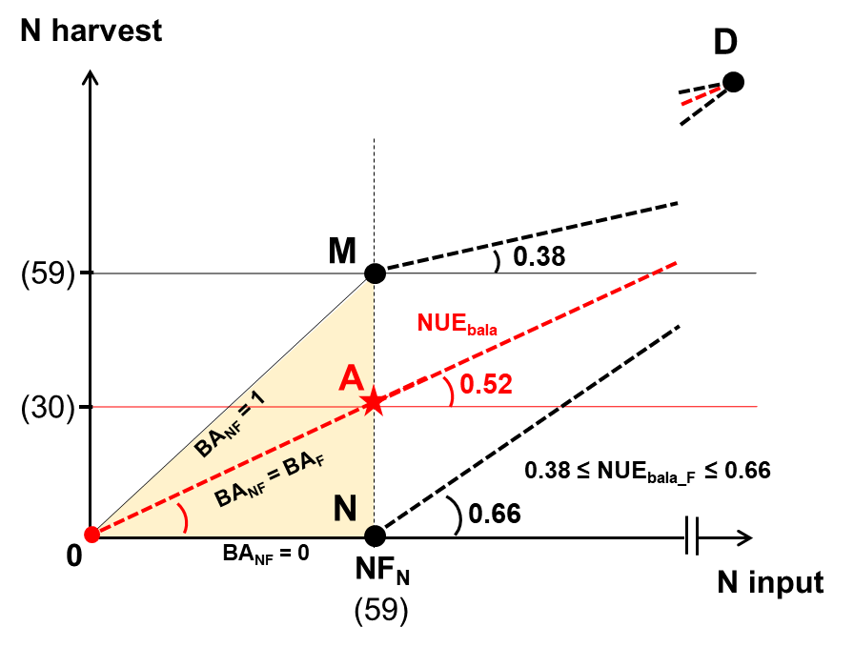
Supplementary Fig. 1. The potential impact of NF_{N} bioavailability (BA_{NF}, long-term uptake% of NF_{N}) on the NUE based on the balance approach using the Chinese cereal cropping system as an example. The positions of points M and N were determined when BA_{NF} equals 1 and 0, respectively (the upper and lower boundaries of BA_{NF}). As a result, the slopes of line MD and line ND are the lower and upper boundaries of the NUE_{bala} for F_{N} use (NUE_{bala_F}).

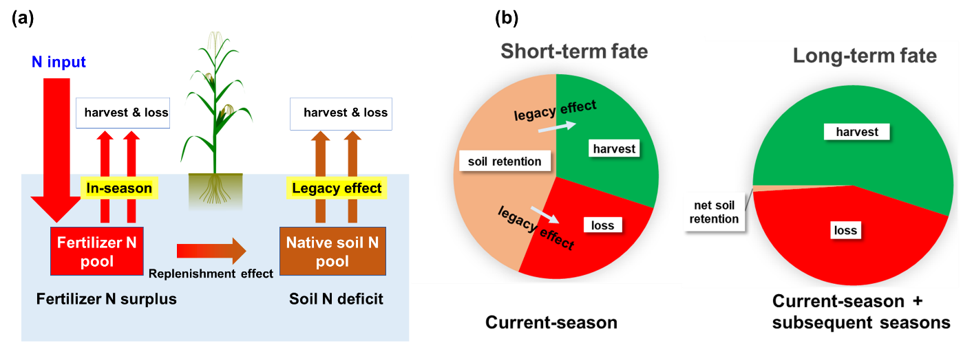
Supplementary Fig. 2. Schematic representation of the legacy effect involving the N-balance calculation (a) and the N-tracer calculation (b) in the cropping systems. The legacy effect refers to the contribution of N inputs to crop N uptake and N loss during subsequent seasons. If the native soil N pool remains balanced, the legacy effect corresponds to exogenous N replenishment and indigenous N consumption. Because of the legacy effect, the fate of N input has two different interpretations: the short-term fate and long-term fate. Nitrogen inputs that are retained in the soil can continually contribute to crop N uptake and N loss during subsequent seasons. Consequently, the long-term uptake and loss are much higher than the short-term uptake and loss. Here, fertilizer N and soil N are distinguished by their sources only during the current season. The residual N fertilizer is assumed to be soil N during subsequent seasons.

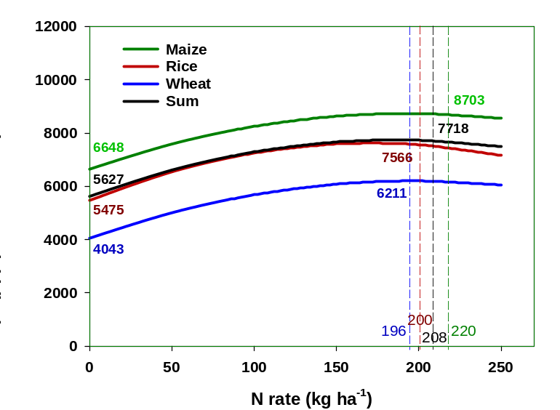

Supplementary Fig. 3. Yield response curve of maize, rice, and wheat in China during 2005–2010. The formulas of response curves used here came from the supplementary information of Zhang et al. (2019), and the raw data came from Wu (2014), Wu et al. (2014, 2015), and Li et al. (2015). Each thin line represents a crop type in a region. The thick lines are the averages of the national fertilizer response trials (n = 1726, 1130 and 1561 for maize, rice, and wheat). The planting areas of maize, rice, and wheat accounted for 43.4%, 31.5% and 25.1% of the sum, respectively. The black line denotes the area-weighted curve for the sum of the three cereal crops. Compared to conventional N fertilization (220, 200, 196 and 208 kg N ha⁻¹ season⁻¹ for maize, rice and wheat and the sum, Table 2S), no N fertilization (the control) decreased the yield of the sum (area-averaged of maize, rice and wheat) by 27.5%. The magnitude of this reduction is consistent with that reported by Wang et al. (2019).

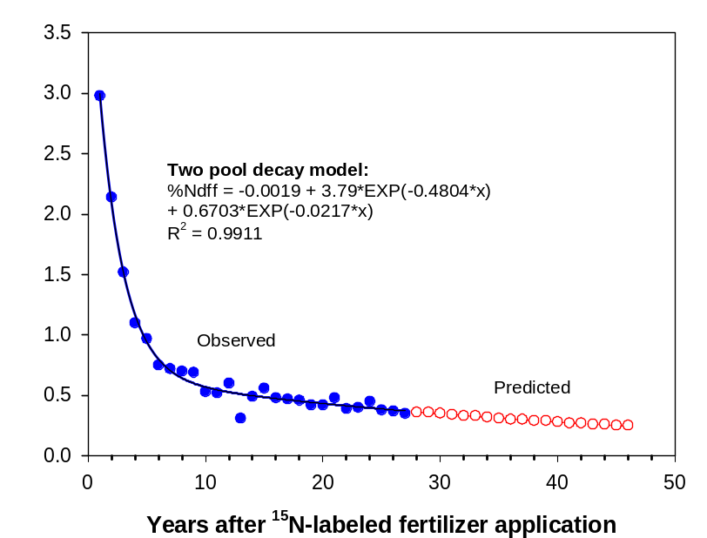

Supplementary Fig. 4. Simulating the long-term trends of %Ndff after ¹⁵N-labeled fertilizer application in soil-cereal cropping systems (pulse ¹⁵N labeling). The observed %Ndff points came from the longest ¹⁵N tracer experiment in the literature (Sebilo et al. 2013). We use those points to predict the long-term trend of %Ndff using a two-pool decay model.

Supplementary References
- Cao Y, and Yin B. 2015. Effects of integrated high-efficiency practice versus conventional practice on rice yield and n fate. Agriculture, Ecosystems and Environment 202: 1–7.
- Chen P, Nie T, Chen S, et al. 2019. Recovery efficiency and loss of ¹⁵N-labelled urea in a rice-soil system under water saving irrigation in the Songnen Plain of Northeast China. Agricultural Water Management 222: 139–153
- Chen Q, Wen X, Pan J, et al. 1996. Fate of nitrogen in soil-crop system by nuclear techniques. Effects of applied rate of ammonium bicarbonate (No. CNIC-01088). China Nuclear Information Centre. Contributed by Chinese Society of Nuclear-Agricultural Sciences.
- Chen X, Chen F, Chen Y, et al. 2013. Modern maize hybrids in northeast china exhibit increased yield potential and resource use efficiency despite adverse climate change. Global Change Biology 19: 923–936.
- Chen Y, Wu C, Tang X, et al. 2010. Fate of nitrogen-15 from organic and inorganic sources in rice-wheat rotation cropping system. Scientia Agricultura Sinica 43: 744–752. (in Chinese with an English abstract)
- Chen Y, Xiao C, Wu D, et al. 2015. Effects of nitrogen application rate on grain yield and grain nitrogen concentration in two maize hybrids with contrasting nitrogen remobilization efficiency. European Journal of Agronomy 62: 79–89.
- Chen Z, Wang H, Liu X, et al. 2016a. The effect of N fertilizer placement on the fate of urea-15N and yield of winter wheat in southeast China. PloS One 11: e0153701.
- Chen Z, Wang H, Liu X, et al. 2016b. The fates of ¹⁵N-labeled fertilizer in a wheat–soil system as influenced by fertilization practice in a loamy soil. Scientific Reports 6, 34754.
- Chen Z, Wang H, Liu X, et al. 2017. Spatial and temporal nitrogen applications for winter wheat in a loamy soil in south-eastern China. Nutrient Cycling in Agroecosystems 109: 43–55.
- Chen, X, Cui, Z, Fan, M, et al. 2014. Producing more grain with lower environmental costs. Nature 514: 486–489.
- Cui Z, Zhang H, Chen X, et al. 2018. Pursuing sustainable productivity with millions of smallholder farmers. Nature 555: 363–366.
- Dai, K. 2012. Optimization of water and nitrogen use efficiencies in winter wheat and summer maize cropping system in North China Plain, Ph. D thesis, Chinese Academy of Agricultural Sciences, Beijing.
- Dang T, Cai G, Guo S, et al. 2002. Fate of and crop response to nitrogen applied to winter wheat growing on Heilu soil. Acta Pedologica Sinica 39: 205–212. (in Chinese with an English abstract)
- Dang T, Guo S, Hao M, et al. 2003. Study on nitrogen efficiencies of dry land wheat by ¹⁵N labeled fertilizer. Acta Agriculturae Nucleatae Sinica 17: 280–285. (in Chinese with an English abstract)
- Fan H, Lv S, and Zeng X. 2010. Effect of different transplanting leaf age on rice yield, nitrogen utilization efficiency and fate of ¹⁵N-fertilizer. Journal of Nuclear Agricultural Sciences 24: 104–107. (in Chinese with an English abstract)
- Guo S, Jiang R, Qu H, et al. 2019. Fate and transport of urea-N in a rain-fed ridge-furrow crop system with plastic mulch. Soil and Tillage Research 186: 214–223.
- Han X, Wang S, Song C, et al. 2003. Fate of fertilizer nitrogen in paddy field of black soil region. Chinese Journal of Applied Ecology 14: 1859–1862. (in Chinese with an English abstract)
- Han Y, Ge D, Wang Q, et al. 2007. Effect of N fertilizer rate on fate of labeled nitrogen and winter wheat yield on different soil fertility fields in Chao Soil area in North Henan. Journal of Soil and Water Conservation 5: 151–154. (in Chinese with an English abstract)
- He M, Yang W, Wang X, et al. 2005. Effects of different N management modes on grain yield and quality as well as fertilizer N use efficiency of winter wheat. Acta Agronomica Sinica 31: 1047–1051. (in Chinese with an English abstract)
- Huang T, Zheng X, Wang Z. 2015. Nitrogen release of returned maize straw and its effects on loess N supply and nitrogen uptake by winter wheat in Guanzhong plain. Scientia Agricultura Sinica 48: 2785–2795. (in Chinese with an English abstract)
- Ji Y, Ju X, Liu X, et al. 2010. Impact of different nitrogen application on nitrogen movement and gaseous loss of winter wheat fields. Journal of Soil and Water Conservation 24: 113–118. (in Chinese with an English abstract)
- Jia S, Wang X, Yang Y, et al. 2011. Fate of labeled urea-15 N as basal and topdressing applications in an irrigated wheat–maize rotation system in North China Plain: I winter wheat. Nutrient Cycling in Agroecosystems 90: 331–346.
- Jiang Y, Liu H, Zhang Y, et al. 2000. Mechanism for the increase of nitrogen utilization rate through high-efficiency urea application. Jiangsu Journal of Agricultural Sciences 16: 180–184. (in Chinese with an English abstract)
- Ju X, Liu X, Pan J, et al. 2007. Fate of ¹⁵N-labeled urea under a winter wheat-summer maize rotation on the north china plain. Pedosphere 17: 52–61.
- Ju X, Liu X, Zhang F. 2002. Distribution and fate of nitrogen fertilizer in various soil nitrogen pool at wheat seedling stage. Plant Nutrition and Fertilizer Science 8: 259–264. (in Chinese with an English abstract)
- Ju X, Pan J, Liu X, et al. 2003. Study on the fate of nitrogen fertilizer in winter wheat/summer maize rotation system in Beijing suburban. Plant Nutrition and Fertilizing Science 3, 264–270. (in Chinese with an English abstract)
- Ju, X. 2000. Transformation and fate of soil-fertilizer nitrogen in winter wheat/summer maize rotation system. Ph. D thesis, China Agricultural University, Beijing.
- Li H, Cong R, Ren T, et al. 2015. Yield response to N fertilizer and optimum N rate of winter oilseed rape under different soil indigenous N supplies. Field Crops Research 181: 52–59.
- Li L. 2011. Manure nitrogen availability and its substitution ratio for chemical fertilizer nitrogen. Master thesis, Chinese Academy of Agricultural Sciences, Beijing.
- Li S, Zhou D, and Lan L. 2002. The fate of fertilizer nitrogen in winter wheat under different water and nitrogen levels. Acta Agriculturae Nucleatae Sinica 16: 315–319. (in Chinese with an English abstract)
- Li Y, Song D, Dang P, et al. 2019. The effect of tillage on nitrogen use efficiency in maize (Zea mays L.) in a ridge–furrow plastic film mulch system. Soil and Tillage Research 195: 104409.
- Li, X. 2007. Fate of fertilizer nitrogen and gaseous N loss in winter wheat-summer maize rotation system in north china plain. Master thesis, Hebei Agricultural University, Baoding.
- Liu F and Yu Z. 1997. Application of ¹⁵N tracer method on dryland winter wheat fertilization and nitrogen absorption and utilization. Soil and fertilizer in China 2: 30–31. (in Chinese)
- Liu X, 2010. Nitrogen fertilizer residual effect and its fate in winter wheat-summer maize rotations in North China Plain. Master thesis, Hebei Agricultural University, Baoding.
- Liu X, Xiao G, Guo R, et al. 2015. The effect of plastic mulch on the fate of urea-N in rain-fed maize production in a semiarid environment as assessed by ¹⁵N-labeling. European Journal of Agronomy 70: 71–77.
- Liu X. 2014. Effect of plastic much on nitrogen cycling and fate of fertilizer nitrogen in field-grown maize at a semiarid site. Ph. D thesis, Lanzhou University, Lanzhou.
- Lollato RP, Figueiredo BM, Dhillon JS, et al. 2019. Wheat grain yield and grain-nitrogen relationships as affected by N, P, and K fertilization: A synthesis of long-term experiments. Field Crops Research 236: 42–57.
- Ma X, Yu Z, Liang X, et al. 2006. Effects of nitrogen application rate and ratio of base and topdressing on nitrogen utilization and soil NO3-N content in winter wheat. Journal of Soil and Water Conservation 20: 95–98. (in Chinese with an English abstract)
- Meng W, Wang D, Yu Z, et al. 2011. A study of the effects of irrigation on nitrogen uptake and distribution of wheat using the ¹⁵N tracer technique. Plant Nutrition and Fertilizer Science 17: 831–837. (in Chinese with an English abstract)
- Pan J, Ju X, Liu X, et al. 2009. Fate of fertilizer nitrogen for winter wheat-summer maize rotation in North China Plain under optimization of irrigation and fertilization. Journal of Nuclear Agricultural Sciences 23: 334–340. (in Chinese with an English abstract)
- Pan J, Zou G, Wei L, et al. 2003. Influence of density and top-dressing of nitrogen fertilizer on yield of wheat with different maturing phases and response of fate of fertilizer nitrogen. Acta Agriculturae Nucleatae Sinica 17: 466–471. (in Chinese with an English abstract)
- Pan J. 2001. Fate of fertilizer Nitrogen in winter wheat/summer maize rotation system at North China plain. Ph. D thesis, China Agricultural University, Beijing.
- Quan Z, Li S, Zhang X, et al. 2020. Fertilizer nitrogen use efficiency and fates in maize cropping systems across China: Field ¹⁵N tracer studies. Soil and Tillage Research 197: 104498.
- Sebilo M, Mayer B, Nicolardot B, et al. 2013. Long-term fate of nitrate fertilizer in agricultural soils. Proceedings of the National Academy of Sciences of the United States of America 110, 18185-18189.
- Shi Y. 2007. Studies on physiological mechanism of quality formation in different type wheat and on nitrogen cycle in plant-soil system. Ph. D thesis, Shandong Agricultural University, Tai’an.
- Sui C, Liu Y, and Zhang M. 2018. Fate of polymer-coated ¹⁵N-urea in the corn-wheat rotation system. International Journal of Agriculture and Biology 20: 387–396.
- Wang D, Xu C, Ye C, et al. 2018. Low recovery efficiency of basal fertilizer-N in plants does not indicate high basal fertilizer-N loss from split-applied N in transplanted rice. Field crops research 229: 8–16.
- Wang J, Han X, and Liu H. 1997. Study on the Fate of Nitrogenous Fertilizer in the Black Soil. Chinese Journal of Ecology 5, 61-63. (in Chinese with an English abstract)
- Wang S, Luo S, Yue S, et al. 2016a. Fate of ¹⁵N fertilizer under different nitrogen split applications to plastic mulched maize in semiarid farmland. Nutrient Cycling in Agroecosystems 105: 129–140
- Wang S, Wang J, Zhao Y, et al. 2019. Assessment of the contribution percentage of inherent soil productivity of cultivated land in China. Journal of Integrative Agriculture 18: 2619–2627.
- Wang X, Wang Z, Li H, et al. 2016b. Dynamics and availability to crops of residual fertilizer nitrogen in upland soil. Acta Pedologica Sinica 53: 1202-1212. (in Chinese with an English abstract)
- Wang, X. 2008. Utilization of residual N by crops and organic N in surface-mulched soil dryland of. North-western China. Ph. D thesis, Northwest Agriculture & Forest University, Yangling.
- Wang, X. 2009. Nitrogen cycling and balance in winter wheat-summer corn rotation system under optimized nitrogen management. Ph. D thesis, Chinese Academy of Agricultural Sciences, Beijing.
- Wu L, Chen X, Cui Z, et al. 2014. Establishing a regional nitrogen management approach to mitigate greenhouse gas emission intensity from intensive smallholder maize production. PLoS One 9: e98481.
- Wu L, Chen X, Cui Z, et al. 2015. Improving nitrogen management via a regional management plan for Chinese rice production. Environmental Research Letters 89: 095011.
- Wu L. 2014. Nitrogen Fertilizer Demand and Greenhouse Gas Mitigation Potential under Nitrogen Limiting Conditions for Chinese Agriculture Production (in Chinese). Doctor Thesis, China Agricultural University, Beijing.
- Xu L, Lin Z, Wu F, et al. 2011. Fate of nitrogen in rice-soil system under different treatment conditions. Jiangsu Journal of Agricultural Science 39: 114–116. (in Chinese)
- Xu M, Dong X, Liu H, et al. 2014. Effects of different management patterns on uptake, distribution and fate of nitrogen in wheat. Journal of Plant Nutrition and Fertilizer 20: 1084–1093. (in Chinese with an English abstract)
- Yang Y, Wang X, Dai K, et al. 2011. Fate of labeled urea-¹⁵N as basal and topdressing applications in an irrigated wheat-maize rotation system in north china plain: Ⅱ summer maize. Nutrient Cycling in Agroecosystems 90: 379–389.
- Yao Y, Zhang M, Tian Y, et al. 2018. Urea deep placement for minimizing NH3 loss in an intensive rice cropping system. Field Crops Research 218: 254–266.
- Yuan L, Zhao B, Lin Z, et al. 2014. Effects of value-added urea on wheat yield and N use efficiency and the distribution of residual N in soil profiles. Journal of Plant Nutrition and Fertilizer 20: 620–628. (in Chinese with an English abstract)
- Zhai X, Wang Z, Dai Z, et al. 2012. Effects of nitrogen topdressing stage on fate of fertilizer nitrogen in winter wheat-soil system using ¹⁵N tracer technique. Shandong Journal of Agricultural Sciences 44: 60–65.
- Zhang C, Ju X, Powlson D, et al. 2019. Nitrogen surplus benchmarks for controlling N pollution in the main cropping systems of China. Environmental Science and Technology 53: 6678–6687.
- Zhang H. 2011. Gaseous loss and balance of nitrogen from paddy field in irrigation area of the upper yellow river. Ph. D thesis, Chinese Academy of Agricultural Sciences, Beijing.
- Zhang Q, Yang Z, Zhang H, et al. 2012. Recovery efficiency and loss of ¹⁵N-labelled urea in a rice-soil system in the upper reaches of the yellow river basin. Agriculture Ecosystems and Environment 158: 118–126.
- Zhang W, Dou Z, He P, et al. 2013. New technologies reduce greenhouse gas emissions from nitrogenous fertilizer in China. Proceedings of the National Academy of Sciences of the United States of America 110: 8375–8380.
- Zhang X, Zhu H, and Sun C. 1999. Studies on the nitrogen fertilizer recommendation system of winter wheat using ¹⁵N field experiment. Chinese Journal of Soil Science 30: 224–226.
- Zhao J and Yu Z. 2006. Effects of nitrogen fertilizer rate on uptake, distribution and utilization of nitrogen in winter wheat under high yielding cultivated condition. Acta Agronomica Sinica 32: 484–490. (in Chinese with an English abstract)
- Zhao J. 2004. Studies on nitrogen cycle in plant-soil system and on physiological basis of kernel yield and quality formation in winter wheat. Ph. D thesis, Shandong Agricultural University, Tai’an.
- Zhong Q. 2004. Studies of nitrogen environmental endurance of winter wheat-summer maize rotation system in North China Plain. Master thesis, China Agricultural University, Beijing.
- Zhong Y, Wang X, Yang J, et al. 2017. Tracing the fate of nitrogen with ¹⁵N isotope considering suitable fertilizer rate related to yield and environment impacts in paddy field. Paddy and Water Environment 15: 943–949.
- Zuo H, Bai Y, Lu Y, et al. 2012. Fate of fertilizer nitrogen applied to winter wheat in North China Plain based on high abundance of ¹⁵N. Scientia Agricultura Sinica 45: 3093–3099. (in Chinese with an English abstract)

