Supporting Information

Investigating the core microbiome concept: Daphnia as a case study
Aditi Gurung¹, Martijn Callens², François Massol³,Caroline Souffreau¹, Shinjini Mukherjee⁴, Shira Houwenhuyse⁵, Robby Stoks⁶, Luc De Meester^{1,7,8}* & Ellen Decaestecker⁹*
Author affiliations:
¹ Department of Biology, Laboratory of Freshwater Ecology, Evolution and Conservation, Division of Ecology, Evolution and Biodiversity Conservation, KU Leuven, Leuven 3000, Belgium.
² Animal Science Unit, Flanders Research Institute for Agriculture, Fisheries and Food (ILVO), Oostende 8400, Belgium
³ Sorbonne Université, Université Paris Cité, Université Paris Est Créteil, CNRS, INRAE, IRD, Institut d’Ecologie et des Sciences de l’Environnement de Paris (UMR7618), 75005 Paris, France.
⁴ Department of Human Genetics, Laboratory of Reproductive Genomics, KU Leuven, Leuven 3000, Belgium.
⁵ Department of Biochemistry and Microbiology, Faculty of Sciences, Ghent University, Ghent 9000, Belgium
⁶ Laboratory of Evolutionary Stress Ecology and Ecotoxicology, KU Leuven, B-3000 Leuven, Belgium
⁷ Department Evolutionary and Integrative Ecology, Research group Evolving metacommunities, Leibniz Institute of Freshwater Ecology and Inland Fisheries, Berlin 12587, Germany.
⁸ Institute of Biology, Freie Universität Berlin D-14195, Berlin, Germany.
⁹ Laboratory of Aquatic Biology, Interdisciplinary Research Facility Life Sciences, KU Leuven, KULAK, Campus Kortrijk, B-8500 Kortrijk, Belgium.

Corresponding author: Luc De Meester, Ellen Decaestecker
Email: luc.demeester@igb-berlin.de
ellen.decaestecker@kuleuven.be

This PDF file includes:

Supporting text
Figures S1 to S3
Tables S1 and S2
SI references

Table 1: Summary overview of definitions of the core microbiome in the literature.
No. | Term | Definition | Author/Reference
1. | Core microbiome | “The core human microbiome is the set of genes present in a given habitat in all or the vast majority of humans. Habitat can be defined over a range of scales, from the entire body to a specific surface area, such as the gut or a region within the gut” | [1]
2. | Substantial core model | As per this definition, the majority of individuals in a population have shared taxa that constitute a substantial portion of their microbiome | [2]
3. | Minimal core model | “All individuals share a few components, and any individual shares many components with a few other individuals, but very little is shared across all individuals” | [2]
4. | No core model | “Nothing is shared by all individuals, and most diversity is unique to a given individual” | [2]
5. | Gradient model | “Individuals next to each other on a gradient, for example, age or obesity, share many components, but individuals at opposite ends share little or nothing” | [2]
6. | Subpopulation model | “Different subpopulations, for example, those defined by geography or disease, have different cores, but nothing is shared across subpopulations” | [2]
7. | Common core | “The component of the microbiome that is found across a considerable proportion of hosts within a defined host population or species” | [3]
8. | Temporal core | “A temporally stable or predictable component of the microbiota” | [3]
9. | Ecological core | “The component of the microbiome that is disproportionally important for shaping the organization and diversity of the ecological community” | [3]
10. | Functional core | “The component of the microbiome that performs essential biological functions to the host, usually in respect to their biochemical, physiological or ecological services to the host” | [3]
11. | Host-adapted core | “A set of microbes that has coevolved with the host species or subpopulation and whose presence increases host fitness in at least some ecological contexts” | [3]

Table 2: List of studies collected for the meta-analysis. The green color indicates studies that were selected for the meta-analysis (i.e., studies with V4 region)

No. | Daphnia species | Clones | Treatment | Sample type | Country | Origin | Primers | Variable region | DNA extraction | Sequencing platform | Acc. no | Reference | Selection
1. | D. magna | OM2NF2, T9, B7, KNO1504 | Treatment with toxic cyanobacteria | Gut | OHZ, Knokke, Heverlee, Belgium | Laboratory | 515F-806R | V4 | Power soil DNA isolation kit, MOBIO Laboratories | v2 PE500 kit, Illumina Miseq platform-2 × 250-nt paired-end reads | PRJNA398629 | Macke et al., 2017[4] | selected
2. | D. magna | BSW7, OM2F8 | Effect of microbial inoculum | Gut | Bysjön Lake,Sweden Heverlee Belgium | Laboratory | 515F-806R | V4 | Power soil DNA isolation kit, MOBIO Laboratories | v2 PE500 kit, Illumina Miseq platform-2 × 250-nt paired-end reads | PRJNA398630 | Macke et al., 2017[4] | selected
3. | D. magna | NIES | Oxytetracycline exposure | Whole animal | Tsukuba, Japan | Laboratory | 515F-806R | V4 | Quick Genomic DNA prep | v2 PE500 kit, Illumina Miseq platform-2 × 250-nt paired-end reads | PRJNA413666 | Callens et al., 2018[5] | selected
4. | D. magna | G2, G6, G9 | Effect of microbial source | Gut | OHZ, Heverlee, Belgium, | Laboratory | 515F-806R | V4 | Power soil DNA isolation kit, MOBIO Laboratories | v2 PE500 kit, Illumina Miseq platform-2 × 250-nt paired-end reads | PRJNA498431 | Macke et al., 2020[6] | selected
5. | D. magna | G1, G2, G3, G4, G5, G6, G7, G8, G9 | Effect of diet (Scendesmus vs. Microcystis) | Gut | OHZ, Knokke, Heverlee, Belgium, Bysjön Lake,Sweden | Laboratory | 515F-806R | V4 | Power soil DNA isolation kit, MOBIO Laboratories | v2 PE500 kit, Illumina Miseq platform-2 × 250-nt paired-end reads | PRJNA498417 | Macke et al., 2020[6] | selected
6. | D. magna | BSW7,F clone, KNO, OM2, NIES | Composition of environmental bacteria | Gut | Bysjön Lake, Sweden, Knokke, Heverlee, Belgium, Tsukuba Japan | Laboratory | 515F-806R | V4 | Phenol-Chloroform-Isoamylalcohol Extraction | v2 PE500 kit, Illumina Miseq platform-2 × 250-nt paired-end reads |  | Callens et al., 2020 [7] | select selected ed
7. | D. magna | 8A | Sulfamethoxazole, Erythromycin, Aztreonam exposure | Whole animal | Leitholm UK | Laboratory | 515F-806R | V4 | DNeasy Blood and TissueKit (Qiagen) | v2 PE500 kit, Illumina Miseq platform-2 × 250-nt paired-end reads | PRJNA543842 | R Cooper et al., 2020 [8] | selected
8. | D. magna | BH, ZWE, L, K, OM2, T8, | Role of local microbiome on exposure to toxic Microcystis | Gut | Kortrijk, Leuven, OHZ, Heverlee Belgium | Laboratory | 515F-806R | V4 | Power soil DNA isolation kit, MOBIO Laboratories | v2 PE500 kit, Illumina Miseq platform-2 × 250-nt paired-end reads | PRJNA690081 | Houwenhuyse et al., 2021 [9] | selected
9. | D. magna | DM1, DM2, DM3, DM4, DM5,  DM15, DM18, DM19, DM20, DM22, DM23 | Lab microbiome vs natural microbiome | Gut | Bysjön Lake Sweden | Laboratory and natural | 515F-806R | V4 | DNeasy PowerSoil ProDNA kit (Qiagen) | v2 PE500 kit, Illumina Miseq platform-2 × 250-nt paired-end reads | PRJNA748877 | Hegg et al., 2021 [10] | selected
10. | D. magna | 8A | Multigenerational effects of antibiotic exposure | Whole animal | Leitholm UK | Laboratory | 515F-806R | V4 | DNeasy PowerSoil ProDNA kit (Qiagen) | v2 PE500 kit, Illumina Miseq platform-2 × 250-nt paired-end reads | PRJNA703930 | R Cooper et al., 2021 [11] | selected
11. | D. magna | MS, KP, KNO, OM2, T8 | The role of microbiome on parasite re-exposure | Gut | OHZ, Knokke, Heverlee Belgium | Laboratory | 515F-806R | V4 | Power soil DNA isolation kit, MOBIO Laboratories | v2 PE500 kit, Illumina Miseq platform-2 × 250-nt paired-end reads | PRJNA688519 | Bulteel et al., 2021 [12] | selected
12. | D. magna, D. dentifera | DM, DD | Effect of daily feeding rythm | Whole animal | Nebraska USA | Laboratory | 515F-806R | V4 | Qiagen DNeasy Blood and Tissue Kit | v2 PE500 kit, Illumina Miseq platform-2 × 250-nt paired-end reads | PRJNA715454 | Pfenning butterworth et al., 2022 [13] | selected
13. | D. magna | Clone 5 | Effect of trimethoprim treatment | Whole animal | Berlin, Germany | Laboratory | fD1-926R | V1 | 10% chelex extraction | 96-capillary ABI3730XL DNA analyzer | KM603394  - KM603467 | Gorokhova et al., 2015 [14] | Not selected
14. | D. magna | KNO15.04 | Variation in food availability | Gut, Whole animal | Knokke, Belgium | Laboratory | 343F-798R | V3-V4 | Phenol-chloroform extraction | 454 pyrosequencing | LN869908-LN869916 | Callens et al., 2016 [15] | Not selected
15. | D. magna | MN | Ephippia-associated microbiota | Ephippium | Munich, Germany |  | 341F, 785R | V3 | Power soil DNA isolation kit, MOBIO Laboratories | Illumina MiSeq (reagent kit v3, 300 bp paired-end reads). | PRJEB20984 | Mushegian et al., 2017 [16] | Not selected
16. | D. magna | FI−N−47−20  RU-RM1-009  RU-BOL1-1  RU-KOR1-1  FI-FHS2-11-8  FI-FUT1-2-1  FR-C1-1  IT-ISR1-8  GB-EL75-69  SE-EL75-69  SE-G1-9  BY-G1-9  IL-M1-8  FI-FSP1-16-2  BE-OM-2  CH-H-149  DE-K35-Mu11  RU-YAK1-1  IR-GG1-7 | Combined effect of temperatura and host clonal line | Whole animal | Finland, Russia, France, Italy,UK, Sweden, Belarus, Israel, Belgium, Switzerland, Iran, Germany | Laboratory | positions  327–969bp | V3-V5 | CTAB-based isolation | 454 LibL sequencing technology (Roche, Switzerland) |  | Sullam K et al., 2017 [17] | Not selected
17. | D. magna | CH.H.149 | Temporal dynamics of microbiota before and after host death | Whole animal | Switzerland | Laboratory | 341F, 785R | V3-V4 | CTAB-based isolation | 300-bp paired-end run, Illumina MiSeq (440nt) | PRJEB26643  ERS2473695–ERS2473793 | Preiswerk D et al., 2018 [18] | Not selected
18. | D. magna | BE-OHZ-M5,  BE-OHZ-M10,  QTL-IXF-1,  FI-Xinb3,  DE-K35-Iinb1,  HU-HO-2,  IR-GG1-1,  IL-M1-1 | Role of gut microbiome in parasitic tolerance (P. ramosa | Whole animal | Belgium, Germany, Finland, Hungary, Iran, Jerusalem,  Switzerland | Laboratory | F (5′-ACACGGYCCARACTCCTAC-3′) and R (5′-TTGCWTCGAATTAAWCCAC-3′) | V3-V5 | DNeasy Blood and Tissue Kit (Qiagen, Netherlands) | 454 GS-FLX instrument with LibL Titanium chemistry (Roche, USA) | PRJNA407858 | Sison-magnus et al., 2018 [19] | Not selected
19. | D. magna | F2.82, F2.918, BE.OHZ.T10, BE.WE.G59, CZ.N1.1, CZ.N2.6, DE.K35.Mu10,DE.KA.F28, ES.DO1.1, I-F1, NO.V.7, TR.EG.1 | Exposure to natural desiments | Whole animal | Belgium, Germany, Turkey, Norway, Czech Republic, Spain | Laboratory | 341F, 785R | V3-V4 | CTAB based isolation | Illumina MiSeq platform | PRJEB30308 | Mushegian et al., 2019 [20] | Not selected
20. | D. magna | CAY,  DE-K35-Iinb1,  FI-Xinb3 | Mercury stress | Whole animal | USA, Germany, Finland | Laboratory | 515F-806R | V4 | DNeasy Blood and Tissue Kit (Qiagen, Germantown, MD) | MiSeq Illumina sequencing platform | PRJNA421566 | JC Fong et al., 2019 [21] | Awaiting submission of sequences, no response from author
21. | D. magna | FA, FB, FC,  IA, IB, IC,  GA, GB, GC | Temp dependent effects in lab-reared vs native pops. | Whole animal | Finland, Israel, Germany | Laboratory | 341F-785R | V3-V4 | Zymo Research Fungal/Bacterial DNA Microprep kit (#D6007) | V3 PE600 kit, Illumina Miseq platform-2 × 250-nt paired-end reads |  | JF Bricker et al., 2020 [22] | Not selected
22. | D. magna | Clone 5 | Ciprofloxacin exposure | Gut | Berlin, Germany | Laboratory | 341F, 805R | V3-V4 | 10% Chelex extraction | MiSeq V3 reagent kit (600-cycles) Illumina MiSeq platform | PRJNA560134 | Motiei et al., 2020 [23] | Not selected
23. | D. pulex | LD33 | Multiple stressor exposure: Copper/Predator cues, antibiotics (Amp, Kanamycin sulphate) | Gut | UK | Laboratory |  | 16S rDNA sequencing (RTL Genomics, Texas, USA) |  |  |  | SA Sadeq et al., 2020 [24] | No response from author,Not selected
24. | D. magna | LRV3.5_15, LRV13.5_1, LRV13_2 & P-IT | Effect of glyphosate | Gut | Denmark,Verbania Italy | Laboratory |  | V1 region | PowerSoil DNA Isolation Kit MoBio (Thermo Fisher Scientific) | 250 bp sequencing, Illumina MiSeq platform | PRJNA606209- | A Suppa et al., 2020 [25] | Not selected
25. | D. magna | Strauss | Effect of poor vs rich diet and, antibiotic exposure (tetracycline HCl) | Gut | China | Laboratory | 338F, 806R | V3-V4 | E.Z.N.A.® soil DNA Kit (Omega Bio-tek, Norcross, GA, U.S.) | MiSeq V3 reagent kit (600-cycles) Illumina MiSeq platform | PRJNA561047 | S. Akbar et al., 2020 [26] | Not selected
26. | D. magna | NIES | Exposure to dragonfruit oligosaccharides |  | Tsukuba Japan |  |  |  |  |  | PRJNA597416 | Sangkuanun et al., 2020 [27] | No response from author,Not selected
27. | D. magna | Laboratory reared clones | Effect of predator kairomone exposure | Gut | China | Laboratory | 27F-1492R | 16S rRNA | HiPure Soil DNA Kits (Magen, Guangzhou, China) | PacBio Sequel platform | Pre-print | Liu et al., 2021 [28] | Not selected
28. | D. magna |  | Exposure to nutrient imbalanced algal diet | Gut | Hong Kong | Laboratory | 341F, 787R | V3-V4 | PureLink Genomic DNA kit (Invitrogen) | Illumina Hiseq 2500 System-2× 250 bp paired-end reads | PRJNA597965 | Ying Dong Li et al., 2021 [29] | Not selected
29. | D. magna | CH | Elevated temp, Microcystis exposure | Gut | China | Laboratory | 338F, 806R | V3-V4 | E.Z.N.A.® soil DNA Kit (Omega Bio-tek) | MiSeq V3 reagent kit (600-cycles) Illumina MiSeq platform | PRJNA660107 | S Akbar et al., 2021 [30] | Not selected
30. | D. magna | G1, G2 | Diet and médium associated microbes | Gut | China | Laboratory | 338F, 806R | V3-V4 | E.Z.N.A.® soil DNA Kit (Omega Bio-tek) | MiSeq V3 reagent kit (600-cycles) ,Illumina MiSeq platform | PRJNA737109 | S Akbar et al., 2021 [31] | Not selected
31. | D. magna | Strauss | Gut microbiome link to host development growth and neutral communication | Gut | Berlin, Germany | Laboratory | 341F, 805R | V3-V4 | DNeasy PowerBiofilm extraction kit (Qiagen) | Illumina NovaSeq 6000 platform (2 × 250 bp paired-end) | PRJNA694094 | RE Shehawy et al., 2021 [32] | Not selected
32. | D. galeata | GR_020, GR_023, GR_024, GR_025, GR_052, GR_053, GR_054, GR_055 | Effect of host genotype on host associated bacterial communities | Gut and whole animal | Greifensee Switzerland | Laboratory | 515F, 806R | V3_V4 | Qiagen Blood & Tissue kit | Novogene UK | https://doi.org/10.25678/0005DS | A rajarajan et al., 2023 [33] | Not selected
33. | D. magna | C3, B, D, H | Effect of pesticide exposure | Whole animal | Belgium | Laboratory | F9-R19 | V3-V4 | NucleoSpin Tissue Kit MacheryNagel | MiSeq V3 reagent kit (600-cycles), Illumina MiSeq platform | Unpublished study from the lab |  | Not selected
34. | D. magna | UKw | Effect of pesticide tolerance | Gut | Belgium | Laboratory | F9-R19 | V3-V4 | NucleoSpin Tissue Kit MacheryNagel | MiSeq V3 reagent kit (600-cycles)2, Illumina MiSeq platform | Unpublished study from the lab |  | Not selected

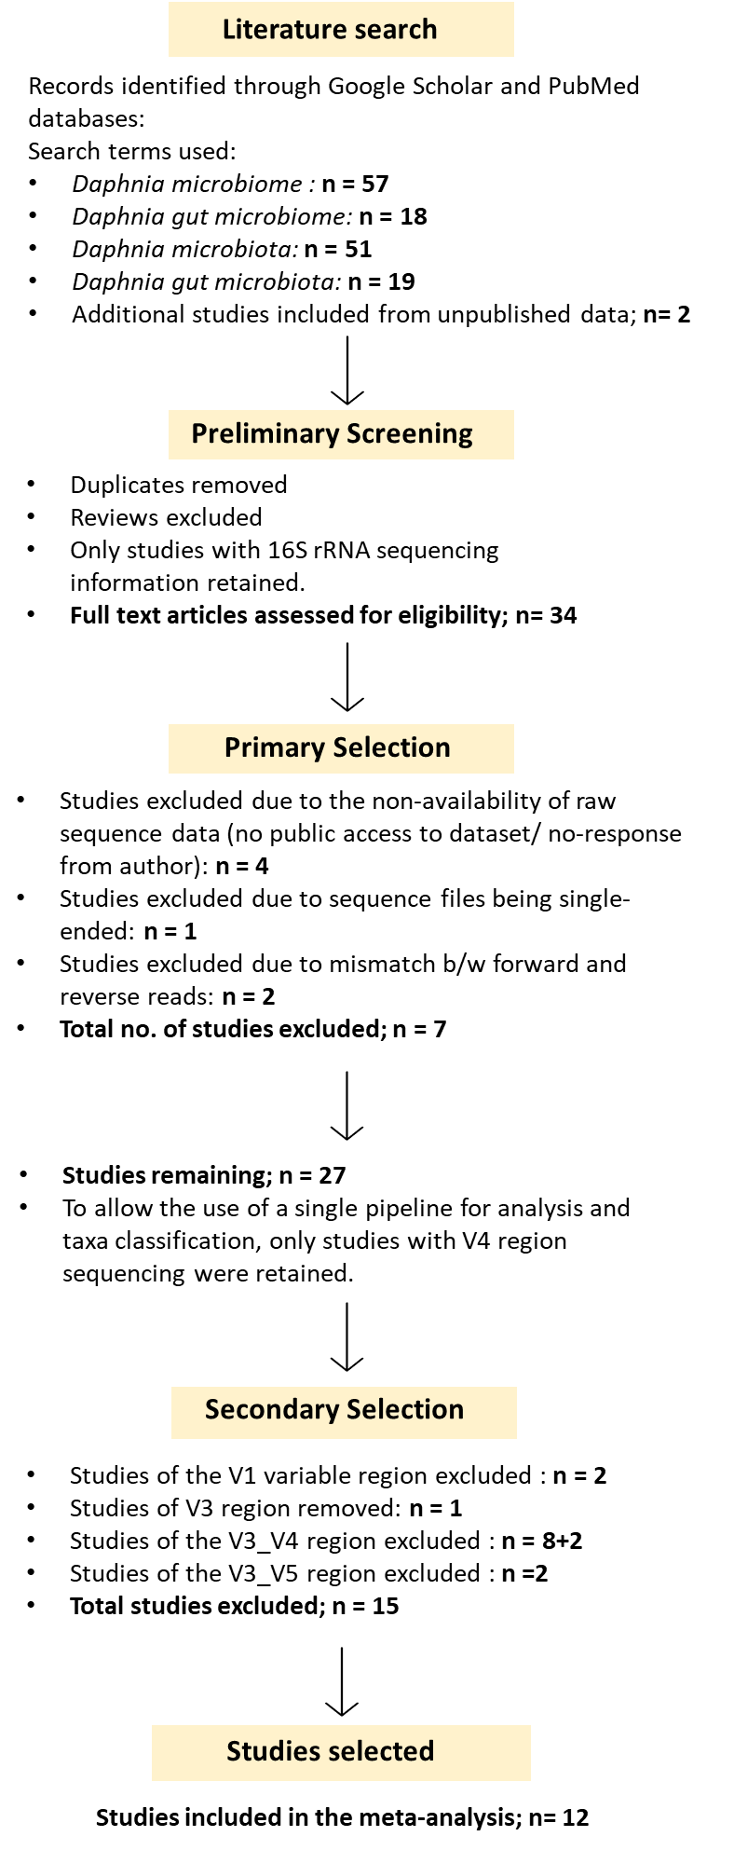
Figure 1: Schematic diagram of the workflow of the literature search and screening criteria for the selection of Daphnia microbiome studies for our analysis on core microbiome (adaptation of the PRISMA diagram, based on Moher et al. [34]). This analysis resulted in the selection of 12 studies that included a total of 656 samples originating from five countries, involving the gut as well as whole-body microbiomes of host animals directly collected from their source habitat as well as cultured in the laboratory. All studies involved the same host species, D. magna.

- Core microbiome in the combined dataset: all gut samples of laboratory and field origin
A total of 423 Daphnia gut microbiomes comprising both laboratory-cultured and field-grown animals were analyzed. This dataset comprised a total of 14,743,383 read counts representing 116,500 OTUs belonging to 957 genera and 29 phyla. From a higher-level analysis conducted at the “phylum” and “order” levels, four phyla were detected in 90% of these samples: Proteobacteria, Bacteroidetes, Actinobacteria and Firmicutes. At the order level, these were Burkholderiales, Chitinophagales, Flavobacteriales, Micrococcales, Rhizobiales and Bacillales. The same groups also met the double criterion of 10⁻⁴ relative abundances and 90% prevalence. The more stringent thresholds of 10⁻³ and 90% prevalence were met by the phyla Proteobacteria, Bacteroidetes and Actinobacteria and the orders Burkholderiales, Rhizobiales, and Micrococcales. Only the phylum Proteobacteria and order Burkholderiales met the 10⁻² relative abundance threshold at 90% prevalence. No taxa were detected on the basis of the relative abundance criteria alone in 99% of the samples.
At the OTU level, no taxa were detected at a 99% prevalence. Limnohabitans planktonicus (OTU1) was detected in the gut samples and was by far the most prevalent group in the digestive tract of Daphnia magna (90% prevalence). Other prevalent bacterial groups, identified at 80% prevalence, included Ideonella paludis and Variovorax sp. (OTU4) (both belonging to the family Comamonadaceae), Staphylococcus sp. (OTU41), unclassified Microbacteriaceae (OTU34) and Escherichia/Shigella sp. (OTU13). The results from the combined prevalence and relative abundance-based thresholds were quite aligned with the prevalence-defined thresholds. Only one OTU, Limnohabitans planktonicus (OTU 1), met the relative abundance threshold of 10⁻³ in 90% of the samples. Other members identified at 50% prevalence for a detection threshold of 10⁻⁴ included Formosimonas sp., Ideonella paludis, Variovorax sp., Pseudomonas sp., Escherichia/Shigella sp., Shinella sp., Emticicia sp., Streptococcus sp., Staphylococcus sp. and unclassified Chitinophagaceae, Rhodobacteriaceae and Comamonadaceae. At a detection threshold of 10⁻⁻³, Formosimonas sp., Variovorax sp., Ideonella paludis, Escherichia/Shigella sp. and unclassified Chitinophagaceae were detected in 50% of the samples. For an assigned threshold of 10⁻², Limnohabitans planktonicus was identified only at 50% prevalence.

- Microbial community composition
To gain an overview of the microbial composition at the different levels of categorization, namely based on countries, sample type and origin, stacked barplots were constructed using the packages microbiome, phyloseq and MicroViz in R. Taxonomic aggregation was carried out at the “Phylum” level to ease visualization and summarization of the top 5 phyla in the community. The top 5 phyla were selected based on their total count abundance in the dataset. To effectively ensure visualization of within-group compositional variation, individual samples are presented without averaging, allowing all samples in each group to be displayed. Additionally, samples were sorted by similarity based on the Bray Curtis distance measure.
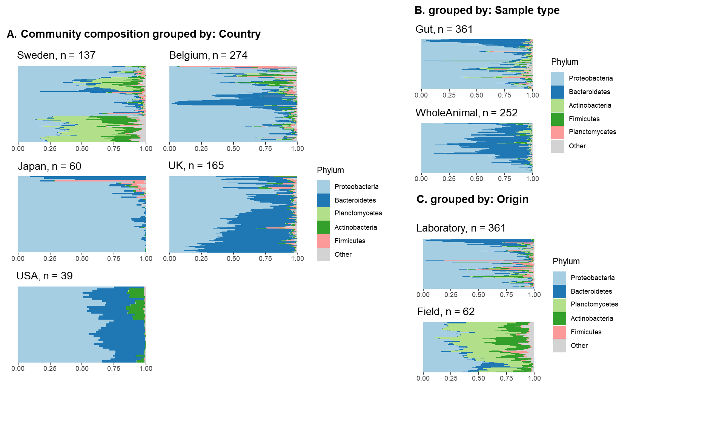
Figure 2: Stacked bar plots representing within-group variation in microbiome composition at the “Phylum” level for the following categorization. A) grouped by Country B) Sample type i.e., gut microbiome and whole microbiome (of laboratory reared animals only) C) Origin i.e., laboratory cultured or field collected samples (for gut samples only).

- Comparison of microbiome composition of laboratory and field samples originating from Lake Bysjön (Sweden)
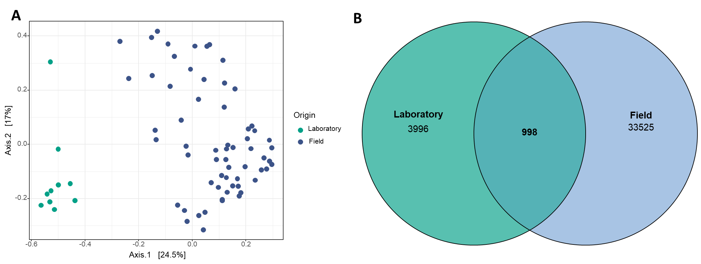
Figure 3: Comparison of laboratory-cultured samples with that of field-grown samples of the Sweden dataset (A) MDS plot highlighting the microbiome community composition of laboratory-cultured clones versus field-grown clones all derived from the same lake (Lake Bysjön, Sweden) (B) Venn diagram representing shared membership between the two sources of origin. From a total of 39,810 OTUs, there occurred an overlap of 998 OTUs exhibiting a 2.5% shared membership between these environments.

References
1. Turnbaugh PJ, Ley RE, Hamady M, Fraser-Liggett CM, Knight R, Gordon JI. The Human Microbiome Project. Nature. 2007;449:804–10.
2. Hamady M, Knight R. Microbial community profiling for human microbiome projects: Tools, techniques, and challenges. Genome Res. 2009;19:1141–52.
3. Risely A. Applying the core microbiome to understand host–microbe systems. J Anim Ecol. 2020;89:1549–58.
4. Macke E, Callens M, De Meester L, Decaestecker E. Host-genotype dependent gut microbiota drives zooplankton tolerance to toxic cyanobacteria. Nat Commun. 2017;8:1608.
5. Callens M, Watanabe H, Kato Y, Miura J, Decaestecker E. Microbiota inoculum composition affects holobiont assembly and host growth in Daphnia. Microbiome. 2018;6:56.
6. Macke E, Callens M, Massol F, Vanoverberghe I, De Meester L, Decaestecker E. Diet and Genotype of an Aquatic Invertebrate Affect the Composition of Free-Living Microbial Communities. Front Microbiol. 2020; 11:380
7. Callens M, De Meester L, Muylaert K, Mukherjee S, Decaestecker E. The bacterioplankton community composition and a host genotype dependent occurrence of taxa shape the Daphnia magna gut bacterial community. FEMS Microbiol Ecol. 2020;96:fiaa128.
8. Cooper RO, Vavra JM, Cressler CE. Targeted Manipulation of Abundant and Rare Taxa in the Daphnia magna Microbiota with Antibiotics Impacts Host Fitness Differentially. mSystems. 2021;6:10.1128/msystems.00916-20.
9. Houwenhuyse S, Stoks R, Mukherjee S, Decaestecker E. Locally adapted gut microbiomes mediate host stress tolerance. ISME J. 2021;15:2401–14.
10. Hegg A, Radersma R, Uller T. A field experiment reveals seasonal variation in the Daphnia gut microbiome. Oikos. 2021;130:2191–201.
11. Cooper RO, Tjards S, Rischling J, Nguyen DT, Cressler CE. Multiple generations of antibiotic exposure and isolation influence host fitness and the microbiome in a model zooplankton species. FEMS Microbiol Ecol. 2022; 10: p.fiac082
12. Bulteel L, Houwenhuyse S, Declerck SAJ, Decaestecker E. The Role of Microbiome and Genotype in Daphnia magna upon Parasite Re-Exposure. Genes. 2021;12:70.
13. Pfenning-Butterworth A, Cooper RO, Cressler CE. Daily feeding rhythm linked to microbiome composition in two zooplankton species. PLOS ONE. 2022;17:e0263538.
14. Gorokhova E, Rivetti C, Furuhagen S, Edlund A, Ek K, Breitholtz M. Bacteria-Mediated Effects of Antibiotics on Daphnia Nutrition. Environ Sci Technol. 2015;49:5779–87.
15. Callens M, Macke E, Muylaert K, Bossier P, Lievens B, Waud M, et al. Food availability affects the strength of mutualistic host–microbiota interactions in Daphnia magna. ISME J.2016; 10:911-20.
16. Mushegian AA, Walser J-C, Sullam KE, Ebert D. The microbiota of diapause: How host–microbe associations are formed after dormancy in an aquatic crustacean. J Anim Ecol. 2018;87:400–13.
17. Sullam KE, Pichon S, Schaer TMM, Ebert D. The Combined Effect of Temperature and Host Clonal Line on the Microbiota of a Planktonic Crustacean. Microb Ecol. 2018;76:506–17.
18. Preiswerk D, Walser J-C, Ebert D. Temporal dynamics of microbiota before and after host death. ISME J.
19. Sison-Mangus MP, Metzger CMJA, Ebert D. Host genotype-specific microbiota do not influence the susceptibility of D. magna to a bacterial pathogen. Sci Rep. 2018;8:9407.
20. Mushegian AA, Arbore R, Walser J-C, Ebert D. Environmental Sources of Bacteria and Genetic Variation in Behavior Influence Host-Associated Microbiota. Appl Environ Microbiol. 2019;85:e01547-18.
21. Fong JC, De Guzman BE, Lamborg CH, Sison-Mangus MP. The Mercury-Tolerant Microbiota of the Zooplankton Daphnia Aids in Host Survival and Maintains Fecundity under Mercury Stress. Environ Sci Technol. 2019;53:14688–99.
22. Frankel-Bricker J, Song MJ, Benner MJ, Schaack S. Variation in the Microbiota Associated with Daphnia magna Across Genotypes, Populations, and Temperature. Microb Ecol. 2020;79:731–42.
23. Motiei A, Brindefalk B, Ogonowski M, El-Shehawy R, Pastuszek P, Ek K, et al. Disparate effects of antibiotic-induced microbiome change and enhanced fitness in Daphnia magna. PLoS One. 2020;15:e0214833.
24. Sadeq SA, Mills RIL, Beckerman AP. The microbiome mediates the interaction between predation and heavy metals. Science of The Total Environment. 2021;775:145144.
25. Suppa A, Kvist J, Li X, Dhandapani V, Almulla H, Tian AY, et al. Roundup causes embryonic development failure and alters metabolic pathways and gut microbiota functionality in non-target species. Microbiome. 2020;8:170.
26. Akbar S, Gu L, Sun Y, Zhou Q, Zhang L, Lyu K, et al. Changes in the life history traits of Daphnia magna are associated with the gut microbiota composition shaped by diet and antibiotics. Sci Tot Environ. 2020;705:135827.
27. Sangkuanun T, Wichienchot S, Kato Y, Watanabe H, Peerakietkhajorn S. Oligosaccharides derived from dragon fruit modulate gut microbiota, reduce oxidative stress and stimulate toll-pathway related gene expression in freshwater crustacean Daphnia magna. Fish Shellfish Immunol. 2020;103:126–34.
28. Liu Q, Akbar S, Ding Z, Zhou Q, Gu L, Sun Y, et al. Anti-predation Defense Traits of Daphnia are Associated With the Gut Microbiota Composition Shaped by Fish Kairomone [Internet]. Research Square; 2021 [cited 2025 Jan 22]. Available from: https://www.researchsquare.com/article/rs-757585/v1
29. Li Y, Xu Z, Liu H. Nutrient-imbalanced conditions shift the interplay between zooplankton and gut microbiota. BMC Genomics. 2021;22:37.
30. Akbar S, Huang J, Zhou Q, Gu L, Sun Y, Zhang L, et al. Elevated temperature and toxic Microcystis reduce Daphnia fitness and modulate gut microbiota. Environmental Pollution. 2021;271:116409.
31. Akbar S, Li X, Ding Z, Liu Q, Huang J, Zhou Q, et al. Disentangling Diet- and Medium-Associated Microbes in Shaping Daphnia Gut Microbiome. Microb Ecol. 2022;84:911–21.
32. El-Shehawy R, Luecke-Johansson S, Ribbenstedt A, Gorokhova E. Microbiota-Dependent and -Independent Production of l-Dopa in the Gut of Daphnia magna. mSystems. 2021;6:e00892-21.
33. Rajarajan A, Wolinska J, Walser J-C, Dennis SR, Spaak P. Host-Associated Bacterial Communities Vary Between Daphnia galeata Genotypes but Not by Host Genetic Distance. Microb Ecol. 2023;85:1578–89.
34. Moher D, Liberati A, Tetzlaff J, Altman DG, PRISMA Group. Preferred reporting items for systematic reviews and meta-analyses: the PRISMA statement. PLoS Med. 2009;6:e1000097.

