Supplementals

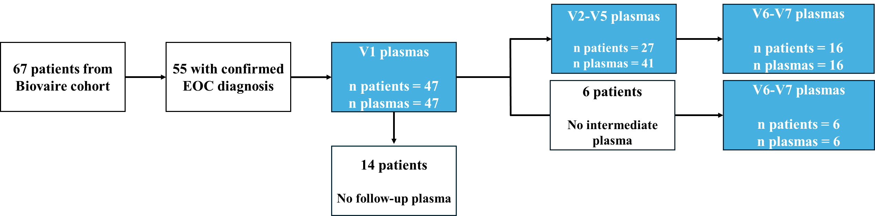

Supplemental Figure 1: Consort diagram of plasma samples used in the study.

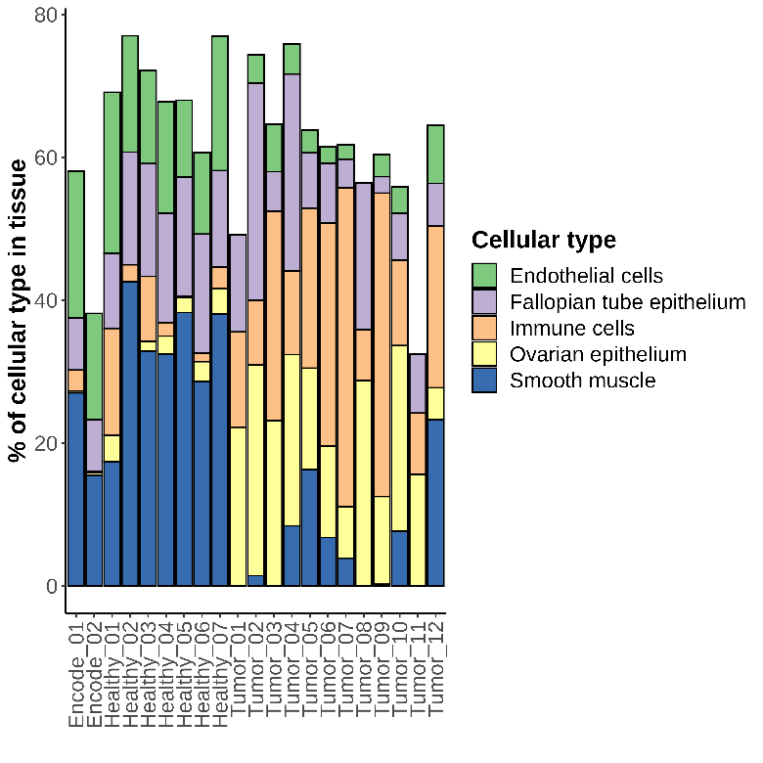
Supplemental Figure 2: Deconvolution of methylation signal from normal ovarian tissues (n = 9) and ovarian tumors (n = 12) using UXM_deconv algorithm (16).

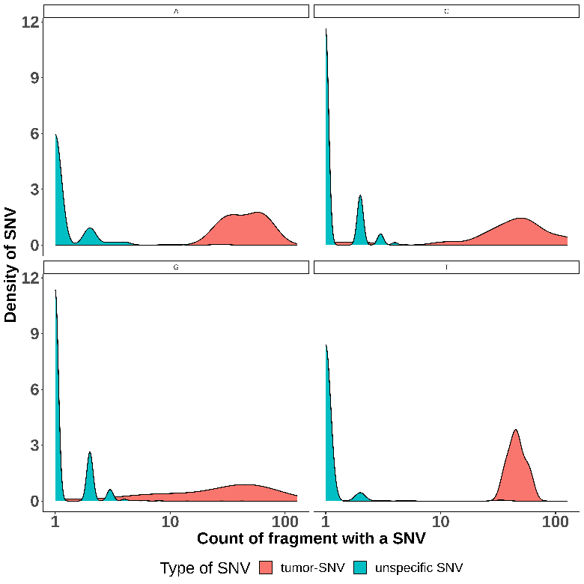
Supplemental Figure 3: This density plot illustrates the distribution of fragment counts for expected variants (tumor-SNVs, shown in red) versus unspecific variants (shown in blue) for a patient before the beginning of the chemotherapy (V1). Expected SNVs are supported by multiple fragments (up to 127), whereas unspecific SNVs are typically supported by only a few fragments (1 to 4). Additionally, sequencing errors are more frequent at cytosine and guanosine bases. A statistical analysis was conducted to compare the frequencies of unspecific and expected SNVs by base type, facilitating the distinction of true ctDNA signals and potential sequencing artifacts.

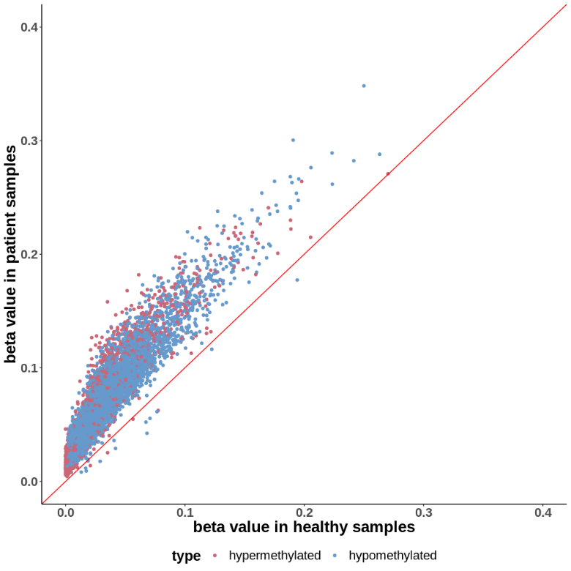
Supplemental Figure 4: Scatter plot illustrating the correlation of average beta values between healthy and baseline patient plasma samples for each retained DMR. Tumor hypermethylated DMRs are shown in red, while tumor hypomethylated DMRs are shown in blue, highlighting the increasing of beta value in the tumor plasma patients as compared to healthy plasma subject.
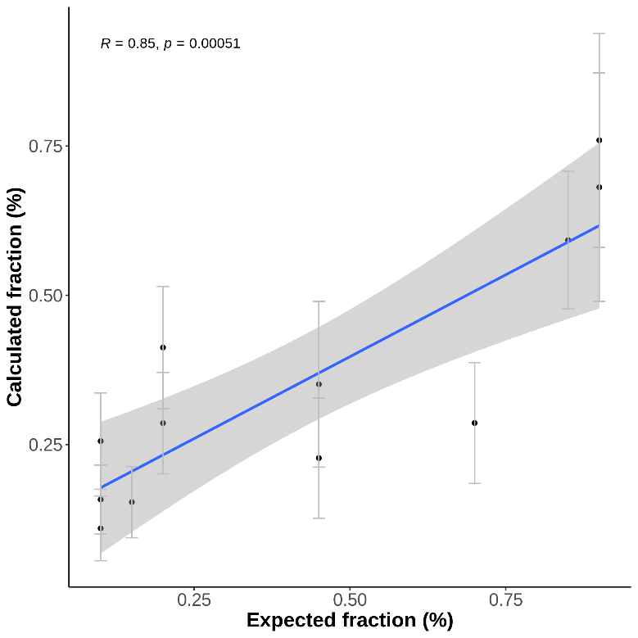
Supplemental Figure 5: Correlation between tumoral DNA quantified by beta values of selected DMRs and expected values from in-house mixes of DNA (n = 12). Error bars represent the 95% confidence intervals of the beta values from DMRs used for tumoral DNA quantification.

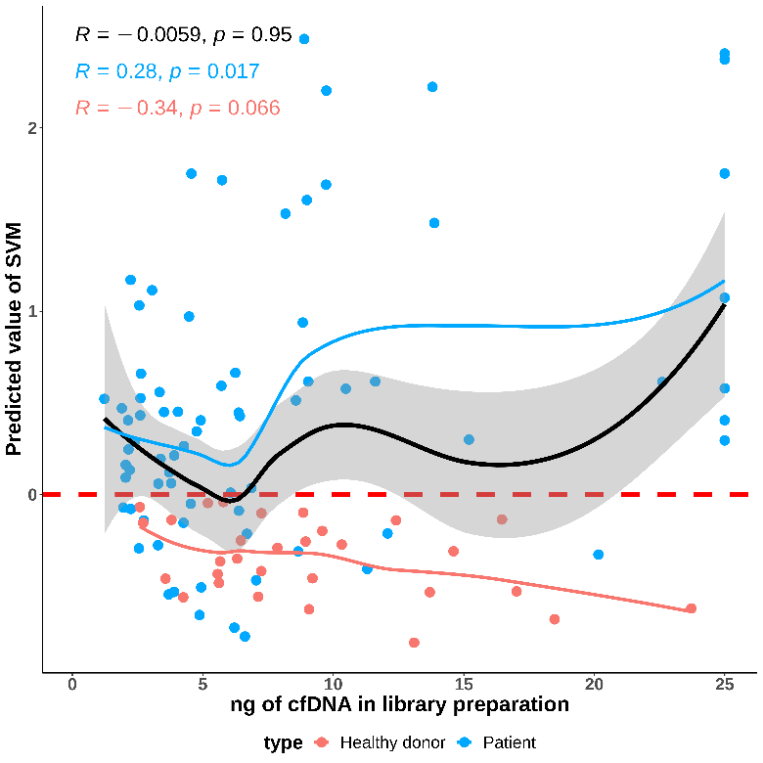

Supplemental Figure 6: Correlation between cfDNA input in library preparation and SVM model predicted values. EOC patient plasmas are represented in blue (n = 75), while healthy subject plasmas are in red (n = 30). The horizontal red dashed line represents the prediction value threshold for sample classification. The black line shows the correlation between predicted values and input amounts for all samples, while the blue line corresponds to patient plasma samples and the red line to healthy subject plasma samples.

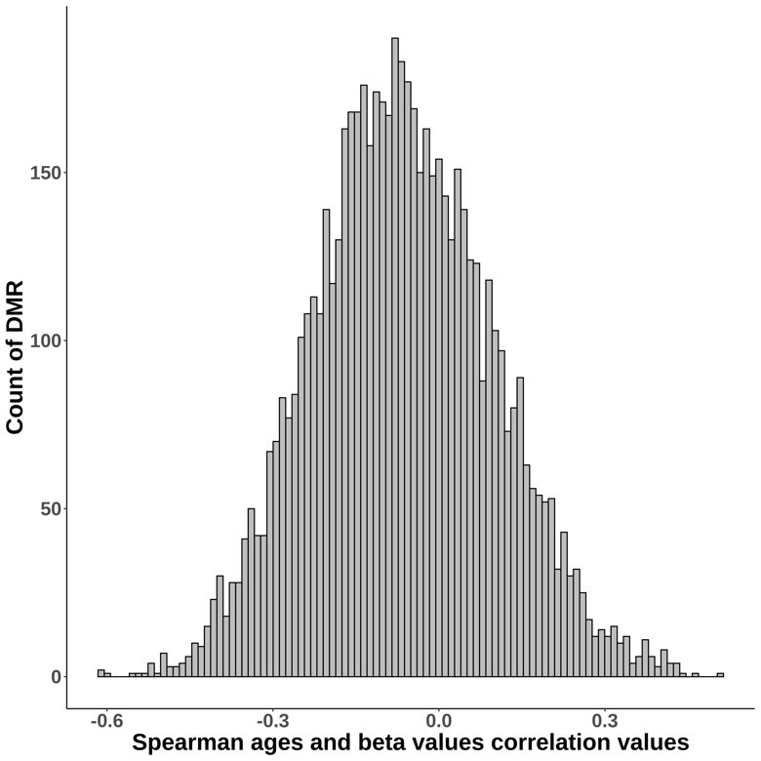

Supplemental Figure 7: Histogram showing the distribution of correlation values for the association between DMRs beta values and healthy donors ages (n = 54 healthy samples).

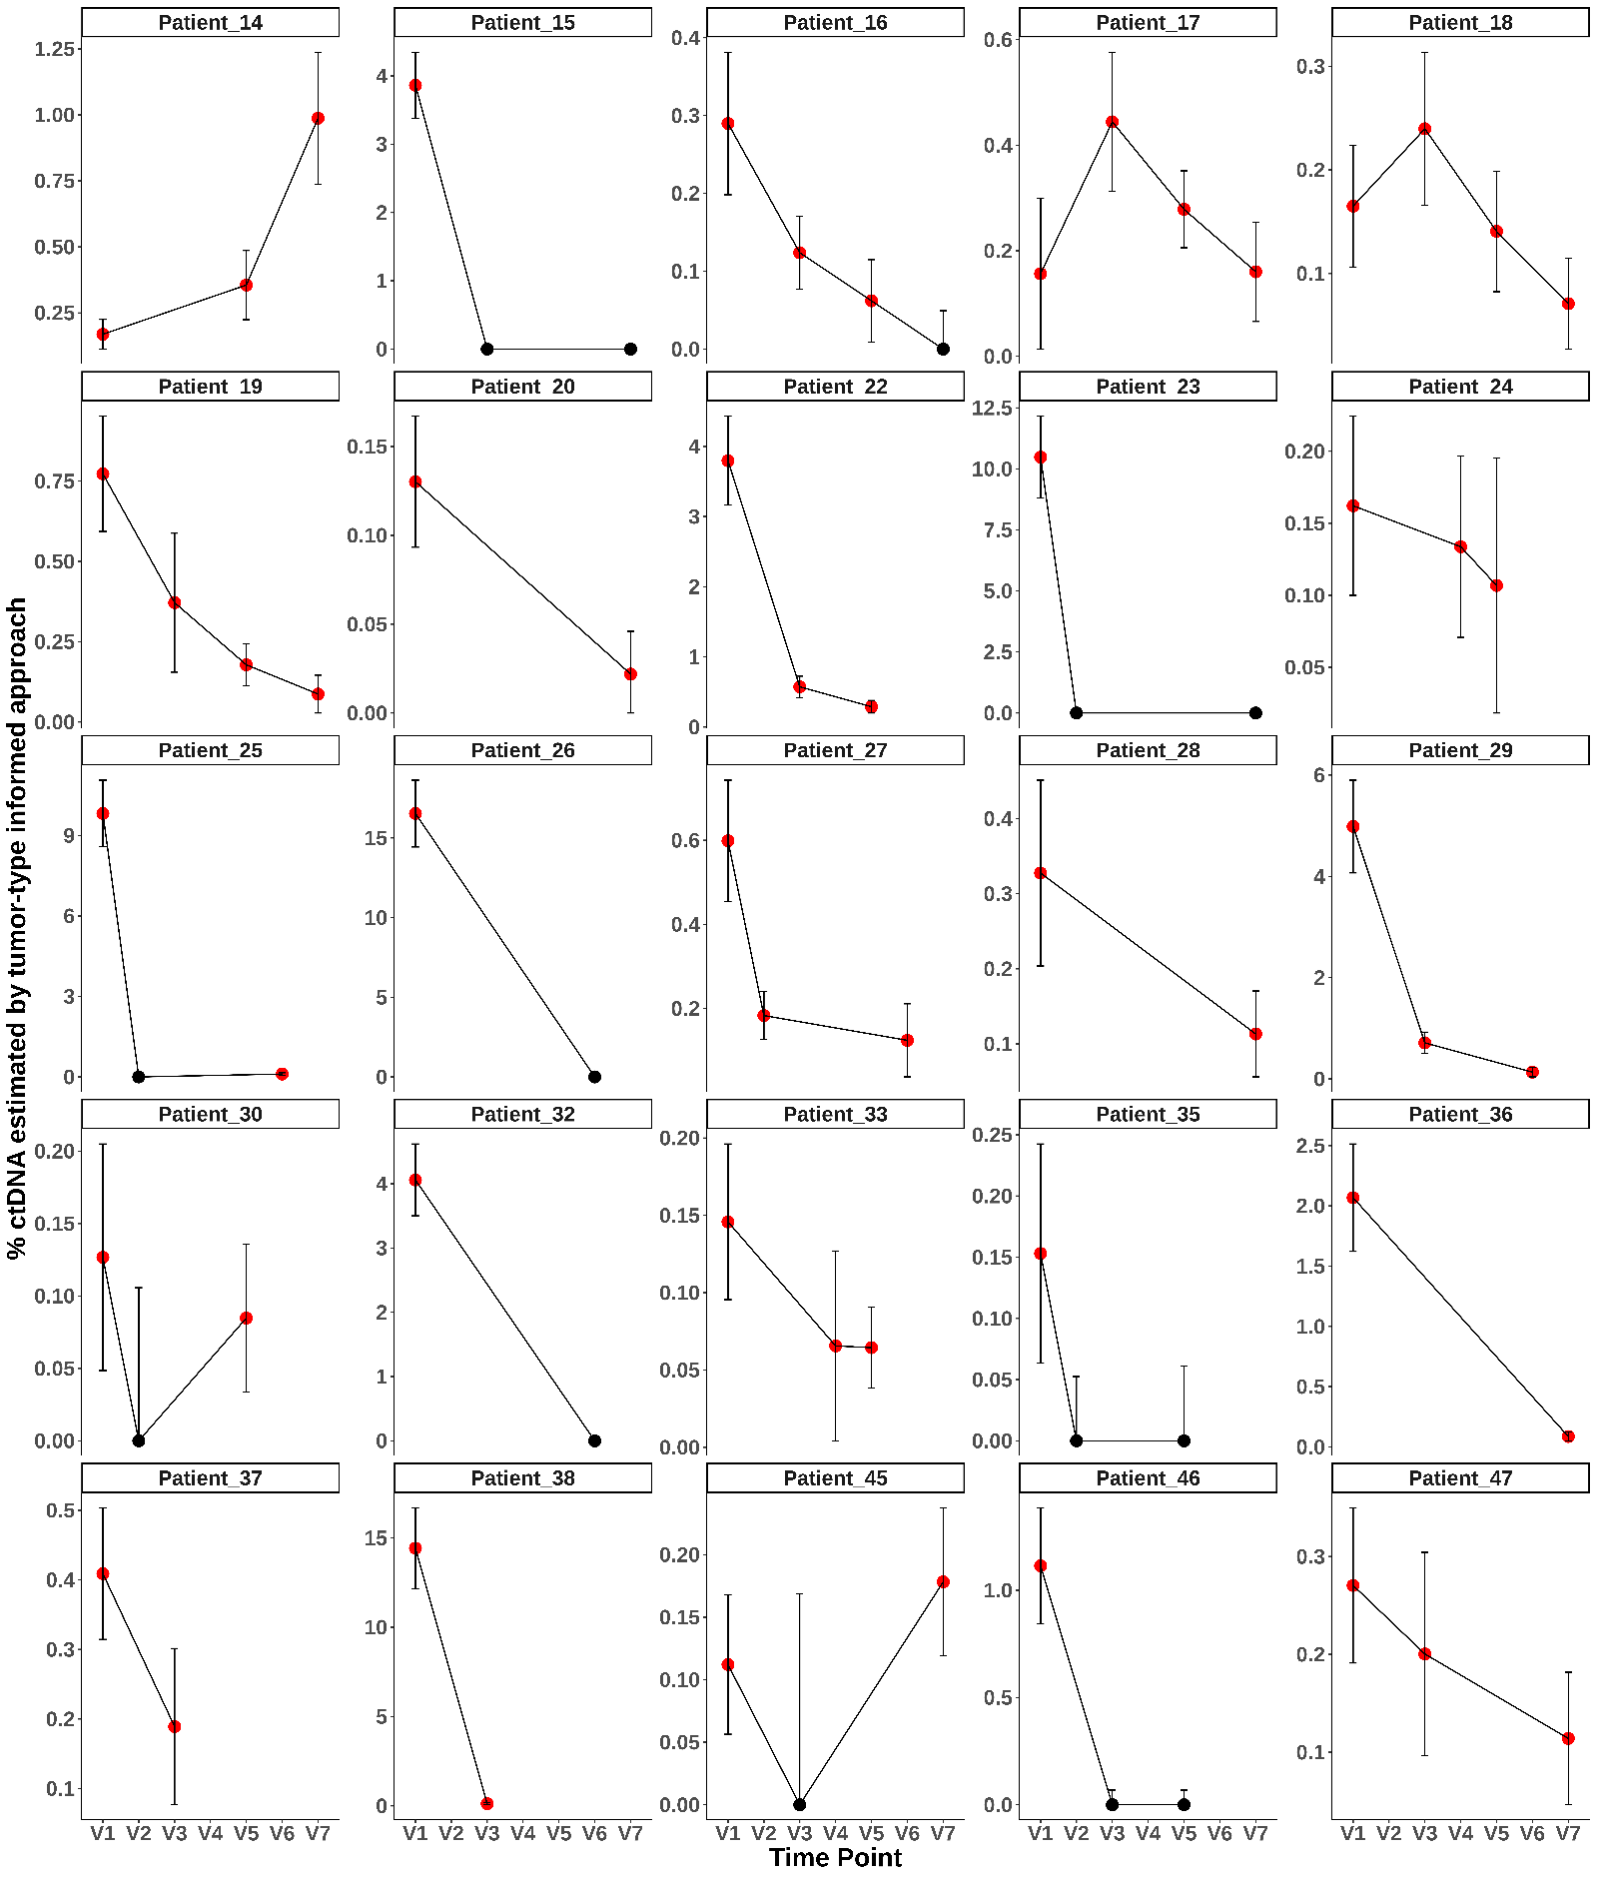
Supplemental Figure 8: ctDNA follow-up with the tumor-type informed approach for patients with multiple plasma samples available and not analyzed with tumor-informed approach. Error bars show the 95% confidence interval (CI95) of beta values for DMRs selected for ctDNA quantification. Red points indicate positive predicted value for ctDNA presence, while black points are negative.

