Supplementary Information

Optical spin readout of a silicon color center in the telecom L-band

Shuyu Wen,^{1,2,3} Gregor Pieplow,⁴ Junchun Yang,^{1,5} Kambiz Jamshidi,⁵ Manfred Helm,^{1,5} Jun-Wei Luo,^{2,3} Tim Schröder,⁴ Shengqiang Zhou,^{1*} & Yonder Berencén^{1**}

¹Helmholtz-Zentrum Dresden-Rossendorf, Institute of Ion Beam Physics and Materials Research, Bautzner Landstrasse 400, 01328 Dresden, Germany
²State Key Laboratory of Superlattices and Microstructures, Institute of Semiconductors, Chinese Academy of Sciences, Beijing 100083, China
³Center of Materials Science and Optoelectronics Engineering, University of Chinese Academy of Sciences, Beijing 100049, China
⁴Humboldt-Universität zu Berlin, Department of Physics, 12489 Berlin, Germany
⁵Technische Universität Dresden, 01062 Dresden, Germany

Corresponding authors: s.zhou@hzdr.de* y.berencen@hzdr.de**

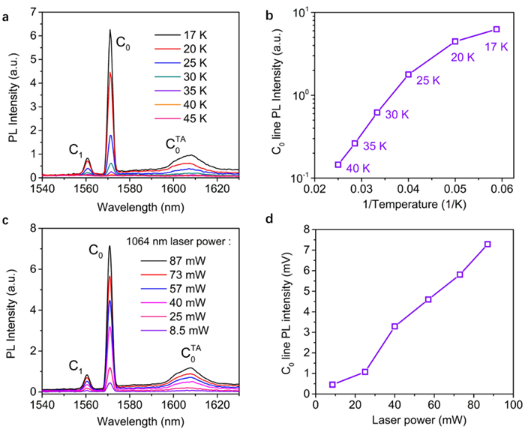
Supplementary Figure S1 | Temperature and excitation power dependence of the photoluminescence (PL) spectra of an ensemble of C centers in silicon. a, Temperature-dependent PL measurement of the C center emission line under 57 mW of 1064 nm laser excitation. The PL signal from the C center is fully quenched above 45 K. b, Near-linear relationship between 1/temperature and the PL intensity of the C₀ line. c, Laser power-dependent PL measurement at 20 K. d, Near-linear relationship between the excitation laser power and the PL intensity of the C₀ line.

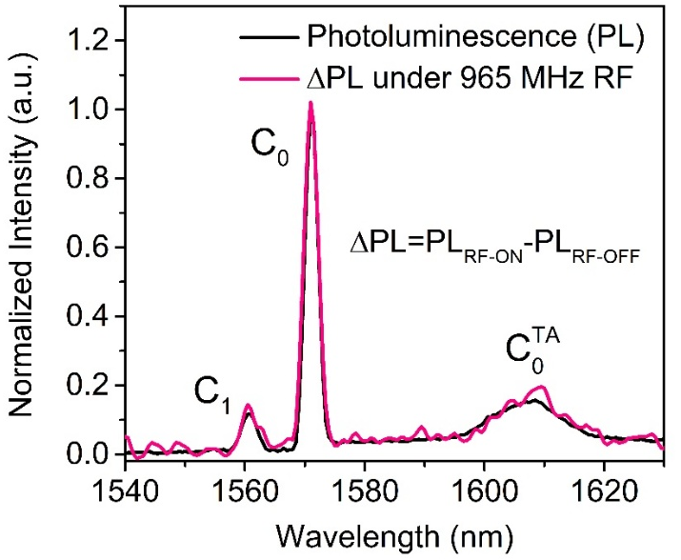
Supplementary Figure S2 | Line shape comparison between PL and RF-modulated PL of the C center in silicon. Comparison of the photoluminescence (PL) spectrum (black) and the differential PL signal ΔPL = PL_{RF-ON} - PL_{RF-OFF} (magenta) under 965 MHz RF excitation and 1064 nm laser excitation. Both the C₀ and C₁ emission lines exhibit optically detected magnetic resonance (ODMR).

