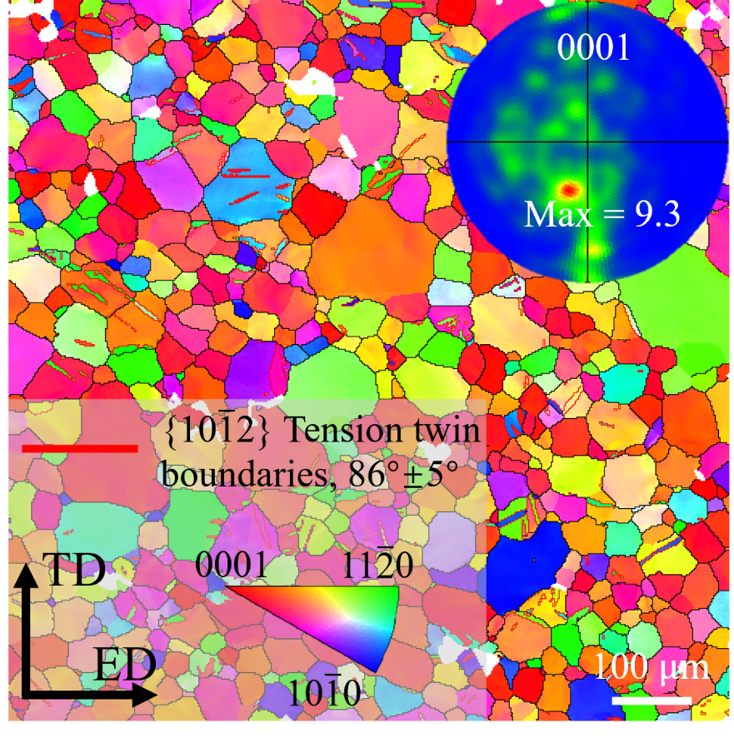
Fig. A1 Supplementary figure of the initial microstructure of the Mg-Zn-Ca sample

