Supplementary Materials
A

Table S1 Oomycete isolates recovered from declining alder (Alnus glutinosa and A. incana) stands in Switzerland with their respective substrate of origin and sequence GenBank accession numbers.
Isolate No. | Species | Isolation source | Accession No.
GN513 | P. bilorbang | Soil | PV082471
GN516 | P. chlamydospora | Soil | PV082472
GN518 | P. chlamydospora | Soil | PV082473
GN509 | P. citrophthora | Water | PV082474
GN519 | P. citrophthora | Water | PV082475
GN520 | P. citrophthora | Water | PV082476
GN131 | P. pseudocryptogea | Soil | PV082477
GN515 | P. gallica | Soil | PV082478
GN531 | P. gallica | Soil | PV082479
GN536 | P. gallica | Soil | PV082480
GN88 | P. gonapodyides | Water | PV082481
GN152 | P. gonapodyides | Soil | PV082482
GN244 | P. gonapodyides | Soil | PV082483
GN507 | P. heteromorpha | Soil | PV082484
GN485 | P. honggalleglyana | Soil | PV082485
GN491 | P. honggalleglyana | Soil | PV082486
GN496 | P. honggalleglyana | Soil | PV082487
GN95 | P. lacustris | Soil | PV082488
GN229 | P. lacustris | Soil | PV082489
GN236 | P. lacustris | Soil | PV082490
GN10 | P. niederhauseri | Soil | PV082491
GN11 | P. niederhauseri | Soil | PV082492
GN5 | P. plurivora | Soil | PV082493
GN376 | P. plurivora | Soil | PV082494
GN484 | P. plurivora | Water | PV082495
GN482 | P. pseudosyringae | Soil | PV082496
GN528 | P. bilorbang | Soil | PV082497
GN531 | P. bilorbang | Soil | PV082498
GN19 | P. × alni | Soil | PV082499
GN210 | P. × alni | Bark | PV082500
GN211 | P. × alni | Bark | PV082501
GN20 | Py. aquatile | Soil | PV082502
GN57 | Py. aquatile | Soil | PV082503
GN106 | Py. aquatile | Soil | PV082504
GN59 | Py. lutarium | Soil | PV082505
GN73 | Pp. chamaehyphon | Water | PV082506
GN171 | Pp. chamaehyphon | Soil | PV082507
GN200 | Pp. chamaehyphon | Soil | PV082508
GN43 | Pp. citrinum | Soil | PV082509
GN405 | Pp. citrinum | Soil | PV082510
GN474 | Pp. citrinum | Soil | PV082511
GN71 | Pp. litorale | Water | PV082512
GN488 | Pp. litorale | Soil | PV082513
GN526 | Pp. litorale | Soil | PV082514
GN7 | Pp. montanum | Soil | PV082515
GN352 | Pp. paucipapillatum | Soil | PV082516
GN468 | Pp. paucipapillatum | Soil | PV082517
GN476 | Pp. paucipapillatum | Soil | PV082518
GN389 | Pp. vexans | Soil | PV082519
GN532 | Pp. vexans | Soil | PV082520
GN533 | Pp. vexans | Soil | PV082521
GN45 | G. heterothallicum | Soil | PV082522
GN16 | G. intermedium | Soil | PV082523
GN26 | G. intermedium | Soil | PV082524

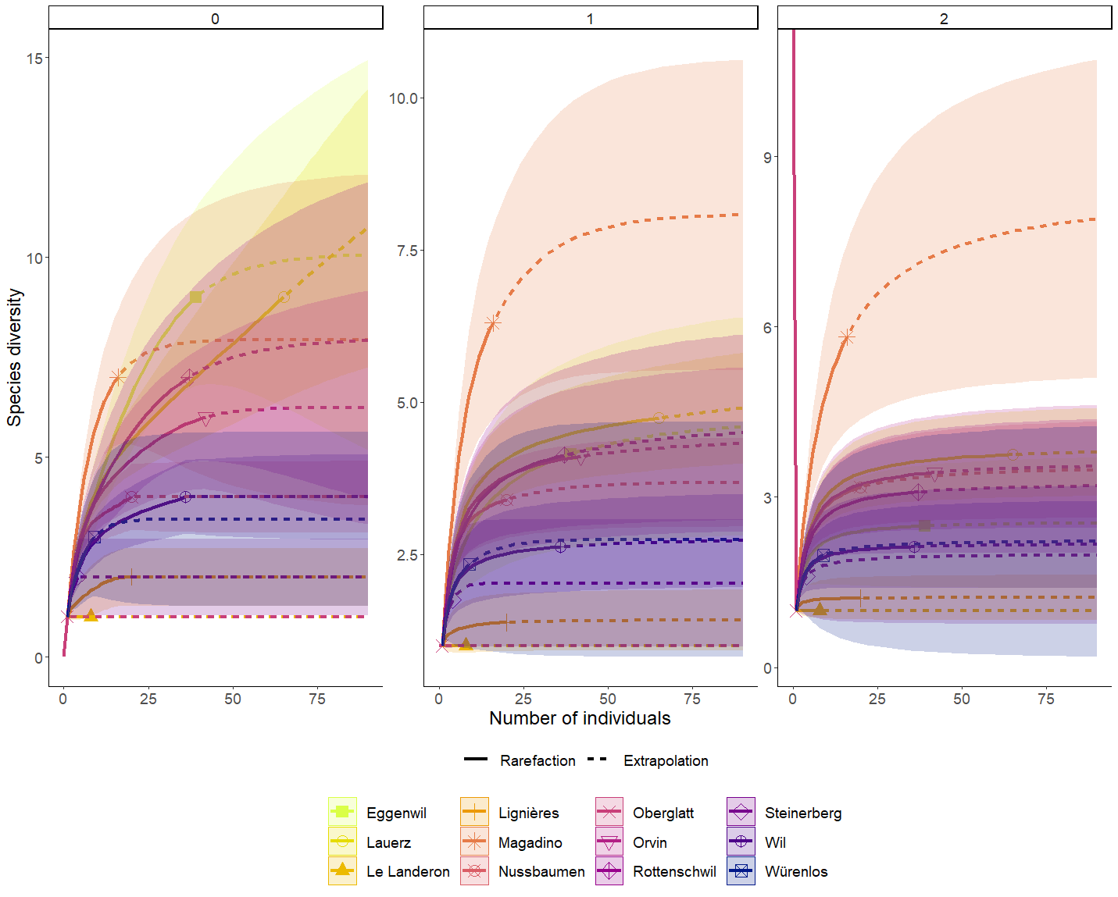

Fig. S1 Oomycete diversity in the rhizosphere soil of symptomatic alder trees at 12 different sites sampled during the present study (for more information see Tables 1 and 3) in Switzerland. The comparison is shown by individual abundance-based rarefaction (solid lines) and extrapolation curves (dashed lines). Each panel is based on the first three Hill numbers [32, 33]: ⁰D (left panel), ¹D (middle panel) and ²D (right panel). The color-shaded regions show the 95% confidence intervals.

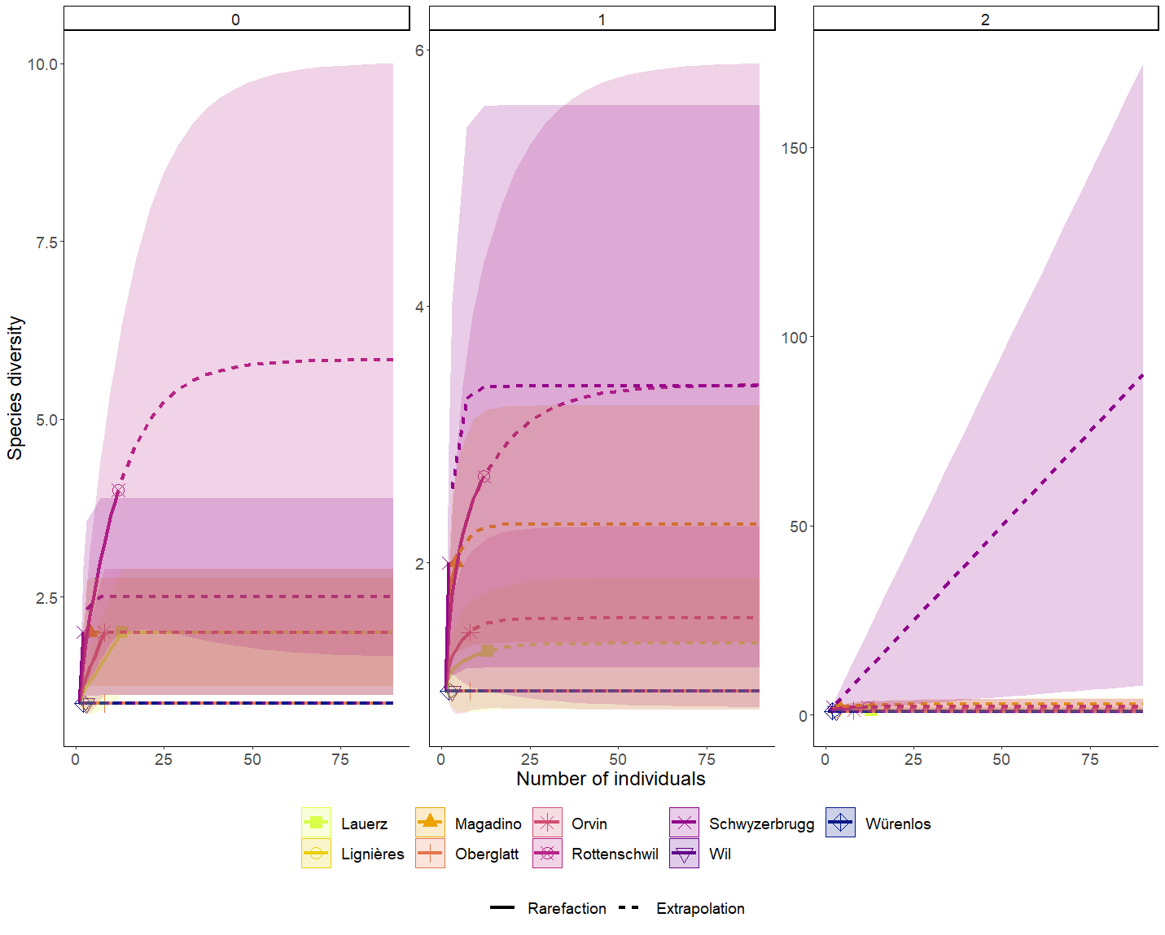
Fig. S2 Oomycete diversity in water samples taken in the declining alder stands at 9 different sites in Switzerland (for more information see Tables 1 and 3). The comparison is shown by individual abundance-based rarefaction (solid lines) and extrapolation curves (dashed lines). Each panel is based on the first three Hill numbers [32, 33]: ⁰D (left panel), ¹D (middle panel) and ²D (right panel). The color-shaded regions show the 95% confidence intervals.

