Supplemental Figure 1 (a,b): Preliminary cohort data. (c,d) Replicate cohort data. Statistics were not performed on the first cohort data alone as n sizes were too small (n=2-4/ group). Effects of DMT 2 mg/kg , Harmaline 1.5 mg/kg, DMT 2 mg/kg + Harmaline 1.5 mg/kg, and DMT 4mg/kg + Harmaline 1.5 mg/kg on total ROS production in the prefrontal cortex and hippocampus of predator exposed rats + daily psychosocial stress (PE/PSS) a) Total ROS in the prefrontal cortex: Control vs PE/PSS and PE/PSS + treatment. b) Total ROS production in the hippocampus: Control vs PE/PSS and PE/PSS + treatment. c) Effects of DMT 2 mg/kg , Harmaline 1.5 mg/kg, and DMT 2 mg/kg + Harmaline 1.5 mg/kg on total ROS production in the prefrontal cortex and d) hippocampus of Sprague Dawley rats with and without PE/PSS
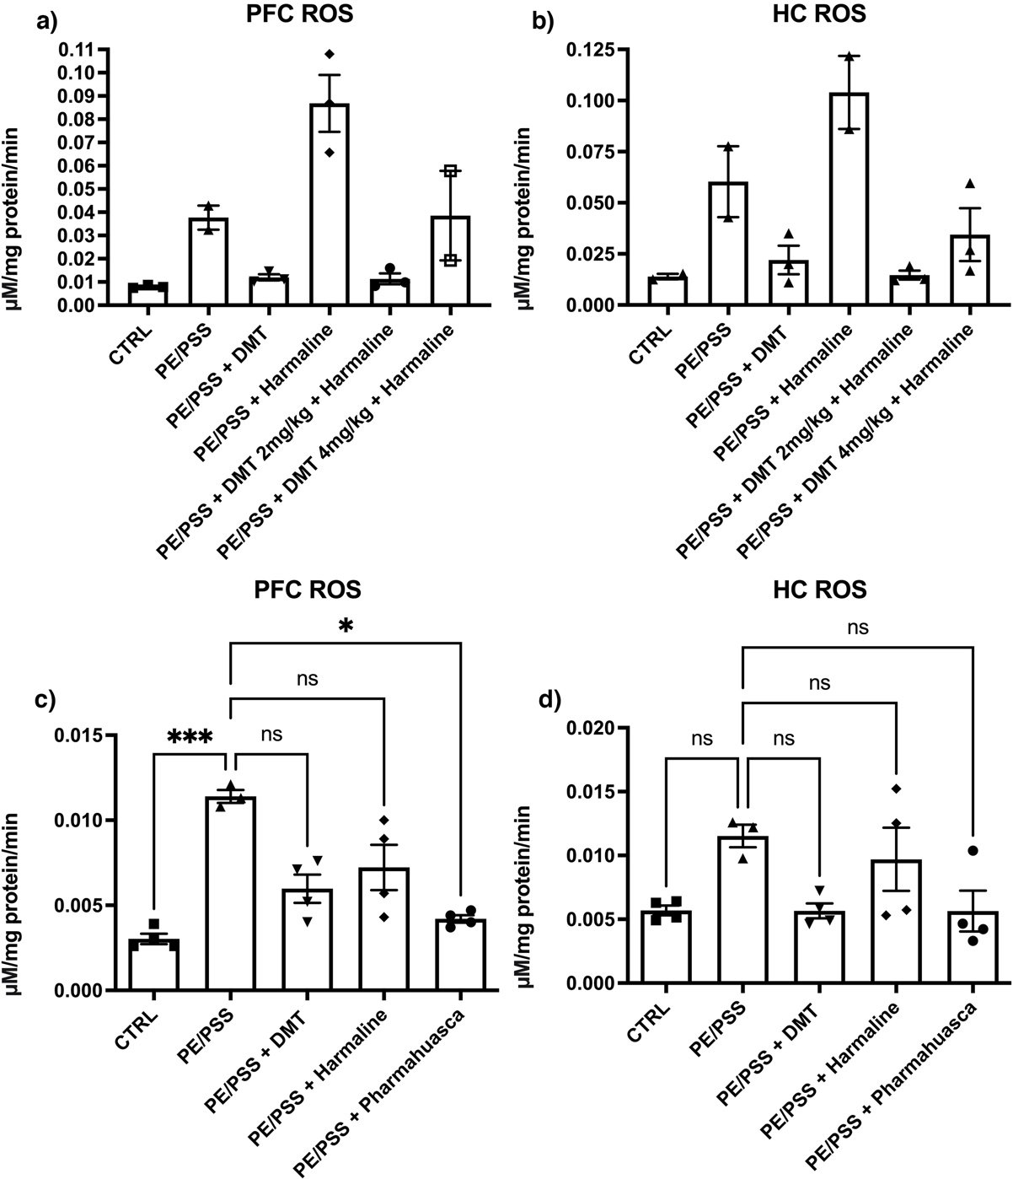

Supplemental Figure 2: Heat plot for pairwise comparisons between control, PE/PSS, and PE/PSS + treatment groups. The heatmap illustrates hierarchical clustering of the scaled counts (z-scores) for a set of biologically relevant differentially expressed genes (FDR<0.1).

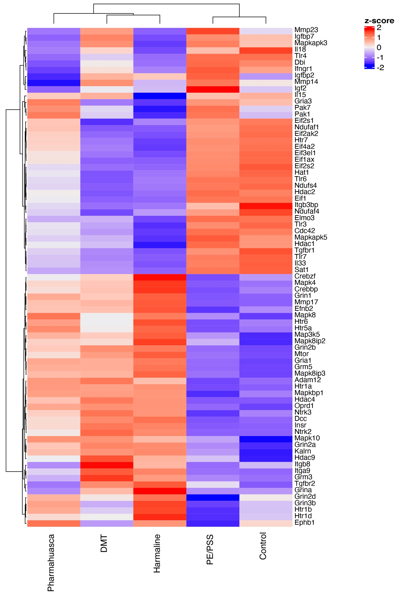

Supplemental Figure 3 (a-o) Novel differentially expressed genes (DEG) observed by RNAseq between control and “PTSD” animals and the effects of DMT alone, harmaline alone, and DMT + Harmaline on their expression. Significance notations are plotted from the RUVseq bioinformatics analysis used to produce differentially expressed genes (DEG).

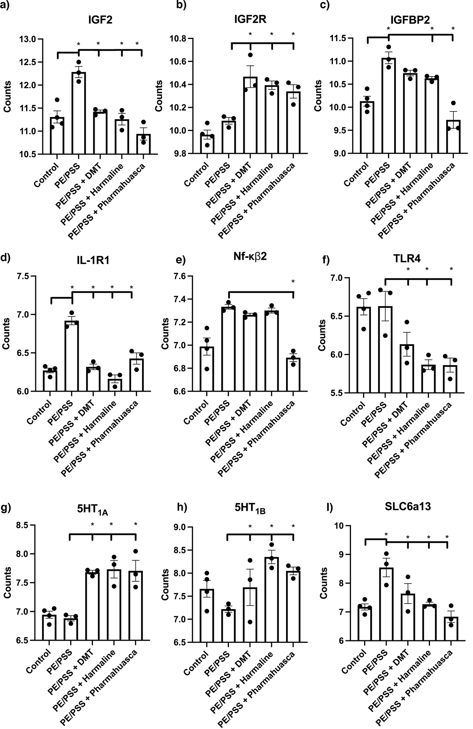
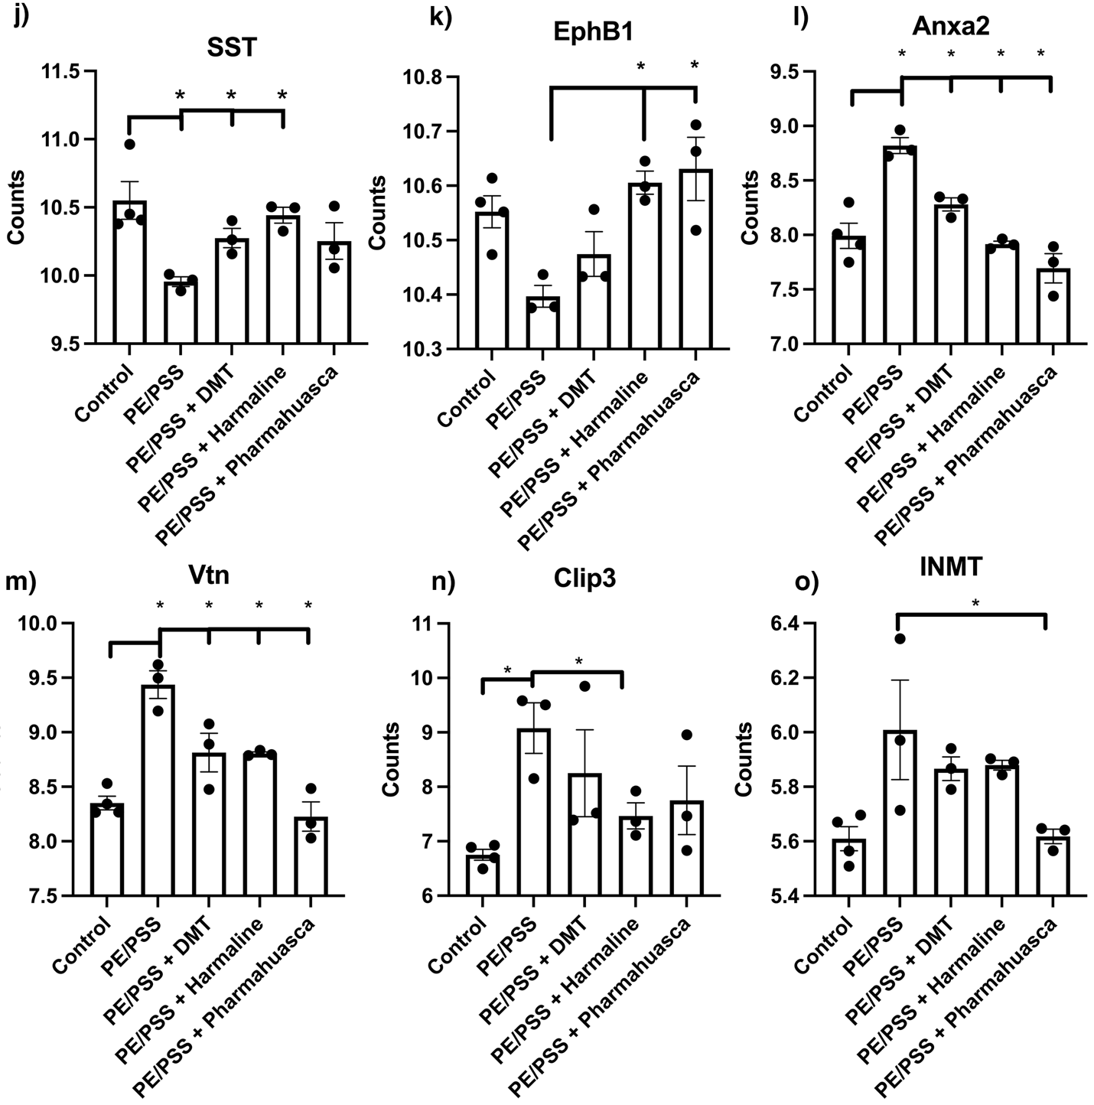

Supplemental Figure 4-6: Heat plot and volcano plots for pair wise comparisons between the treatment/control and PTSD groups
The heatmaps illustrate hierarchical clustering of the top 500 most variable genes obtained from pairwise comparisons, except for the Control vs PTSD group where the analysis returned 193 genes (all shown). The heatmap in 2A illustrated supervised hierarchical clustering shows of the averaged counts for a subset of genes implicated in PTSD pathology. The volcano plots illustrate differentially expressed genes in pairwise comparisons (LFC>1, FDR>0.1).

Supplemental Figure 4
a. Volcano plot and b. Heat plot: PE/PSS vs DMT (all genes = 3869)
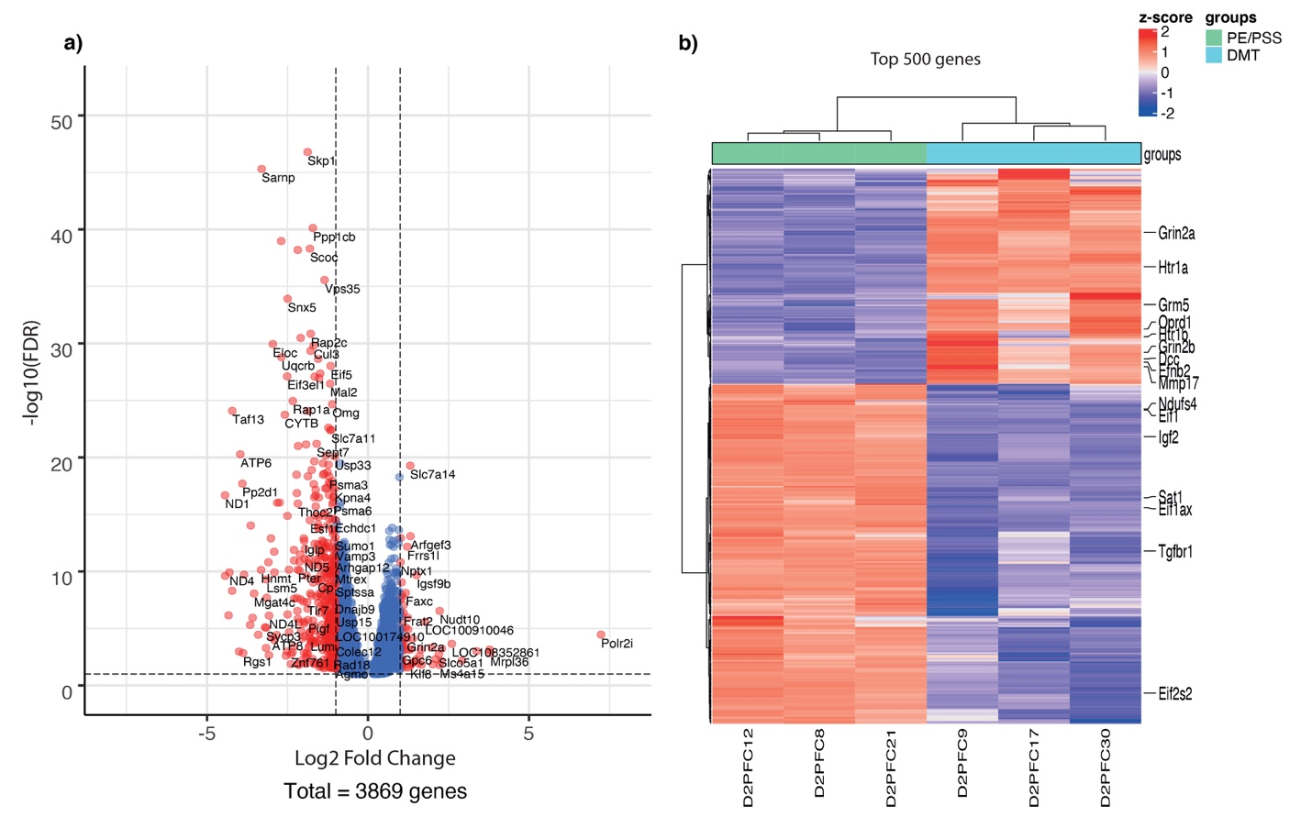

Supplemental Figure 5
a. Volcano plot and b. Heat plot: PE/PSS vs Harmaline (all genes = 5278)

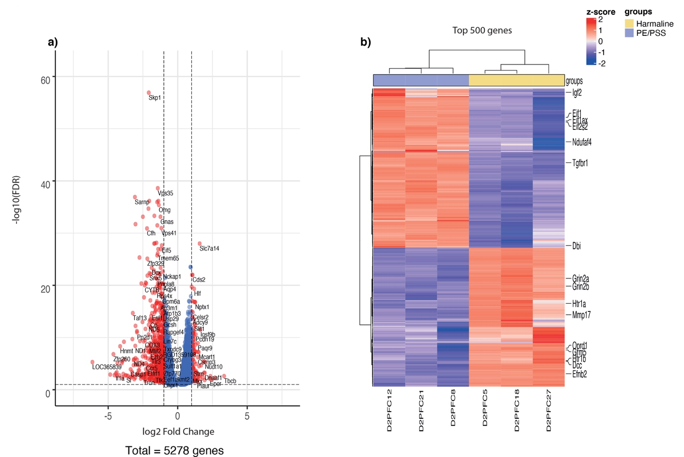

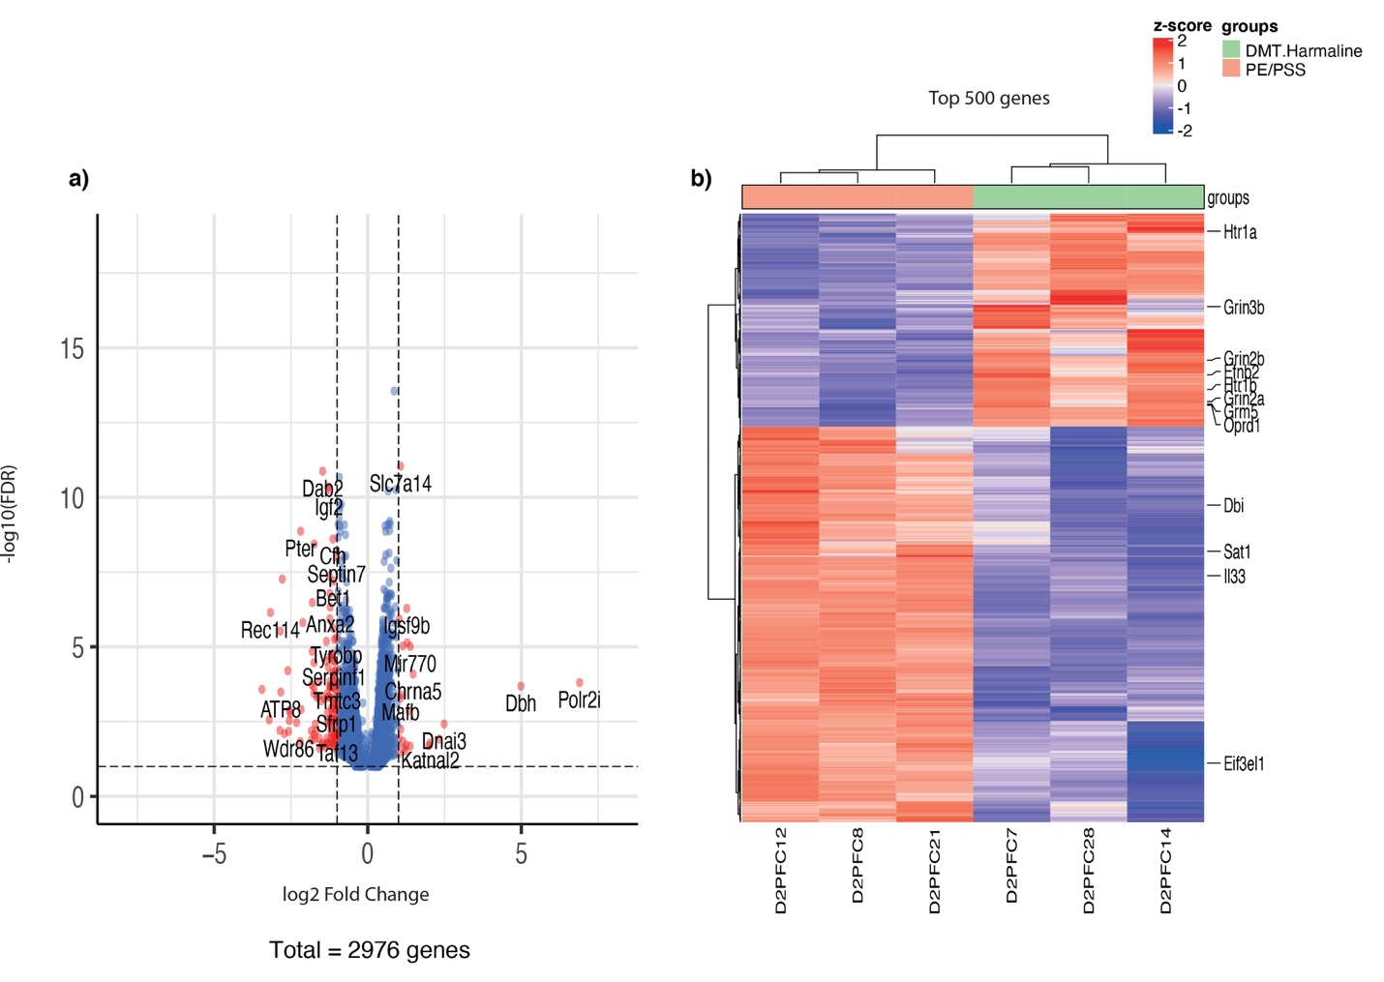
Supplemental Figure 6
a. Volcano plot and b. Heat plot: PE/PSS vs Pharmahuasca (all genes = 2976)

Supplemental Figure 7 Gene Set Enrichment Analysis (GSEA) for Gene Ontology (GO) cellular component and GO Biological Process analysis of PE/PSS vs PE/PSS + DMT, PE/PSS + Harmaline, and PE/PSS + Pharmahuasca. a) GO cellular component for DMT b) GO biological process for DMT c) GO cellular component for Harmaline d) GO biological process for Harmaline e) GO cellular component for Pharmahuasca f) GO biological process for Pharmahuasca

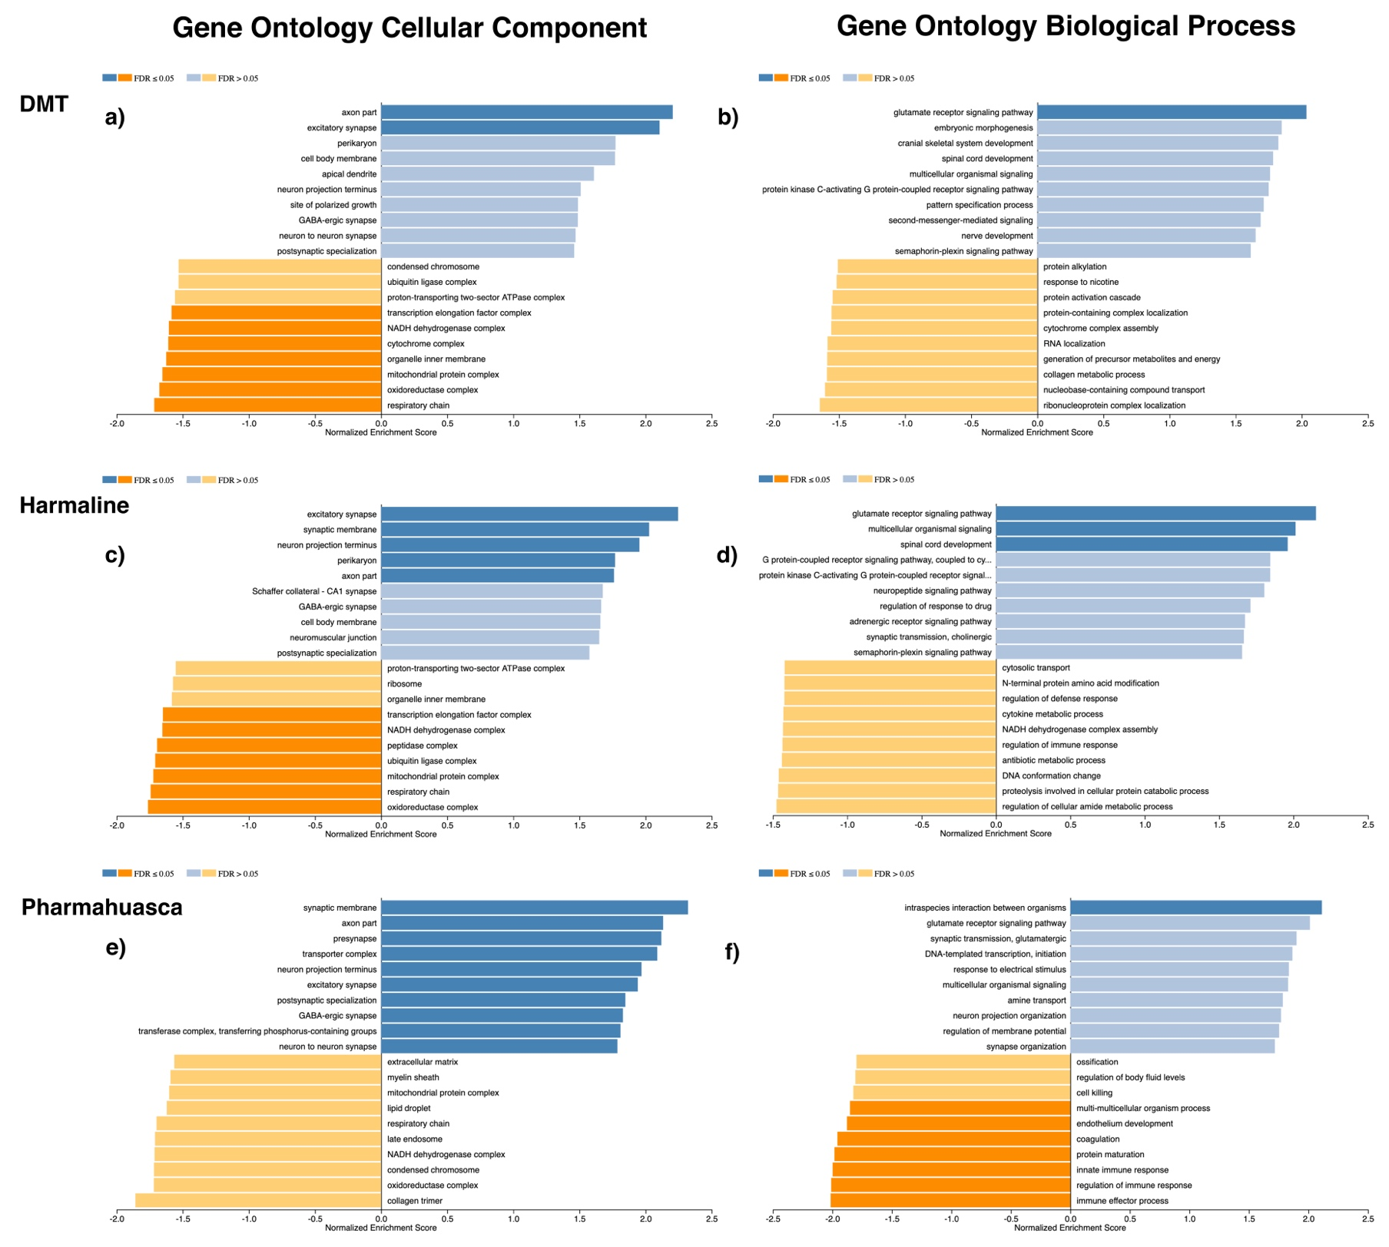

Supplemental Figure 8: KEGG pathway analysis of PE/PSS vs PE/PSS + DMT, PE/PSS + Harmaline, and PE/PSS + Pharmahuasca a) DMT b) Harmaline c) Pharmahuasca

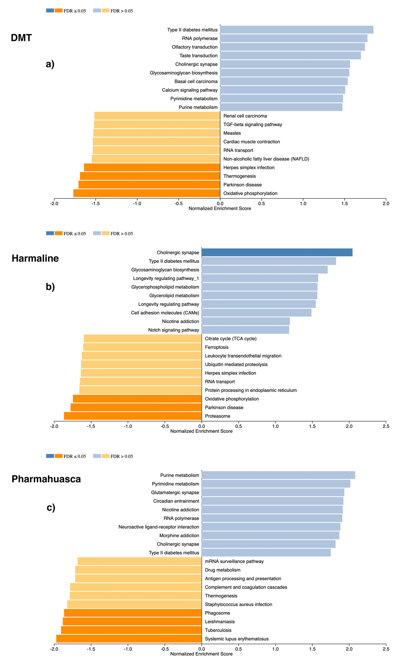

Supplemental Figure 9: Effects of PE/PSS + DMT vs PE/PSS + Vehicle on the IPA NRF2-mediated Oxidative Stress Response pathway. Red indicates upregulated transcripts; green indicates downregulated transcripts and grey indicates uncertainty in the direction of modulation. White indicates parts of the pathway that do not significantly differ between groups.
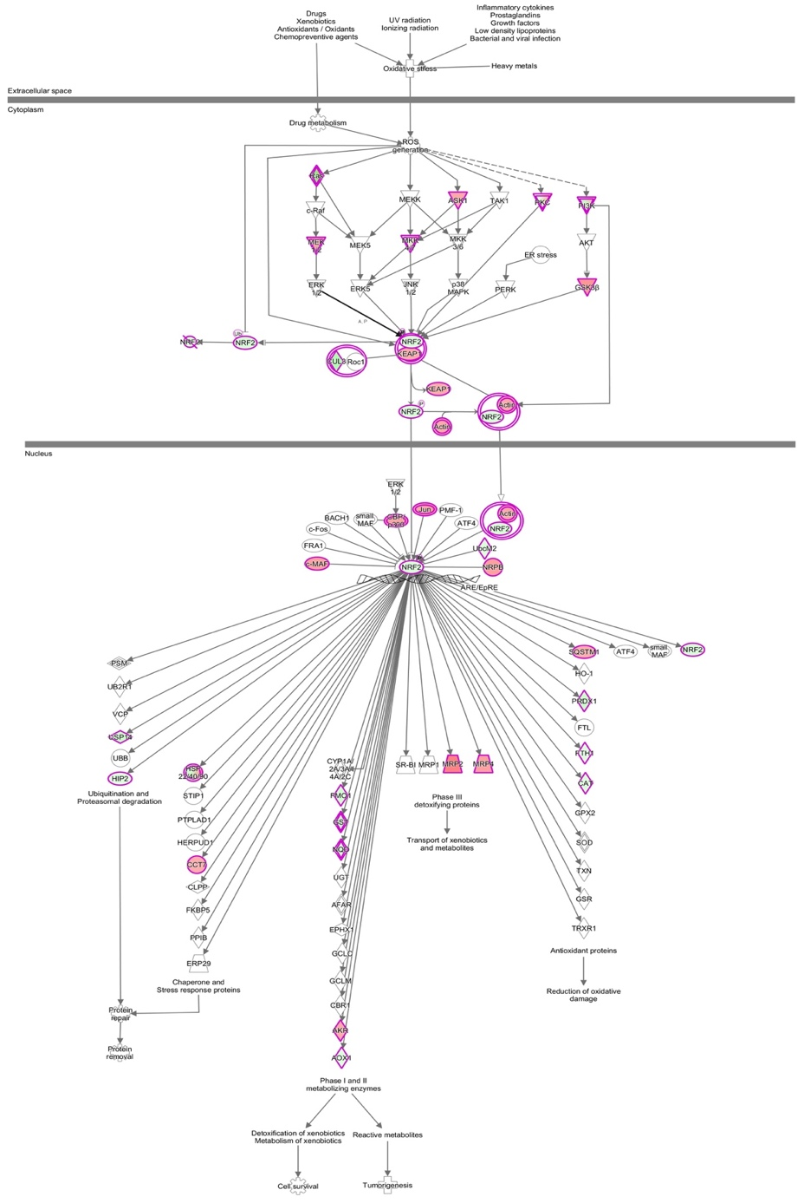
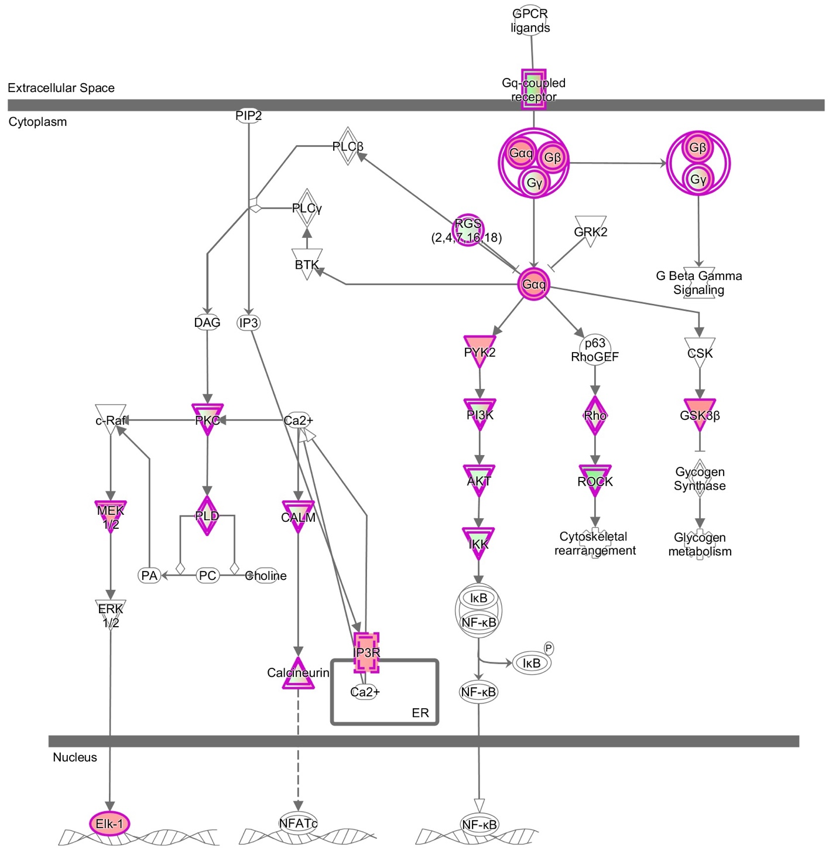
Supplemental Figure 10: Schematic of transcriptional changes in the IPA Gα_{q} signaling pathway between PE/PSS + DMT vs PE/PSS animals. Red indicates upregulated transcripts and green indicates downregulated transcripts and grey indicates uncertainty in the direction of modulation. White indicates parts of the pathway that do not significantly differ between groups

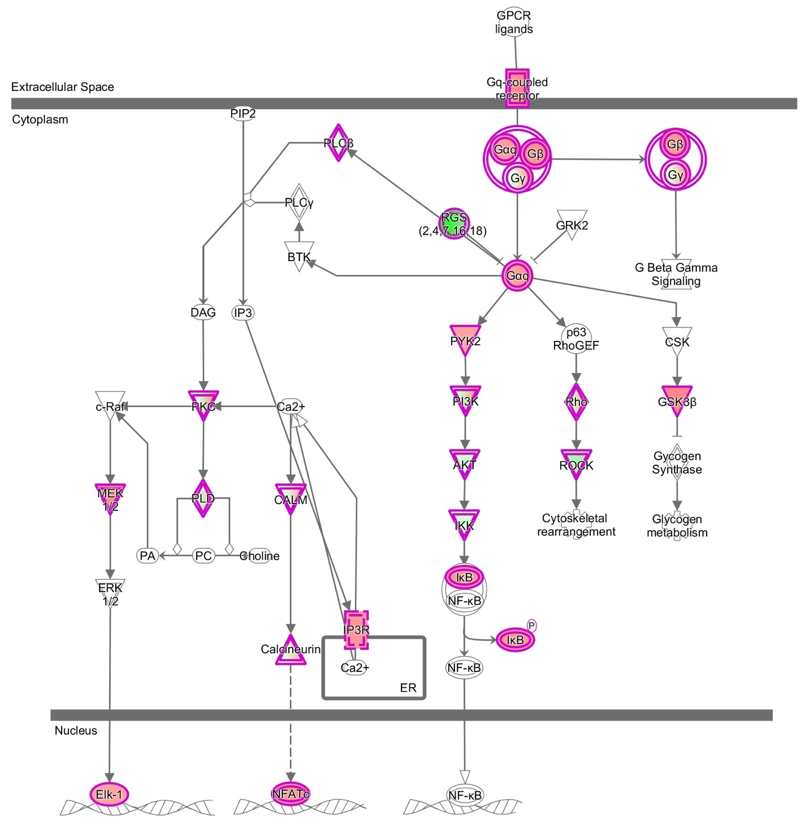
Supplemental Figure 11: Effects of PE/PSS + Harmaline vs PE/PSS animals on the IPA Gα_{q} signaling pathway. Red indicates upregulated transcripts; green indicates downregulated transcripts and grey indicates uncertainty in the direction of modulation. White indicates parts of the pathway that do not significantly differ between groups

Supplemental Figure 12: Effects of PE/PSS + Pharmahuasca vs PE/PSS animals on IPA Neuroinflammation pathway. Red indicates upregulated transcripts; green indicates downregulated transcripts and grey indicates uncertainty in the direction of modulation. White indicates parts of the pathway that do not significantly differ between groups

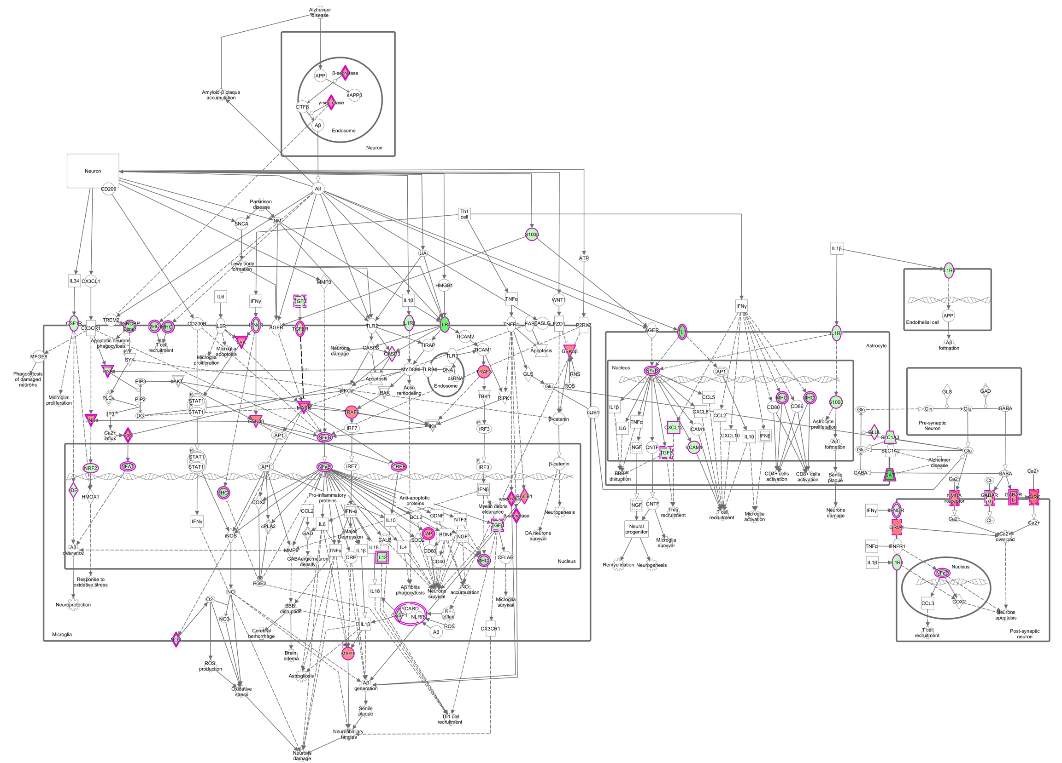
Supplemental Figure 13: Schematic of transcriptional changes in the IPA Synaptogenesis Signaling pathway between PE/PSS + Pharmahuasca vs PE/PSS + Vehicle treated animals. Red indicates upregulated transcripts; green indicates downregulated transcripts and grey indicates uncertainty in the direction of modulation. White indicates parts of the pathway that do not significantly differ between groups

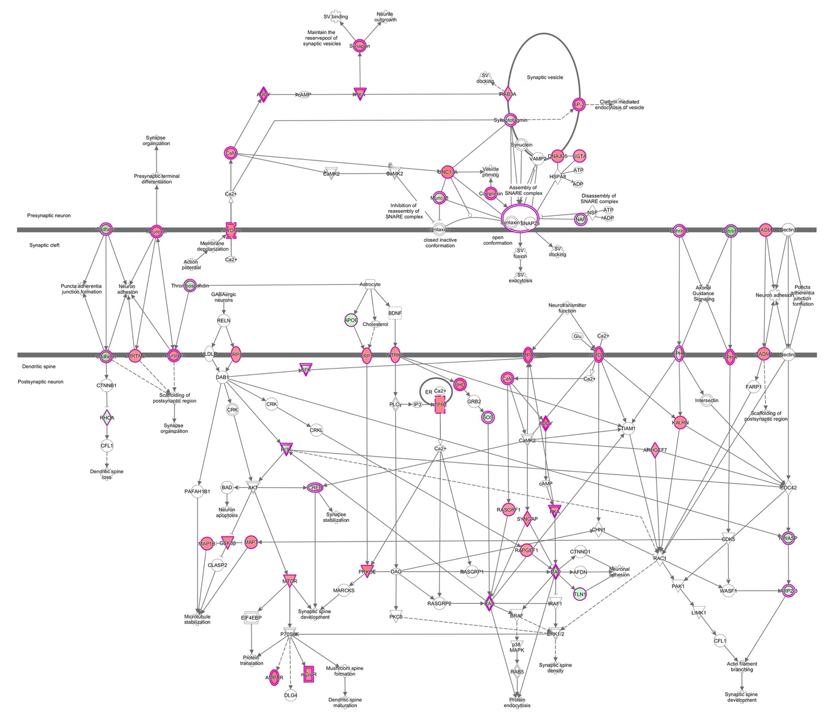

Supplemental Figure 14: Effects of PE/PSS + Pharmahuasca vs PE/PSS animals on IPA Opioid signaling pathway. Red indicates upregulated transcripts; green indicates downregulated transcripts and grey indicates uncertainty in the direction of modulation. White indicates parts of the pathway that do not significantly differ between groups.

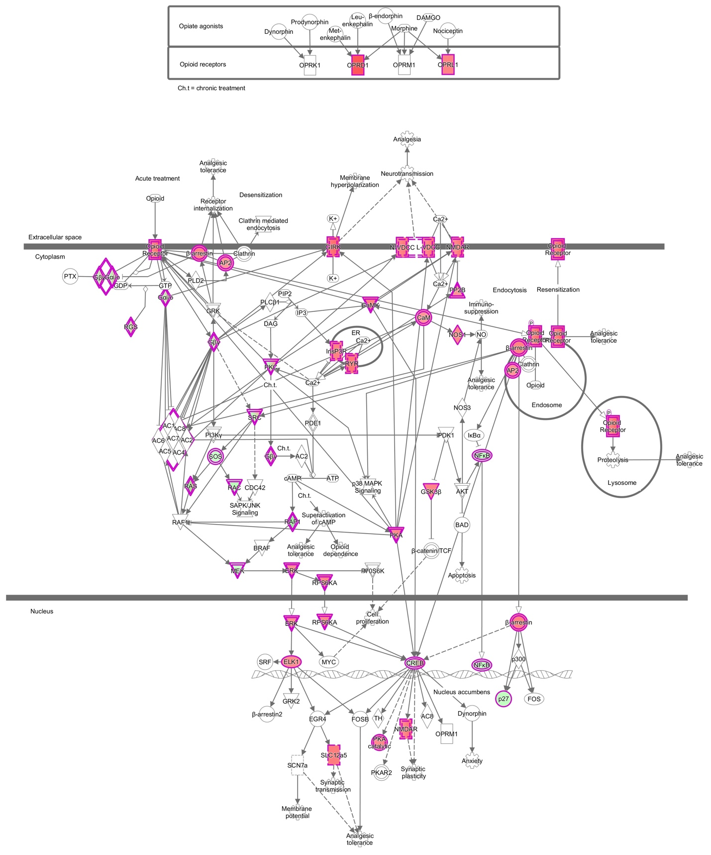
Supplemental Figure 15: Effects of PE/PSS + Pharmahuasca vs PE/PSS + Vehicle on IPA pathway for CREB signaling. Red indicates upregulated transcripts; green indicates downregulated transcripts and grey indicates uncertainty in the direction of modulation. White indicates parts of the pathway that do not significantly differ between groups
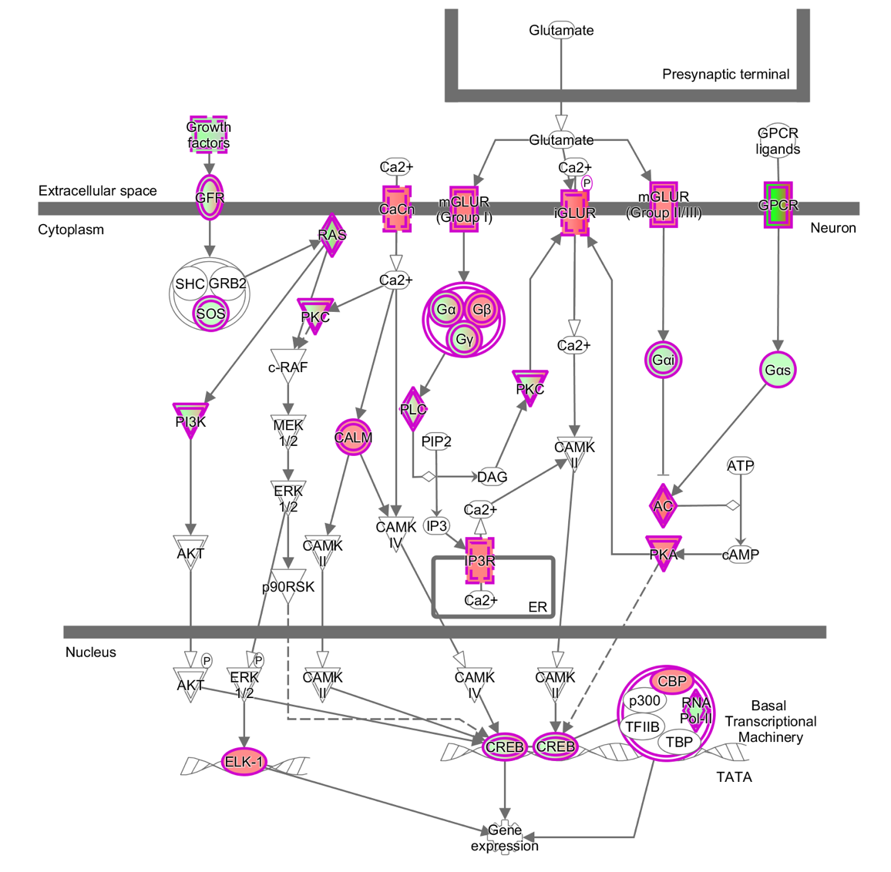

Supplemental Figure 16: (a-d) Confirmation of four genes from RNAseq by RT-PCR. Significance values were obtained in Graphpad PRISM 8 by one way ANOVA followed by Tukey’s post hoc test for multiple comparisons. a) (F _{4,13})= 7.488, p=.0023). Tukey’s post hoc test revealed significant differences between Control and PTSD (p=.0163), PTSD vs PTSD + DMT (p=.0395), PTSD vs PTSD + DMT + Harmaline (p=.0020) b) (F _{4,13})= 1.081, p=.4055). Tukey’s post hoc test did not reveal any significant differences) c) (F_{4,19})= 8.195, p=.0005) Tukey’s post hoc test revealed significant differences between Control and PTSD (p=.0013), PTSD vs PTSD + DMT (p=.0010), PTSD vs PTSD + Harmaline (p=.0014), and PTSD vs PTSD + DMT + Harmaline (p=.0014). d) (F(_{4,15})= 3.317, p=.0390). Tukey’s post hoc test did not reveal any significant differences

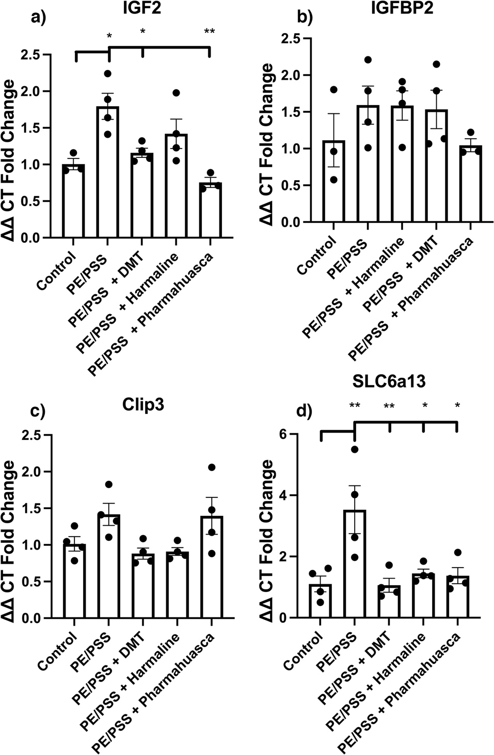

Supplemental Figure 17: (a-c) In vitro analysis of binding affinity and Gα_{q}-dependent canonical signaling at the human 5-HT_{2A}R for 5-HT, DMT, and harmaline. a) Competition binding isotherm for 5-HT at human 5-HT_{2A}R. b) Competition binding isotherm for DMT at human 5-HT_{2A}R. c) Competition binding isotherm for harmaline at human 5-HT_{2A}R.

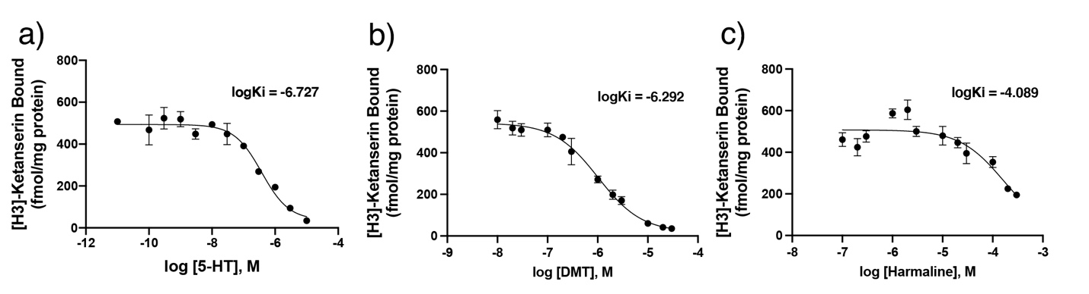

Supplemental Figure 18: PCR primer table

GAPDH F | 5’ CCC TGT TGC TGT AGC CAT ATT 3’
GAPDH R | 5’ ACT CCC ATT CTT CCA CCT TTG 3’
IGF2 F | 5’ TAC CAG CGA GAG CCA GTA A-3’
IGF2 R | 5’ GCC AAG CGA TAG AGA CAG ATA AA 3’
IGFBP2 F | 5’ GTG ATG GGT GTG GAG GAT TT 3’
IGFBP2 R | 5’ AGG AAC GGA GGT ACA GGT TA -3
Clip3 F | 5’ GCA TCT CGT ATC CAG AGG ATT G -3’
Clip3 R | 5’ CTG TTG TGA AGG TGC GTT TG 3’
Slc6a13 F | 5’ GGT TTC CCT ATC TCT GCT ACA AG 3’
Slc6a13 R | 5’ CTC CAG GAA GAA GAC AGG AAT G 3’

Supplemental Figure 19 (a-b): Hierarchical clustering before and after applying RUVseq
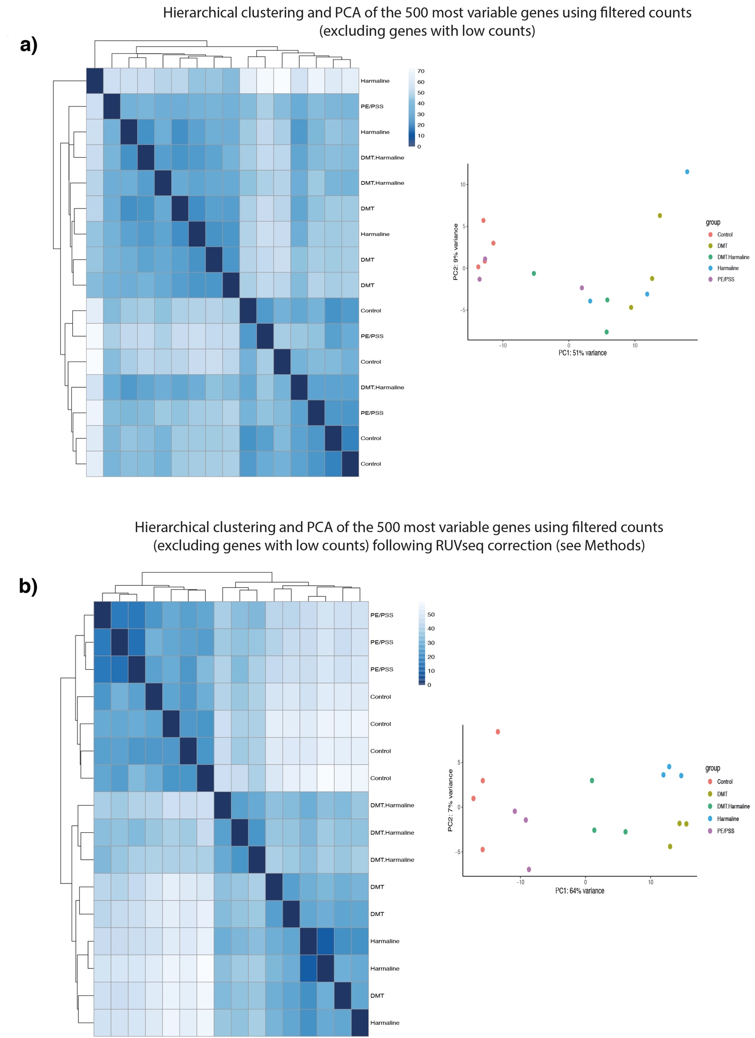

Supplemental Figure 20: Hypothetical schema of the interaction of N,N-DMT with the 5HT_{2A}R and the Sigma1 receptor to modulate ROS production, reduce inflammation, and to induce neuroplasticity. Created with BioRender.com

