Engineered Supercooling Systems for Enhanced Long-Term Preservation of Red Blood Cells in Commercial Blood Bags

Qi Liu^{1#}, Shichun Wang^{1#}, Jie Yan¹, Ronghua Diao¹, Haishui Huang^{3,4}, Feng Xu^{3,4*}, Chunyan Yao^{1,2*}
¹Department of Blood Transfusion, First Affiliated Hospital, Third Military Medical University (Army Medical University), Chongqing, 400038, P.R. China.
²State Key Laboratory of Trauma and Chemical Poisoning, Third Military Medical University, Chongqing, 400038, P.R China.
³The Key Laboratory of Biomedical Information Engineering of Ministry of Education, School of Life Science and Technology, Xi’an Jiaotong University, Xi’an 710049, P.R. China.
⁴Bioinspired Engineering and Biomechanics Center (BEBC), Xi’an Jiaotong University, Xi’an, 710049, P.R. China.
#The authors contributed equally as co–first authors.
*Corresponding authors: yaochunyan@tmmu.edu.cn (C.Y.Y.); fengxu@mail.xjtu.edu.cn (F.X.).

Present address:
No.30 Gaotanyan Street, Shapingba District, Chongqing, China.
Telephone: 86-23-68766661
No.28 West Xianning Road, Beilin District, Xi'an, Shaanxi Province, China.
Telephone: 86-29-88267486

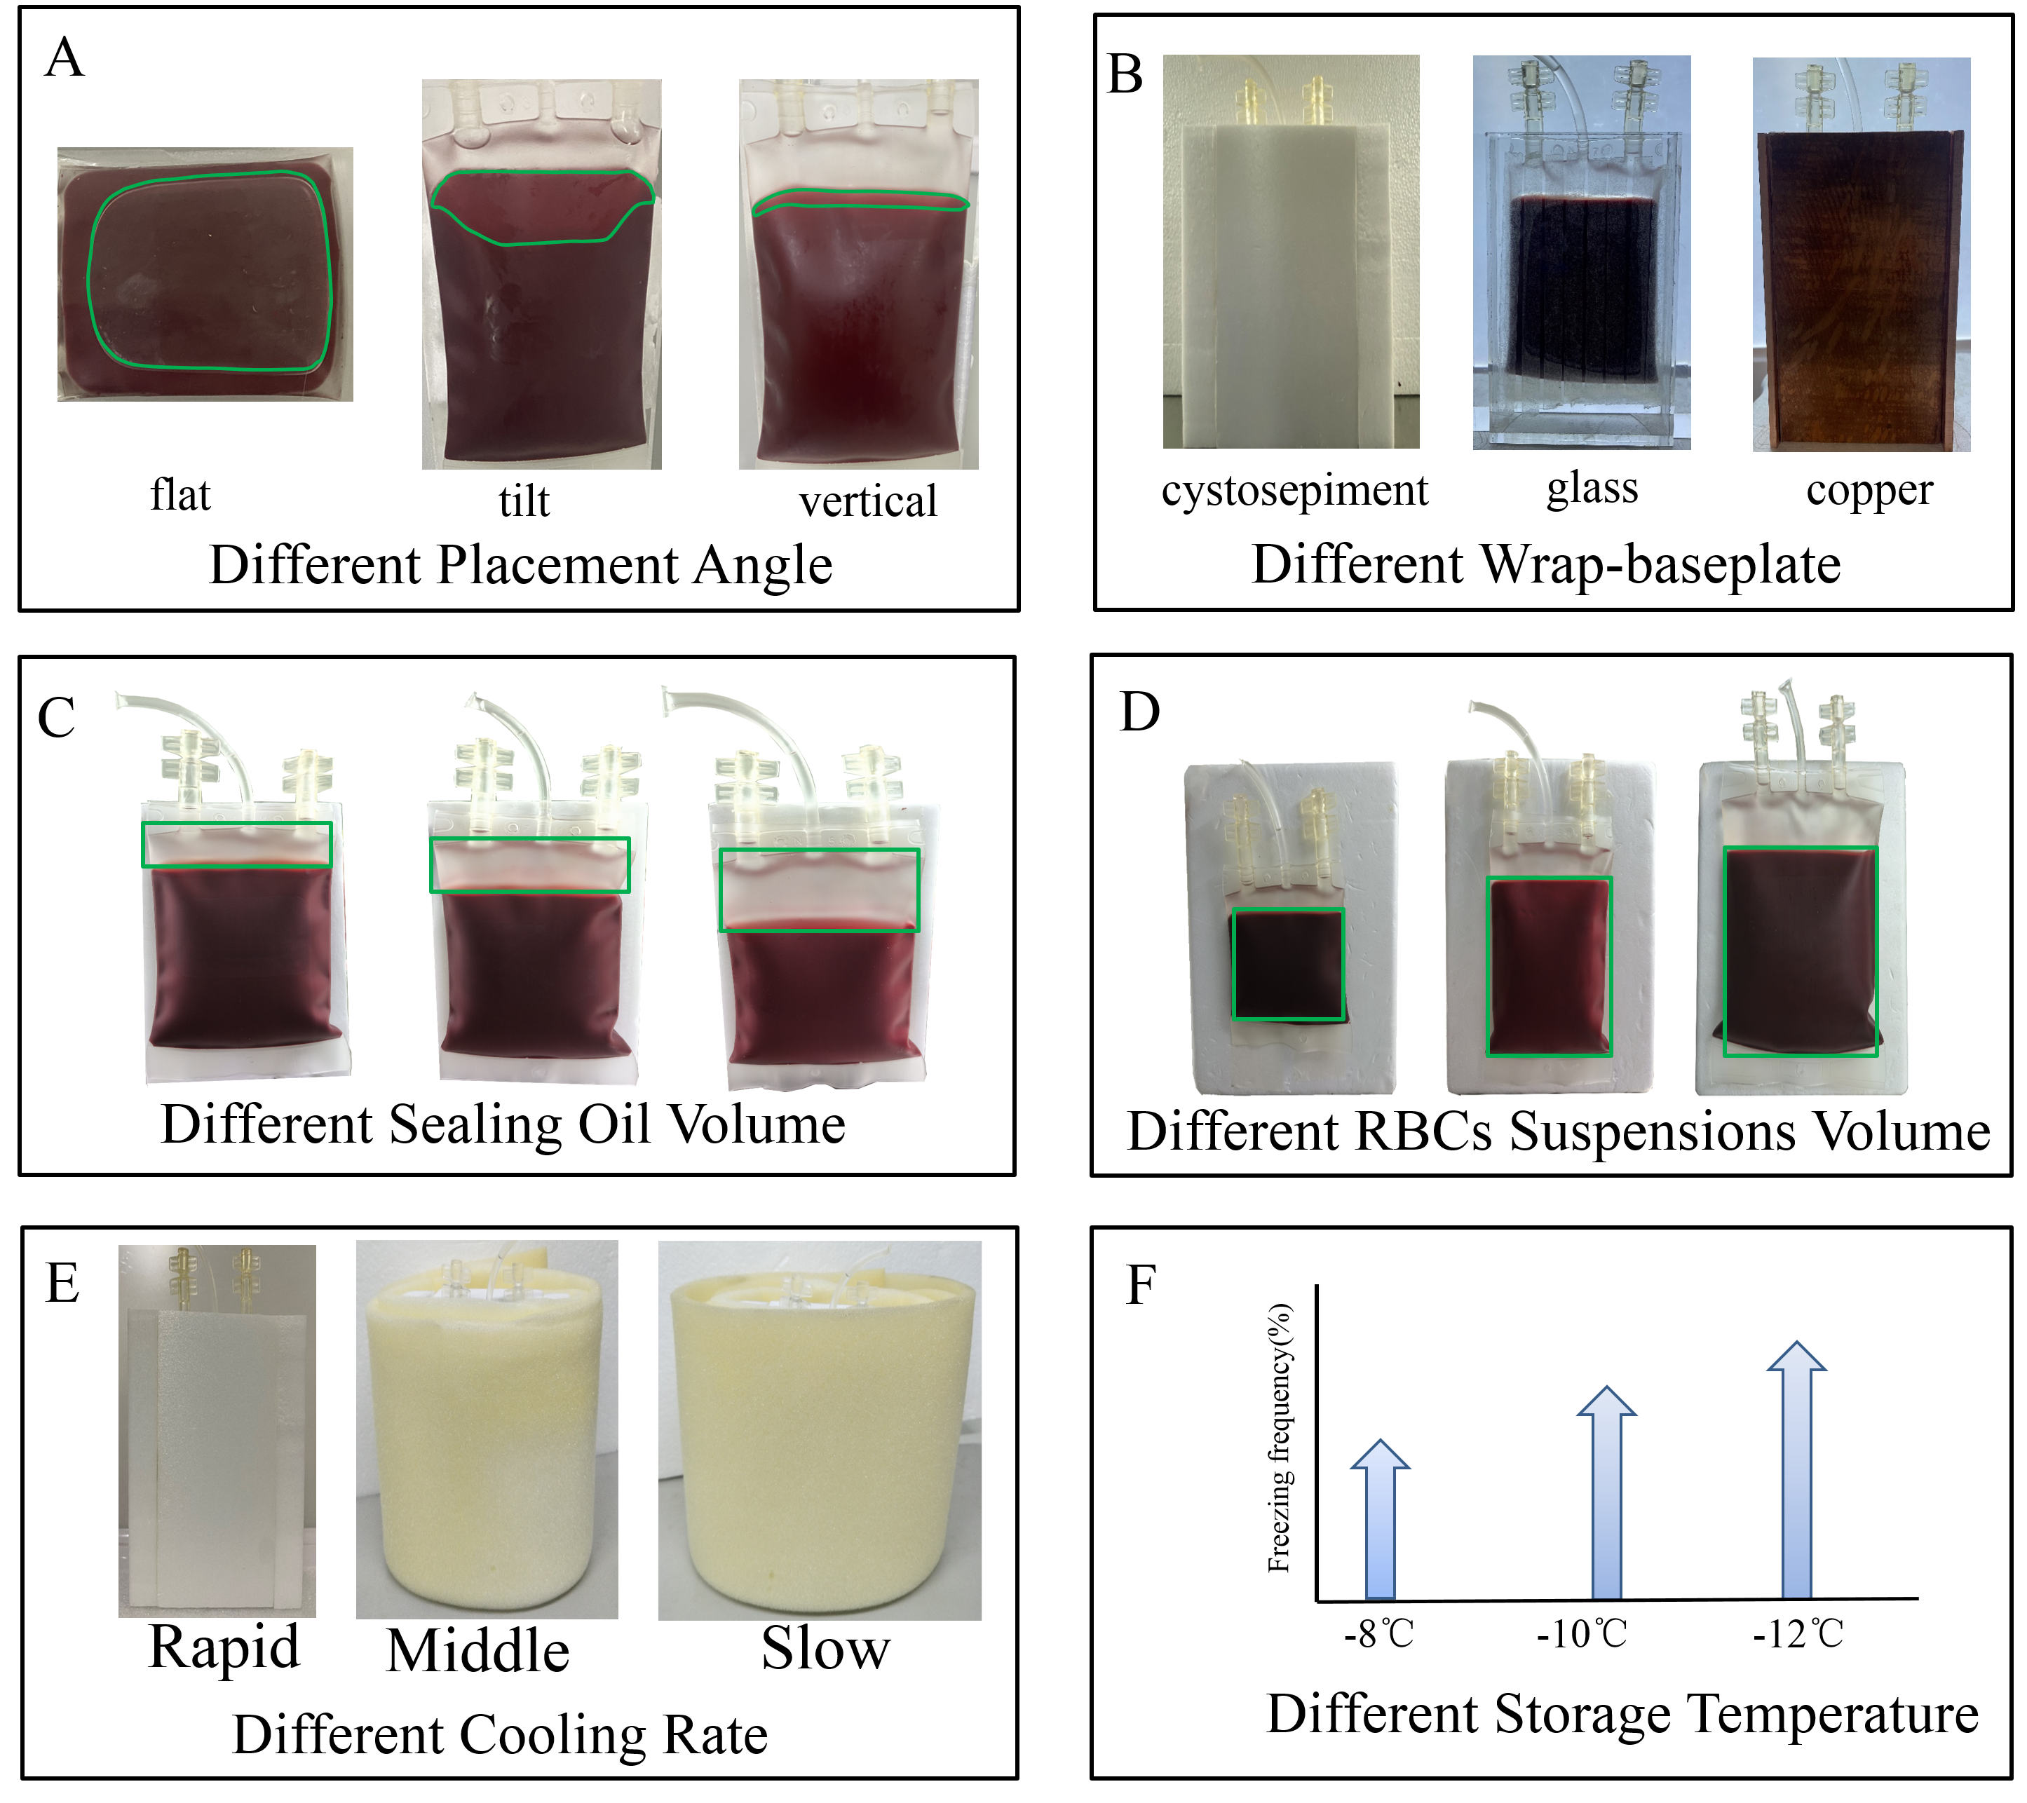
Figure S1. Establish of the orthogonal experimental. A) Placement angle effect on supercooling preservation, the area of the green box represents the RBCs suspensions/air interface. The orientation of the blood bag influences the interface between the RBC suspension and the ambient air. If we consider the blood bag filled with RBC suspension as a cuboid, it is evident that the contact surface with the air when laid horizontally is considerably larger than when placed vertically, while larger contact surface augments the likelihood of freezing. Thus, a vertical orientation for the blood bag seems preferable for supercooling preservation. B) Different of wrap-baseplate. C) Different of the sealing oil volume (the area of the green). the volume of the sealing oil, beyond a critical threshold, has negligible impact on freezing frequencies. The primary takeaway message here is that preventing air bubbles and sloshing are more pivotal factor than the height of the seal. D) Different of the RBCs suspensions volume (the area of the green). E) Different of cooling rate by wrapping different thicknesses insulated sponges. the cooling rate prominently dictates cell survival, while a marginally reduced cooling rate encourages the system's thermal equilibrium, curbing disturbances from thermal fluctuations during this phase. F) Different of storage temperature was set by refrigerator. A lower storage temperature enhances the odds of ice formation due to heterogeneous nucleation in the RBC suspension.

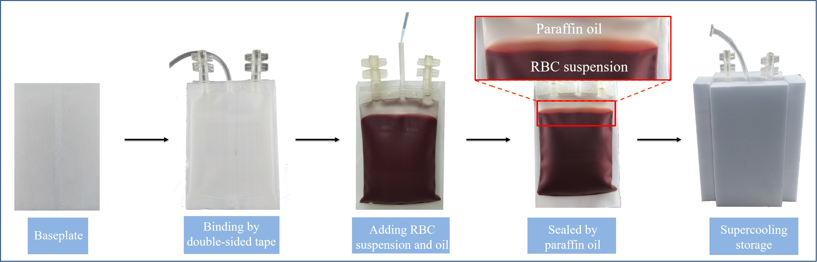
Figure S2. Supercooling preservation procedures for pRBCs and detailed pictorial illustration for critical steps.

Figure S3. Metabolic process of red blood cells. Energy metabolic changes during RBC storage are well documented. Glycolysis, the sole energy source for RBCs, proceeds tenfold slower at 3°C compared to 25°C^{[1]}. Continuous glycolytic metabolism in the confined environment of a storage unit causes a gradual acidification of intracellular pH. This acidification, in turn, restricts the activity of glycolytic enzymes, leading to the depletion of intracellular high-energy compounds, ATP, and 2,3-DPG^{[2-4]}.

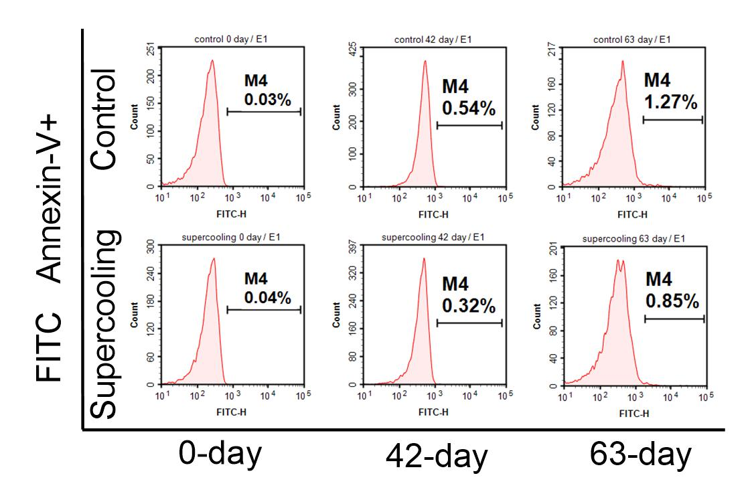
Figure S4. Analysis of PS exposure. PS exposure was detected by flow cytometric on 0, 42, and 63 days of storage.

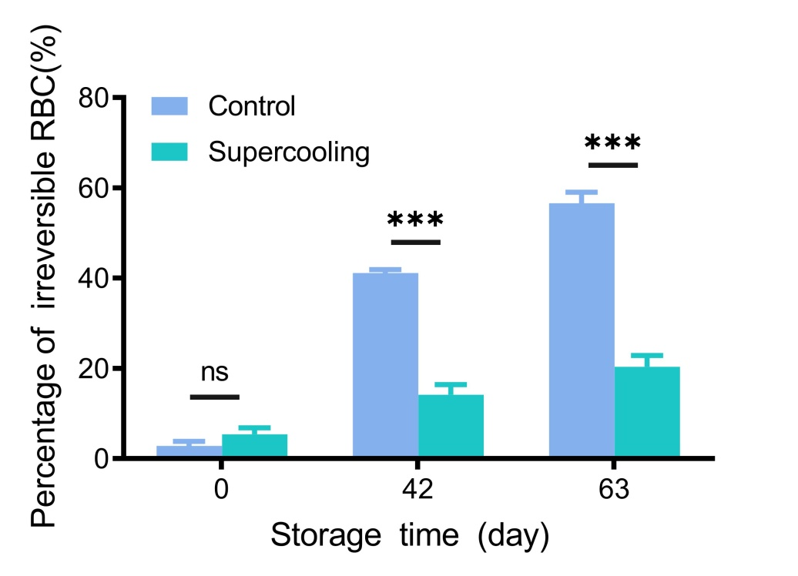
Figure S5. The percentage of irreversible RBC.

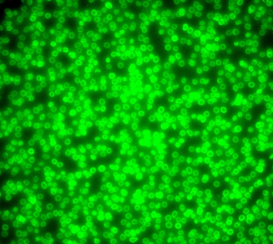
Figure S6. RBCs were label by CFSE⁺ in vitro.

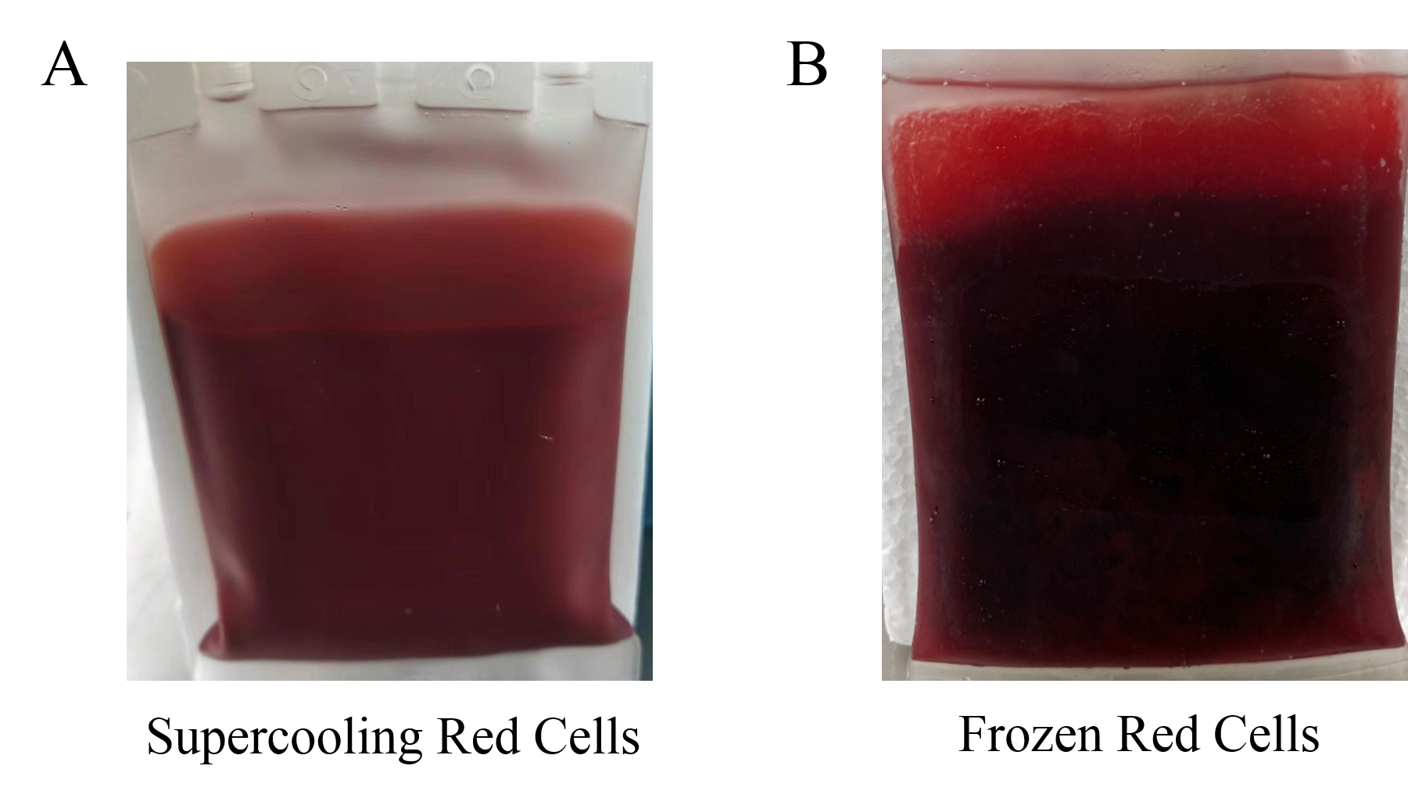
Figure S7. Appearance of pRBCs suspensions. A) A stable supercooled suspension is characterized by its transparency and enhanced lucidity due to the absence of ice crystal heterogeneity, B) Frozen red cells suspension.
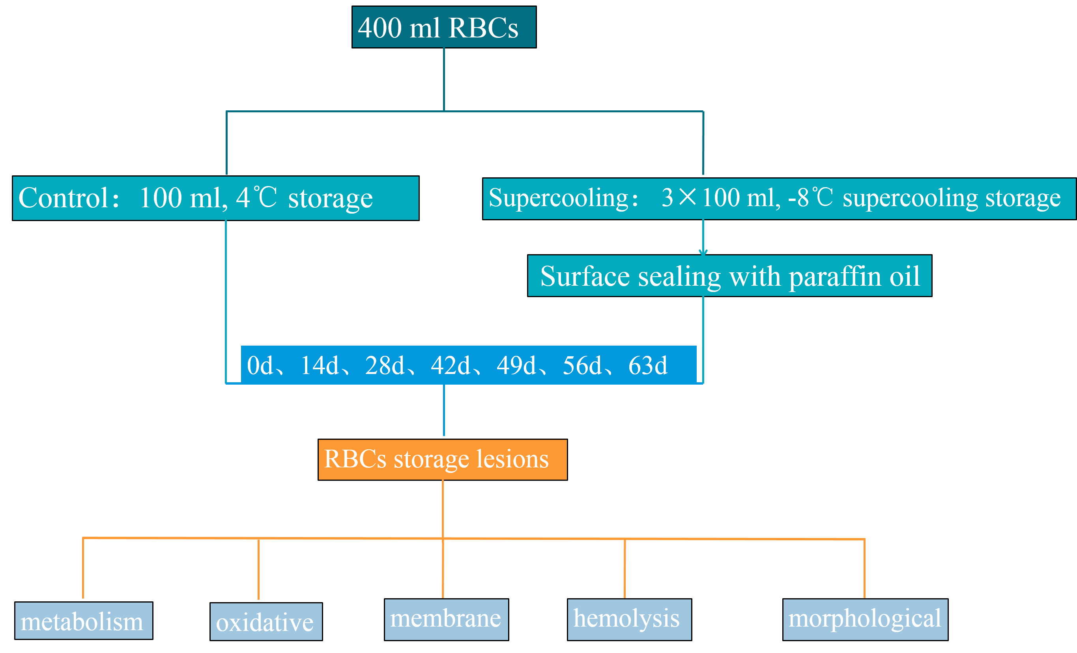
Figure S8. Sample groups and preparation.

Table S1. Data comparing 42-day control stored pRBCs with 63-day supercooling stored pRBCs.
Hematological parameters
Groups | HCT (%) | RBC (×10¹² /L) | Hb (g/L) | MCV (fL) | MCH (pg) | RDW (fL)
Control 42-day | 58.25±4.51 | 6.23±0.63 | 156.25±6.02 | 93.80±5.49 | 25.34±3.02 | 56.78±1.59
Supercooling 63-day | 59.92±3.94 | 6.34±0.45 | 162.33±9.52 | 94.57±2.60 | 25.82±3.43 | 51.57±4.99

Metabolic parameters
Groups | pH | Glucose (mmol/L) | Lactate (mmol/L) | ATP (nmol/mg) | 2,3-DPG (nmol/L)
Control 42-day | 6.42±0.10 | 13.18±1.04 | 17.12±0.92 | 1.86±0.42 | 374.42±43.90
Supercooling 63-day | 6.43±0.06 | 13.13±0.94 | 17.17±0.36 | 1.77±0.38 | 343.17±8.43

Oxidation parameters
Groups | ROS (OD/Hb) | MDA (mmol/L) | SOD (U/mgHb) | CAT (U/mgHb)
Control 42-day | 763.92±89.21 | 11.31±1.14 | 33.42±6.29 | 0.30±0.11
Supercooling 63-day | 865.83±74.17 | 11.78±1.30 | 32.50±4.19 | 0.23±0.03

Membrane damage
Groups | Free-hemoglobin (g/L) | Hemolysis (%)
Control 42-day | 2.58±0.23 | 0.69±0.06
Supercooling 63-day | 3.17±0.14 | 0.78±0.02
NOTE: Comparing supercooling-preserved RBCs at 63 days (-8°C) with those conventionally preserved at 42 days (4°C) shows no variations in standard hematological metrics like hematocrit (HCT), RBC count, hemoglobin concentration (Hb), mean corpuscular volume (MCV), mean corpuscular hemoglobin (MCH), and red cell distribution width (RDW). However, metabolic and oxidative stress markers indicate a distinction in ROS. Free Hb in stored RBC supernatant is higher in the control group, although both remained below the 0.8% threshold. (*p <0.05; **p <0.01; ***p <0.001, Control 42-day: N=12; Supercooling 63-day: N=6).

Movie S1: Supercooling RBCs suspension of bags were tilted. During stability tests, bags containing the supercooled RBC suspensions were tilted to ensure that no freezing events had occurred, given that a frozen suspension would remain static during tilting.

References
1. J. R. Hess, Red cell storage. J Proteomics. 2010; 73(3), 368-373.
2. S. de Bruin et al., Storage of red blood cells in alkaline PAGGGM improves metabolism but has no effect on recovery after transfusion. Blood Adv. 2022; 6(13), 3899-3910.
3. A. Hay et al., Sphingosine 1-phosphate has a negative effect on RBC storage quality. Blood Adv. 2023; 7(8), 1379-1393.
4. J. Rabcuka et al., Metabolic reprogramming under hypoxic storage preserves faster oxygen unloading from stored red blood cells. Blood Adv. 2022; 6(18), 5415-5428.

